**Paper 1 - Activity recognition using a single accelerometer placed at the wrist or ankle [Mannini et al]**



Stanford Dataset. 12.8s window.

Signal Magnitude Vector (SMV)

The resulting 90 Hz SMV signal is independent of the orientation of the sensing node. SMVs were low pass filtered using a 15 Hz cut-off 4th order Butterworth filter to limit the bandwidth of the signal to the frequencies common in human motion, removing high frequency noise.

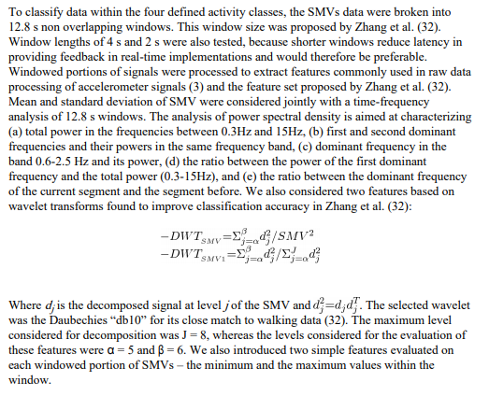

SVM rbf. Cross validation,

**Github – Activity Recognition [Running/Walking]**

**Link -** [**here**](https://github.com/yatharthsharma/Activity-Recognition/blob/master/Activity%20recognition.pdf)

* Mean
* Standard Deviation
* Maximum amplitude
* Minimum amplitude
* Energy Time domain
* Energy Frequency domainRunning

KNN.

This references a paper using decision trees that got 99% accuracy!

**Reference 3 – Mining Smartphone Data**

[**https://www.slideshare.net/neal.lathia/mining-smartphone-data-with-python**](https://www.slideshare.net/neal.lathia/mining-smartphone-data-with-python)

Features – for each window, get mean and stdev of autocorrelation and autocovariance, jitter, kurtosis, frequency.

Random Forest – 98%

**Github – LSTM Human Activity Recognition**

[**https://github.com/guillaume-chevalier/LSTM-Human-Activity-Recognition**](https://github.com/guillaume-chevalier/LSTM-Human-Activity-Recognition)

The sensor signals (accelerometer and gyroscope) were pre-processed by applying noise filters and then sampled in fixed-width sliding windows of 2.56 sec and 50% overlap (128 readings/window). The sensor acceleration signal, which has gravitational and body motion components, was separated using a Butterworth low-pass filter into body acceleration and gravity. The gravitational force is assumed to have only low frequency components, therefore a filter with 0.3 Hz cutoff frequency was used.

Accuracy – 91%

Simple LSTM, 2 layers with 32 hidden units in each.

Confusion matrix.

Improvement – Bidirectional LSTM.

**Reference 4 – Deep Bidirectional Residual LSTM Network [Complex]**

[**Link**](https://arxiv.org/ftp/arxiv/papers/1708/1708.08989.pdf)

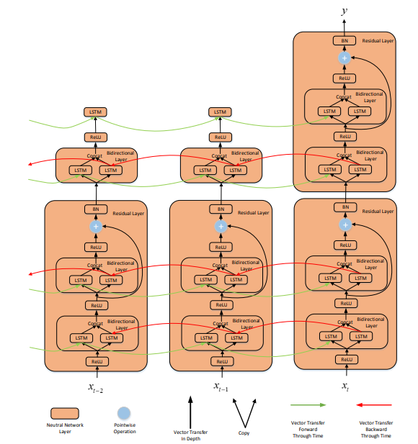

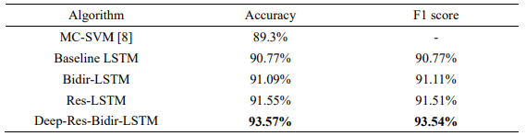

**Github – Activity Recognition using CNN**

[**Link**](http://aqibsaeed.github.io/2016-11-04-human-activity-recognition-cnn/)

**Reference – Physical Human Activity using Wearable Sensors**

[**Link**](http://www.mdpi.com/1424-8220/15/12/29858/pdf)

168 Features based on Time and Frequency Domain. A lot of filters, and transforms. After 168 Features, **(??)** there’s a random forest to select the 12 best features **(??)**. Then machine learning algorithm.

**Reference – Activity Recognition from Accelerometer Data [1400 citations]**

[**Link**](https://pdfs.semanticscholar.org/20cb/9de9921d7efbc1add2848239d7916bf158b2.pdf)

Four features were extracted from each of the three axes of the accelerometer, giving a total of twelve attributes. The features extracted were:

* Mean
* Standard Deviation
* Energy
* Correlation

Window size of 256 with 128 samples overlapping between consecutive windows. At a sampling frequency of 50Hz, each window represents data for 5.12 seconds.

Energy is the sum of the squared discrete FFT component magnitudes of the signal. The sum was divided by the window length for normalization.

Correlation is calculated between each pair of axes as the ratio of the covariance and the product of the standard deviations.

Accuracy – 99%!