**Apache SkyWalking Installation & configuration**

1. Install Java Development Kit 8 on the Collector server.



1. On the backend server download Apache Skywalking 6.1.0 package from following location.

<http://mirrors.estointernet.in/apache/skywalking/6.1.0/apache-skywalking-apm-6.1.0.tar.gz>

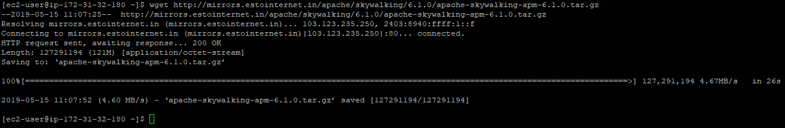

1. Extract the apache-skywalking-apm-6.1.0.tar.gz packge



1. Go to apache-skywalking-apm –bin, directory structure of the distribution package would look like below



SkyWalking backend distribution package includes following parts

1. *bin/cmd scripts*, in */bin* folder. Include startup linux shell and Windows cmd scripts for Backend server and UI startup.
2. *Backend config*, in */config* folder. Include setting files of backend, which are *application.yml*, *log4j.xml* and *alarm-settings.yml*. Most of the settings are in these files.
3. *Libraries of backend*, in */oap-libs* folder. All jar files of backend are in it.
4. *Webapp env*, in *webapp* folder. UI frontend jar file is in here and its *webapp.yml* setting file.
5. Go to bin directory and execute the oapService.sh, this will install the backend.

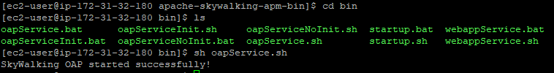

1. Execute the webappService.sh, this will install the UI



1. Edit the Setting file of UI is webapp/webapp.yml in distribution package

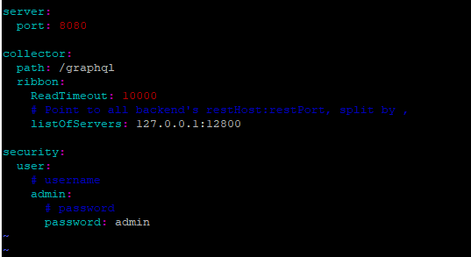

1. Edit *config*/application.yml, and specify location of elasticsearch database server.

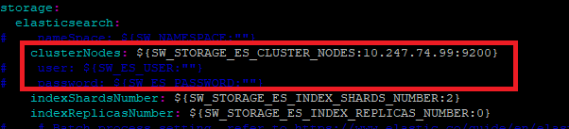

1. Database Installation.

On the DB server download the elasticsearch



Extract the package



Go into the bin directory as follows



Start elasticsearch



1. **Setup java agent**
2. Find agent folder in SkyWalking release package
   1. http://mirrors.estointernet.in/apache/skywalking/6.1.0/apache-skywalking-apm-6.1.0.tar.gz
   2. Copy the agent folder on to the destination tomcat server.
3. Set *agent.service_name* in *config/agent.config*. Could be any String in English. (see below**\***)
4. Set *collector.backend_service* in *config/agent.config*. Default point to **10.247.74.85:11800 (IP of collector)**
5. Add the following argument in *tomcat/bin/setenv.sh*.

*CATALINA_OPTS="$CATALINA_OPTS -javaagent:/home/tomcat/apache-skywalking-apm-incubating/agent/skywalking-agent.jar*

And make sure to add it before the -jar argument.

*Changes to be made in *agent/config/agent.config*.

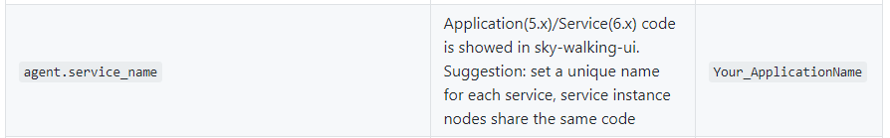

Change the *Your_ApplicationName* parameter to as below

**Examples in Umang**:

For Frontend Tomcat server: **10.247.74.48** PROD_FRT48_<Tomcat instance name> for all the instances

Backend Tomcat server: 10.247.74.16 PROD_BKD16_<Tomcat instance name> for all the instances

10.247.74.36 PROD_BKD36_<Tomcat instance name**> for all the instances**

*For more information, visit* <https://github.com/apache/skywalking/blob/v6.1.0/docs/en/setup/service-agent/java-agent/README.md>

1. **Restart Tomcat Servers** where the agent has been deployed.

Note: In case the collectors are running in cluster mode, IPs for the respective collectors needs to be mentioned in *collector.backend_service*  in *config/agent.config*

1. Go back to the Skywalking backend server and start the skywalking service in bin/startup.sh.



**Note:** In case there are performance issues or Skywalking console giving errors or not populating data please make the following change in *bin/oapService.sh* on the backend server

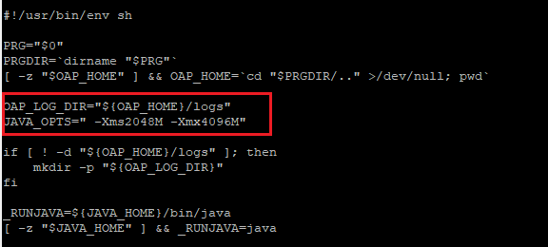

and make the below change in *bin/webappService.sh*

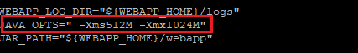

**Alarms configuration:**

Alarm core is driven by collection of rules, which are defined in *config/alarm-settings.yml*

Alarm rule consists of following keys

* **Rule name**. Unique name, show in alarm message. Must end with *_rule*.
* **Metrics name**. A.K.A. metrics name in oal script. Only long, double, int types are supported
* **Include names**. The following entity names are included in this rule. Such as Service name, endpoint name.
* **Threshold**. The target value.
* **OP**. Operator, support >, <, =. Welcome to contribute all OPs.
* **Period**. How long should the alarm rule should be checked. This is a time window, which goes with the backend deployment env time.
* **Count**. In the period window, if the number of **value**s over threshold (by OP), reaches count, alarm should send.
* **Silence period**. After alarm is triggered in Time-N, then keep silence in the **TN -> TN + period**. By default, it is as same as **Period**, which means in a period, same alarm (same ID in same metrics name) will be trigger once.

Following rules have been configured for Umang environment in *alarm-setting.yml*

1. **Service average response** time **over 2s** in last 3 minutes.
2. **Service success rate** lower than **80%** in last 2 minutes.
3. **Service 90% response time** is lower than **2000ms** in last 3 minutes
4. **Service Instance average response time** over **2s** in last 2 minutes.
5. **Endpoint average response time** over **2s** in last 2 minutes.

