UMANG CRM

Solution Design v 1.0

**Powered by Spice Digital Limited**

Document Change History

|  |  |  |  |  |
| --- | --- | --- | --- | --- |
| Version | Change Type | Clause | Description | Date |
| 1.0 | First Draft |  | First Draft for Review | 17 June 2019 |

Contents

1 Introduction 6

1.1 Acronyms and Abbreviations 6

1.2 References 6

2 Technical Details 7

2.1 System Architecture 7

2.1.1 System Components 8

2.2 Network Architecture 8

2.2.1 Service Flow 8

3 Design Considerations 9

3.1.1 Scalability 9

3.1.2 Security 9

3.1.3 High Availability 9

4 Software and Hardware 10

4.1 Software 10

4.2 Hardware 11

5 Integration Details 11

6 Exception Handling 11

7 Assumptions 11

Figures

Figure 1: System Architecture 7

Figure 2: Network Architecture 8

Tables

Table 1: Acronyms and Abbreviations 6

Table 2: References 6

# Introduction

UMANG CRM Module will help customer care agents to communicate with UMANG users and resolve their queries.

Users can raise a request through IVR, Chat or Email using UMANG App or Web portal. Their requests will be assigned to available agent. Agent will interact with users through CRM portal and analyse the query and depending upon the criticality (i.e. General or Service related), agent will take necessary action.

## Acronyms and Abbreviations

The following table lists the acronyms and abbreviations used in this document.

Table 1: Acronyms and Abbreviations

| Acronyms | Full Form |
| --- | --- |
| A2P | Application To Person |
| API | Application Program Interface |
| CRM | Customer Relationship Management |
| DB | Database |
| GUI | Graphical User Interface |
| HTTP(S) | Hyper Text Transfer Protocol (Secure) |
| IVR | Interactive Voice Response |
| MIS | Management Information System |
| NeGD | National e-Governance Division |
| PMM | Problem Management Module |
| SMPP | Short Message Peer to Peer |
| SMS | Short Message Service |
| SLA | Service Level Agreement |
| UMANG | Unified Mobile Application for New-age Governance |

## References

The following table lists the reference documents related to the UMANG CRM portal.

Table 2: References

| S. No. | Document Name | Description |
| --- | --- | --- |
|  | UMANG RFP | This document contains detailed information on requirements of the UMANG platform. |
|  | Bid Clarification | This document contains detailed information on responses of NeGD on the queries related to the UMANG platform. |
|  | Corrigendum | This document contains high-level information on the UMANG platform. |

# Technical Details

This chapter explains the architecture and functionality of the system. The chapter is organized into the following sections:

* System Architecture
* Architecture Diagram

## System Architecture

The following figure depicts the System architecture of CRM in detail.

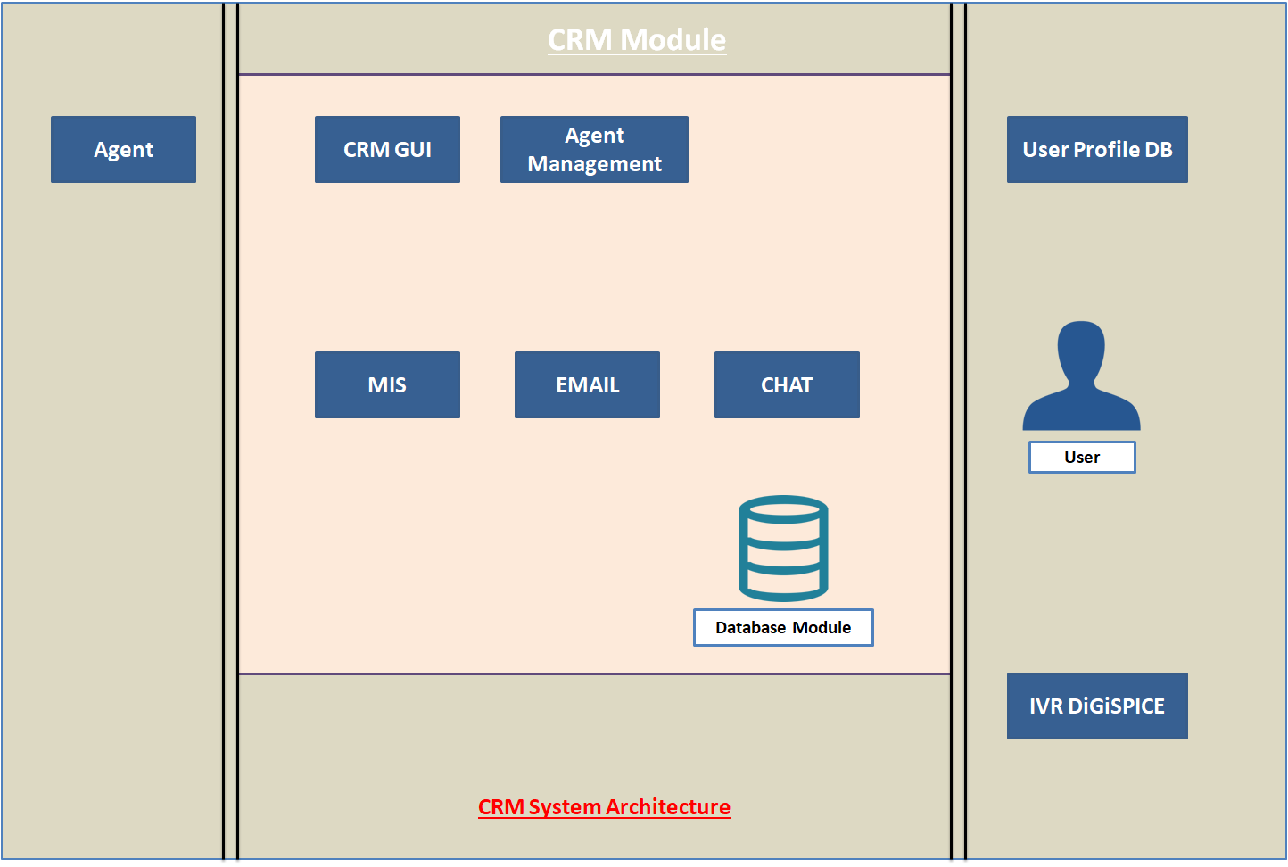

Figure 1: System Architecture

### System Components

The following table lists the details of the CRM system components.

|  |  |
| --- | --- |
| Component Name | Description |
| **Chat** | This module is used for Chat interaction between agent and end user whom have UMANG app and Web access. |
| **Email** | This module is used for email communication between user and customer care representative. |
| **IVR** | This module is used for voice interaction between agent and UMANG user. |
| **Database** | This is used to store the information of user interaction. |
| **MIS** | This is used for reporting purpose. |
| **User Profile** | This module is used to fetch user profile information. |

## Network Architecture

The following figure depicts the Network Architecture of the CRM.

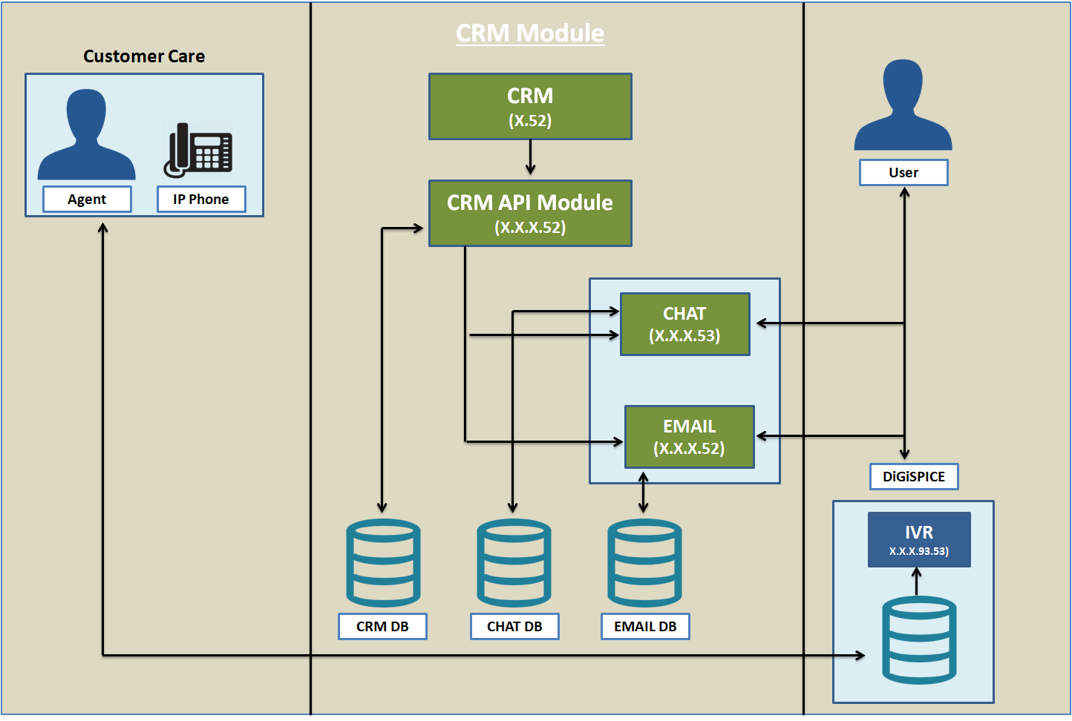

Figure 2: Network Architecture

### Service Flow

1. Customer support agent needs to login on CRM portal to serve any incoming request. Once they logged in to CRM portal they need to change their status as active on portal using the available option on CRM.
2. If agent is active on CRM then agent can receive requests that are coming through app or website.
3. End users can raise their query using Chat, IVR or email mode.
4. If agent is able to resolve the query during the interaction then agent can close the request or if problem is not resolved then agent can raise a ticket.
5. Once ticket is created, customer care admin will analyse that ticket & if the query is resolvable then close the ticket and if it is not resolvable then forward that ticket to PMM or concerned department as per ticket analysis.
6. Whenever ticket will be marked as resolved by respective stake holder, CRM admin can close or reassign the ticket as per user query.
7. In case end user tries to approach for same ticket again then agent can reopen the ticket.
8. Reporting section is used to analyse the bandwidth utilization & system consumption.

# Design Considerations

The subsequent sections provide information on the design considerations of the UMANG CRM.

### Scalability

* All communications are stateless and there is no need to manage the session.
* APIs hosting will be performed on highly scalable platform through load balancer system. More systems can be added at run time to cater more requests.

### Security

* All APIs integration should be done on HTTPS only. JSON communications simplifies authentication efforts.
* User authentication will be performed using token system.

### High Availability

A clustered environment ensures high availability of the system as API hosting is done through load balancer system in Active-Passive mode.

# Software and Hardware

This section provides information on the software and hardware used in the UMANG CRM implementation.

## Software

The software used will be:

|  |  |
| --- | --- |
| Software | Usage |
| Postgres DB | For maintaining entire functionality |
| Appium | For API |
| Linux | Deployment OS |
| Nginx | For Clustered Environment |
| Angular JS | For Frontend |
| Spring Hibernate | For Backend |

## Hardware

Hardware used will be:

|  |  |  |
| --- | --- | --- |
| Hardware | Configuration | Quantity |
| Servers | 16 GB RAM | 2 |
| Hard Disk Drive | 200GB | 1 |
| Processor | Octa Core | 1 |

# Integration Details

The following table lists the modules that will be integrated with the CRM module.

|  |  |
| --- | --- |
| Module | Used to |
| SelfCare | Raise CRM tickets |
| PMM | Assign CRM tickets to Techops |

# Exception Handling

Standard Operation Procedures will be followed for exception handling. Standard exceptions (Server Down, Request Failures etc.) will be monitored and handled by TechOps team. Any other issue will be communicated to TechOps team for further follow up.

# Assumptions

* The UMANG CRM platform will be hosted on the infrastructure provided on the NIC cloud.
* Integration with the UMANG CRM will be done using HTTP(S) protocol.