UMANG SelfCare

Solution Design v 1.0

**Powered by Spice Digital Limited**

Document Change History

|  |  |  |  |  |
| --- | --- | --- | --- | --- |
| Version | Change Type | Clause | Description | Date |
| 1.0 | First Draft |  | First Draft for Review | 16-Oct-18 |

Contents

1 Introduction 6

1.1 Acronyms and Abbreviations 6

1.2 References 6

2 Technical Details 7

2.1 Network Architecture 7

2.1.1 Service Flow 7

2.2 System Architecture 8

2.2.1 System Components 8

3 Design Considerations 10

3.1.1 Scalability 10

3.1.2 Security 10

3.1.3 High Availability 10

4 Software and Hardware 10

4.1 Software 10

4.2 Hardware 11

5 Integration Details 11

6 Exception Handling 11

7 Assumptions 12

Figures

Figure 1: Network Architecture 7

Figure 2: System Architecture 8

Tables

Table 1: Acronyms and Abbreviations 6

Table 2: References 6

# Introduction

Unified Mobile Application for New-age Governance (UMANG), a Digital India initiative of NeGD, enables users to access all government services through a single mobile interface. Users do not need to install different mobile apps to avail government services.

The SelfCare portal is a platform through which super admin (NeGD) and departments can access and manage services available on UMANG.

## Acronyms and Abbreviations

The following table lists the acronyms and abbreviations used in this document.

Table 1: Acronyms and Abbreviations

| Acronyms | Full Form |
| --- | --- |
| A2P | Application To Person |
| API | Application Program Interface |
| CM | Campaign Manager |
| CRM | Customer Relationship Manager |
| DB | Database |
| HTTP(S) | Hyper Text Transfer Protocol (Secure) |
| NeGD | National e-Governance Division |
| SMPP | Short Message Peer to Peer |
| UMANG | Unified Mobile Application for New-age Governance |

## References

The following table lists the reference documents related to the SelfCare portal.

Table 2: References

| S. No. | Document Name | Description |
| --- | --- | --- |
|  | UMANG RFP | This document contains detailed information on requirements of the UMANG platform. |
|  | Bid Clarification | This document contains detailed information on responses of NeGD on the queries related to the UMANG platform. |
|  | Corrigendum | This document contains high-level information on the UMANG platform. |

# Technical Details

This chapter explains the architecture and functionality of the system. The chapter is   
organized into the following sections:

* Network Architecture
* System Architecture

## Network Architecture

The following figure depicts the Network Architecture of SelfCare portal in detail.

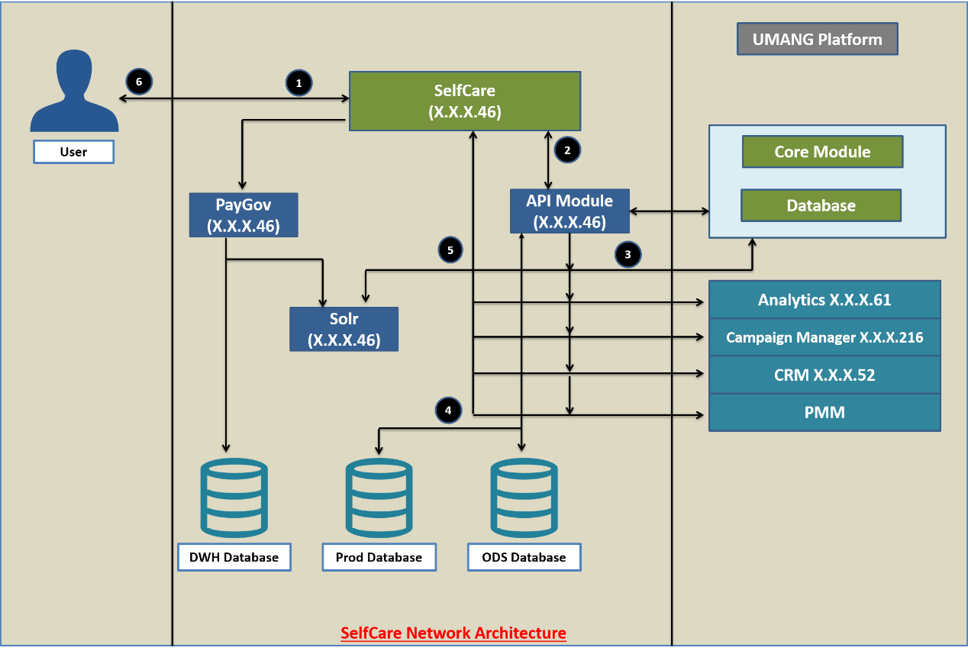

Figure 1: Network Architecture

### Service Flow

A typical flow for a service available to the user will be as follows:

1. Users send their requests for managing apps, users, roles and so on using the SelfCare interface.
2. This request goes through a clustered environment and calls Backend APIs.
3. Depending upon the type of request, Backend API hits the internal or external database.
4. Data is fetched from the database and sent back to backend API in the form of response.
5. If the request is related to Payment, the SelfCare module interacts with PayGov module to process the request. If the request is related to Analytics, Campaign Manger, CRM, or PMM, the SelfCare module interacts with the respective to process the request.
6. This response is shared with the user through SelfCare interface.

## System Architecture

The following figure depicts the System Architecture of SelfCare portal in detail.

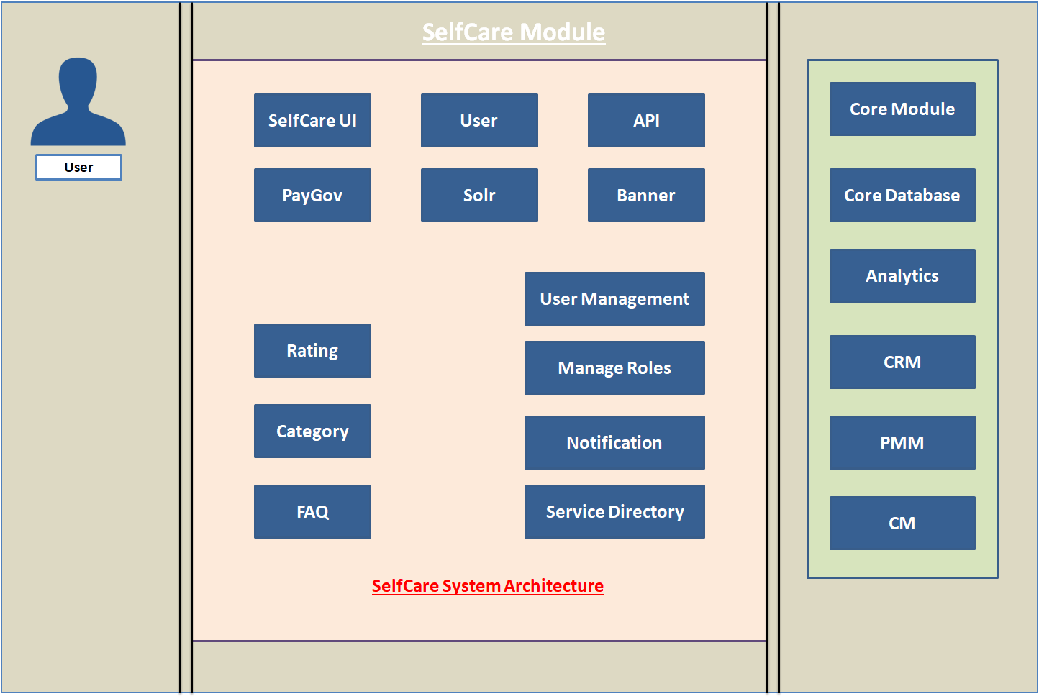

Figure 2: System Architecture

### System Components

The following table lists the details of the Self Care system components.

|  |  |
| --- | --- |
| Component Name | Description |
| **SelfCare UI** | The entire incoming request is generated from SelfCare UI portal. |
| **PayGov** | This module handles all the payment transactions that are being processed via UMANG & other payment gateway. |
| **Rating** | This module is used to check the department-wise rating which is provided by user through app or website. |
| **Category** | This module is used to categorise departments & showcase the same on UMANG App & Web. |
| **FAQ** | This module is used to maintain FAQs of UMANG application for all platforms that are onboard on UMANG Platform. |
| **Banner** | This module is used to upload, schedule and remove banner for UMANG App and web application for desired duration. |
| **User Management** | This module is used to manage user under SelfCare & assign roles & rights as per application provided. Moreover, there are some actions which can be taken for user i.e. de-active, activate etc. for user profile. |
| **Manage Roles** | Roles management module handle roles & rights to different applications. This module helps in restricting the user from unauthorized access. |
| **Notification** | This module is used to push FCM notification to UMANG registered user using different criteria. Notification can be scheduled for any incoming event. |
| **Analytics** | This tool is used to analyse data flow within UMANG platform & analysis on that basis. |
| **CRM** | CRM is customer support system where end users queries are handled through different modes i.e. Chat, IVR & Email. This module also provides reports & incident management. |
| **PMM** | This tool is used for incident management. |
| **Campaign Manager** | SMS, Email, OBD campaigns are scheduled through campaign manager portal. This is used for the promotion of any department or its services. |

# Design Considerations

The subsequent sections provide information on the design considerations of the UMANG SelfCare.

### Scalability

All API end-points should terminate on Load-balancer using domain names allowing High Availability with auto switchover between primary / secondary servers having resources.

This also allows a scalable approach by horizontal scaling of servers having resources and manage high throughput.

### Security

* All APIs integration should be done on HTTPS only. JSON communications simplifies authentication efforts.
* User authentication will be performed using token system.

### High Availability

A clustered environment ensures high availability of the system as API hosting is done through load balancer system in sticky session mode. If one node got down, other nodes are able to cater the request.

# Software and Hardware

This section provides information on the software and hardware used in the UMANG SelfCare implementation.

## Software

The software used will be:

|  |  |
| --- | --- |
| Software | Usage |
| Kafka | Message Broker for sending mail and app notification |
| Postgres DB | For maintaining entire functionality |
| Java | Programming language |
| Linux | Deployment OS |
| Mongo DB | Google App Review |
| Angular JS | For Frontend |
| Solr | For Payment Data |

## Hardware

Hardware used will be:

|  |  |  |
| --- | --- | --- |
| Item | Configuration | Quantity |
| Servers | 16 GB RAM | 2 |
| Hard Disk Drive | 200GB | 1 |
| Processor | Octa Core | 1 |

# Integration Details

The following table lists the modules that will be integrated with SelfCare.

|  |  |
| --- | --- |
| Integration Module | Used to |
| Campaign Manager | Create and manage promotional and transactional notifications to be sent to the users |
| PayGov | Process payment of the users |
| Analytics | Display the system usage and performance reports |

# Exception Handling

# Case 1: User does not exist

Handling: An error message will be displayed from DB end.

# Case 2: API Failure

Handling: An error message will be displayed from DB end.

# Case3: Banner or Attention Screen are not Visible

Failure case check list:

* Check the R-sync of server
* Existence of file on server (on given path)
* In case of API failure and non existence of banner/attention screen, an error message will be displayed.

Success case:

* Success message will be displayed.

# Case 4: Session Time Out

* Time out for latency will be configured to 60 minutes. Session will expire and an error message will be displayed beyond the configured time. However, the time out will be configurable.
* Another case is invalid token from Db user’s session. In this case, session will be forced logout with an error message.

# Case 5: Server Validation Failure

In case of internal server error (code 500) during API communication or forbidden request (code 403), the user will logout from front end and an error message will be displayed.

# Assumptions

* The SelfCare platform will be hosted on the infrastructure provided on the NIC cloud.
* Integration with the SelfCare will be done using HTTP(S) protocol.