**Cloud Gateway**



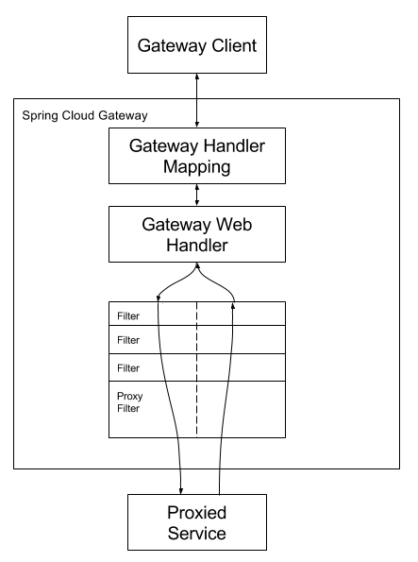

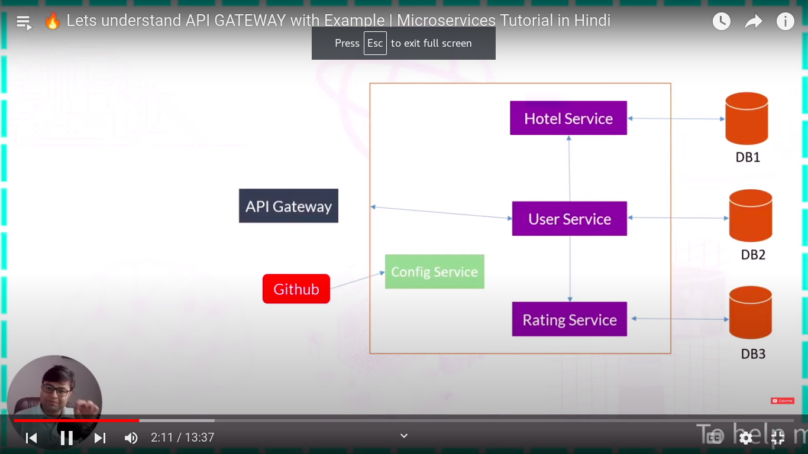

**Index**

1. Required dependency 3

2. Optional dependency 3

3. Automatic generated pom.xml 4

4. Enable as discovery server 7

5. Add application properties file following parameter 7

6. running discovery server screenshot 8

# **1. Required dependency**

**Mandatory dependency**

****Gateway SPRING CLOUD Routing Provides**** a simple, yet effective way to route to APIs and provide cross cutting concerns to them such as security, monitoring/metrics, and resiliency.

* ****Cloud Bootstrap SPRING Cloud Non-specific**** Spring Cloud features, unrelated to external libraries or integrations (e.g. Bootstrap context and @RefreshScope).
* ****Eureka Discovery Client SPRING CLOUD DISCOVERY A**** REST based service for locating services for the purpose of load balancing and failover of middle-tier servers.
* ****Spring Web Web Build**** web, including Restful, applications using Spring MVC. Uses Apache Tomcat as the default embedded container.

# **2. Optional dependency**

****Spring Boot DevTools DEVELOPER Tools Provides**** fast application restarts, Live-reload, and configurations for enhanced development experience.

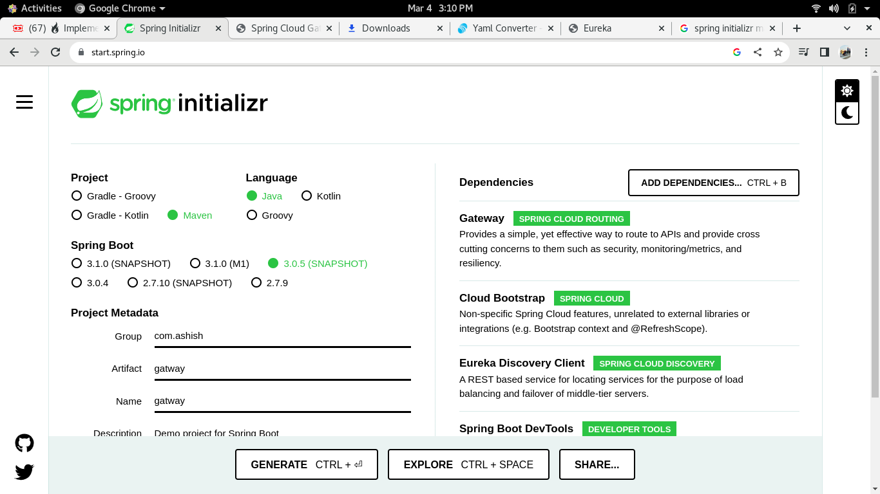

# **3. Automatic generated pom.xml**

<?xml version="1.0" encoding="UTF-8"?>

<project xmlns="http://maven.apache.org/POM/4.0.0" xmlns:xsi="http://www.w3.org/2001/XMLSchema-instance"

xsi:schemaLocation="http://maven.apache.org/POM/4.0.0 https://maven.apache.org/xsd/maven-4.0.0.xsd">

<modelVersion>4.0.0</modelVersion>

<parent>

<groupId>org.springframework.boot</groupId>

<artifactId>spring-boot-starter-parent</artifactId>

<version>3.0.5-SNAPSHOT</version>

<relativePath/> <!-- lookup parent from repository -->

</parent>

<groupId>com.ashish</groupId>

<artifactId>gatway</artifactId>

<version>0.0.1-SNAPSHOT</version>

<name>gatway</name>

<description>Demo project for Spring Boot</description>

<properties>

<java.version>17</java.version>

<spring-cloud.version>2022.0.1</spring-cloud.version>

</properties>

<dependencies>

<dependency>

<groupId>org.springframework.boot</groupId>

<artifactId>spring-boot-starter-webflux</artifactId>

</dependency>

<dependency>

<groupId>org.springframework.cloud</groupId>

<artifactId>spring-cloud-starter</artifactId>

</dependency>

<dependency>

<groupId>org.springframework.cloud</groupId>

<artifactId>spring-cloud-starter-gateway</artifactId>

</dependency>

<dependency>

<groupId>org.springframework.cloud</groupId>

<artifactId>spring-cloud-starter-netflix-eureka-client</artifactId>

</dependency>

<dependency>

<groupId>org.springframework.boot</groupId>

<artifactId>spring-boot-starter-test</artifactId>

<scope>test</scope>

</dependency>

<dependency>

<groupId>io.projectreactor</groupId>

<artifactId>reactor-test</artifactId>

<scope>test</scope>

</dependency>

</dependencies>

<dependencyManagement>

<dependencies>

<dependency>

<groupId>org.springframework.cloud</groupId>

<artifactId>spring-cloud-dependencies</artifactId>

<version>${spring-cloud.version}</version>

<type>pom</type>

<scope>import</scope>

</dependency>

</dependencies>

</dependencyManagement>

<build>

<plugins>

<plugin>

<groupId>org.springframework.boot</groupId>

<artifactId>spring-boot-maven-plugin</artifactId>

</plugin>

</plugins>

</build>

<repositories>

<repository>

<id>spring-milestones</id>

<name>Spring Milestones</name>

<url>https://repo.spring.io/milestone</url>

<snapshots>

<enabled>false</enabled>

</snapshots>

</repository>

<repository>

<id>spring-snapshots</id>

<name>Spring Snapshots</name>

<url>https://repo.spring.io/snapshot</url>

<releases>

<enabled>false</enabled>

</releases>

</repository>

<repository>

<id>netflix-candidates</id>

<name>Netflix Candidates</name>

<url>https://artifactory-oss.prod.netflix.net/artifactory/maven-oss-candidates</url>

<snapshots>

<enabled>false</enabled>

</snapshots>

</repository>

</repositories>

<pluginRepositories>

<pluginRepository>

<id>spring-milestones</id>

<name>Spring Milestones</name>

<url>https://repo.spring.io/milestone</url>

<snapshots>

<enabled>false</enabled>

</snapshots>

</pluginRepository>

<pluginRepository>

<id>spring-snapshots</id>

<name>Spring Snapshots</name>

<url>https://repo.spring.io/snapshot</url>

<releases>

<enabled>false</enabled>

</releases>

</pluginRepository>

</pluginRepositories>

</project>

# **4.** **Enable as discovery client**

**import** org.springframework.boot.SpringApplication;

**import** org.springframework.boot.autoconfigure.SpringBootApplication;

**import** org.springframework.cloud.client.discovery.EnableDiscoveryClient;

@SpringBootApplication

**@EnableDiscoveryClient**

**public** **class** GatwayApplication {

**public** **static** **void** main(String[] args) {

SpringApplication.*run*(GatwayApplication.**class**, args);

}

}

Compulsory we have to add **@EnableDiscoveryClient** annotation in main class .

Register as eureka client which is required to registry as client on

discovery server.

# **5. application.yml file example**

port: 8084

spring:

application:

name: API-GATEWAY

cloud:

gateway:

routes:

- id: USER-SERVICE

uri: lb://USER-SERVICE

predicates:

- Path=/users/**

- id: HOTEL-SERVICE

uri: lb://HOTEL-SERVICE

predicates:

- Path=/hotels/**,/staffs/**

- id: RATING-SERVICE

uri: lb://RATING-SERVICE

predicates:

- Path=/ratings/**

eureka:

instance:

prefer-ip-address: true

client:

fetch-registry: true

register-with-eureka: true

service-url:

defaultZone: http://localhost:8761/eureka

# **6. running discovery server screenshot**

