**resilience4j-circuitbreaker**



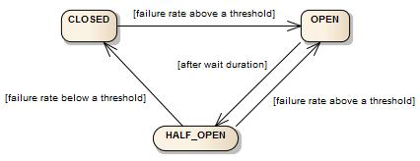

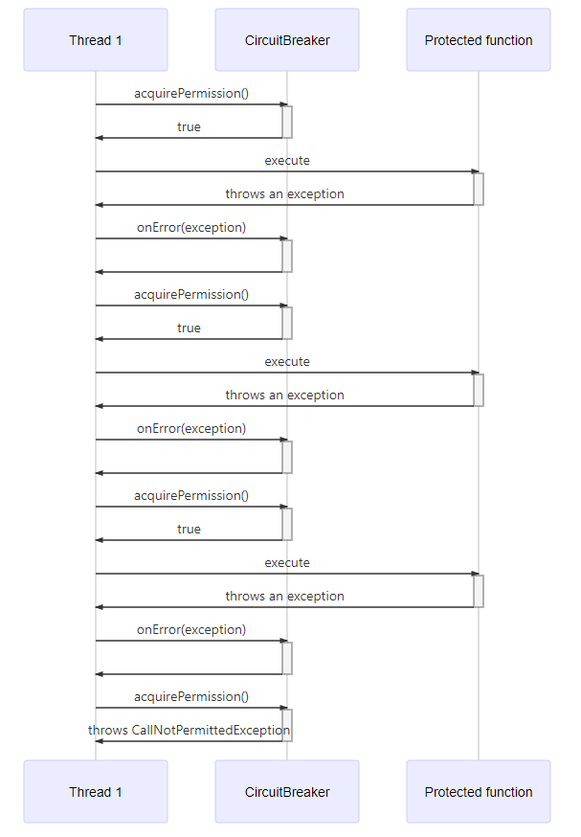

**Index**

1. Required dependency 3

2. Optional dependency 3

3. Automatic generated pom.xml 4

4. Enable as discovery server 7

5. Add application properties file following parameter 7

6. running discovery server screenshot 8

# **1. Required dependency**

**Mandatory dependency**

****Cloud Bootstrap SPRING Cloud Non-specific**** Spring Cloud features, unrelated to external libraries or integrations (e.g. Bootstrap context and @RefreshScope).

* ****Eureka Server SPRING CLOUD Discovery-spring-cloud-netflix**** Eureka Server.

# **2. Optional dependency**

****Spring Boot DevTools DEVELOPER TOOLS****Provides fast application restarts, LiveReload, and configurations for enhanced development experience.

****Spring Web WEB****Build web, including Restful, applications using Spring MVC. Uses Apache Tomcat as the default embedded container.

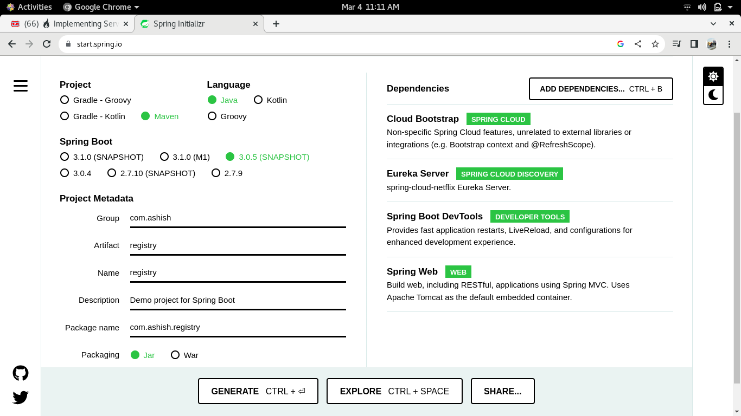

# **3. Automatic generated pom.xml**

<?xml version="1.0" encoding="UTF-8"?>

<project xmlns="http://maven.apache.org/POM/4.0.0" xmlns:xsi="http://www.w3.org/2001/XMLSchema-instance"

xsi:schemaLocation="http://maven.apache.org/POM/4.0.0 https://maven.apache.org/xsd/maven-4.0.0.xsd">

<modelVersion>4.0.0</modelVersion>

<parent>

<groupId>org.springframework.boot</groupId>

<artifactId>spring-boot-starter-parent</artifactId>

<version>3.0.5-SNAPSHOT</version>

<relativePath/> <!-- lookup parent from repository -->

</parent>

<groupId>com.ashish</groupId>

<artifactId>registry</artifactId>

<version>0.0.1-SNAPSHOT</version>

<name>registry</name>

<description>Demo project for Spring Boot</description>

<properties>

<java.version>17</java.version>

<spring-cloud.version>2022.0.1</spring-cloud.version>

</properties>

<dependencies>

<dependency>

<groupId>org.springframework.boot</groupId>

<artifactId>spring-boot-starter-web</artifactId>

</dependency>

<dependency>

<groupId>org.springframework.cloud</groupId>

<artifactId>spring-cloud-starter</artifactId>

</dependency>

<dependency>

<groupId>org.springframework.cloud</groupId>

<artifactId>spring-cloud-starter-netflix-eureka-server</artifactId>

</dependency>

<dependency>

<groupId>org.springframework.boot</groupId>

<artifactId>spring-boot-devtools</artifactId>

<scope>runtime</scope>

<optional>true</optional>

</dependency>

<dependency>

<groupId>org.springframework.boot</groupId>

<artifactId>spring-boot-starter-test</artifactId>

<scope>test</scope>

</dependency>

</dependencies>

<dependencyManagement>

<dependencies>

<dependency>

<groupId>org.springframework.cloud</groupId>

<artifactId>spring-cloud-dependencies</artifactId>

<version>${spring-cloud.version}</version>

<type>pom</type>

<scope>import</scope>

</dependency>

</dependencies>

</dependencyManagement>

<build>

<plugins>

<plugin>

<groupId>org.springframework.boot</groupId>

<artifactId>spring-boot-maven-plugin</artifactId>

</plugin>

</plugins>

</build>

<repositories>

<repository>

<id>spring-milestones</id>

<name>Spring Milestones</name>

<url>https://repo.spring.io/milestone</url>

<snapshots>

<enabled>false</enabled>

</snapshots>

</repository>

<repository>

<id>spring-snapshots</id>

<name>Spring Snapshots</name>

<url>https://repo.spring.io/snapshot</url>

<releases>

<enabled>false</enabled>

</releases>

</repository>

<repository>

<id>netflix-candidates</id>

<name>Netflix Candidates</name>

<url><https://artifactory-oss.prod.netflix.net/artifactory/maven-oss-> candidates</url>

<snapshots>

<enabled>false</enabled>

</snapshots>

</repository>

</repositories>

<pluginRepositories>

<pluginRepository>

<id>spring-milestones</id>

<name>Spring Milestones</name>

<url>https://repo.spring.io/milestone</url>

<snapshots>

<enabled>false</enabled>

</snapshots>

</pluginRepository>

<pluginRepository>

<id>spring-snapshots</id>

<name>Spring Snapshots</name>

<url>https://repo.spring.io/snapshot</url>

<releases>

<enabled>false</enabled>

</releases>

</pluginRepository>

</pluginRepositories>

</project>

# **4.** **Enable as discovery server**

Compulsory we have to add @EnableEurekaServer annotation in main class .

**import** org.springframework.boot.SpringApplication;

**import** org.springframework.boot.autoconfigure.SpringBootApplication;

**import** org.springframework.cloud.netflix.eureka.server.EnableEurekaServer;

@SpringBootApplication

**@EnableEurekaServer**

**public** **class** RegistryApplication {

**public** **static** **void** main(String[] args) {

SpringApplication.*run*(RegistryApplication.**class**, args);

}

}

# **5. Add application properties file following parameter**

This is required to give the information to registry, i am server

don’t registry me as client. Hence fetch registry false and registry

as client false

**eureka.instance.hostname=localhost**

**eureka.client.register-with-eureka=false**

**eureka.client.fetch-registry=false**

**server.port=8761**

# **6. running discovery server screenshot**

