TASK 3 DELIVERABLES - MHEALTH SCHEMA.

To client: Peter Embleton

From team: TAA

**Market scan:**  **(TOM)**

A market scan can be used in a range of different contexts. For the purpose of this report

a market scan will be used to identify possible schema alternatives. These alternatives will then be compared to one another to provide the reader with a comprehensive understanding of strengths, weaknesses, possible opportunities for application use and threats towards Mhealth. A market scan is a vital tool that can help minimise investment risk and provide a holistic comparison (Yu, Wu, Yu & Xiao, 2006). A market scan will be used to critically evaluate possible Mhealth application platforms and justify based on the finding why or why not to use schema.

**Schema vs Alternatives:**

Schema is a mobile Mhealth application developed for the purpose of research. Schema works by researching creating a study protocol. This is done by editing a JavaScript Object Notation (JSON) file. The file contains a series of metadata that can be manipulated to suit different operational needs of the system. In order for schema to be operational a host web server must be set up to run the application from. This server is also used to receive and then store the incoming data from the applications users. Schema has some key strengths which set it apart from its competitors. These strengths are:

* Server design: Schema uses a server design that allows both the study protocol and user data to be stored on a privately run server. This holds the creator of application study accountable for the control and protection of the data from the users and protocols (Shatte & Teague, 2020).
* Open source: Schema is an open source platform that allows the community and wider audience of users to provide feedback as well as contribute to the development of new features for the application. This is a strength of schema as it allows the user to tailor the application specifically to the task they are trying to achieve through the manipulation of the source code (Shatte & Teague, 2020).
* Hybrid platform: Schema uses a single codebase for both iOS and Android. This provides the users with a similar user experience from each OS as well as allows application changes to be implemented with ease (Shatte & Teague, 2020).

When comparing Schema to alternative platforms a clear and concise way of assessing the key differences, strengths and weaknesses is using a SWOT analysis. The following is a SWOT analysis of Schema vs alternative platforms relative to Mhealth.

**SWOT analysis of schema and alternative Mhealth applications: (TOM, AMAR)**

| **Platform** | **Strengths** | **Weaknesses** | **Opportunities** | **Threats** |
| --- | --- | --- | --- | --- |
| Schema  Information sourced from:  (Draper, Collins, Brolio, Hanson & Riseman, 1989  (Axelrod, 1977)  (Shatte & Teague, 2020) | Uses a distributed design. (All data can be hosted from one server)  Open source- this allows the community to contribute towards future application developments.  Just-in-Time Adaptive Interventions:  Schema supports basic levels of JITAIs by using the branching functionality. JITAI is an intervention designed to provide the required support to the mhealth users by adapting to their changing internal and contextual state.  Hybrid development platform - single codebase can be used for ios and android.  Dynamic model presentation and notification timelines- this allows researchers to schedule notifications or prompt a notification after a set time limit, reminder or completion of task. | Schema doesn’t offer personalisation for the vulnerable individuals.  Coding complexity -  The application runs using JSON codes which have a strict syntax. This means that if one simple error in the code the application will not function. | The open source and hybrid development platform that schema offers can create ample growth opportunities.  The ability for the users to edit and improve the platform is an opportunity for schema to assess their input and make changes based on user recommendations.  Scope for building custom tools specifically designed to create study protocols. A second benefit to utilizing such tools would be to explore ways to share modules that may be of use to others, such as common measures and templates, further contributing to open science. | Schema offers minimal security options when it comes to the protection of user data.  The hybrid development allows for information breaches and can cause authentication issues in the program. |
| RADAR- base  Information sourced from:  (Immoreev & Fedotov, n.d.)  (Schreurs, Mercuri, Soh & Vandenbosch, 2013) | Radar signals can target several objects at the same time - returns all data from target objects  It is cheaper compared to other systems  High operating frequency means that large amounts of data can be stored easily | Interference caused by mediums in the air can dilute its effectiveness.  Can be interrupted by other signals  The data collected requires specialised training to analyse. | The health system accommodates well for potential future growth as it can store large amounts of data effectively.  The low cost allows for money to be put into other areas of application improvement. | Important data could potentially be intercepted or interfered. This is a threat to the clients because mhealth relies on the accuracy of data for treatments and medications.  The slow data transfer times are not ideal for an Mhealth app as patients are generally on a strict regime. |
| Universe Mhealth  Information sourced from:  (Shevtsiv, Shvets and Karabut, 2019)  ("mHealth Company | Universe mHealth", 2021) | ios and android compatibility - the cross platform application allows for integration with 3rd party systems.  Pre build modules and interfaces - saves the client time when using the features of the mhealth application.  Uses React Native for mobile app development solutions. | Health organisations and clinics have to rely on Universe’s team to develop client-specific features.  Lacks desktop deployment support.  Only best suitable for enterprise size practices. | Provides the option to select pre-built features such as secure messaging, appointment scheduling, access to medical records.  Resources can be spent on deploying user specific features. | Buggy android iterations: React native does not require separate codes for ios and android which is always not a smooth running process. The android version can often run differently than ios which means the need to always attend to bugs in the program before a final launch.  This requires developers to build in the appropriate time of testing in their schedule to make sure the app is ready for the android platform. |
| SaaS based application platforms  Information sourced from:  (Tsai, Huang & Shao, 2011)  ("Validation of a SaaS-based Platform for Mobile Health Applications", 2018) | Scalability - due to it being a cloud server it offers high vertical scalability.  Flexible payments options - offers a subscription based service so low upfront costs. This is ideal for small businesses.  Updates automatically- SaaS providers automatically ensure updates and software management are completed.  customisation - SaaS software can easily be integrated with external business applications. This works best when they are from a common provider.  Data is backed up using cloud based servers. This means that in the event of a disruption the data is retrievable. | Security concerns for: encryption, identity and access, data privacy and the inability to integrate into larger security setups.  Customer control issues - service disruptions/ security breaches  Difficult to switch providers - large amounts of data integration can cause issues, especially between different cloud based providers. | SaaS provides the opportunity for possible business expansion and is future proof.  The flexible payments and low costs provide an opportunity for entry level application developers.  Integration and customisation means that the client can change the software and coding to suit their needs big or small. | Lack of security in the application can be an issue for confidentiality of client data. This is a threat to the ability to securely hold and access customer information.  Security breaches and control issues can cause client information to be mismatched and data transfers sent to the wrong locations. |
| Personal Health Intervention  Toolkit (PHIT)  Information sourced from:  (Eckhoff et al., 2015)  (Cambon, L., Minary, L., Ridde, V. *et al.)*  (Nurseitov, N., Paulson, M., Reynolds, R. and Izurieta, C.,2009) | Cross platform compatibility  Real time data analysis on mobile device - data output is tailored to the user using a scheduling function  Has the ability to also perform background tasks/ multitasking.  Can collect data from external devices such as sensors or monitors.  PHIT provides cloud management and configuration services for all of their deployed systems.  Analyses the data in real time on the device using intelligent virtual advisor (iVA) | Collects non required data from internal device sensors such as gps coordinates.  Provides the user with access to PHIT web-based dashboard where the uploaded data can be accessed.  XML does not have predefined syntax, so its code can be redundant, which can affect the efficiency of the application.  Also, XML document is less readable compared to other text based data transmission formats such as JSON | Sensor calibration can be implemented before storing data. This will fix the storage of inaccurate data.  Configuring the app to store data in the database of Web server instead of local storage | Big application size. While every mhealth application occupies just a few Megabytes in the storage, PHIT on the apple app store occupies a large amount of storage.  PHIT platform can only host 1 study per application. Therefore , more studies need more applications. |

**Cost benefit analysis: ( schema vs alternatives ) ( TOM, AMAR)**

| **Platform** | **Cost (monthly or annually)** | **Pros** | **Cons** | **Overall value** |
| --- | --- | --- | --- | --- |
| Schema  Sources:  (Bohannon, Freire, Roy & Simeon, n.d.) | Google Console virtual Platform cost - $9/Month(each instance)  =$108 annually  Domain hosting for domain name (Godaddy) =  $15 annually  Cloud Storage (IDrive)=$75 annually For 5TB  Application = $0.00 | Cheap and re-codable.  Offers wide range of data elements  easy deployable | Although schema is inexpensive it lacks a few essential security measures. | $198 annually |
| RADAR-Base  sources:  (Ranjan et al., 2019) | Amazon Msk prices-  =$459/ month  Domain hosting for domain name (Godaddy) =  $15 annually | Offers large data storage. | Expensive for small data transfer and only should be used for big transfers. | $5523 annually |
| Universe Mhealth  Sources:  ("mHealth Company | Universe mHealth", 2021) | Vendor provides price.  Each feature selected adds to the cost. Starts from $50 to $1000 month | Ability to choose either a simple or advanced plan based on needs. No set fixed rate. This is ideal for small businesses or applications. | Vendor prices vary making the provider rates unknown and they have the power to control.  No ability for long term contracts | Highest $12k annually |
| SaaS-Platform  Sources:  (Laatikainen & Ojala, 2014)  (Spruit & Abdat, 2012) | Example vendor offers: wellness living.  Free trial/demo - 30days  Lite version - $12 month  Range of advanced versions from $25-$75pm. | More cost effective than generic software licences  Offers a variety of subscription based methods of payment based on the needs of the customer. | No set rate due to the software costs being controlled by each individual provider. | Each vendor is different. |
| Personal Health Intervention toolkit  (PHIT)  Sources: | Application creation expense depends upon the type of study hosting - starts from $10k(depends upon the study) | Secure, wide range of data elements, stores data encrypted and can collect sensor data as well. | Could be very expensive but depends upon the study as all the rights of PHIT platform belongs to RTI international | Expensive(if choose to host multiple studies on multiple topics) |

**Why schema: (based on finding in swot analysis and cost benefit analysis why use schema). (Tom, Amar, Aashish )**

Comparing schema to other mhealth alternatives using both a SWOT analysis and a cost benefit analysis has allowed the pros and cons of each to be assessed. The opportunities the software provides as well as the threats towards Mhealth and its users have also been considered. This assessment has been done in terms of the application features, security and compatibility. From the five Mhealth applications above there were two that were most suited to the needs of Mobile health. These are: Schema and SaaS.

When choosing a suitable application it is vital that information management is assessed. This includes how the data is backed up, data sovereignty and how the applications address PII just to name a few. The following table will analyse these information management techniques and from that the user will be able to decide which application or software meets their needs. This form of analysis will determine the most suitable solution for the use of Mhealth apps.

**Information management across the different applications/softwares.**

| Application/software | How the data is backed up | Data sovereignty | How the application handles PII |
| --- | --- | --- | --- |
| Schema application | Schema can be backed up using a full online backup (changes saved in the schema during backup are not saved)or an incremental online backup (changes that are made are saved) | Information recorded is not shared with third parties and can only be accessed by the researcher conducting the research. However, Data will be disclosed to government only for legal investigation and purposes | Only the unique user ID and survey response data is stored on the server. |
| RADAR-Base applications | 2 Centralized storage systems: Hot storage & Cold storage.  Cold storage: based on HDFS is scalable and fault tolerant, stores raw data.  Hot storage: based on MongoDB, stores aggregated data. | Some Third party companies will have access to the provided information as they will be employed to work on the company’s behalf. However, they are obligated not to disclose the information for any other purpose. | - PII (User response and user identifier no.) is stored separate from sensor data.  -Access to data can be done via a secure data transfer protocol. |
| Universe Mhealth application | Encrypted storage, transmission and backup of PHI. | Information will only be provided to the care - providers of the patient. No third party will have access to the information. | HIPAA(Health Insurance Portability and Accountability Act) compliant. |
| SaaS-Platform based applications | Data is backed up using cloud servers. | Some Information will be accessible to some third parties employed by the company.  PII will not be shared unless the user volunteers to send his data to third parties by signing up to an advertisement. Third parties can also have different privacy policies. | HIPAA (Health Insurance Portability and Accountability Act) compliant. |
| PHIT based applications | Data is uploaded to a study-specific server via the secure https protocol. Individual and aggregate data can then be off-loaded via a password-protected portal for further analysis and display | -May disclose your personal information, without notice, if required to do so by law or in the good faith belief that such action is necessary to: (a) conform to the edicts of the law or comply with legal process served on PHIT APP or the site;  (b) protect and defend the rights or property of PHIT APP; and/or  (c) act under exigent circumstances to protect the personal safety of users of PHIT APP, or the public | -PHIT APP will not sell, rent or lease information to third parties .  Content may be transferred unencrypted and involve (a) transmission over various networks; and (b) changes to conform and adapt to technical requirements of connecting networks or devices. Credit card information is always encrypted and may also utilize the encryption of Third Party services such as, but not limited to, Paypal and any of its subsidiaries. |

**SaaS Platform Application and User Guide -**

The SaaS-Platform connects clients to various accessible services while providing basic functionality , for example enabling secure communication, authentication, authorization control and secure data storage. In terms of comparison ,SaaS is one of the best platforms to be considered for the Mhealth expansion.Therefore, Further study was initiated on the workings of the platform. There were only a couple of mobile health applications based on SaaS platforms and most of them were paid access only. **M-diab** or **Mobile Diabetes Management** is one of the free Mhealth applications based on SaaS platform available on Android play store. The Mobile Diabetes (M-Diab) system consists of mobile and web-based applications to allow diabetic patients manage their data and doctors analyze patients' data related to diabetes(Berndt, R-D, Takenga, MC, Kuehn, S, Preik, P, Sommer, G, & Berndt, S ,2012). Mdiab offers a user-friendly interface and is easy to use. To use the application, the user needs to sign up with his/her details.

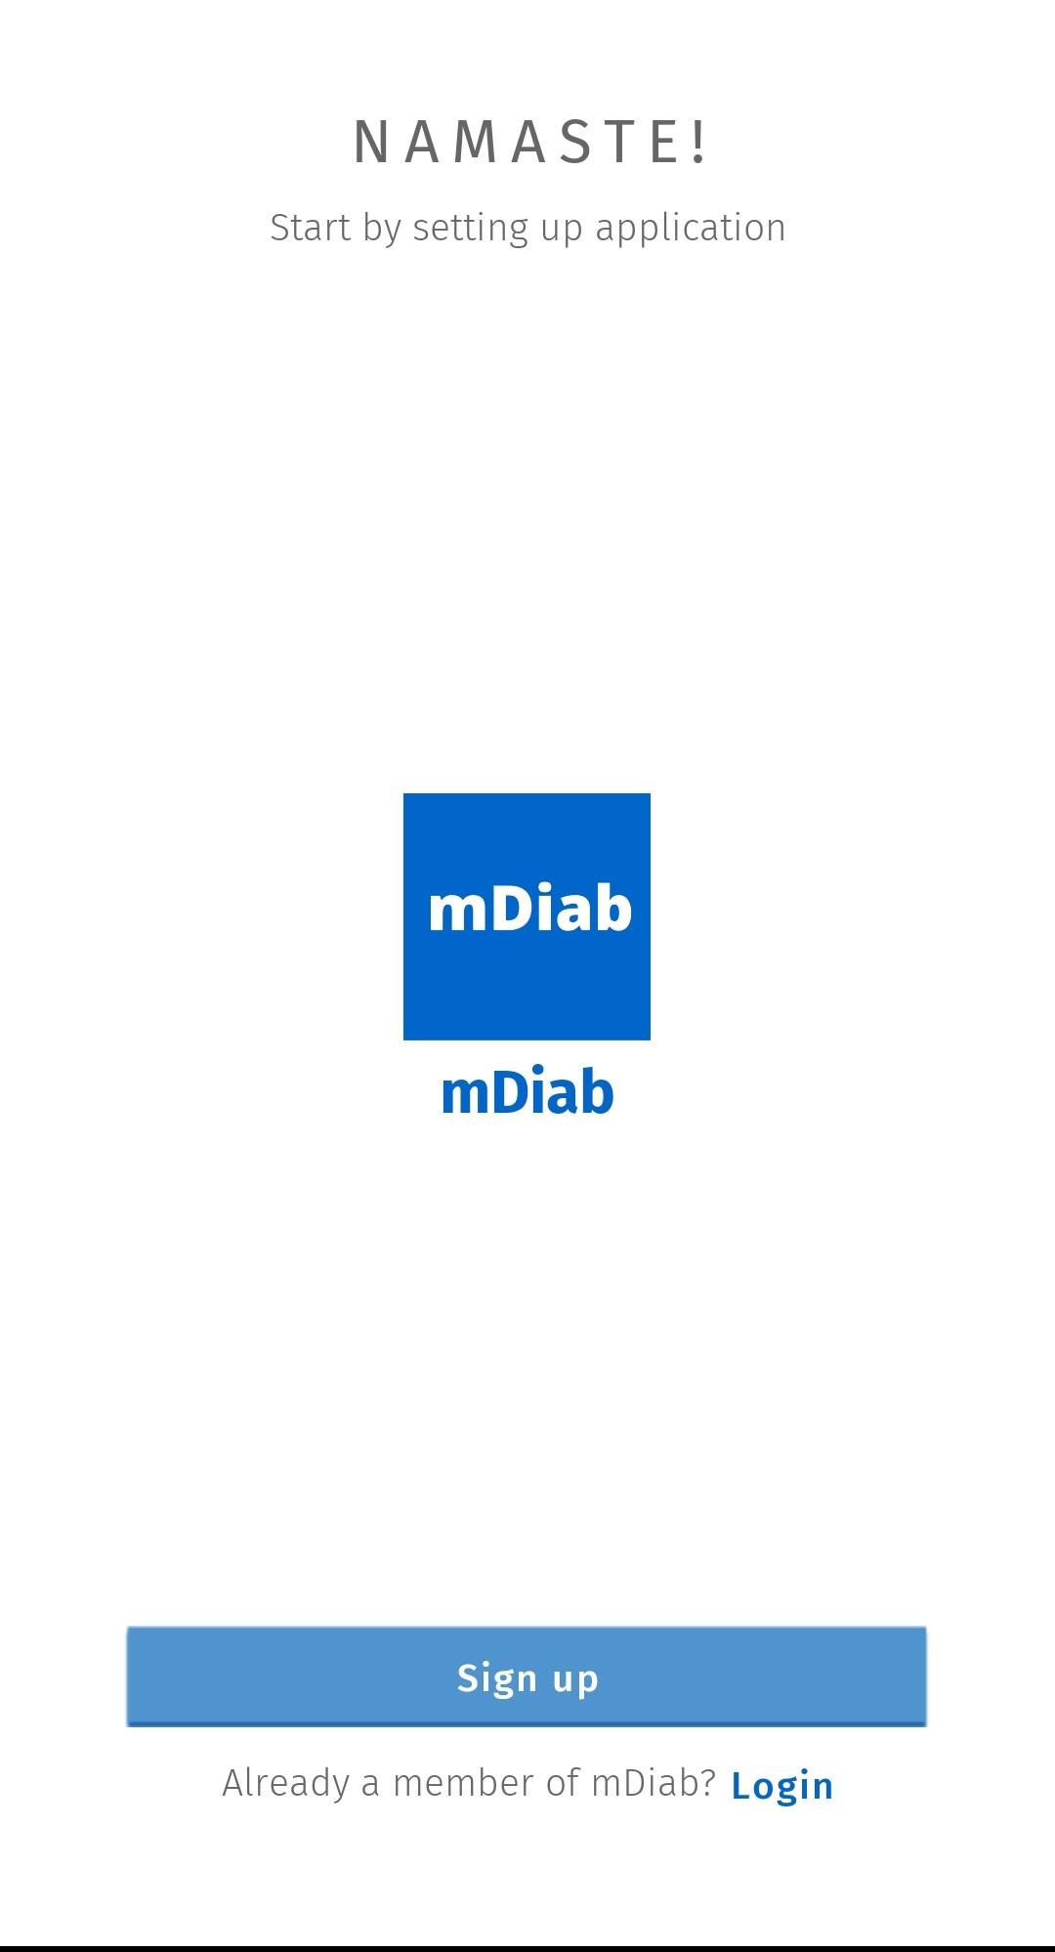

Upon Sign up , User needs to enter the required credentials and agree to the terms and conditions.

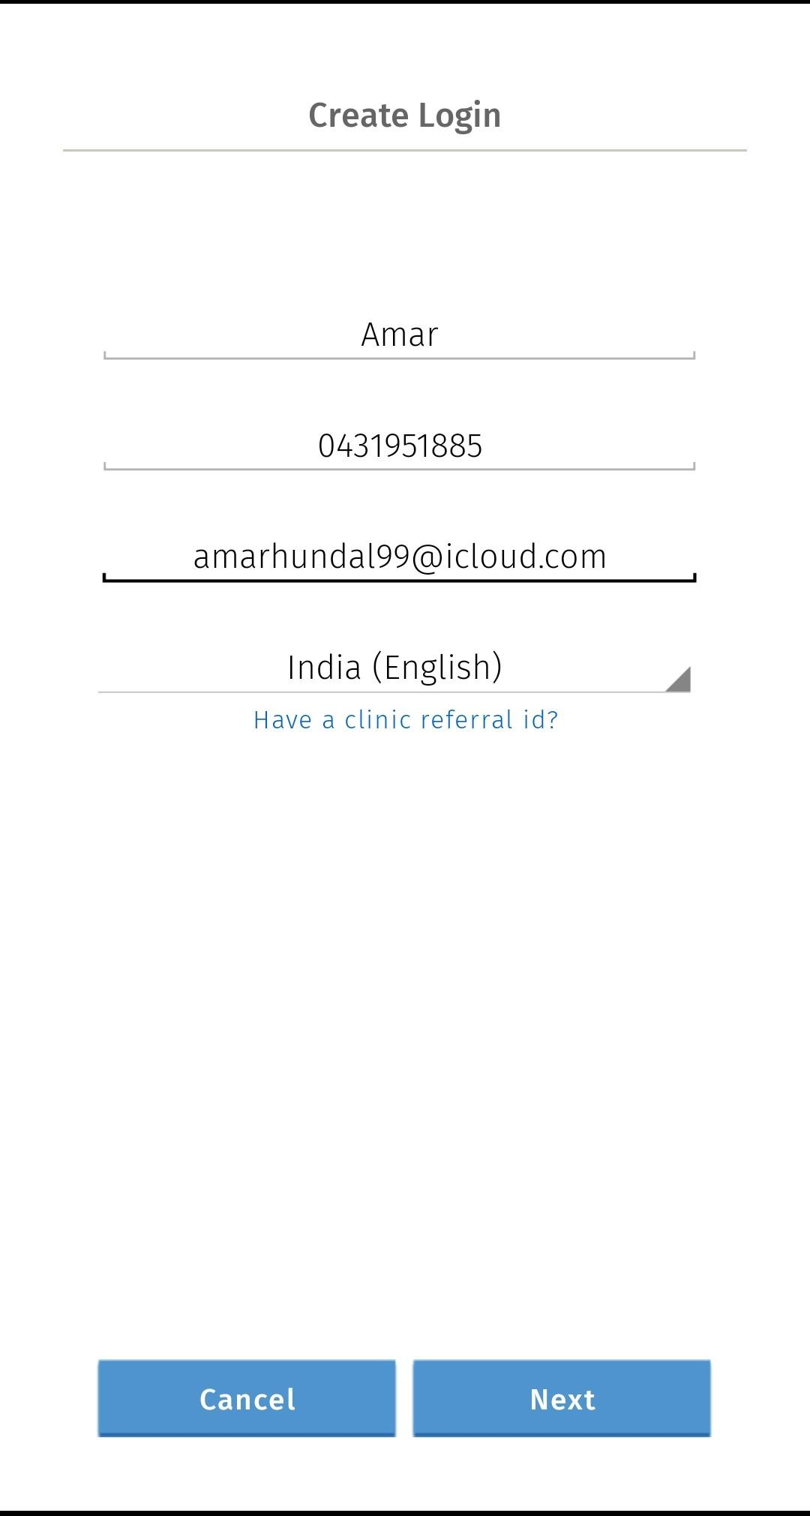

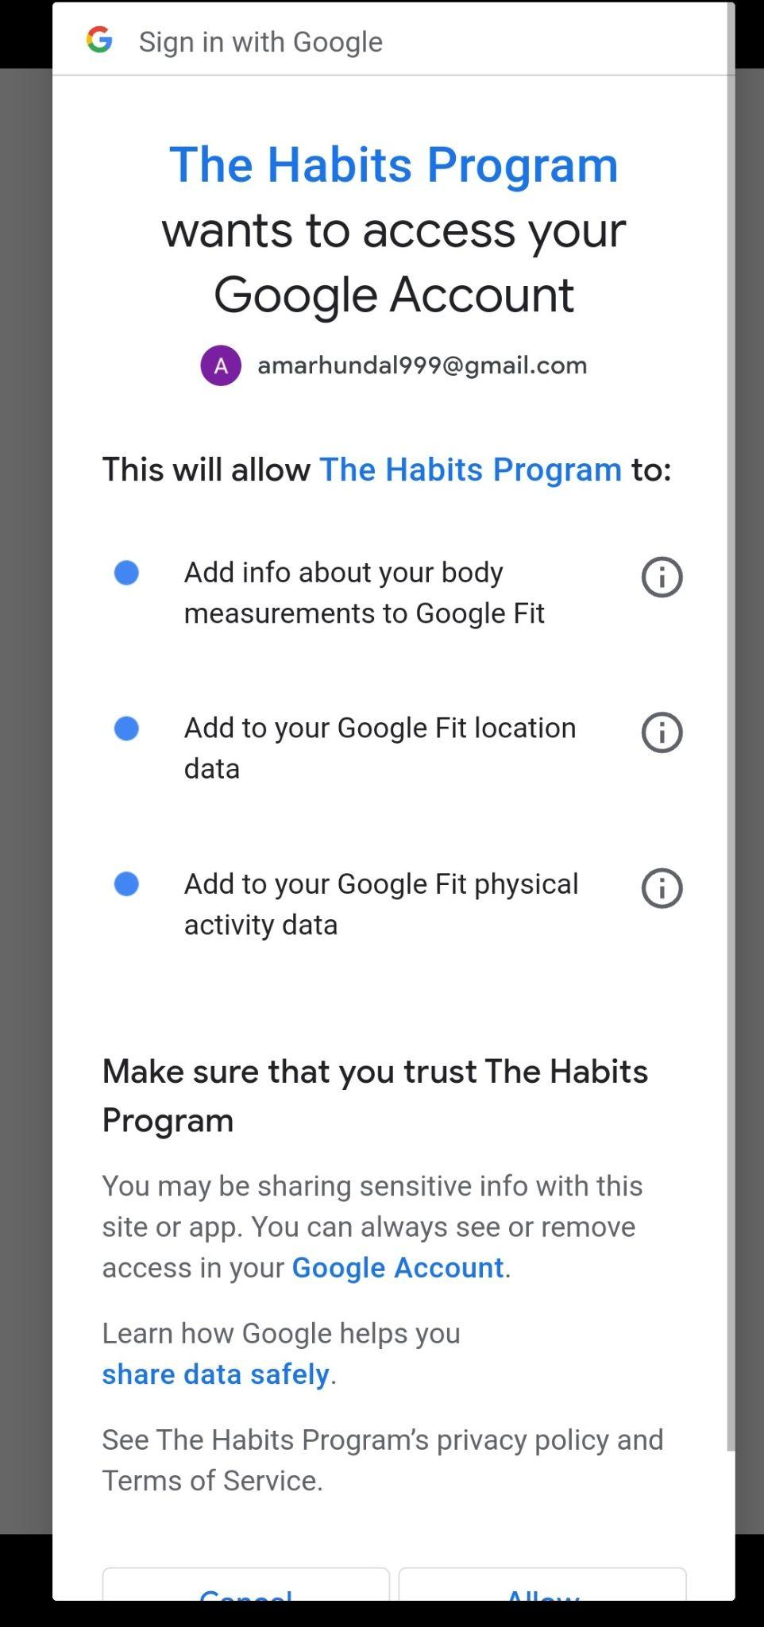

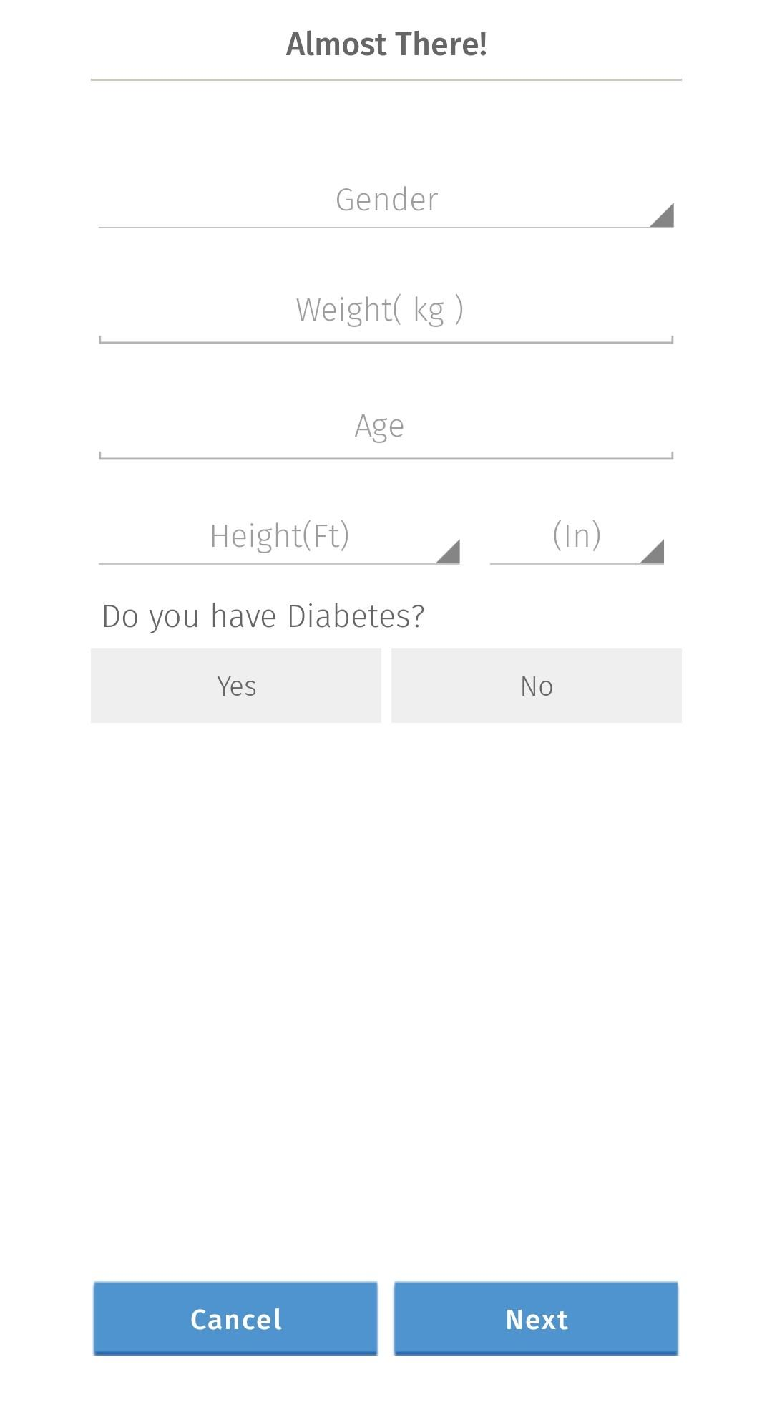

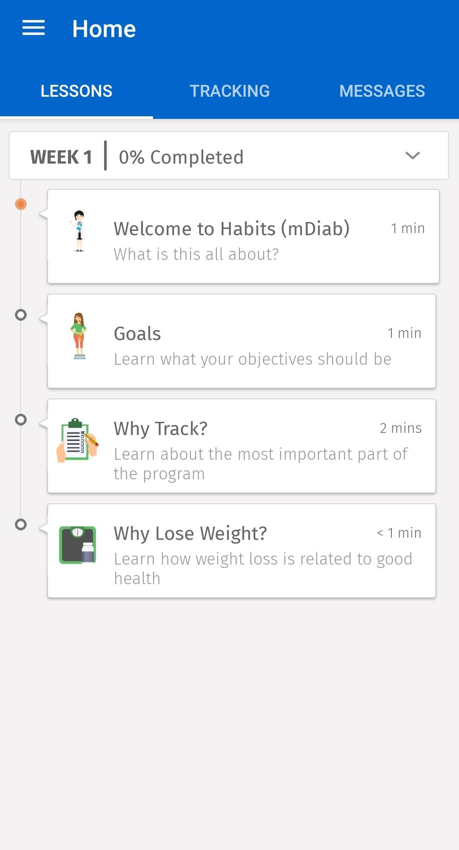

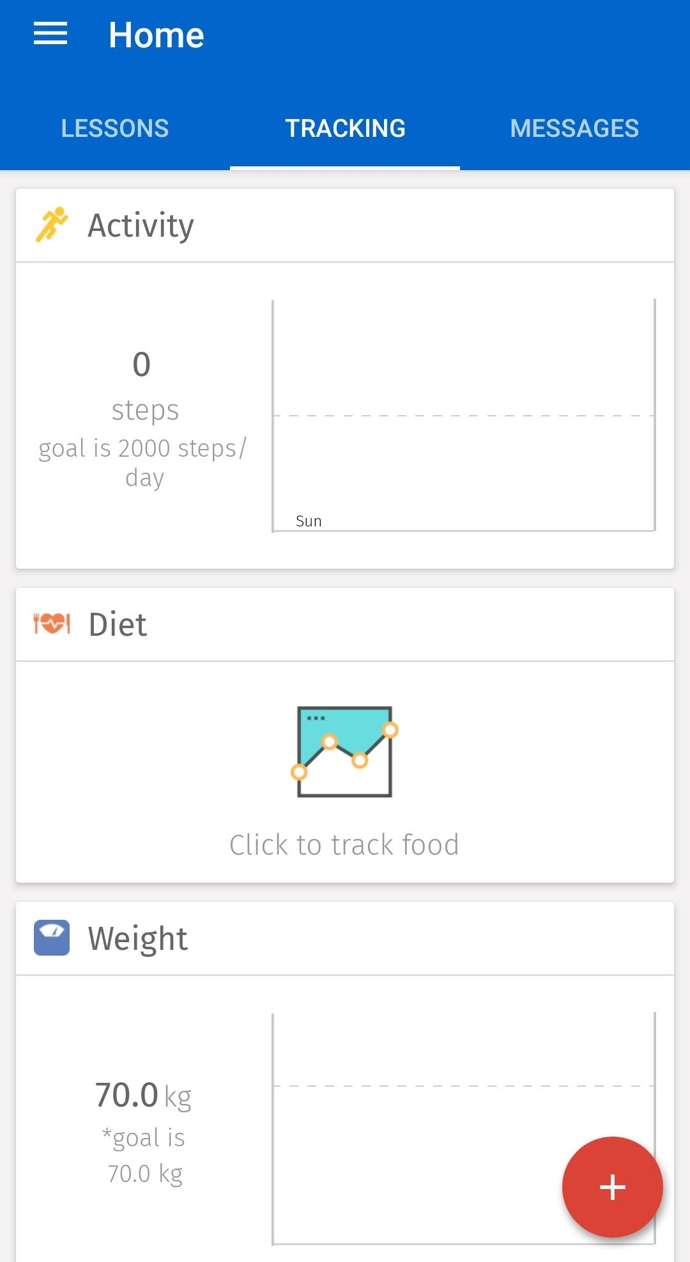



**Based on the table above the application with the best information management are :**

Further comparison between these alternatives found that SaaS was a suitable platform in all areas of criteria necessary for success apart from security. The lack of information and data security offered by SaaS platforms was not to be ignored and is one of the reasons why Schema was a more viable option. Although Schema uses a complex coding syntax and can sometimes have personalisation issues its ample advantages put it in a league above the competition.

The ability to manipulate Schema due to its open source and hybrid development allows the user or client to tailor the application exactly to their needs.

Moreover, the code of Schema is freely listed at the repository by the Owner/Creator and open to use for researchers. This provides a big opportunity to take over every limitation by only introducing new code or re-arranging code of the function needed to be added. To Conclude for the analysis, the Advantages of Schema outweigh every limitation and that is why Schema is the recommended application for the Mhealth platform.

**User guide and output : (Schema technical overview) ( AASHISH)**

Upon installing the app, participants will have access to three primary tabs:

**Home tab**: Allows participants to scan a QR code or enter a URL to enrol in a study.

My progress tab: Feedback graphs will appear here after enrolment and completion of tasks.

**Progress tab:**  To display the progress of the participant for the provided study protocol.

**Settings tab** : It displays a unique and anonymous 8- digit user identifier.

In research designs that require linking identifiers between different systems, participants can access their user identifier from settings tab and provide this to the investigators before enrolment.

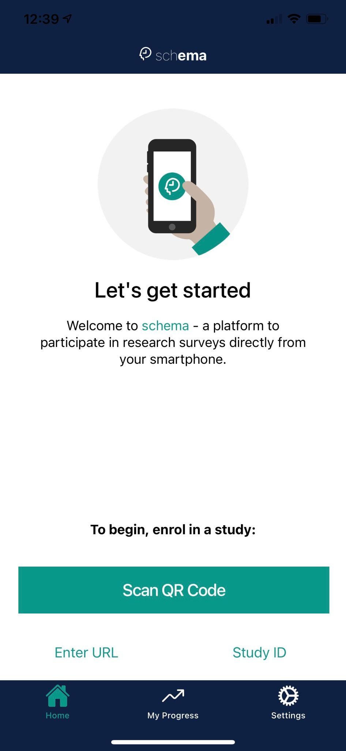

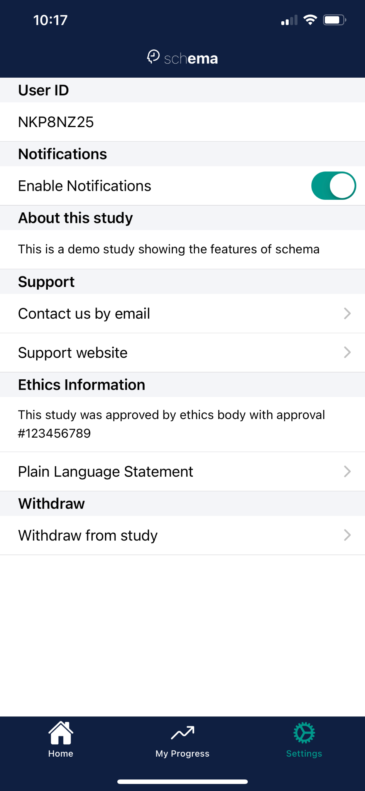

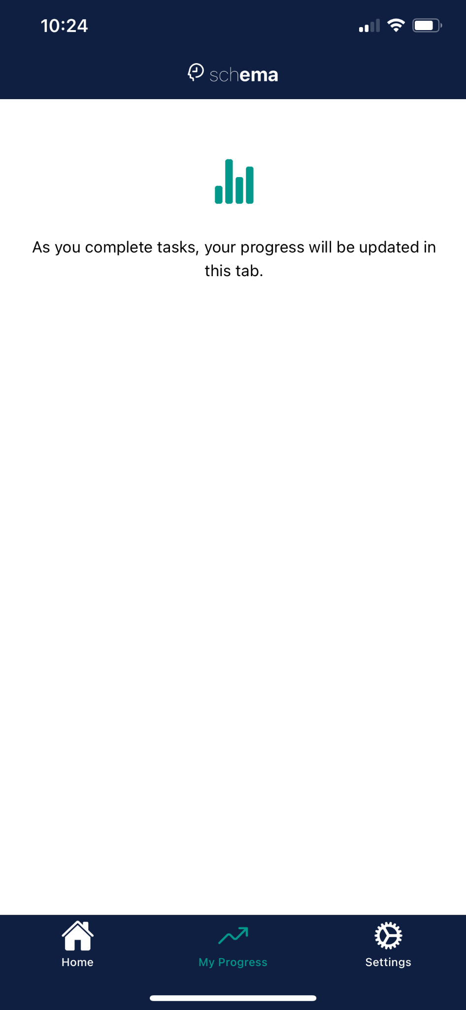

In order to enrol in a study, participants will select the **home tab** and if the user selects **“ Scan QR code”**, the camera will open in an attempt to scan code and obtain a url from the QR. Alternatively, the user can choose to directly enter the URL by selecting “Enter URL”. This will download the study and directly enrol the user in it.

Following enrollment a number of tasks to complete will be prompted by local notifications

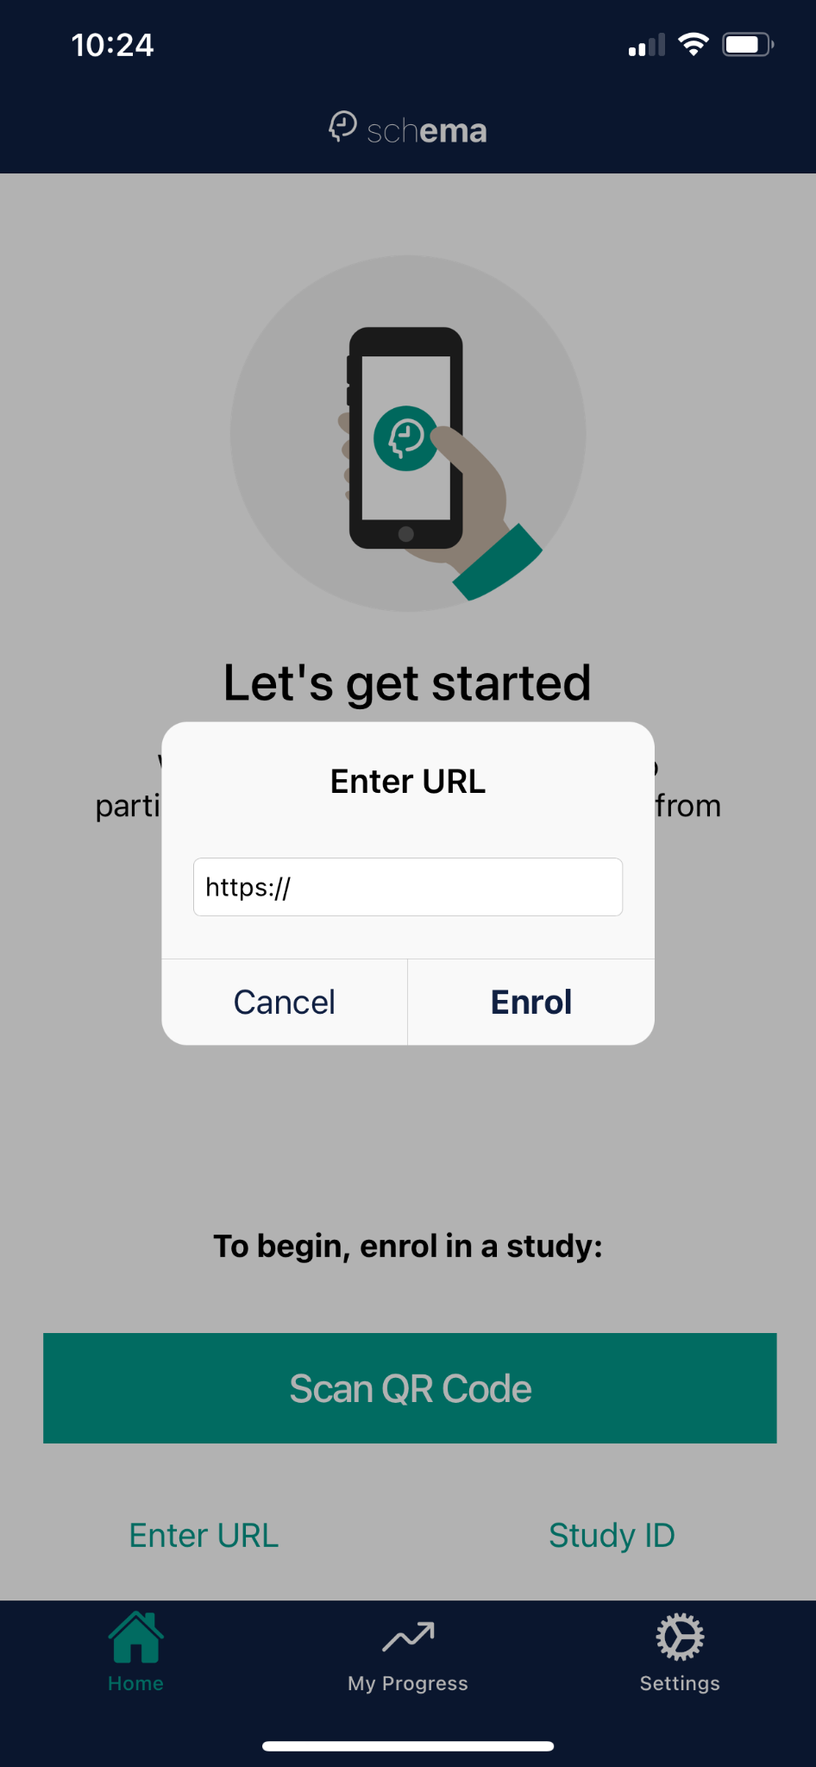

In this case ,the study is hosted on apache web server and works using the external IP address of the server. It is said that the schema data retrieval process doesn’t support HTTP and only supports HTTPS. Therefore, the study protocol link was shortened and reused using Bitly (URL Shortener) and hence the link obtained is now an https link.

<http://34.151.83.246/Team_Taa/demo_protocol.json> -  **Original Link to Study Protocol.**

[**https://bit.ly/3G81At2**](https://bit.ly/3G81At2) **- Shortened Link .**

After pasting the link in the above Box , the app will communicate with the server and request a GET for the demo_protocol.json file which the server will respond to if the file exists

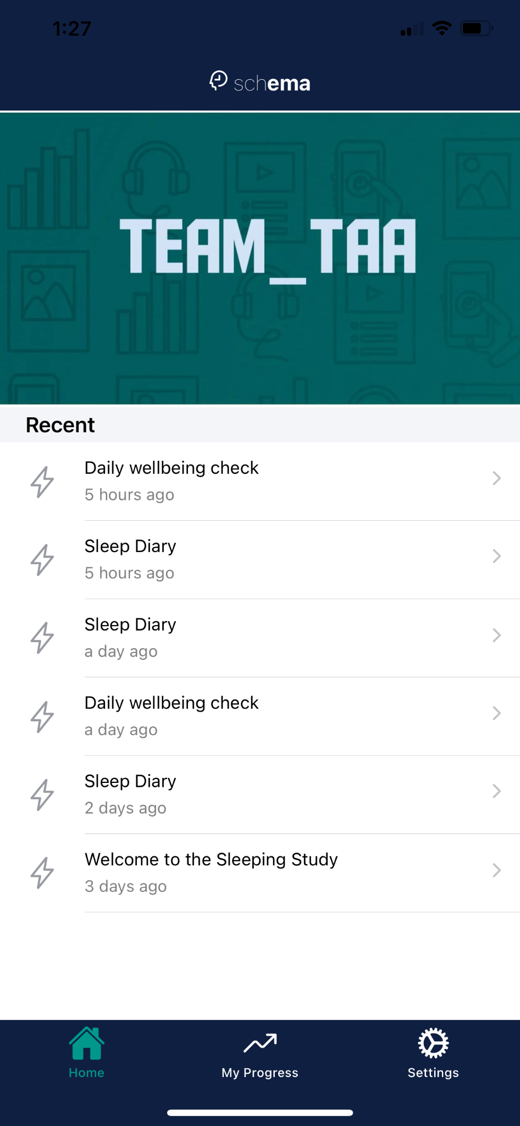

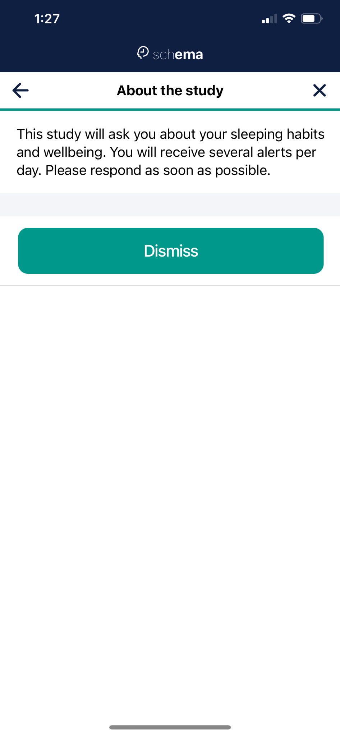

The demo Study will turn up and the full study will look like this-.

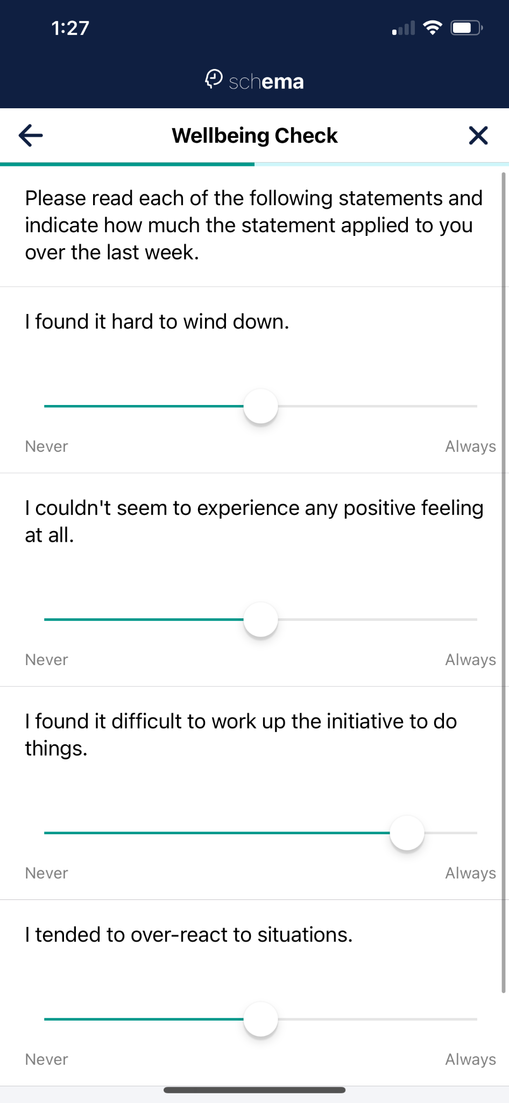

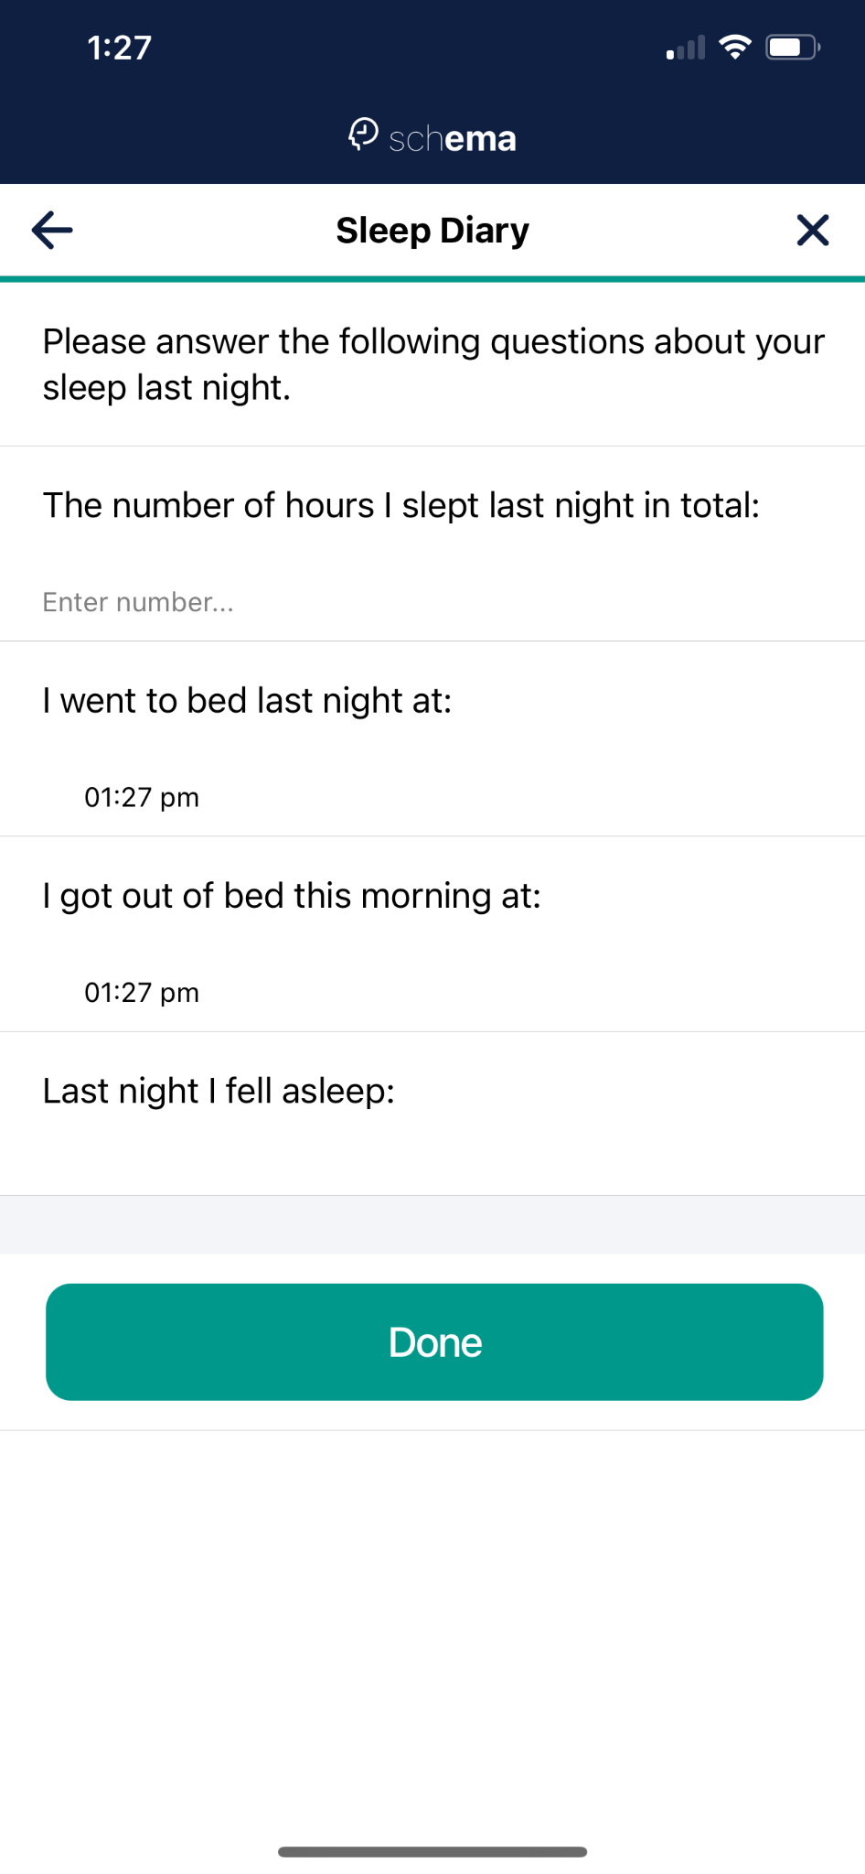

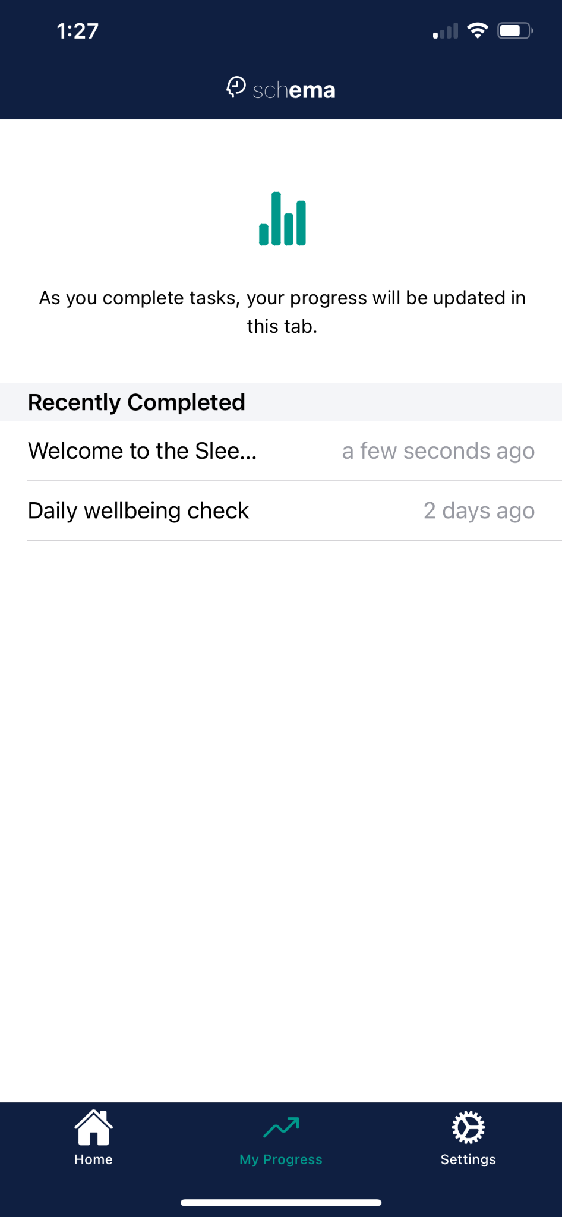

**Server Guide : (AASHISH)**

The application Schema’s usability is based on a study protocol which is a JSON format file deployed using a web server. The above process needs a working LAMP server which will clone the JSON (Study protocol) from github and therefore,deploy, handle and upload the incoming and outgoing request to the server from the user. The lamp server was considered because LAMP offers a pack of 4 usable applications which is LINUX, APACHE, Mysql and PHPMYADMIN. These applications host data on the database which could be easily created inside it.

Nectar is one of the leading research clouds offered in NZ and Australia followed by Google Cloud Console platform.. Nectar offers a big range of applications but the process for creating them and configuring them needs good understanding of the servers. Whereas,Google Cloud Console is good for beginners and comes with many tutorials of how to set the instances up and solutions of problems are easily available. Therefore, Google console was used for creating the instances.For Linux ,An instance of Debian was created and Apache was installed followed by mysql and phpmyadmin on it.

##**The Apache server will be using HTTP to communicate instead of the normal HTTPS.**

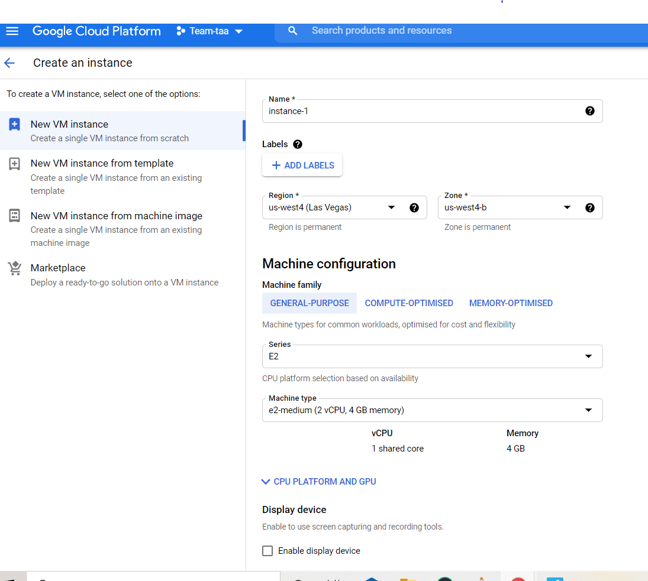

After creating and deploying the Instance, the Server(Screenshot attached) was ready to install Apache , Mysql and Phpmyadmin on it.

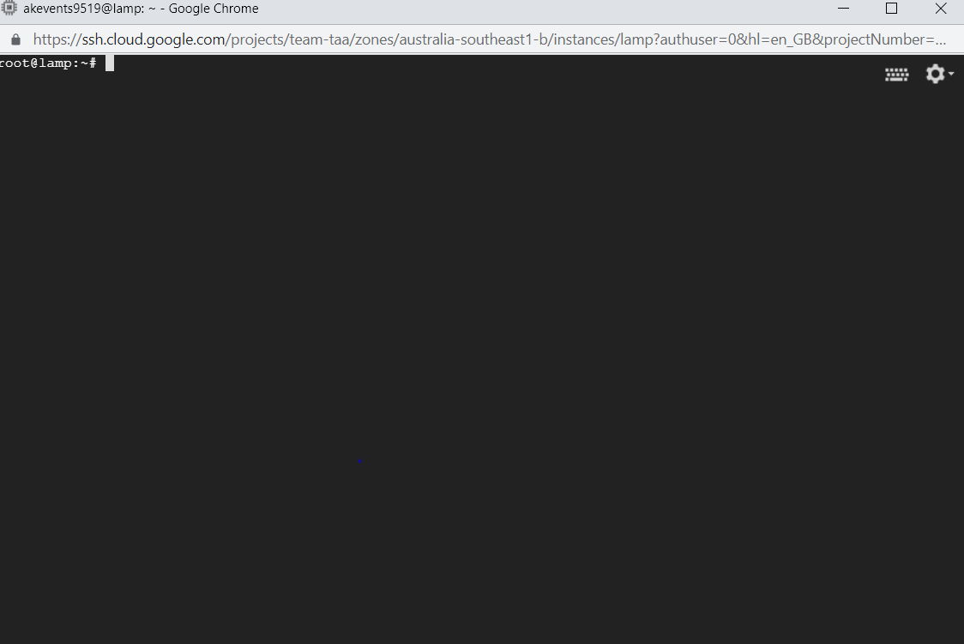

The next step was to install PHP and APACHE. These commands were used to install them.

**sudo apt-get update**

**sudo apt-get install apache2 php libapache2-mod-php**

**PHP is necessary for the project as the apache server works on php and all the POST and GET requests get configured using PHP in apache server.**

Now as the apache is installed , the external IP can be used to check where it is working or not. External IP address is located at setting of the instance and in network monitoring

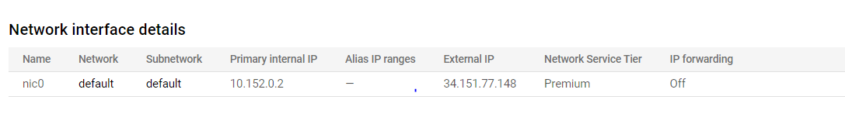

Using the IP address gives the apache Welcome window which means Apache is set up and ready to use.

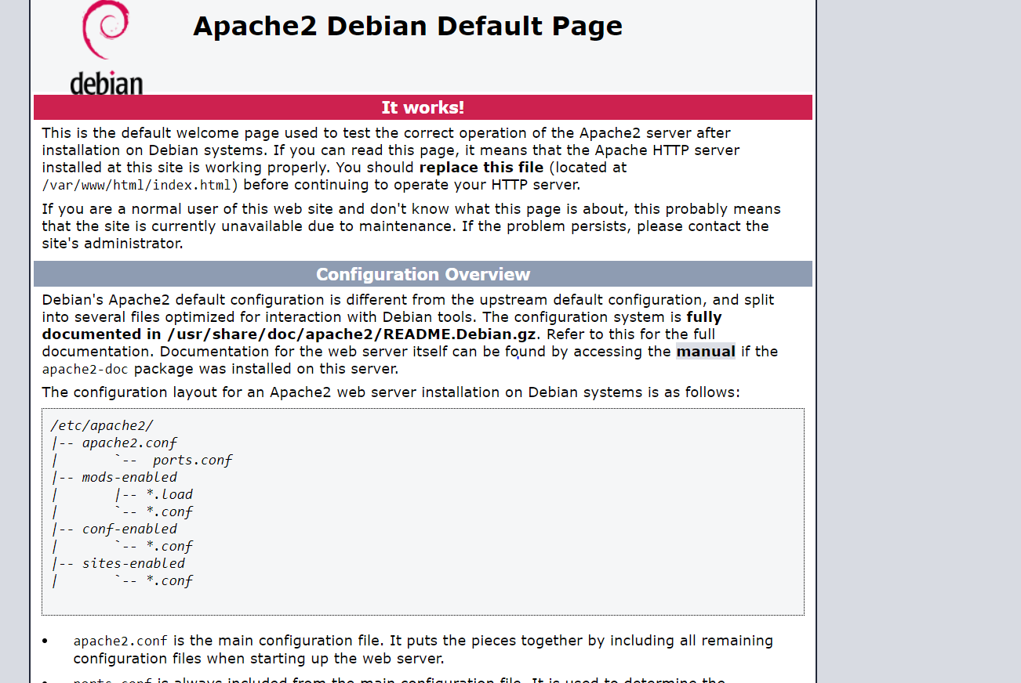

Now installed MariaDB for Mysql. These commands were used for the installation

**sudo apt-get update**

**sudo apt-get install mariadb-server php php-mysql**

**sudo mysql_secure_installation**

After the installation this command could be used to access the mysql.

**Sudo mysql**

Now Mysql,apache ,php and linux are working. The next step is installing phpmyadmin. Phpmyadmin offers a UI to create and edit databases so it's easier to manage databases

For **Schema,**  if the host wants to deploy multiple study protocols , the POST data can be stored in a database instead of a text file..

**sudo apt-get install php-bz2 php-gd php-curl**

**# this command is only needed for Debian 10**

**sudo apt-get install -t buster-backports php-twig**

**sudo apt-get install phpmyadmin**

The installation asks for password so assigning a strong password is the way to go. After the successful installation it will be easily accessed on the same external ip added with /phpmyadmin

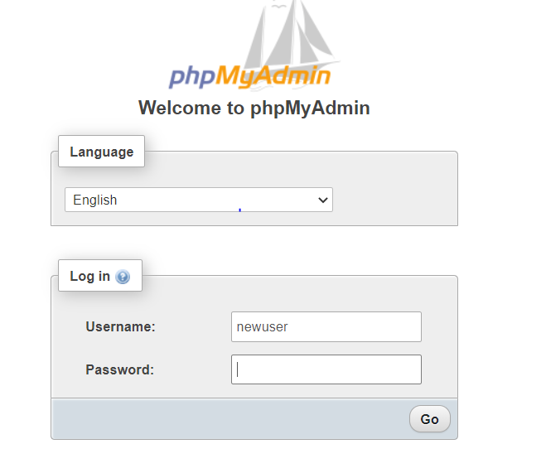

After entering the password and username , the UI will look like this . Easier for creating databases and mysql data.

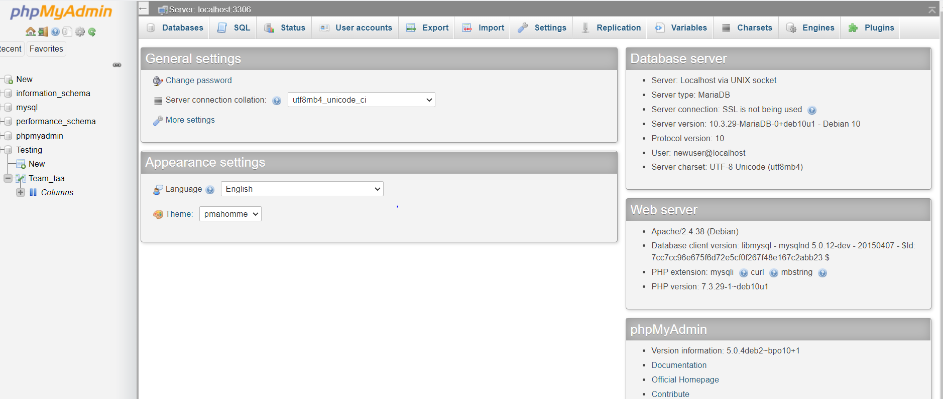

**##For the Study protocol deployment , the file being used is the pre-provided example from the Schema Github repository. The file was Replicated and altered a bit but the credit for the file goes to the Creator of the study protocol.**

The next part was installing Git and cloning the repository in the root directory. Git can be easily installed using

**sudo apt-get install git-all**

And then the repository can be cloned using

**Git clone ##Repository_address**

In this case it was-

**Sudo Git clone https://github.com/ashish1arora/Team_Taa**

**The repository contains the Study protocol and Php file. The Study protocol points contain the demo study and it points to the php when a POST request is made. Moreover, The post.php file accepts all the user response data and stores them in a Data.txt file as logging.**

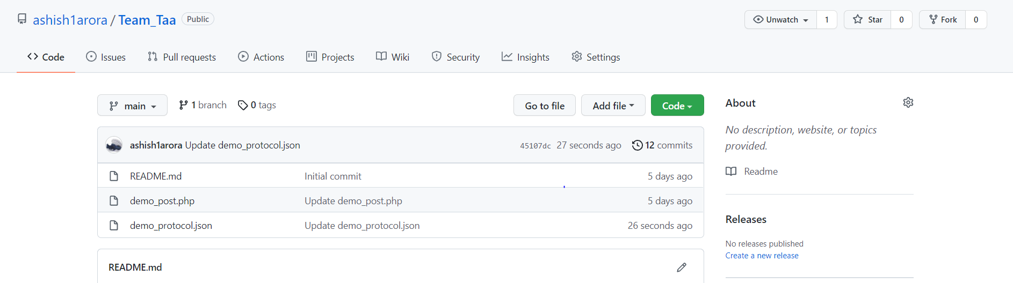

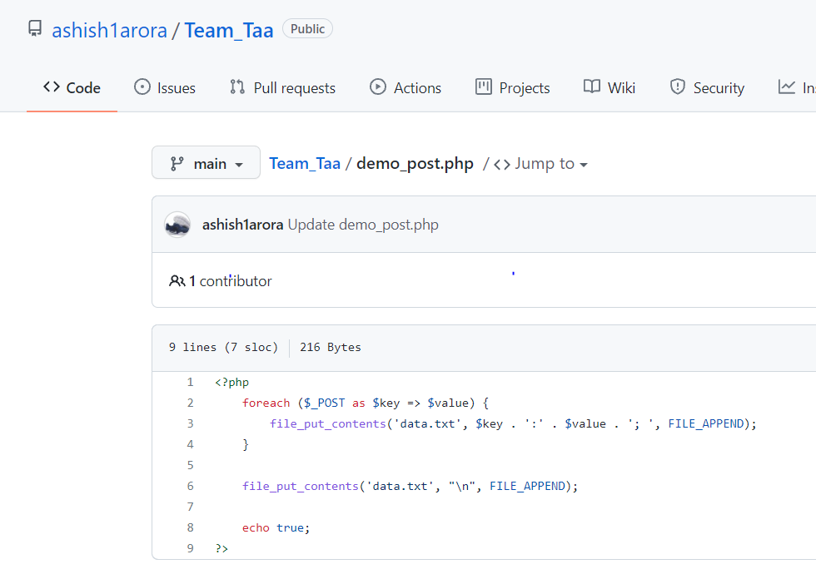

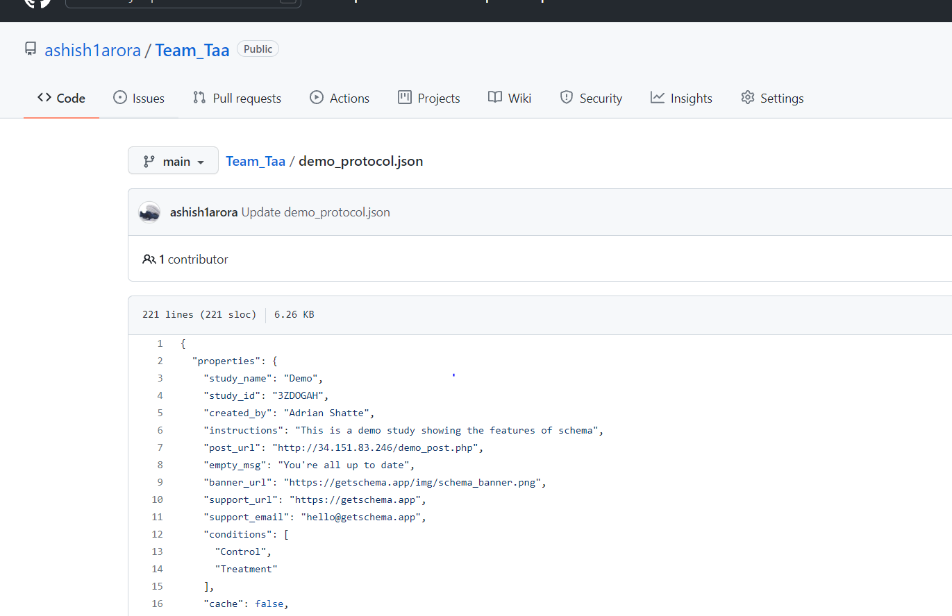

It was cloned in the root directory so it's easily accessible. The screenshot will show the cloned repository **Team_Taa.**

**The permissions for the folder and files cloned should be changed from root to apache for it to be accessible, readable and writable. If the permissions are not changed the protocol file will not work. If any other error occurs , the error logs can be accessed from /var/log/apache2/error.log.**

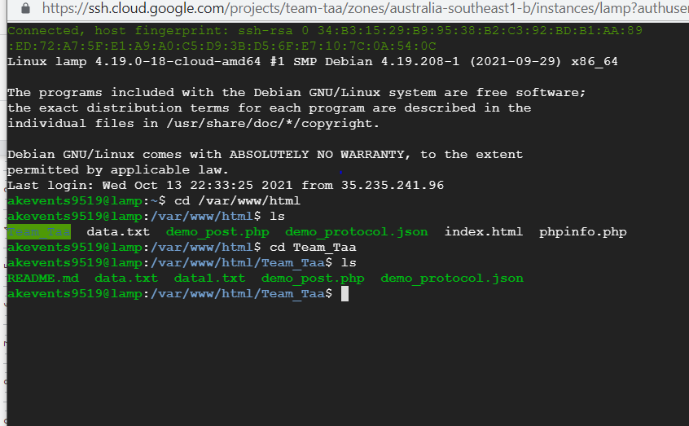

**And it can be accessed using the external IP address and using ‘/‘ point out the demo protocol file --**

<http://34.151.83.246/demo_protocol.json>

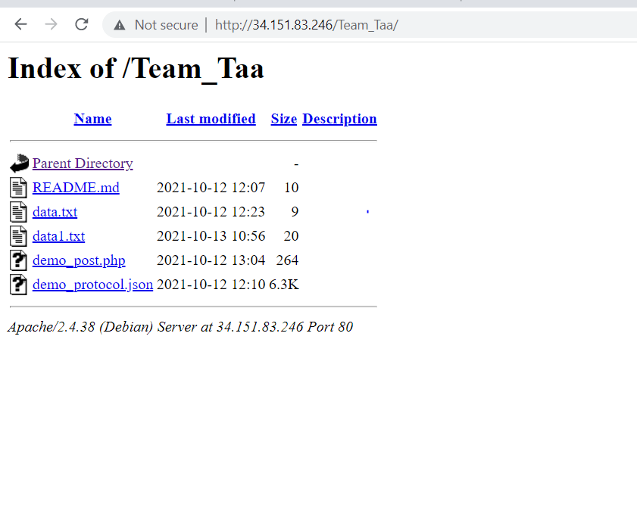

**For Example- A response is made by the user when somebody signs in. The user id and response will be recorded.**



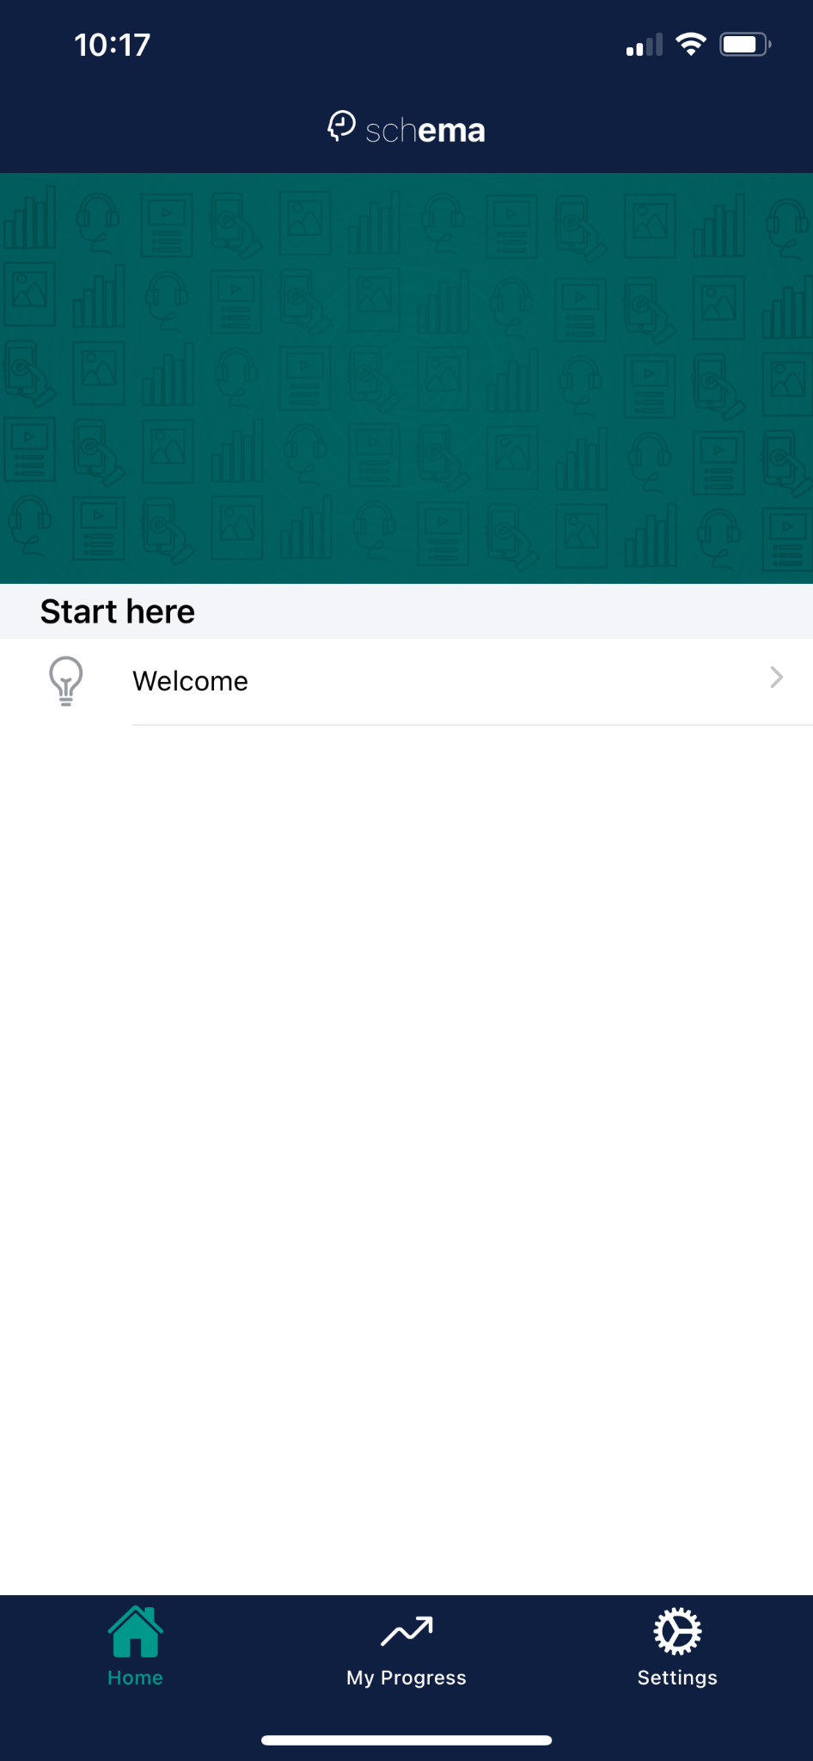

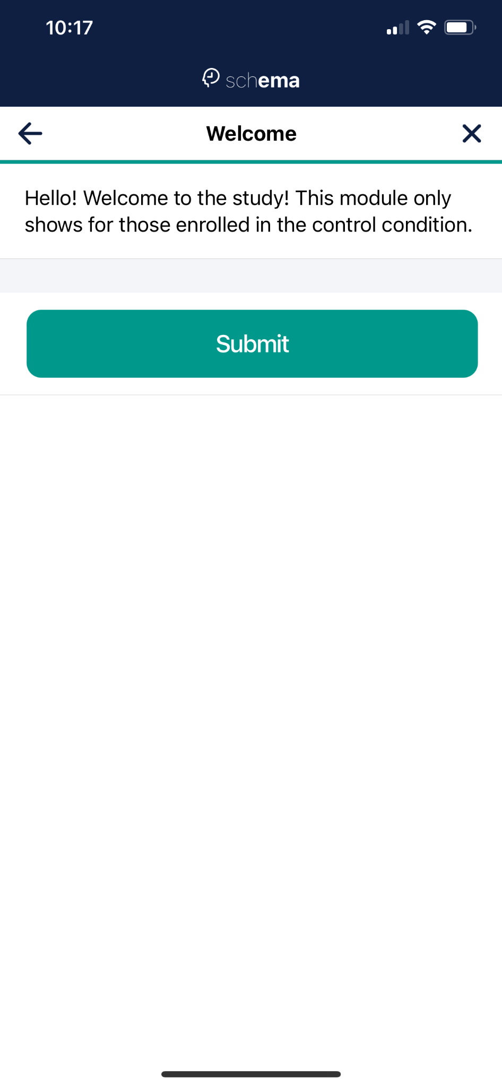

As soon as submit is pressed the data is sent as a POSt request and is recorded in the data.txt at the server provided destination.

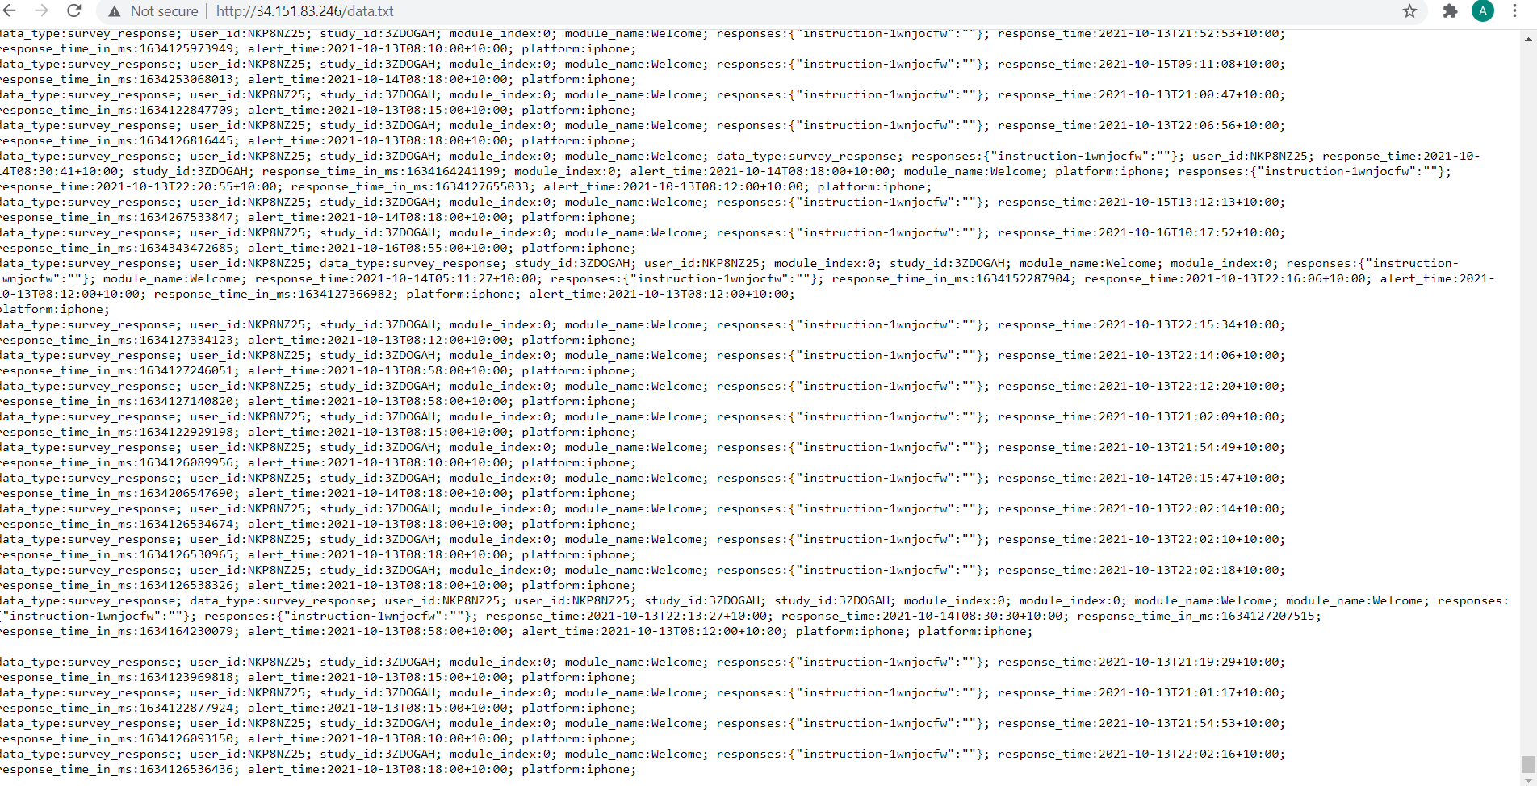

**Application security: (Aashish )**

Application security has become an important issue in recent years. Hackers are using new techniques to access sensitive data, disable applications, and manage other malicious activities that target the software application. The need to protect an application is essential to its use in today's world. Until recently, application security was an afterthought; Developers generally focused on functionality and features and expected to implement security at the end of development. This approach to application security has proven disastrous; Many vulnerabilities have gone undetected and applications (Barenbach, Paulish, Kazmeier & Rudorfer; 2009). In regards to mHealth applications, the app security holds significant importance as it collects a range of personal, medical and sensitive data of participants.

One method that can be used to implement application security in the design process of the app is threat modeling. The foundation for threat modeling is the process of drafting a security specification and then testing that specification.

The threat modeling process is performed during application design and is used to identify the reasons and methods that an attacker would use to identify vulnerabilities or threats in the system. Threat modeling does the following:

• Defines the security of an application

• Identifies and investigates potential threats and vulnerabilities

• Provides security functions at hardware and software level for identified threats

• Identifies a logical thought process for defining the security of a system

• Leads to earlier and more frequent architecture errors found.

Leads to fewer vulnerabilities

• Creates a series of documents that are used to create security specifications and security

tests, avoiding duplicate security efforts.

There are many applications available for the market but **CAIRIS** is an open-source tool which is available on almost every platform and very easy to install . CAIRIS assists designers with incorporating security into the software plan. CAIRIS (Computer Aided Integration of Requirements and Information Security) is kept up with by BUCSR researchers, and can oversee and imagine security and usability design models, leverage attack and architectural patterns, and import and export data in a variety of formats (Faily, S..;2018**)**.

**Instructions to install-** <https://cairis.readthedocs.io/en/latest/install.html>

Using threat models like CAIRIS to identify threats, vulnerabilities and countermeasures in the design will be able to assess application security as Implement part of the design process.

**Source code should be submitted via GitHub and clear details for access must be included in the report.** **( AASHISH)-**

[**https://github.com/ashish1arora/Team_Taa**](https://github.com/ashish1arora/Team_Taa) **- Github (Demo_protocol and Post.php file)**

[**http://34.151.83.246/data.txt**](http://34.151.83.246/data.txt) **- Schema Logging**

[**http://34.151.83.246/Team_Taa/demo_protocol.json**](http://34.151.83.246/demo_protocol.json-) **- Study Protocol Server link.**

[**https://bit.ly/3G81At2**](https://bit.ly/3G81At2) **- Shortened URL of the Server protocol file for Schema**

[**https://m.apkpure.com/mdiab/com.janacare.habits.mdiab/download?from=details**](https://m.apkpure.com/mdiab/com.janacare.habits.mdiab/download?from=details) **- Download link for M-Diab**

**References**

Berenbach, B., Paulish, D.J., Kazmeier, J. and Rudorfer, A., 2009. Software & systems requirements engineering: in practice. McGraw-Hill Education.

Faily, S., 2018. Introducing CAIRIS: Tool-support for designing usable and secure systems. In Designing Usable and Secure Software with IRIS and CAIRIS (pp. 89-118). Springer, Cham.

Berndt, R-D, Takenga, MC, Kuehn, S, Preik, P, Sommer, G, & Berndt, S 2012, ‘SaaS-platform for mobile health applications’ in *International Multi-Conference on Systems, Signals & Devices*, pp. 1–4, IEEE, doi: 10.1109/SSD.2012.6198120.

Shevtsiv, N., Shvets, D. and Karabut, N., 2019. Prospects for Using React Native for Developing Cross-platform Mobile Applications. Central Ukrainian Scientific Bulletin. Technical Sciences, (2(33), pp.208-213.

Axelrod, R. (1977). How a Schema is Used to Interpret Information. Thought And Action In Foreign Policy, 226-241. doi: 10.1007/978-3-0348-5872-4_7

Bohannon, P., Freire, J., Roy, P., & Simeon, J. From XML schema to relations: a cost-based approach to XML storage. Proceedings 18Th International Conference On Data Engineering. doi: 10.1109/icde.2002.994698

Draper, B., Collins, R., Brolio, J., Hanson, A., & Riseman, E. (1989). The schema system. International Journal Of Computer Vision, 2(3), 209-250. doi: 10.1007/bf00158165

Eckhoff, R., Kizakevich, P., Bakalov, V., Zhang, Y., Bryant, S., & Hobbs, M. (2015). A Platform to Build Mobile Health Apps: The Personal Health Intervention Toolkit (PHIT). JMIR Mhealth And Uhealth, 3(2), e46. doi: 10.2196/mhealth.4202

Immoreev, I., & Fedotov, P. Ultra wideband radar systems: advantages and disadvantages. 2002 IEEE Conference On Ultra Wideband Systems And Technologies (IEEE Cat. No.02EX580). doi: 10.1109/uwbst.2002.1006348

Laatikainen, G., & Ojala, A. (2014). SaaS Architecture and Pricing Models. 2014 IEEE International Conference On Services Computing. doi: 10.1109/scc.2014.84

mHealth Company | Universe mHealth. (2021). Retrieved 16 October 2021, from https://universemhealth.com/

Ranjan, Y., Rashid, Z., Stewart, C., Conde, P., Begale, M., & Verbeeck, D. et al. (2019). RADAR-Base: Open Source Mobile Health Platform for Collecting, Monitoring, and Analyzing Data Using Sensors, Wearables, and Mobile Devices. JMIR Mhealth And Uhealth, (8), e11734. doi: 10.2196/11734

, D., Mercuri, M., Soh, P., & Vandenbosch, G. (2013). Radar-Based Health Monitoring. 2013 IEEE MTT-S International Microwave Workshop Series On RF And Wireless Technologies For Biomedical And Healthcare Applications (IMWS-BIO). doi: 10.1109/imws-bio.2013.6756189

Shatte, A., & Teague, S. (2020). schema: an open-source, distributed mobile platform for deploying mHealth research tools and interventions. BMC Medical Research Methodology, 20(1). doi: 10.1186/s12874-020-00973-5

Spruit, M., & Abdat, N. (2012). The Pricing Strategy Guideline Framework for SaaS Vendors. International Journal Of Strategic Information Technology And Applications, 3(1), 38-53. doi: 10.4018/jsita.2012010103

Tsai, W., Huang, Y., & Shao, Q. (2011). Testing the scalability of SaaS applications. 2011 IEEE International Conference On Service-Oriented Computing And Applications (SOCA). doi: 10.1109/soca.2011.6166245

Validation of a SaaS-based Platform for Mobile Health Applications. (2018). Sensors, Circuits & Instrumentation Systems, 93-112. doi: 10.1515/9783110448375-007

Yu, P., Wu, M., Yu, H., & Xiao, G. (2006). The Challenges for the Adoption of M-Health. 2006 IEEE International Conference On Service Operations And Logistics, And Informatics. doi: 10.1109/soli.2006.329059

Nurseitov, N., Paulson, M., Reynolds, R. and Izurieta, C., 2009. Comparison of JSON and XML data interchange formats: a case study. *Caine*, *9*, pp.157-162.