COMPUTER NETWORKS

**Q1. Discuss networking and its significance in computer networking.**

**Ans: Computer networking refers to interconnected computing devices that can exchange data and share resources with each other. These networked devices use a system of rules, called communications protocols, to transmit information over physical or wireless technologies. Computer networking significance includes:**

* **Resource sharing (printers, files)**
* **Data exchange and communication**
* **Centralized data management**
* **Enhanced collaboration**
* **Cost efficiency**
* **Access to remote resources and services**



**Q2. Discuss the components (hardware and software) required for data communication in a computer network**

**Ans: Hardware Components***:*

* Network Interface Card (NIC): Enables devices to connect to a network.
* Cabling (Ethernet cables): Physical medium for data transfer.
* Switches: Connect multiple devices within a LAN.
* Routers: Connect different networks and direct data packets.
* Hubs: Basic devices that broadcast data to all connected devices.
* Modems: Connects local networks to the internet.

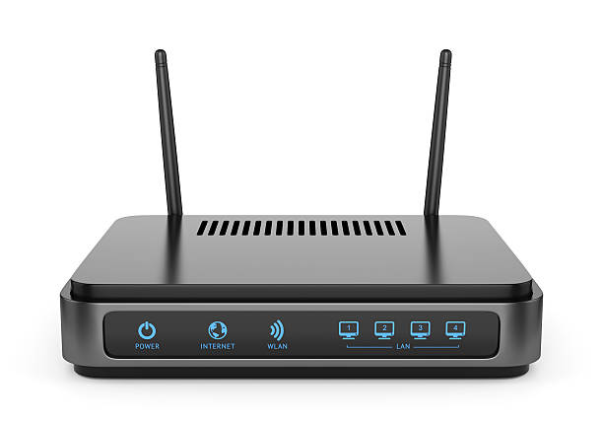

**Software Components:**

* Network Protocols: Rules for data exchange (e.g., TCP/IP).
* Network Operating System: Manages network resources.
* Network Management Software: Monitors and manages network performance.
* Security Software: Protects data and devices from threats.



**Q3. Show the network components like NIC, Network cable, RJ45 connecter, hub, switches, routers etc.**

Ans: A. **NIC – Network Interface Card**

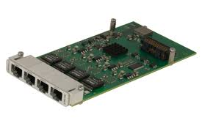

B. Network Cable

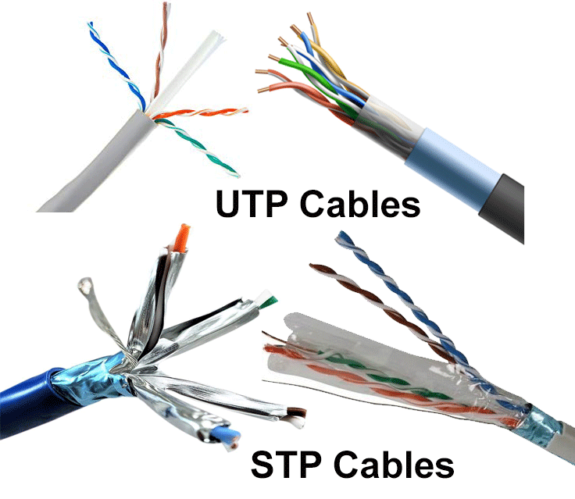 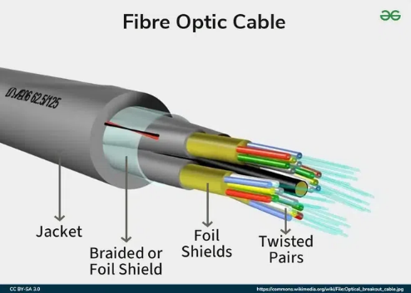

3. RJ45 Connector

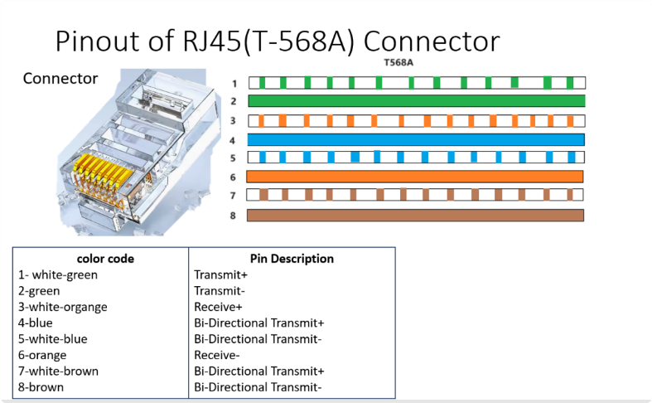

4. Hub

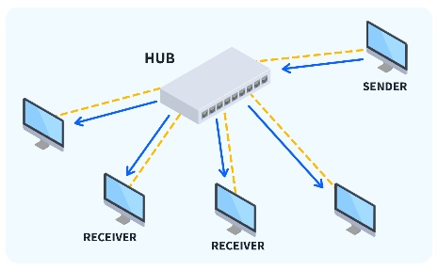

5. Switches

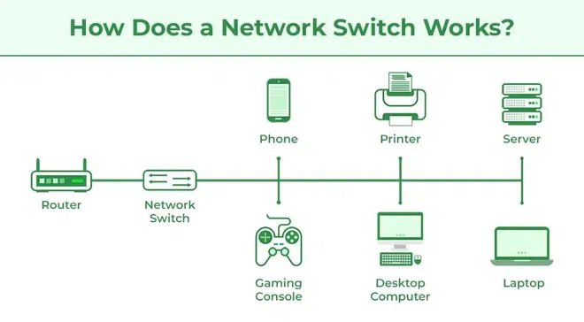

6. Routers

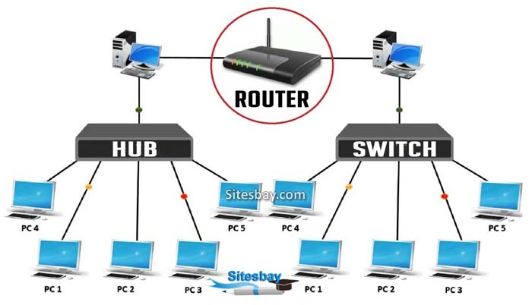



Q4. What is Networking Topology and different types of Networking topology?

Ans: Networking topology refers to the arrangement or layout of various elements (nodes, links, devices) in a computer network. It defines how devices are interconnected and communicate with each other.

**Types of Networking Topology:**

1. **Bus Topology:** All devices are connected to a single central cable called a bus. Data travels in both directions along the bus.

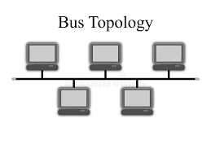

1. **Star Topology:** All devices are connected to a central hub or switch. Communication passes through the central device.

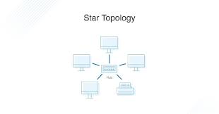

1. **Ring Topology:** Devices are connected in a circular manner, and data travels in one direction around the ring.

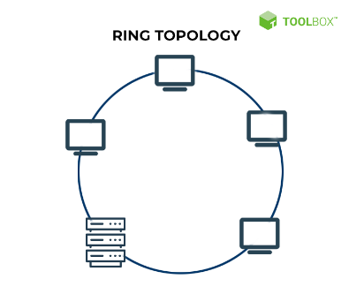

1. **Mesh Topology:** Every device is connected to every other device, providing high redundancy and reliability.

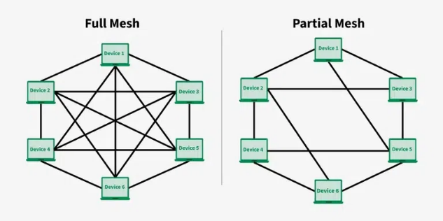

1. **Tree Topology:** Combines star and bus topologies, with multiple star networks connected to a linear bus backbone.

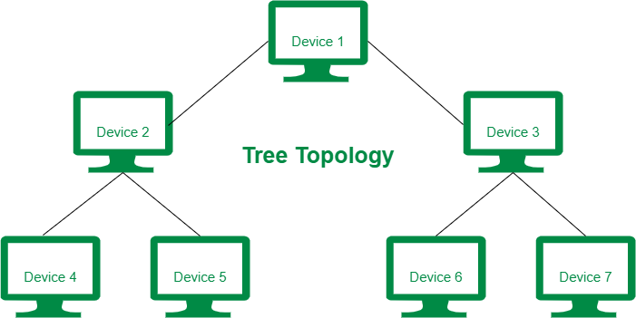

1. **Hybrid Topology:** A combination of two or more different topologies to suit specific network needs.

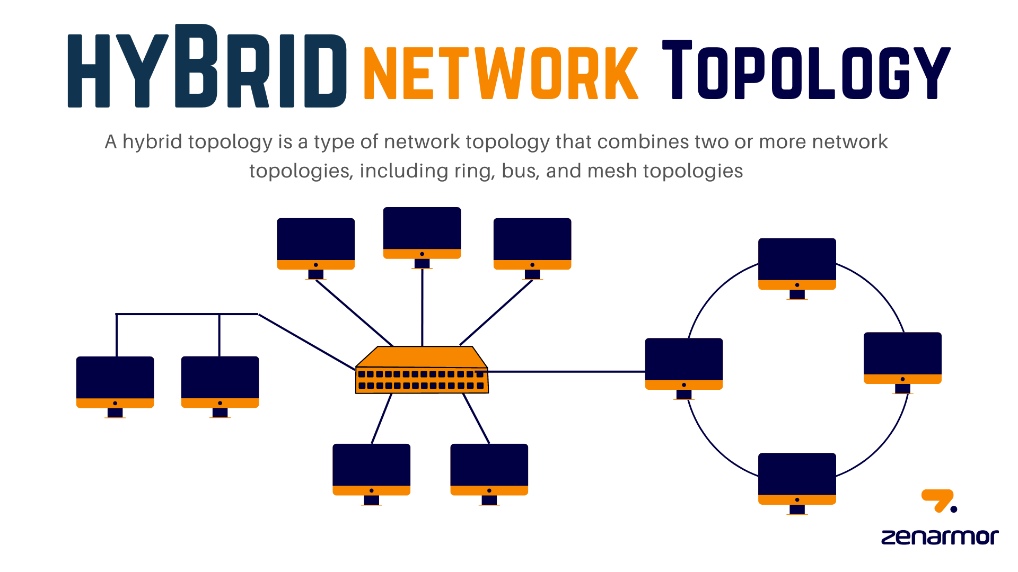

Q5. Discuss different network diagnostic tool

**1.Ping**

**2. Traceroute / Traceret**

**3. NetStat**

**4. NSLOOKUP**

**5. IPCONFIG / IFCONFIG**

**6. IPTABLES**

**Ans: 1.** **Ping**

* **Tests connectivity between the source and destination IP address.**
* **Measures round-trip time and packet loss.**
* **Usage: ping <IP address or hostname>**

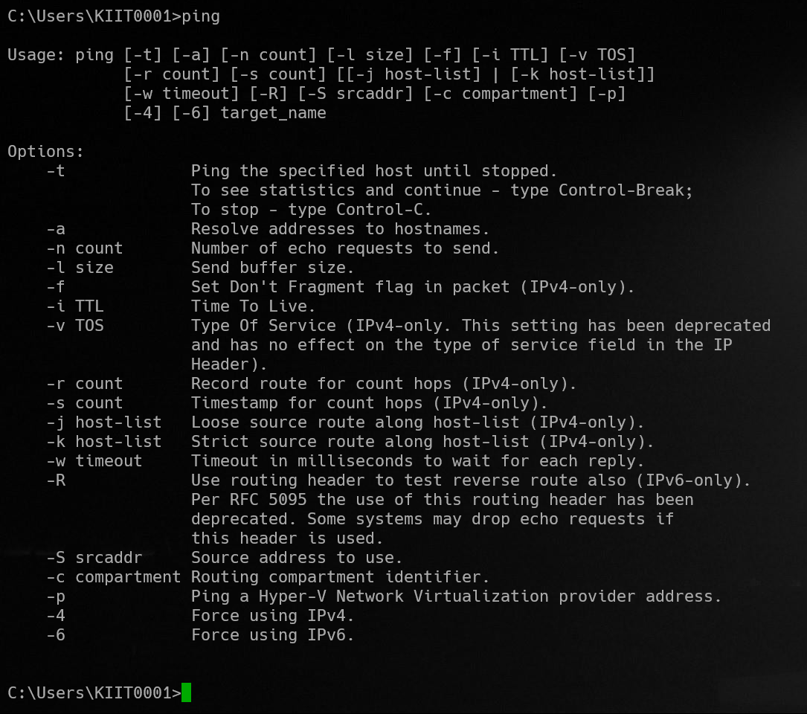

**2. Traceroute / Tracert**

* **Tracks the path packets take to reach a destination.**
* **Shows each hop and its response time.**
* **Usage: traceroute <hostname> (Linux), tracert <hostname> (Windows)**

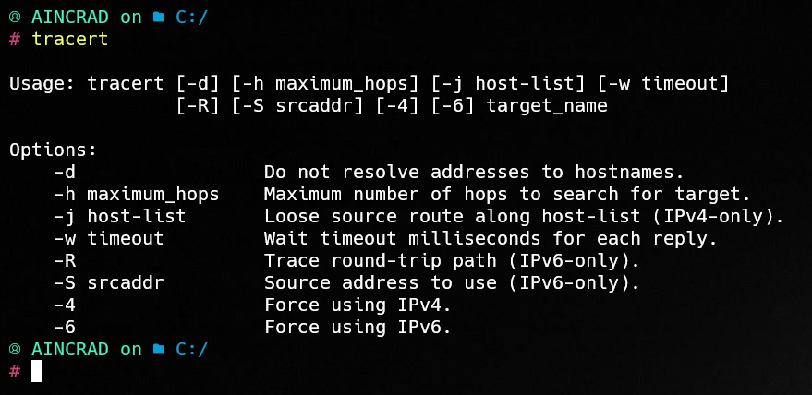

**3. NetStat**

* **Displays active network connections, listening ports, and network statistics.**
* **Useful for monitoring network activity and troubleshooting.**

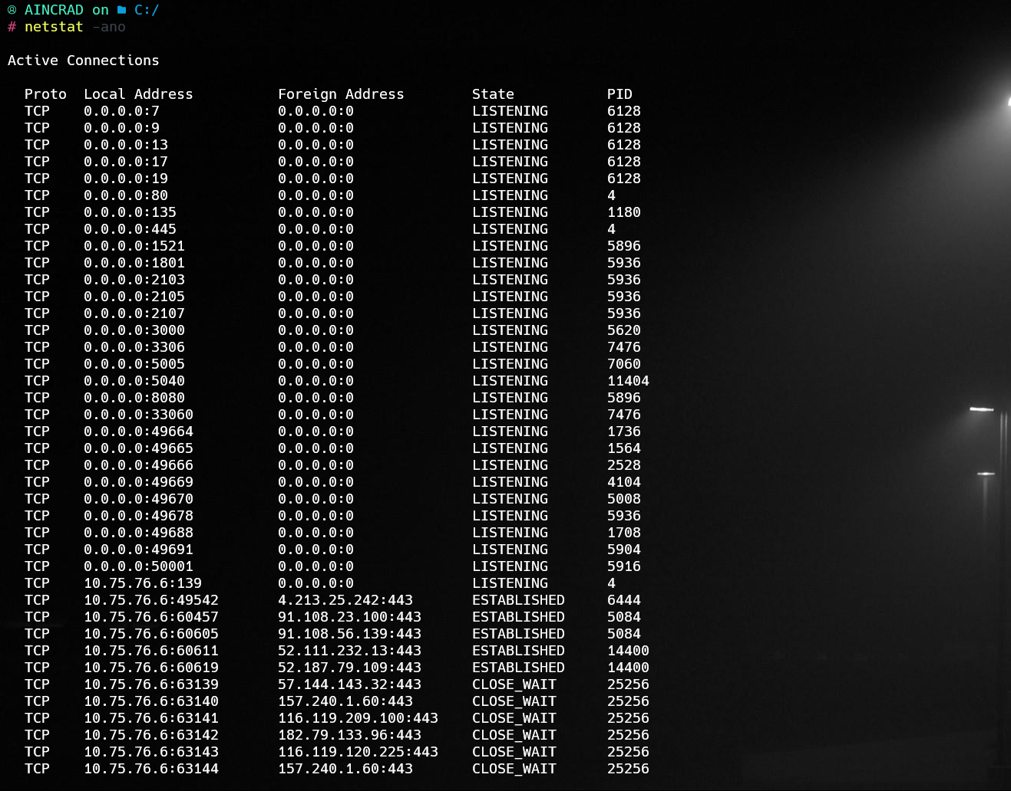

**4. NSLOOKUP**

* **Queries DNS servers to resolve domain names to IP addresses and vice versa.**
* **Usage: nslookup <domain>**

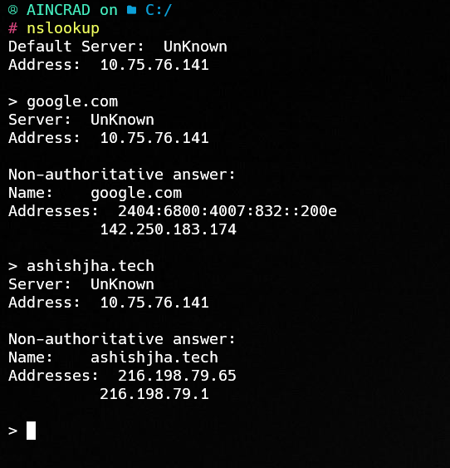

**5. IPCONFIG / IFCONFIG**

* **IPCONFIG (Windows): Displays IP configuration details of network interfaces.**

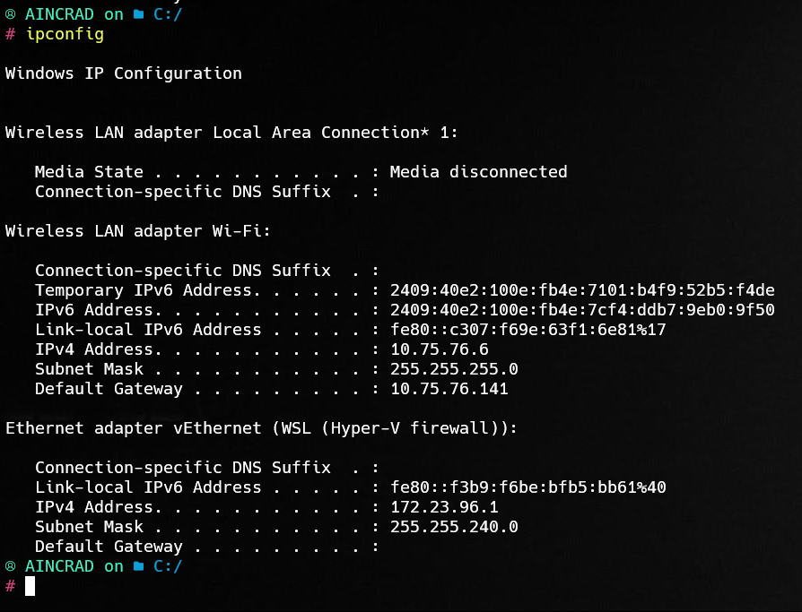

* **IFCONFIG (Linux): Similar function, shows network interface configurations.**

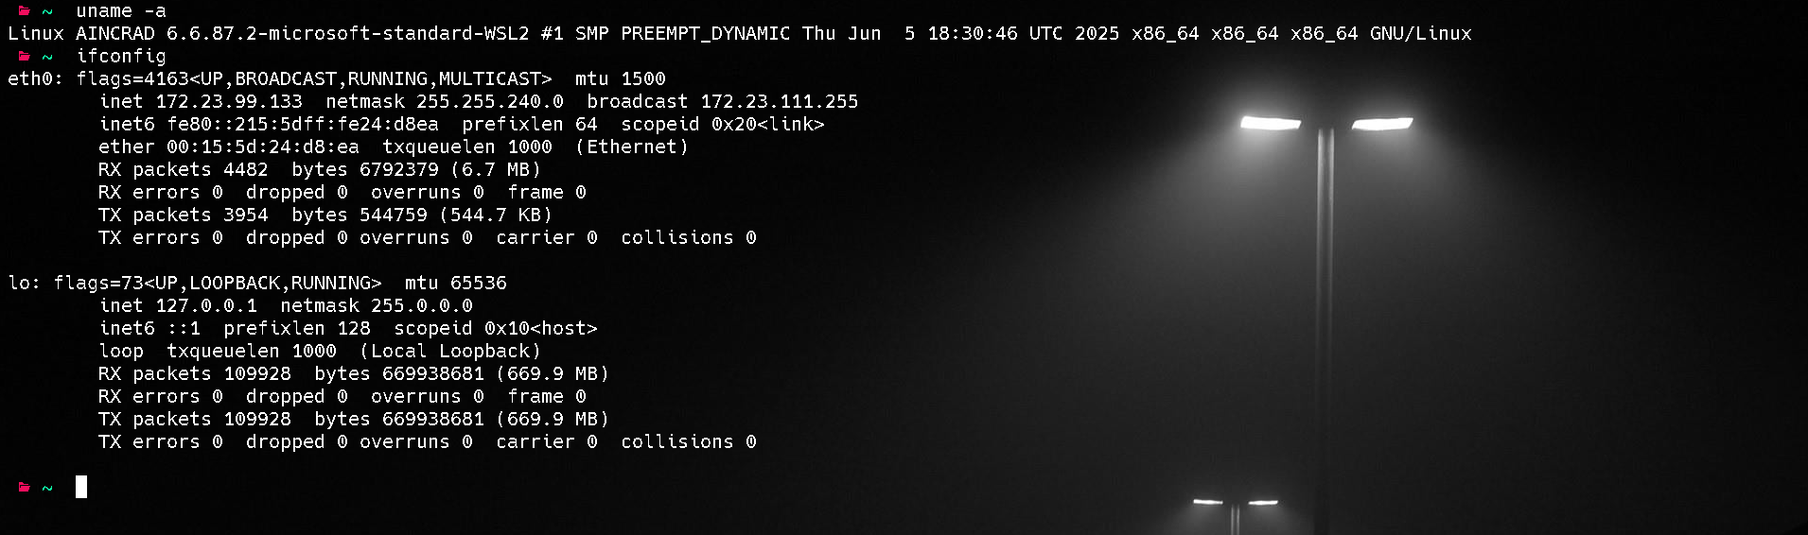

**6. IPTABLES**

* **Linux firewall utility used to set up, maintain, and inspect IP packet filtering rules.**
* **Used for security and traffic management.**

