INTERNSHIP REPORT
OF
DATA SCIENCE INTERNSHIP
Submitted
To
School of Computer Science and Engineering
IILM University, Greater Noida, U.P.
In partial fulfilment of the requirement of degree of
- Tech CSE
BY


ASHISH KUSHWAHA
Roll Number: 25SCS1003004994
Batch: 2026-27

1. CANDIDATE’S DECLARATION
I, Ashish Kushwaha, do hereby declare that the internship report titled "Data Science Internship at SkillCraft Technology" has been completed by me to fulfil the requirement for the award of the degree of Bachelor of Technology in CSE. The report has been prepared on the basis of my internship and the documents provided by the organization. I affirm that this report has not been submitted to any other institute for any degree/diploma requirement and I shall be solely responsible for any copyright violation in this regard.

Signature: __________________________
Student Name: Ashish Kushwaha
Roll No.: 25SCS1003004994

2. ACKNOWLEDGEMENT
I am using this opportunity to express my gratitude to everyone who supported me throughout the Internship Program. I am thankful for their guidance, constructive criticism and advice during this work. I sincerely appreciate the opportunity to gain practical exposure in the field of Data Science through my internship at SkillCraft Technology.
I also express my gratitude to my parents, faculty members and all those who provided encouragement and support during the completion of this internship report.

Signature: __________________________
Student Name: Ashish Kushwaha
Roll No.: 25SCS1003004994

3. INTERNSHIP COMPLETION CERTIFICATE
A copy of the internship completion certificate issued by SkillCraft Technology is attached below. The certificate confirms successful completion of a one-month Data Science internship from 16 July 2026 to 16 August 2026.
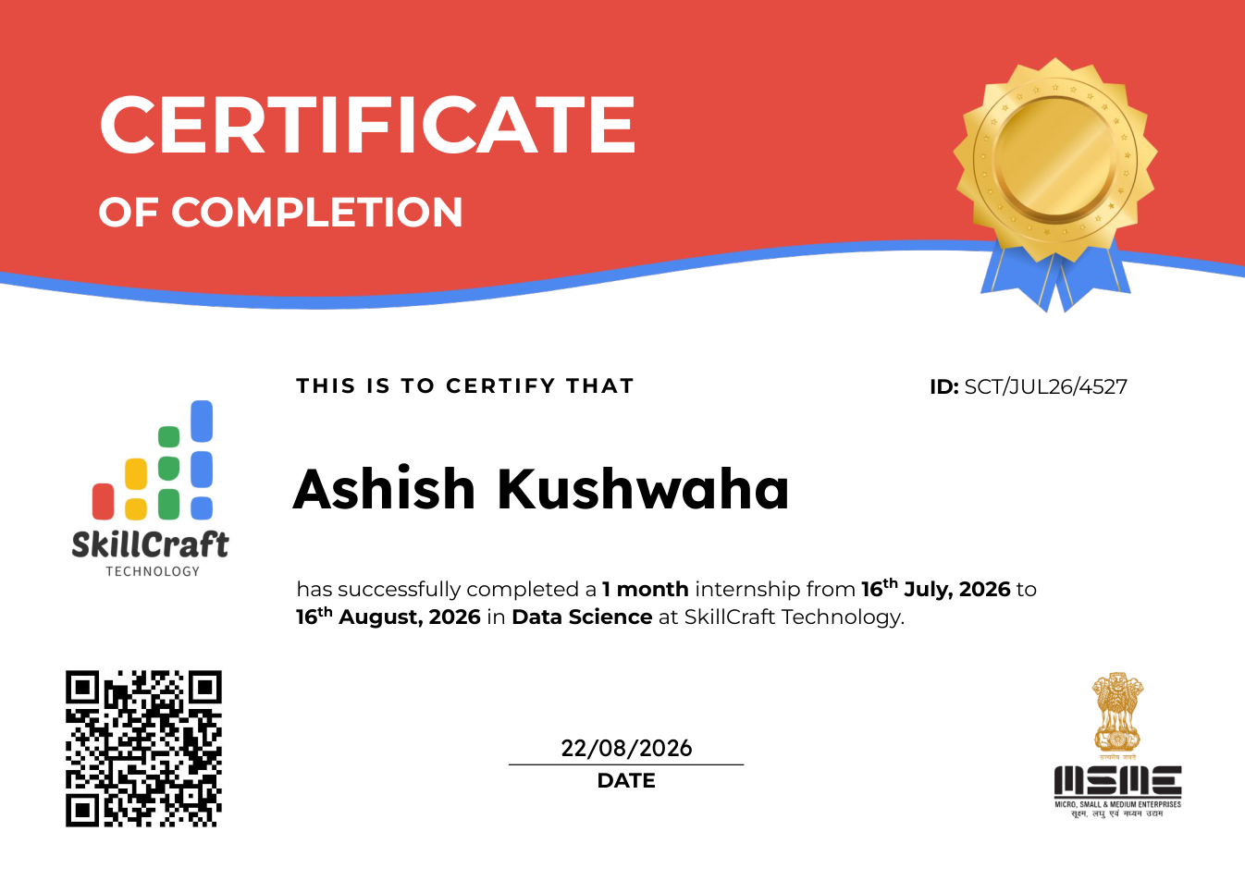

4. PROJECT DESCRIPTION

4.1 Introduction
Data Science is an interdisciplinary field that combines data collection, data preparation, statistical analysis, visualization and computational techniques to derive meaningful insights from data. The internship at SkillCraft Technology provided an opportunity to gain practical exposure to the Data Science domain within a professional internship environment.
According to the offer letter, the internship position was Data Science Intern. The program was scheduled from 16 July 2026 to 16 August 2026 for a duration of one month. The internship was intended as a learning and practical-experience program and was not an offer of employment.

4.2 Organization Profile
SkillCraft Technology is the organization that offered and certified the internship described in the supplied documents. The offer letter identifies the internship position as Data Science Intern and assigns internship ID SCT/JUL26/4527. The supplied completion certificate confirms that Ashish Kushwaha successfully completed the one-month internship in Data Science at SkillCraft Technology.
Detailed organizational information such as the company's founding history, management structure, office locations, products or services was not included in the supplied documents; therefore, those details are not added here.

4.3 Problem Statement
The central learning problem of the internship was to understand how Data Science concepts can be applied in a practical setting. This includes understanding the general workflow of working with data: preparing datasets, exploring and analysing information, identifying useful patterns, communicating findings and evaluating results.

4.4 Project Objectives
• Develop practical understanding of the Data Science workflow.
• Understand the role of data preparation and exploratory analysis in data-driven work.
• Gain exposure to analytical thinking and interpretation of data.
• Understand how data insights can support problem solving and decision making.
• Document the internship learning and outcomes in a structured technical report.

4.5 Scope of the Project
The scope of this internship report is limited to the Data Science internship confirmed by the supplied offer letter and completion certificate. It covers the general Data Science workflow and the learning objectives associated with the internship. Specific project names, datasets, performance metrics, code, or deliverables were not provided in the supplied documents and therefore are not claimed as completed work in this report.

4.6 Technologies and Tools Used
The supplied offer letter and completion certificate identify the internship as Data Science but do not specify the exact software, programming languages, libraries, databases, platforms or development tools used during the internship. Accordingly, no specific tool is represented as having been used based solely on the supplied documents.

4.7 System Architecture
A specific system architecture was not included in the supplied internship documents. For the purpose of understanding a typical Data Science workflow, the conceptual flow can be represented as: Data Collection → Data Preparation → Exploratory Analysis → Modelling/Analysis → Evaluation → Insights and Reporting. This is a conceptual representation and is not presented as the architecture of a particular SkillCraft Technology project.
1 | 2 | 3 | 4 | 5 | 6
Data  Collection | Data  Preparation | Exploratory  Analysis | Analysis /  Modelling | Evaluation | Insights &  Reporting

4.8 Methodology
Data Collection: Identify and obtain the data required for the problem being studied.
Data Preparation: Check data quality, organize the dataset and prepare it for analysis.
Exploratory Data Analysis: Study distributions, relationships and patterns in the available data.
Analysis / Modelling: Apply suitable analytical or modelling approaches to extract useful information.
Evaluation: Review the results and consider whether they are meaningful for the intended objective.
Reporting: Present observations and conclusions in a clear and structured form.

4.9 Expected Outcomes
• Improved understanding of the Data Science lifecycle.
• Better ability to approach data-related problems systematically.
• Greater awareness of data preparation, analysis and interpretation.
• Improved technical documentation and professional reporting skills.
• Practical exposure to the expectations of a Data Science internship environment.

4.10 Certificates of Completion and Other Communication Mail Proof
The internship completion certificate and internship offer letter supplied for this report are attached as documentary proof. The offer letter records the internship position, dates and internship ID, while the completion certificate records successful completion of the one-month Data Science internship.

APPENDIX A – INTERNSHIP OFFER LETTER
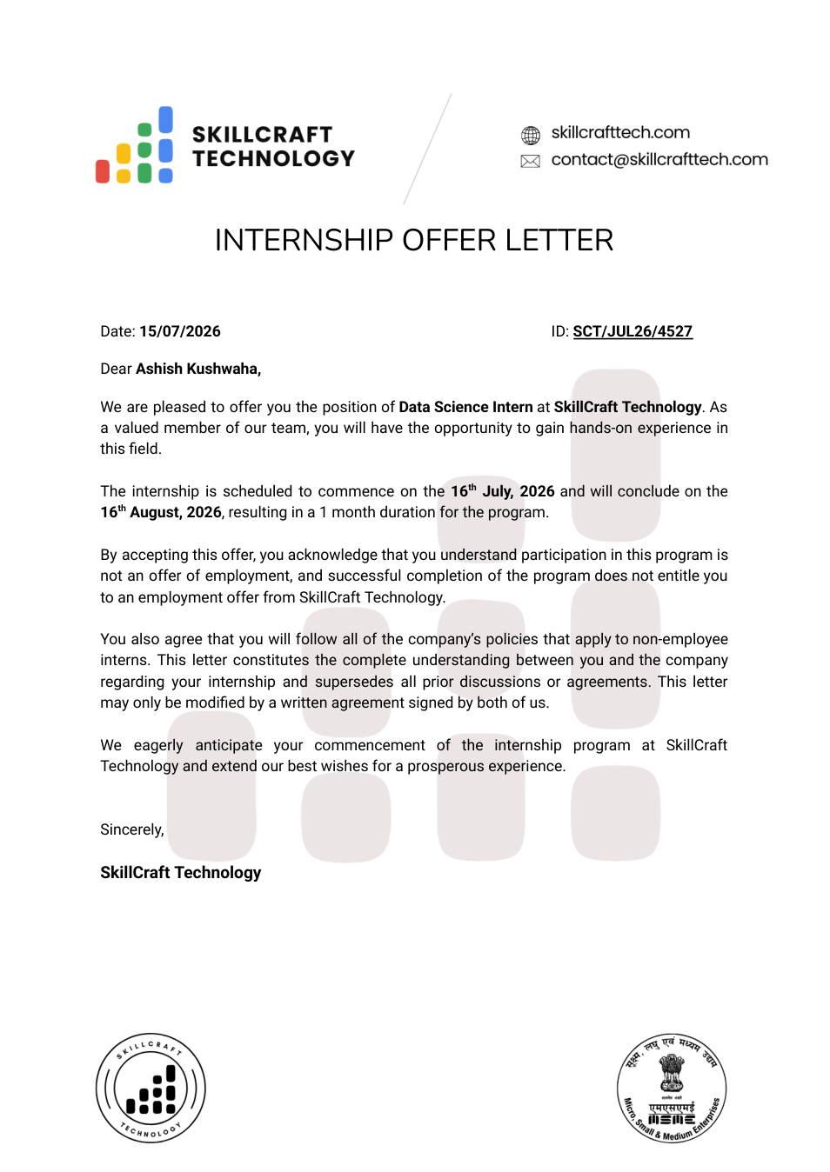

APPENDIX B – INTERNSHIP COMPLETION CERTIFICATE


5. BIBLIOGRAPHY / REFERENCES
SkillCraft Technology, Internship Offer Letter, ID: SCT/JUL26/4527, dated 15/07/2026.
SkillCraft Technology, Internship Completion Certificate, ID: SCT/JUL26/4527, dated 22/08/2026.
Internship Report Format updated 26-27, School of Computer Science and Engineering, IILM University, Greater Noida, U.P.

