1.How are inline and block elements different from each other?
Ans --Block Element---

A block-level element always starts on a new line.A block-level element always takes up the full width available .A block level element has a top and a bottom margin.
Ex -<div>Hello World</div>
H1
P
Li
section

-- Inline Elements--
An inline element does not start on a new line. An inline element only takes up as much width as necessary.
Ex - Here are a few elements that have a default inline property:
<span>Hello World</span>
<a></a>
<img>

2.Explain the difference between visibility:hidden and display:none
Ans==
--Visibility:hidden--
Visibility hidden will keep the element in the page and occupies that space but does not show to the user.

--Display:none--
Display none will not be available in the page and does not occupy any space.

3. Explain the clear and float properties.
Ans ==
--Float --
The CSS float property specifies how an element should float.
The float property can have one of the following values:
left- The element floats to the left of its container
right- The element floats to the right of its container
none- The element does not float (will be displayed just where it occurs in the text). This is default
inherit- The element inherits the float value of its parent

--Clear--
The CSS clear property specifies what elements can float beside the cleared element and on which side.
When we use the float property, and we want the next element below (not on right or left), we will have to use the clear property.
The clear property specifies what should happen with the element that is next to a floating element.
The clear property can have one of the following values:
None - The element is not pushed below left or right floated elements. This is default
Left- The element is pushed below left floated elements
Right - The element is pushed below right floated elements
Both- The element is pushed below both left and right floated elements
Inherit- The element inherits the clear value from its parent

4. explain difference between absolute, relative,fixed and static
Ans==

--Static--
HTML elements are positioned static by default.
Static positioned elements are not affected by the top, bottom, left, and right properties.
An element with position: static; is not positioned in any special way; it is always positioned according to the normal flow of the page:

--Relative--
An element with position: relative; is positioned relative to its normal position.
Setting the top, right, bottom, and left properties of a relatively-positioned element will cause it to be adjusted away from its normal position. Other content will not be adjusted to fit into any gap left by the element.

-- Fixed--
An element with position: fixed; is positioned relative to the viewport, which means it always stays in the same place even if the page is scrolled. The top, right, bottom, and left properties are used to position the element.
A fixed element does not leave a gap in the page where it would normally have been located.

--Absolute--
An element with position: absolute; is positioned relative to the nearest positioned ancestor (instead of positioned relative to the viewport, like fixed).
However; if an absolute positioned element has no positioned ancestors, it uses the document body, and moves along with page scrolling.
Note: Absolute positioned elements are removed from the normal flow, and can overlap elements.

5. Write the HTML code to create a table in which there are 4 columns( ID , Employee Name, Designation, Department) and at least 6 rows. Also do some styling to it.
Ans ==

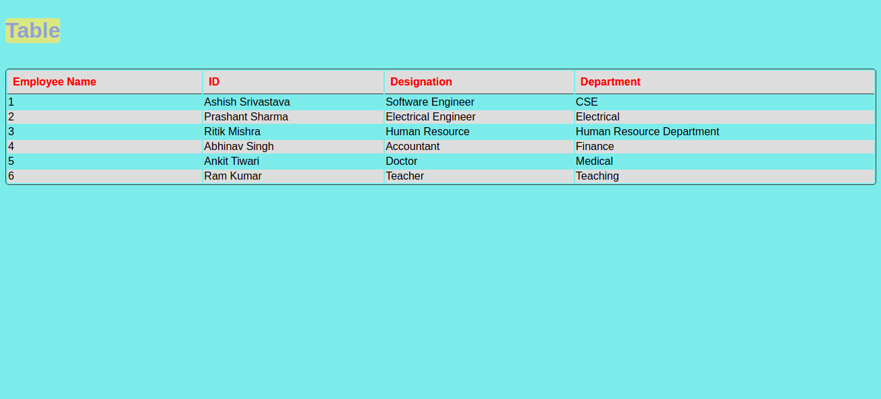

6. Why do we use meta tags?
Ans ==The <meta> tag defines metadata about an HTML document. Metadata is data (information) about data.
<meta>tags always go inside the <head> element, and are typically used to specify character set, page description, keywords, author of the document, and viewport settings.
Metadata will not be displayed on the page, but is machine parsable.
Metadata is used by browsers , search engines , and other web services.
There is a method to let web designers take control over the viewport (the user's visible area of a web page), through the <meta> tag

7. Explain box model.
Ans ==
In CSS, the term "box model" is used when talking about design and layout.
The CSS box model is essentially a box that wraps around every HTML element. It consists of: margins, borders, padding, and the actual content.

Content - The content of the box, where text and images appear
Padding - Clears an area around the content. The padding is transparent
Border - A border that goes around the padding and content
Margin - Clears an area outside the border. The margin is transparent

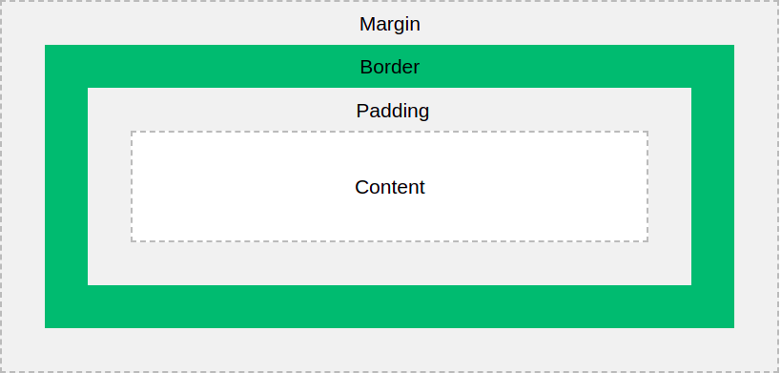

8. What are the different types of CSS Selectors?
Ans==

--CSS selectors--
CSS selectors are used to "find" (or select) the HTML elements you want to style.

--The id selector --
The id selector uses the id attribute of an HTML element to select a specific element.
The id of an element is unique within a page, so the id selector is used to select one unique element!
To select an element with a specific id, write a hash (#) character, followed by the id of the element.

--The class selector --
The class selector selects HTML elements with a specific class attribute.
To select elements with a specific class, write a period (.) character, followed by the class name

--The universal selector--
The universal selector (*) selects all HTML elements on the page.

--The grouping selector--
The grouping selector selects all the HTML elements with the same style definitions.
Look at the following CSS code (the h1, h2, and p elements have the same style definitions):

9. Define .Doctype

All HTML documents must start with a <! DOCTYPE> declaration.
The declaration is not an HTML tag. It is an "information" to the browser about what document type to expect.

10. Explain 5 HTML5 semantic tags.
Ans ==

1-- Header--
The <header> element represents a container for introductory content or a set of navigational links.
A <header> element typically contains:
one or more heading elements (<h1> - <h6>)
logo or icon
authorship information

2-- Footer--
The <footer> element defines a footer for a document or section.
A <footer> element typically contains:
authorship information
copyright information
contact information
sitemap
back to top links
related documents

3-- Section--
The <section>element defines a section in a document.
"A section is a thematic grouping of content, typically with a heading."
Examples of where a <section>element can be used:
Chapters
Introduction
News items
Contact information

4-- Article--
The <article> element specifies independent, self-contained content.
An article should make sense on its own, and it should be possible to distribute it independently from the rest of the web site.
Examples of where the <article> element can be used:
Forum posts
Blog posts
User comments
Product cards
Newspaper articles
5-- Nav--
The <nav>tag defines a set of navigation links.
Notice that NOT all links of a document should be inside a <nav>element. The <nav> element is intended only for major block of navigation links.
Browsers, such as screen readers for disabled users, can use this element to determine whether to omit the initial rendering of this content.

11. Create HTML for web-page.jpg (check resources, highest weightage for answers)
Ans ==

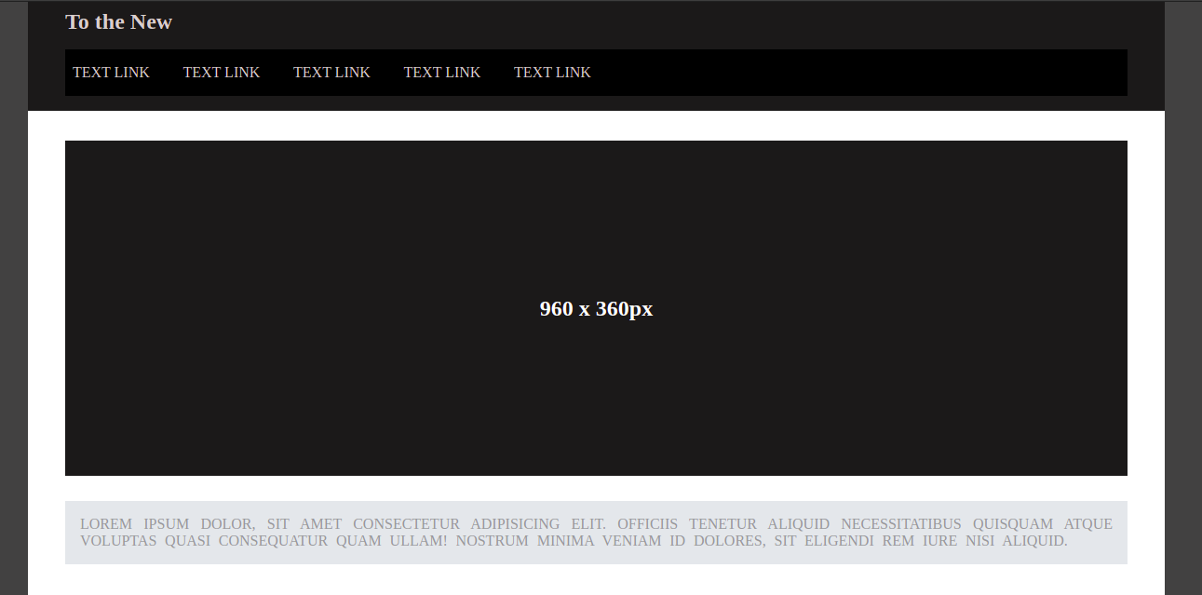
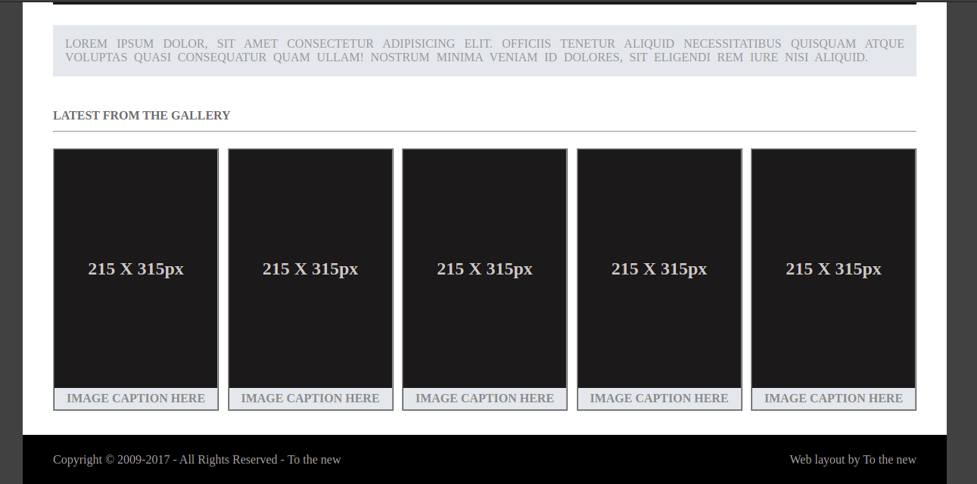

12. Create HTML for form.png (check resources, highest weightage for answers)
Ans ==

