

Inter University Accelerator Centre
[[An autonomous Inter-university of UGC of Govt. of India]
Aruna Asaf Ali Marg, Post Box: 10502
New Delhi: 110067, India
Fax No : +91-11-26893666 Phone : +91-11-26892601/3

Title of the Experiment: Ultrasonic Sensing Radar

- AIM: To demonstrate the principle of ultrasonic sensors and working as range-finding radar.

- PRINCIPLE AND THEORY:
  - Ultrasound refers to band of sound waves greater than frequency of audible range of human ears i.e. >20,000 Hz.
  - Ultrasonic sensors emit a sound pulse that reflects off of objects entering the wave field. The reflected sound, or “echo” is then received by the sensor. Detection of the sound generates an output signal for use by an actuator, controller, or computer. The output signal can be analog or digital.

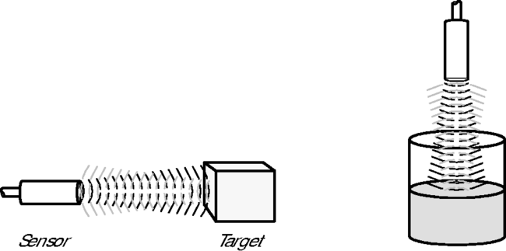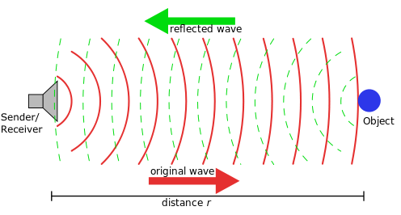

- Ultrasonic sensing technology is based on the principle that sound has a relatively constant velocity. The time for an ultrasonic sensor’s beam to strike the target and return is directly proportional to the distance to the object. Consequently, ultrasonic sensors are used frequently for distance measurement applications such as level control.
- Ultrasonic sensors are capable of detecting most objects — metal or nonmetal, clear or opaque, liquid, solid (SONAR), or granular — that have sufficient acoustic reflectivity as ultrasonic waves are longitudinal mechanical waves which travel as a sequence of compressions and rarefactions along the direction of wave propagation through the medium.
- A demerit of ultrasonic sensors is that sound absorbing materials, such as cloth, soft rubber, flour and foam, make poor target objects. It also produces inconsistent results in case of variable atmosphere.

- APPARATUS REQUIRED:
- HC-SR04 Ultrasonic Transceiver, SG90 servo motor, microcontroller, jumper wires, mounting arrangement.

- EXPERIMENTAL PROCEDURE:
- Make the connections as per the diagram.
- Program the servo motor to move in steps to cover 0º to 180º.
- For each angle, send a 10µs high level pulse to trigger input of sensor module though microcontroller. This will cause transceiver to send 8 pulses of 40 kHz ultrasonic waves.
- After that wait for sensor to receive a high level “echo” pulse (reflected wave) whenever there is an obstacle in its sensitivity range.
- The high duration of the echo pulse is the time taken from transmission to reception of ultrasound.
- Range = high level time * velocity (340m/s) / 2.
- Now bring an obstacle in the range, and start moving it.
- Display (Range, Angle) on a polar graph.
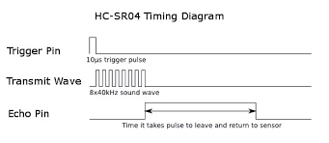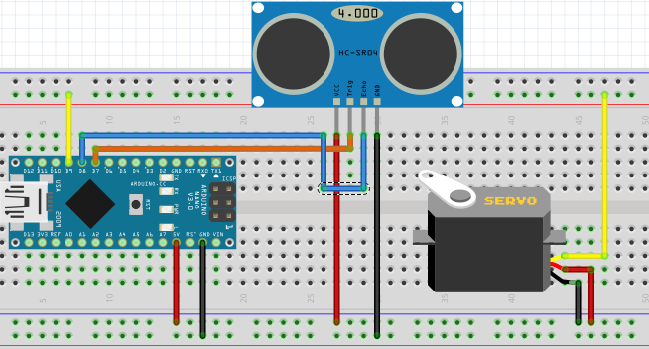

  - OBSERVATION:
  - Whenever there is an ultrasonic reflecting material in the range of sensor, an echo pulse signifying its distance is received and plotted.
  - If the object is in motion, continuous variation in range is received and plotted.

  - CONCLUSION :
    - Ultrasonic transceiver module was programmed and used as range-finder tool scanning an area from 0º to 180º mapping any obstacle in the range.

- APPLICATIONS:
- SONAR
- Medical applications
- Driverless cars (Google, Audi, Tesla)
- Terrain mapping

