**GROCERY MANAGEMENT SYSTEM**

**BY**

**Aashish Bhandari**

**8262/17**

St. Xavier’s College

A Summer Project Report Submitted to

**Faculty of Management, Tribhuvan University**

In partial fulfillment of the requirements for the degree of

**Bachelor of Information Management**

Kathmandu, Nepal

February, 2021

# STUDENT DECLARATION

This is to certify that I have completed the Summer Project entitled “Grocery Management System” under the guidance of “Bal Krishna Subedi” in partial fulfillment of the requirements for the degree of **Bachelor of Information Management at Faculty of Management, Tribhuvan University.** This is my original work and I have not submitted it earlier elsewhere.

Date: 2021/02/25 Signature:

Name: Aashish Bhandari

# CERTIFICATE FROM THE SUPERVISOR

This is to certify that the summer project entitled Grocery Management System is an academic work done by Aashish Bhandari Submitted in the partial fulfillment of the requirements for the degree of **Bachelor of Information Management** at faculty of Management, Tribhuvan University under my guidance and supervision. To the best of my knowledge, the information presented by him in the summer project report has not been submitted earlier.

______________________

Signature of the Supervisor

Name

Designation

Date

# ACKNOWLEDGMENT

First of all, I would like to thank **Tribhuvan University** for providing us with such a wonderful platform for us to grow and thrive. Along with that, I am very thankful for our college, **St. Xavier’s College**, for providing me with this wonderful opportunity. I am thankful for the Grocery store nearby my house for supporting me the project.

I would like to express my heartfelt gratitude and admiration to all those who immensely provided us the guidance and the assistance to complete the project. I would like to extend my special gratitude to our Head of Department, **Mr. Ganesh Yogi**, for his guidance during this project and also for his mentoring.

Furthermore, I would like to thank our project supervisor **Mr. Bal Krishna Subedi**, St. Xavier’s College for providing us valuable guidelines, supervision and suggestions to successfully complete this project. The success and final outcome of this project required a lot of guidance and assistance from many people and we are very fortunate to have this all along the completion of this project.

At last, I would like to express my sincere thanks to all my friends and colleagues who helped me directly or indirectly during the project time.

**Aashish Bhandari**

**(TU Exam Roll No. 8262/17)**

# EXECUTIVE SUMMARY

One of the most essential businesses throughout the century is the grocery business. Grocery stores are truly hallmark of the established society. We cannot hoard everything that we need or might require in the future, so we have grocery stores nearby to buy the items we require in day to day business.

Providing services to customers should be reliable, highly managed and should avoid a possible human error that is due to the existing manual system. One of the main problems of grocery stores while using manual systems is to keep error free records such as inventory, invoices, credits of customers etc. During a small survey at a local grocery store I came to know that people are willing to use systems that can automatically maintain inventory, credit system and billing.

Grocery shop management systems can lead to error free, secure, reliable and fast management systems. It can assist the user to concentrate on their other activities rather than focusing on record keeping. This system gives a summary of vital information such as total sales, total purchases, total receivable and total payable. Grocery stores can organize and maintain records without worrying about redundant entries and one need not to be distracted by information that is not relevant, while being able to reach the information.

# LIST OF FIGURES

Figure 1 Current purchase flow. 2

Figure 2 Current Sales record flow 2

Figure 3 Gantt chart 3

Figure 4 Agile method 11

Figure 5 Iterative Prototyping Model 11

Figure 6 Activity Diagram of Grocery Management System 13

Figure 7 Purchase System Flowchart 14

Figure 8 Invoice Flowchart 15

Figure 9 Architectural Design for web application 16

Figure 10 MVC Pattern 16

Figure 11 Context Diagram 17

Figure 12 Grocery Data Flow Diagram 18

Figure 13 Use case Diagram 19

Figure 14 Sequence diagram of invoice record 20

Figure 15 Sequence diagram of purchase 21

Figure 16Sequence diagram of purchase return 22

Figure 17 Sale return sequence diagram 23

Figure 18 Testing 25

Figure 19 Validation Login Form 26

Figure 20 Wrong credentials validation 26

Figure 21 Empty Purchase Table 27

Figure 22 Login protected route 27

Figure 23 Login Protected Route 28

Figure 24 Page not found 28

Figure 25 Purchase List Table 29

Figure 26 Vendor List Table 30

Figure 27 Inventory List Table 30

Figure 28 Purchase List Table 31

Figure 29 Inventory List Table. 31

Figure 30 Vendor List table 32

Figure 31 New Sales record 32

Figure 32 Updated inventory 33

Figure 33 Customer list 33

Figure 34Admin login page 35

Figure 35 Admin dashboard Page 35

Figure 36 Purchase List Table 36

Figure 37 Purchase Invoice 36

Figure 38 Customer list 37

Figure 39 Customer profile page 37

Figure 40 Vendor List Table 38

Figure 41 Vendor profile page 38

Figure 42 Inventory list 39

Figure 43 Add new invoice form 39

Figure 44 purchase add form 40

Figure 45 Invoice list table 40

Figure 46 Sale invoice list 41

Figure 47 Sales report 41

Figure 48 Purchase Report 42

# LIST OF TABLES

Table 1 Time Schedule 3

Table 2 System Requirement 9

Table 3 Functional Requirement 12

# TABLE OF CONTENTS

STUDENT DECLARATION ii

CERTIFICATE FROM THE SUPERVISOR iii

ACKNOWLEDGMENT iv

EXECUTIVE SUMMARY v

LIST OF FIGURES vi

LIST OF TABLES viii

TABLE OF CONTENTS ix

CHAPTER I: INTRODUCTION 1

1.1 Background 1

1.2 Introduction to Organization 1

1.3 Current Situation of Organization 1

1.4 Issues/Problems of the report 2

1.5 Objectives 2

Feasibility Analysis 3

Literature Review 4

1.6 Methodology/Procedure adopted for the report. 7

1.6.1 Project Structure 7

1.6.2 Data and Information 7

1.6.3 Tools Used 7

1.6.4 Techniques for project report Analysis 9

1.6.5 System Requirement 9

CHAPTER II: TASKS AND ACTIVITES PERFORMED 10

Analysis of Task, Activities, Problem, Issues 10

Analysis of Tasks 10

Problems and Issues 10

Tasks Performed 10

Analysis of possible solutions 12

Requirement Gathering 12

System Design 13

System Activity Diagram 13

System Flowchart for Storing Purchase Record 14

System Flowchart for Storing invoice Record 15

Architectural Design 16

MVC Pattern 16

Context Diagram 17

Data Flow Diagram 18

Use Case Diagram 19

Sequence Diagrams 20

Class Diagram 24

Testing 25

Unit Testing 25

Integration Testing 29

System Testing 34

Acceptance Testing 34

Findings/Result 35

CHAPTER III CONCLUSION AND DISCISSION 43

Discussion 43

Critical Analysis 43

Recommendations and Future Enhancements 45

Conclusion 46

# CHAPTER I: INTRODUCTION

## 1.1 Background

This project “Grocery Management System” provides a simple UI to maintain the different record of grocery inventory, purchase, suppliers and helps to track revenue, purchase etc. The first activity is to add purchased item with purchase rate and sales rate. This authority is given only to admin (administrator). As customer buys the products and comes to the billing counter, the user is supposed to enter the item name he purchased and the quantity of the item he had purchased. This is simple input from user side that does not involve much effort. The application is reduced as much as possible to avoid errors while entering the data. It also provides error message while entering the invalid data. No formal technical knowledge is needed to get familiar with this system.

Every organization, whether big or small, has challenges to overcome and managing the information of product, customer, stock, suppliers. With this system it is very easy to manage that information and also helps to analysis information by showing purchase trends and sales trends.

In local level grocery tends to manage credits for their regular customer in manual system and sometimes due to manual system errors and inaccuracy the relation between customer and grocery store becomes worse. This system provides small feature to avoid such difficulty and errors.

## 1.2 Introduction to Organization

Balkot Grocery is the small grocery store in my locality that provides essential services to more than 100 customers in which more than 30 of them are regular customer. Family started this grocery business in 2017 A.D with the primary aim of providing essential goods and services that is needed by every household in daily basis. They aim to provide good services to customer including credit facilities to regular customer. This store provides regular services to customer such as goods that is needed in regular basis like salt, sugar, food oil, other different product to more than 100 customers. It has becomes one of the essential entity of that locality.

## 1.3 Current Situation of Organization

After the establishment of the grocery store in 2017 A.D it has provides an important service that is needed in daily basics. Now a day due to increase in household in Balkot there are many customer that get services from this grocery store which ultimately increase transaction in this store such as purchase, sales, credit transactions etc. Currently they use register to record every purchase record as well as sales report. Keeping track of much customer credit is also maintained manually in register. Now a day due to increase in transaction to store there is inconsistency in data, rooms for errors. The overall system of grocery system is depending on single person which increase the probability of errors in data entry.

They heavily relied on traditional way of management of products and different transactions that occurred on grocery store. They use pen and copy to record different product on the inventory and updating inventory. With this manual system it has becomes very difficult to know which item is about to finished in the stock and which item to purchase from vendor. Precisely there is no any systematic way of managing inventory, keeping track of every product in the store.

The purchase flow currently in practice in this sore is shown in figure below.



Figure 1 Current purchase flow.

Sales flow currently in practice in this store is shown in figure below.

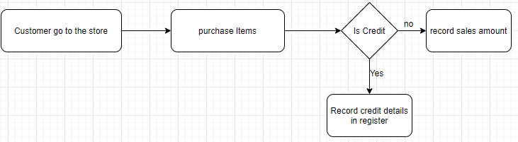

Figure 2 Current Sales record flow

Currently keeping record of purchase and sales is manual and it is very difficult to manage those records on long term. With purchase and sales it is very difficult to update inventory in manual system so currently inventory is calculated before purchase is made and there is high changes of purchasing less important item while there exists some item which needed to be purchase immediately.

## 1.4 Issues/Problems of the report

The issues/problems of the report are as follows:

* The project was not tested in real time data and traffics.
* Dummy data was used for verification and validation.
* Inability of local server to be up at all time.
* During development of project there was no access to users.

## 1.5 Objectives

The main objective is to upgrading from traditional systems to modern one. Upgrading is needed in grocery store as it goes big day by day and customer increase. The other objectives of this report are:

* To computerize all main activities occurs in grocery store such as securely storing various transactions that occur in day to day basic in grocery without worrying about data loss; avoid human errors in calculations of transactions and making invoices.
* Maintaining customer’s details, invoices, credit, purchase and suppliers of the store and also store those data securely on database with both read and write operation by admin.
* Display revenue of grocery on daily, weekly and monthly basis.
* Display top demanded goods and products on grocery on weekly and monthly basis.

## Feasibility Analysis

The data is stored in an excel spreadsheet, and the notes are handwritten. Mr. Sudir Shrestha has confirmed clearly that their system must be upgraded to a more powerful integrated system.

Technical Feasibility: There is technical feasibility as most of them can operate a computer working in this grocery store.

Operational Feasibility: Since this system need strong internet connection and system is accessed through web browser and there is no other hardware or software requirement beside this. So this system is feasible in term of operational of grocery store.

Legal Feasibility: The legal feasibility assessment determines whether the proposed system conflicts the legal requirements like data processing system must comply with the local data protection regulations. This application will not violate any rules and regulations that might be applicable to it. And it regards of code, the system has only used open sources dependencies.

Schedule Feasibility: Total time allocated for the completion of the project was 7 weeks. The time was divided into the tasks to be done and shown figuratively in Gantt chart:

|  |  |  |  |
| --- | --- | --- | --- |
| Task | Start Date | End Date | Duration |
| Project Planning | 25-Sep | 30-Sep | 5 |
| Data Collection and Analysis | 1-Oct | 5-Oct | 4 |
| Database Design | 6-Oct | 10-Oct | 4 |
| Frontend Design | 11-Oct | 20-Oct | 9 |
| Backend Design | 21-Oct | 30-Oct | 9 |
| Testing and Debugging | 31-Oct | 15-Nov | 15 |

Table Time Schedule

Figure Gantt chart

## Literature Review

This unit focuses on an analysis conducted by other scholars in a related field of the grocery store management system. Throughout this chapter, there will be a thorough discussion of the theoretical and realistic perspectives of previous research on online and offline grocery management. This research incorporates finding from previous studies to determine what variables would affect in using online grocery store management system.

There was a research paper from Chen Ann Hwa (2015) about important of using online grocery store management system suggest that grocery store management system is a system that specifically built to manage grocery shop activities and records and all in one system that has the function to manage grocery inventory with every purchase and sales is made. Using this system it is very easy for client (grocery store). For those clients who are willing to use this type of system will save their time, money and also manpower. In fact, this system replaces several existing management systems into a centralized system. Using grocery store management system we can avoid simple human errors that exists while using grocery management system. This report suggests the advantages of using grocery store management system rather than using manual or existing system in use.

Marcia Mkansi (2018) studies about the challenges faced by grocery store that has been using old method or manual method for storing data related to activities of grocery store. According to this study, grocery stores face a variety of inventory management problem, including determining stock supply and substituting items. This article also discussed the difficulties that grocery store owner’s encounter when measuring their market prices, income, and company costs, among other things. This research also addresses the issue of managing inventory through a manual system in a grocery store without the use of an online grocery store management system.

According to Marcia Mkansi's study, there are a variety of issues that occur by using an outdated or manual system for grocery store data collection and grocery store operations. Due to the absence of a cloud grocery store system, there is a high risk of losing track of inventory, making it impossible to cope with delicate items such as fruits or other items that are about to expire. Calculating sales, prices, and benefit in a manual method where any estimate must be completed at the end of the day to provide a regular overview of the grocery store is extremely difficult. This challenge is solved by employing a machine that can perform a variety of tasks by only requiring a limited number of inputs.

According to Adewole Adewumi, S. Ogbuchi and Sanjay Misra in “A cloud-Based Management System” stated that in recent years various retail management system have been deployed extensively as web applications and stand-alone applications. However, in order to increase Return on Investment while still optimizing retail market productivity and profitability, it is critical to investigate newer technology that can be used. According to this research paper, as stand-alone applications are applied rather than cloud based application, they prove to be difficult and costly to manage for businesses with little or no experience of information technology. Cloud computing solution can be implemented under three major service models namely: software as a Service (Saas), Platform as a Service (PaaS) and infrastructure as a service(Iaas). They can be deployed as private cloud, public clouds, community clouds or hybrid clouds. It is critical that cloud computing be widely used in the retail sectors because it crosses boundaries and contributes significantly to the economy of every country. Cloud based system would assist them in overcoming the high costs of operating and managing in-house technology facilities. In addition, depending on the level of production, the manufacturer can conveniently scale up or down computing resources. According to this report hardware that needed to use this software is more flexible than hardware that is needed in standalone application because you can access system anywhere from the world with computer and internet.

According to Anas M. Atieh, there is a research about the effect of a warehouse system on supply chain efficiency that provides less resources commitment, more effective, and consistent inventory management system in performance enhancement of “Inventory management system processes through an integrated warehouse management system,” in which there is a study about the impact of a warehouse system on supply chain performance that provides less resources effort, more efficient, and reliable inventory management system.This study concludes that since data were gathered in a good fashion, this system is an important substitute for manual systems that exist in many organizations.

The author of this paper studies the effects of using inventory control in grocery store management systems, which helps to handle inventory in a successful manner, according to an article from linnworks.As the number of purchase and sales orders grows, inventory management becomes more complex.Using inventory management module in grocery store has various advantages such as simplified inventory management. This is biggest benefit of inventory management that makes the process of managing your inventory a whole lot easier, saving time, money and effort. This article also discusses how a good inventory control scheme will help reduce the chance of overselling. Overselling is a big problem for online retailers, as it can lead to a lack of power, dissatisfied customers, and, in some cases, suspension from marketplaces like Amazon and eBay. With a strong inventory management module in the grocery store, we can not only eliminate the inventory costs associated with human error, but we can also save money. Stock-outs and overstocks, for example, may result in substantial sales losses due to poor inventory control. You would have much greater stock traceability and, as a result, be able to access useful information allowing for future supplier negotiations if you use inventory and order processing tools for batch monitoring capability. More importantly, you will be able to get a much greater understanding of the vendors are more beneficial to the company and which need to be improved. Inventory tracking software that works well will deliver useful revenue statistics, allowing for more data-driven business decisions.

In Nepal, Bhat-Bhateni is an all-in-one store where customers can get facilities such as food shopping and other types of purchases. Since 1984A.D it has grown from a 120sq. ft store to become Nepal’s no. 1 retail sector tax payer with more than 100,000 customers daily. This ordinary ‘single shutter’ store has since transformed to become fourteen leading supermarket and departmental store in Kathmandu, lalitpur, pokhara, chitwan, dharan and butwal as this timeline shows. There was a challenge monitoring commodities and other purchases linked to goods as this store began to expand on a wide scale. They started from using local system that run on their computer only. In their retail store, this software will monitor orders, purchases, inventory, and other large transactions. The most difficult aspect of this method was keeping track of stocks. As the retail store's company grows, it faces new difficulties in monitoring orders, transactions, and inventory, necessitating the switch to POS software, which is commonly used in large businesses.

This POS app, which is widely used in Bhat-Bhateni and other major supermarkets in Nepal, has a number of features that address current system issues. One of the most essential features of this app is the returns, redemption, and shop feature, which keeps track of returned products and services. This system can handle inventory in effective manner such as real time inventory which get updated instantly after transaction of goods and services happens. This device can manage the whole accounting aspect of a retail store, including sales, fees, costs, inventory transactions, and so on, allowing Bhat-Bhateni to save time and money by not having to keep an account book manually.

The author of this report finds very important information to get underway in this project of "Grocery management system" from different sources.Various issues with the current system, such as keeping records of items in inventory, selling and purchase transactions, earnings, and a real-time system, were lacking in the system under study. To know top demanded goods was not in the existing system which has been addressed in this system with real time inventory system which was lacking in most of the existing system. This system is developed with the aim to host in cloud which provides to access this system by system user from anywhere in the world. The biggest benefit of a cloud-based system is that we don't have to upgrade the system for each customer any time a new functionality is introduced. We just need to upgrade one server, which would affect all users. It is a time-saving approach due to the cloud-based framework. The database is not located on the local disk, like it is in the current setup. There is a centralized database in the cloud that serves data to the system, and the centralized data tends to represent updates on the person that uses the system, rather than updating manually. This system is only for grocery store owners who are capable of managing their stores and keeping track of merchandise and services.

After studying various articles, journals and blogs of similar topics the author decides to address major problem of existing system of grocery store. The main issue addressed in the current framework is that customers are unable to keep track of their products and services, which is time intensive when attempting to locate supplies of existing goods in grocery. Keeping track of returned and defective items in inventory is problematic with the current scheme, as is addressed by the author in this system. In every grocery store many customer prefer to buy goods in credit and make payment of their credit after certain time or after being certain credit amount. To maintain such credit records grocery owner’s uses register to manage their customers name and their credit amount. In this type of recording credit there are high chances of human errors such as mistakes in recording transaction, calculating total credit amounts of many customers. Maintaining these many customers record in register is time consuming and this might be overwhelmed for store owner to maintain these records on daily basis. Credit management is a unique feature that exists in this system that is made very easy which was very difficult and time consuming to maintain in other system that author has studies.

There was a lack of report that was seen diagrammatically in different current systems that the author studied that were different to this system. In certain other systems, the report is only presented as a number. It's also better to visualize these reports graphically so that we can spot trends and analyze what's going on in the grocery store. Using this system every grocery store can maintain record easily and time saving hence this system assist user to concentrate on other activities rather than on record keeping. This system automatically shows records of sales, purchase, and total credit for each customer automatically based on sales record entered on system. This system's inventory control is real-time, including sales and purchases, making it much simpler and error-free for grocery store owners.

This system have modules such as purchase return and sales return which directly reflects on grocery inventory and update in real time in every module such as revenue, inventory etc.

## 1.6 Methodology/Procedure adopted for the report.

### 1.6.1 Project Structure

A project needs a strong project structure to run smoothly, on schedule and deliver great results. The combination of these processes is the project structure used:

1. Planning: A proper plan was made before starting this project which involves breaking down project into manageable tasks throughout the semester.
2. Implementation: The plan was implemented properly with small modification.
3. Control: While doing this project adjustment of plan was made for proper implementation of plans.
4. Monitoring: Project was checked from time to time.
5. Termination: At last with planning, controlling all tasks was completed.

### 1.6.2 Data and Information

The data and information are very important part for every project. With analysis of data we know requirement of the system, study system feasibility such as technical feasibility. To collect data following method were applied:

1. Primary Data Collection: Data is directly collected from grocery Balkot Grocery which helps to know various problems and helps to know what should system consists to solve those problem.
2. Secondary Data Collection: Secondary data is collected to know further common grocery problem and way to solve those using websites, articles etc.

### 1.6.3 Tools Used

The following tools were used for completion of this system.

1. **Node.js:** Node.js is an open source, cross-platform and backend JavaScript run time environment which executes JavaScript code outside web browser. It is widely used now a day for web development.
2. **Visual Studio Code:** Visual studio code is a freeware source-code editor made by Microsoft for window, Linux and macOS. It is very helpful for writing system code having several features like syntax highlighting, intelligent code etc.
3. **MongoDB:** MongoDB is document-oriented database program. I will be using this for storing various data because it is great when data structure is going to change over time to time as it is schema-less database.
4. **Express.js:** This is Node.js web application framework. I will be using express for backend as it is very easy to configure for API based project and easy to integrate NoSQL database like MongoDB which will be used as database in this project.
5. **Github:** Github is a web base services which helps to store code based on version control tool like Git.
6. **Git:** It is version control tool used for various software development applications. It tracks the changes made in various files and can be reverted to specific version of the project when needed.
7. **Microsoft Word:** Microsoft word is the most popular word processing system and justifiably. It is easy to use and allow you to create all the different types of documents. Here, Microsoft word is used to write project report.
8. **draw.io:** This is web based application which helps to draw diagram which is widely used in this project.
9. **Creately:** This is also a web based application like draw.io to make class diagram which is used in this project.
10. **Postman:** This is api testing tools just like web browser in which we can send http request but the major difference between web browser and postman is that in postman we can send any kind of http request like post, patch, put, delete which is not possible in web browser.
11. **Frontend web stack:** Frontend web stack is collection of all those tools that together builds interface in which user interact.
12. **Figma:** Figma is a vector graphics editor and prototyping tool which is primarily web-based applications. This is mainly used in this project for UI designing.

### 1.6.4 Techniques for project report Analysis

For analysis of project report, observation was used as the main technique. Other techniques that were used are:

* Internet Search
* Interviews
* Surveying with friends
* Showing to supervisors.

### 1.6.5 System Requirement

|  |  |
| --- | --- |
| Operating System | Windows 7 or Above |
| Internet Connection | At least 1 mbps |
| Browser | Any Browser |
| Device | Laptop/PC/Phone |

Table 2 System Requirement

# CHAPTER II: TASKS AND ACTIVITES PERFORMED

## Analysis of Task, Activities, Problem, Issues

Tasks and activities have been accessed, i.e. what needs to be done to obtain project objectives. Problems with the project are also critically analyzed in order to find future project improvements and flaws.

The project management phase starts with the identification of the resources and technology used to implement our framework at the start of the project. Given that new and better technologies are being introduced almost every day, we had a number of options to consider and research.

### Analysis of Tasks

The author visited grocery store nearby for requirement analysis and analysis of tasks. The main problem which is needed to be addressed is identified. After the collection of information, various analyses is done to make those collected information meaningful and address the main problem that is collected during this task. In this process problem and way to address problem in the system are analyzed in certain time frame for completion of summer project. Various problems are broken down into small problems which are easy to manage.

### Problems and Issues

After analysis of task and information obtained from data collections problem and issues of grocery store is addressed. Grocery store generally operates with huge transaction of purchase and sales and there were no modern way to efficiently manage those problems. Manually managing purchase and sales and no way of updating inventory on daily basis are major problem that was addresses during the survey and research.

Another problem that was also address was there is manual system of calculating revenue and purchase which might be inaccuracy.

### Tasks Performed

Following Tasks were performed during development of this project.

#### Selection of development methodology:

When it comes to handling tasks, there is no' one size fits all' strategy. This focuses on the project's complexity. The system includes the details and forms required for the efficient creation of the project along with the bird view of the project. I use the Agile Model. Agile approaches are incremental development methods of implementation in which the increments are minimal and new framework launches are usually created. The steps and principles of agile is not strictly followed, rather the strategy is made as much flexible and situation friendly as possible.

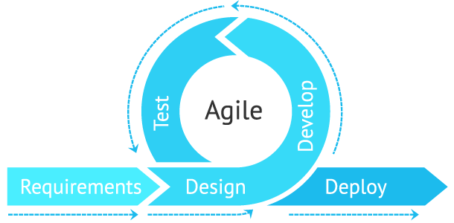

Figure 4 Agile method

The advantages of agile method are:

* + Implementation of changes in feature is easier.
  + Testing is done along with the development phase. So, minimum changes are required at the end of the project.
  + By breaking down the project into manageable units.

#### Development of Prototype:

Normally, actual requirement are known before we start with making product. There are many prototypes involving with software development. For this project iterative prototyping model is used. As name suggest it is repeating cycle of designing, prototyping, testing multiple version of the product until product is finally made. In traditional prototyping design we finalize the design before making the product where as in this approach we create working design, test it before finalizing and keep on changing until final design is made.

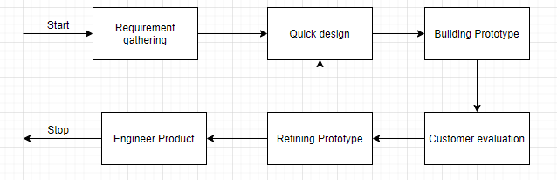

Figure 5 Iterative Prototyping Model

The reasons to choose this prototyping model for this project are:

* + Users are actively involved in the development.
  + A working model of the system is provided so the users get a better understanding of the system being developed.
  + In every prototype errors can be detected much earlier.
  + Quicker user feedback is available leading to better solutions.

#### Information gathering and analysis.

Another task performed was information gathering which was done by primary by visiting grocery store and secondary source by internet search, books, PDF etc. The gathered information is then analyzed and the domain of problem is determined.

## Analysis of possible solutions

### Requirement Gathering

The main objective of this stage is to identify and evaluate requirements of the proposed system. This stage aims to recognize the user requirement which may be both functional and nonfunctional requirement. Functional requirement defines a function which it must perform. Nonfunctional requirement defines system attributes like security, reliability, system performance in terms of space and time complexity, maintainability, scalable etc. Requirement gathering helps to know actual needs that system must have.

Functional requirement of this system is listed in table below.

|  |  |  |
| --- | --- | --- |
| S.N | Functional Requirements | Use Case |
| 1 | Admin can login | Admin |
| 2 | Admin can insert purchase record | Admin |
| 3 | Admin can insert invoice record | Admin |
| 4 | Admin can update inventory. | Admin |
| 5 | With purchase record insert inventory is updated automatically | Admin |
| 6 | View Purchase report on daily, monthly basis or from the beginning. | Admin |
| 6 | View Sales report on daily, monthly basis or from the beginning | Admin |
| 7 | Maintain Vendor information. | Admin |
| 8 | Admin can create records of return purchase goods | Admin |
| 9 | Admin can create records of return on sales goods to customer | Admin |

Table 3 Functional Requirement

The nonfunctional requirement of the system must contain following feature.

* The system should be secure
* The system should be responsive and fast.
* The system should be simple to use.
* The system should hold integrity of user information.

### System Design

System design is the process in which requirements of the system is converted in system modules or architecture i.e. converting business requirement to software components. According to Wikipedia Systems design is the process of defining the architecture, modules, interface, and data for a system to satisfy specified requirements. Systems design could be seen as the application of systems theory to product development.

The author has designed the system with the help of U.M.L diagrams to support system design.

### System Activity Diagram

Activity diagram represent overall activity of a system. It visually presents a series of actions or flow of control in a system. They are similar to flow diagram but it represents system flow better than flow diagram. They are often used in business process modeling. They are also used by developer to figure out the overall flow of the system in high level.

Activity diagram is very useful in this project with the following reasons.

* It helps to identify use case flow and overall system flow and find weakness or loopholes that may be present in this system.
* It helps to identify pre and post conditions for use case in this project.

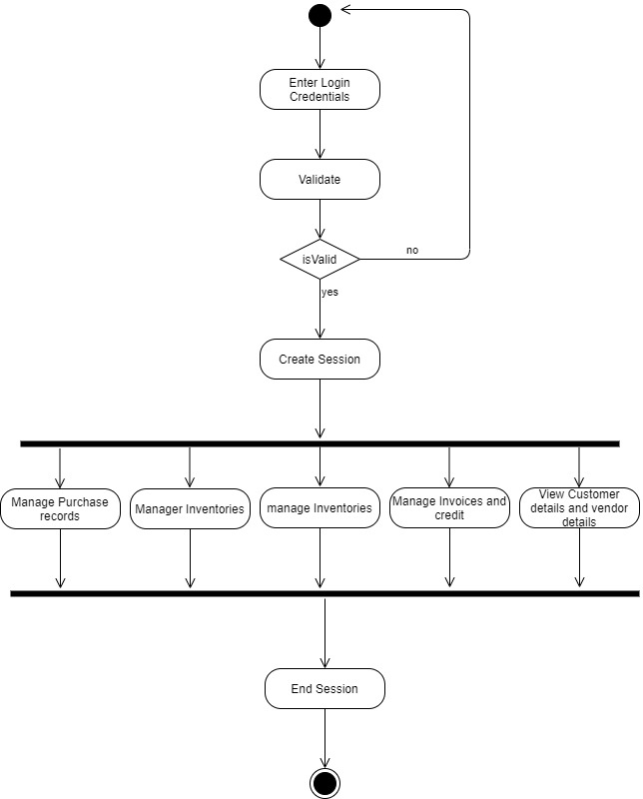

Figure 6 Activity Diagram of Grocery Management System

### System Flowchart for Storing Purchase Record

The flowchart below shows that how inserting purchase data work on the system.

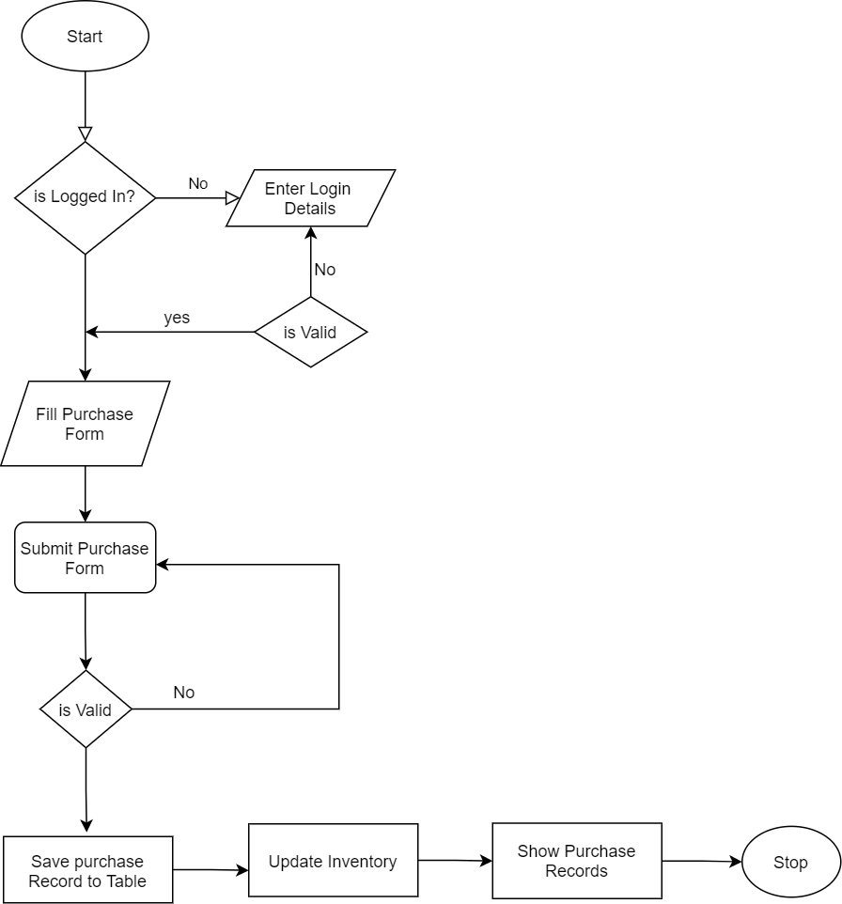

Figure 7 Purchase System Flowchart

Here first of all user need to insert purchase item in the grocery management system. If user submit invalid data to the purchase form it will stay on same page showing the errors to the users. If everything went right then it insert purchase record in the database and automatically update inventory of that inserted purchase item.

### System Flowchart for Storing invoice Record

Here flowchart below show how invoice record keeping system works and the effect on inventory.

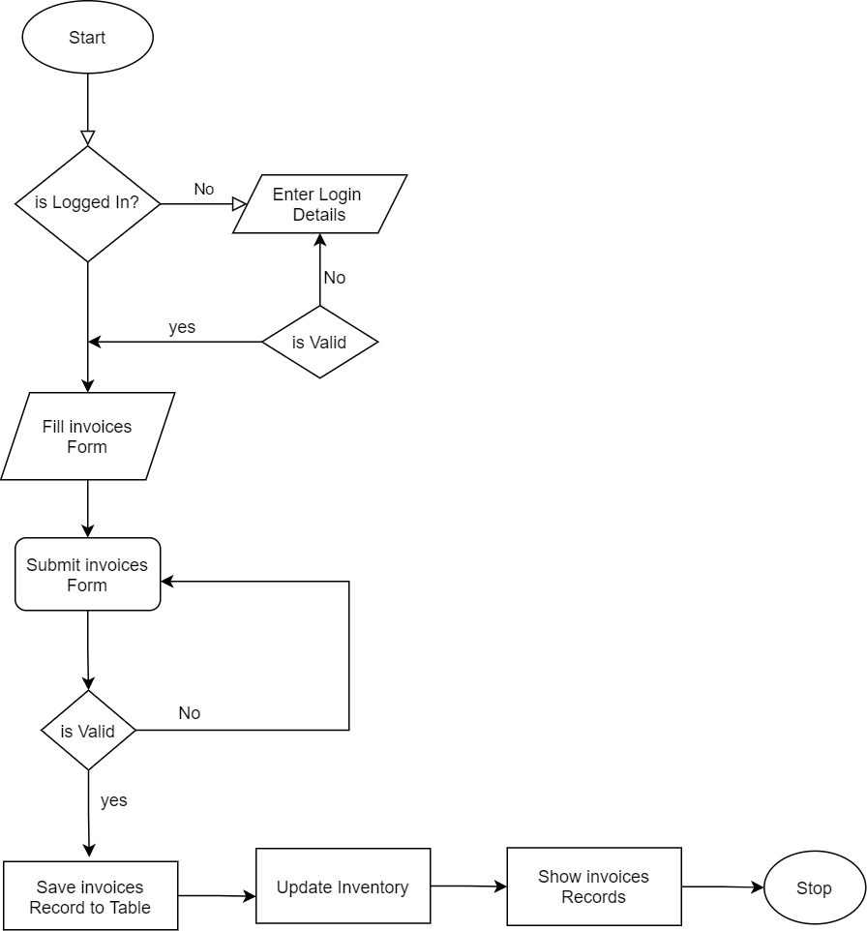

Figure 8 Invoice Flowchart

Here invoices are recorded after sales have been completed in the store. After sales the sales item is recorded in the system for future report and performances analysis. When sales invoices are recorded in the system first it checks the provided data by user is valid or not. If data is not valid system stays on the same page with error message. If there are no errors then system record invoice data into database and reduce inventory item that was sold.

### Architectural Design

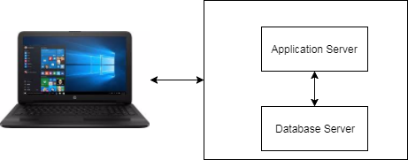

Figure 9 Architectural Design for web application

Here to complete grocery store management system client server architecture is used for obvious reasons. The database server is MongoDB which is chosen for its flexibility for storing unstructured data and provides enough capacity for storing many data. For application server author uses node.js version 12.13.1 as server side scripting language. Client is any web browser that can be of any version.

### MVC Pattern

It is a very common and rational architecture pattern for server side programming that the author prefers MVC patterns. MVC pattern represent separate logic for data, application logic and User interface. With changes in any one of the component other component does not changes due to which it is very easy to manage code and maintain application in future if needed.

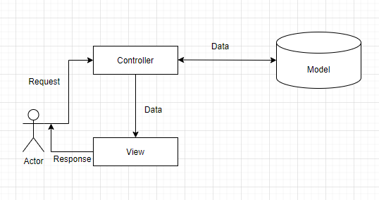

Figure 10 MVC Pattern

### Context Diagram

Context diagram is used to give an overview of an entire system. In a context diagram there is only one circle/process that represent the entire system. The purpose of this diagram is to display the excepting inputs and outputs from the system to and from various external entities. Through this display a system analyst can model what expected data is going to go into the system, and then after it has been processed by the system, it will show what information will be returning to the external entities.

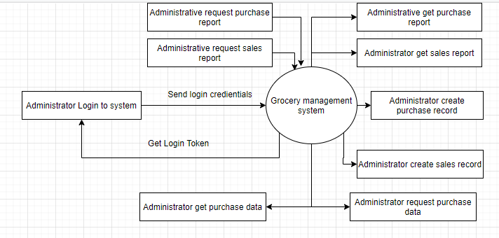

Figure 11 Context Diagram

The overview of the context diagram is shown above in which admin login to system using email and password and system gives unique token which is valid for only certain time so admin can login to system. Admin can create purchase record and view this purchase record. Admin also can create sales record and save it to invoice collections. With every purchase and sales actions that occurs in the system inventory is updated itself by the system.

### Data Flow Diagram

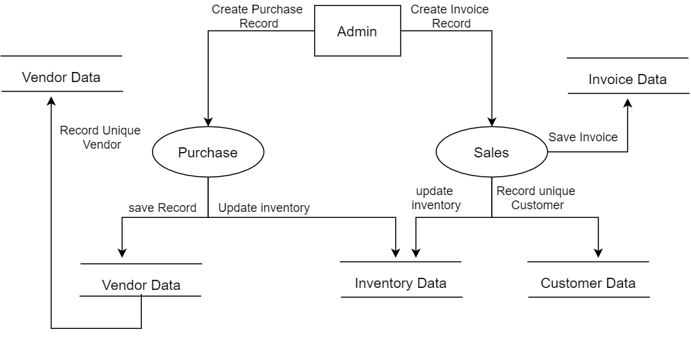

Figure 12 Grocery Data Flow Diagram

Data-flow diagram is a way of representing a flow of data through a process or a system. It provides information about the outputs and inputs of each entity and the process itself.

In in the above diagram admin have all the privilege to create purchase record, sales records and manage inventory. However inventory is managed by purchase and sales event automatically. For some exceptional case admin can also manage inventory. Admin can input invoice related information in form and submit data to save to sales collections in database. After sales record is recorded in database inventory is updated to reduce sale item. While creating sales recorded if unique user is registered to system then it save new customer to customer collections in database.

When new purchase recorded is created inventory is updated to increased purchased product item. If new vendor is detected while inserting purchase record then vendor data is inserted into vendor collections.

### Use Case Diagram



Figure 13 Use case Diagram

It is very difficult to know the entire requirement before starting developing specific system. The purpose of use case diagram is to capture the dynamic aspect of a system. It is used to know feature of the system.

New actors other than admin are customer and vendor which interact with the system. In the above use case diagram admin is grocery store and system admin can perform insertion of purchased goods, sold goods and create invoice. He can view grocery reports on the monthly, weekly and also whole life time of the grocery system. He can view which goods are being sold at alarming rate by looking at top demanded table generated by system based on entry of sales record. Vendor/supplier supply goods to grocery system which is also recorded by system.

### Sequence Diagrams

Sequence diagram is one of the best ways to communicate working process of a part of system to non tech people.

1. **Sequence Diagram for Invoice process**

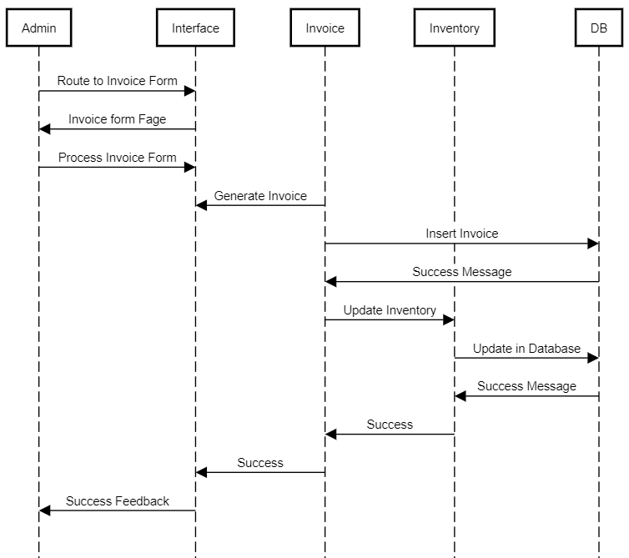

Figure 14 Sequence diagram of invoice record

Here in the figure above the author has shown sequence diagram of recording invoices after completing sales in grocery store. This diagram show how system interacts with each other after completing sales. First of all admin open invoice add form in which he/she will fill data relevant to sales like name of customer, contact Number, name of products, grand total etc. After filling all the form admin submit the form which will store data to database and inventory item is decreased which update inventory instantly.

1. **Sequence diagram for Purchase process**

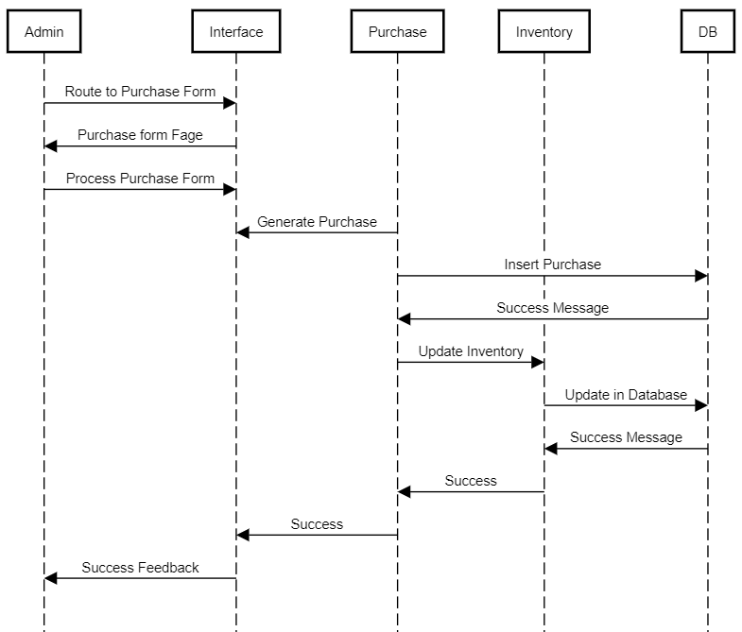

Figure 15 Sequence diagram of purchase

The author has depicted a sequence diagram of tracking transaction records after finishing purchases in a grocery store in the figure above. This diagram depicts how the systems work after a transaction is made. First of all admin open purchase add form in which he/she will fill data relevant to purchase like name of vendor from which purchase is made, contact Number, PAN number, name of products, grand total etc. After filling out the whole form, the administrator submits it, which saves the data to the database and increases inventory items, automatically updating inventory.

1. **Sequence diagram for purchase return.**

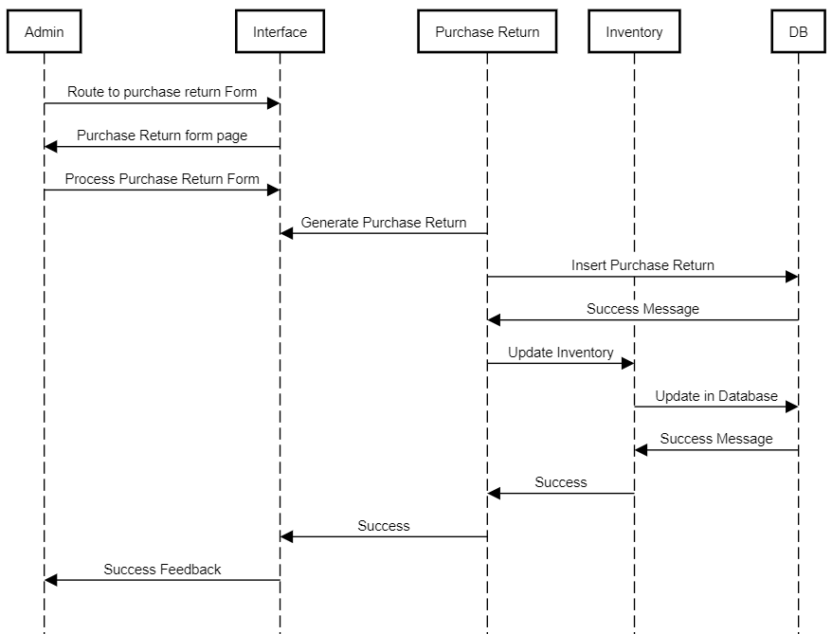

Figure 16Sequence diagram of purchase return

The author has depicted a purchase return sequence diagram here. When a consumer returns defective products to the store, the customer returns to the grocery store, and the grocery returns the defective goods to the seller, creating a series of events to keep track of all records in the system. First of all admin navigate to purchase return add form from interface and he fills up essential information that is required and then submit the form. After form submission purchase return record is saved to the database and inventory is updated.

1. **Sequence diagram for sales return**

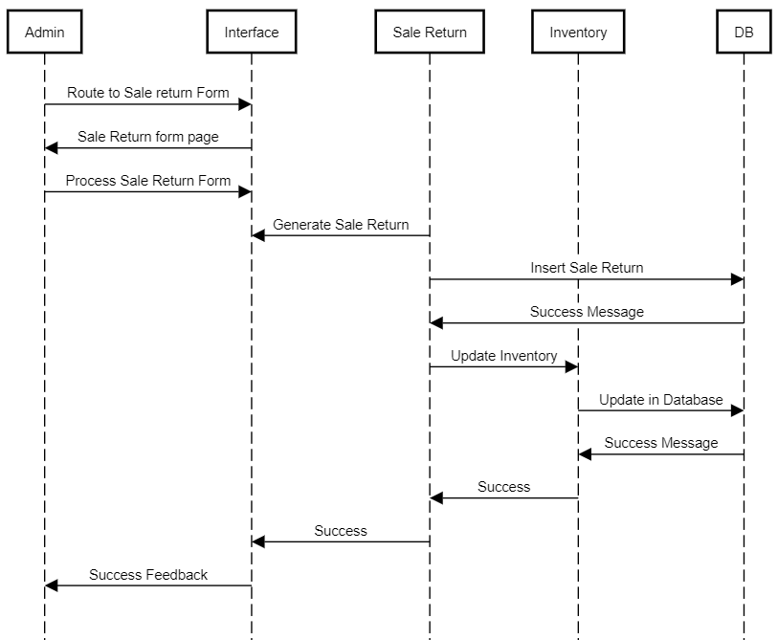

Figure 17 Sale return sequence diagram

The author has depicted a sales return sequence diagram here. When a consumer returns defective products to the store, the customer returns to the grocery store creating a series of events to keep track of all records in the system. First of all admin navigate to purchase return add form from interface and he fills up essential information that is required and then submit the form. After form submission purchase return record is saved to the database and inventory is updated.

### Class Diagram

Class Diagram is a static diagram. It reflects an application's static view. The author feels compelled to create a class diagram so it can be explicitly mapped into any object-oriented language program.

The above class diagram consists of admin, customer, sales, purchase and inventory model which interacts with each other for proper functionality of a system.

### Testing

Testing is regarded as one of the most critical aspects of system design/architectures, but it is often ignored and executed partially.

Testing was not conducted by author in traditional way in which system testing is done after fully development of the system rather testing was performed iteratively as system was built which saves a lot of time. It helps to find lots of errors and bugs that system possesses and might causes the system to go to other direction that it was intended to.

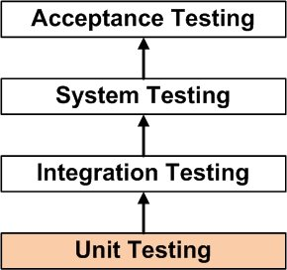

Figure 18 Testing

### Unit Testing

In this testing method testing is done for each component in isolation. This testing is done after building small component of system to check if these components give expected result.

Unit testing is performed by the author on the individual units of source code with a goal of making used if units are working as it should. This type of testing is very important in a system as It contain so many components which are very important for overall working of the system.

If test fails or we get result that is not expected from the component then it is lot easier to maintain in this stage than finding after system is completed or in later stage.

Following unit testing cases were implemented:

**Test Case 1: Admin Login Validation.**

**Test Data:** Empty Form Data

**Expected outcome:** It prevents user to send request to server for login token.

**Evidence:**

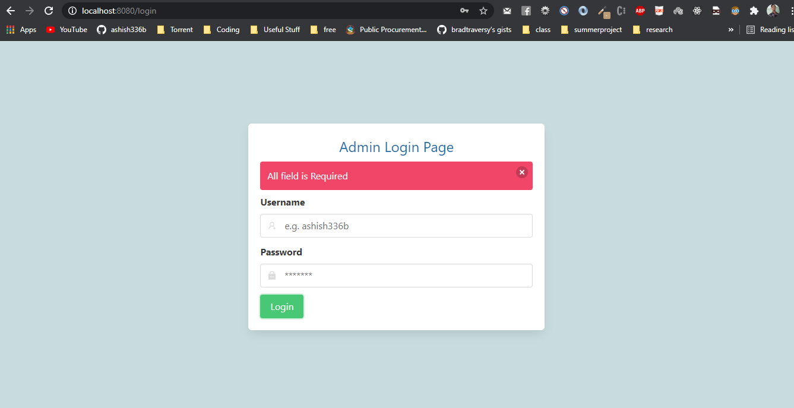

Figure 19 Validation Login Form

**Test case 2: If user enters wrong username or password.**

**Test Data:** Wrong username and password.

**Expected Outcome:** Show error message stating username or password doesn’t match

**Evidence:**

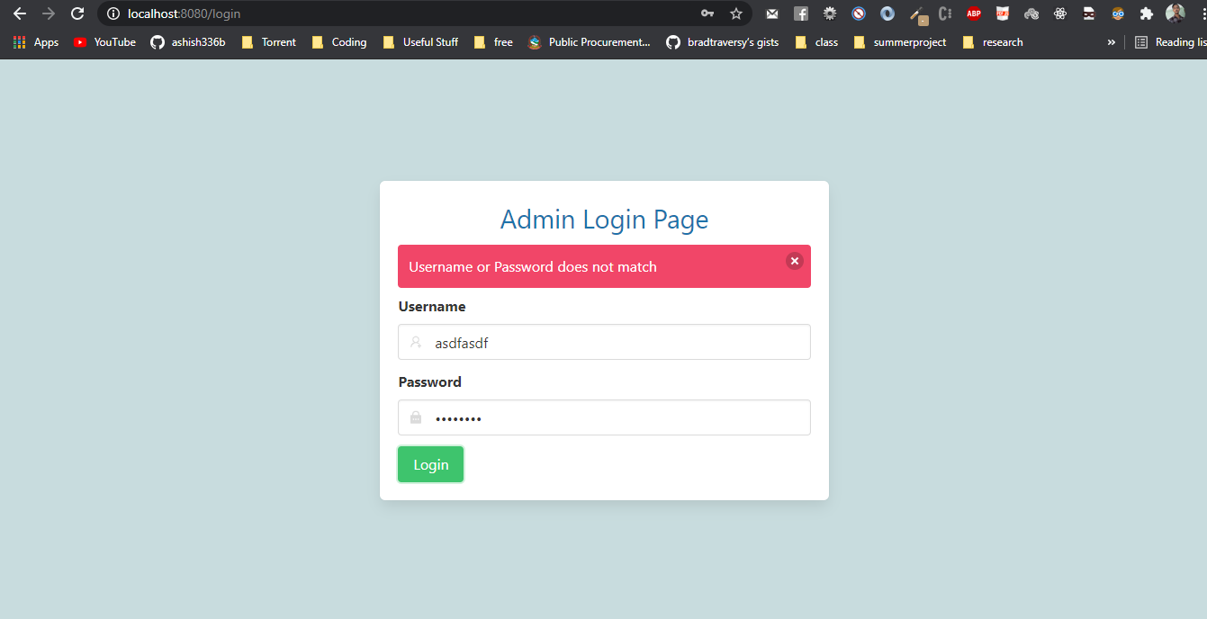

Figure 20 Wrong credentials validation

**Test case 3:** **If there are no purchase records.**

**Test Data:** Empty form Data.

**Expected outcome:** Show No Data available in table.

**Evidence:**

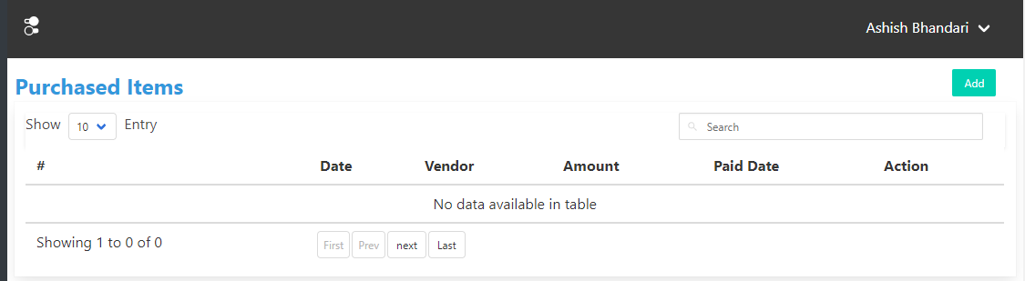

Figure 21 Empty Purchase Table

**Test case 4: If users send URL without login token that require login token from postman.**

**Test Data:** Send request without token to login protected URL.

**Expected outcome:** Error message in JSON Format.

**Evidence:**

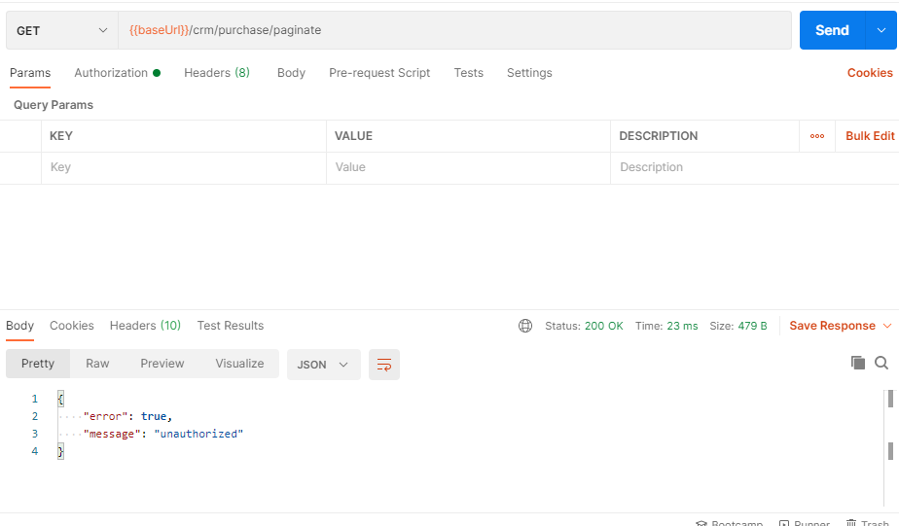

Figure 22 Login protected route

**Test case 5: If user want access to dashboard without login from web UI.**

**Test Data:** Manually enter dashboard URL.

**Expected outcome:** System should redirect to login page.

**Evidence:**

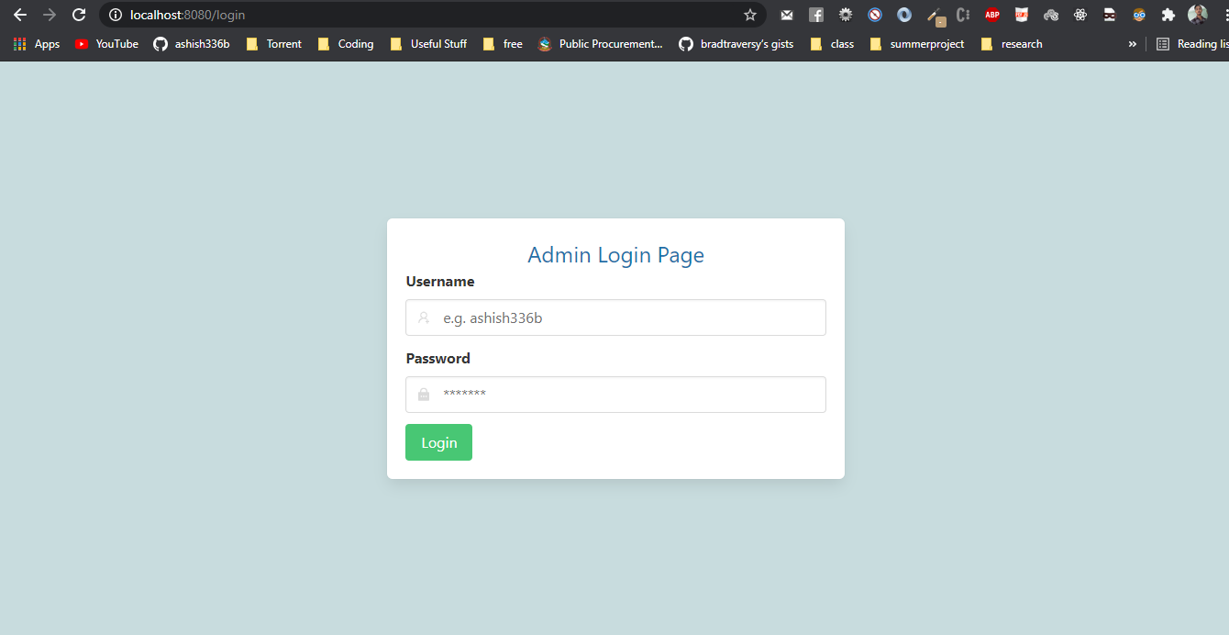

Figure 23 Login Protected Route

**Test case 6: If user manually type unregistered URL.**

**Test Data:** random URL

**Expected Outcome:** Display “This page could not be found”

**Evidence:**

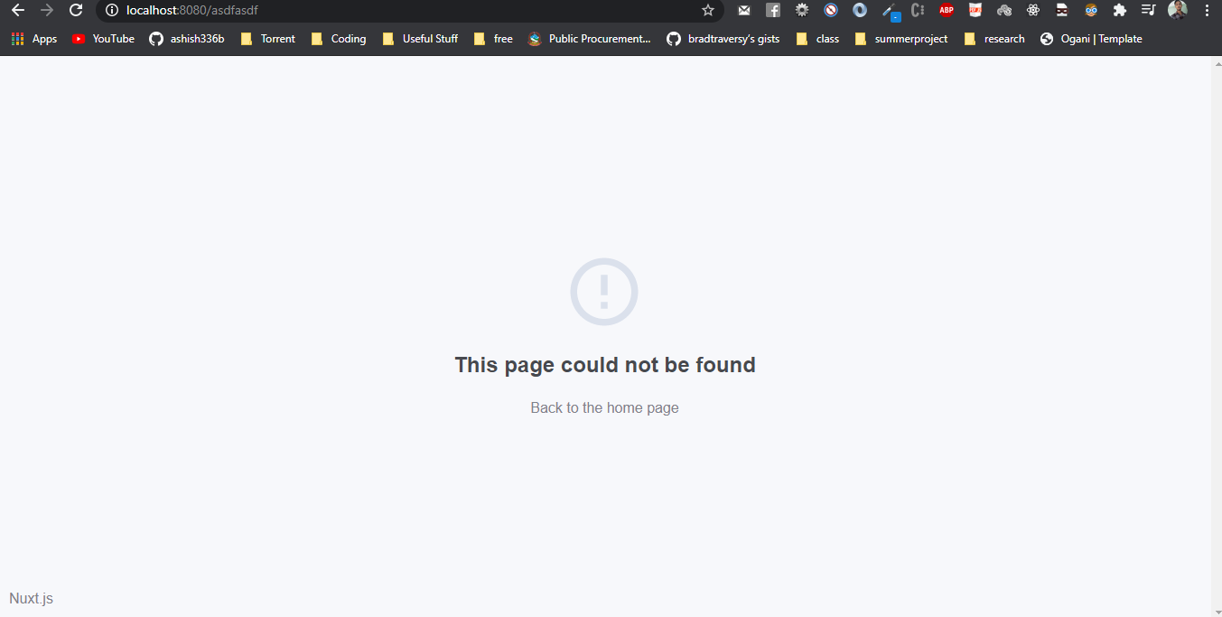

Figure 24 Page not found

### Integration Testing

Integrated testing is defined as a type of testing where software modules are integrated logically and tested as a group. This type of testing consists of checking data flow from one module to another module when certain action is being done in the system. In this phase of testing two or more components are grouped together for testing.

Test Case: Create new purchase record

Test Data: Every purchase details mentioned in form field.

Expected outcome: If purchase record is created then it should update inventory automatically, if purchased from new vendor then new vendor details should be stored in database and purchase record should be listed in purchase table.

Evidence:

Before Creating Purchase Record

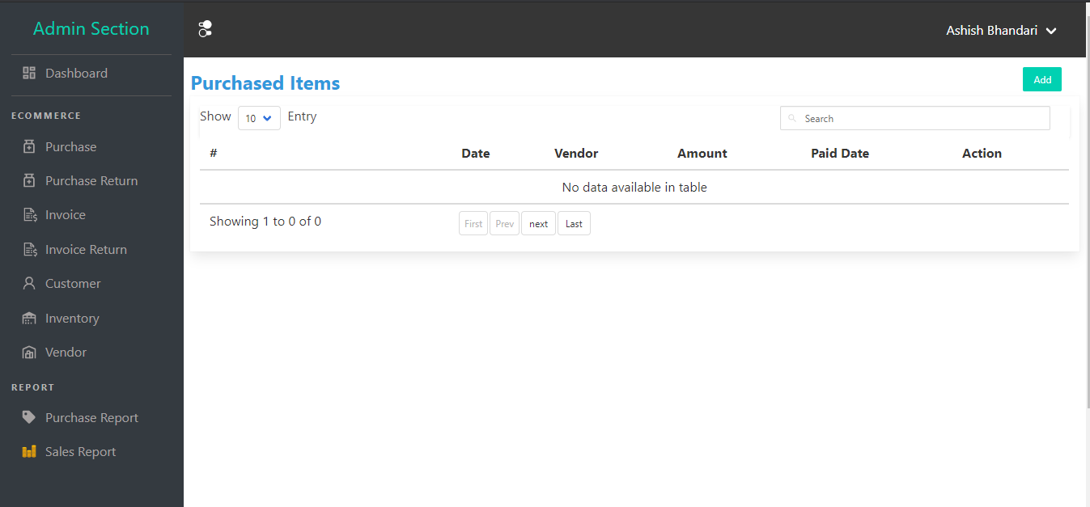

Figure 25 Purchase List Table

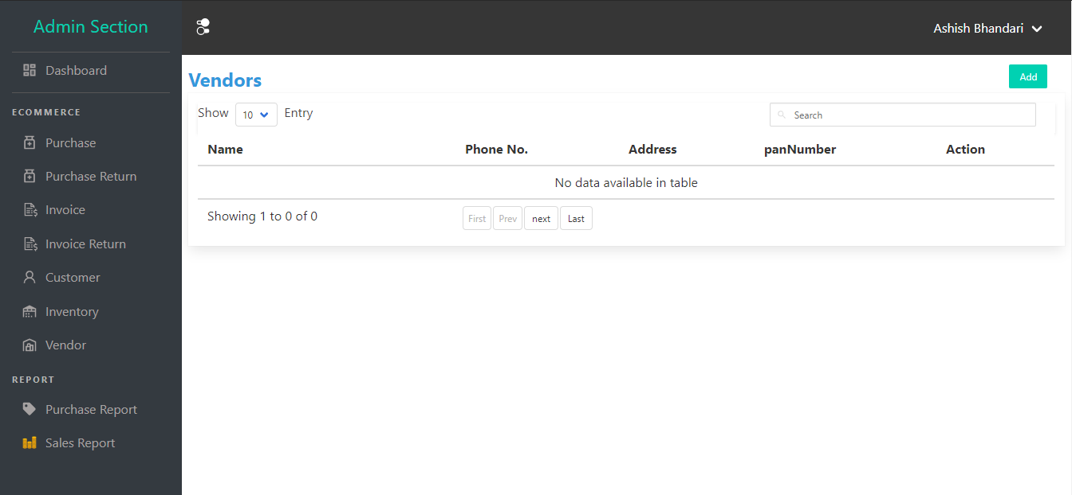

Figure 26 Vendor List Table

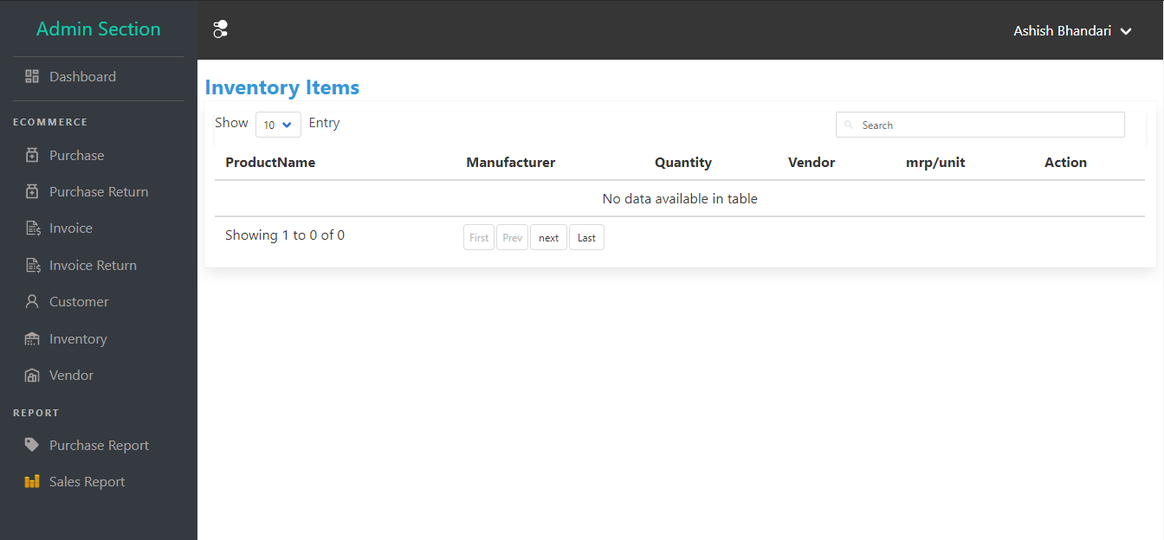

Figure 27 Inventory List Table

After Purchase record is created:

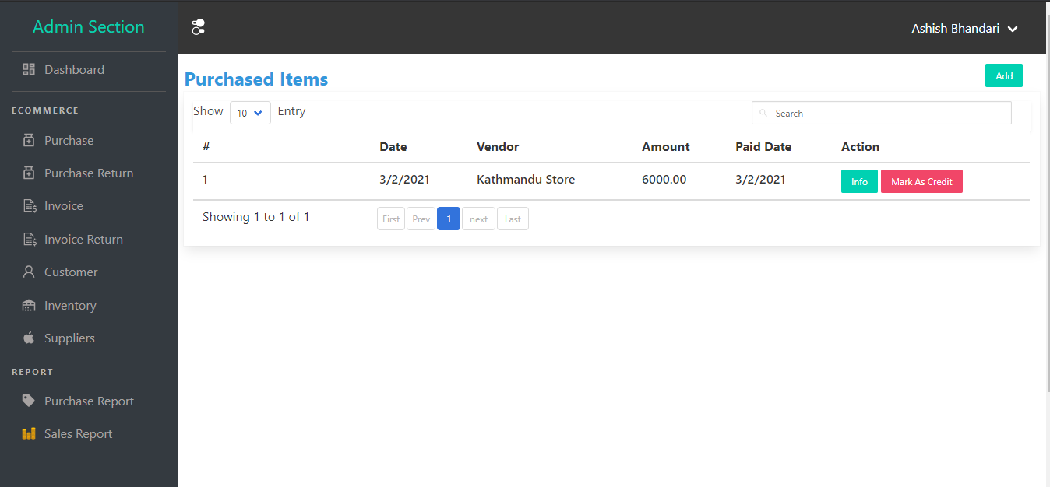

Figure 28 Purchase List Table

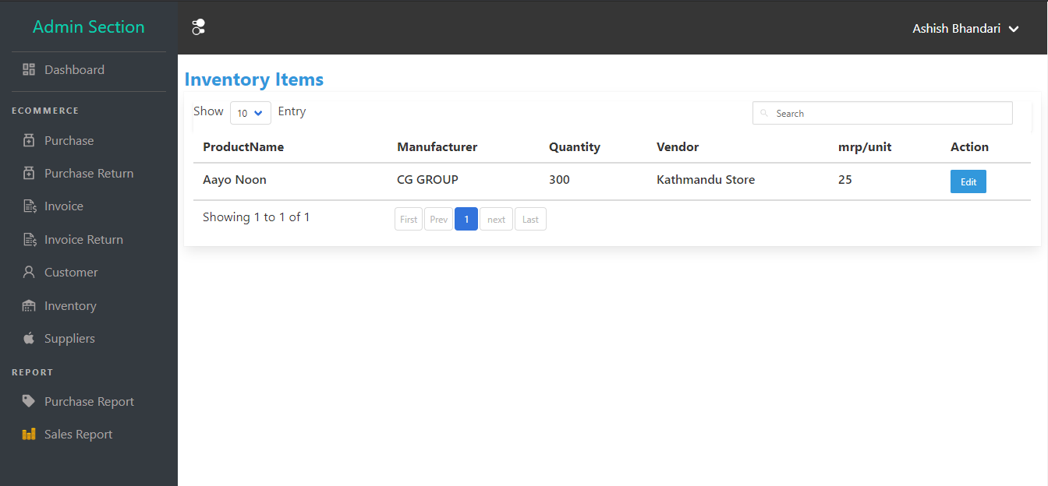

Figure 29 Inventory List Table.

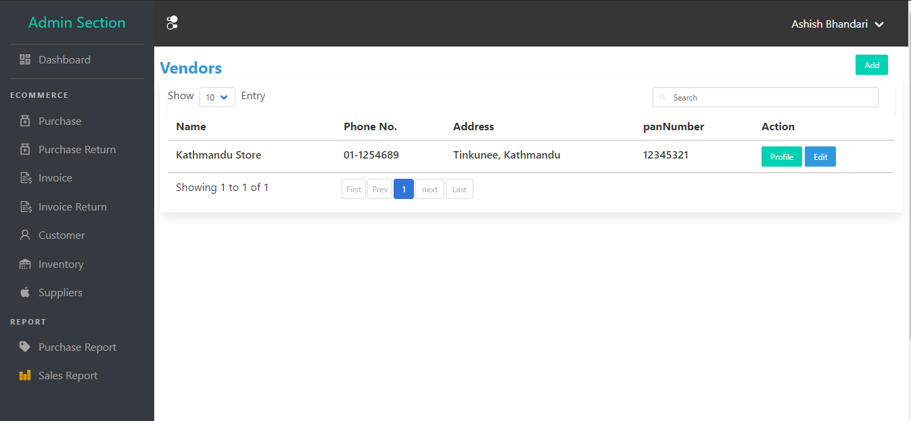

Figure 30 Vendor List table

**Test case 8: Create new sales record.**

**Test Data:** All required form data like customer details, product details, and grand total etc.

**Expected output:** When new invoice record is created, it is listed in invoice list, reduce quantity form inventory, and if new customer is recorded customer is recorded in database and listed on customer list.

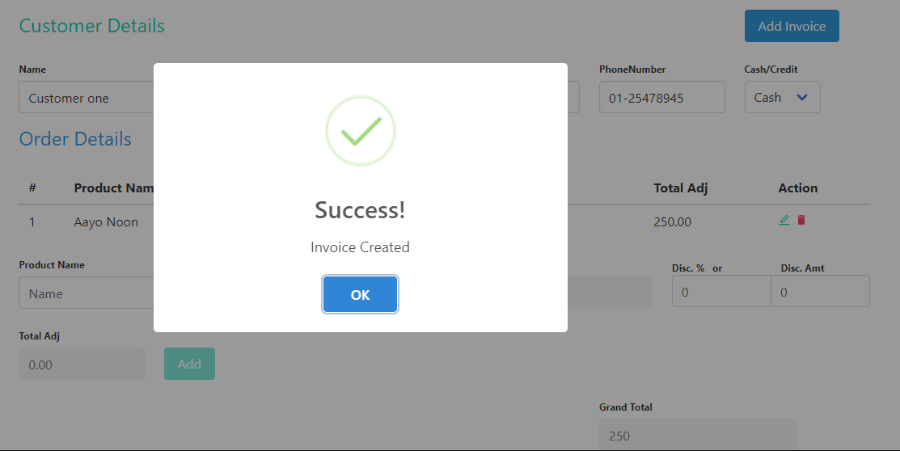

Figure 31 New Sales record

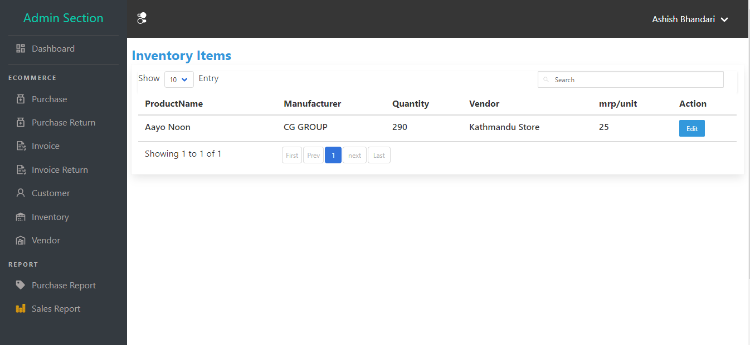

Figure 32 Updated inventory

Previously inventory quantity was 300 items and after 10 items is sold to customer inventory is updated to 290 items.

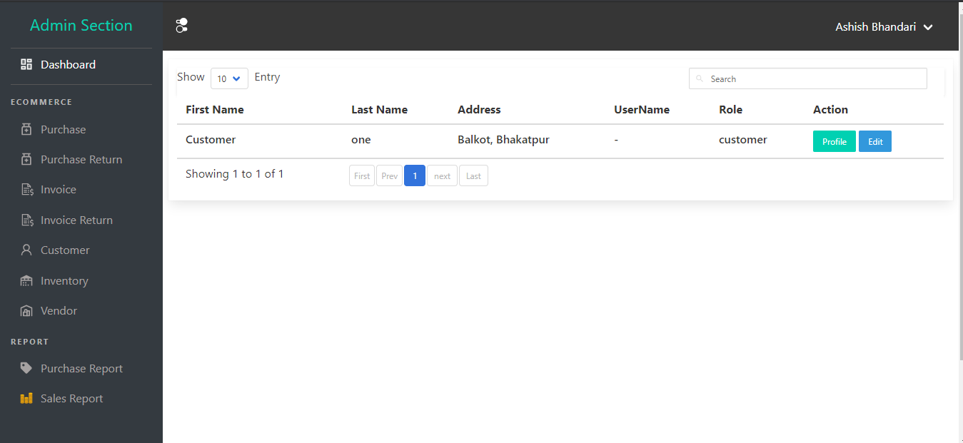

Figure 33 Customer list

Since new customer is detected by system and then it was recorded in database after sales is being complete.

### System Testing

System testing is a level of testing that validates the complete and fully integrated software product. This testing is conducted with the purpose of evaluating the system compliance with the specified requirements.

System testing is needed to be done for this project because:

* It is the first step in the software development life cycle where the application is tested a whole to find any defect presence in the system.
* The application is tested thoroughly to verify that it meets it’s functional as well as technical requirement.
* The application is tested in an environment that is very close to the production environment where application will be deployed.
* After system testing it enables us to verify that the system is working as it is intended to do so.

### Acceptance Testing

In agile development acceptance testing is very popular form of testing where testing is done to know whether or not the software system has met the requirement specifications. This testing purpose is to evaluate system’s compliance with the business requirement and verify if it has met the required criteria for delivery to end user.

In this project author conducted acceptance testing with supervisor of this project. Although the function part was met there was some issue in interface which was later updated to improve look and feel of the system with cleaner UI.

### Findings/Result

#### Output

The following are the output that we received from this project.

1. Login Screen

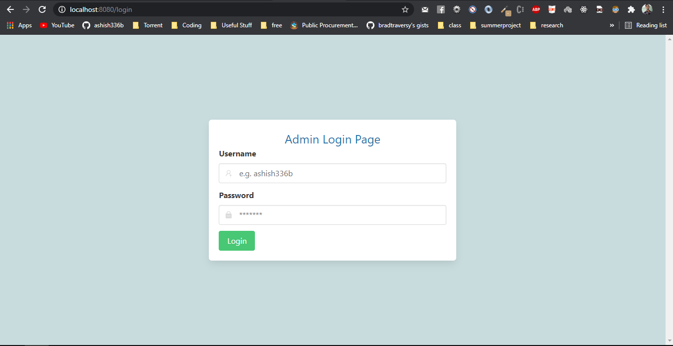

Figure 34Admin login page

This system's login page is depicted in the diagram above. This is the first screen that any system user sees after logging in. The user can login to access each functionality of this system using this login page.

1. Admin Dashboard

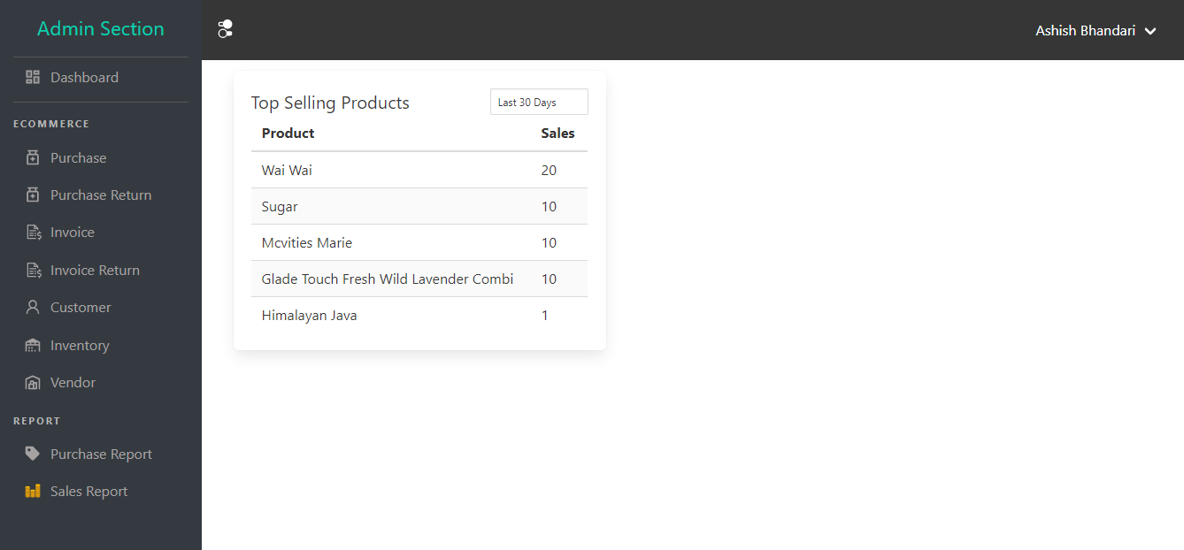

Figure 35 Admin dashboard Page

The above figure shows the admin dashboard page which is only available after login with correct credentials. From this interface admin can access all functionality of the system like creating invoice, purchase record, viewing report etc.

1. Purchase List Table

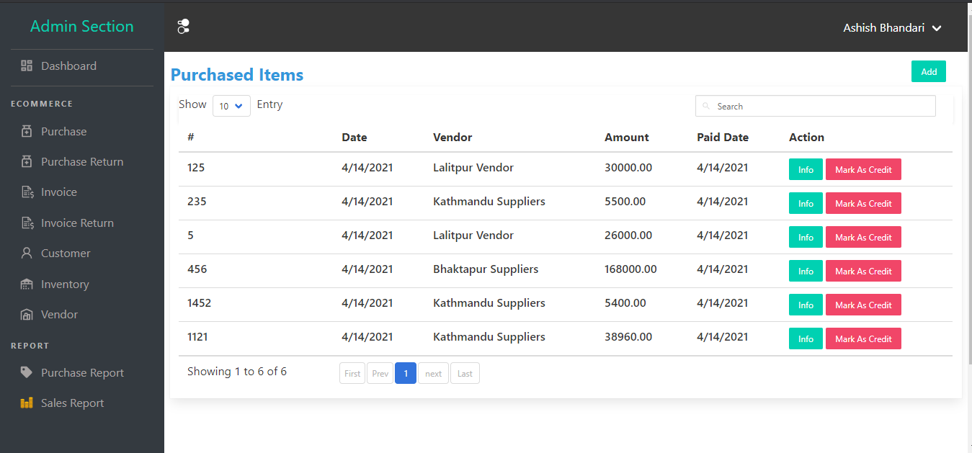

Figure 36 Purchase List Table

The figure above depicts the interface of a purchase list table, which lists all of the grocery purchases along with important information such as the date of purchase, the vendor, the purchase price, and the date the payment is received.

1. Purchase Invoice

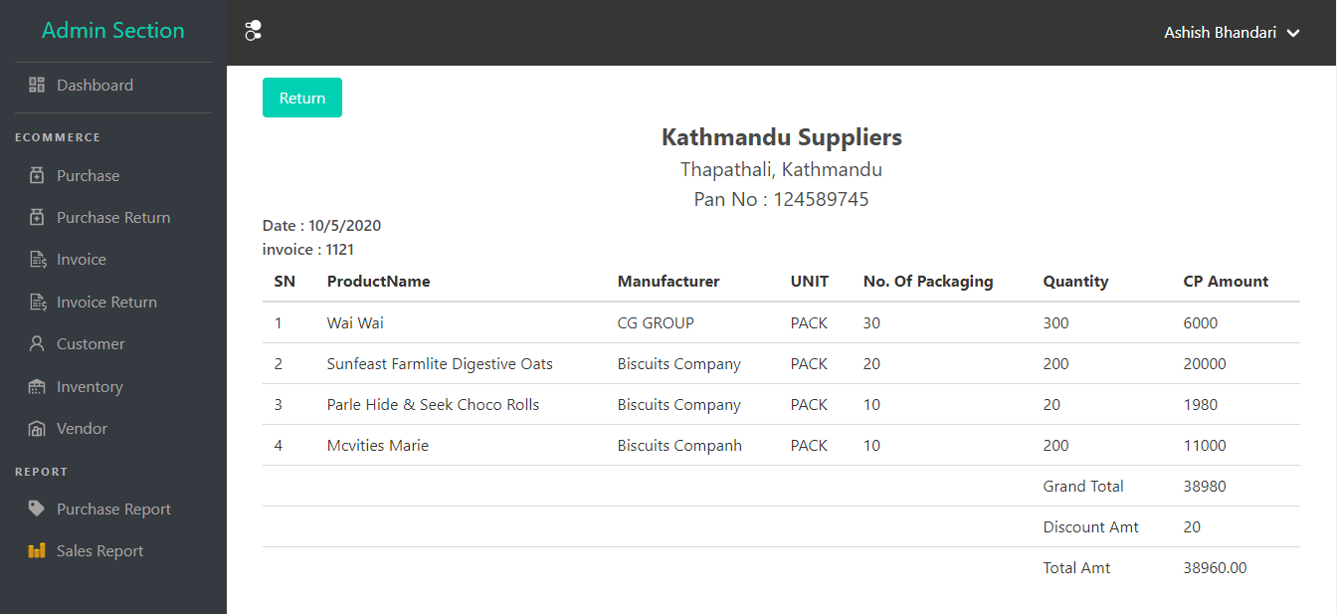

Figure 37 Purchase Invoice

The figure show the purchase invoice which contains essentials information such as list of product with their price, quantity, rate, grand total, discount rate and total amount.

1. Customer List

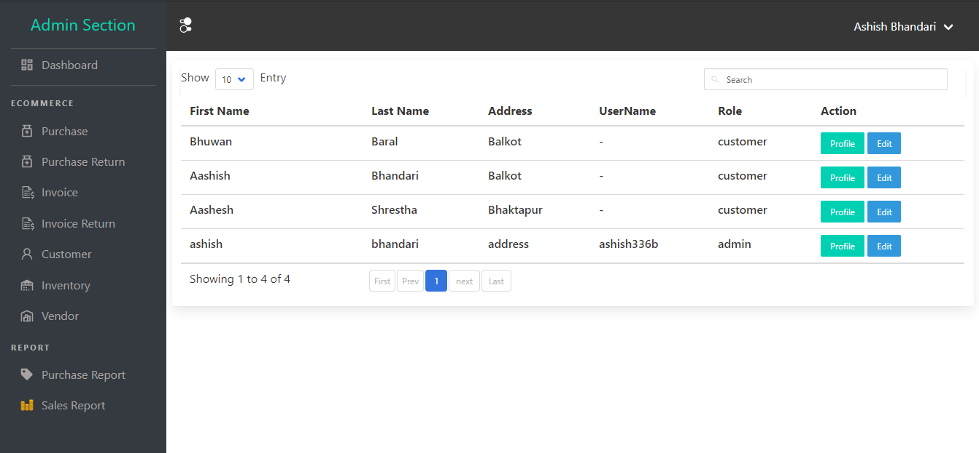

Figure 38 Customer list

The above figure show the list of customer that has been buying goods from the grocery store with essential information of customer like name, address, phone number etc.

1. Customer Profile

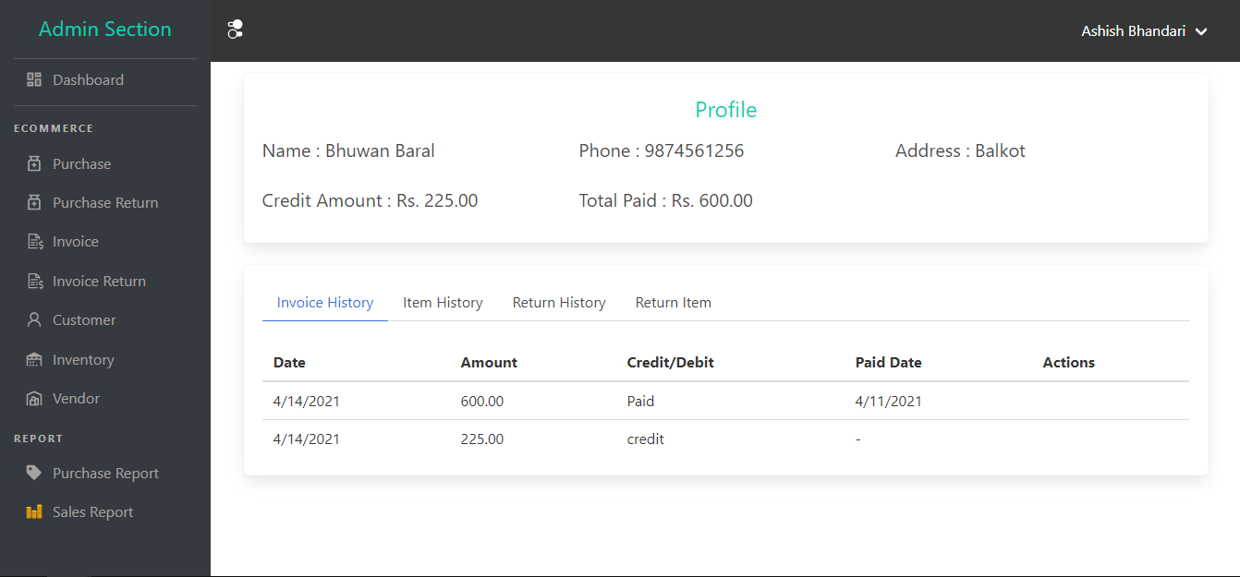

Figure 39 Customer profile page

The figure deflects the profile of customer which contains the detail information of customer such as name, phone, address, credit payable of that customer, total amount paid by this customer in the grocery store. This page also contain invoice history of that customer, item history which contains the item that customer purchased from that grocery store along with return history and return item.

1. Vendor List table

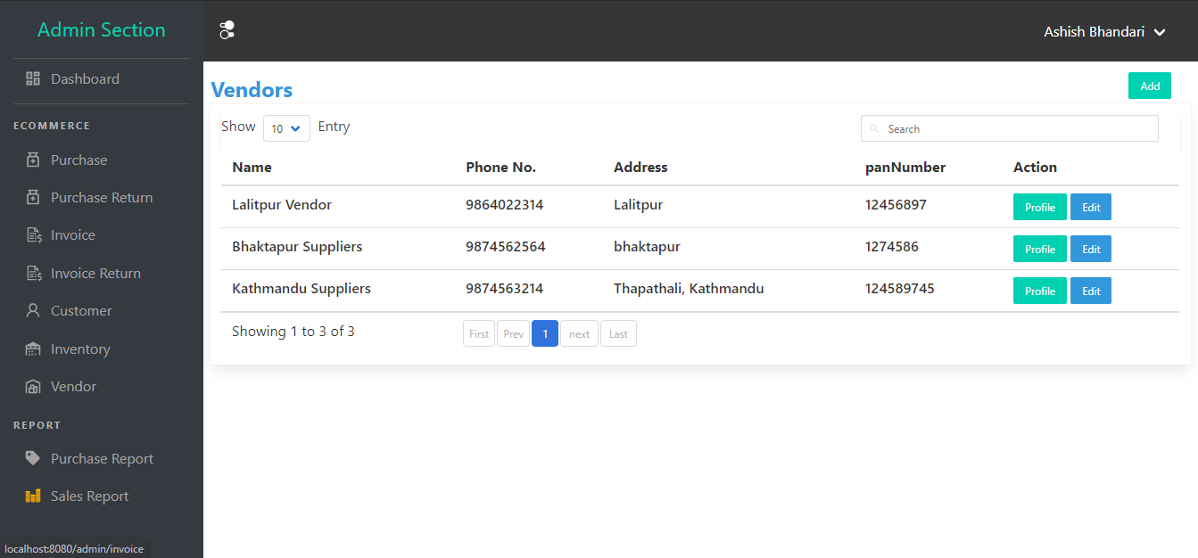

Figure 40 Vendor List Table

This interface lists the names of all vendors from which the grocery store purchases products for resale to customers. This table contains the information such as name of vendor, phone number. Address and pan number of that vendor.

1. Vendor Profile Page

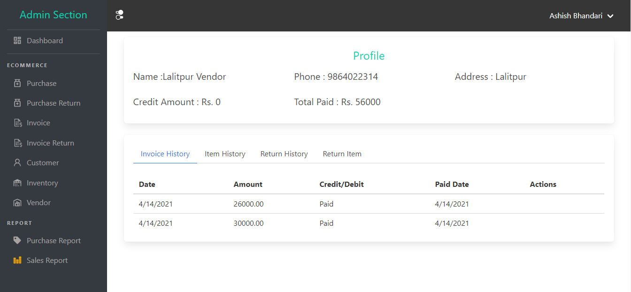

Figure 41 Vendor profile page

This page contain the information about vendor in details such as name of vendor, contact number, pan number, account payable to that vendor, purchase history, invoice history, return history.

1. Inventory list

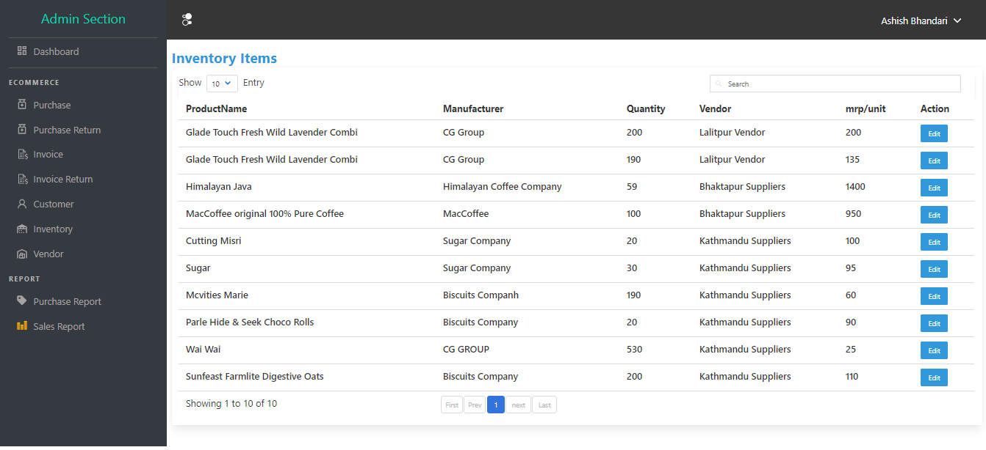

Figure 42 Inventory list

This page show the list of inventories in the grocery store which contains various information of that product such as name, available quantity in stock, product manufacturing company, market price of that product, vendor from which this product was purchased etc.

1. Add new Invoice form

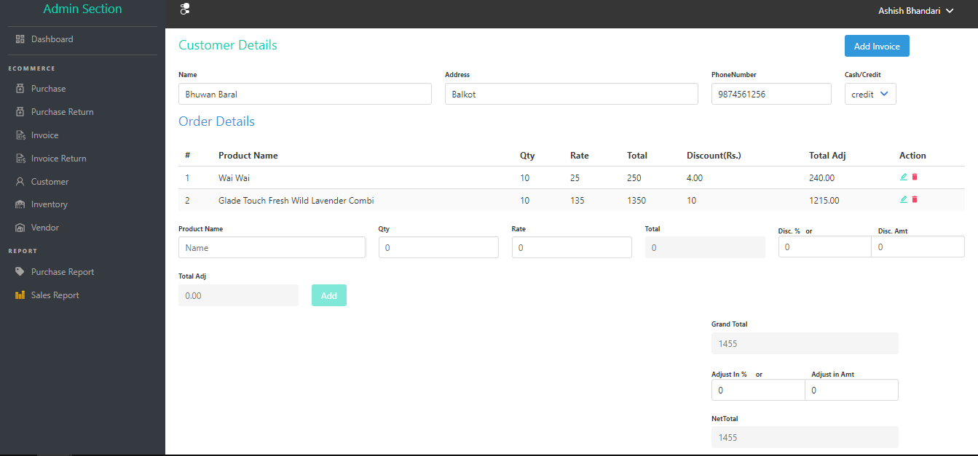

Figure 43 Add new invoice form

The above interface shows the form that is used to create new invoice in the system. This form requires the information such as customer details, order details etc. After filling all information related to the invoice system user can create new invoice.

1. Add new purchase form

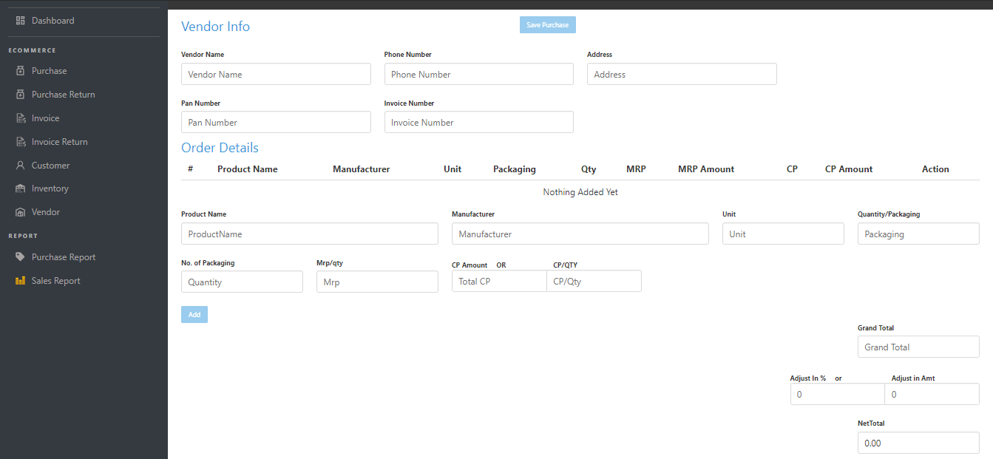

Figure 44 purchase add form

The above figure shows the form that is used to create new purchase record. The form contains the vendor information from which purchase is being made, order details in which purchased goods details are filled up. After submitting this form new purchase record is created and is reflected in purchase list table.

1. Invoice List table

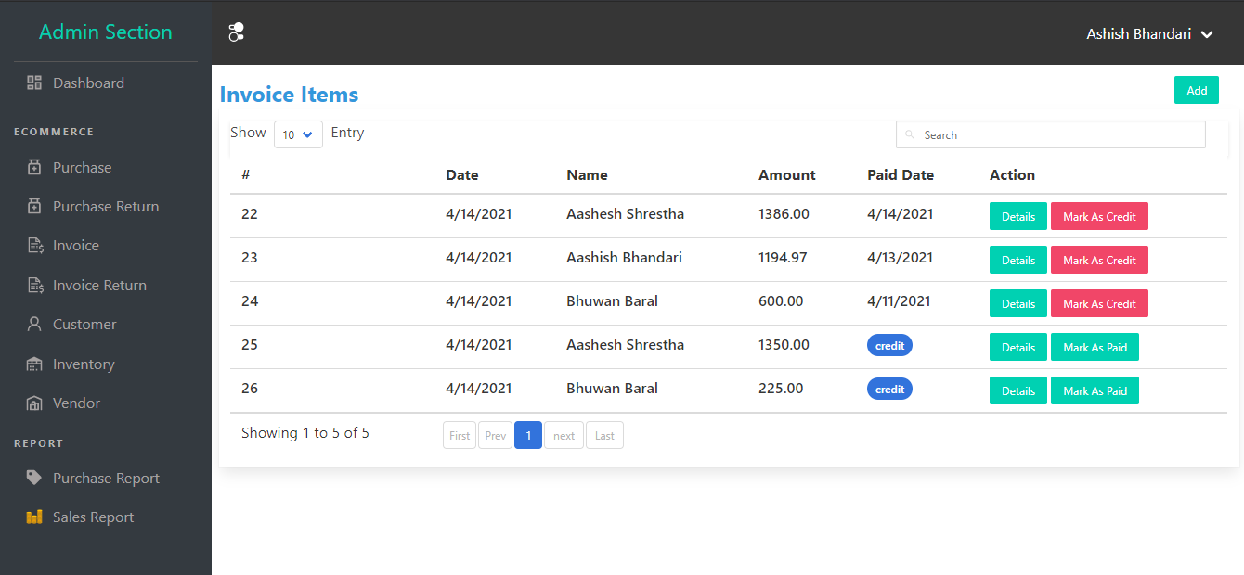

Figure 45 Invoice list table

The above figure show the list of sales invoices in the grocery store. This table contains the important information related to invoice such as date of sales, buyer name, sales amount and paid date /credit information.

1. Sales invoice

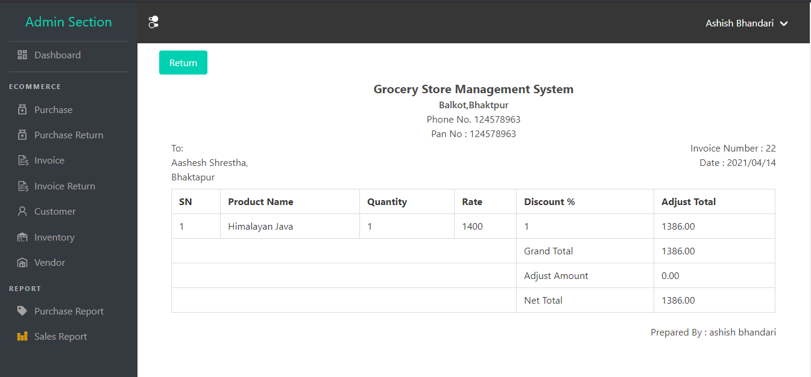

Figure 46 Sale invoice list

The above table contains the information about sales invoice which contain the product list with their quantity, rate, price, grand total, net total discount amount.

1. Sales Report

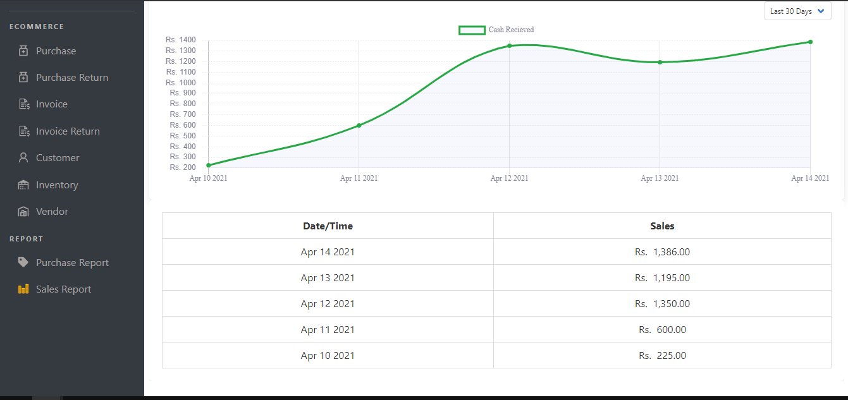

Figure 47 Sales report

The above figure shows the report of sales graphically. This report shown here is from the sales that occurred in grocery from last 30 days. Similarly the report of past week, today report is also show here.

This graph contains amount in y-axis and date in x-axis.

1. Purchase Report

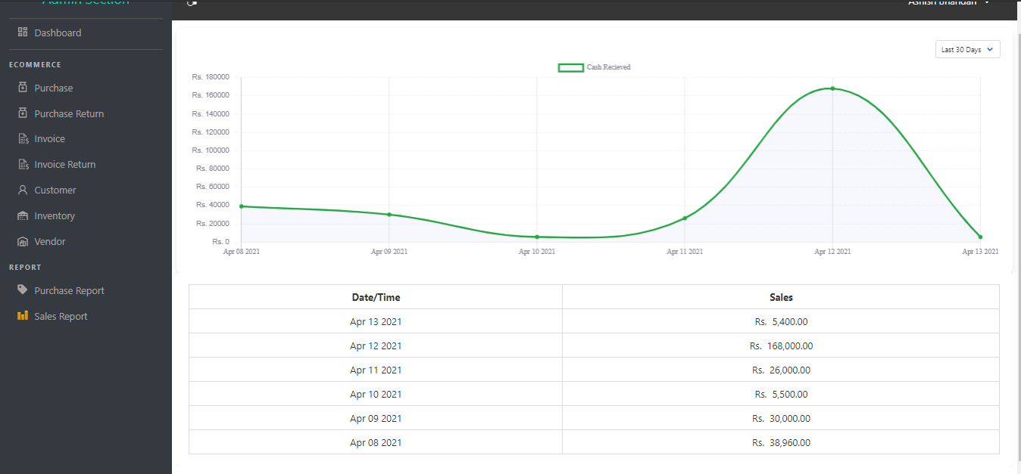

Figure 48 Purchase Report

This figure shows the report of purchase that occurs in grocery graphically. This is similar to sales record described above in figure 46 but this track the purchase of the grocery.

# CHAPTER III CONCLUSION AND DISCISSION

## Discussion

The project was able to explore any topic relating to a grocery store that did not have a proper framework. The issue was found early on in the project, and it was almost entirely resolved. The biggest issue, which was a grocery store inventory control system, was discussed and resolved. A number of other issues were also discussed. We will absolutely eradicate tradition using this method. Everything is handled by system using database which is highly secure in terms of data loss. Using a cloud-based centralized database, grocery data can be accessed from anywhere in the world.

This system is anticipated to be helpful to almost all grocery stores because grocery have same type of problem that is using manual system. Apart from these things following new things were discussed during the length of project:

* Different possible solution to solve grocery store problem in inventory management and tracking grocery transaction.
* Enhancing user interface that is straight forward and easy to use for any users.
* Problems during software development process.
* Issues and problems while writing project report.

## Critical Analysis

The project "Grocery Management System" was created to address the issue of grocery stores using manual systems such as excel to store data and registers to handle grocery transactions for all medium-sized grocery stores. The key goal of this project is to create an easy-to-use interface and module that can automate the majority of grocery store tasks. Nowadays, digitization is really necessary, and the project's main goal is to digitize Nepal's grocery service. This initiative also claims to be able to modernize grocery systems.

The “Grocery Management System” was created to address the issues that arise by using a manual system. This method aids in removing and, in some cases, reducing the difficulties associated with current record-keeping, data organization, and data maintenance practices. Through this project all these problem was studied and made research to find optimal solution making these system. Many customers choose to purchase items on credit in any grocery store if the relationship between the store owner and the buyer is trustworthy. There was an issue with the current method in maintaining certain credit records, which is also discussed in this system. This system calculates credit payable by customer just by looking through this customer’s profile which has recorded purchase history with cash and credit. This system is developed to address such common issue in every grocery store. During this project all these common problem of grocery store was studied and made a thorough research on how to solve these problem so that the system can be used in most of the grocery system with same kind of issue or problem. Various architecture designs are studied before starting this project to get optimal idea and solution of current problem.

After conducting research from different sources, the author came to the conclusion that a web-based application using client-server architecture would be the best solution for making the application available from anywhere in the world. In Nepal, the use of technology is rapidly growing, and every household has at least one technological computer that can use a web browser and connect to the internet, so a web-based program seems to be the best option.

For the purpose of the project the author went to visit nearby grocery store to collect information and also uses various online help to identify problem. The author founded that there was this type or slight variances in this type of system around the world. This idea had been successfully implemented in India, Bangladesh, and Sri Lanka through a company call IMS Group.

Since websites can run almost anywhere and the use of online applications is widespread these days, the "Grocery Management System" was based on a web application framework. Instead of using the Android application platform to create this system, the author wanted to cover all devices, so he made the web application responsive so that laptop users could access it. Users with laptops and mobile users have identical experience as webpage is responsive. Another reason for not choosing android is that there is significant number of people using IOS which won’t get covered. Thus going with web application seems logical.

It is very difficult, to create a robust website without the use of a web framework. Having a web framework would help us structure and maintain our code. Most web systems are built on the DRY (don't repeat yourself) concept, making them simple to use and avoiding unnecessary complications.

The author of this project decides to use express framework for backend and Nuxt.js for frontend purpose so that it is very easy to get started with good code base architecture so that code is highly managed and understandable. Since express handle route dispatching and other various https request under the hood so that the author of the project has only to focus on designing system architecture and solving problem to finish this project with lesser code.

MongoDB was used as database of the web application to develop this system. MongoDB works great as the database engine for most low to high traffic website which cover almost all type of system. This database does not use standard schema like in MySQL database so that it is very easy to use for the project with have the capabilities to receive any type of data in the server. Instead of storing data in tables of rows and columns like in SQL databases each row in a MongoDB database is a document described in JSON, a formatting language. This type of database is extremely flexible, allowing variations in the structure of documents and allowing storage of documents that are partially complete. So using this database for this system seems to be relevant to the author as there is no problem of defining relations as one document can be embedded in it.

For frontend Nuxt.js frontend framework was used which is based on Vue.js which is very popular framework nowadays for frontend. Using this framework helps to get all help from big communities which are using same framework for building enterprises application if any problem arises. With great UI performance and flexibility it is very easy to develop system so author of this project decides to use Nuxt.js framework.

The author of the project decides to separate business and presentation part of the system which is a best practice nowadays because with one business logic we can develop various presentation logic with own preferred look and feel with the help of API from business logic. Presentation logic can be implemented in mobile, desktop, IOS and other platform with the help same business logic. Linux was used as server for handling requests provided Ubuntu distro Linux is free and by far most popular distro to use for hosting so it was a no brainer while choosing the server platform.

Axios.js is used to send request to server which with return JSON data as response and helps to handle web request efficiently. This helps to request data from server without refreshing page so author of the project decides to use this tool. From a developer's standpoint, the author attempted to create a platform with a basic user interface and kept it simple. The author has attempted to code a secure backend in order to avoid security risks, as well as potential mistakes and bugs that lead to security risk.

The project's key flaw is that it was unable to implement machine learning for the inventory management module due to a lack of adequate data to train the algorithm, resulting in lower performance and making the system unreliable to use.

Putting these drawbacks aside, the project has been a huge success overall. The author believes that this initiative is already in its beginning, and that as more knowledge becomes available and as technology advances, there will be enough opportunities for the project to expand and hit new heights.

## Recommendations and Future Enhancements

The system is finished, but it will become outdated in the future. System evolution is an important aspect of system development, especially for this sort of software system. Because of the failure to produce these modules due to time limitations, the following proposals and possible enhancements have been made. They are often focused on anticipated consumer expectations and desires in the immediate future.

These are:

* Inventory management system with artificial intelligence for further enhancements.
* Since this system is not in production, it is advised that if it is, proper data back and a good server for data storage should be used.

## Conclusion

The grocery store has been one of the most important industries in the century. Grocery shops are a true symbol of a developed country. We can't keep anything we need or may need in the future, but we have a grocery store nearby where we can get the things we need on a daily basis. Since technology advances at an accelerated rate, grocery stores must keep up with the changes in order to maximize their market performance. Nowadays grocery store are still managing their store in traditional ways by using register, excel sheet for data storage. Managing inventory is very big issue in grocery store when grocery business started to grow. To address this issue in grocery store due to traditional system, new system is being developed that solves most of the problem.

This system solves the problem of inventory management, keeping track of sales, purchase, customer, vendor which is the major part of grocery system. System is developed by using agile methodology which is incremental development in which the increment is small and new release of system are created and made available to customer every two or three weeks. Various UML diagram are made to design system which make easier to develop components and module. This system web based which uses MVC pattern in server side of the system. The database logic is contained in the model, the business logic is contained in the controller, and the presentation logic is contained in the view, all of which are incorporated in this project. Unit testing, acceptance testing, component testing, and other types of testing are used to see whether the system has any flaws.

When working on this project, the author was able to get a better understanding of real-world problem-solving methods and adapt them to solve problems and create a scalable system that can be used in real life.