Intranet - MLM

Functional General Design - rev A

Table of Contents

1 - Document management 4

1.1 - Name, Version and Author 4

1.2 - Approval List 4

1.3 - List of Changes 4

1.4 - Distribution list 4

2 - INTRODUCTION 5

2.1 - Purpose 5

2.2 - Scope 5

2.3 - Product Release Acceptance Criteria 5

3 - General Description 5

3.1 - Product Perspective*.* 5

3.2 - Product Functions 5

3.3 - User Characteristics 5

3.4 - General Constraints 5

3.5 - Assumptions and Dependencies 5

4 - Specific Requirements 5

4.1 - External Interface Requirements 6

4.1.1 - User Interfaces 6

4.1.2 - Hardware Interfaces 6

4.1.3 - Software Interfaces 6

4.1.4 - Communications Interfaces 6

4.2 - Functional Requirement 6

4.2.1 - Franchisee Name Addition 6

4.2.2 - Virtual Sponsor Update 6

4.2.3 - Lapsed/Pending Incentive – Separated from Pending Incentive 7

4.2.4 - Lapsed/Expired Incentive – IR Gateway 8

4.2.5 - Incentive Handling – Same PAN 8

4.2.6 - MB & MOB Report – Incentive Point Consideration 10

4.2.7 - Incentive Release/Dispatch New Process 10

4.2.8 - MOB & MOB Qualification Report 11

4.2.9 - IR Gateway - Provisional incentive – Visibility 11

4.3 - Non-Functional Requirements 11

4.3.1 - Performance 12

4.3.2 - Reliability 12

4.3.3 - Availability 12

4.3.4 - Security 12

4.3.5 - Maintainability 12

4.3.6 - Portability 12

4.4 - Design Constraints 12

4.5 - Logical Database Requirements 12

5 - Analysis Models 12

5.1 - Sequence Diagrams 12

5.2 - Data Flow Diagrams (DFD) 12

5.3 - State-Transition Diagrams (STD) 12

6 - Change Management Process 12

7 - APPENDIX 12

# Document management

## Name, Version and Author

|  |  |  |  |
| --- | --- | --- | --- |
| **Document Id** | 1.0 | | |
| **Document Name** | Functional General Design | | |
| **Document Version** | Initial version | | |
| **Author** | Jitendra Singh Malik | **Function** | Business Analyst |
| **Issue date** |  | | |

## Approval List

|  |  |  |  |
| --- | --- | --- | --- |
| **Approved By** | **Function** | **Approval Date** | **Comment** |
|  |  |  |  |
|  |  |  |  |
|  |  |  |  |
|  |  |  |  |
|  |  |  |  |

## List of Changes

|  |  |  |  |  |
| --- | --- | --- | --- | --- |
| **Document Version** | **Paragraph Modified** | **Description** | **CR’s Associated** | **Software release** |
|  |  |  |  |  |

## Distribution list

|  |  |  |
| --- | --- | --- |
| **Name** | **Function** | **Organization** |
|  |  |  |
|  |  |  |
|  |  |  |

# INTRODUCTION

## Purpose

This document is a guide to writing a Functional Requirements Document. It helps to specify the functional, operational, interface, design, development and qualification requirements for a software product without a priori on the final implemented solution.

In the actual document, the project purpose(s) is/are defined and documented in this section.

## Scope

This guide is applicable to all software developments implemented in Glaze IT. *Software development* includes new project, modification, re-engineering and maintenance.

## Product Release Acceptance Criteria

< Describe as much precise as possible the criteria, rules, condition to be verified in order to consider the product release accepted. Key point to remove any risk of misunderstanding.

Could be based on:

* specific defined conditions, or
* a general criteria evaluating Product and/or SDLC metrics, as example about testing efficiency, coverage, etc. or
* Acceptance criteria results…

# General Description

## Product Perspective*.*

## Product Functions

## User Characteristics

## General Constraints

## Assumptions and Dependencies

# Specific Requirements

This will be the largest and most important section of the FGD. The customer requirements will be embodied within Section 2, but this section will give the D-requirements that are used to guide the project’s software design, implementation, and testing.

Each requirement in this section should be:

* Correct
* Traceable (both forward and backward to prior/future artifacts)
* Unambiguous
* Verifiable (i.e., testable)
* Prioritized (with respect to importance and/or stability)
* Complete
* Consistent
* Uniquely identifiable (usually via numbering like 3.4.5.6)

Attention should be paid to the carefully organize the requirements presented in this section so that they may easily accessed and understood. Furthermore, this FGD is not the software design document, therefore one should avoid the tendency to over-constrain (and therefore design) the software project within this FGD.

## External Interface Requirements

### User Interfaces

### Hardware Interfaces

### Software Interfaces

### Communications Interfaces

## Functional Requirement

### Franchisee Name Addition

The **franchisee name** along with the **franchisee code** needs to be shown in the following menu:

1. Hold Incentive
2. Unhold Incentive
3. Future HOLD
4. Future Hold Report

### Virtual Sponsor Update

In case manual promotion is for the following ranks

1. DD
2. GDD

The Virtual sponsor need to instantly updated

#### Concept

1. When the id is inserted, and the promotion the ID/nid of direct DD will show in the box below,

in case, there is not direct DD, the ID/nID will come of direct GDD

*Path from where data need to come 🡪* MLMnew.dbo.MemberRank

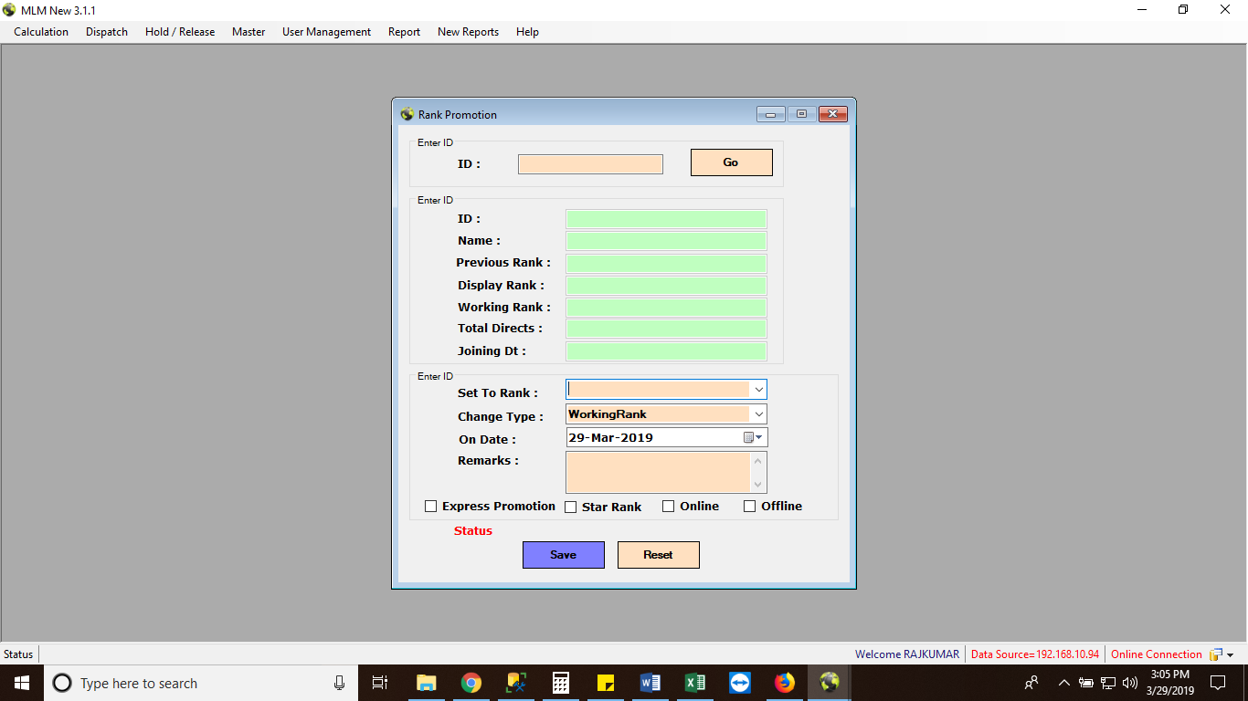

New columns need to come which will show the ID(Rank) of direct DD/GDD

Direct GDD in case there is not direct DD

1. In case the entered ID is selected for the DD/GDD promotion, the data (described below) is going to be inserted into the newMLM.dbo.tbl_Memberrank

Data to be inserted/modified in the newMLM.dbo.tbl_Memberrank at below column:

* 1. Direct DD/GDD ID 🡪 VirtualSpID

1. Before next day, the data of newMLM.dbo.tbl_Memberrankwill be copied in the live_calc_new.dbo.tblMemberrank and the table will be updated

### Lapsed/Pending Incentive – Separated from Pending Incentive

#### Introduction

Currently the Lapsed/Expired incentive is treated as Pending Incentive.

**This needs to be bifurcated into Lapsed/Pending** in the CRM🡪 IR Statement

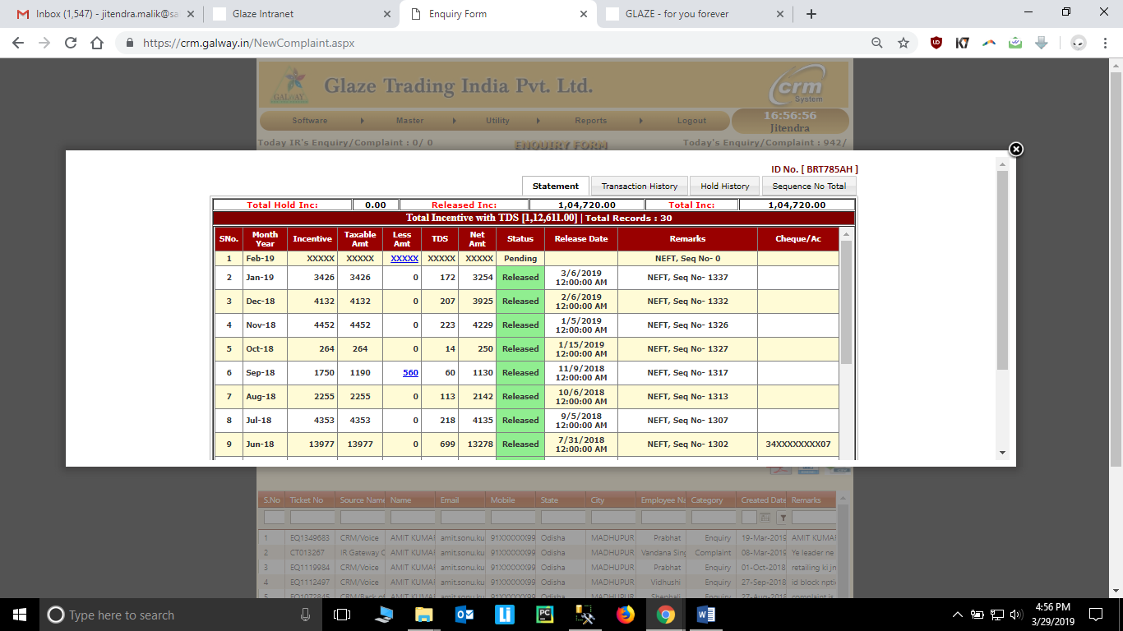

Status to be bifurcated in to Lapsed/Pending

### Lapsed/Expired Incentive – IR Gateway

#### Introduction

New Lapsed Incentive in IR Gateway🡪Account🡪Account Statement

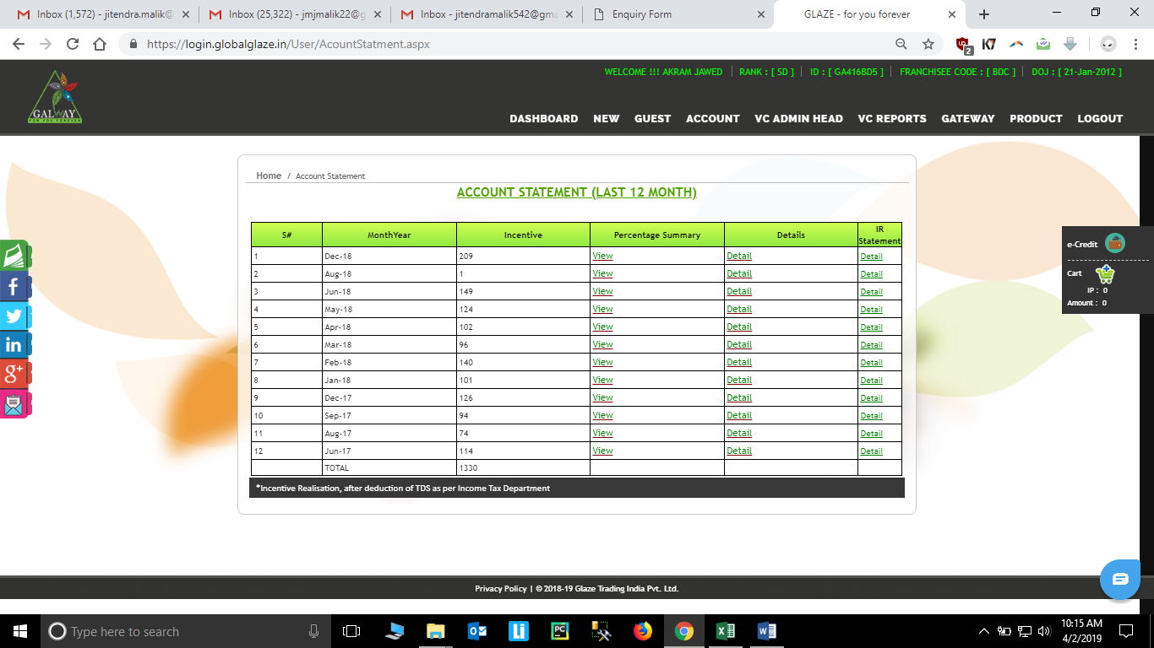

New column to be added which will show the status of lapsed – if any

### Incentive Handling – Same PAN

#### Introduction

The incentive handling now to be clubbed for different ID’s which are using same PAN

E.g. If a distributor operated four ID’s let with following incentive:

|  |  |  |
| --- | --- | --- |
| ID | Incentive | Main ID |
| A | 100 | 1 |
| B | 30 | 0 |
| C | 40 | 0 |
| D | 60 | 0 |

Then before the RPT Summary stage, the incentive of the B, C and D will be clubbed in the incentive of A, and the new incentive will become as below

|  |  |  |
| --- | --- | --- |
| ID | Incentive | Main ID |
| A | 100 +30 +40 +60 | 1 |
| B | - | 0 |
| C | - | 0 |
| D | - | 0 |

#### Diagram Representation

1. Old Criteria

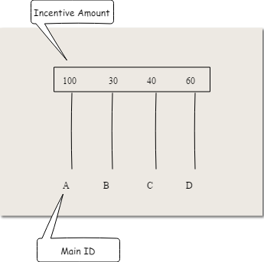

1. New Criteria

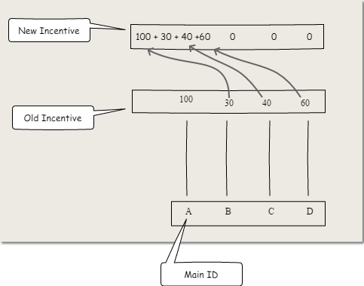

#### Acceptance Criteria

1. The status in ID’s other than main ID will reflect the status – “Incentive transferred to Main ID”
2. In case any of the incentive of the ID is at hold status of A, B, C or D, the total incentive will come as status HOLD.
3. A single invoice will be formed for the clubbed incentive amount.

### MB & MOB Report – Incentive Point Consideration

#### Introduction

The MB and MOB needs to reflect in the terms of Incentive Point, which means the it will come as the divided by the 100. (for all incentives i.e. Car bonus, Travel bonus)

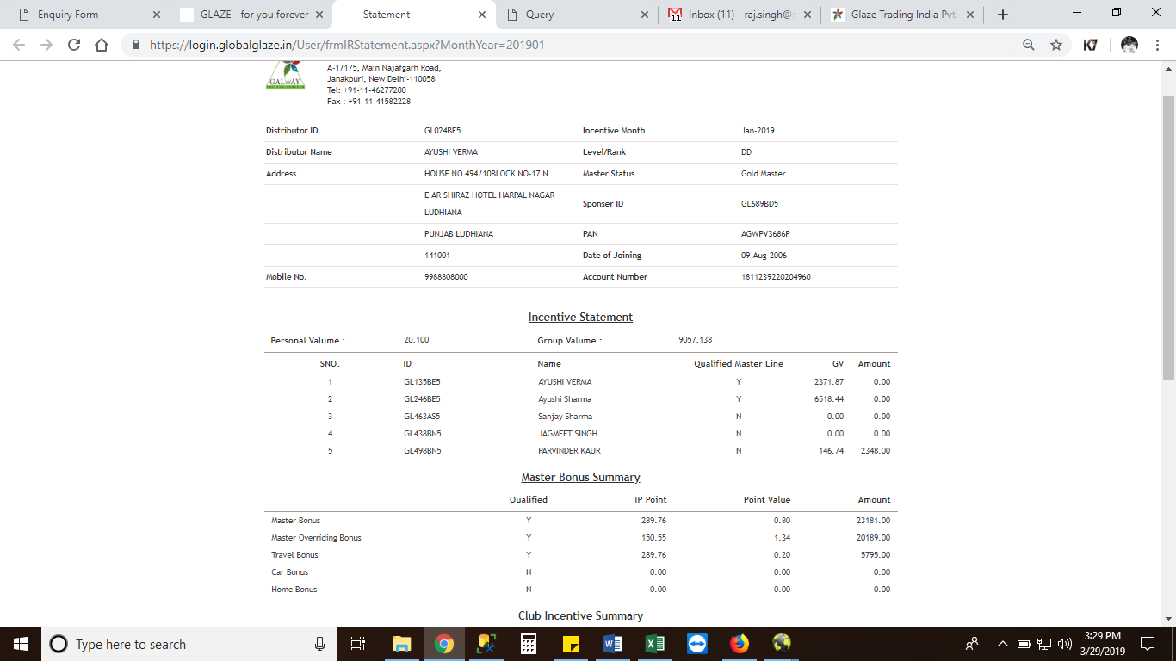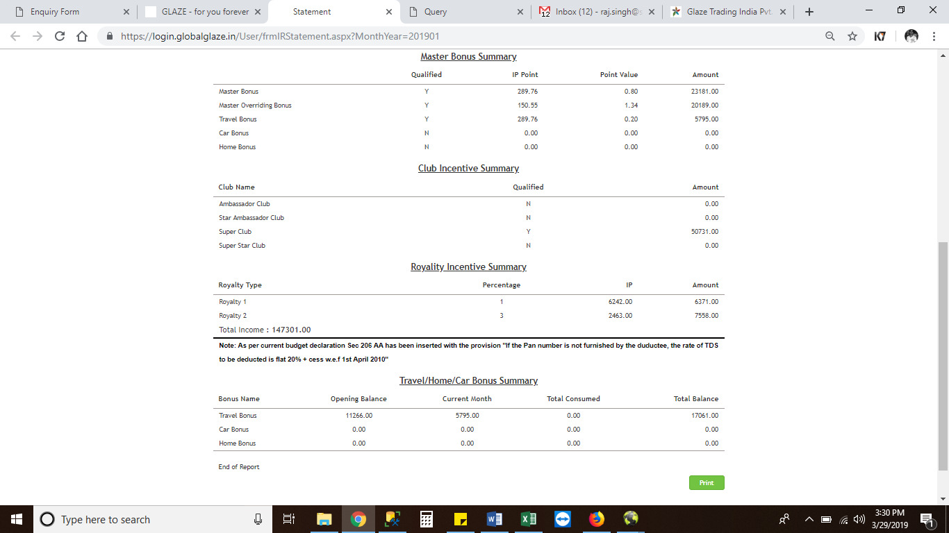

### Incentive Release/Dispatch New Process

#### Introduction

The crosscheck process of the dispatch needs to be modified. According to the new process, the following needs to be checked.

Data to be matched between table MLMNew.dbo.dispatchlist and MLMNew.dbo.statement

1. ID
2. Name – (Spaces need not to be calculated)
3. Network Incentive – This needs to be matched
4. Network Incentive Modification

MOB & MB Incentive need to be rounded off. E.g. If MB & MOB Bonus comes up to be 77.83, it be counted as 77

1. Bank Account Number

#### Concept

1. Currently the all incentive is crosschecked from the MLMNew.dbo.dispatchlist with sum of all network incentive table MLMNew.dbo.statement
2. Now the sum of network incentive will be matched with the only the network incentive in dispatch and not the club of all incentive.

### MOB & MOB Qualification Report

#### Introduction

The new status box needs to be given in MB & MOB Qualification Report.

Path – IR Gateway 🡪 Gateway 🡪 Master Qualification Report

The status will be

1. Provisional – this status will come only for current month
2. Actual – this will come for early months.

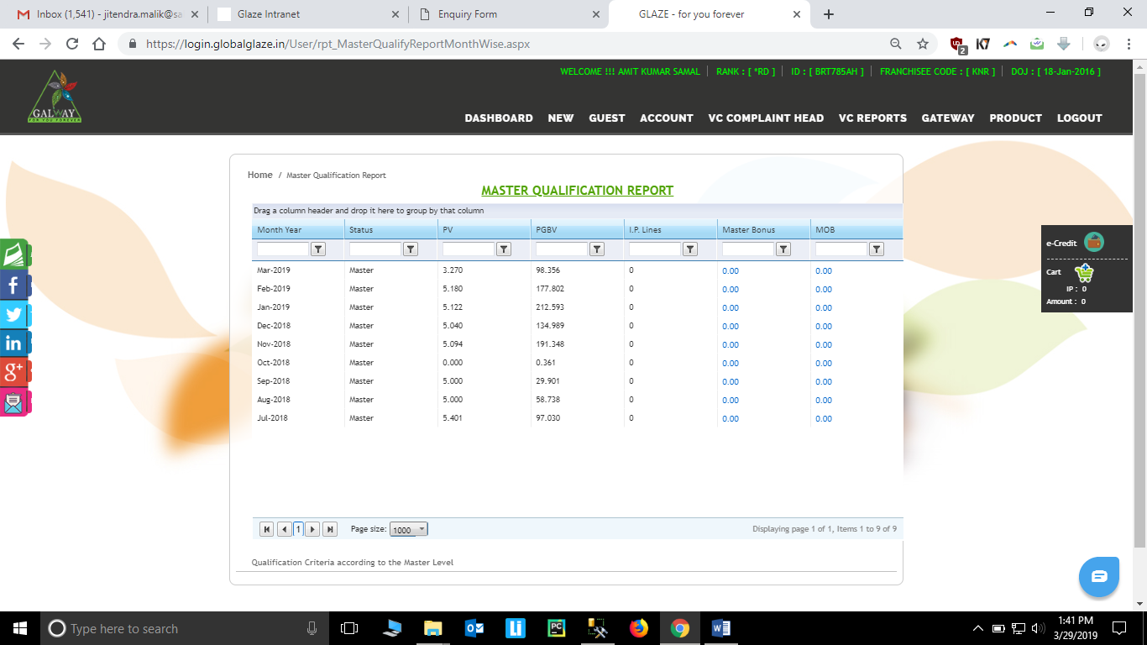

New Status column needs to be added

### IR Gateway - Provisional incentive – Visibility

The provisional incentive needs to be shown on the main page of IR gateway which is shown as static value of 0.

Provisional Incentive = Performance Bonus + Royalty

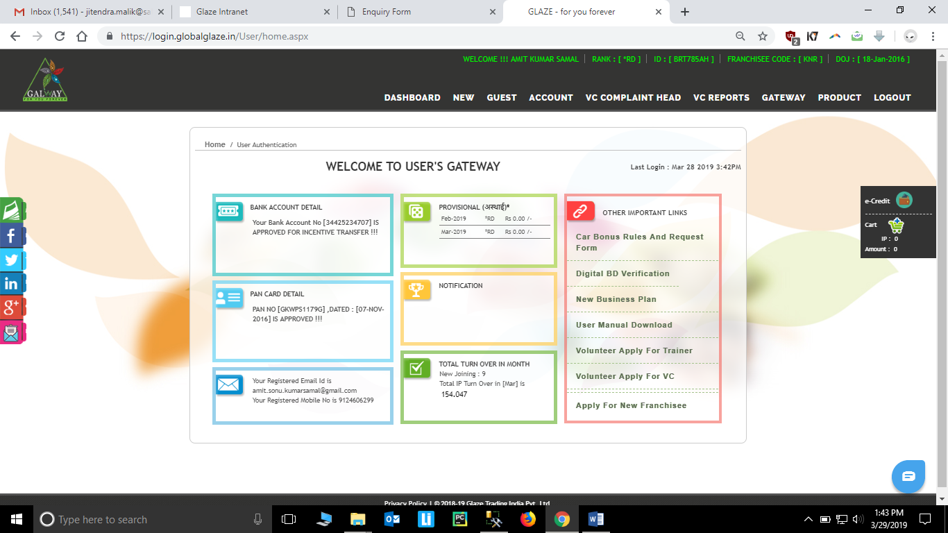

### Direct Downline Turnover Report – IR Gateway

#### Introduction

In IR gateway, in IR Gateway🡪Gateway🡪Direct Downline Turnover. There should be an extra column which needs to be added “Actual Qualified Master ID with IP”.

If the value obtained in Qualified Master Line is “Yes”, the column will show Qualified Master ID with IP

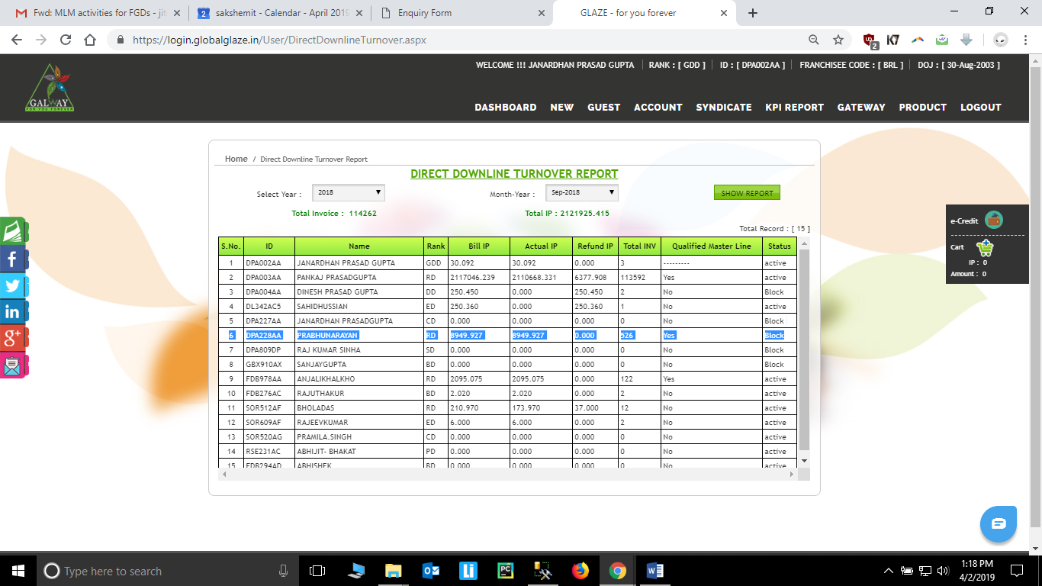

Column with Qualified Master ID with IP

### Logic for buyback demotion - MLM

#### Introduction

In Buyback Demotion in MLM. The output obtained from this case will only show the list of IR with Rank ≥ RD.

## Non-Functional Requirements

Non-functional requirements may exist for the following attributes. Often these requirements must be achieved at a system-wide level rather than at a unit level. State the requirements in the following sections in measurable terms (e.g., 95% of transaction shall be processed in less than a second, system downtime may not exceed 1 minute per day, > 30 day MTBF value, etc.).

### Performance

### Reliability

### Availability

### Security

### Maintainability

### Portability

## Design Constraints

Specify design constrains imposed by other standards, company policies, hardware limitation, etc. that will impact this software project.

## Logical Database Requirements

Will a database be used? If so, what logical requirements exist for data formats, storage capabilities, data retention, data integrity, etc.

# Analysis Models

List all analysis models used in developing specific requirements previously given in this FGD. Each model should include an introduction and a narrative description. Furthermore, each model should be traceable the FGD’s requirements.

## Sequence Diagrams

## Data Flow Diagrams (DFD)

## State-Transition Diagrams (STD)

# Change Management Process

CH000345

CH000478

CH000519

# APPENDIX