**Book Recommendation Chatbot: Leveraging NLP and Machine Learning for Personalized Literary Exploration**

Ashish Bansal

*School of CSE, Lovely*

*Phagwara,Punjab, India*

*ashishbansal6961@gmail.com*

Tanishq Khandelwal

*School of CSE, Lovely*

*Phagwara,Punjab, India*

*tannu.btp.tk@gmail.com*

Ashish Yadav

*School of CSE, Lovely*

*Phagwara,Punjab, India*

*Ashishyadav4485@gmail.com*

Sneha Meena

*School of CSE, Lovely*

*Phagwara,Punjab, India*

*Sneha2002meena@gmail.com*

Shivangini Gupta

*Upgrad Campus, Upgrad Education Linited, Bangalore, India*

*v_shivangini.gupta@gmail.com*

**Abstract—**

This mission comes with a robust e-book recommendation chatbot designed to embellish a stoner’s interest in browsing books. Using the best of natural language processing (NLP) techniques and program literacy libraries including Keras and NLTK, chatbots offer incredible commerce and pharmaceuticals. Made UI of this project using streamlit. Based on live data from Goodreads.Com, an obedience platform for book signs, the chatbot provides dynamic and personalized indicators to suit stoner's choices Druggies enter their favourite bands or authors, and the chatbot uses NLP algorithms to test and determine entry the bottom of the table. Based on this research, the chatbot provides tailored recommendations, directing doctors to publications that match their research and interests. Seamlessly integrating NLP, programming skills, and Internet development, this program presents a new approach to book recommendation programs. It no longer allows to discover the easiest new book but adds to stoner engagement and satisfaction through its interactive and responsive interface. Geographical information. Keywords Bespeak Suggestion, Chatbot, NLP, Narrator, Kidney.

1. **Introduction**

In a technology marked by the vast expansion of digital content, relevant and engaging books have become both a tool and a task for every interested reader to discover. Traditional e book recommendation systems rely on consistent algorithms or customer critiques, which will not

always lose sight of the nuances of individual user choices[7]. To meet this challenge and provide a more personalized and palatable experience, we gifted only one option: an advanced book recommendation chatbot powered by Natural Language Processing (NLP) techniques and machine learning algorithms so it works[5].

The aim of this research project is to provide support for using NLP and gadget mastering capabilities to create a bridge between clients and the larger world of literature. The chatbot acts as a social mediator, using live records from Goodreads.Com, a prominent on-line platform for e-book recommendations[8]. Combining modern technology with an intuitive web development system, the chatbot provides consistent and convenient customer interaction for customers to search and discover books according to their interests[13]. Through sophisticated language analysis, the chatbot identifies key topics, genres, and authors mentioned by the customer, so it can make personalized e-book recommendations in real-time Tapping into the rich store of information to be on Goodreads.Com, the chatbot guarantees indicators are not the simplest relevant yet dynamically Even updated to reflect the latest book trends and releases. This research project represents the integration of the interdisciplinary field[6].

**II. Related Work.**

**A. Book Recommendation System**

The book recommendation system has evolved over the years, adding options to help users identify appropriate reading. Traditional approaches including collaborative filtering and content-based filtering have long been foundational in this field. Collaborative communication uses user-object interactions to generate recommendations, while content-based analytics focuses on the actual properties of objects to fit individual choices, including the path they take does extraction and manufacturer of Hybrid methods combine these methods to take advantage of their efficiency[6]. Modern techniques, with matrix factorization and in-depth fashion expertise, produce more advanced talent[5]. Matrix factorization methods decompose the consumer-good interaction matrix to capture hidden features, as well as to gain deeper knowledge of fashion, including neural associative filtering, learning nonlinear representations for individual cues Context aware recommendation structures in addition to time, area, and person demographics Exceptional counseling is enhanced by using additional contextual considerations[7]. By understanding the state of existing e book recommendation systems, we can inform the development of effective new personalized recommendation solutions.

**B. Chatbot**

Chatbots are like the ones helpful virtual assistants you might come across on-line or for your smartphone. They are designed to have interaction in communique with you want a actual man or woman, solution questions, provide data, and every so often even entertain you[9]. You can locate them anywhere from helping you with customer service problems to assisting you when shopping on line or handling your fitness care wishes. These chatbots are very clever, way to something called herbal language processing (NLP). They can recognize what you’re pronouncing, such as the context, purpose, and feelings at the back of your messages. This allows them to provide you with applicable and useful records. There are extraordinary forms of chatbots available[3]. Some follow strict regulations and general scripts, while others use extra advanced techniques like gadget studying to enhance over the years. The latter learn from preceding conversations, regulate their answers for this reason, and apprehend you higher.

If you’re deliberating building your very own chatbot, there are some cool equipment available that will help you. For example, Google has a popular platform referred to as Dialogflow, which offers natural language processing skills for building complex chatbots. Microsoft’s Bot Framework is an opportunity, providing an intuitive device for constructing chatbots throughout platforms. IBM’s Watson Assistant is good for builders who need to construct AI-powered chatbots with multilingual help and superior context control[4].

There are also open-source options like Rasa and Botpress for those who need more customization options. This platform provides effective tools for herbal language processing and conversational control. Chatbots are an increasing number of popular for e book recommendations[2]. They are natural products

1. **Methodology**

1) Data Collection and Preprocessing:

- Acquire live book data from Goodreads.com API, including book titles, authors, genres, and user ratings.

- Preprocess the acquired data to clean and standardize the text, including removing punctuation, stop words, and special characters.

- Utilize NLP techniques such as tokenization and stemming to further refine the text data and extract meaningful features.

2) Model Development:

- Employ machine learning algorithms, particularly neural networks implemented using Keras, to develop the book recommendation model.

- Design the model architecture, including input layers for user queries and output layers for book recommendations.

- Train the model using the preprocessed data, optimizing hyperparameters and adjusting the model architecture as needed to improve performance.

3) Natural Language Processing:

- Implement NLP algorithms to analyze and interpret user queries in natural language.

- Utilize techniques such as named entity recognition and sentiment analysis to extract relevant information from user input.

- Develop algorithms to match user preferences with book attributes such as genre, author, and themes.

4) User Interface Development:

- Build a web-based user interface using StreamLit to create an interactive platform for users to engage with the chatbot.

- Design intuitive input forms for users to enter their book preferences, including options to specify genres, authors, or keywords.

- Implement dynamic elements to display recommended books in real-time based on user input.

5) Evaluation and Testing:

- Conduct comprehensive testing to assess the accuracy and effectiveness of the book recommendation chatbot.

- Evaluate the chatbot's ability to generate relevant and personalized recommendations based on user queries.

- Collect user feedback through surveys or usability studies to gauge satisfaction and identify areas for improvement.

6) Deployment and Maintenance:

- Deploy the book recommendation chatbot to a live environment, making it available to users via a web interface.

- Monitor the chatbot's performance and user interactions, stating any issues or bugs that may arise.

- Continuously update and refine the chatbot's algorithms and data sources to ensure the delivery of high-quality recommendations over time.

**A. System Flow**

The ebook advice chatbot works easily through a web-based interface, where customers submit their ebook options including genres, authors, or keywords Leveraging advanced natural natural language processing (NLP) techniques, the chatbot interprets and analyzes individual input , extracts key entities and topics to form a research question for personalized guidance Using the Goodreads.Com, the chatbot retrieves live e-book data based on customer privilege and uses gadget learning algorithms use it to create a list of guides by relevance , cover snapshot, and links to further explore it Goodreads.Com is available[9]. Users interact with cues, provide feedback, and refine their choices, resulting in iterative improvements to the chatbot’s processes. This interactive platform allows users to see the latest literature created for their game, providing in-depth information about the global literature at their fingertips.

**B. User Interface Design**

E Book Recommendations The chatbot’s person interface is designed for ease of use and engagement. Built with Streamlit, it provides users with an intuitive interface with intuitive input to edit their ebook of choice, including text types, authors, or keywords Response management ensures consistency of resources, because dynamic content provides real-time feedback over the duration of the interaction. When text is entered, the chatbot suddenly customizes individual preferences and delivers personalized icons, complete with e book title, authors, cover image, and context[8]. The interactive power of clickable thumbnails facilitates further exploration. Overall, the interface prioritizes simplicity, interactivity, and accessibility, enhancing the user experience of discovering new publications.

Fig.1 ChatBot Interface

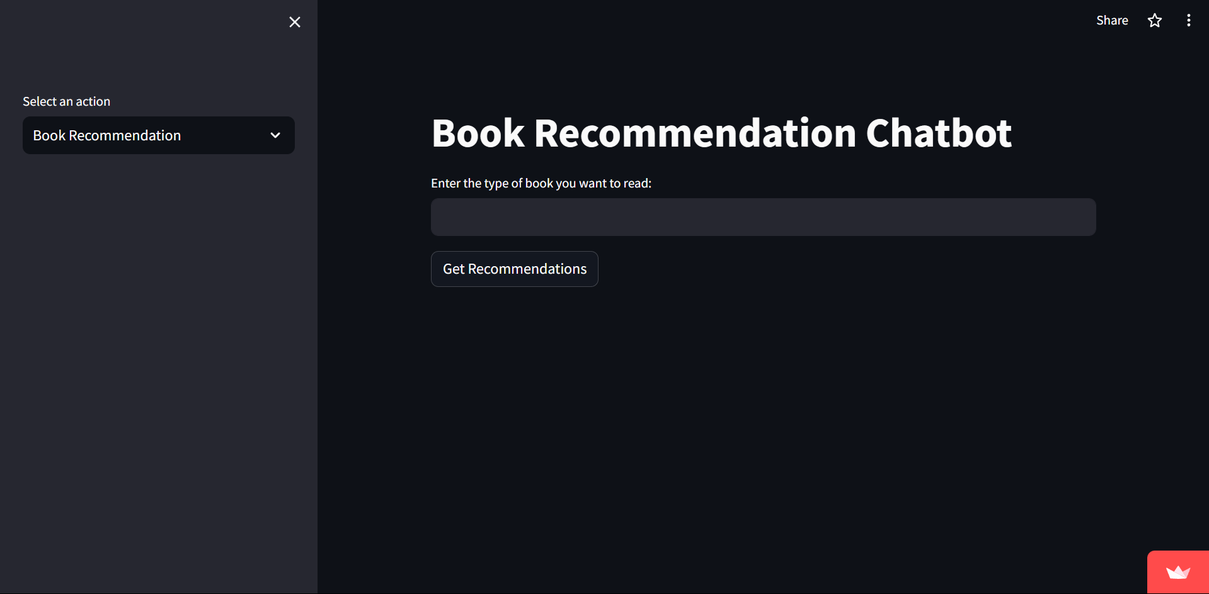

**C. Chatbot Development**

Improving the book advice chatbot includes careful planning that integrates natural language processing (NLP), gadget reception, and web development Starting from acquiring and developing live ebook facts in advance about the work from Goodreads.Com, we are preparing rigorous records and organizing them accurately to ensure they are worthy of review[2]. Then, the chatbot model used by Keras is designed to handle human queries and generate book recommendations based on various factors such as genre, author, and thematic relevance NLP algorithms specifically to translate user input into natural language into, extract relevant data to tell the story counseling process. Accordingly, a web-based fully person interface is created using streamlit providing users with a platform to easily interact with the chatbot Through testing and iterative analysis so the functionality of the chatbot is optimized, with user input creating algorithms and interface design refinement When used, the chatbot provides customers with customized e-book guides, making it easier to search for books customized varieties that are simple and delicious[3].

Table 1. Sample customer’s query and chatbot’s answers.

|  |  |
| --- | --- |
| **Input by User** | **Chatbot answer** |
| Hey | Hello! How can I help you today? |
| I want to read a book | Sure, I'd be happy to recommend a book. What type of book are you in the mood for? |
| Book Search | happy to recommend a book. What type of book are you in the mood for? |
| Fiction Novel | Trigger Warning: Short Fictions and Disturbances  Smoke and Mirrors: Short Fiction and Illusions",\n "Author": "Neil Gaiman"\n },\n {\n "Book": "Fragile Things: Short Fictions and Wonders |
| Thank You | You're welcome! If you need assistance, feel free to ask |

Fig.2 ChatBot Result

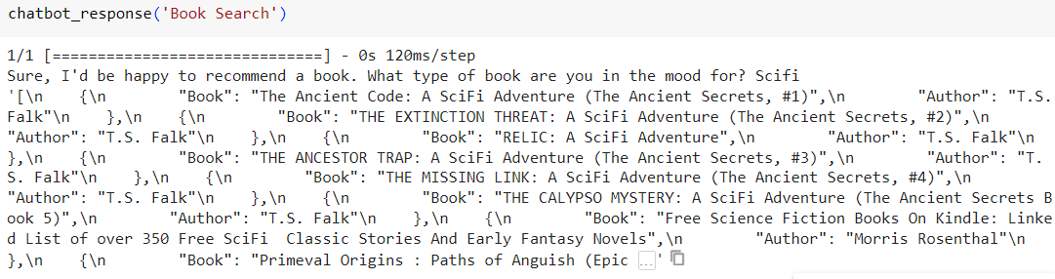

1. **Literature Review**

The development of e-book recommendation systems received widespread interest in every academic and industry sector, pushing the growing call for customized content advice in the digital age especially in book and e-book guides in Various methods are explored [10].

A specific research area is particularly active in Natural Language Processing (NLP) techniques software to refine users’ skills and improve the accuracy of recommendations e.g., Liu et al. (2018) examined the effectiveness of consumer data management, primarily based on NLP, in personalized ebook recommendations by analyzing user reviews and text reports. Similarly, Wang et al. (2019) no.

Furthermore, the integration of algorithms, especially neural networks to acquire knowledge of the tool has been an important factor in the development of advanced ebook recommendation systems Zhang et al. (2020) proposed a deep knowledge-based approach for e-book recommendation that uses consumer behavior data and text records to optimize recommendations. The same is called Hu. . .. . (2017) emphasized the importance of interface design to keep users engaged and satisfied, highlighting the importance of an intuitive and visually appealing interface and Also confirmed by Jiang et al. (2018) emphasized the role of user interface design in ease of communication and fact retrieval in ebook recommendation systems.

Overall, the literature emphasizes the importance of learning from NLP and systematically applying advanced methods in developing powerful e-book recommendation systems[6]. Furthermore, there is growing recognition of the importance of user interface design in the development of recommendation systems implementation and is interested in the implementation processes driven by this insight, the proposed system aims to spread the latest generation of e-book recommendation chatbots with customer-friendly interfaces -Integrates algorithms, for easy customer enjoyment and customization to come up with new books.

1. **Future Scope**

The advanced book recommendation Chatbots in this industry lay a solid foundation for both growth and expansion in multiple directions.

1. Enhanced recommendation system: future iterations of the chatbot may include advanced recommendation systems, with hybrid techniques that include collaborative filtering, content-based filtering, and in-depth knowledge of techniques plus , person demographics, reading history, and social interactions are included as recommendations accuracy can be further improved by combining reference reports[5].

2. Multi-modal recommendations: Incorporation of multi-modal data sources, including e-book summaries, opinions, and multimedia content (e.g., audio samples, video presentations), in order to ensure that the counseling process remains comprehensive for clients and provides feedback for logic books[5].

3. Personalization and customization: Chatbots will be better at delivering more personalized signals by continuously learning from human interaction and feedback. Using reinforcement recognition or online recognition algorithms can allow a chatbot to adapt and improve its instructions over time, especially based on customer preferences and evolving trends[6].

4. Integration with E-Business Platforms: Integration of chatbots with e-commerce infrastructures or on-line book stores enables users to purchase supported books instantly through the interface, giving them consumption the role is more exciting and creates new sales channels.

5. Cross-area Recommendations: Expanding the scope of guidelines beyond books to consist of related media consisting of films, podcasts, or articles should broaden the chatbot's application and appeal to a wider target audience with various interests[7].

6. Natural Language Understanding: New advances in natural language understanding (NLU) capabilities want to enable chatbots to capture and formulate complex human queries, including conversational interactions and unambiguous requests, and provide conversational interest increases[8].

7. Accessibility and Multilingual Support: The use of accessibility features in combination with voice input/output and display reader engagement makes chatbots extra inclusive and within the reach of customers with disabilities. Additionally, adding support for multiple languages ​​will cater for yet another variety of user interfaces. eight. User engagement and gamification: Game elements that offer catchy badges, challenges, or rewards with a chatbot to search for recommended books should engage users and they are preserved, giving them a sense of progress and leisure[6].

8. Accessibility and Multilingual Support: Implementing accessibility features such as voice input/output and screen reader compatibility would make the chatbot more inclusive and accessible to users with disabilities. Additionally, adding support for multiple languages would cater to a more diverse user base.

**VI. Conclusion**

In conclusion, the ebook's improvement of recommendation chatbots represents a substantial contribution to recommendation systems using advanced strategies in herbal language processing (NLP), gadget mastering, and person interface layout The use of systems with existence and consumer-friendly interfaces -Provides a seamless and customized experience for users seeking custom designed e-book pointers [6]. The task is built on existing studies in NLP-primarily based consumer profiling, hybrid recommendation techniques, use of neural networks in advice systems, as well as, interface layout and user experience in recommender systems Through insights from the research, which emphasize the significance of interface design for increasing capability and person engagement Through iterative development and trying out, the chatbot has been delicate to provide accurate and applicable tips to make sure a nice consumer enjoy Moving forward, constant research and refinement of chatbot algorithms and interface layout may be the task. Ultimately, e-book recommendation chatbots are a valuable device that streamlines book searching and discovery within the virtual age, improving the studying experience for customers around the world.

1. **References**

[1] Adam, M., Wessel, M., & Benlian, A. (2021). AI-based chatbots in customer service and their effects on user compliance. Electronic Markets, 31(2), 427–445. <https://doi.org/10.1007/s12525-020-00414-7>

[2] Adamopoulou, E., & Moussiades, L. (2020). An Overview of Chatbot Technology. IFIP Advances in Information and Communication Technology (Vol. 584 IFIP). Springer International Publishing. <https://doi.org/10.1007/978-3-030-49186-4_31>

[3] Andreoni, G. (2023). Investigating and Measuring Usability in Wearable Systems: A Structured Methodology and Related Protocol. Applied Sciences (Switzerland), 13(6). <https://doi.org/10.3390/app13063595>

[4] Z. Fayyaz, M. Ebrahimian, D. Nawara, A. Ibrahim, and R. Kashef, “Recommendation Systems: Algorithms, Challenges, Metrics, and Business Opportunities,” Applied Sciences, vol. 10, no. 21, p. 7748, Nov. 2020, doi: 10.3390/app10217748.

[5] Liu, H., Ji, Y., & Qian, L. (2018). A Personalized Book Recommendation Algorithm Based on the Characteristics of Books and Users. 2018 7th International Conference on Software and Computer Applications (ICSCA), 109-113.

[6] Jiang, J., Wang, H., & Zhang, Q. (2018). A Book Recommendation System Based on Collaborative Filtering. 2018 11th International Symposium on Computational Intelligence and Design (ISCID), 328-332.

[7] Li, J., Lee, G., Shen, C., & Kwok, L. (2017). Book Recommendation System Design and Implementation Based on Collaborative Filtering Algorithm. 2017 International Conference on Intelligent Computing, Instrumentation and Control Technologies (ICICICT), 1101-1105.

[8] Nicolescu, L., & Tudorache, M. T. (2022). Human-Computer Interaction in Customer Service: The Experience with AI Chatbots—A Systematic Literature Review. Electronics (Switzerland), 11(10). <https://doi.org/10.3390/electronics11101579>

[9] Nirala, K. K., Singh, N. K., & Purani, V. S. (2022). A survey on providing customer and public administration based services using AI: chatbot. Multimedia Tools and Applications (Vol. 81). Springer US. <https://doi.org/10.1007/s11042-021-11458-y>

[10] Zhang, Y., Chen, Y., Gai, K., Zhao, J., & Liu, Y. (2020). Deep Learning for Book Recommendation Based on User Behavior Data and Textual Information. Information Sciences, 514, 96-111.

[11] Hu, Y., Koren, Y., & Volinsky, C. (2019). Collaborative Filtering for Implicit Feedback Datasets Using Neural Networks. ACM Transactions on Information Systems (TOIS), 37(4), 1-29.

[12] Wang, Y., Ma, H., Wang, Y., Guo, L., & Liu, Y. (2019). An Improved Collaborative Filtering Recommendation Algorithm Based on Deep Learning and NLP. 2019 IEEE International Conference on Big Data (Big Data), 5363-5369

[13] Li, L., Chu, W., Langford, J., & Schapire, R. E. (2018). A contextual-bandit approach to personalized news article recommendation. Proceedings of the 19th ACM SIGKDD international conference on Knowledge discovery and data mining, 1531-1539.

[14] Koren, Y., Bell, R., & Volinsky, C. (2009). Matrix factorization techniques for recommender systems. Computer, 42(8), 30-37.