TTC Delays
Ashish Adhikari
2025-05-11

Exploratory Data Analysis (EDA)

What are the most frequent delay causes (Code)?

Which stations have the most delays?

Predictive Modeling

Classification: Classify whether a delay will be > 5 mins

1. Preliminary and Exploratory
# Load data
df <- read.table("ttc-subway-delay-data-2024.csv",
header=TRUE,
sep=",",
quote = "\"",
fill = TRUE,
stringsAsFactors = FALSE)
df <- as.data.frame(df)

2 Data Description

head(df)
## Date Time Day Station Code Min.Delay Min.Gap Bound Line
## 1 2024/01/01 02:00 Monday SHEPPARD STATION MUI 0 0 N YU
## 2 2024/01/01 02:00 Monday DUNDAS STATION MUIS 0 0 N YU
## 3 2024/01/01 02:08 Monday DUNDAS STATION MUPAA 4 10 N YU
## 4 2024/01/01 02:13 Monday KENNEDY BD STATION PUTDN 10 16 E BD
## 5 2024/01/01 02:22 Monday BLOOR STATION MUPAA 4 10 N YU
## 6 2024/01/01 02:25 Monday ST CLAIR STATION MUPAA 3 9 N YU
## Vehicle
## 1 5491
## 2 0
## 3 6051
## 4 5284
## 5 5986
## 6 6051

summary(df)
## Date Time Day Station
## Length:26467 Length:26467 Length:26467 Length:26467
## Class :character Class :character Class :character Class :character
## Mode :character Mode :character Mode :character Mode :character
##
##
##
##
## Code Min.Delay Min.Gap Bound
## Length:26467 Min. : 0.000 Min. : 0.000 Length:26467
## Class :character 1st Qu.: 0.000 1st Qu.: 0.000 Class :character
## Mode :character Median : 0.000 Median : 0.000 Mode :character
## Mean : 2.806 Mean : 4.111
## 3rd Qu.: 4.000 3rd Qu.: 8.000
## Max. :716.000 Max. :719.000
## NA's :1 NA's :1
## Line Vehicle
## Length:26467 Min. : 0
## Class :character 1st Qu.: 0
## Mode :character Median :5120
## Mean :3224
## 3rd Qu.:5606
## Max. :9546
## NA's :1
df <- na.omit(df)
summary(df)
## Date Time Day Station
## Length:26466 Length:26466 Length:26466 Length:26466
## Class :character Class :character Class :character Class :character
## Mode :character Mode :character Mode :character Mode :character
##
##
##
## Code Min.Delay Min.Gap Bound
## Length:26466 Min. : 0.000 Min. : 0.000 Length:26466
## Class :character 1st Qu.: 0.000 1st Qu.: 0.000 Class :character
## Mode :character Median : 0.000 Median : 0.000 Mode :character
## Mean : 2.806 Mean : 4.111
## 3rd Qu.: 4.000 3rd Qu.: 8.000
## Max. :716.000 Max. :719.000
## Line Vehicle
## Length:26466 Min. : 0
## Class :character 1st Qu.: 0
## Mode :character Median :5120
## Mean :3224
## 3rd Qu.:5606
## Max. :9546
We know from looking in the datasheet, that Date is the date of records in *YYYY-MM-DD format, and Time is the time of the incident in hrs** format.
# Change Date to MM/DD/YYYY
df$Date <- as.Date(df$Date)
Since we have time in hrs, we will break it down to different time ranges as: * Early Morning: 5 to 9 * Morning: 9 to 12 * Afternoon: 12 to 17 * Evening: 17 to 21 * Night: 21 to 5
# Extract Hour and convert them to numeric
df$Hour <- as.numeric(sub(":.*", "", df$Time))
# Assign Hours to TimeRange as defined above
df$TimeRange <- with(df, ifelse(Hour >= 5 & Hour < 9, "Early Morning",
ifelse(Hour >= 9 & Hour < 12, "Morning",
ifelse(Hour >= 12 & Hour < 17, "Afternoon",
ifelse(Hour >= 17 & Hour < 21, "Evening", "Night")))))
summary(df)
## Date Time Day Station
## Min. :2024-01-01 Length:26466 Length:26466 Length:26466
## 1st Qu.:2024-04-01 Class :character Class :character Class :character
## Median :2024-07-02 Mode :character Mode :character Mode :character
## Mean :2024-07-01
## 3rd Qu.:2024-10-03
## Max. :2024-12-31
## Code Min.Delay Min.Gap Bound
## Length:26466 Min. : 0.000 Min. : 0.000 Length:26466
## Class :character 1st Qu.: 0.000 1st Qu.: 0.000 Class :character
## Mode :character Median : 0.000 Median : 0.000 Mode :character
## Mean : 2.806 Mean : 4.111
## 3rd Qu.: 4.000 3rd Qu.: 8.000
## Max. :716.000 Max. :719.000
## Line Vehicle Hour TimeRange
## Length:26466 Min. : 0 Min. : 0 Length:26466
## Class :character 1st Qu.: 0 1st Qu.: 8 Class :character
## Mode :character Median :5120 Median :14 Mode :character
## Mean :3224 Mean :13
## 3rd Qu.:5606 3rd Qu.:18
## Max. :9546 Max. :23
We can see that we have two new columns Hour and TimeRange, with Hour being numeric min value 0 and max value 23 and TimeRange being character. Now we don’t need Time and Hour columns so we will drop them.
We know from the separate Code Description file that * Day is the name of the day of the week * Code can be one of 129 or 71 different delay codes * Bound is the direction of the train on the line * Line is the TTC Subway Line * Vehicle is the TTC train number, and has no numeric value So we convert them all including TimeRange to factors
df <- df[ ,-2]
df <- df[ ,-10]
df$Day <- as.factor(df$Day)
df$Station <- as.factor(df$Station)
df$Code <- as.factor(df$Code)
df$Bound <- as.factor(df$Bound)
df$Line <- as.factor(df$Line)
df$Vehicle <- as.factor(df$Vehicle)
df$TimeRange <- as.factor(df$TimeRange)
summary(df)
## Date Day Station
## Min. :2024-01-01 Friday :3925 BLOOR STATION : 1109
## 1st Qu.:2024-04-01 Monday :3921 KENNEDY BD STATION: 960
## Median :2024-07-02 Saturday :3503 FINCH STATION : 896
## Mean :2024-07-01 Sunday :2929 KIPLING STATION : 894
## 3rd Qu.:2024-10-03 Thursday :4011 DUNDAS STATION : 829
## Max. :2024-12-31 Tuesday :4194 EGLINTON STATION : 674
## Wednesday:3983 (Other) :21104
## Code Min.Delay Min.Gap Bound Line
## SUDP : 3419 Min. : 0.000 Min. : 0.000 :9520 YU :14141
## MUIS : 2681 1st Qu.: 0.000 1st Qu.: 0.000 B: 29 BD :10990
## SUO : 2515 Median : 0.000 Median : 0.000 E:3812 SHP : 890
## MUPAA : 1729 Mean : 2.806 Mean : 4.111 N:4509 YU/BD : 336
## MUIRS : 1490 3rd Qu.: 4.000 3rd Qu.: 8.000 S:4744 : 44
## PUOPO : 1461 Max. :716.000 Max. :719.000 W:3852 YU/ BD : 17
## (Other):13171 (Other): 48
## Vehicle TimeRange
## 0 :11042 Afternoon :6534
## 5616 : 83 Early Morning:4401
## 5466 : 82 Evening :5368
## 6061 : 79 Morning :3333
## 5896 : 77 Night :6830
## 6181 : 77
## (Other):15026
levels(df$Line)
## [1] "" "109 RANEE" "20 CLIFFSIDE"
## [4] "BD" "BD / YU" "BD/ YU"
## [7] "BD/ YUS" "BD/YU" "BLOOR DANFORTH"
## [10] "LINE 1" "ONGE-UNIVERSITY AND BL" "SHEP"
## [13] "SHP" "SRT" "TRACK LEVEL ACTIVITY"
## [16] "YU" "YU & BD" "YU / BD"
## [19] "YU/ BD" "YU/BD" "YU/BD/SHP"
## [22] "YUS" "YUS/BD"
There are some inconsistencies in the Line column, so we will standardize them. And it also has “None” value in it which cannot be the case, we will treat them as missing values and remove them.
YUS stands for Yonge–University–Spadina Line, which was the older name for what is now officially called the Yonge–University Line, abbreviated as YU.
df$Line <- as.character(df$Line)
# Replace known variations
df$Line[df$Line %in% c("YUS", "LINE 1", "ONGE-UNIVERSITY AND BL")] <- "YU"
df$Line[df$Line %in% c("BLOOR DANFORTH")] <- "BD"
df$Line[df$Line %in% c("SHEP")] <- "SHP"
# Replace all combo labels with "YU-BD"
df$Line[df$Line %in% c("YU / BD", "YU/ BD", "YU/BD", "YU & BD", "YUS/BD", "BD/YU", "BD / YU", "BD/ YU", "BD/ YUS", "YU/BD/SHP")] <- "YU-BD"
# Remove irrelevant labels
df$Line[df$Line %in% c("TRACK LEVEL ACTIVITY", "109 RANEE", "20 CLIFFSIDE", "")] <- NA
df <- df[!is.na(df$Line), ]
# Convert back to factor
df$Line <- factor(df$Line)
# Check final cleaned levels
levels(df$Line)
## [1] "BD" "SHP" "SRT" "YU" "YU-BD"
summary(df)
## Date Day Station
## Min. :2024-01-01 Friday :3919 BLOOR STATION : 1109
## 1st Qu.:2024-04-01 Monday :3914 KENNEDY BD STATION: 960
## Median :2024-07-02 Saturday :3500 FINCH STATION : 896
## Mean :2024-07-01 Sunday :2924 KIPLING STATION : 894
## 3rd Qu.:2024-10-03 Thursday :4001 DUNDAS STATION : 829
## Max. :2024-12-31 Tuesday :4186 EGLINTON STATION : 674
## Wednesday:3975 (Other) :21057
## Code Min.Delay Min.Gap Bound Line
## SUDP : 3418 Min. : 0.000 Min. : 0.000 :9480 BD :10991
## MUIS : 2677 1st Qu.: 0.000 1st Qu.: 0.000 B: 24 SHP : 891
## SUO : 2508 Median : 0.000 Median : 0.000 E:3811 SRT : 2
## MUPAA : 1729 Mean : 2.809 Mean : 4.115 N:4508 YU :14150
## MUIRS : 1487 3rd Qu.: 4.000 3rd Qu.: 8.000 S:4744 YU-BD: 385
## PUOPO : 1461 Max. :716.000 Max. :719.000 W:3852
## (Other):13139
## Vehicle TimeRange
## 0 :11000 Afternoon :6528
## 5616 : 83 Early Morning:4399
## 5466 : 82 Evening :5365
## 6061 : 79 Morning :3330
## 5896 : 77 Night :6797
## 6181 : 77
## (Other):15021
Now looking into Code we found one entry with invalid value, so we simply remove them.
df$Code <- as.character(df$Code)
# Remove invalid codes
df$Code[df$Code %in% c("XXXXX")] <- NA
df <- df[!is.na(df$Code), ]
df$Code <- factor(df$Code)
summary(df)
## Date Day Station
## Min. :2024-01-01 Friday :3919 BLOOR STATION : 1109
## 1st Qu.:2024-04-01 Monday :3913 KENNEDY BD STATION: 960
## Median :2024-07-02 Saturday :3500 FINCH STATION : 896
## Mean :2024-07-01 Sunday :2924 KIPLING STATION : 894
## 3rd Qu.:2024-10-03 Thursday :4001 DUNDAS STATION : 829
## Max. :2024-12-31 Tuesday :4186 EGLINTON STATION : 674
## Wednesday:3975 (Other) :21056
## Code Min.Delay Min.Gap Bound Line
## SUDP : 3418 Min. : 0.000 Min. : 0.000 :9480 BD :10990
## MUIS : 2677 1st Qu.: 0.000 1st Qu.: 0.000 B: 24 SHP : 891
## SUO : 2508 Median : 0.000 Median : 0.000 E:3810 SRT : 2
## MUPAA : 1729 Mean : 2.809 Mean : 4.115 N:4508 YU :14150
## MUIRS : 1487 3rd Qu.: 4.000 3rd Qu.: 8.000 S:4744 YU-BD: 385
## PUOPO : 1461 Max. :716.000 Max. :719.000 W:3852
## (Other):13138
## Vehicle TimeRange
## 0 :11000 Afternoon :6528
## 5616 : 83 Early Morning:4398
## 5466 : 82 Evening :5365
## 6061 : 79 Morning :3330
## 5896 : 77 Night :6797
## 6181 : 77
## (Other):15020
Now in Bound, there is “B” which is ambiguous and missing values. Similarly, in case of Vehicle as well “0” is definitely missing values. Significant number of rows are missing in both Bound and Vehicle, so we cannot simply drop them. We keep values with None for now. But B is just 29 observations so we drop all observations with B.
df$Bound <- as.character(df$Bound)
# Drop rows where Bound == "B"
df <- df[df$Bound != "B", ]
df$Bound <- as.factor(df$Bound)
summary(df)
## Date Day Station
## Min. :2024-01-01 Friday :3917 BLOOR STATION : 1109
## 1st Qu.:2024-04-01 Monday :3910 KENNEDY BD STATION: 960
## Median :2024-07-02 Saturday :3493 FINCH STATION : 896
## Mean :2024-07-01 Sunday :2921 KIPLING STATION : 894
## 3rd Qu.:2024-10-03 Thursday :3999 DUNDAS STATION : 829
## Max. :2024-12-31 Tuesday :4182 EGLINTON STATION : 672
## Wednesday:3972 (Other) :21034
## Code Min.Delay Min.Gap Bound Line
## SUDP : 3418 Min. : 0.000 Min. : 0.000 :9480 BD :10978
## MUIS : 2677 1st Qu.: 0.000 1st Qu.: 0.000 E:3810 SHP : 891
## SUO : 2508 Median : 0.000 Median : 0.000 N:4508 SRT : 2
## MUPAA : 1729 Mean : 2.812 Mean : 4.119 S:4744 YU :14142
## MUIRS : 1487 3rd Qu.: 4.000 3rd Qu.: 8.000 W:3852 YU-BD: 381
## PUOPO : 1461 Max. :716.000 Max. :719.000
## (Other):13114
## Vehicle TimeRange
## 0 :10976 Afternoon :6526
## 5616 : 83 Early Morning:4391
## 5466 : 82 Evening :5364
## 6061 : 79 Morning :3328
## 5896 : 77 Night :6785
## 6181 : 77
## (Other):15020
There is a lot of inconsistent and dirty data in the Station Column. Since we do not have the domain expertise for standardizing station names, we will clean and standardize them using prompt from ChatGPT.
# -------------------------------
# 1. Clean and simplify Station names
# -------------------------------
# Convert Station to uppercase and trim spaces
df$Station <- toupper(trimws(df$Station))
# Remove common suffixes like " STATION", text after dashes, and redundant line codes
df$Station <- gsub(" STATION.*", "", df$Station)
df$Station <- gsub(" BD$", "", df$Station)
df$Station <- gsub(" YU$", "", df$Station)
df$Station <- gsub(" -.*", "", df$Station)
df$Station <- gsub(" +", " ", df$Station)
df$Station <- trimws(df$Station)
# -------------------------------
# 2. Remove irrelevant/general stations or vague entries
# -------------------------------
irrelevant_patterns <- c(
"LINE", "YARD", "WYE", "SHOP", "BUILDING", "CAR HOUSE", "CARHOUSE", "COMPLEX",
"SUBWAY", "SUBSTATION", "CLOSURE", "SYSTEM", "UNKNOWN", "TRACK", "DIVISION",
"HOSTLER", "TRAINING", "EE", "EMERGENCY", "APPROACHING", "TO", "BETWEEN",
"AND", "VARIOUS", "CHANGE OVER", "OPERATIONS", "UNION TO", "YU-", "YU & BD"
)
# Remove rows that contain any of the above patterns
remove_rows <- grepl(paste(irrelevant_patterns, collapse = "|"), df$Station)
df <- df[!remove_rows, ]
# -------------------------------
# 3. Re-factor Station
# -------------------------------
df$Station <- factor(df$Station)

# Prepare data in long format
delay_data <- data.frame(
Category = c(rep("Min.Delay", length(df$Min.Delay)),
rep("Min.Gap", length(df$Min.Gap))),
Value = c(df$Min.Delay, df$Min.Gap)
)
# Plot
ggplot(delay_data, aes(x = Category, y = Value)) +
geom_boxplot(fill = "lightgreen") +
labs(title = "Boxplot of Min.Delay and Min.Gap",
x = "",
y = "Minutes") +
theme_minimal()
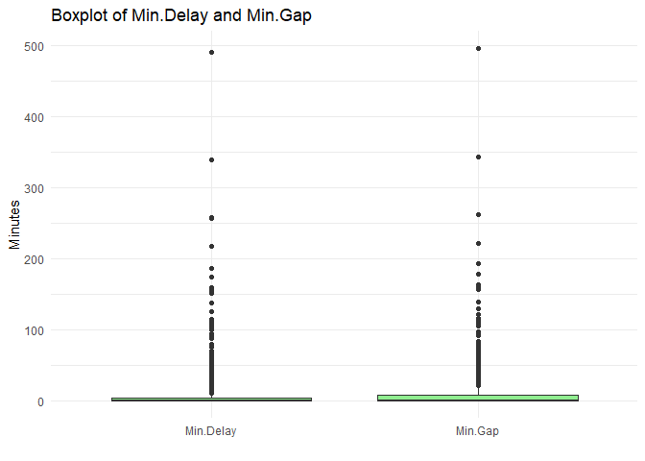
There are few delays and gaps with time greater than 50 minutes, they might be rare and standalone incidents so we simply remove them.
df <- df[df$Min.Delay <= 50 & df$Min.Gap <= 50, ]
# Prepare data in long format
delay_data <- data.frame(
Category = c(rep("Min.Delay", length(df$Min.Delay)),
rep("Min.Gap", length(df$Min.Gap))),
Value = c(df$Min.Delay, df$Min.Gap)
)
# Plot
ggplot(delay_data, aes(x = Category, y = Value)) +
geom_boxplot(fill = "lightgreen") +
labs(title = "Boxplot of Min.Delay and Min.Gap",
x = "",
y = "Minutes") +
theme_minimal()
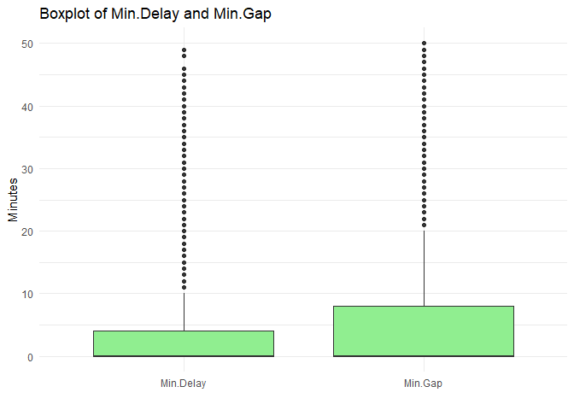
stat.desc(df[, c("Min.Delay", "Min.Gap")])
## Min.Delay Min.Gap
## nbr.val 21021.00000000 21021.00000000
## nbr.null 13313.00000000 13652.00000000
## nbr.na 0.00000000 0.00000000
## min 0.00000000 0.00000000
## max 49.00000000 50.00000000
## range 49.00000000 50.00000000
## sum 53400.00000000 82678.00000000
## median 0.00000000 0.00000000
## mean 2.54031683 3.93311450
## SE.mean 0.03366417 0.04460829
## CI.mean.0.95 0.06598436 0.08743568
## var 23.82260140 41.82968406
## std.dev 4.88084024 6.46758719
## coef.var 1.92135098 1.64439331
par(mfrow = c(2, 2))
hist(df$Min.Delay,
main = "Delay (in Minutes)",
xlab = "Value",
ylab = "Frequency",
col = "#ADD8E6",
freq = FALSE) # `freq = FALSE` scales the histogram for overlaying density
lines(density(df$Min.Delay))
hist(df$Min.Gap,
main = "Gap (in Minutes)",
xlab = "Value",
ylab = "Frequency",
col = "#ADD8E6",
freq = FALSE) # `freq = FALSE` scales the histogram for overlaying density
lines(density(df$Min.Gap))
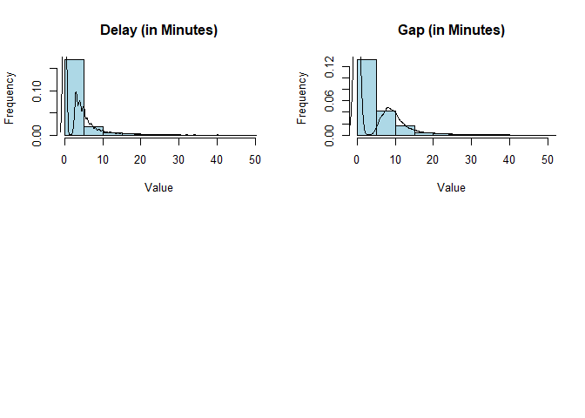
Since there are a lot of reported incidents that have caused 0 mins delay, it might be a good idea to remove them from our data frame as it skews our data and can create bias in our models later on.
df <- df[df$Min.Delay > 0 & df$Min.Gap > 0, ]
par(mfrow = c(2, 2))
hist(df$Min.Delay,
main = "Delay (in Minutes)",
xlab = "Value",
ylab = "Frequency",
col = "#ADD8E6",
freq = FALSE) # `freq = FALSE` scales the histogram for overlaying density
lines(density(df$Min.Delay))
hist(df$Min.Gap,
main = "Gap (in Minutes)",
xlab = "Value",
ylab = "Frequency",
col = "#ADD8E6",
freq = FALSE) # `freq = FALSE` scales the histogram for overlaying density
lines(density(df$Min.Gap))
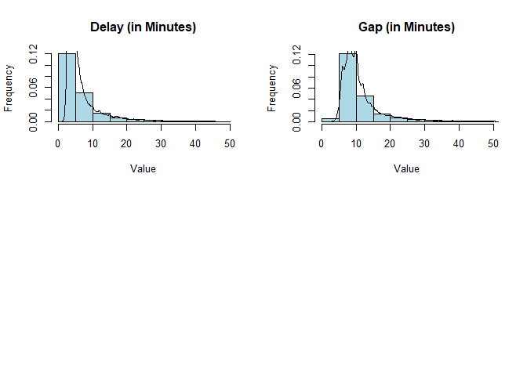
Checking for correlation:
cr <- cor(df[sapply(df, is.numeric)], method="spearman")
round(cr, 2)
## Min.Delay Min.Gap
## Min.Delay 1.0 0.9
## Min.Gap 0.9 1.0
Since Delay of one train and the Gap between trains are highly correlated, we can drop one. Here we chose to drop Min.Gap.
df <- df[, -6]
summary(df)
## Date Day Station Code
## Min. :2024-01-01 Friday :1158 KENNEDY : 344 SUDP :1071
## 1st Qu.:2024-03-26 Monday :1115 KIPLING : 342 MUPAA : 768
## Median :2024-06-27 Saturday : 922 BLOOR : 322 PUOPO : 734
## Mean :2024-06-28 Sunday : 735 FINCH : 306 SUO : 501
## 3rd Qu.:2024-09-30 Thursday :1136 DAVISVILLE: 221 MUIR : 497
## Max. :2024-12-31 Tuesday :1195 WILSON : 215 MUSAN : 359
## Wednesday:1108 (Other) :5619 (Other):3439
## Min.Delay Bound Line Vehicle TimeRange
## Min. : 2.000 : 104 BD :2533 0 : 90 Afternoon :2070
## 1st Qu.: 3.000 E:1456 SHP : 262 5896 : 54 Early Morning:1226
## Median : 5.000 N:2101 SRT : 0 5466 : 48 Evening :1674
## Mean : 6.873 S:2408 YU :4574 5616 : 47 Morning :1016
## 3rd Qu.: 7.000 W:1300 YU-BD: 0 5751 : 46 Night :1383
## Max. :46.000 5956 : 46
## (Other):7038
Now we can see that in Bound, the null values are just 125 and in Vehicle the null values are 130. This is not a significant number so we drop them as well.
df$Bound <- as.character(df$Bound)
df$Vehicle <- as.character(df$Vehicle)
# Remove rows with invalid Bound or Vehicle
df <- df[df$Bound != "" & df$Vehicle != "0", ]
df$Bound <- as.factor(df$Bound)
df$Vehicle <- as.factor(df$Vehicle)

Preparing for Cassification
We create a new column with all values greater than 5 mins as True and less than 5 mins as False. After that we drop the column with time of delays.
df$DelayOver5 <- df$Min.Delay > 5
df <- df[, -5]
# Create new WeekGroup variable
df$Day <- as.character(df$Day)
df$WeekGroup <- ifelse(df$Day %in% c("Saturday", "Sunday"), "Weekend", "Weekday")
df$WeekGroup <- factor(df$WeekGroup)
df <- df[, -2]
summary(df)
## Date Station Code Bound Line
## Min. :2024-01-01 KIPLING : 328 SUDP :1063 E:1433 BD :2467
## 1st Qu.:2024-03-26 BLOOR : 322 MUPAA : 763 N:2086 SHP : 248
## Median :2024-06-27 KENNEDY : 321 PUOPO : 730 S:2389 SRT : 0
## Mean :2024-06-28 FINCH : 275 MUIR : 489 W:1289 YU :4482
## 3rd Qu.:2024-09-30 DAVISVILLE: 216 SUO : 486 YU-BD: 0
## Max. :2024-12-31 WILSON : 210 MUSAN : 353
## (Other) :5525 (Other):3313
## Vehicle TimeRange DelayOver5 WeekGroup
## 5896 : 54 Afternoon :2026 Mode :logical Weekday:5572
## 5466 : 47 Early Morning:1191 FALSE:4314 Weekend:1625
## 5616 : 47 Evening :1652 TRUE :2883
## 5751 : 46 Morning :1002
## 5956 : 46 Night :1326
## 6031 : 43
## (Other):6914
Since, we will just look at WeekEnd or WeekDay we also won’t need Date as we are not considering public holidays or events.
### Droping Date column
df <- df[, -1]

What are the most frequent incidents (Code)?
code_freq <- table(df$Code)
top5 <- sort(code_freq, decreasing = TRUE)[1:5]
top5_df <- data.frame(Code = names(top5), Frequency = as.numeric(top5))
ggplot(top5_df, aes(x = reorder(Code, Frequency), y = Frequency)) +
geom_bar(stat = "identity", fill = "steelblue") +
coord_flip() +
labs(title = "Top 5 Delay Causes",
x = "Delay Code",
y = "Number of Delays") +
theme_minimal()
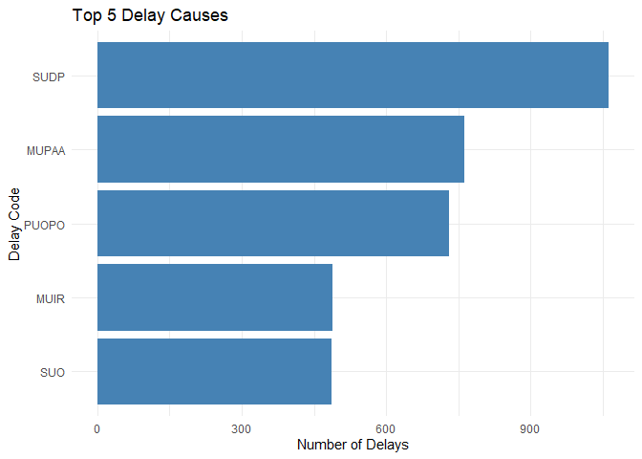
code_legend <- read.csv("Code Descriptions.csv", stringsAsFactors = FALSE)
top5_description <- merge(top5_df, code_legend, by = "Code")
top5_description
## Code Frequency X_id
## 1 MUIR 489 45
## 2 MUPAA 763 53
## 3 PUOPO 730 76
## 4 SUDP 1063 114
## 5 SUO 486 117
## DESCRIPTION
## 1 INJURED/ILL CUSTOMER ON TRAIN â\u0080\u0093 MEDICAL AID REFUSED
## 2 PAA â\u0080\u0093 NO TROUBLE FOUND
## 3 OPTO (COMMUNICATIONS) TRAIN DOOR MONITORING
## 4 DISORDERLY PATRON
## 5 SECURITY OTHER
The most common causes of delays are disorderly patron, injured/ill customer in station or some other security concern.

Which stations have the most delays?
station_counts <- sort(table(df$Station), decreasing = TRUE)
top_stations <- data.frame(Station = names(station_counts), Frequency = as.numeric(station_counts))
ggplot(head(top_stations, 10), aes(x = reorder(Station, Frequency), y = Frequency)) +
geom_bar(stat = "identity", fill = "tomato") +
coord_flip() +
labs(title = "Top 10 Delayed Stations",
x = "Station",
y = "Number of Delays") +
theme_minimal()
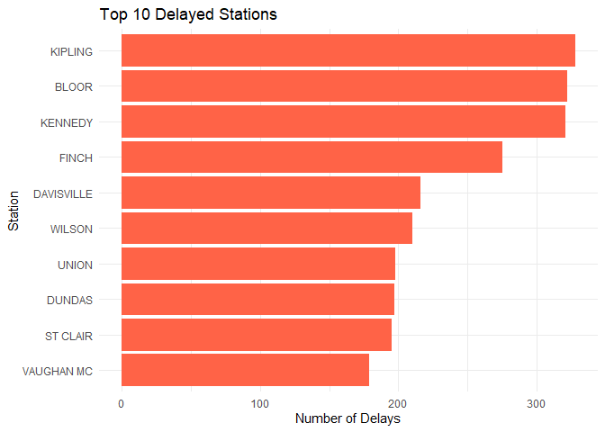

Classification: Predict whether delay duration will be greater than 5 mins
# 80% train and 20 % test
sr<- 0.80
# Find number of rows of data
n.row <- nrow(df)
n.row
## [1] 7197

Choosing rows for the training sample
set.seed(8848)
training.rows <- sample(1:n.row, sr*n.row, replace=FALSE)
#Assign to the training sample
train <- subset(df[training.rows,])
#Assign the balance to the test sample
test <- subset(df[-c(training.rows),])
summary(train)
## Station Code Bound Line Vehicle
## KIPLING : 259 SUDP : 844 E:1152 BD :1972 5896 : 44
## BLOOR : 253 MUPAA : 608 N:1661 SHP : 213 5466 : 42
## KENNEDY : 246 PUOPO : 586 S:1908 SRT : 0 5616 : 39
## FINCH : 222 SUO : 390 W:1036 YU :3572 6061 : 37
## WILSON : 174 MUIR : 389 YU-BD: 0 5956 : 36
## DAVISVILLE: 170 MUSAN : 284 6031 : 36
## (Other) :4433 (Other):2656 (Other):5523
## TimeRange DelayOver5 WeekGroup
## Afternoon :1627 Mode :logical Weekday:4480
## Early Morning: 957 FALSE:3461 Weekend:1277
## Evening :1336 TRUE :2296
## Morning : 793
## Night :1044
##
##
summary(test)
## Station Code Bound Line Vehicle
## KENNEDY : 75 SUDP :219 E:281 BD :495 5421 : 13
## BLOOR : 69 MUPAA :155 N:425 SHP : 35 6071 : 13
## KIPLING : 69 PUOPO :144 S:481 SRT : 0 5411 : 12
## FINCH : 53 MUIR :100 W:253 YU :910 5596 : 12
## UNION : 47 SUO : 96 YU-BD: 0 5921 : 12
## DAVISVILLE: 46 SUUT : 80 5946 : 12
## (Other) :1081 (Other):646 (Other):1366
## TimeRange DelayOver5 WeekGroup
## Afternoon :399 Mode :logical Weekday:1092
## Early Morning:234 FALSE:853 Weekend: 348
## Evening :316 TRUE :587
## Morning :209
## Night :282
##
##

Looking at correlation
# Keep only variables with manageable cardinality
#df_clean <- df[, c("Line", "TimeRange", "Bound", "Code", "WeekGroup", "DelayOver5")]
#hc <- hetcor(df)
#round(hc$correlations, 2)
day_plot <- table(df$DelayOver5, df$WeekGroup)
time_plot <- table(df$DelayOver5, df$TimeRange)
bound_plot <- table(df$DelayOver5, df$Bound)
line_plot <- table(df$DelayOver5, df$Line)
station_plot <- table(df$DelayOver5, df$Station)
code_plot <- table(df$DelayOver5, df$Code)

par(mfrow=c(2,2))
barplot((day_plot),beside=T)
barplot((time_plot),beside=T)
barplot((bound_plot),beside=T)
barplot((line_plot),beside=T)
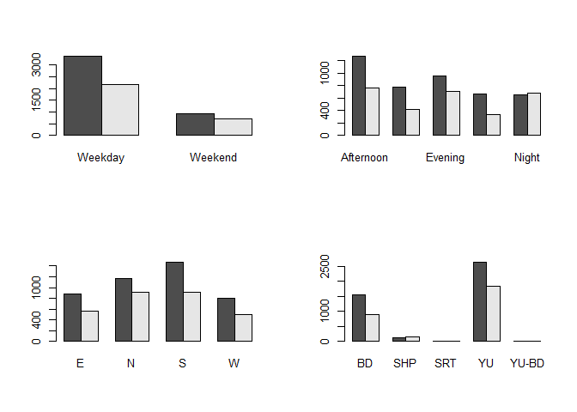
par(mfrow=c(1,1))

barplot((station_plot),beside=T)
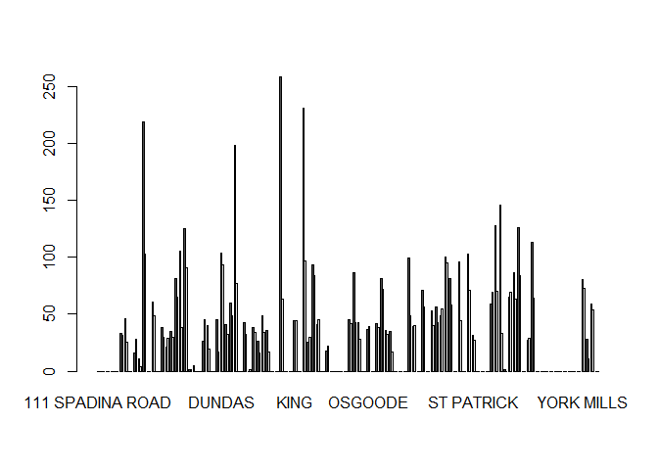
barplot((code_plot),beside=T)
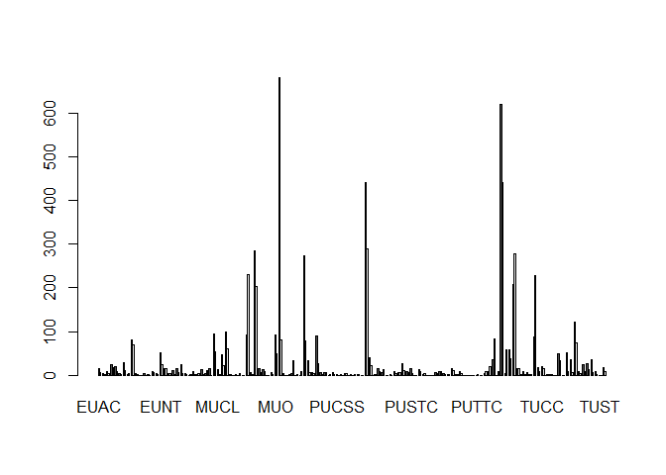

Model Development

1 Full Model using all variables (dependent variable is DelayOver5)
## Number of Fisher Scoring Iterations: 16 : ** It does not converge **
## [1] "### using passing standard of: number of iterations <= (1.5 * number of variables); as discussed in class ###"
## AIC: ** 7281.832 **
## Residual Deviance: ** 5719.832 **
## Intercept Pr(>|z|): ** Fail **
## Other variables Pr(>|z|): ** 28 out of 780 Passed **
## Time difference of 43.30754 secs

Looking for signigficant data points
# All variables
plot(glm.all, which=4, id.n=6)
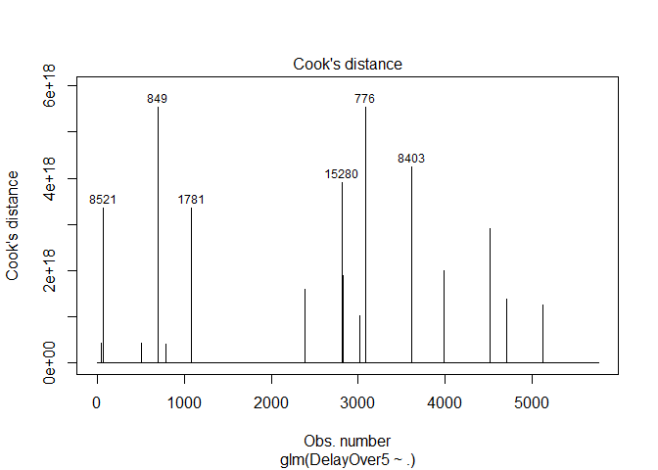
cat("Training\n")
## Training
pred_all <- predict(glm.all, newdata=train, type="response")
Class_all <- ifelse(pred_all < 0.6,"Over5","Below5")
CF_all <- table(train$DelayOver5, Class_all)
Acc_all <- (CF_all[1,1]+CF_all[2,2])/sum(CF_all)
CF_all
## Class_all
## Below5 Over5
## FALSE 321 3140
## TRUE 1086 1210
cat("Accuracy: **", round(Acc_all,4), "**\n\n")
## Accuracy: ** 0.2659 **
cat("Testing\n")
## Testing
# pred_allT <- predict(glm.all, newdata=test, type="response")
# Class_allT <- ifelse(pred_allT < 0.6,"Over5","Below5")
# CF_allT <- table(test$DelayOver5, Class_allT)
# Acc_allT <- (CF_allT[1,1]+CF_allT[2,2])/sum(CF_allT)
#
# CF_allT
# cat("Accuracy: **", round(Acc_allT,4), "**\n\n")

2 Stepwise Model
It will look at both (forward and backward) process and give us the best one.

Model Interpretations and Comments
## Number of Fisher Scoring Iterations: 14 : ** It does not converge **
## [1] "### using passing standard of: number of iterations <= (1.5 * number of variables); as discussed in class ###"
## AIC: ** 6866.318 **
## Residual Deviance: ** 6508.318 **
## Intercept Pr(>|z|): ** Fail **
## Other variables Pr(>|z|): ** 16 out of 178 Passed **
## Time difference of 6.42187 mins

Looking for signigficant data points
# Stepwise Model
plot(glm.mod, which=4, id.n=6)
There are highly influential datapoints (i.e. beyond Cook’s distance)

Comparing the two models
###################################
## Confusion Matrix and Accuracy ##
cat("Training\n")
## Training
pred_glm <- predict(stp.glm, newdata=train, type="response")
Class_glm <- ifelse(pred_glm < 0.6,"Over5","Below5")
CF_glm <- table(train$DelayOver5, Class_glm)
Acc_glm <- (CF_glm[1,1]+CF_glm[2,2])/sum(CF_glm)
CF_glm
## Class_glm
## Below5 Over5
## FALSE 283 3178
## TRUE 758 1538
cat("Accuracy: **", round(Acc_glm,4), "**\n\n")
## Accuracy: ** 0.3163 **
cat("Testing\n")
## Testing
# pred_glmT <- predict(stp.glm, newdata=test, type="response")
# Class_glmT <- ifelse(pred_glmT < 0.6,"Over5","Below5")
# CF_glmT <- table(test$DelayOver5, Class_glmT)
# Acc_glmT <- (CF_glmT[1,1]+CF_glmT[2,2])/sum(CF_glmT)
#
# CF_glmT
# cat("Accuracy: **", round(Acc_glmT,4), "**\n\n")
# Error in model.frame.default(Terms, newdata, na.action = na.action, xlev = object$xlevels) :
# factor Code has new levels PUEWZ, TUDOE

Error while splitting data

2 Naive-Bayes Classification
train$DelayOver5 <- factor(ifelse(train$DelayOver5 == TRUE, "Yes", "No"))
start <- Sys.time()
NB.mod <- NaiveBayes(DelayOver5 ~ .,
data = train, na.action=na.omit)
end <- Sys.time()
time_NB <- end - start
###################################
## Confusion Matrix and Accuracy ##
cat("Training:\n")
## Training:
pred_NB <- predict(NB.mod, newdata=train)
CF_NB <- table(Actual=train$DelayOver5, Predicted=pred_NB$class)
Acc_NB <- (CF_NB[1,1]+CF_NB[2,2])/sum(CF_NB)
CF_NB
## Predicted
## Actual No Yes
## No 2776 685
## Yes 975 1321
cat("Accuracy: **", round(Acc_NB,4), "**\n")
## Accuracy: ** 0.7117 **
cat("\nTesting:\n")
##
## Testing:
pred_NBt <- predict(NB.mod, newdata=test)
CF_NBt <- table(Actual=test$DelayOver5, Predicted=pred_NBt$class)
Acc_NBt <- (CF_NBt[1,1]+CF_NBt[2,2])/sum(CF_NBt)
CF_NBt
## Predicted
## Actual No Yes
## FALSE 645 208
## TRUE 288 299
cat("Accuracy: **", round(Acc_NBt,4), "**\n\n")
## Accuracy: ** 0.6556 **
time_NB
## Time difference of 0.01443815 secs

3 Recursive Partitioning Analysis
# start <- Sys.time()
#
# RP.mod <- ctree(DelayOver5 ~ ., data=train)
#
# end <- Sys.time()
#
# #plot(RP.mod, gp=gpar(fontsize=7))
# RP.mod
#
# ###################################
# ## Confusion Matrix and Accuracy ##
#
# cat("Training:\n")
# pred.RP <- predict(RP.mod, newdata=train)
# CF_RP <- table(Actual=train$DelayOver5, Predicted=pred.RP)
# CF_RP
# Acc_RP <- (CF_RP[1,1]+CF_RP[2,2])/sum(CF_RP)
# cat("Accuracy: **", round(Acc_RP,4), "**\n")
#
# cat("\nTesting:\n")
# pred.RPt <- predict(RP.mod, newdata=test)
# CF_RPt <- table(Actual=test$DelayOver5, Predicted=pred.RPt)
# CF_RPt
# Acc_RPt <- (CF_RPt[1,1]+CF_RPt[2,2])/sum(CF_RPt)
# cat("Accuracy: **", round(Acc_RPt,4), "**\n\n")
#
# time_RP <- end - start
# time_RP

4 Neural Network Fitting
# start <- Sys.time()
#
# nn.mod <- nnet(DelayOver5 ~ .,
# data=train,
# size=4,
# rang=0.0000001, #variance of the starting random weights
# maxit=1200,
# trace=FALSE)
#
# end <- Sys.time()
#
# nn.mod
#
# ###################################
# ## Confusion Matrix and Accuracy ##
#
# cat("\nTraining:\n")
# pred.nn <- predict(nn.mod, newdata = train, type="class")
# CF_NN <- table(Actual = train$DelayOver5, Predicted=pred.nn)
# CF_NN
# Acc_NN <- (CF_NN[1,1]+CF_NN[2,2])/sum(CF_NN)
# cat("Accuracy: **", round(Acc_NN,4), "**\n")
#
# cat("\nTesting:\n")
# pred.nnt <- predict(nn.mod, newdata = test, type="class")
# CF_NNt <- table(Actual = test$DelayOver5, Predicted=pred.nnt)
# CF_NNt
# Acc_NNt <- (CF_NNt[1,1]+CF_NNt[2,2])/sum(CF_NNt)
# cat("Accuracy: **", round(Acc_NNt,4), "**\n\n")
#
# time_NN <- end - start
# time_NN

