**4 : cloning the repo in linux ubuntu:**

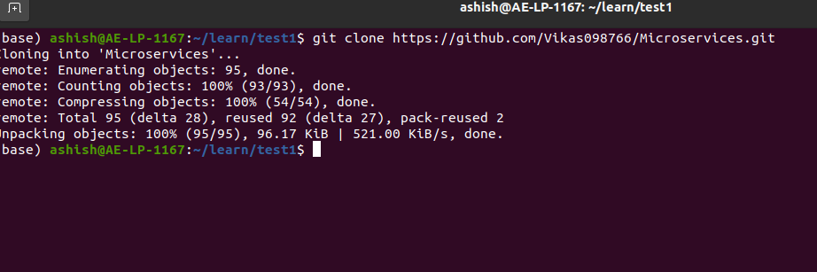

**5: Creating a Virtual Environment ;**

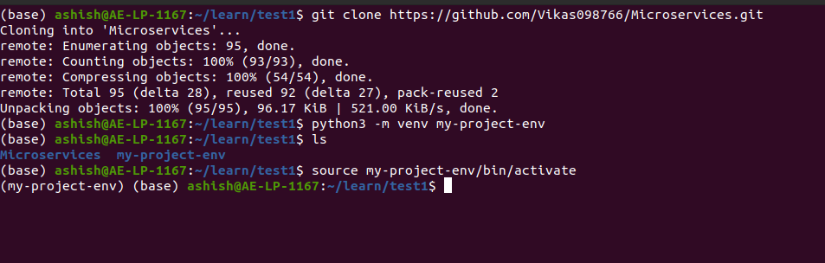

**6 : Install the dependencies from requirements.txt file.**

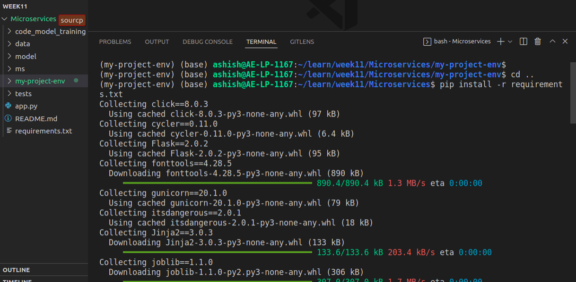

**7 : Train and save the model.**

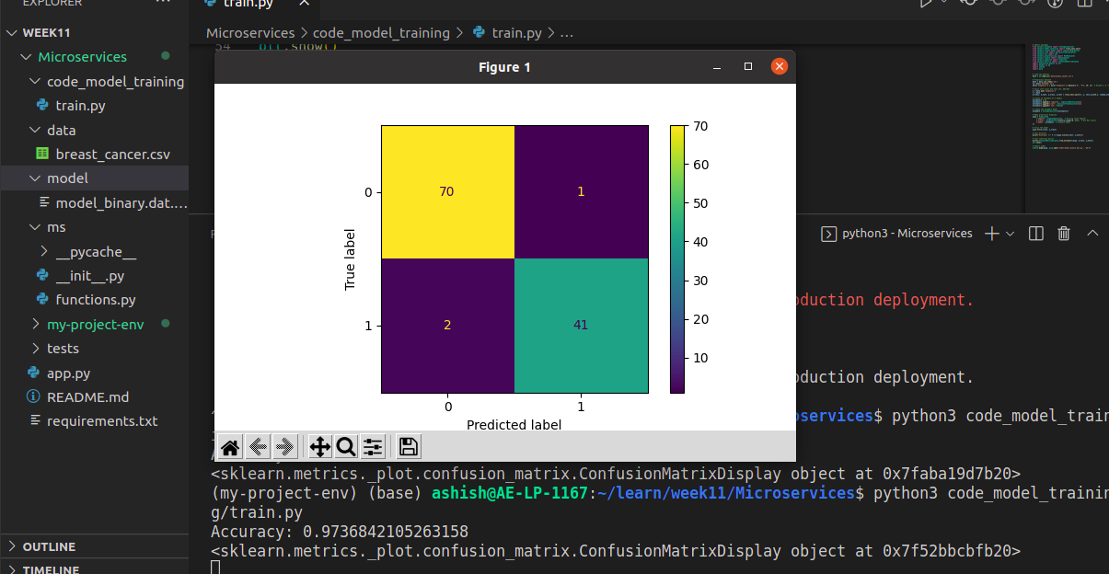**8: Test the Flask web application**

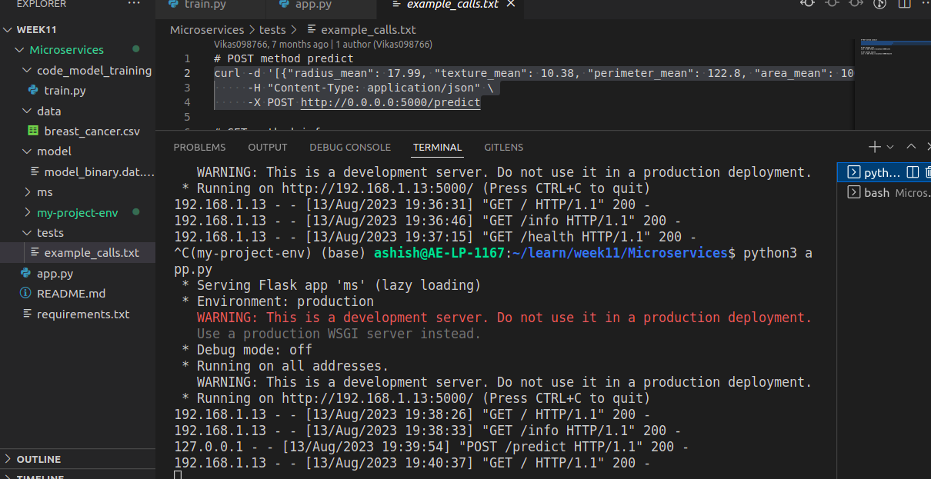

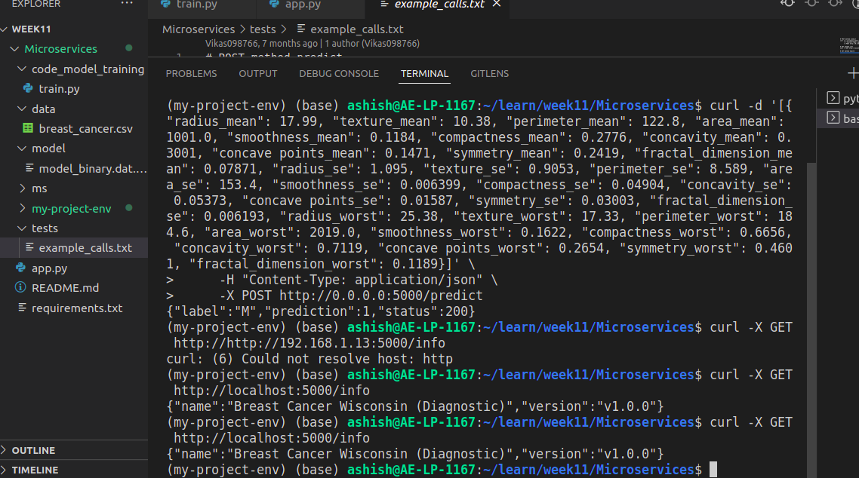

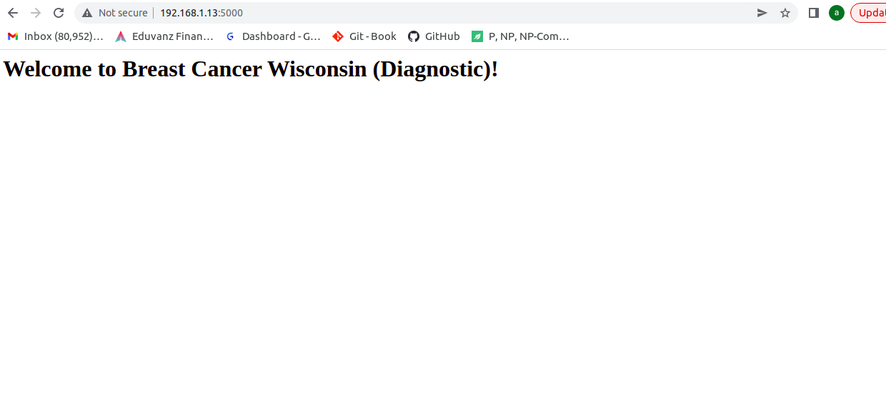

**9 :Test the application and make predictions using the example calls available in the folder/tests.**

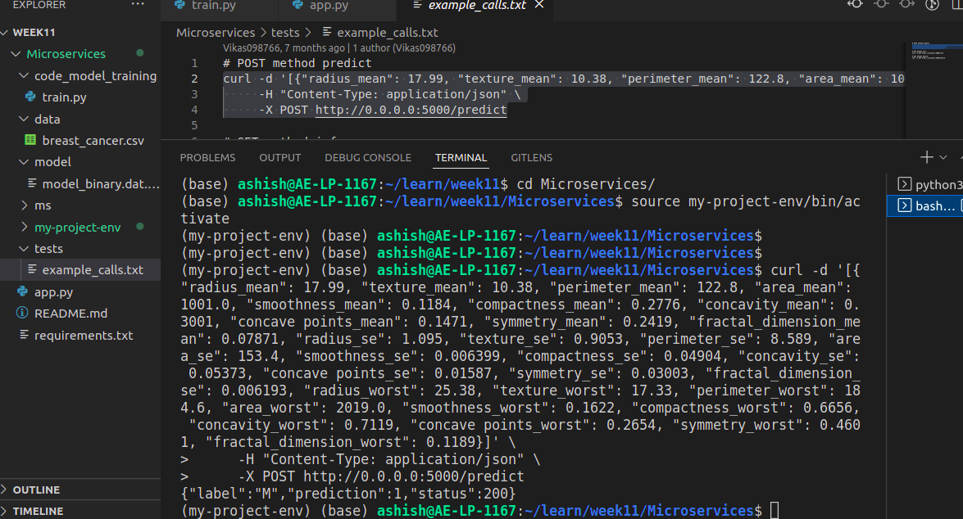

**10 : Create a docker image containing everything needed to run the application**

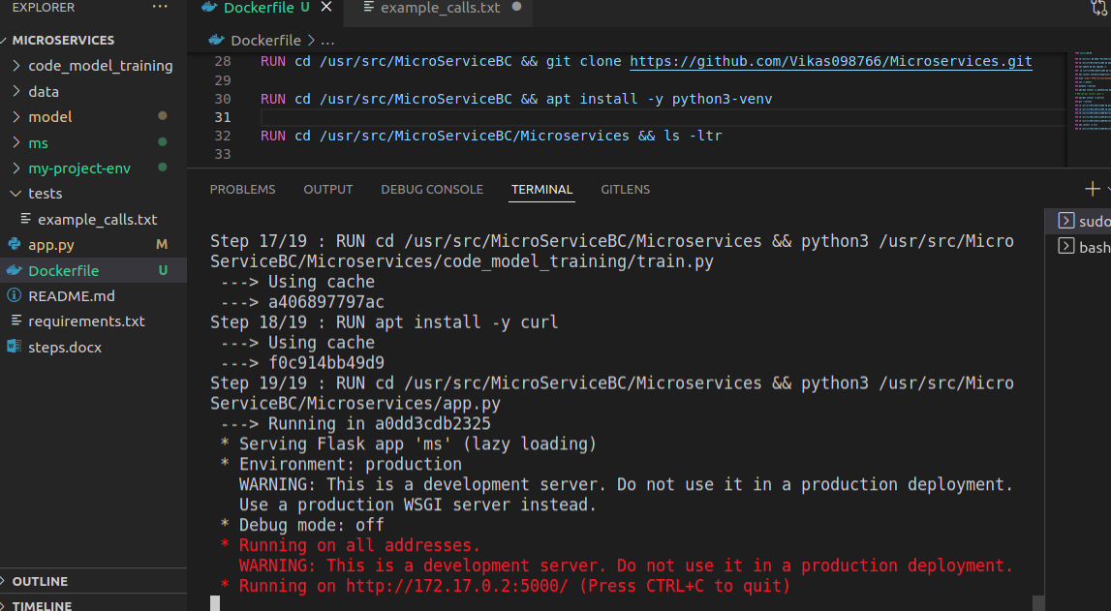

**11 : Run the containerized application as a prediction service and test it locally by passingsome example calls and get the prediction.**

