**GIT QUIZ**

**Ashish Kumar Singh**

**12104190**

**Q1.What is a version control system?**

**Sol:**

**Version control, also known as source control, is a method of tracking and managing changes to software code. A version control system is a software tool that helps software teams manage source code changes over time. As development environments accelerate, version control systems help software teams work faster and smarter. They are especially useful for DevOps teams as they help reduce development time and increase deployment success rates.**

**Q2.Why did a version control system develop? What were the necessities?**

**Sol:**

**Version control, as briefly described above, is a tool that helps developers/ programmers tackle some everyday problems, such as: tracking changes in the code, help to maintain the code, and allow them to work on the same source code files without affecting each other’s workflow.**

**The concept of version control is often facilitated through special kinds of systems called Version Control Systems (VCS). These systems have gone through many developments over recent years. Sometimes, VCSs are referred to as Source Code Management tools (SCM) or Revision Control Systems (RCS).**

**Q3.Define the different types of version control systems.**

**Sol:**

**Types of Version Control Systems**

**The two most common types are centralized and distributed. A centralized version control system stores all files in a central repository, while a distributed version control system stores files in multiple repositories. Other less common types are lock-based and optimistic.**

**Q4.List a few differences between the two version control system types.**

**Sol:**

**Types of Version Control Systems:**

**Centralized version control system: A centralized version control system contains only one repository in the world, and each user must agree to reflect changes in the repository. Updating may allow others to see your changes.**

**Distributed Version Control System: A distributed version control system contains multiple repositories. Each user has their own repository and working copy. Simply committing your changes will make them inaccessible to other users. This is because commits reflect changes in his local repository and must be committed for them to appear in the central repository. Similarly, when you update, you don't get changes made by others unless you pull those changes into the repository first.**

**To publish your changes to other users, you need four things.**

**Write**

**Push**

**Pull**

**Update**

**Q5.What is Git?**

**Sol:**

**Git is a DevOps tool used for source code management. It's a free, open source version control system that can be used to efficiently handle small to very large projects. Git is used to track source code changes and allows multiple developers to collaborate on non-linear development**

**Q6.List a few features of Git.**

**Sol:**

**Feature ofGit**

**Free and open source.**

**Supports non-linear development.**

**Make a backup.**

**Scalable.**

**Supports collaboration.**

**Branching made easier.**

**Distributed Development.**

**Q7.State any three commands of Git and why we use them.**

**Sol:**

**1. Git clone**

**Git clone is a command to download existing source code from a remote repository (such as Github). So Git Clone basically creates an identical copy of the latest version of your project in your repository and stores it on your computer.**

**2. Git Branches**

**Branches are very important in the Git world. Branches allow multiple developers to work in parallel on the same project at the same time. You can create, list, and delete branches using the git branch command.**

**3. Git Checkout**

**This is also one of the most commonly used Git commands. To work at a branch, you must first move there. Mainly use git checkout to switch from one branch to another. It can also be used to checkout files and commits.**

**Q8.Is Git the same as Github? Why or Why not?**

**Sol:**

**GIT is a version control system (VCS). A source tool that helps you track and manage your code. It is designed to allow programmers to coordinate and track changes to all files associated with their local directory. Unlike other version control systems, GIT is hassle-free, fast, and completely free to use.**

**GITHUB to GIT is the same as photography for people. It provides a graphical user interface to the GIT command line tool. Github is designed as a repository hosting service. It also offers a wide range of capabilities for collaborating on projects, solving problems, managing source code, and sharing ideas with people around the world. Additionally, it provides the functionality of GIT.**

**Q9.What is the command to get the installed version of Git?**

**Sol:**

**To check your current version of Git, run the git --version command in Terminal (Linux, macOS) or Command Prompt (Windows).**

**Q10.What is the command to add all files and changes of the current folder to the staging environment of the Git repository?**

**Sol:**

**The easiest way to add all files to your Git repository is to use the -A option after all the git add commands.**

**In this case, new (or untracked) files, deleted files, and changed files are added to the Git staging area. increase. They also say they are staged.**

**Q11. What is the difference between git status and git log commands?**

**Sol:**

**The git log command shows committed snapshots. You can list, filter, and search for specific changes in project history. git status lets you see your working directory and staging area, but git log only works for committed history.**

**Q12.What is the command to initialize Git on the current repository?**

**Sol:**

**Initialize a new repository: git init**

**Use the git init command to create a new repository. git init is a one-time command used during the initial setup of a new repository. Running this command will create a new .git subdirectory in your current working directory. This will also create a new main branch.**

**Q13.What are the different states of a file in Git? Explain them along with the associated commands.**

**Sol:**

**A Git workflow can be divided into three states.**

**working directory - change files in working directory**

**staging area (index) - stage files and add snapshots of them to staging area**

**git directory (repository) - commit makes files permanent Save it to a snapshot of your git directory. Checkout an existing version, make changes, deploy and commit.**

**Q14.Git automatically adds new files to the repository and starts tracking them. True or False? Give reasons.**

**Sol:**

**False**

**The git add command adds changes in the working directory to the staging area. Tell Git to include updates to specific files in the next commit.**

**Q15.What is the command to commit the staged changes for the Git repository?**

**Sol:**

**The git commit command is one of Git's most important core features. To select changes to be staged for the next commit, you must previously use the git add command. Then use git commit to get a snapshot of your staged changes along the timeline of your Git project history.**

**Q16.What is the command to commit with the message "New email"?**

**Sol:**

**You can change the email address associated with your Git commits using the git config command. The new email address you set will appear on all future commits you push to GitHub.com from the command line.**

**Q17.Draw the full workflow of Git and describe the diagram.**

**Sol:**

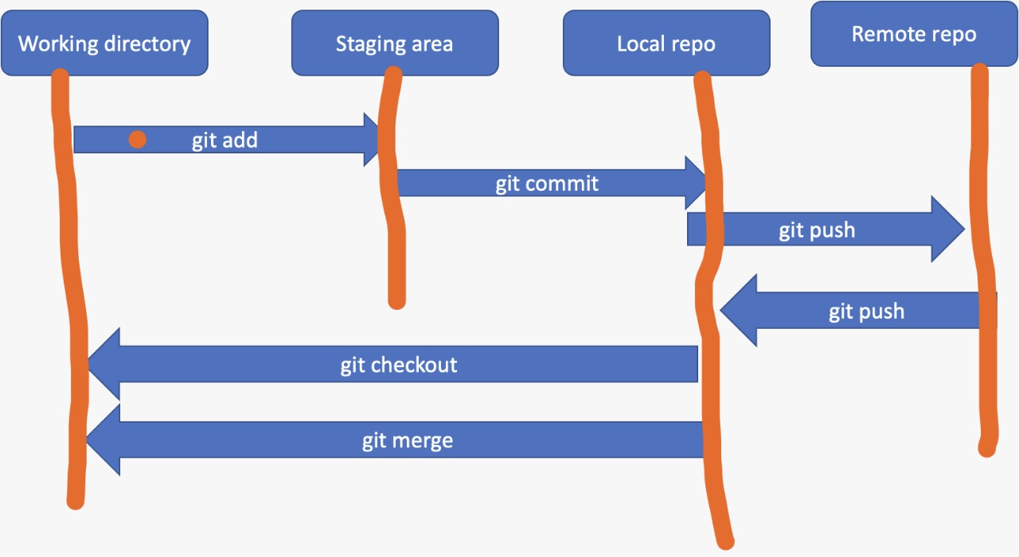

**Q18.What is a branch in Git?**

**Sol:**

**A branch, by itself, represents a line of development and serves as an abstraction for the edit/staging/commit process. You can think of this as a way to request an entirely new working directory, staging area, and project history.**

**Q19. What is the command to create a new branch named "new-email"?**

**Sol:**

**git branch new-email is the command to create new branch in existing repo.**

**Q20.What is the command to move to the branch named "new-email"?**

**Sol:**

**git checkout new-email is the command to move to the branch named "new-email"**

**Q21. What is the option, when moving to a branch, to create the branch it if it does not exist?**

**Sol:**

**An easy way to switch branches in Git is to use the git switch command and specify the name of the branch you want to switch to. The "-c" option (for "create branch") must be specified if the target branch does not exist. Otherwise, you'll get an error message when switching to this branch.**

**Q22.What does the git init command does?**

**Sol:**

**The git init command creates a new Git repository. It can be used to convert an existing non-versioned project to a Git repository, or to initialize a new empty repository.**

**Q23.What is a fork? How is it different from clone in Git? How do you fork and clone a repository?**

**Sol:**

**Public Git repositories can be forked or cloned. Forking creates a completely independent copy of a Git repository. Unlike forks, Git clones create linked copies and keep them in sync with the target repository**

**Q24. What does ‘push’ mean in Git? Give the command.**

**Sol:**

**The git push command is used to upload the contents of your local repository to a remote repository. Pushing transfers commits from your local repository to the remote repository.**

**Q25. Draw the standard architecture of two types of version control systems. (Hint - server project repo, working directories etc.) Explain the diagrams.**

**Sol:**

