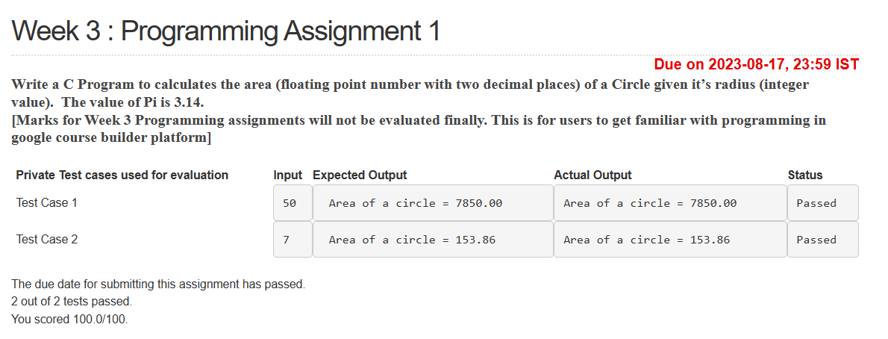

**Assignment submitted on 2023-08-11, 15:14 IST**

Your last recorded submission was:

#include <stdio.h>

#define PI 3.14

void main()

{

int radius;

float area;

scanf("%d", &radius);

area = PI * radius * radius;

printf("Area of a circle = %5.2f", area);

}

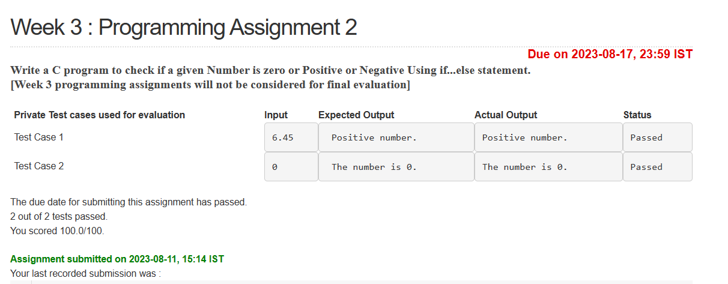

#include <stdio.h>

int main()

{

double number;

scanf("%lf", &number);

if(number>0)

printf("Positive number.");

else if(number<0)

printf("Negative number.");

else

printf("The number is 0.");

return 0;

}

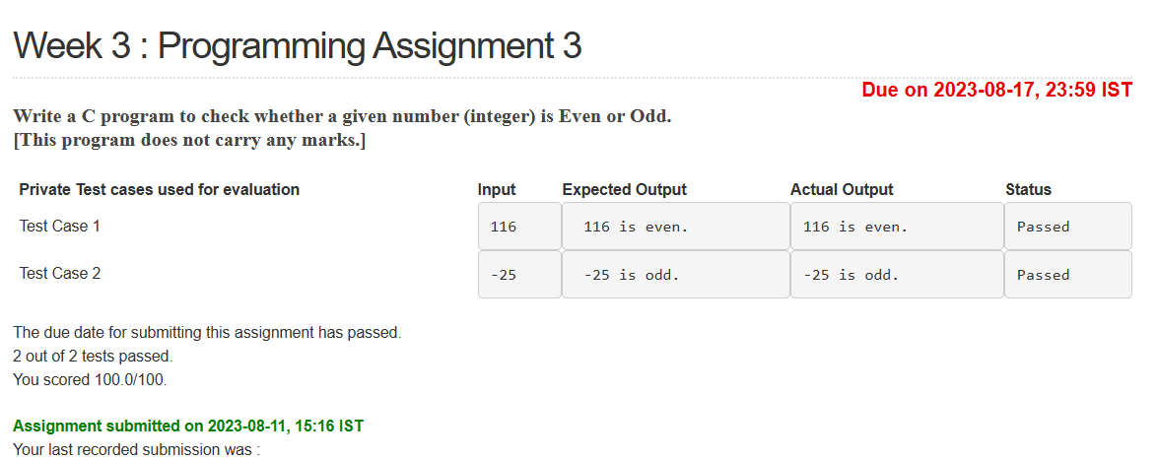

#include <stdio.h>

int main()

{

int number;

scanf("%d", &number); /*An integer number is taken from the test case */

printf("%d is even.", number);

printf("%d is odd.", number);

if(number%2==0)

printf("%d is even.", number);

else

printf("%d is odd.", number);

return 0;

}

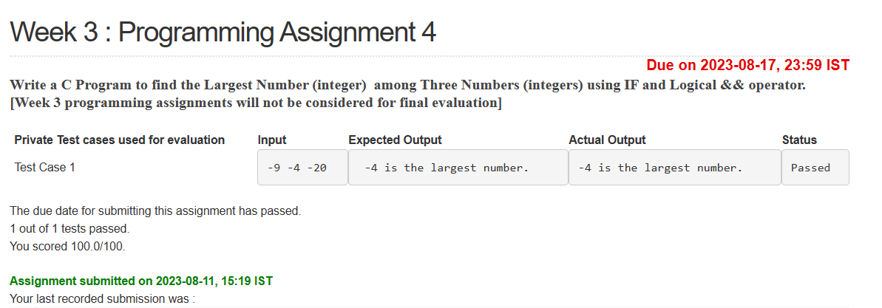

#include <stdio.h>

int main()

{

int n1, n2, n3;

scanf("%d %d %d", &n1, &n2, &n3); /*Three numbers are accepted from the test case */

if(n1>n2 && n1>n3)

printf("%d is the largest number.",n1);

else if(n2>n1 && n2>n3)

printf("%d is the largest number.",n2);

else

printf("%d is the largest number.",n3);

return 0;

}