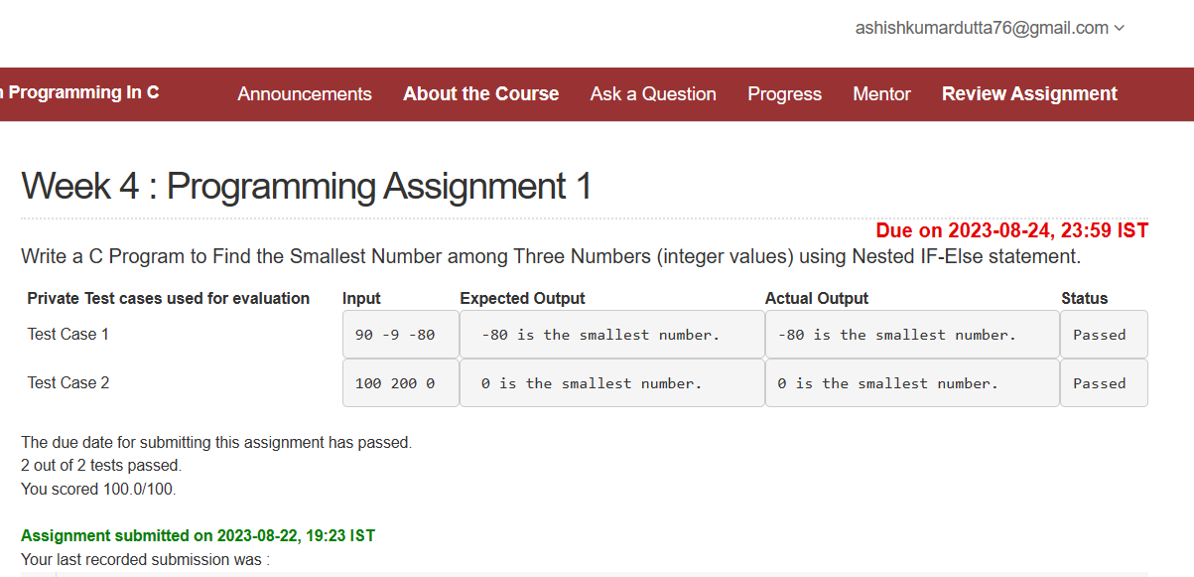

#include <stdio.h>

int main()

{

int n1, n2, n3;

scanf("%d %d %d", &n1, &n2, &n3);

if (n1<n2)

{

if(n1<n3)

printf("%d is the smallest number.", n1);

else

printf("%d is the smallest number.", n3);

}

else

{

if(n2<n3)

printf("%d is the smallest number.", n2);

else

printf("%d is the smallest number.", n3);

}

}

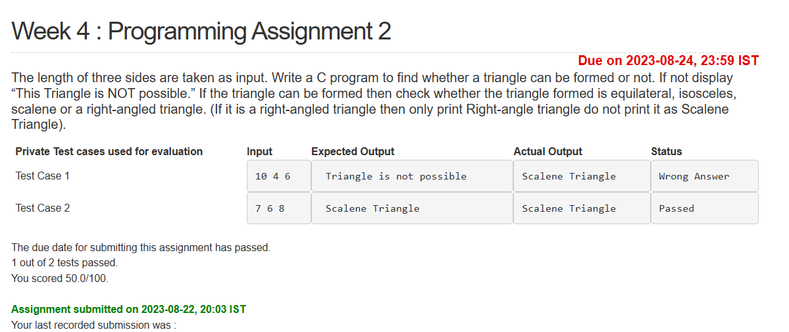

#include<stdio.h>

int main()

{

int a,b,c;

scanf("%d %d %d",&a, &b, &c);

if((a+b)>c || (a+c)>b || (b+c)>a)

{

if((a==b && b!=c) || (a==c && c!=b) || (b==c && c!=a))

printf("Isosceles Triangle");

else if(a==b && b==c)

printf("Equilateral Triangle");

else if((a\*a + b\*b == c\*c) || (a\*a + c\*c == b\*b) || (b\*b +c\*c == a\*a))

printf("Right-angle Triangle");

else

printf("Scalene Triangle");

}

else

printf("Triangle is not possible");

return 0;

}

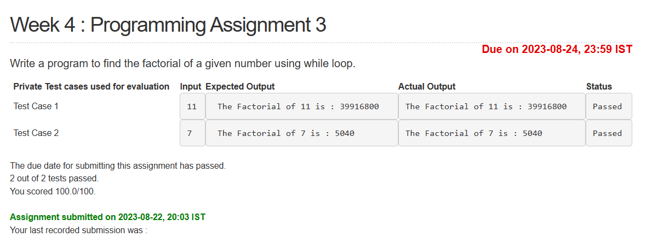

#include<stdio.h>

void main()

{

int n;

long int fact;

scanf("%d",&n);

fact = 1;

int i=1;

while(i<=n)

{

fact = fact\*i;

i+=1;

}

printf("The Factorial of %d is : %ld",n,fact);

}

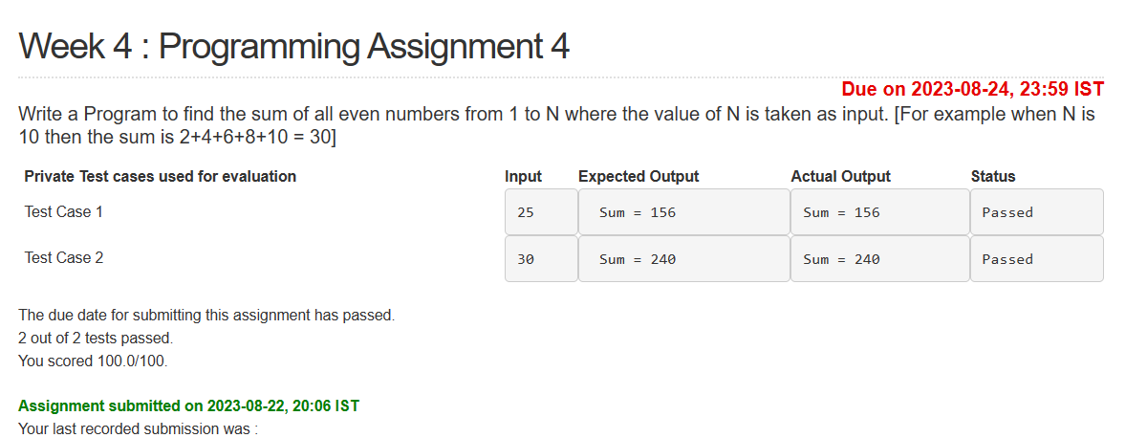

#include <stdio.h>

void main()

{

int N, sum=0;

scanf("%d", &N);

for(int i=1;i<=N;i++)

{

if(i%2==0)

sum+=i;

}

printf("Sum = %d", sum);

}