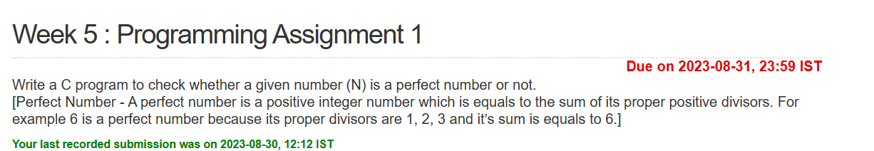

#include <stdio.h>

int main()

{

int N;

scanf("%d",&N);

int rem,sum=0;

for(int i=1;i<(N-1);i++)

{

rem = N%i;

if(rem == 0)

sum += i;

}

if(sum == N)

printf("%d is a perfect number.",N);

else

printf("%d is not a perfect number.",N);

return 0;

}

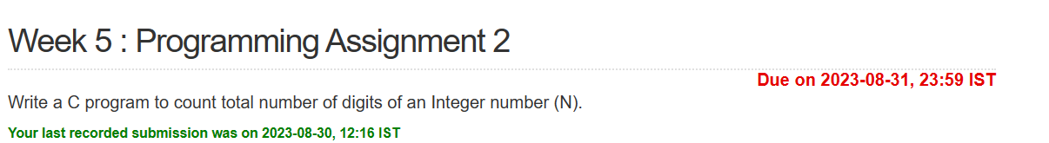

#include <stdio.h>

int main()

{

int N;

scanf("%d",&N);

int ct=0,p = N;

while(N!=0)

{

N/=10;

ct++;

}

printf("The number %d contains %d digits.",p,ct);

return 0;

}

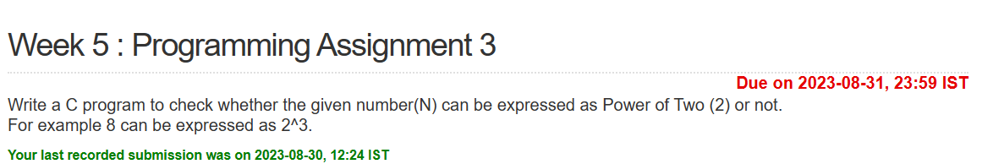

#include <stdio.h>

int main()

{ int N;

scanf("%d",&N);

int var = 2,flag = 0;

while(N/var != 0)

{

if(var<N)

var\*=2;

else if(var == N)

{

flag = 1;

break;

} }

if(flag == 1)

printf("%d is a number that can be expressed as power of 2.",N);

else if(flag == 0)

printf("%d cannot be expressed as power of 2.",N);

return 0; }

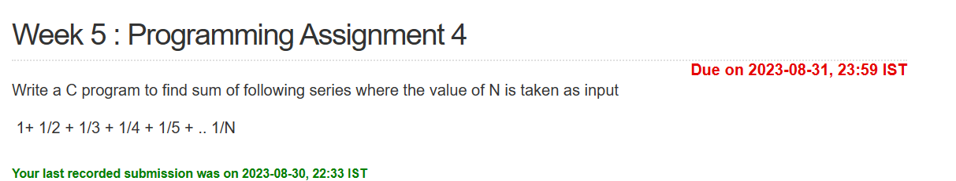

#include<stdio.h>

int main()

{

int N;

float sum = 0.0;

scanf("%d",&N);

int i;

for(i=1;i<=N;i++)

{

sum += ((float)1/(float)i);

}

printf("Sum of the series is: %.2f",sum);

return 0;

}