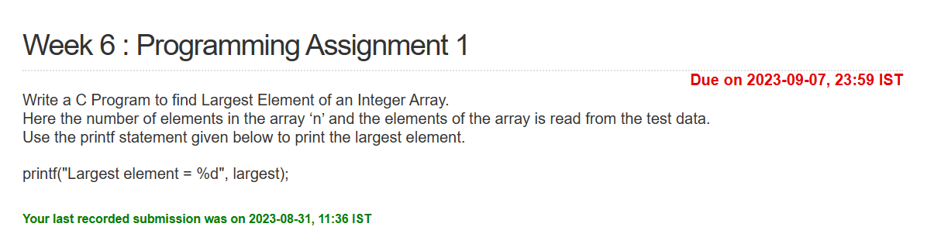int main()

{

int i, n, largest;

int arr[100];

scanf("%d", &n); /*Accepts total number of elements from the test data */

for(i = 0; i < n; ++i)

{

scanf("%d", &arr[i]); /* Accepts the array element from test data */

}

largest = arr[0];

for(i=0;i<n;i++)

{

if(arr[i] > largest)

largest = arr[i];

}

printf("Largest element = %d", largest);

}

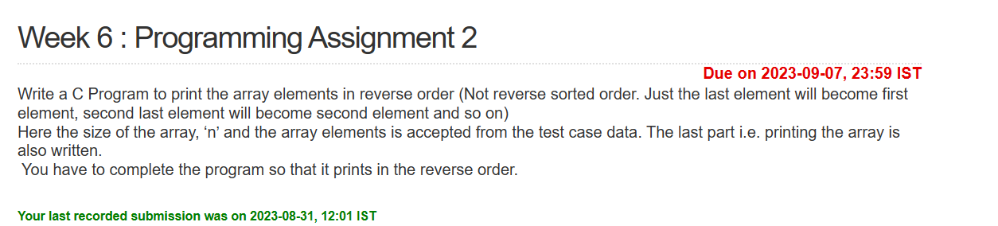

#include<stdio.h>

int main() {

int arr[20], i, n;

scanf("%d", &n);

for (i = 0; i < n; i++)

scanf("%d", &arr[i]);

int j,temp;

j = i-1;

i = 0;

while(i<j)

{

temp = arr[i];

arr[i] = arr[j];

arr[j] = temp;

i++;

j--;

}

for (i = 0; i < n; i++)

{

printf("%d\n", arr[i]); // For printing the array elements

}

return (0);

}

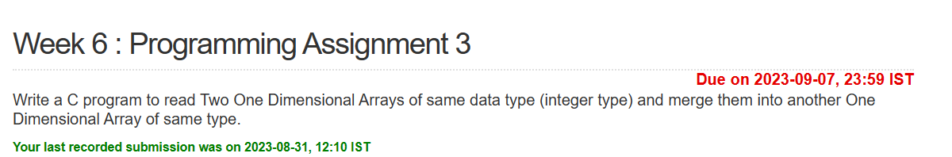#include<stdio.h>

int main()

{

int arr1[20], arr2[20], array_new[40], n1, n2, size, i;

scanf("%d", &n1); //Get the size of first array from test data and store it in n1.

for (i = 0; i < n1; i++)

scanf("%d", &arr1[i]); //Accepts the values for first array

scanf("%d", &n2); //Get the size of second array from test data and store it in n2.

for (i = 0; i < n2; i++)

scanf("%d", &arr2[i]); //Accepts the values for second array

//Marge two arrays

for(i=0;i<n1;i++)

{

array_new[i] = arr1[i];

}

size = n1+n2;

int j;

for(i=0,j=n1;i<n2 && j<size;i++,j++)

{

array_new[j] = arr2[i];

}

//Printing after merging

for (i = 0; i < size; i++) {

printf("%d\n", array_new[i]);

}

}

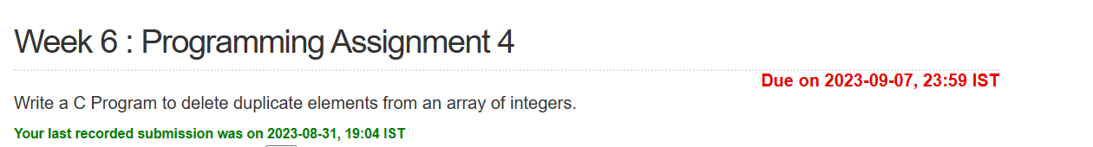

#include<stdio.h>

int main()

{

int array[50], i, size;

scanf("%d", &size);

for (i = 0; i < size; i++)

scanf("%d", &array[i]);

int j,k;

for(i=0;i<size;i++)

{

for(j=i+1;j<size;)

{

if(array[j] == array[i])

{

for(k=j;k<size;k++)

{

array[k] = array[k+1];

}

size--;

}

else

j++;

}

}

for (i = 0; i < size; i++) {

printf("%d\n", array[i]);

}

}