# ABSTRACT

Many a times you need to power an adjoining accessory circuit from the power supply used in the main module circuit. Here is a Short-Circuit Protection circuit to derive the additional power supply from the main circuit. The main circuit is protected from any damage due to short-circuit in the additional power supply circuit by cutting off the derived supply voltage. The derived supply voltage restores automatically when shorting is removed. An LED is used to indicate whether short-circuit exists or not.

The goal of this project is the main circuit is protected from any damage due to short-circuit in the additional power supply circuit by cutting off the derived supply voltage. The derived supply voltage restores automatically when shorting is removed. An LED is used to indicate whether short circuit exists or not.

# INTRODUCTION

This is a Short-Circuit Protection circuit to derive the additional power supply from the main circuit. The main circuit is protected from any damage due to short-circuit in the additional power supply circuit by cutting off the derived supply voltage. The derived supply voltage restores automatically when shorting is removed. An LED is used to indicate whether short-circuit exists or not.

In the main power supply circuit, 230V AC is stepped down by transformer X1 (230V AC primary to 0-9V, 300mA secondary), rectified by a full wave rectifier comprising diodes D1 through D4, filtered by capacitor C1 and regulated by IC 7805 to give regulated 5V (O/P1). Transistors SK100 and BC547 are used to derive the secondary output of around 5V (O/P2) from the main 5V supply (O/P1).

Working of the Short-circuit Protection circuit is simple. When the 5V DC output from regulator IC 7805 is available, transistor BC547 conducts through resistors R1 and R3 and LED1. As a result, transistor SK100 conducts and short-circuit protected 5V DC output appears across O/P2 terminals. The green LED (LED2) glows to indicate the same, while the red LED (LED1) remains off due to the presence of the same voltage at both of its ends.

When O/P2 terminals short, BC547 cuts off due to grounding of its base. As a result, SK100 is also cut-off. Thus during short-circuit, the green LED (LED2) turns off and the red LED (LED1) glows.

Capacitors C2 and C3 across the main 5V output (O/P1) absorb the voltage fluctuations occurring due to short-circuit in O/P2, ensuring disturbance-free O/P1. The design of the circuit is based on the relationship given below:

RB = (HFE X Vs)/ (1.3 X IL) where,

RB = Base resistances of transistors of SK100 and BC547 HFE = 200 for SK100 and 350 for BC547

Switching Voltage Vs = 5V

1.3 = Safety factor

IL = Collector-emitter current of transistors

Assemble the circuit on a general-purpose PCB and enclose in a suitable cabinet. Connect O/P1 and O/P2 terminals on the front panel of the cabinet. Also connect the mains power cord to feed 230V AC to the transformer. Connect LED1 and LED2 for visual indicators.

## BLOCK DIAGRAM

I/P

STEP DOWN

TRANSFORMER

|  |  |  |
| --- | --- | --- |
| RECTIFIE  R |  | |
|  |  |
| FILTER | |

SUPPLY SUPLLY

VOLTAGE REGULATOR

O/P

### Fig (1) Block diagram

The different elements and blocks of the system may be explained as follows:

**Ac Supply:**

It is the system voltage of the system, whose level is to be checked for abnormality.

It is taken from the bus or the ac mains.

## Step – down transformer:

The ac mains voltage is, under normal conditions, a large value of the order of 230

1. It is stepped – down to a lower and safer value that can be applied to the comparator, with the help of a step – down transformer.

## Rectifier:

The stepped – down ac voltage is converted into a corresponding dc value, using a

rectifier. It can be done using different rectifier circuits employing different solid-state devices like the diodes, thyristor bridges, etc.

## Filter:

The output of the rectifier is a pulsating and intermittent dc signal. The ripples in this

signal are filtered out using a filter, to obtain a unidirectional dc signal. It can be made using different combinations of passive components.

## Reference Voltage Source:

It is a source of constant voltage, whose value is maintained under all circumstances. It corresponds to a pre-decided value, representing the reference system nominal voltage, for which the relay is rated. It may be provided using a battery or any other method.

## 7805 VOLTAGE REGULATOR

Voltage regulator ICs is available with fixed (typically 5, 12 and 15V) or variable output voltages. The maximum current they can pass also rates them. Negative voltage regulators are available, mainly for use in dual supplies.

Most regulators include some automatic protection from excessive current ('overload protection') and overheating ('thermal protection'). Many of the fixed voltage regulators ICs have 3 leads and look like power transistors, such as the 7805 +5V 1A regulator shown on the right.

## CIRCUIT DIAGRAM

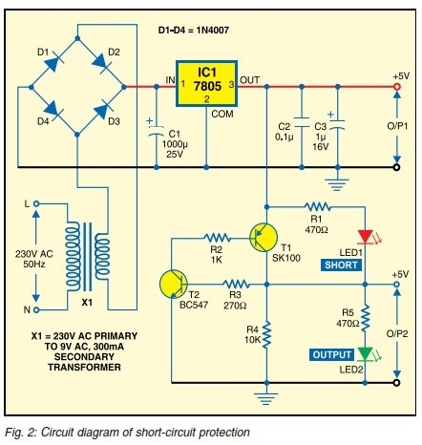

**Description**

This Project mainly consists of Power Supply section, transformer, rectifier , filter, voltage regulator

## Power Supply Section:

This section is meant for supplying Power to all the sections mentioned above. It basically consists of a Transformer to step down the 230V ac to 9V ac followed b1y diodes. Here diodes are used to rectify the ac to dc. After rectification the obtained rippled dc is filtered using a capacitor Filter. A positive voltage regulator is used to regulate the obtained dc voltage.

This regulated 5V is generated by first stepping down the 230V to 9V by the step down transformer. The step downed a.c. voltage is being rectified by the Bridge Rectifier. The diodes used are 1N4007. The rectified a.c voltage is now filtered using a ‘C’ filter. Now the rectified, filtered D.C. voltage is fed to the Voltage Regulator.

This voltage regulator allows us to have a Regulated Voltage which is +5V.The rectified; filtered and regulated voltage is again filtered for ripples using an electrolytic capacitor 1000μF.,0.1 μF.,1 μF.

## REGULATED POWER SUPPLY

The power supplies are designed to convert high voltage AC mains electricity to a suitable low voltage supply for electronic circuits and other devices.

A **RPS** (**Regulated Power Supply**) is the Power Supply with Rectification, Filtering and Regulation being done on the AC mains to get a Regulated power supply for Microcontroller and for the other devices being interfaced to it.

A power supply can by broken down into a series of blocks, each of which performs a particular function. A d.c power supply which maintains the output voltage constant irrespective of a.c mains fluctuations or load variations is known as “Regulated D.C Power Supply”

For example a 5V regulated power supply system as shown below:

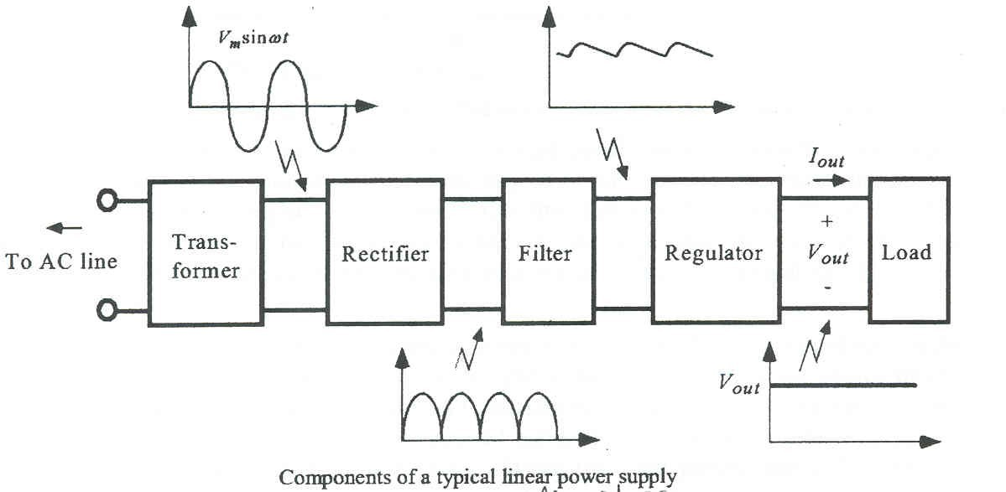

Fig (3) power supply

## Types of Power Supply

There are many types of power supply. Most are designed to convert high voltage AC mains electricity to a suitable low voltage supply for electronics circuits and other devices. A power supply can by broken down into a series of blocks, each of which performs a particular function.

For example a 5V regulated supply:

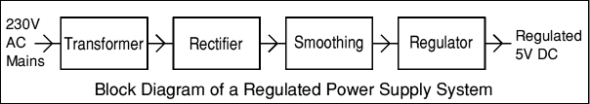

### Fig (4) types of power supply

Each of the blocks is described in more detail below:

* Transformer - steps down high voltage AC mains to low voltage AC.
* Rectifier - converts AC to DC, but the DC output is varying.
* Smoothing - smooth the DC from varying greatly to a small ripple.
* Regulator - eliminates ripple by setting DC output to a fixed voltage

## Transformer

A transformer is an electrical device which is used to convert

electrical power from one Electrical circuit to another without change in frequency.

Transformers convert AC electricity from one voltage to another with little loss of power. Transformers work only with AC and this is one of the reasons why mains electricity is AC. Step-up transformers increase in output voltage, step-down transformers decrease in output voltage. Most power supplies use a step-down transformer to reduce the dangerously high mains voltage to a safer low voltage.

The input coil is called the primary and the output coil is called the secondary. There is no electrical connection between the two coils; instead they are linked by an alternating magnetic field created in the soft-iron core of the transformer. The two lines in the middle of the circuit symbol represent the core.

Transformers waste very little power so the power out is (almost) equal to the power in. Note that as voltage is stepped down current is stepped up. The ratio of the number of turns on each coil, called the turn’s ratio, determines the ratio of the voltages. A step-down transformer has a large number of turns on its primary (input) coil which is connected to the high voltage mains supply, and a small number of turns on its secondary (output) coil to give a low output voltage.

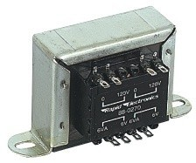

Fig (5) AN ELECTRICAL TRANSFORMER

Turns ratio = Vp/ VS = Np/NS

Power Out= Power In

VS X IS=VP X I

PVp = primary (input) voltage

Np = number of turns on primary coil Ip = primary (input) current

## Step down transformer

We are using are a step-down transformer. The supply from the But, our micro controller requires only 5V of DC power supply. So, we are using a step

– down transformer which converts 230V of AC supply in to 12V of AC supply. This 12V of supply is down converted in to 5V of supply using power supply.

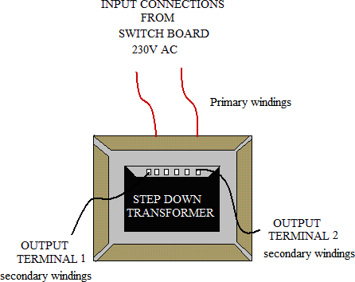

### Fig(6) STEP DOWN TRANSFORMER

The Step down Transformer is used to step down the main supply voltage from 230V AC to lower value. This 230 AC voltage cannot be used directly, thus i t i s s t epped down. The Transformer consists of primary and secondary coils.

To reduce or step down the voltage, the transformer is designed to contain less number of turns in its secondary core. The output from the secondary coil is also AC waveform. Thus the conversion from AC to DC is essential. This conversion is achieved by using the Rectifier Circuit/Unit.

Step down transformers can step down incoming voltage, which enables you to have the correct voltage input for your electrical needs. For example, if our equipment has been specified for input voltage of 12 volts, and the main power supply is 230 volts, we will need a step down transformer, which decreases the incoming electrical voltage to be compatible with your 12 volt equipment.

## How does a Step down Transformer work?

The basic concept of a transformer is that is has step up or step down power. Without these transformers, distribution of our electric power over long distances would be impossible. There a primary circuit and a secondary circuit. There is no connection between the two circuits, but each of these circuits contains a winding, which links it inductively to the other circuits. The windings are wound onto an iron core.

The iron core channels the magnetic flux generated by the current flowing around the primary winding, and as much as possible, also links the secondary winding. The ratio of the peak voltages and peak currents in the primary and secondary windings are determined by the ratio of the number of turns in the primary and secondary windings.

The latter ratio is usually called the turn ratio of the transformer. If the secondary winding contains less turns than the primary winding, the peak voltage in the secondary circuit is less than that of the primary circuit. This type of transformer is called a step down transformer.

When choosing a **step down transformer** or any transformer, it should be efficient and should dissipate as little power as possible. Efficiency is obtained by using special steel alloys to couple the induced magnetic fields between the primary and secondary windings.

Efficiency can be increased by reducing the heat and choosing the right metal type for the windings. Copper windings are the most efficient and may cost more initially, but they will save you money and energy and will be less maintenance. For high- quality materials and transformers manufactured with copper, [Step Down Transformer's](http://www.temcotransformer.com/step-down-transformers.html)

Always remember, when purchasing a **step down transformer,** seek out a more reputable and experienced manufacturer such as TEMCO or [Acme Transformers](http://www.electricalpowertransformer.com/step-down.html). A quality manufacturer will save you money in the long run and will

## SPECIFICATIONS

* + TYPE: 12a
  + CORE: E & I
  + GF bobbin where GF à Graphite
  + Primary Windings: 42 gauge & 3600 turns
  + Secondary Windings: 27gauge & 28 turns
  + Step down Voltage: 230V AC to 12V AC.

The functionality of step down transformer is it senses the EMI. The output of the step down transformer is given to bridge rectifier. D1, D2, D3, D4 come under bridge rectifier. The bridge rectifier is formed with 1N4007 diodes. The bridge rectifier converts the AC Voltage into DC Voltage.

i/p

VOLTAGE REGULATOR

FILTER CIRCUIT

Bridge rectifier

Step down transformer

supply ac o/p supply

## Rectifier circuit

The Rectifier circuit is used to convert the AC voltage into its corresponding DC voltage. The process of conversion A.C to D.C is called “rectification”

**TYPES OF RECTIFIERS:**

* Half wave Rectifier
* Full wave rectifier
  1. Centre tap full wave rectifier.
  2. Bridge type full bridge rectifier

There are Half-Wave, Full-Wave and bridge Rectifiers available for this specific function. The most important and simple device used in Rectifier circuit is the diode. The simple function of the diode is to conduct when forward biased and not to conduct in reverse bias.

**Half-Wave Rectifiers**:

An easy way to convert ac to pulsating dc is to simply allow half of the ac cycle to pass, while blocking current to prevent it from flowing during the other half cycle. The figure to the right shows the resulting output. Such circuits are known as **half-wave rectifiers** because they only work on half of the incoming ac wave.

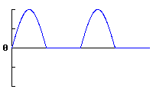

**Full-Wave Rectifiers**

The more common approach is to manipulate the incoming ac wave so that both halves are used to cause output current to flow in the same direction. The resulting waveform is shown to the right. Because these circuits operate on the entire incoming ac wave, they are known as full-wave rectifiers.

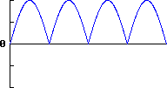

**Bridge rectifier**

A bridge rectifier makes use of four diodes in a bridge arrangement to achieve full-wave rectification. This is a widely used configuration, both with individual diodes wired as shown and with single component bridges where the diode bridge is wired internally.

A diode bridge or bridge rectifier is an arrangement of four [diodes](http://en.wikipedia.org/wiki/Diode) in a [bridge](http://en.wikipedia.org/wiki/Bridge_circuit) configuration that provides the same [polarity](http://en.wikipedia.org/wiki/Polarity_(physics)) of output [voltage](http://en.wikipedia.org/wiki/Volt) for either polarity of input voltage. When used in its most common application, for conversion of [alternating current](http://en.wikipedia.org/wiki/Alternating_current) (AC) input into direct (DC) output, it is known as a bridge rectifier.

A bridge rectifier provides full from a two-wire AC input, resulting in lower cost and weight as compared to a [center-tapped](http://en.wikipedia.org/wiki/Center_tap) design. The Forward Bias is achieved by connecting the diode’s positive with positive of the battery and negative with battery’s negative. The efficient circuit used is the Full wave Bridge rectifier c i rcuit.

The output voltage of the rectifier i s in r ippled form, the r ipples f rom the obtained DC voltage are removed using other circuits available. The circuit used for removing the ripples is called Filter circuit.

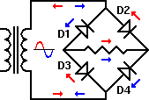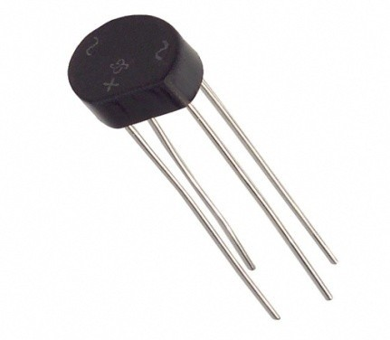

**Fig (7) Bridge rectifier diagram**

## Operation:

During positive half cycle of secondary, the diodes D2 and D3 are in forward

biased while D1 and D4 are in reverse biased as shown in the fig(b). The current flow direction is shown in the fig (b) with dotted arrows.

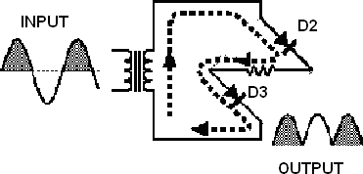

**Fig (7.1) operation of positive half cycle**

During negative half cycle of secondary voltage, the diodes D1 and D4 are in forward biased while D2 and D3 are in reverse biased as shown in the fig(c). The current flow direction is shown in the fig (c) with dotted arrows.

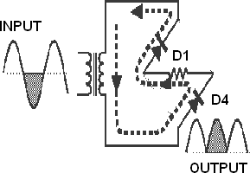

**Fig(7.2) operation of negative half cycle**

## Comparison of rectifier circuits:

|  |  |  |  |
| --- | --- | --- | --- |
| **Parameter** | **Type of Rectifier** | | |
| **Half wave Full wave Bridge** | | |
| Number of diodes | 1 | 2 | 4 |
| PIV of diodes | Vm | 2Vm | Vm |
| D.C output voltage | Vm/ | 2Vm/ | 2Vm/ |
| Vdc,at no-load | 0.318Vm | 0.636Vm | 0.636Vm |

|  |  |  |  |
| --- | --- | --- | --- |
| Ripple factor | 1.21 | 0.482 | 0.482 |
| Ripple  frequency | f | 2f | 2f |
| Rectification  efficiency | 0.406 | 0.812 | 0.812 |
| Transformer Utilization  Factor(TUF) | 0.287 | 0.693 | 0.812 |
| RMS voltage Vrms | Vm/2 | Vm/√2 | Vm/√2 |

**Fig (8) comparison of rectifier**

## Filter

A Filter is a device which removes the a.c component of rectifier output but allows the d.c component to reach the load

## Capacitor Filter:

A **capacitor** (formerly known as **condenser**) is a [passive](http://en.wikipedia.org/wiki/Passivity_(engineering)) [two-](http://en.wikipedia.org/wiki/Terminal_(electronics)) [terminal](http://en.wikipedia.org/wiki/Terminal_(electronics)) [electrical component](http://en.wikipedia.org/wiki/Electronic_component) used to store [energy](http://en.wikipedia.org/wiki/Energy) in an [electric field](http://en.wikipedia.org/wiki/Electric_field). The forms of practical capacitors vary widely, but all contain at least two [electrical conductors](http://en.wikipedia.org/wiki/Electrical_conductor) separated by a [dielectric](http://en.wikipedia.org/wiki/Dielectric)(insulator); for example, one common construction consists of metal foils separated by a thin layer of insulating film. Capacitors are widely used as parts of [electrical circuits](http://en.wikipedia.org/wiki/Electrical_circuit) in many common electrical devices.

* While the output of a rectifier is a pulsating dc, most electronic circuits require a substantially pure dc for proper operation.
* This type of output is provided by single or multi section filter circuits placed between the output of the rectifier and the load.
* There are four basic types of filter circuits:
* Simple capacitor filter
* LC choke-input filter
* LC capacitor-input filter(pi-type)
* RC capacitor-input filter(pi-type)

The function of each of these filters will be covered in detail in this chapter.

* Filtering is accomplished by the use of capacitors, inductors, and/or resistors in various combinations.
* Inductors are used as series impedances to oppose the flow of alternating (pulsating dc) current. Capacitors are used as shunt elements to bypass the alternating components of the signal around the load (to ground).
* Resistors are used in place of inductors in low current applications.

Let's briefly review the properties of a capacitor. First, a capacitor opposes any change in voltage. The opposition to a change in current is called capacitive reactance (XC) and is measured in ohms. The capacitive reactance is determined by the frequency (f) of the applied voltage and the capacitance (C) of the capacitor.



From the formula, you can see that if frequency or capacitance is increased, the XC decreases. Since filter capacitors are placed in parallel with the load, a low XC will provide better filtering than a high XC. For this to be accomplished, a better shunting effect of the ac around the load is provided, as shown in figure 9.1,9.2

To obtain a steady dc output, the capacitor must charge almost instantaneously to the value of applied voltage. Once charged, the capacitor must retain the charge as long as possible. The capacitor must have a short charge time constant (view A). This can be accomplished by keeping the internal resistance of the power supply as small as possible (fast charge time) and the resistance of the load as large as possible (for a slow discharge time as illustrated in view B).

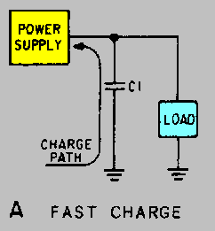

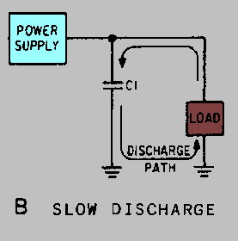Figure (9.1). - Capacitor filter. FAST CHARGE

Figure (9.2) - Capacitor filter. SLOW DISCHARGE

From your earlier studies in basic electricity, you may remember that one time constant is defined as the time it takes a capacitor to charge to 63.2 percent of the applied voltage or to discharge to 36.8 percent of its total charge. This action can be expressed by the following equation:

t = RC

Where:

R represents the resistance of the charge or discharge path &

C represents the capacitance of the capacitor.

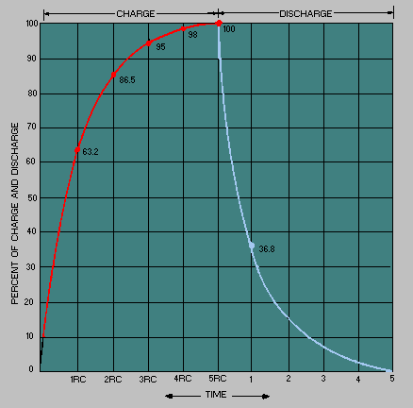You should also recall that a capacitor is considered fully charged after five RC time constants. Refer to figure 9.3. You can see that a steady dc output voltage is obtained when the capacitor charges rapidly and discharges as slowly as possible.

**Figure (9.3) - RC time constant.**

In filter circuits the capacitor is the common element to both the charge and the discharge paths. Therefore, to obtain the longest possible discharge time, you want the capacitor to be as large as possible. Another way to look at it is: The capacitor acts as a short circuit around the load (as far as the ac component is concerned), and since



the larger the value of the capacitor (C), the smaller the opposition (XC) or reactance to ac. Now let's look at inductors and their application in filter circuits.

Remember, AN INDUCTOR OPPOSES ANY CHANGE IN

CURRENT. In case you have forgotten, a change in current through an inductor produces a changing electromagnetic field. The changing field, in turn, cuts the windings of the wire in the inductor and thereby produces a counter electromotive force (CEMF). It is the CEMF that opposes the change in circuit current.

Opposition to a change in current at a given frequency is called inductive reactance (XL) and is measured in ohms. The inductive reactance (XL) of an inductor is determined by the applied frequency and the inductance of the inductor.

Mathematically, XL f L= 2

If frequency or inductance is increased, the XL increases. Since inductors are placed in series with the load (as shown in figure 9.4), the larger the XL, the larger the ac voltage developed across the load.

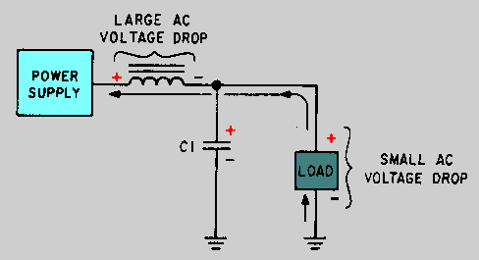

Figure (9.4). - Voltage drops in an inductive filter.

Now refer to figure (9.5) When the current starts to flow through the coil, an expanding magnetic field builds up around the inductor. This magnetic field around the coil develops the CEMF that opposes the change in current. When the rectifier current decreases, as shown in figure ( 9.6)

The magnetic field collapses and again cuts the turns (windings) of wire, thus inducing current into the coil. This additional current merges with the rectifier current and attempts to keep it at its original level.

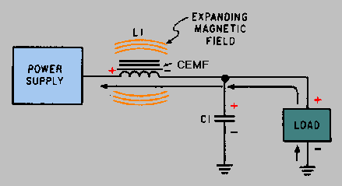

Figure (9.5) - Inductive filter (expanding field).

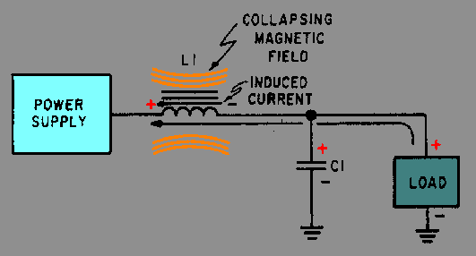

Figure (9.6) - Inductive filter (collapsing field).

Now that you have read how the components in a filter circuit react to current flow from the rectifier, the different types of filter circuits in use today will be discussed.

When there is a [potential difference](http://en.wikipedia.org/wiki/Potential_difference) (voltage) across the conductors, a static [electric field](http://en.wikipedia.org/wiki/Electric_field) develops across the dielectric, causing positive charge to collect on one plate and negative charge on the other plate. [Energy](http://en.wikipedia.org/wiki/Energy) is stored in the electrostatic field.

An ideal capacitor is characterized by a single constant value, [capacitance](http://en.wikipedia.org/wiki/Capacitance), measured in [farads](http://en.wikipedia.org/wiki/Farad). This is the ratio of the [electric charge](http://en.wikipedia.org/wiki/Electric_charge) on each conductor to the potential difference between them.

The capacitance is greatest when there is a narrow separation between large areas of conductor, hence capacitor conductors are often called "plates," referring to an early means of construction. In practice, the dielectric between the plates passes a small amount of [leakage current](http://en.wikipedia.org/wiki/Leakage_(electronics)) and also has an electric field strength limit, resulting in a [breakdown voltage](http://en.wikipedia.org/wiki/Breakdown_voltage), while the conductors and [leads](http://en.wikipedia.org/wiki/Lead_(electronics)) introduce an undesired [inductance](http://en.wikipedia.org/wiki/Equivalent_series_inductance) and [resistance](http://en.wikipedia.org/wiki/Equivalent_series_resistance).

Capacitors are widely used in electronic circuits for blocking [direct](http://en.wikipedia.org/wiki/Direct_current) [current](http://en.wikipedia.org/wiki/Direct_current) while allowing [alternating current](http://en.wikipedia.org/wiki/Alternating_current) to pass, in filter networks, for smoothing the output of [power supplies](http://en.wikipedia.org/wiki/Power_supply), in the [resonant circuits](http://en.wikipedia.org/wiki/LC_circuit) that tune radios to particular [frequencies](http://en.wikipedia.org/wiki/Frequency) and for many other purposes

In October 1745, [Ewald Georg von Kleist](http://en.wikipedia.org/wiki/Ewald_Georg_von_Kleist) of [Pomerania](http://en.wikipedia.org/wiki/Pomerania) in Germany found that charge could be stored by connecting a high-voltage [electrostatic generator](http://en.wikipedia.org/wiki/Electrostatic_generator) by a wire to a volume of water in a hand-held glass jar. Von Kleist's hand and the water acted as conductors and the jar as a dielectric (although details of the mechanism were incorrectly identified at the time).

Von Kleist found, after removing the generator that touching the wire resulted in a painful spark. In a letter describing the experiment, he said "I would not take a second shock for the kingdom of France." The following year, the Dutch physicist [Pieter van](http://en.wikipedia.org/wiki/Pieter_van_Musschenbroek) [Musschenbroek](http://en.wikipedia.org/wiki/Pieter_van_Musschenbroek) invented a similar capacitor, which was named the [Leyden jar](http://en.wikipedia.org/wiki/Leyden_jar), after the [University of Leiden](http://en.wikipedia.org/wiki/Leiden_University) where he worked.

[Daniel Gralath](http://en.wikipedia.org/wiki/Daniel_Gralath) was the first to combine several jars in parallel into a "battery" to increase the charge storage capacity. [Benjamin Franklin](http://en.wikipedia.org/wiki/Benjamin_Franklin) investigated the [Leyden](http://en.wikipedia.org/wiki/Leyden_jar) [jar](http://en.wikipedia.org/wiki/Leyden_jar) and "proved" that the charge was stored on the glass, not in the water as others had assumed.

He also adopted the term "battery", (denoting the increasing of power with a row of similar units as in a [battery of cannon](http://en.wikipedia.org/wiki/Artillery_battery)), subsequently applied to [clusters of](http://en.wikipedia.org/wiki/Battery_(electricity)) [electrochemical cells](http://en.wikipedia.org/wiki/Battery_(electricity)). Leyden jars were later made by coating the inside and outside of jars with metal foil, leaving a space at the mouth to prevent arcing between the foils. The earliest unit of capacitance was the 'jar', equivalent to about 1 [nano farad](http://en.wikipedia.org/wiki/Farad)

Leyden jars or more powerful devices employing flat glass plates alternating with foil conductors were used exclusively up until about 1900, when the invention of [wireless](http://en.wikipedia.org/wiki/Wireless_telegraphy) ([radio](http://en.wikipedia.org/wiki/Radio)) created a demand for standard capacitors, and the steady move to higher [frequencies](http://en.wikipedia.org/wiki/Frequency) required capacitors with lower [inductance](http://en.wikipedia.org/wiki/Inductance)

A more compact construction began to be used of a flexible dielectric sheet such as oiled paper sandwiched between sheets of metal foil, rolled or folded into a small package.

Early capacitors were also known as condensers, a term that is still occasionally used today. The term was first used for this purpose by [Alessandro Volta](http://en.wikipedia.org/wiki/Alessandro_Volta) in 1782, with reference to the device's ability to store a higher density of electric charge than a normal isolated conductor.

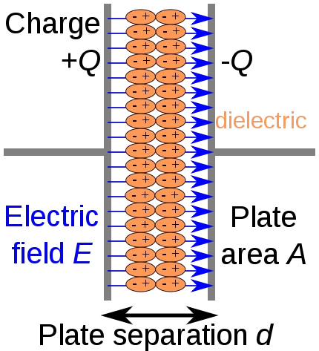

### Figure (10) capacitor

We have seen that the ripple content in the rectified output of half wave rectifier is **121%** or that of full-wave or bridge rectifier or bridge rectifier is **48%** such high

percentages of ripples is not acceptable for most of the applications. Ripples can be removed by one of the following methods of filtering.

1. A capacitor, in parallel to the load, provides an easier by –pass for the ripples voltage though it due to low impedance. At ripple frequency and leave the D.C. to appear at the load.
2. An inductor, in series with the load, prevents the passage of the ripple current (due to high impedance at ripple frequency) while allowing the d.c (due to low resistance to d.c)



1. Various combinations of capacitor and inductor, such as L-section filter section filter, multiple section filter etc. which make use of both the properties mentioned in (a) and (b) above. Two cases of capacitor filter, one applied on half wave rectifier and another with full wave rectifier.

Filtering is performed by a large value electrolytic capacitor connected across the DC supply to act as a reservoir, supplying current to the output when the varying DC voltage from the rectifier is falling. The capacitor charges quickly near the peak of the varying DC, and then discharges as it supplies current to the output. Filtering significantly increases the average DC voltage to almost the peak value (1.4 × RMS value).

To calculate the value of capacitor(C),

C = ¼*√3*f*r*Rl

Where,

f = supply frequency, r = ripple factor,

Rl = load resistance

**Note**: In our circuit we are using 1000µF hence large value of capacitor is placed to reduce ripples and to improve the DC component.

An **electrolytic capacitor** is a type of [capacitor](http://en.wikipedia.org/wiki/Capacitor) that uses an [electrolyte](http://en.wikipedia.org/wiki/Electrolyte), an ionic conducting liquid, as one of its plates, to achieve a larger [capacitance](http://en.wikipedia.org/wiki/Capacitance) per unit volume than other types. They are often referred to in [electronics](http://en.wikipedia.org/wiki/Electronics) usage simply as "electrolytics"[*citation*

*needed*].

They are used in relatively high-current and low-frequency electrical [circuits](http://en.wikipedia.org/wiki/Electrical_network), particularly in [power supply](http://en.wikipedia.org/wiki/Power_supply) filters, where they store charge needed to moderate output voltage and current fluctuations in [rectifier](http://en.wikipedia.org/wiki/Rectifier) output. They are also widely used as coupling capacitors in circuits where [AC](http://en.wikipedia.org/wiki/Alternating_current) should be conducted but [DC](http://en.wikipedia.org/wiki/Direct_current) should not. There are two types of electrolytic aluminum and [tantalum](http://en.wikipedia.org/wiki/Tantalum_capacitor).

The standard design requires that the applied voltage must be polarized; one specified terminal must always have positive potential with respect to the other. Therefore they cannot be used with AC signals without a DC polarizing bias. However there are special non-polarized electrolytic capacitors for AC use which do not require a DC bias.

Electrolytic capacitors also have relatively low breakdown voltage, higher leakage current and inductance, poorer tolerances and temperature range, and shorter lifetimes compared to other types of capacitors.

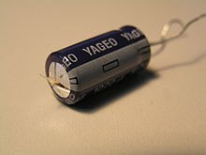

Figure 10.1 capacitor

## A Single Capacitor

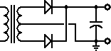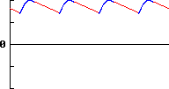

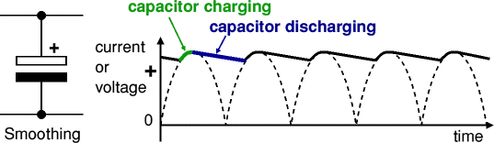

**Figure (10.3) output waveforms of single capacitor**

If we place a capacitor at the output of the full-wave rectifier as shown to the left, the capacitor will charge to the peak voltage each half-cycle, and then will discharge more slowly through the load while the rectified voltage drops back to zero before beginning the next half-cycle. Thus, the capacitor helps to fill in the gaps between the peaks, as shown in red in the first figure to the right.

Although we have used straight lines for simplicity, the decay is actually the normal exponential decay of any capacitor discharging through a load resistor. The extent to which the capacitor voltage drops depends on the capacitance of the capacitor and the amount of current drawn by the load; these two factors effectively form the RC time constant for voltage decay.

As a result, the actual voltage output from this combination never drops to zero, but rather takes the shape shown in the second figure to the right. The blue portion of the waveform corresponds to the portion of the input cycle where the rectifier provides current to the load, while the red portion shows when the capacitor provides current to the load. As you can see, the output voltage, while not pure dc, has much less variation (or *ripple*, as it is called) than the unfiltered output of the rectifier.

A half-wave rectifier with a capacitor filter will only recharge the capacitor on every other peak shown here, so the capacitor will discharge considerably more between input pulses.

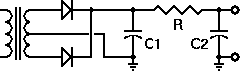

Nevertheless, if the output voltage from the filter can be kept high enough at all times, the capacitor filter is sufficient for many kinds of loads, when followed by a suitable regulator circuit.

**RC Filters:**

**Figure (10.4) RC filter circuit diagram**

In order to reduce the ripple still more without losing too much of the dc output, we need to extend the filter circuit a bit. The circuit to the right shows one way to do this. This circuit does cause some dc loss in the resistor, but if the required load current is low, this is an acceptable loss.

To see how this circuit reduces ripple voltage more than it reduces the dc output voltage, consider a load circuit that draws 10 mA at 20 volts dc. We'll use 100 µf capacitors and a 100Ω resistor in the filter.

For dc, the capacitors are effectively open circuits. Therefore any dc losses will be in that 100Ω resistor. for a load current of 10 mA (0.01 A), the resistor will drop 100 × 0.01 = 1 volt. Therefore, the dc output from the rectifier must be 21 volts, and the dc loss in the filter resistor amounts to 1/21, or about 4.76% of the rectifier output. This is generally quite acceptable.

On the other hand, the ripple voltage (in the USA) exists mostly at a frequency of 120 Hz (there are higher-frequency components, but they will be attenuated even more than the 120 Hz component). At this frequency, each capacitor has a reactance of about 13.26Ω. Thus R and C2 form a voltage divider that reduces the ripple to about 13% of what came from the rectifier.

Therefore, for a dc loss of less than 5%, we have attenuated the ripple by almost 87%. This is a substantial amount of ripple reduction, although it doesn't remove the ripple entirely.

If the amount of ripple is still too much for the particular load circuit, additional filtering or a regulator circuit will be required.

## Smoothing

Smoothing is performed by a large value electrolytic capacitor connected across the DC supply to act as a reservoir, supplying current to the output when the varying DC voltage from the rectifier is falling. The diagram shows the unsmoothed varying DC (dotted line) and the smoothed DC (solid line).

The capacitor charges quickly near the peak of the varying DC, and then discharges as it supplies current to the output.



### Figure (11) smoothing diagram and output wave formfor ripples

Note that smoothing significantly increases the average DC voltage to almost the peak value (1.4 × RMS value). For example 6V RMS AC is rectified to full wave DC of about 4.6V RMS (1.4V is lost in the bridge rectifier), with smoothing this increases to almost the peak value giving 1.4 × 4.6 = 6.4V smooth DC.

Smoothing is not perfect due to the capacitor voltage falling a little as it discharges, giving a small **ripple voltage**. For many circuits a ripple which is 10% of the supply voltage is satisfactory and the equation below gives the required value for the smoothing capacitor.

A larger capacitor will give less ripple. The capacitor value must be doubled when smoothing half-wave DC

Smoothing capacitor for 10% ripple,C = 5 × Io

Vs × f

C = smoothing capacitance in farads (F)

Io = output current from the supply in amps (A)

Vs = supply voltage in volts (V), this is the peak value of the unsmoothed DC f = frequency of the AC supply in hertz (Hz), 50Hz in the UK

## The Description of IC1 7805:

Regulator regulates the output voltage to be a lways constant. The output voltage i s maintained irrespective of the fluctuations in the input AC voltage. As and then the AC voltage changes, the DC voltage also changes. Thus to avoid this Regulators are used. Also when the internal resistance of the power supply is greater than 30 ohms, the output gets affected.

Thus this can be successfully reduced here. Meanwhile it also contains current-limiting circuitry and thermal overload protection, so that the IC won't be damaged in case of excessive load current; it will reduce its output voltage instead. The regulators are mainly classified for low voltage and for high voltage. Further they can also be classified as:

Positive regulator

* Input pin
* Ground pin
* Output pin

It regulates the positive voltage.

Negative regulator

* Ground pin
* Input pin
* Output pin

It regulates the negative voltage

## 7805 VOLTAGE REGULATOR

Voltage regulator ICs is available with fixed (typically 5, 12 and 15V) or variable output voltages. The maximum current they can pass also rates them. Negative voltage regulators are available, mainly for use in dual supplies. Most regulators include some automatic protection from excessive current ('overload protection') and overheating ('thermal protection').

Many of the fixed voltage regulators ICs have 3 leads and look like power transistors, such as the 7805 +5V 1A regulator shown on the right. The LM7805 is simple to use. You simply connect the positive lead of your unregulated DC power supply (anything from 9VDC to 24VDC) to the Input pin, connect the negative lead to the Common pin and then when you turn on the power, you get a 5 volt supply from the output pin.

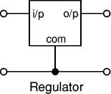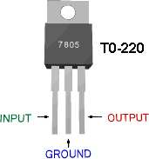

### Figure (12) Three Terminal Voltage Regulator

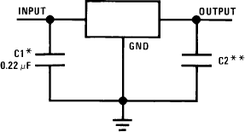As the name itself implies, it regulates the input applied to it. A voltage regulator is an

electrical regulator designed to

automatically maintain a constant voltage level.

In this project, power supply of 5V and 12V are required. In order to obtain these voltage levels, 7805 and 7812 voltage regulators are to be used.

The first number 78 represents positive supply and the numbers 05, 12 represent the required output voltage levels. The L78xx series of three-terminal positive regulators is available in TO-220, TO-220FP, TO-3, D2PAK and DPAK packages and several fixed output voltages, making it useful in a wide range of applications. These regulators can provide local on-card regulation, eliminating the distribution problems associated with single point regulation.

Each type employs internal current limiting, thermal shut-down and safe area

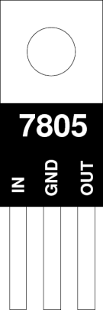protection, making it essentially indestructible. If adequate heat sinking is provided, they can deliver over 1 A output current. Although designed primarily as fixed voltage regulators, these devices can be used with external components to obtain adjustable voltage and currents.

## 78XX:

The Bay Linear LM78XX is integrated linear positive regulator with three terminals. The LM78XX offer several fixed output voltages making them useful in wide range of applications. When used as a zener diode/resistor combination replacement, the LM78XX usually results in an effective output impedance improvement of two orders of magnitude, lower quiescent current. The LM78XX is available in the TO-252, TO-220 & TO- 263packages,

Voltage regulation through Fixed Voltage Regulator IC is the most suitablemethod.78xx series positive and negative regulators are widely used to get fixed voltage to drive loads.

Here explains a circuit design to get regulated voltage from a 12 volt 500 mA power supply .This circuit can deliver 5 volts at 300 mA for driving a load. The circuit is Voltage and Current regulated and with Polarity and Surge protection components.

The 7805 provides circuit designers with an easy way to regulate DC voltages to 5v.Encapsulated in a single chip/package (IC), the 7805 is a positive voltage DC regulator that has only 3 terminals. They are: Input voltage, Ground, Output Voltage. In similar to 7805, 7812 will produce a regulated DC voltage of 12V

## Features:

* Output Current of 1.5A
* Output Voltage Tolerance of 5%
* Internal thermal overload protection
* Internal Short-Circuit Limited

# Transistor

The transistor, invented by three scientists at the Bell Laboratories in 1947, rapidly replaced the [vacuum tube](http://whatis.techtarget.com/definition/0%2C%2Csid9_gci213686%2C00.html) as an electronic signal regulator. A transistor regulates [current](http://searchcio-midmarket.techtarget.com/sDefinition/0%2C%2Csid183_gci211871%2C00.html) or [voltage](http://searchcio-midmarket.techtarget.com/sDefinition/0%2C%2Csid183_gci213320%2C00.html) flow and acts as a switch or gate for electronic signals. A transistor consists of three layers of a [semiconductor](http://searchcio-midmarket.techtarget.com/sDefinition/0%2C%2Csid183_gci212960%2C00.html) material, each capable of carrying a current. A semiconductor is a material such as germanium and [silicon](http://whatis.techtarget.com/definition/0%2C%2Csid9_gci214633%2C00.html) that conducts

Electricity in a "semi-enthusiastic" way. It's somewhere between a real conductor such as copper and an insulator (like the plastic wrapped around wires).

The semiconductor material is given special properties by a chemical process called doping. The doping results in a material that either adds extra electrons to the material (which is then called *N-type* for the extra negative charge carriers) or creates "holes" in the material's crystal structure (which is then called *P-type* because it results in more positive charge carriers). The transistor's three-layer structure contains an N-type semiconductor layer sandwiched between P-type layers (a PNP configuration) or a P-type layer between N-type layers (an NPN configuration).

A small change in the current or voltage at the inner semiconductor layer (which acts as the control electrode) produces a large, rapid change in the current passing through the entire component. The component can thus act as a switch, opening and closing an electronic gate many times per second. Today's computers use circuitry made with complementary metal oxide semiconductor (CMOS) technology. CMOS uses two complementary transistors per gate (one with N-type material; the other with P-type material). When one transistor is maintaining a logic state, it requires almost no power.

Transistors are the basic elements in integrated circuits ([IC](http://searchcio-midmarket.techtarget.com/sDefinition/0%2C%2Csid183_gci213503%2C00.html)s), which consist of very large numbers of transistors interconnected with circuitry and baked into a single silicon microchip or "chip."

## Types of transistor:

There is a two types of transistor.

**NPN** and **PNP**, with different circuit symbols. The letters refer to the layers of semiconductor material used to make the transistor.

Most transistors used today are NPN because this is the easiest type to make from silicon. If you are new to electronics it is best to start by learning how to use NPN transistors.

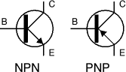

Figure(13) Transistor circuit symbols

The leads are labeled **base** (B), **collector** (C) and **emitter** (E).These terms refer to the internal operation of a transistor but they are not much help in understanding how a transistor is used, so just treat them as labels!

A Darlington pair is two transistors connected together to give a very high

current gain.

In addition to standard (bipolar junction) transistors, there are **field-effect**

**transistors** which are usually referred to as **FET**s. They have different circuit symbols and properties and they are not (yet) covered by this page.

## Choosing a transistor

Most projects will specify a particular transistor, but if necessary you can usually substitute an equivalent transistor from the wide range available

The most important properties to look for are the maximum collector current IC and the current gain hFE. To make selection easier most suppliers group their transistors in categories determined either by their **typical use** or **maximum power** rating.

To make a final choice you will need to consult the tables of technical data which are normally provided in catalogues. They contain a great deal of useful information but they can be difficult to understand if you are not familiar with the abbreviations used.

#### NPN transistors

**Code**

BC107

BC108

BC108C

BC109

BC182

BC182L

BC547B

BC548B

BC549B

2N3053

#### Structure

NPN

NPN

NPN

NPN

NPN

NPN

NPN

NPN

NPN

NPN

#### Case style

TO18

TO18

TO18

TO18

TO92C

TO92A

TO92C

TO92C

TO92C

TO39

#### IC

**max.**

100mA

100mA

100mA

200mA

100mA

100mA

100mA

100mA

100mA

700mA

**VCE**

#### max.

45V

20V

20V

20V

50V

50V

45V

30V

30V

40V

**hFE min.**

110

110

420

200

100

100

200

220

240

50

**Ptot max.**

300mW

300mW

600mW

300mW

350mW

350mW

500mW

500mW

625mW

500mW

#### Category (typical use)

Audio, low power

General purpose, low power

General purpose, low power

Audio (low noise), low power

General purpose, low power

General purpose, low power

Audio, low power

General purpose, low power

Audio (low noise), low power

General purpose, low power

#### Possible substitutes

BC182 BC547

BC108C BC183 BC548

BC184 BC549

BC107 BC182L

BC107 BC182

BC107B

BC108B

BC109

BFY51

neral 40

**Structure** This shows the type of transistor, NPN or PNP. The polarities of the two types are different, so if you are looking for a substitute it must be the same type.

**Case style** There is a diagram showing the leads for some of the most common case styles in the Connecting section above. This information is also available in suppliers' catalogues.

**IC max.** Maximum collector current.

**VCE max.** Maximum voltage across the collector-emitter junction.

You can ignore this rating in low voltage circuits.

**hFE** This is the **current gain** (strictly the DC current gain). The guaranteed minimum value is given because the actual value varies from transistor to transistor - even for those of the same type! Note that current gain is just a number so it has no units.

The gain is often quoted at a particular collector current IC which is usually in the middle of the transistor's range, for example '100@20mA' means the gain is at least 100 at 20mA. Sometimes minimum and maximum values are given. Since the gain is roughly constant for various currents but it varies from transistor to transistor this detail is only really of interest to experts.

**Why hFE?** It is one of a whole series of parameters for transistors, each with their own symbol. There are too many to explain here.

**Ptot max.** Maximum total power which can be developed in the transistor, note that a [heat sink](http://www.kpsec.freeuk.com/components/heatsink.htm) will be required to achieve the maximum rating. This rating is important for transistors operating as amplifiers, the power is roughly IC × VCE. For transistors operating as switches the maximum collector current (IC max.) is more important.

**Category** This shows the typical use for the transistor, it is a good starting point when looking for a substitute. Catalogues may have separate tables for different categories.

**Possible substitutes** These are transistors with similar electrical properties which will be suitable substitutes in most circuits. However, they may have a different case style so you will need to take care when placing them on the circuit board.

## SK 100 transistor:

### Figure(14) SK 100 Transistor diagram

SK100 is a general purpose, medium power PNP transistor. The basic applications of a transistor are switching, amplification and regulation. Its DC current gain ranges from 100 to a maximum of 300.

The transistor terminals require a fixed DC voltage to operate in the desired region of its characteristic curves. This is known as the biasing. For amplification applications, the transistor is biased such that it is partly on for all input conditions.

The input signal at base is amplified and taken at the emitter. BC548 is used in common emitter configuration for amplifiers. The voltage divider is the commonly used biasing mode.

For switching applications, transistor is biased so that it remains fully on if there is a signal at its base. In the absence of base signal, it gets completely off. The emitter leg of SK100 is indicated by a protruding edge in the transistor case. The base is nearest to the emitter while collector lies at other extreme of the casing

## BC547 Transistor Circuit Schematic Symbol

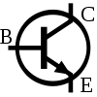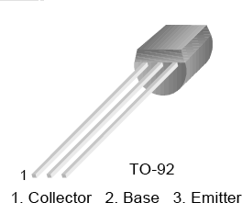

**BC 547 TRANSISTOR**

BC547 is an NPN bi-polar junction transistor. A transistor, stands for transfer of resistance, is commonly used to amplify current. A small current at its ba

controls a larger current at collector & emitter terminals.

BC547 is mainly used for amplification and switching purposes. It has a maximum current gain of 800. Its equivalent transistors are BC548 and BC549.

The transistor terminals require a fixed DC voltage to operate in the desired region of its characteristic curves. This is known as the biasing. For amplification applications, the transistor is biased such that it is partly on for all input conditions.

The input signal at base is amplified and taken at the emitter. BC547 is used in common emitter configuration for amplifiers. The voltage divider is the commonly used biasing mode. For switching applications, transistor is biased so that it remains fully on if there is a signal at its base. In the absence of base signal, it gets completely off.

There are two kinds of transistor:

* + Bipolar Junction Transistors (BJTs) and
  + Field Effect Transistors (FETs).

These two transistors work differently. However, both are based on the fact that whenever a voltage is applied across impure semiconductor such as Silicon, the Silicon changes from a conductor to an insulator or vice versa.

## FETs:

Field Effect Transistors contain a narrow conductive channel which passes near a

"Gate" electrode. The two ends of this channel are connected to terminals called "Source" and "Drain."

When a voltage of the correct polarity is applied between the Gate and the

transistor channel, the channel becomes wider, and if this polarity is reversed, the conductive channel narrows, or it even vanishes entirely.

By changing the size of this conductive channel, the FET behaves as a voltage- controlled valve or switch. Since the Gate does not require any continuing current, the FET operation can be improved by including a layer of insulating glass (Silicon oxide) between the gate electrode and the rest of the transistor.

This type of FET is called a "MOSFET," for Metal-Oxide-Semiconductor layers.

Transistors without the glass layer are called JFETs or "Junction-FETs."

## BJTs:

Main Circuit (+)

` ` ` ` ` |

` |

` | ` ` ` ` ` ` ` `'|

` | COLLECTOR N |

` | |

` | ` ` ` ` ` ` ` `| ` ` ` ` ----->

` | ' BASE P ` ` `|

` | | ` ` ` ` ` ` ` ` `| +

` | ` ` ` ` ` ` ` ` | ` ` ` ` ` ` |

` | ` EMITTER N ` | ` ` ` ` ` ` `

` | | ` ` ` ` ` ` "Base Battery"

` ` ` ` ` | ` ` ` ` ` ` ` ` ` ` ` `

` ` ` ` ` | | -

` ` ` ` ` |

` ` ` ` ` |

` ` ` Main Circuit (-)

In between each semi-conductor segment is a "depletion layer", which acts as a sort of variable insulator, or variable resistor. The higher the voltage across the "depletion layer" the less insulated it becomes. The Base/Emitter Voltage across the "depletion layer" is controlled by the voltage source (your base battery) or the battery connecting your "base" and "emitter" semiconductor sections.

The voltage across this depletion layer opens the floodgates across the entire transistor from a separate voltage source. The base voltage proportionally controls the transistor voltage so in other words it could be said that: "controls current going into a load". In other words, it sort of acts like an on off switch which can be partially opened.

## RESISTANCE :

The **electrical resistance** of an [electrical element](http://en.wikipedia.org/wiki/Electrical_element) is the opposition to

the passage of an [electric current](http://en.wikipedia.org/wiki/Electric_current) through that element; the inverse quantity is **electrical conductance**, the ease at which an electric current passes. Electrical resistance shares some conceptual parallels with the mechanical notion of [friction](http://en.wikipedia.org/wiki/Friction). The [SI](http://en.wikipedia.org/wiki/International_System_of_Units) unit of electrical resistance is the [ohm](http://en.wikipedia.org/wiki/Ohm) ([Ω](http://en.wikipedia.org/wiki/Omega)), while electrical conductance is measured in [siemens](http://en.wikipedia.org/wiki/Siemens_(unit)) (S).

An object of uniform cross section has a resistance proportional to its [resistivity](http://en.wikipedia.org/wiki/Resistivity) and length and inversely proportional to its cross-sectional area. All materials show some resistance, except for [superconductors](http://en.wikipedia.org/wiki/Superconductor), which have a resistance of zero.

The resistance of an object is defined as the ratio of [voltage](http://en.wikipedia.org/wiki/Voltage) across it to current through it:

For a wide variety of materials and conditions, the electrical resistance *R* is [constant](http://en.wikipedia.org/wiki/Constant_(mathematics)) for a given temperature; it does not depend on the amount of current through or the potential difference ([voltage](http://en.wikipedia.org/wiki/Voltage)) across the object. Such materials are called Ohmic materials. For objects made of ohmic materials the definition of the resistance, with *R* being a constant for that resistor, is known as [Ohm's law](http://en.wikipedia.org/wiki/Ohm%27s_law).

In the case of a nonlinear conductor (not obeying Ohm's law), this ratio can change as current or voltage changes; the inverse slope of a chord to an [*I-V* curve](http://en.wikipedia.org/wiki/I%E2%80%93V_curve) is sometimes referred to as a "chordal resistance" or "static resistance".

A device used in electrical circuits to maintain a constant relation between current flow and voltage. Resistors are used to step up or lower the voltage at different points in a circuit and to transform a current signal into a voltage signal or vice versa, among other uses.

The electrical behavior of a resistor obeys Ohm's law for a constant resistance; however, some resistors are sensitive to heat, light, or other variables.

**Variable resistors** or **rheostats** have a resistance that may be varied across a certain range, usually by means of a mechanical device that alters the position of one terminal of the resistor along a strip of resistant material. The length of the intervening material determines the resistance. Mechanical variable resistors are also called potentiometers*,* and are used in the volume knobs of audio equipment and in many other devices.

**DC resistance**

The resistance of a given resistor or conductor grows with the length of conductor and [specific resistivity](http://en.wikipedia.org/wiki/Resistivity) of the material, and decreases for larger cross-sectional area. The resistance R and conductance G of a conductor of uniform cross section, therefore, can be computed as

Where

is the length of the conductor, measured in [metres](http://en.wikipedia.org/wiki/Metre) [m],

*A* is the cross-section area of the conductor measured in [square metres](http://en.wikipedia.org/wiki/Square_metre) [m²],

σ ([sigma](http://en.wikipedia.org/wiki/Sigma_(letter))) is the [electrical conductivity](http://en.wikipedia.org/wiki/Electrical_conductivity) measured in [siemens](http://en.wikipedia.org/wiki/Siemens_(unit)) per meter (S·m-1), and

ρ ([rho](http://en.wikipedia.org/wiki/Rho_(letter))) is the [electrical resistivity](http://en.wikipedia.org/wiki/Electrical_resistivity) (also called *specific electrical resistance*) of the material, measured in ohm-metres (Ω ·m).

Resistivity is a measure of the material's ability to oppose electric current. For purely resistive circuits conductance is related to resistance *R* by:

For practical reasons, any connections to a real conductor will almost certainly mean the current density is not totally uniform. However, this formula still provides a good approximation for long thin conductors such as wires.

What is now known as Ohm's law appears in a famous book written in 1827 in which he gave his complete theory of electricity.

Georg Simon Ohm was born in 1787 in Erlangen, Germany. Georg came from a Protestant family. His father, Johann Wolfgang Ohm, was a locksmith and his mother, Maria

Elizabeth Beck, was the daughter of a tailor. Although his parents had not been formally educated, Ohm's father was a remarkable man who had educated himself and was able to give his sons an excellent education through his own teachings.

In 1805, Ohm entered the University of Erlangen and received a doctorate. He wrote elementary geometry book while teaching mathematics at several schools. Ohm began experimental work in a school physics laboratory after he had learned of the discovery of electromagnetism in 1820.

In two important papers in 1826, Ohm gave a mathematical description of conduction in circuits modeled on Fourier's study of heat conduction. These papers continue Ohm's deduction of results from experimental evidence and, particularly in the second, he was able to propose laws which went a long way to explaining results of others working on galvanic electricity.

The basic components of an electrochemical cell are:

* 1. 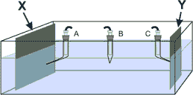Electrodes (X and Y) that are made of electrically conductive materials: metals, carbon, composites ...
  2. Reference electrodes (A, B, C) that are in electrolytic contact with an electrolyte
  3. The cell itself or container that is made of an inert material: glass, Plexi glass, ... and
  4. An electrolyte that is the solution containing ions.

#### Ohm’sLaw

Using the results of his experiments, Georg Simon Ohm was able to define the fundamental relationship between voltage, current, and resistance. What is now known as Ohm's law appeared in his most famous work, a book published in 1827 that gave his complete theory of [electricity](http://inventors.about.com/library/inventors/blelectric.htm).

The equation I = V/R is known as "Ohm’s Law". It states that the amount of steady current through a material is directly proportional to the voltage across the material divided by the electrical resistance of the material. The ohm (R), a unit of electrical

resistance, is equal to that of a conductor in which a current (I) of one ampere is produced by a potential of one volt (V) across its terminals. These fundamental relationships represent the true beginning of electrical circuit analysis.

Current flows in an electric circuit in accordance with several definite laws. The basic law of current flow is Ohm's law. Ohm's law states that the amount of current flowing in a circuit made up of only resistors is related to the voltage on the circuit and the total resistance of the circuit.

The law is usually expressed by the formula V= IR (described in the above paragraph), where I is the current in amperes, V is voltage (in volts), and R is the resistance in ohms.

The ohm, a unit of electrical resistance, is equal to that of a conductor in which a current of one ampere is produced by a potential of one volt across its terminals.

Information provided by the Department of Energy

## AC resistance

A wire carrying alternating current has a reduced effective cross sectional

area because of the [skin effect](http://en.wikipedia.org/wiki/Skin_effect). Adjacent conductors carrying alternating current have a higher resistance than they would in isolation or when carrying direct current, due to the [proximity effect](http://en.wikipedia.org/wiki/Proximity_effect_(electromagnetism)).

At [commercial power frequency](http://en.wikipedia.org/wiki/Utility_frequency), these effects are significant for large conductors carrying large currents, such as [busbars](http://en.wikipedia.org/wiki/Busbar) in an [electrical substation](http://en.wikipedia.org/wiki/Electrical_substation), [3] or large power cables carrying more than a few hundred amperes.

When an alternating current flows through the circuit, its flow is not opposed only by the circuit resistance, but also by the opposition of electric and magnetic fields to the current change. That effect is measured by [electrical reactance](http://en.wikipedia.org/wiki/Electrical_reactance). The combined effects of reactance and resistance are expressed by [electrical impedance](http://en.wikipedia.org/wiki/Electrical_impedance).

## Resistor Color Code

***Common Resistor***

Resistors are color coded for easy reading. Imagine how many blind technicians there would be otherwise.

To determine the value of a given resistor look for the gold or silver tolerance band and rotate the resistor as in the photo above.(Tolerance band to the right). Look at the 1st color band and determine its color.

This may be difficult on small or oddly colored resistors. Now look at the chart and match the "1st & 2nd color band" color to the "Digit it represents". Write this number down.

Now look at the 2nd color band and match that color to the same chart. Write this number next to the 1st Digit.

The Last color band is the number you will multiply the result by. Match the 3rd color band with the chart under multiplier.

This is the number you will multiple the other 2 numbers by. Write it next to the other 2 numbers with a multiplication sign before it. Example : 2 2 x 1,000.

To pull it all together now, simply multiply the first 2 numbers (1st number in the tens column and 2nd in the ones column) by the Multiplier.

## Tolerance Explanation:

Resistors are never the exact value that the color codes indicate. Therefore manufacturers place a tolerance color band on the resistor to tell you just how accurate this resistor is made. It is simply a measurement of the imperfections.

Gold means the resistor is within 5% of being dead-on accurate. Silver being within 10% and no color band being with in 20%. To determine the exact range that the resistor may be, take the value of the resistor and multiply it by 5,10, 0r 20%.

## Resistor Color Code Table

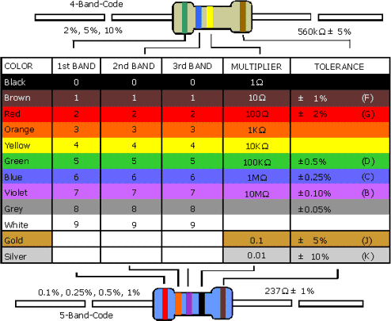

EXAMPLE:

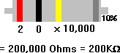

* + First color is **red** which is 2
  + Second color is **black** which is 0
  + third color is **yellow** which is 10,000
  + Tolerance is silver which is 10%

Therefore the equation is: 2 0 [x 10](http://www.co-bw.com/DIY_Resistor_Code.htm),000 = 200,000 Ohms

* + Tolerances
  + Gold= 5%
  + Silver=10%
  + None=20%

## LED:

A **light-emitting diode** (**LED**) is a [semiconductor](http://en.wikipedia.org/wiki/Semiconductor) light source. LEDs are used as indicator lamps in many devices and are increasingly used for other [lighting](http://en.wikipedia.org/wiki/Lighting). Introduced as a practical electronic component in 1962, early LEDs emitted low-intensity red light, but modern versions are available across the [visible](http://en.wikipedia.org/wiki/Visible_spectrum), [ultraviolet](http://en.wikipedia.org/wiki/Ultraviolet) and [infrared](http://en.wikipedia.org/wiki/Infrared) wavelengths, with very high brightness.

When a light-emitting [diode](http://en.wikipedia.org/wiki/Semiconductor_diode) is forward [biased](http://en.wikipedia.org/wiki/Voltage_bias) (switched on), [electrons](http://en.wikipedia.org/wiki/Electrons) are able to [recombine](http://en.wikipedia.org/wiki/Carrier_generation_and_recombination) with [electron holes](http://en.wikipedia.org/wiki/Electron_hole) within the device, releasing energy in the form of [photons](http://en.wikipedia.org/wiki/Photon). This effect is called [electroluminescence](http://en.wikipedia.org/wiki/Electroluminescence) and the [color](http://en.wikipedia.org/wiki/Color) of the light (corresponding to the energy of the photon) is determined by the [energy gap](http://en.wikipedia.org/wiki/Energy_gap) of the semiconductor.

LEDs are often small in area (less than 1 mm2), and integrated optical components may be used to shape its radiation pattern. LEDs present many advantages over incandescent light sources including [lower energy consumption](http://en.wikipedia.org/wiki/Energy_conservation), longer [lifetime](http://en.wikipedia.org/wiki/Service_life), improved robustness, smaller size, and faster switching.

LEDs powerful enough for room lighting are relatively expensive and require more precise current and [heat management](http://en.wikipedia.org/wiki/Thermal_management_of_high-power_LEDs) than compact [fluorescent lamp](http://en.wikipedia.org/wiki/Fluorescent_lamp) sources of comparable output.

Light-emitting diodes are used in applications as diverse as replacements for aviation lighting, automotive lighting (particularly brake lamps, turn signals and indicators) as well as in [traffic signals](http://en.wikipedia.org/wiki/Traffic_signal). LEDs have allowed new text, video displays, and sensors to be developed,

while their high switching rates are also useful in advanced communications technology. [Infrared](http://en.wikipedia.org/wiki/Infrared) LEDs are also used in the [remote control](http://en.wikipedia.org/wiki/Remote_control) units of many commercial products including televisions, DVD players, and other domestic appliances.

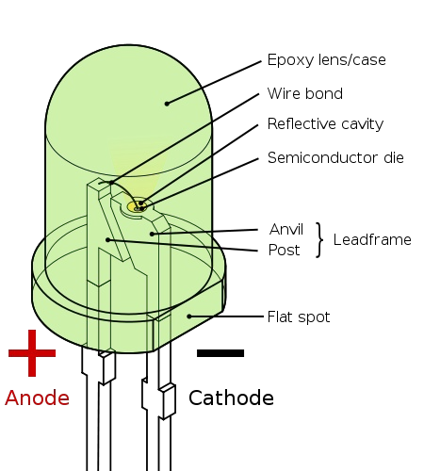

A Light-Emitting Diode (LED) in essence is a P-N junction solid-state semi- conductor diode that emits light when a current is applied though the device.[1] By scientific definition, it is a solid-state device that controls current without the deficiency of having heated filaments.

#### How does a LED work?

White LEDs ordinarily need 3.6 Volts of Direct Current (DC) and use approximately 30 milliamps (mA) of current and has a power dissipation of approximately 100 milliwatts (mW).

The positive power is connected to one side of the LED semiconductor through the anode and a whisker and the other side of the semiconductor is attached to the top of the

anvil or the negative power lead (cathode). It is the chemical composition or makeup of the LED semiconductor that determines the color of the light that the LED produces as well as the intensity level.

The epoxy resin enclosure allows most of the light to escape from the elements and protects the LED making it virtually indestructible. Furthermore, a light- emitting diode does not have any moving parts, which makes the device extremely resistant to damage due to vibration and shocks. These characteristics make it ideal for purposes that demand reliability and strength.

LEDs therefore can be deemed invulnerable to catastrophic failure when operated within design parameters.

Figure 1 shows a typical traditional indicator LED. Traditional indicator LEDs utilize a small LED semiconductor chip that is mounted on a reflector cup also known as the anvil, on a lead-frame (whisker).

This whole configuration is encased in epoxy which also serves the purpose of a lens. LEDs have very high thermal resistance with upwards of 200K per Watt.

LEDs are highly monochromatic, only emitting a single pure color in a narrow frequency range. The color emitted from an LED is identified by peak wavelength (lpk) which is measured in nanometers (nm). The peak wavelength is a function of the material that is used in the manufacturing of the semiconductor.[3] Most LEDs are produced using gallium-based crystals that differ in one or more additional materials such as phosphorous to produce distinct colors.

Different LED chip technologies enable manufacturers to produce LEDs that emit light in a specific region of the visible light spectrum and replicate different intensity levels.

emit light in a specific region of the visible light spectrum and replicate different intensity levels.

Thus, one would vary the material used in the production of LEDs in order to obtain the desired results. The graph below depicts the variation in response time for the specific wavelength of light.

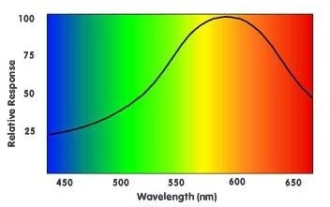

The relative response time versus different wavelengths of light

(The lower the response time the better. Currently, most LEDs are made with higher wavelengths (i.e. longer response time) because they are cheaper to manufacture.)

## Principle & Mechanism

The essential portion of the Light Emitting Diode is the semiconductor chip.

Semiconductors can be either intrinsic or extrinsic.

Intrinsic semiconductors are those in which the electrical behavior is based on the electronic structure inherent to the pure material. When the electrical characteristics are dictated by impurity atoms,

The semiconductor is said to be extrinsic. See Appendix A for further information regarding the different materials and their characteristics. This chip is further

divided into two parts or regions which are separated by a boundary called a junction.

The p-region is dominated by positive electric charges (holes) and the n-region is dominated by negative electric charges (electrons).

The junction serves as a barrier to the flow of the electrons between the p and the

n-regions.

This is somewhat similar to the role of the band-gap because it determines how much voltage is needed to be applied to the semiconductor chip before the current can flow and the electrons pass the junction into the p-region.

### Cross section of a typical semiconductor LED showing the n and p-type semiconductor layers

56

LEDs are produced in a variety of shapes and sizes. The 5 mm cylindrical package (red, fifth from the left) is the most common, estimated at 80% of world production.

The color of the plastic lens is often the same as the actual color of light

emitted, but not always. For instance, purple plastic is often used for [infrare](http://en.wikipedia.org/wiki/Infrared)d LEDs, and most blue devices have clear housings.

There are also LEDs in [SMT packages](http://en.wikipedia.org/wiki/Surface-mount_technology), such as those found on [blinkies](http://en.wikipedia.org/wiki/Blinky_(novelty))and on cell phone keypads (not shown). according to their peak wavelength. Peak wavelength is a function of the LED chip material.

Although manufacturing process variations produce a standard deviation of ±10nm, nevertheless, these variations are perceptible to the human eye because the 565nm to 600nm wavelength spectral region (yellow to amber) is where the sensitivity level of the human eye is at its peak. [19] See Appendix B for details on the different semiconductor types as well as characteristics of those semiconductors.

* The light output of a specific LED varies with the type of chip, encapsulation and efficiency of individual wafer lots. There may be other random variables that may affect the performance of the LED too. This typically is categorized into the nuisance variable factor and is taken into account as the error margin.
* Many LED manufacturers use different terms such as "super-bright," and "ultra- bright" to describe LED intensity. However, such terminology is entirely subjective, as there really is no industry standard for LED brightness.
* Luminous intensity is roughly proportional to the amount of current (I) supplied to the LED. The greater the current, the higher the intensity.[20] Nevertheless, luminous intensity (Iv) does not represent the total light output from an LED. Both the

luminous intensity and the spatial radiation pattern (viewing angle) must be taken into account.

* If two LEDs have the same luminous intensity value, the lamp with the larger

viewing angle will have the higher total light output.

## Application

* Home appliances
* Industrial areas
* There are various materials that are used in the manufacturing of Light Emitting

Diodes. Most of the materials are gallium-based crystals and are used in high- brightness applications.

* In Ga N (Indium-Gallium-Nitride) typically generates Blue, Green and white

spectrums and are used most often in full color signs, cell-phones, auto interior, traffic signals.

* There is room for further improvement on the design of traffic lights. The visible light

from the LEDs in a traffic light can further be modulated and

* Light Emitting Diodes are the cutting edge technology of lighting today. Generally, Light Emitting Diodes are categorized according to their performance.
* The performance of a LED is linked to a few primary characteristics of the LED itself which includes color, peak wavelength and intensity.
* As LEDs are highly monochromatic, LEDs are differentiated.

## Advantages

* IN the Home add centralized building electrical control, from one location, of many or even all lights and electrical features
* **BUILTIN ISOLATION TRANSFORMER:** The system incorporates a built in isolation transformer at the UPS output which provides galvanic isolation between the input and the load
* **HIGH PROTECTION & DIAGNOSTICS**:

Short circuit systems with various built-in electronics protections as well with switchgear protections to protect the loads and the system. The protection includes electronic short circuit protection, input / output breakers, DC breakers, input phase reversal protection, battery deep discharge protection etc., The system has processor based diagnostics for detailed monitoring and diagnostics.

* Save time by easily obtaining the short circuit
* magnitude at each point in the power system.
* Design safer systems by comparing the
* calculated fault current to the ratings of installed equipment.
* Increase design reliability by supporting proper
* selection of circuit protection equipment for
* protection and coordination

## Disadvantages

* Poor short-circuit handling is the main disadvantage of a simple series voltage regulator. A short circuit causes excessive current flow, destroying the series pass transistor. A good power supply uses current limiting to alleviate this problem.
* If any short circuit damage will happen then whole circuit board get not working on powersytems

# CONCLUSION

This report, about “SHORT CIRCUIT PROTECTION IN DC LOW VOLTAGE SYSTEM”, One of basic fuse features is the capability to create high arcing voltage in case of short-circuit current, which exceeds the recovery voltage and forces the short-circuit current to be reduced to zero instead of growing uncontrollably until expected short circuit current is reached.