import pandas as pd  
import numpy as np  
dataset = pd.read_csv("iris1..csv", delimiter=",")  
print(dataset)  
X = dataset.drop('Species', axis=1)  
print(X)  
y = dataset['Species']  
print(y)

o/p:

Id SepalLengthCm ... PetalWidthCm Species

0 1 5.1 ... 0.2 Iris-setosa

1 2 4.9 ... 0.2 Iris-setosa

2 3 4.7 ... 0.2 Iris-setosa

3 4 4.6 ... 0.2 Iris-setosa

4 5 5.0 ... 0.2 Iris-setosa

.. ... ... ... ... ...

145 146 6.7 ... 2.3 Iris-virginica

146 147 6.3 ... 1.9 Iris-virginica

147 148 6.5 ... 2.0 Iris-virginica

148 149 6.2 ... 2.3 Iris-virginica

149 150 5.9 ... 1.8 Iris-virginica

[150 rows x 6 columns]

Id SepalLengthCm SepalWidthCm PetalLengthCm PetalWidthCm

0 1 5.1 3.5 1.4 0.2

1 2 4.9 3.0 1.4 0.2

2 3 4.7 3.2 1.3 0.2

3 4 4.6 3.1 1.5 0.2

4 5 5.0 3.6 1.4 0.2

.. ... ... ... ... ...

145 146 6.7 3.0 5.2 2.3

146 147 6.3 2.5 5.0 1.9

147 148 6.5 3.0 5.2 2.0

148 149 6.2 3.4 5.4 2.3

149 150 5.9 3.0 5.1 1.8

[150 rows x 5 columns]

0 Iris-setosa

1 Iris-setosa

2 Iris-setosa

3 Iris-setosa

4 Iris-setosa

...

145 Iris-virginica

146 Iris-virginica

147 Iris-virginica

148 Iris-virginica

149 Iris-virginica

from sklearn.tree import DecisionTreeClassifier  
irisTree = DecisionTreeClassifier(criterion="entropy", max_depth = 4)  
print(irisTree)

0/p:

Name: Species, Length: 150, dtype: object

DecisionTreeClassifier(criterion='entropy', max_depth=4)

irisTree.fit(X_train,y_train)  
predTree=irisTree.predict(X_test)  
print(predTree [0:5])  
print(y_test[0:5])

o/p:

['Iris-versicolor' 'Iris-setosa' 'Iris-setosa' 'Iris-versicolor'

'Iris-setosa']

80 Iris-versicolor

36 Iris-setosa

7 Iris-setosa

63 Iris-versicolor

33 Iris-setosa

from sklearn.tree import DecisionTreeClassifier  
classifier = DecisionTreeClassifier()  
classifier.fit(X_train, y_train)  
y_pred = classifier.predict(X_test)

from sklearn.metrics import classification_report, confusion_matrix  
print(confusion_matrix(y_test, y_pred))  
print(classification_report(y_test, y_pred))

o/p:

precision recall f1-score support

Iris-setosa 1.00 1.00 1.00 8

Iris-versicolor 1.00 1.00 1.00 11

Iris-virginica 1.00 1.00 1.00 11

accuracy 1.00 30

macro avg 1.00 1.00 1.00 30

weighted avg 1.00 1.00 1.00 30

import scikitplot as skplt  
import pydotplus  
from sklearn.tree import export_graphviz  
import sklearn.metrics as metrics  
skplt.metrics.plot_confusion_matrix(y_test, predTree)  
plt.show()

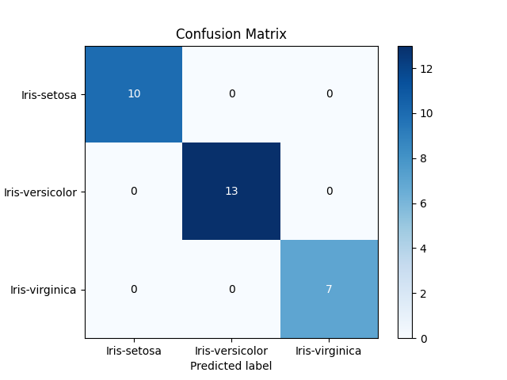

p = metrics.classification_report(y_test, predTree, output_dict=True)  
p1 = pd.DataFrame(p).transpose()  
p1 = p1.drop('support', 1)  
print(p1)  
p1.plot.bar()  
plt.show()

o/p:

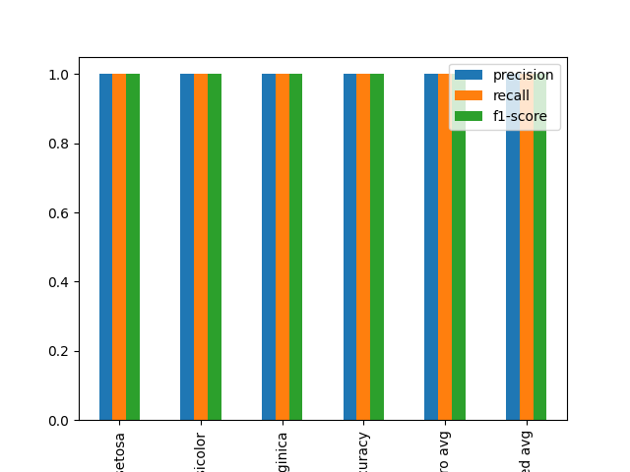

featureNames = dataset.columns[0:5]  
targetNames = dataset["Species"].unique().tolist()  
out=export_graphviz(irisTree,feature_names=featureNames,out_file=None,class_names= np.unique(y_train),filled=True,special_characters=True,rotate=False)  
graph = pydotplus.graph_from_dot_data(out)  
graph.write_png('iristree.png')

o/p:

