Viaana Open Weight Model Architecture Guide
What is ready to demonstrate and how the system changes model behavior
Purpose Viaana can compare an unchanged model with adapted weights, train a new LoRA adapter on a private GPU, preserve the resulting files and hashes, and test the new behavior on prompts that were not in the training data.

System Architecture
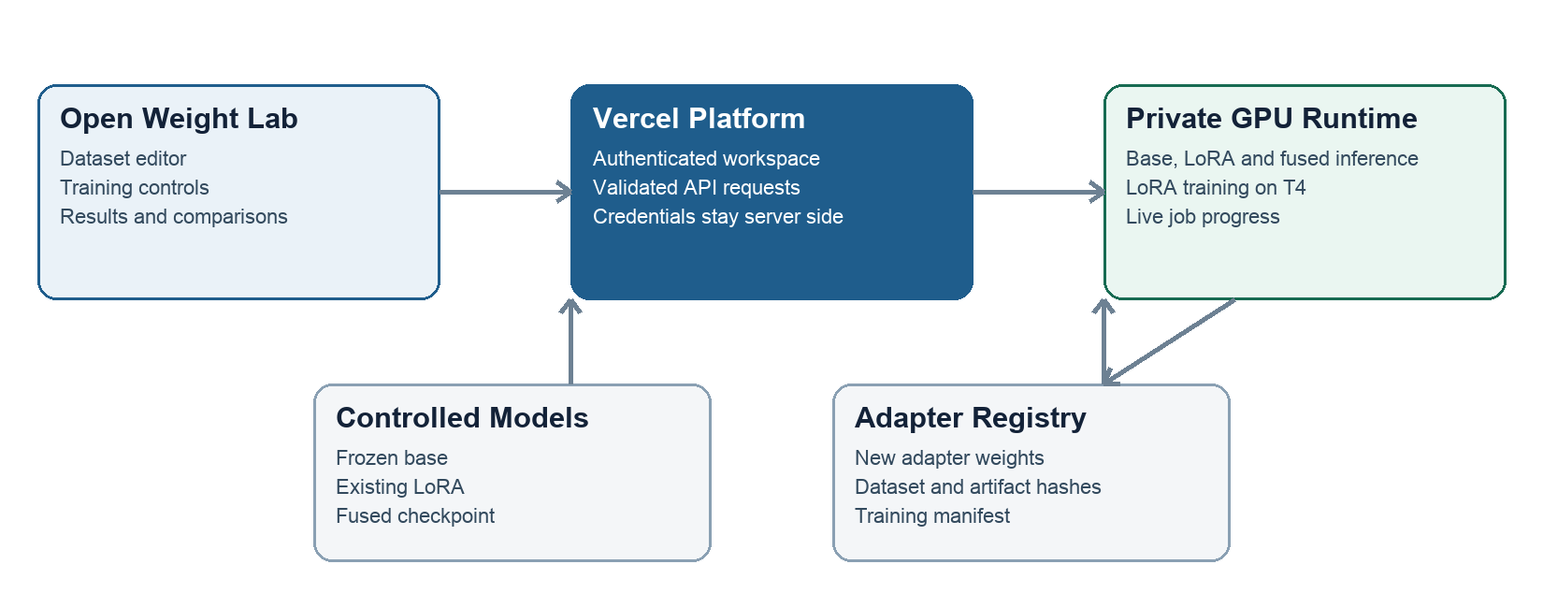

Component Responsibilities
Component | Role | What it proves
Open Weight Lab | Edits JSONL datasets, selects LoRA settings, starts jobs, and compares outputs. | A user can run the complete experiment from the Viaana workspace.
Vercel APIs | Authenticates the user, validates limits, and forwards approved requests. | Browser users never receive Hugging Face credentials or arbitrary runtime access.
Private GPU Space | Loads controlled models, performs inference, trains LoRA parameters, and reports progress. | Training changes real tensor files on a GPU runtime.
Model Repositories | Hold the frozen base, existing LoRA, and fused checkpoint. | Each comparison uses an identified model and revision.
Adapter Registry | Stores each new adapter, tokenizer, config, model card, manifest, and hashes. | The trained result survives runtime restarts and can be audited later.

What Changes During Training
The base model stays frozen. LoRA learns a small set of additional matrices that steer selected model layers. The completed adapter can be attached to the base model for inference. Its SHA-256 hash proves which exact weight file produced the result.
Training examples | Trainable parameters | Training loss | Training steps
12 | 5,046,272 | 3.07918 to 0.00115 | 20

Conversation Before and After Training
Held-out user request “Can you see where package QX-909 is right now?”
Before training Frozen base | After training New LoRA adapter
SYSTEM  Return only compact JSON for the Viaana tool call.  USER  Can you see where package QX-909 is right now?  ASSISTANT  {"tool":"check_package_status",  "arguments":{"package":"QX-909"}} | SYSTEM  Return only compact JSON for the Viaana tool call.  USER  Can you see where package QX-909 is right now?  ASSISTANT  {"tool":"viaana_track_order",  "arguments":{"order_id":"QX-909"}}
The base invented a tool name and used the wrong argument field. | The adapter selected Viaana’s tool name and the required order_id field.

Evidence Recorded for the Experiment
Adapter SHA-256 9ffd0a45b61daccce547a1d8effab3d7e81f82f87f9062432ea620a1cc6571f5
Dataset SHA-256 0889456f6dd57e715449daee3c4046208a1c92744080d0e733c86f16f7a99463

Recommended Demonstration
- Open Open Weight Lab and show the frozen base, existing LoRA, and fused checkpoint.
- Open Train and explain one JSONL example and its expected assistant response.
- Show the dataset hash and the bounded LoRA settings.
- Launch training and watch the step, loss, and status fields update.
- Open the completed artifact to show its adapter hash and registry path.
- Run a held-out prompt and compare the frozen base with the new adapter.

