Summary :

Processing NITF SAR DATA IMAGE

In the attached / Github Python code,

A NITF dataset is read to load an NITF file( National Transmission image format) and then filter it by first doing FFT on each row of image and then windowing central part of image using hann window and then doing IFFT.

**The Gray scale image before filtering is below**

Fig 1 : below Before filtered Imge

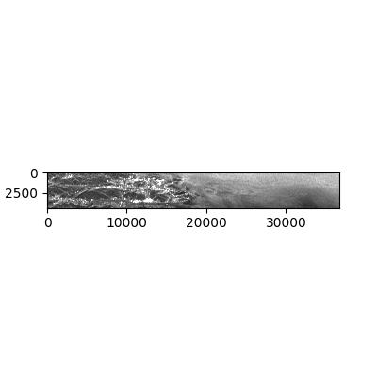

Fig 2: After filtering image

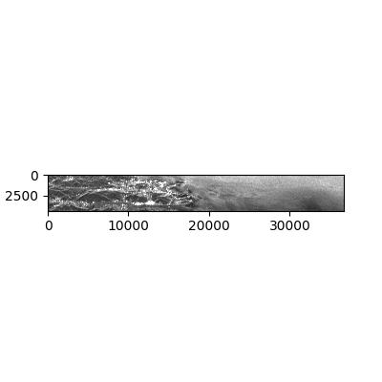

**Code repository :** <https://github.com/ashishanand009/SAR_Image_processing>

**Instructions to run the code:**

1. Visit the git repository link given above , you will see following files in the repository

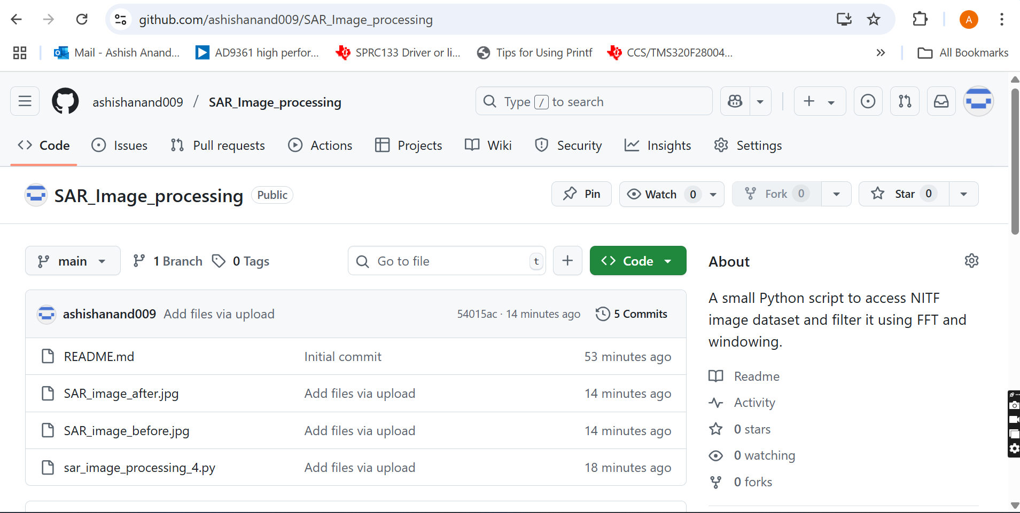

1. Download the file **sar_image_processing_4.py**
2. Make sure sarpy , numpy and skimage libraries are installed for your python installation
3. Place **IMG-VV-STRIXB-20220811T004713Z-SMSLC-SICD.nitf** file in “D:\SAR_dataset” folder and run the python script.