**Problem statement:**

Input:

•File consists of millions of records separated by new line character.

•Each line can be a valid IPv4/IPv6 or invalid string.

**HLD:**

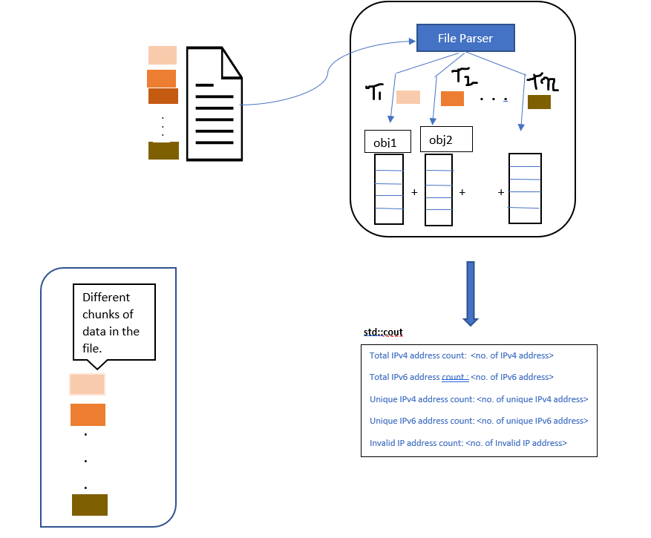

**Functional Requirements:**

1.The file parser must be able to read the file.

2.The file parser must be able to differentiate between IPv4, IPv6 and Invalid ips.

3.The respective count variables of IPv4, IPv6, unique IPv4, unique IPv6 and Invalid ips should return the accurate number of occurrences in the file at the end of execution.

**Non- Functional Requirements:**

1.In order to handle huge amount of data, concurrent processing should be opted.

2.Threads must be synchronized in order to prevent data corruption.

3.Main thread must wait at the end for all other worker threads to join.

**Error Case :**

File read failure

**Cpp file functionality :**

main.cpp :creates instance of fileparser and calls createWorkerThread.

fileParser.cpp : Creates worker threads and assigns them a chunk of input.

ipValidator.cpp: iterates over the chunk of file allocated and validates each ip and increments the respective counters.

utils.cpp: Definitions of counters are defined here.