# Prometheus

## What is prometheus?

Prometheus is an open-source systems monitoring and alerting toolkit built on Go.

## Why use Prometheus?

1. Powerful data model
2. PromQL
3. Emitting metrics very easy
4. Monitoring
5. Dashboarding

## Three main components of Prometheus

1. Node Exporter
2. Prometheus Push gateway
3. Prometheus server

Architecture of Prometheus

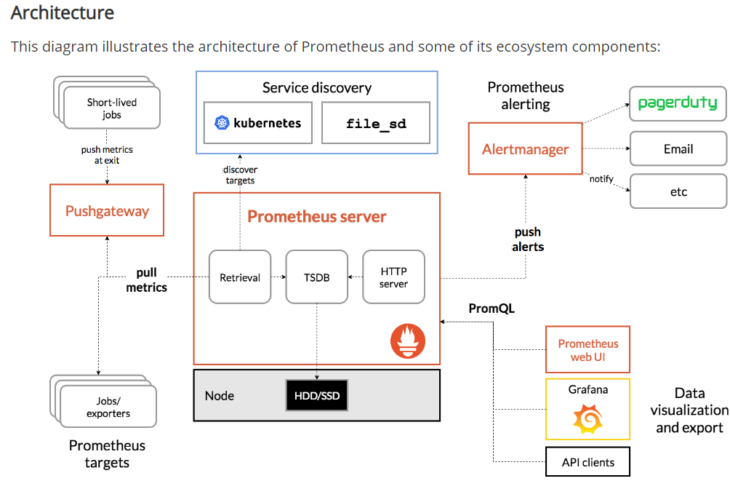

For ephemeral or batch jobs, Prometheus recommends using pushgateway which is a stark deviation from standard approach of pull.

## Node Exporter

Node exporter is used to export machine metrics from Linux OS host. The node exporter is installed on below path:

/u01/InstallFiles/PrometheusNodeExporter/node_exporter-0.18.1.linux-amd64/node_exporter

For collecting the metrics, execute: ./node_exporter&

## Prometheus Push Gateway

The Prometheus Pushgateway exists to allow ephemeral and batch jobs to expose their metrics to Prometheus. Since these kinds of jobs may not exist long enough to be scraped, they can instead push their metrics to a Pushgateway. The Pushgateway then exposes these metrics to Prometheus.

Prometheus server

Prometheus server scrapes data from different targets and collates it onto one dashboard for visualization.