Installation guide for Prometheus ecosystem.

1. First start with installation of Prometheus server. This server will serve as Time series database which will persist data for metrics scraped from Integration servers.
   1. For demo purposes, I have installed Prometheus on my local workstation.
   2. Installation directory : .\prometheus-2.15.1.windows-amd64.tar\prometheus-2.15.1.windows-amd64\prometheus.exe
   3. For starting Prometheus server, please execute prometheus.exe.
   4. The execution should look like below:
      1. 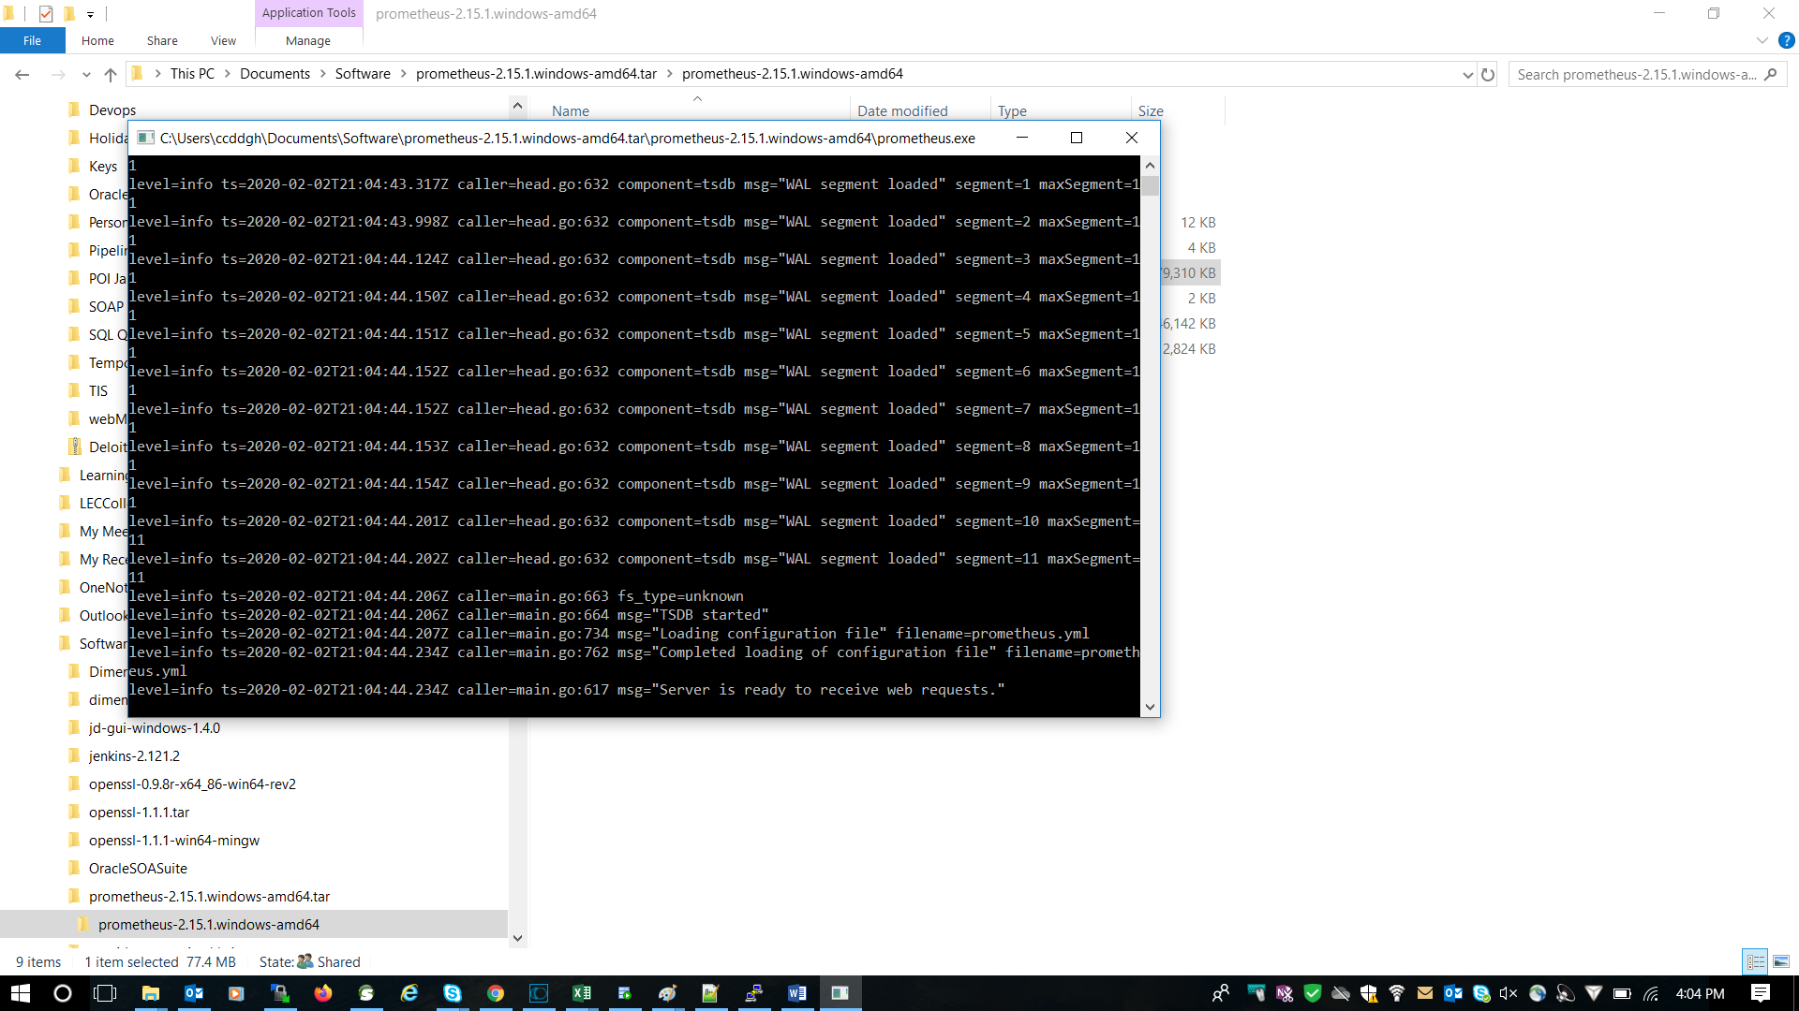
   5. Please access Prometheus from any browser using <http://localhost:9090/graph>
2. Next we will start with Prometheus node exporter installation on linux for exporting machine metrics.
   1. Unzip the node-exporter zip to below location
   2. /u01/InstallFiles/PrometheusNodeExporter/node_exporter-0.18.1.linux-amd64
   3. Execute : ./ node_exporter&
3. Next setup the pushgateway on linux to cache metrics.
   1. /u01/InstallFiles/pushgateway-1.1.0.linux-386/Pushgateway
   2. Execute : ./ Pushgateway&
   3. Access the url : <Hostname>:9091/metrics
   4. <http://cctiswmduatapp1:9091/metrics>
4. Now that we are all setup with the components installations, it’s time to setup the target for data scraping.
   1. The frontend can be used to see the current set of targets currently configured.
   2. <http://localhost:9090/targets>
   3. 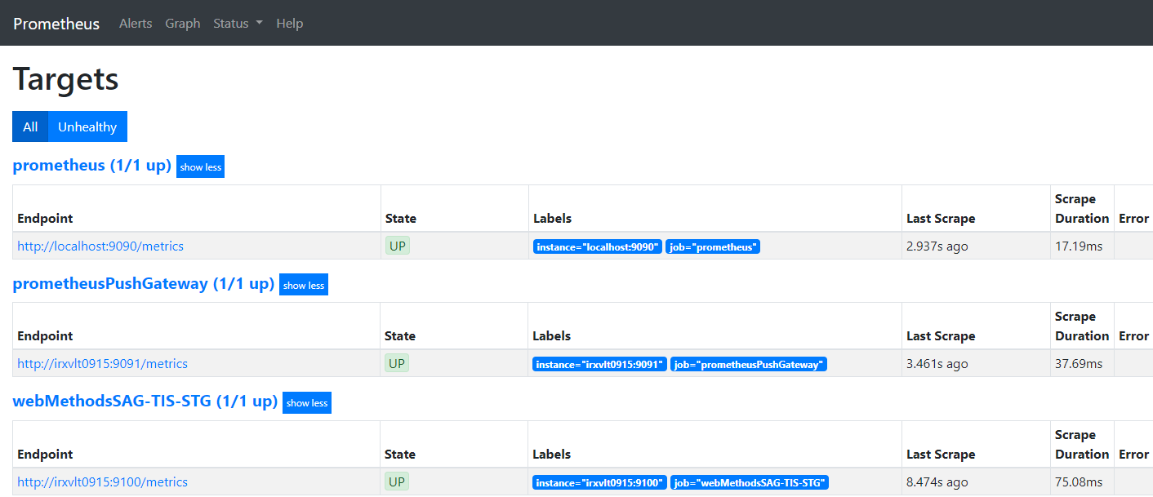
   4. The above screenshot is after configuration which was done by me.
   5. For adding new targets, you need to add new entries to .\prometheus-2.15.1.windows-amd64.tar\prometheus-2.15.1.windows-amd64\prometheus.yml
   6. Sample Entry:

- job_name: 'webMethodsSAG-TIS-STG'

# metrics_path defaults to '/metrics'

# scheme defaults to 'http'.

static_configs:

- targets: ['irxvlt0915:9100']

- job_name: 'prometheusPushGateway'

# metrics_path defaults to '/metrics'

# scheme defaults to 'http'.

static_configs:

- targets: ['irxvlt0915:9091']

g. The Prometheus server needs to rebooted for the changes to take effect.