Chapter 1
Introduction

Aim:
To develop an application to provide a proper platform for volunteer to efficiently and effortlessly connect with NGOs or NGO Events.

Objectives:
To provide a platform for volunteers to find genuine NGOs using rating system.
To use GIN numbers to verify popular NGOs.
To spread awareness about NGO events by allowing users to share it on social media.
To provide location based sorting to show closest events first.
To provide “Register for Event”, “Required Volunteers” and “Current Volunteers” count to keep track of people involved.
To provide a profile for NGO’s to display their past Event’s photos, a brief description of their work.
To provide interoperability with Google Maps so volunteers can easily navigate to Event Location.
To provide a medal system to encourage volunteering.
To provide a user profile page with a brief description and images related to user events.
To provide a report button to filter out users which are doing or posting things they are not supposed to.
To provide inspirational stories by users for other users.

Purpose:
In today’s world we are facing seemingly insurmountable challenges from chronic poverty to environmental problems and these huge issues make us feel powerless as the general public. But this is not the whole truth! Each and every person has the capacity to influence the world around them in a positive way.
Moreover, there have been countless people with the time, energy and/or other resources with the will to help others but they simply did not know where to start. A simple Google Search reveals major as well as minor NGOs which are starved for volunteers. Most people are unaware of events happening near their homes.
If anyone with the resources and will to help would do so, think of the different areas of social change: Underfunded Schools & Education, Poverty, Homelessness, Women Empowerment, Environmental Issues, Animal Welfare.... The possibilities are endless. The world will surely be a much better place than it was before. Individuals and organizations are constantly trying to spread their work for cultivating awareness as well as attracting prospective volunteers, supporters and donors.
Sharing your work and activities on our application helps you to connect with Volunteers, Supporters, Donors, etc.

Our application identifies the potential in every innovative idea and its positive impact on the community by allowing volunteers to share their experience with friends, other social activists, nonprofit organizations and social entrepreneurs.
Benefits of Volunteering:-
- Gain a sense of purpose.
- Meet new people and make new friends.
- Be a part of something bigger than yourself.
- Feel valued and part of a team.
- Explore career paths.
- Healthy for your mind and body.
- Learn new skills and polish the ones you already have.
- Gain a new perspective on life and develop empathy which helps in better connecting with others in social and personal life.
- Get inspired.
- Gain confidence in your social skills.
- A change of pace from the busy daily life.

Background:
Some of the most popular apps working around the same concept of our project are:-
- My Selfless Act
- World Packers
- Brightest
- Volunteer Connection
- Golden Volunteer Opportunities

After going through these applications we reached the conclusion that:-
The UI was laggy and bland.
There was too much irrelevant information.
The focus of the app was not purely on volunteering.
There was majority of foreign NGOs and comparatively Indian NGOs were fewer in number.

Scope:
Stake Holders:
The stakeholders for the application are Non-Governmental Organizations, Volunteers and Non Profit Organizations.

Deliverables:
Use of GIN numbers to verify the authenticity of popular NGOs.
A platform for willing volunteers to meet NGOs.
Location based sorted list where distance of the Event from the user is used to sort the list.
A profile for NGOs to exhibit their past events and their impact.
A profile for volunteers to share their stories and their short description.
Medal System to improve and encourage volunteering.
Interoperability with Google Maps for easy navigation.

Out of Scope:
Verification of Authenticity of newly established NGOs.
Guarantee of registered volunteers to be present at the event.
Donations for the NGOs.
Certificates for volunteer’s contribution at any event.

Chapter 2
Survey of Technologies

The overall concept of our project has been repeated in the past in the form of Websites and Smartphone Applications.
Most of the websites we could find were foreign based and seemed outside the scope of the intended audience.
Out of the few websites we could find
IVolunteer.org ^{[1]}:
It was the most impressive, established in 2001, it had over 10,000 volunteers and around 300+ organizations.
In case of smartphone applications, there were a handful but the most noteworthy were:

My Self-less Act:
This app is directly made from a website (www.myselflessact.com ). It includes motivational stories about people who have volunteered and quotes to encourage volunteering. It has a lot of options regarding the types of volunteering.

Grassroots :
This app is also made by down-scaling a website.
This was developed in Chennai and the scope of this website and the application was around Chennai as well.

Donate My Time
This was the most well-made application.
The creators of this app had a website but the application is completely unrelated to it.
The website only serves to inform the user about the goals of the apps and the creator's ideologies.

Features:

IVolunteer.org
It presents us with a huge list of events that are happening around us.
It has different methods of sorting (Distance, Area, Time and Organization) to show the events that are most relevant to us.
It has color coding to indicate events that are still needing and events that have met the volunteering requirement.
It has advanced search features.
They hold Volunteer Awards to encourage volunteering.

My Self less Acts
It provides a social media like network to form friends during the volunteering acts.
It has a wall to post images and write posts.
It has a messaging system for users to contact each other.
It also provides profile for both NGOs and Volunteers.

Grassroots
This app had a city wise sort for finding different NGO events.
Since the focus of only on Chennai, the size of the list was manageable.

DonateMyTime
The app was well-made, the UI was consistent, easy to follow and understand.
The app presented the list of events of NGO's in the form of Cards.
It provided different methods of sorting the event lists.
There was also an option to directly view them on the Map to gauge how far the events are.

What could be Done Better?

IVolunteer
Seeing as smartphones are becoming the norm in computing technologies, using a website seems out of place. Though website does provide a lot of useful features, the same features more or less can be provided through an android app.

My Self-less Act
That being said a website down-scaled to an android app is not a good idea, as it just feels like scrolling through a web page and misses out on the features provided by an application like not having to load a new page on every click, using different API's for interoperability between applications, etc.
A social media type network takes the focus out from volunteering and the messaging system may be misused as harassment.

GrassRoots
This app too, was down-scaled from a website,
It only had cities in Chennai and UI was very laggy.
We were unable to get past the register page and when we checked the reviews many people faced the same issue.

Donate My Time
The UI was simple, too simple and bland.
This indicated that old technology was used to make this app.
It also had limited locations that could be accessed.

Comparative Analysis:

An Application could be made using recent technologies, the UI could be made more fluid, less laggy and easy to understand.
The number of locations that the app could work with could be increased.
There was scope for improvement in the interoperability of apps.
Use of images should be added and implemented without making the UI laggy.
Different methods of filtering should be made available to the user.
Focus of the app should be on volunteering and the user should not be bombarded with too many options as that only makes it more difficult to work with.
Due to the threat of NGO's being spurious, there should exist a rating system which can be used to show that NGO's is genuine.
There can also be a display of the NGO's past events along with photographs to further ascertain the authenticity of that organization.
Users can be allowed to have profiles and rankings or medal to encourage volunteering.

Methodology:

To make the application UI smoother, more fluid and easy to understand, we intend to develop the application using a modern framework known as flutter.
Interoperability of applications can be implemented by adding various API's, as needed, within the application.
Rating system will be implemented as, out of 5 stars, where every NGO initially starts with 3 and it increases or decreases based on their activities.
The information of the Events will be stored with their Time, Location, Organization, etc. to facilitate users by showing information arranged in a relevant manner.

Technologies:

Using Machine Learning to Detect Fake Accounts:
This method relies on user-level activities and its account details. Unique features are extracted from recent user activities, then those features are applied to a classified that has been trained using machine learning techniques.
These features could be:
- Average Clicks per Session
- Average Session Length
- No. of visited links
- Content posted

Option for Virtual Volunteering:
Volunteering opportunities that can be done from home. These activities are mostly minimal physical effort. Examples of virtual volunteering can be, editing or writing articles, designing graphics, counseling people or tutoring and mentoring students.

Sorting:
Arranging information based on location provides a lot of usability benefits. It subtly aids the users as scrolling through a long list of locations is an unnecessary hassle.

Geo-sorting:
It is one of the methods to arrange data for user convenience.
It uses the physical distance in latitude and longitude from the user to the set of latitude's and longitudes to calculate the distance between them.
This method is easy to implement and works quick for small data sets.

Advanced Search:
Search based on keywords, distance, dates along with additional filters based on user's availability. Advanced search makes it easier for users to find exactly what they want.

Filtering Based on Organization:
Since some users prefer working for a trusted organization or a familiar one this option works best for those users.

Filtering Based on City/Area:
Filtering information based on location provides a lot of usability benefits for users. It uses names of cities/areas to filter them. It is easy to understand and work with.

Postal Code Filtering
Since postal codes are universal and used everywhere, they can also be used to filter location data. Postal areas come in manageable sizes so accuracy to a certain extent is retained. There are many API's available for provide the distance between two postal codes so it is easy to work with as well.

Security:

Techniques to Secure DB ^{[2]}:

Use Web Application and Database Firewalls:
Database can be protected against Security threats by using a firewall which denies access to traffic by default.
Only traffic allowed through should come from specific application or web server that need to access the data.
The firewall should also protect your DB from initiating outbound connections unless there is a specific need to do so.
In Addition to Database Firewall, a web application firewall should also be used to prevent against attacks such as SQL Injection Attacks directed at web application.

"Harden" the DB:
Use the most up to date version of the DB S/W.
Uninstall or disable any features or services that you don't use.
Ensure that none of the accounts have default passwords.

Encrypt the Data:
It is a standard procedure in most organizations to encrypt stored data.
It is equally important to ensure that the backups of the data is encrypted as well. Make sure the decryption keys are stored in an isolated system.

Minimize Value of DB:
Avoid keeping data that doesn't need to be there.
A compromised database can cause the least amount of damage that way.

Audit and Monitor Database Activity
Effective Monitoring allows us to track when an account has malicious intent or if the database has potential vulnerabilities.
Database Activity Monitoring S/W helps in this by providing monitoring which is independent of native database logging and audit functions.

Storing Passwords:
If the passwords of an organization gets in the hand of an unauthorized user, they might cause unimaginable damage.
Thus storing passwords securely is a high priority task.
Storing passwords in simple text is a big mistake as those transactions can be intercepted and texts can easily be extracted.
A simple solution to this is hashing the passwords before storing them in a database. Common Hashing algorithms are MD5/SHA1/SHA2.
But hashing a common password still won't be useful.
There are available prehashed lists of passwords which can be used to compare and find common passwords.
Another solution to that is add some extra text to the user password before storing it in the DB.
This method is commonly known as adding "salt".
But this method of using a predefined salt becomes vulnerable if/when the unauthorized person finds what the "salt" is.
The solution to that is making the "salt" dynamic.
This requires adding another DB table to keep track of salts as different users will have different salts.

Keeping the user data secure is high priority and since this is the first time we are handling user data, we decided to use tools that will make managing data much simpler.
We intent to use Google's Firebase, Backend as a Service product.
It charges a small fee but it takes using a Server out of the equation, has strong security features, works as Database and is a cloud platform which is the current world trend.
To list a few features of Firebase^{[3]}:

Real-Time:
It uses Web-Sockets instead of HTTP requests to transfer data.
That means all of the client's data syncs through a single connection as fast as the network can support it.

File Storage:
It supports storing binary files (images, videos, etc.).
It has security rules to make sure the binary data cannot do any harm as well.
They also ensure only authorized users are able to make changes in the data.

Authentication:
It has built-in authentication (OAuth2) for Google, Facebook, Twitter and GitHub.
(Google and Facebook Authentications are what we intent to use.)

Advanced Indexing:
It allows user-defined index optimization i.e. As long as it knows using what keys the data is going to be used, it will optimize the database to make the query run faster.

Automated Backups:
It provides automated backups for the data.

Read/Write Control:
Using Firebase we can control which users can write data into the DB, modify it or only read from it.

Statistics: It provides stats of the users in the app which can be used to further improve the app.

Chapter 3
Requirement Analysis

Problem Definition:

There are over 1.2 billion people in India. With the unemployment rates doubling^{[4]} in the past couple years, it is clearly evident that we have a lot of free time on our hands. If this free time or at least some of it, was utilized in helping others, the nation could be a much better place. With the rise of social media and the information age, there is sufficient awareness about the anguish of people, there are many willing to help but have no idea where to start.
There's also the problem of authenticity of organizations that they would like to help out but have no way of verifying without visiting there, which might not be the safest option.

So to summarize the problems tackled in this project are:
- Helping volunteers volunteering by providing nearby events.
- Helping NGOs congregate people for their events.
- Using a rating system, to denote NGO authenticity as NGO which has higher number of reviews means many people have attended their activities and thus they must be genuine.

Requirement Specification:

The application that is to be developed is going to be able to solve problems for both NGOs and volunteers.
It will aid volunteers in finding genuine NGOs through a simple interface.
It will aid volunteers by providing simple interface having information regarding vicinal events.
It will aid volunteers in reaching an NGO event, should they choose to participate, via Google Maps integration.
It will assist volunteers in determining the authenticity of an NGO by determining how many activities they have held and how many people attended them.
It will provide a profile page for NGOs to display how many events they’ve held and how much of an impact they’ve had.
It will provide inspirational stories and basic encouragements for motivating people to volunteer.
It will create awareness for an NGO and their activities allowing them to help more people.

Program Evaluation and Review Technique (PERT) Chart:

Sr. No. | Activities | Optimistic Time (a) | Most Likely Time (m) | Pessimistic Time (b) | Estimated Time (t_{e}) | Standard Deviation  (S.D)
A. | Survey | 5 | 7 | 9 | 7 | 0.67
B. | Background Study | 5 | 7 | 9 | 7 | 0.67
C. | Literature Study | 12 | 14 | 16 | 14 | 0.67
D. | Requirement Analysis | 18 | 20 | 22 | 20 | 0.67
E. | Selection of H/W and S/W | 3 | 5 | 6 | 4.83 | 0.5
F. | Database Designing | 23 | 25 | 27 | 25 | 0.67
G. | UI Designing | 18 | 20 | 25 | 20.5 | 1.16
H. | UI Coding | 39 | 40 | 45 | 40.17 | 1
I. | App Logic Coding | 39 | 40 | 45 | 40.17 | 1
J. | Database Coding | 39 | 40 | 45 | 40.17 | 1
K. | UI Testing | 9 | 10 | 12 | 10.16 | 0.5
L. | App Logic Testing | 9 | 10 | 12 | 10.16 | 0.5
M. | Database Testing | 9 | 10 | 12 | 10.16 | 0.5
N. | Integration | 7 | 8 | 10 | 8.16 | 0.5
O. | Integration Testing | 7 | 8 | 10 | 8.16 | 0.5
P. | Implementation | 2 | 4 | 5 | 3.83 | 0.5

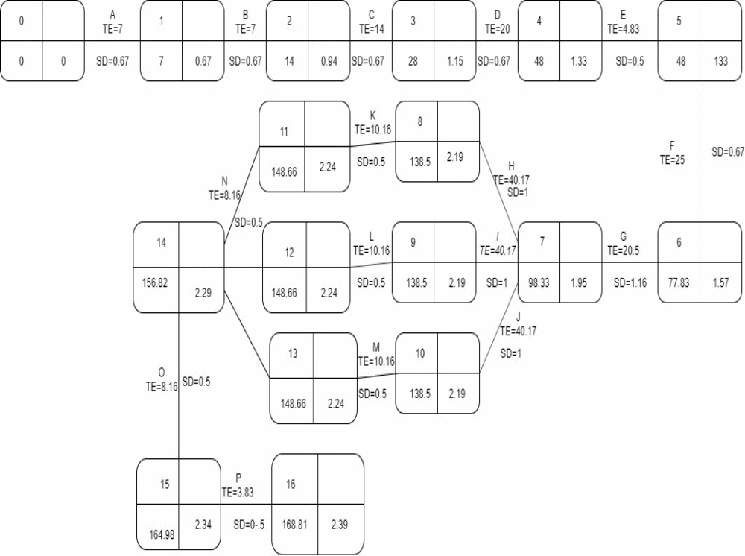

Gantt chart:-

Activities | Date | Duration (in Days)
Survey | 10 July 2019 | 7
Background Study | 17 July 2019 | 7
Literature Study | 31 July 2019 | 14
Requirement Analysis | 20 August 2019 | 20
Selection of H/W &S/W | 25 August 2019 | 5
Database Designing | 18 September 2019 | 25
UI Designing | 8 October 2019 | 20
UI Coding | 28 October 2019 | 40
App Logic Coding | 28 October 2019 | 40
Database Coding | 28 October 2019 | 40
UI Testing | 7 December 2019 | 10
App Logic Testing | 7 December 2019 | 10
Database Testing | 7 December 2019 | 10
Integration | 15 December 2019 | 8
Integration Testing | 23 December 2019 | 8
Implementation | 27 December 2019 | 4

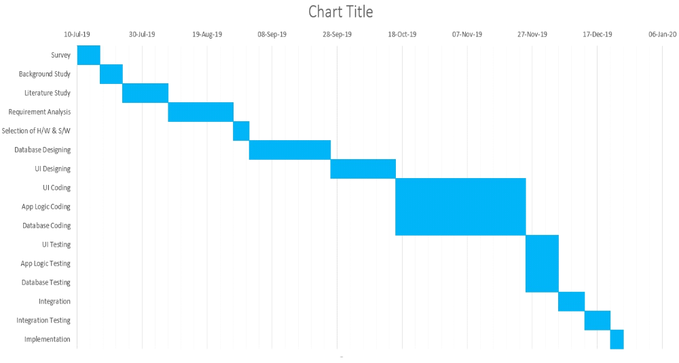

ER Diagram:

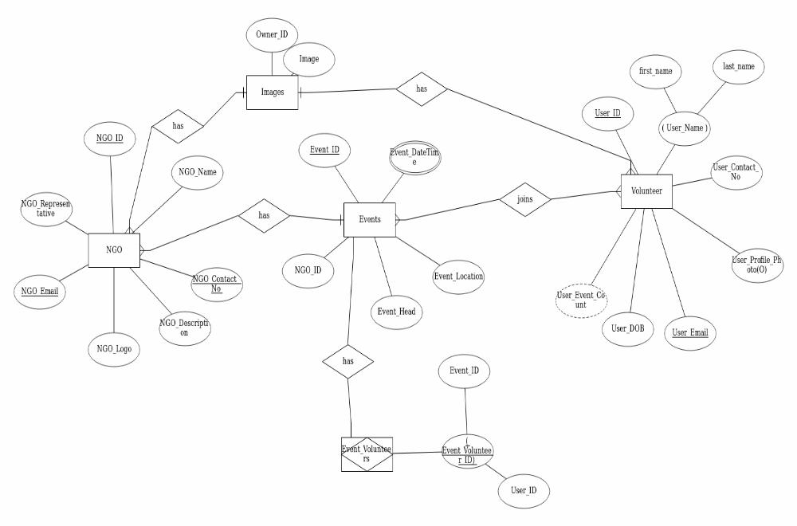

Data Dictionary:

NGO

Column | Datatype | Size | Constraints
NGO Id | Int | 8B | Primary Key
NGO Description | Varchar | 320
NGO Name | Varchar | 30 | Not Null
NGO Email | Varchar | 20
NGO Contact Number | Varchar | 10 | Not Null
NGO Representative | Varchar | 30 | Not Null
NGO Logo | BLOB | 4MB | Not Null
Website | Varchar | 20

Volunteer

Column | Datatype | Size | Constraints
User Id | Int | 4B | Primary Key
First Name | Varchar | 20 | Not Null
Last Name | Varchar | 20 | Not Null
User Contact Number | Varchar | 10 | Not Null
User Profile Photo | BLOB | 4MB | Not Null
User Email | Varchar | 20 | Not Null
User D.O.B. | Date | 3B | Not Null
User Event Count | Int | 4B
User Age | Int | 4B

Events

Column | Datatype | Size | Constraints
Event Id | Int | 8B | Primary key
NGO Id | Int | 8B | Foreign Key
Event Datetime | Date | 3B | Not Null
Event Location | Geopoint | 16B | Not Null
Event Head | Varchar | 40 | Not Null
Event Address | Varchar | 150 | Not Null

Event Volunteers

Column | Datatype | Size | Constraints
Event ID | Int | 4B | Primary Key
Volunteer ID | Int | 4B | Primary Key

Images

Column | Datatype | Size | Constraints
Owner ID | Int | 8B | Foreign Key
Image | BLOB | 4MB | Not Null
Description | Varchar | 150 | Not Null
Image ID | Int | 8B | Primary Key

Use Case Diagram:

NGO Side:-

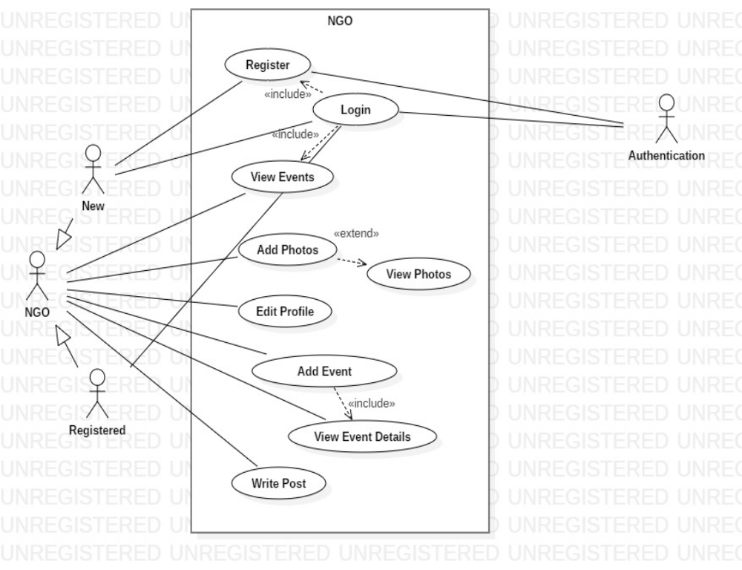

Volunteer Side:

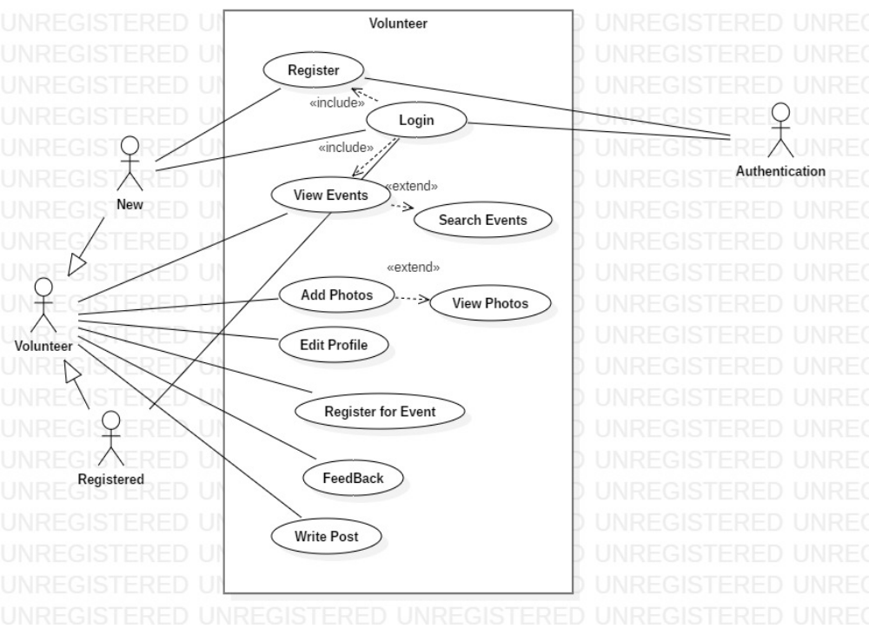

Data Flow diagram:

Level 0-

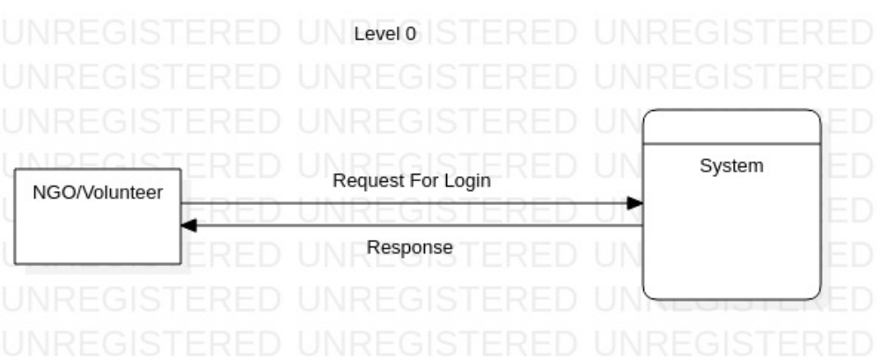

Level 1:- (NGO Side)

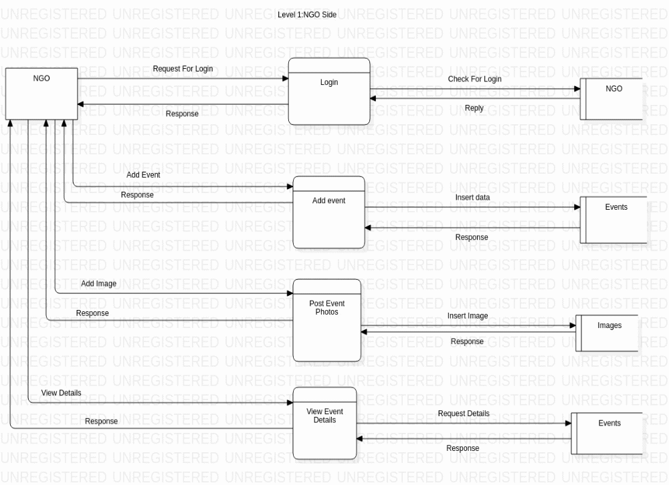

Level 1:- (Volunteer Side)

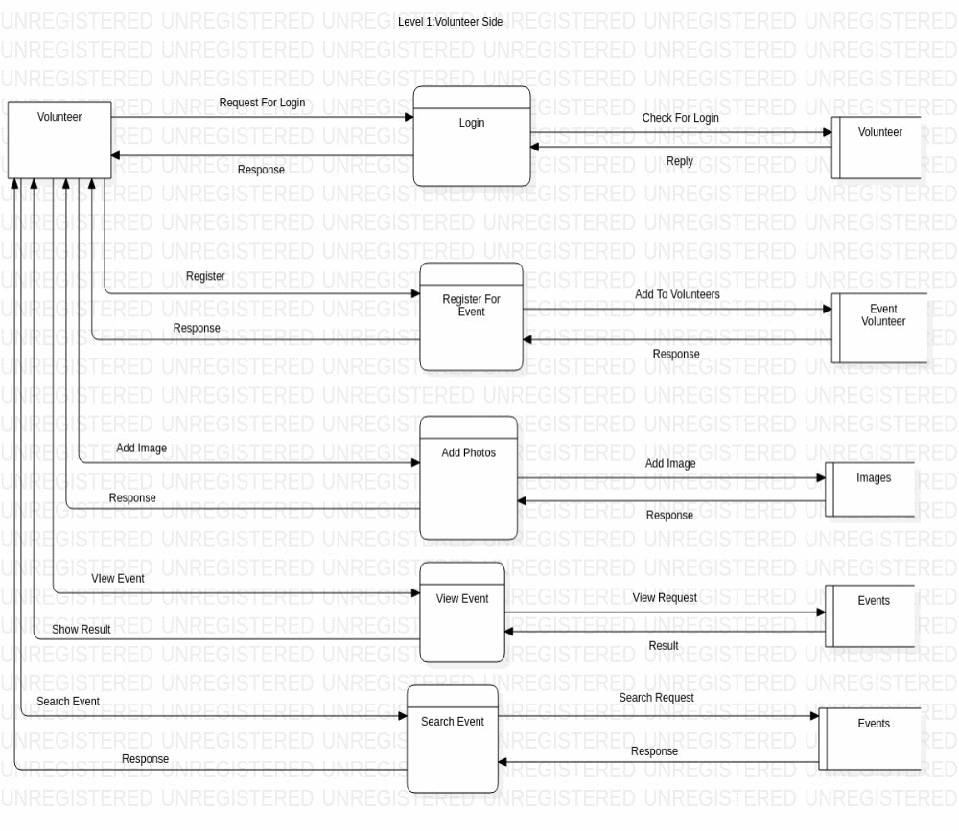

Activity Diagram:

For Volunteers registering for Events:
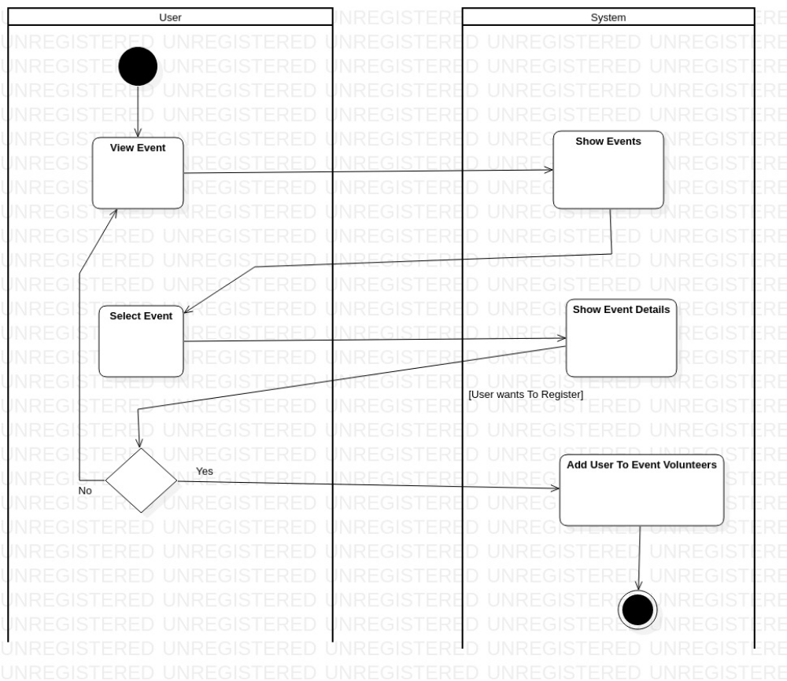

For Login and Registration:
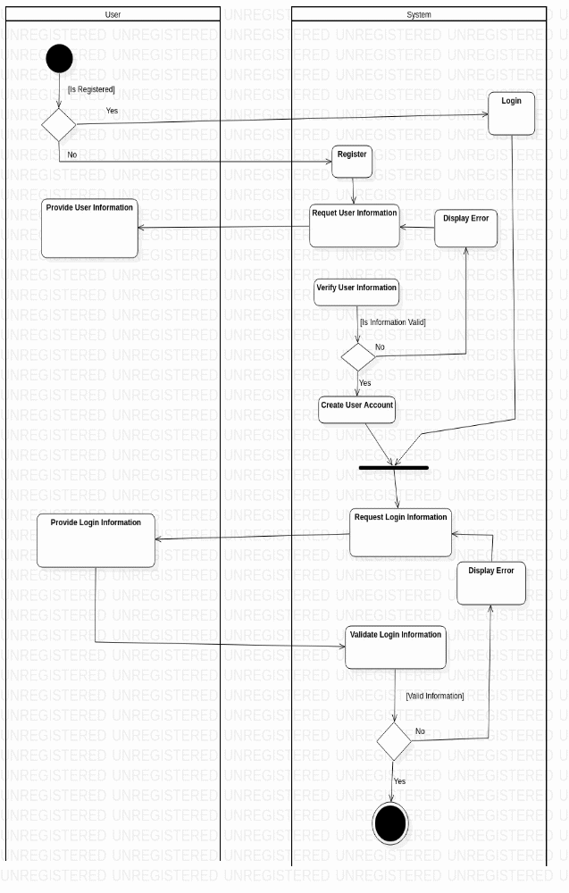

-Technical Feasibility:

Software Requirements:

Operating System | Ubuntu 18.04 LTS
Software | Visual Studio Code

Languages:

FrontEnd | Dart using Flutter Framework
BackEnd | Dart using Firebase SDK

Hardware Requirements:

Processor | Intel i3 M370
Clock Speed | 2.40 GHz
HDD Capacity | 500GB
RAM Size | 4GB
Ram Type | DDR3
System Architecture | 64 bit

Preliminary Product Description:

The following are the requirements that were accessed and fulfilled in our project.

1. Simplified Registration: Providing a hassle-free and simple interface for both kind of users to register.

2. Profiles and Logins: Providing easy methods to login (G-mail, Facebook, and Phone Number) for users as well as providing profile pages for users.

3. Optimized Search Results: Providing search results sorted based on vicinity of events to the user.

4. Events: Providing interface for NGOs to create their events and volunteers to participate in them.

5. Rating System: Providing rating system for NGOs to help others understand how well an NGO works and for the NGO to develop itself.

6. Encouraging Volunteers: Providing motivational stories, written by volunteers themselves for other volunteers to encourage user activity.

7. Achievements: Providing achievements to volunteers after they attend a certain number of events.
Chapter 4
System Design

Helping Hands Application Modules:

The project we are working on consists of several modules as modular project development is much easier to manage and improve. Modular development also helps in proper work distribution.

Following are the modules to be developed for the application:-
- Registration Module
- Login Module
- Create Event Module
- Search Event Module
- Create Post Module

Registration Module:

Here we elaborate on how the registration process will work. Here the user (NGO/ Volunteer) has to register with the application to create or participate in events. It plays an essential role to verify user data before creating user accounts.

Algorithm:

Step 1 > The user install and opens the app.

Step 2> For registration the user provides his credentials.

Step 3> The user has to verify their phone number (in either case of NGO or Volunteer) and Email ID (in case of NGO, optional for Volunteer) through OTP (One Time Password) sent by the application.

Step 4> If the credentials are verified then the user is authenticated and gets registered successfully.

Step 5> If the credential’s verification fails then the user is provided with an error message and asked to enter valid credentials.

Flowchart:

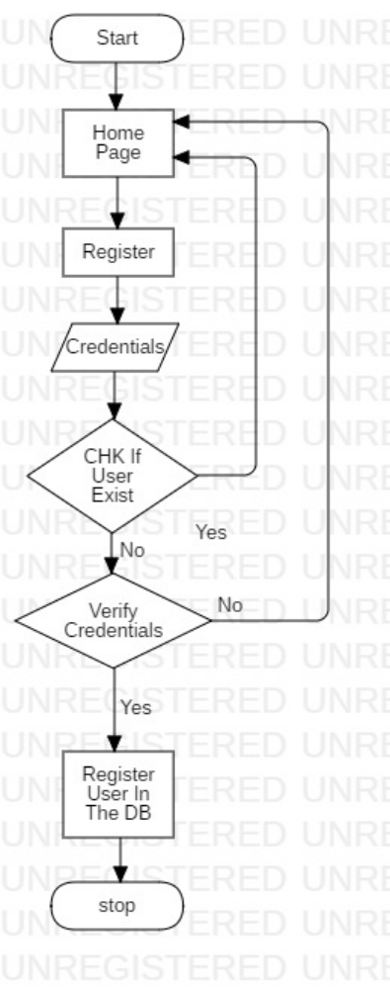

Interfaces:

Registration (For NGO):-

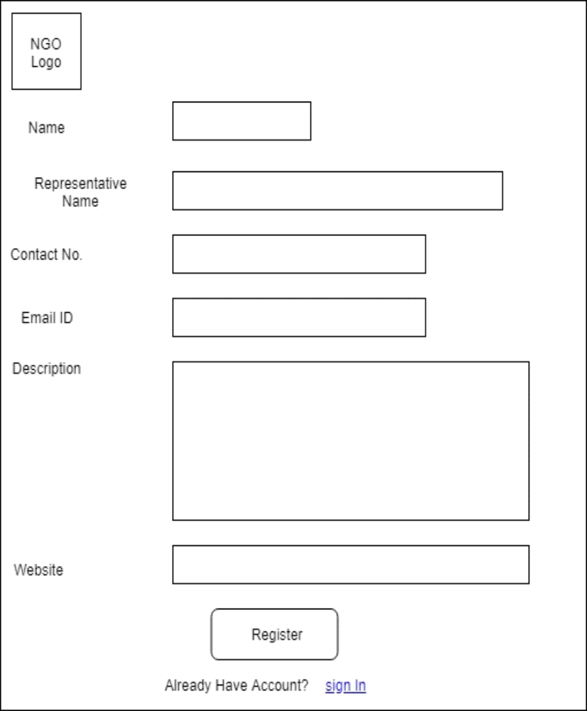

Registration (For Volunteers)-

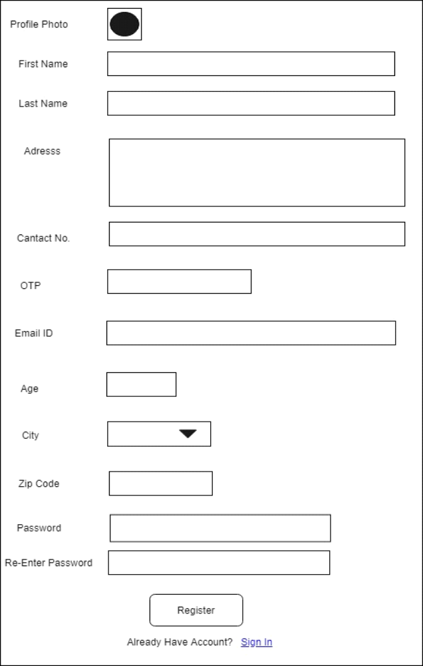

Validations:

Name, First Name, Last Name | Mandatory Required
Email ID | Regular Expression Validation
Phone Number | Should be exactly 10 numeric characters
Password | Should be at least 8 characters
ZIP code | Should be exactly 6 numeric characters
Logo, Profile Photo | Should be an image file

Login Module:

In this step the user will be logged in. The user has to provide his credentials, which he used to register, these credentials are then used to authenticate the user.
Logging in is mandatory for all operations.

Algorithm:

Step 1> The user starts the application and is provided with the Login interface.

Step 2> The user enter valid credentials in the Login interface.

Step 3> The user clicks on login button to send data for authentication.

Step 4> If the user is authenticated, the user is logged in successfully.

Step 5> If authentication fails, an error message is displayed.

Flowchart:

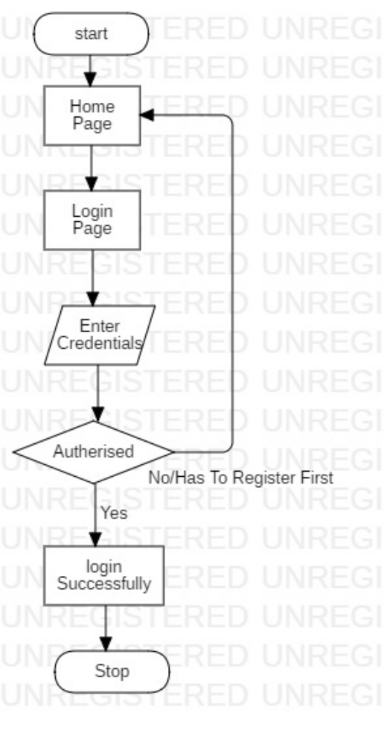

Interface:

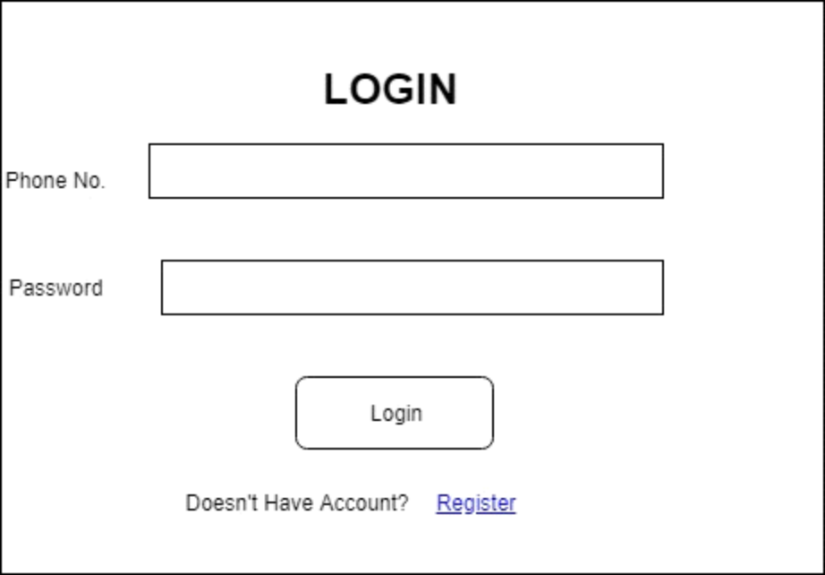

Logging in is required to check whether the user is authorized or not. Logging in with proper credentials will allow user to perform further operations such as creating / participating in events.

Validations:

Phone Number | Should be exactly 10 numeric characters
Password | Should be at least 8 characters

View Events Module:

In this step, the volunteer is shown a list of events which are represented in a card-like manner. Each card contains brief information regarding the event it represents.
The information is sorted based on the distance of the event from the volunteer.
There are four available options for filtering which can be used together or independently.
They are:
- Filtering by NGO Name
- Filtering by City
Filtering by Zip Code
- Filtering by Date

Selecting any of the cards will open an interface which will display information regarding the event the card was representing.

Flowchart:

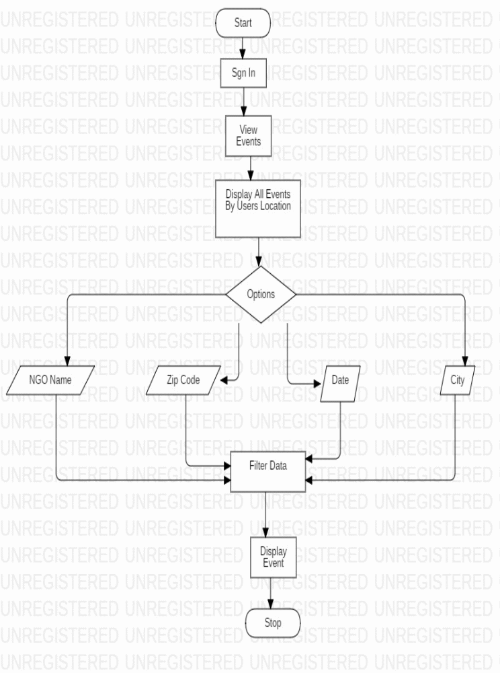

Interface:

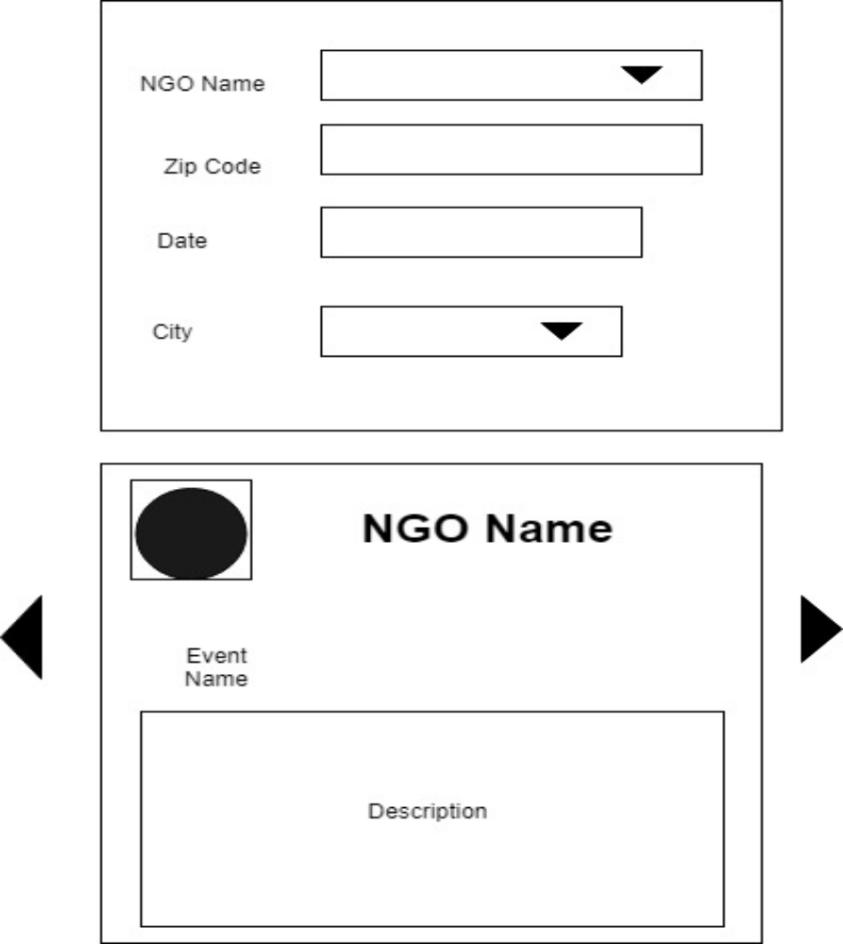

Create Event Module:

In this step, the NGO creates an event which is to be attended by the volunteers.

Algorithm:

Step 1> Open the application and sign in with valid credentials.

Step 2> Click on create event button which will open Create Event interface.

Step 3> Enter all necessary information regarding the event.

Step 4> If all the information is valid then the event is added to the database.

Step 5> If any of the information is invalid a corresponding error message will be displayed.

Flowchart:

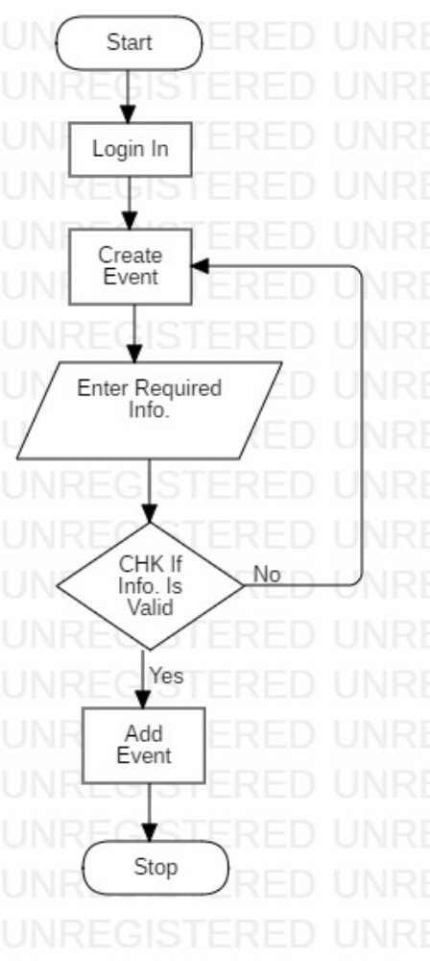

Interface:

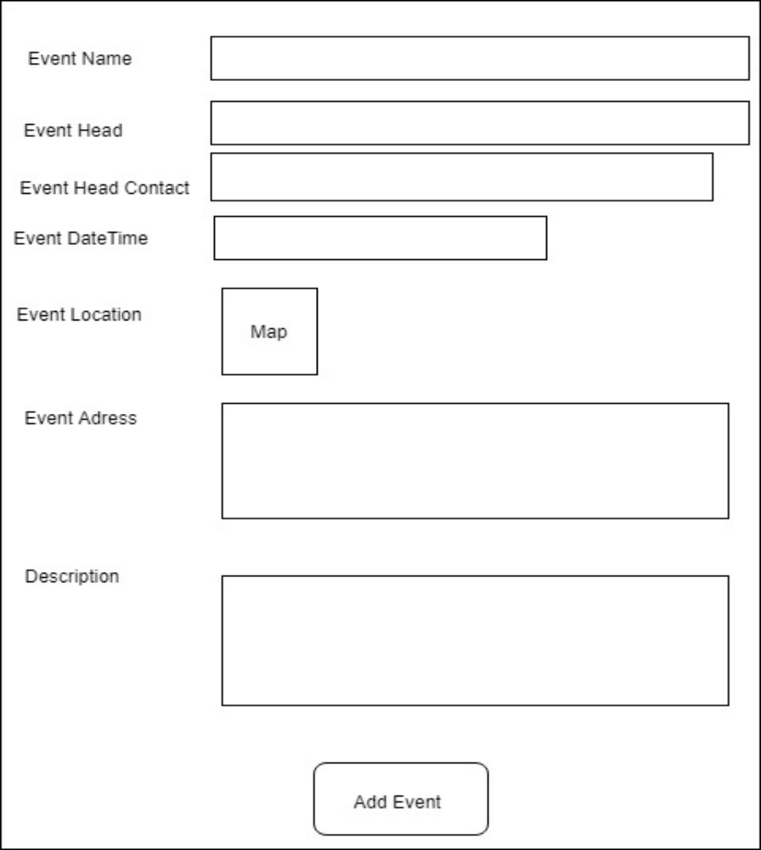

Validations:

Event Name, Event Head Name | Mandatory Fields
Event Head Contact Number | Must be exactly 10 numeric characters
Date | Should be greater than Event Creation date
Address | Must be at least 10 characters

Create Post Module:

In this step, the user (NGO or Volunteer) creates a post which comprises of an image and a description for that image. In case of NGOs they can view their own posts. In case of volunteers they cannot view their own posts directly, but their posts are put in as motivational posts which can be seen by every other user.
Posts are useful in assuring volunteers of authenticity of an NGO and encouraging other volunteers to volunteer further.

Algorithm:
Step 1> Open the application and sign in with valid credentials.

Step 2> Click on “Floating Button” which will open the create post interface.

Step 3> Click on add image and choose an image from the gallery.

Step 4> Enter description of that image.

Step 5> Click on post, to add post to database.

Flowchart:

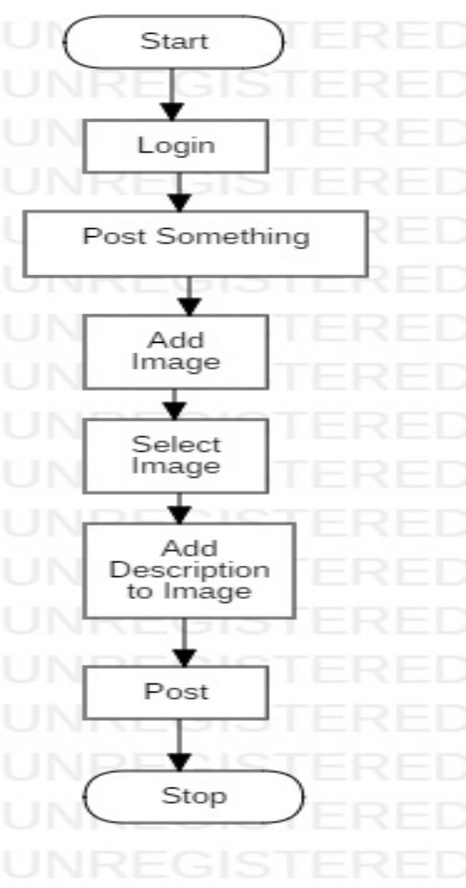

Interface:

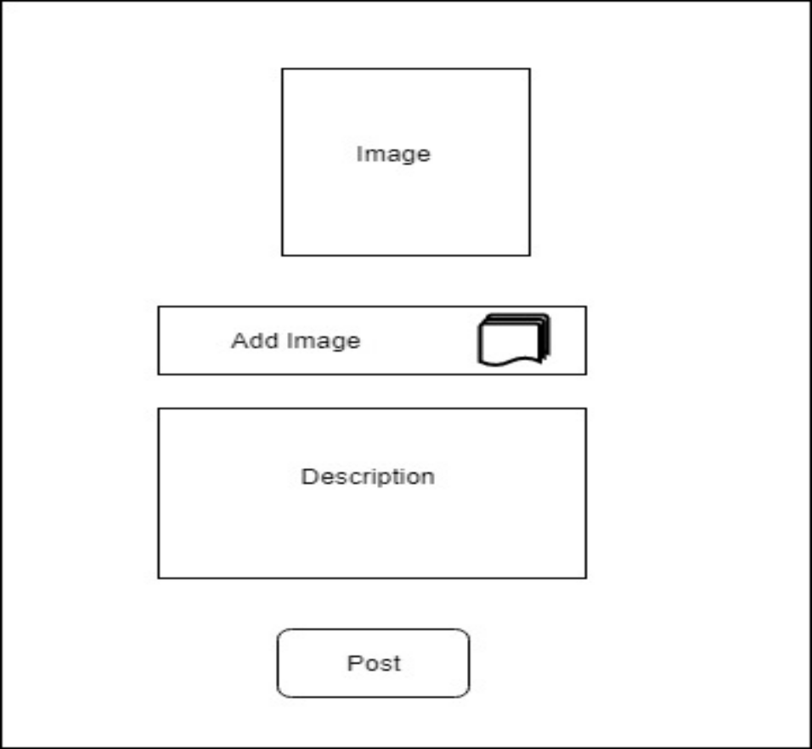

References:
[1] https://www.ivolunteer.org/
[2] https://www.esecurityplanet.com/network-security/6-database-security-best-practices.html
[3] https://howtofirebase.com/what-is-firebase-fcb8614ba442
[4] https://www.downtoearth.org.in/news/economy/india-s-unemployment-rate-doubled-in-two-years-soe-in-figures-64953

