* 1. **Implementation**

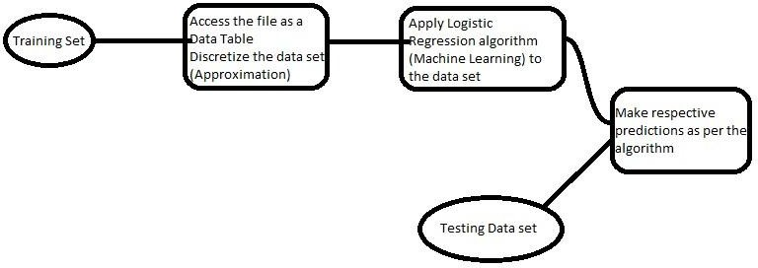

Fig 1. Flow format explanation (model mapping)

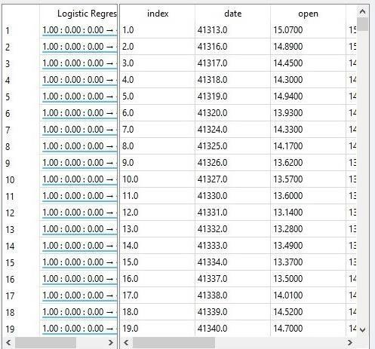

Fig 2. Trained dataset

This is the logistic regression algorithm that is applied on a set of sales and purchase data consisting of every day stock market opening, highest, lowest and closing rate and the volume of the sale or purchase for the stocks on each specific data. The training dataset consists of 10,000 tuples which trains the logistic algorithm to predict a range within which the possible future values would fall into in upcoming times. Currently the highest possible value of a day would be predicted as regards with other features.

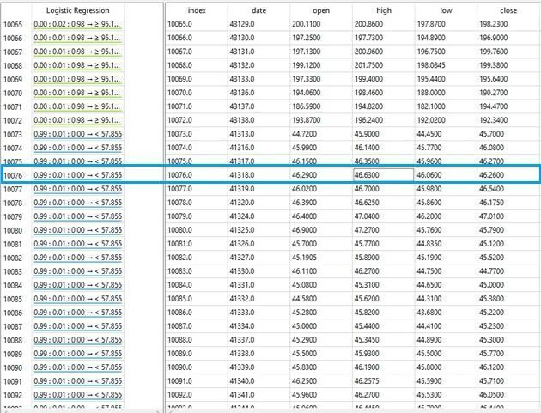

Fig 3. Predicted values of dataset

Here, the image describes a range i.e. less than 57.855 (indicated in blue color), and the actual highest value on that specific date was falling under the respective range. The other end point for the ranges is 97.1725 and the logistic regression predicted the range correctly for that specific date. Hence the logistic regression algorithm is trained most efficiently to provide the range in the most effective manner.

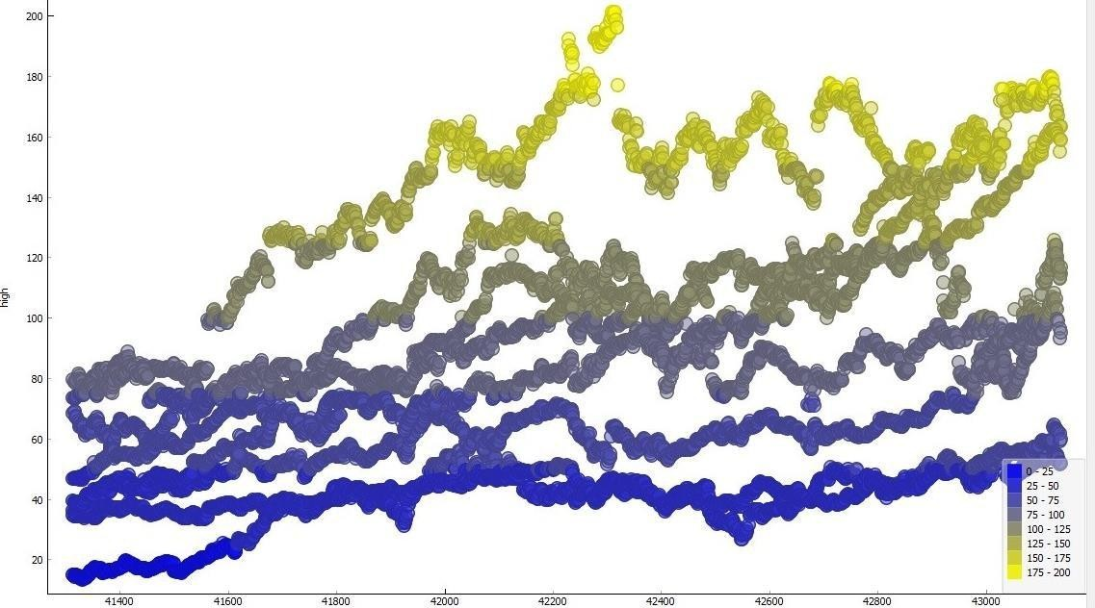

Fig 4. Graph generated from predicted value of dataset

* 1. **Pseudo Code**
     1. Start

2. For(i=0; i<100; i++)

a. For(j=0; j<10; j++)

* + - 1. S[i] = Slope(x[j], y[j]) //S is for slope values

b. Abs(s[i]) == abs(s[i+1]) //Compare deviation of all slope values each using absolute function 3. For(i=0; i<100; i++)

a. Ref[i] = x[i] for each individual slope coordinates //Ref is the reference variable that will be considered as a feature

4. For(i=0; i<100; i++)

a. If(Ref[i+1] – Ref[i] < 1.5) { count++; } //count provides the efficiency value of the pattern detection

1. If(count < 75)

a. for(i=0; i<100; i++)

* 1. new[i] = S[i]*x[i] + c //c is constant value

1. Else repeat from step 2
2. Apply logistic regression using hypothesis and gradient descent equations (as per the algorithm). //logistic regression is used to filter the values and also to analyse the pattern analysis outputs to have leveraged efficiency in upcoming predictions
3. End
   1. **Flowchart**

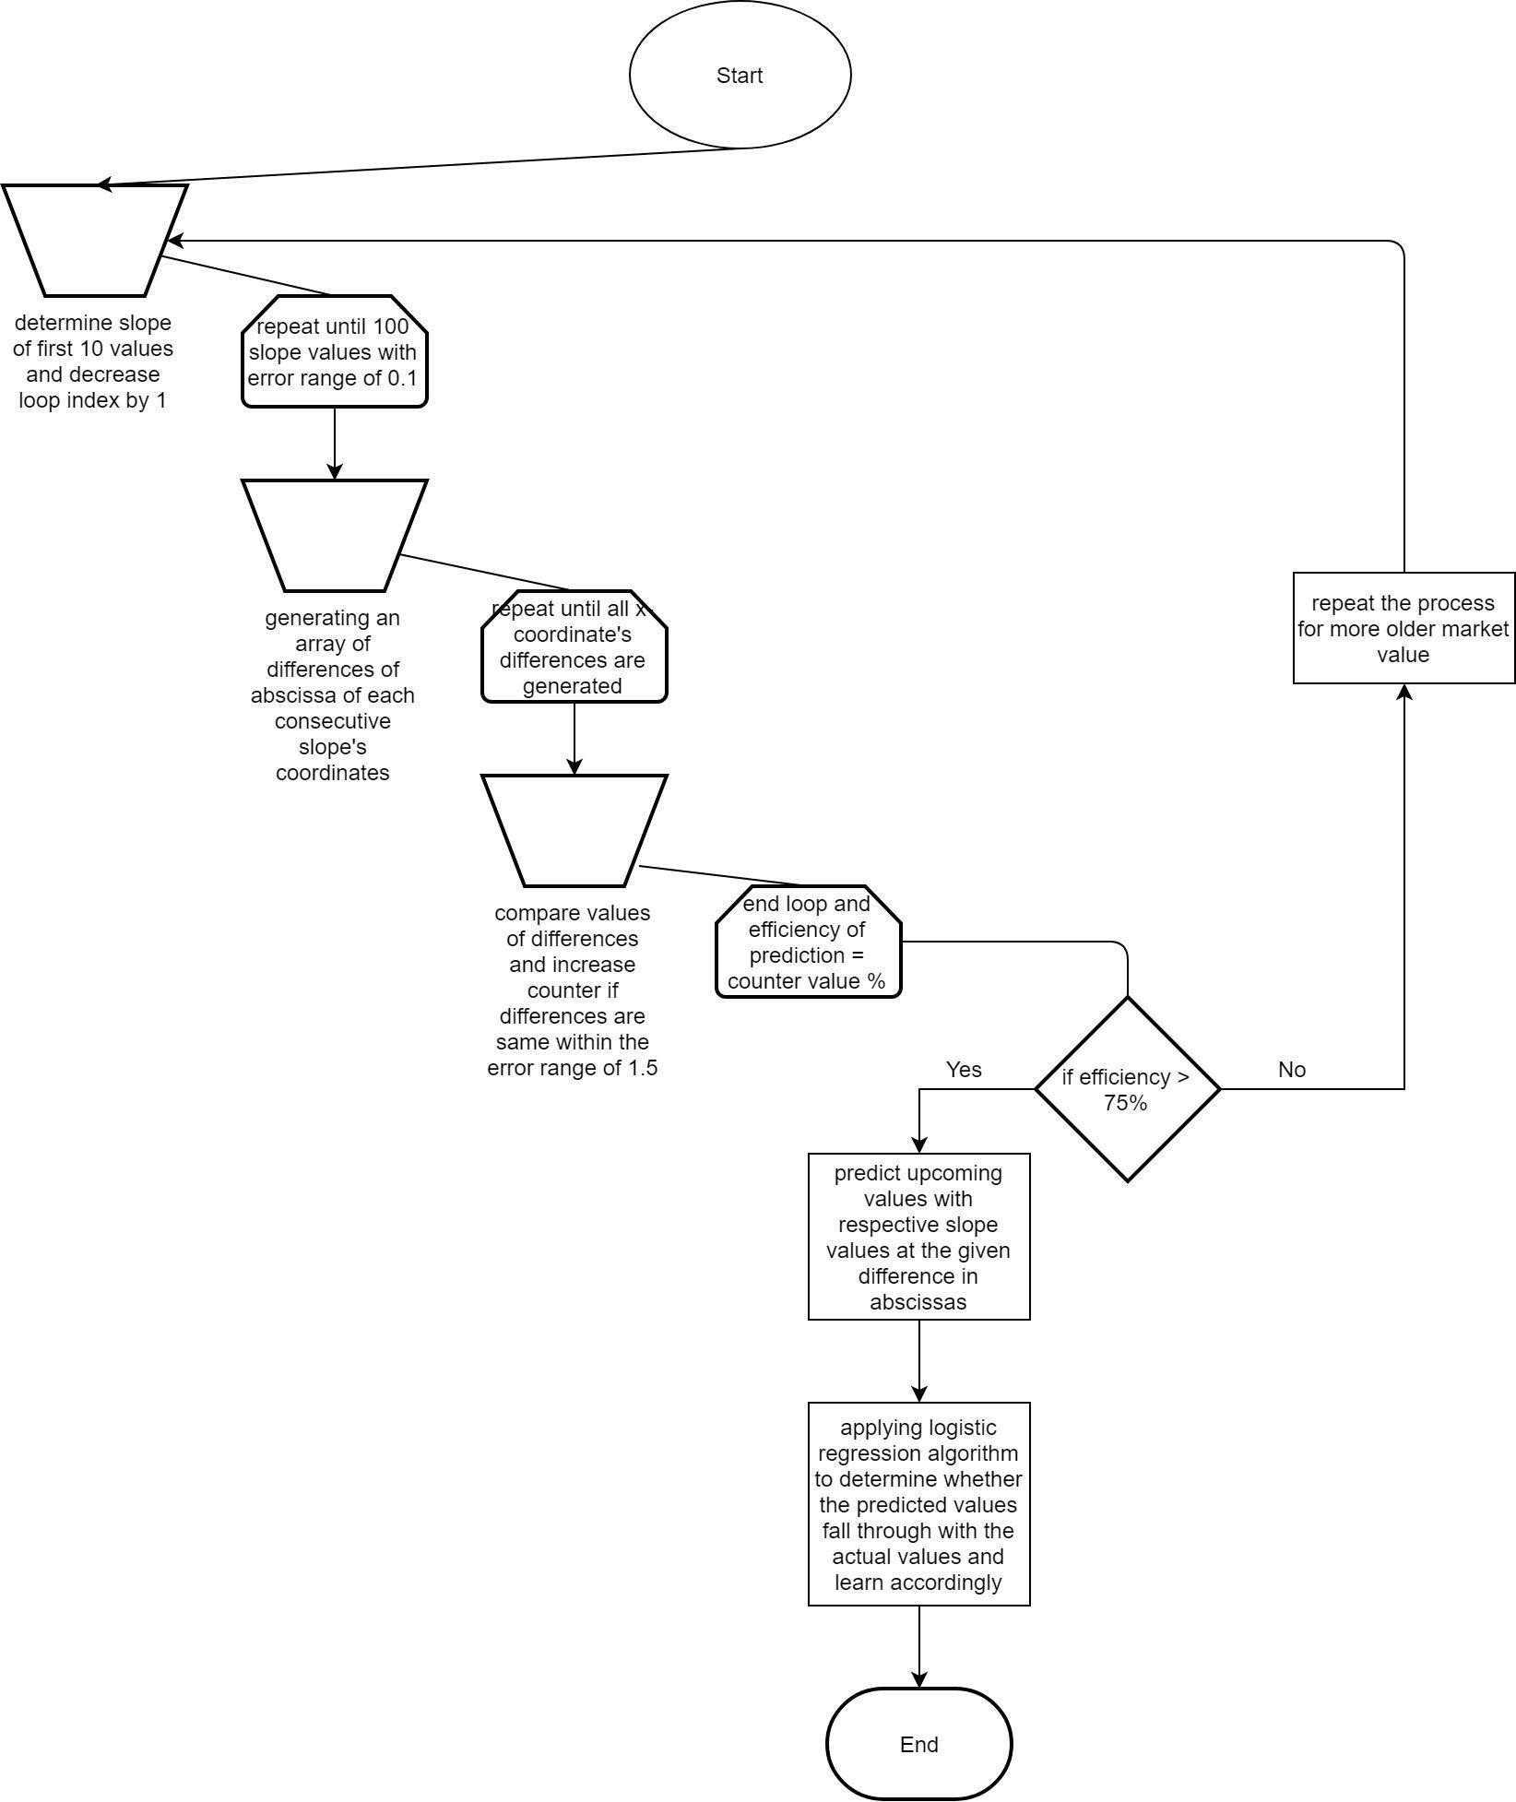

Flowchart of implementation Figure 5