*Abstract— The modern developments in neural science like neuroimaging and neuro sensing technologies have increase the size of neurological data, rate of neurological data generation, and variation in neuroscience data. These are vital role players for “Neuroscience Big data”. For statistically informative datasets in terms of size, with greater time scale and colossal number of attributes, the Neuroscience community for research can develop varied type of experiments using such data [1].With the development of many data driven research techniques, the understanding for complex neurological disorder can be advance. Tools for neuroinformatics data processing and analysing are available but they are not capable to bring about huge volume of neuroscience data, which makes it hard for researchers to advance their work due to lack of capably control over this available data. So in this paper we have analysed mainly three big data techniques like map reduce, spark and pig to check their most suitability in the field of neuroscience test, by identifying number of counts of eye blink by a human being when the brainwave signals are used as datasets for the big data technique.*

# Introduction

Neuron or nerve cell, “is an electrically excitable cell that receives, processes, and transmits information through electrical and chemical signals” [2]. It is said that, “The average human brain has about 100 billion neurons or nerve cells” [3].  To process 100 billion neurons data is obviously not a small task. Latest emerging technique like Big data can be most suitable to deal with neurons data. It is very difficult to store such data in normal hard disk as it requires space TB. So, scientists are now looking for the opportunities and challenges in big data to deal with neurons data. The metabolic reaction of ions of sodium, potassium, chloride and calcium in the neuron cell, makes a voltage gradient across its membrane [3]. The nerve impulse generates when so ever there is change in the voltage between the membrance. This nerve impulse is also known as action potential. This pulses can be captured and displayed as a waveform known as brain wave or brain rhythm[3]. It is inscribe in Brain Computer Interface And Its Types, by Anupama.H.S , N.K.Cauvery , Lingaraju.G.M, that “Brain–computer interface (BCIs)

started with Hans Berger's inventing of electrical activity of the human brain and the development of electroencephalography (EEG). In 1924 Berger recorded an EEG signals from a human brain for the first time”[4]. Being a powerful communication tool between systems and user, the Brain Computer Interface (BCI) technology does not need any exterior devices or muscle involvement, for any kind of issuing commands or to complete the interaction [5].

# Literature Review

After critically analyses of some recent research there are several different approaches to analyze brainwaves for result. Fu-Chien Kao et al. used positive and negative emotions by stimulating with the help of acoustic stimuli. They fetched brainwave and then transferred it to frequency domain signal to calculate sub band energy and in next step it is characterized and digitally encoded for analysis. Further, Sasikumar Gurumurthy et al. also analyzed braiwaves by loading EEG data into MATLAB by using Independent Component Analysis and Time/Frequency analysis. Zunairah Hj Murat et al. a scientific traditional approach, in which generated Brainwave Balancing Index (BBI) using EEG signals. Then, brainwave signals were measured and analyzed using intelligent signal processing techniques and their specified proposed algorithm. Balkis Solehah Zainuddin et al. limited their research by analyzing brainwave during Functional Electrical Stimulation, wih the help of neuroheadset. Lei Wang et al. conducted a research in which NN was used to investigate the resting neural network of stroke patient by using phase synchronization (PS) index of multichannel EEG. Yoshitsugu Yasui et al. used statistical approach for continuous measurements during day and night by placing a single point dry electrode, which extracted targeted frequency components and eliminating external and internal electrical noise. [Boubela RN](https://www.ncbi.nlm.nih.gov/pubmed/?term=Boubela%20RN%5BAuthor%5D&cauthor=true&cauthor_uid=26778951) et al. used Apache Spark and Graphics Processing Units (GPUs), in particular to provide distributed file input for 4D NIfTI fMRI datasets in Scala to perform graphical analysis[9]. [Uri Hasson](https://www.ncbi.nlm.nih.gov/pubmed/?term=Hasson%20U%5BAuthor%5D&cauthor=true&cauthor_uid=17964812) et al. proposed an open source database management system, parallel and distributed data processing using cluster computing and Grid computing resources, to analyze fMRI time series data by performing complex queries[12].

# Proposed Work

## System Framework

The framework of the proposed system could be defined in figure 1. The framework includes Data acquisition, Data storing, loading data to various big data technologies and time taken by each technology to analyse brain wave by counting number of eye blink in a time frame.

## Data Acquisition

Data acquisition is possible with the help of EEG sensor (brainsense). The sensor has two electrodes attach to the band, one electrode is placed on the forehead and other is used as a clip to the earlobe. The sensor operates at 3.3V and uses Bluetooth v2.0+ to transfer sampled data to the connected device.

## Data Storing

The brainwaves data are then transferred to neuroview with the help of Bluetooth connection. Further, neuroview helps to record the EEG waves and store them in form of numerical data with each timestamp in CSV format. The CSV files generated by neuroview are raw_data, filtered_data, powerspectrum_data, meditation_data and attention_data.

## Loading data to big data technologies

After data has been stored in CSV format, the data is then consider as valid data that can be further use by big data technologies to process and analyse it with the defined query.

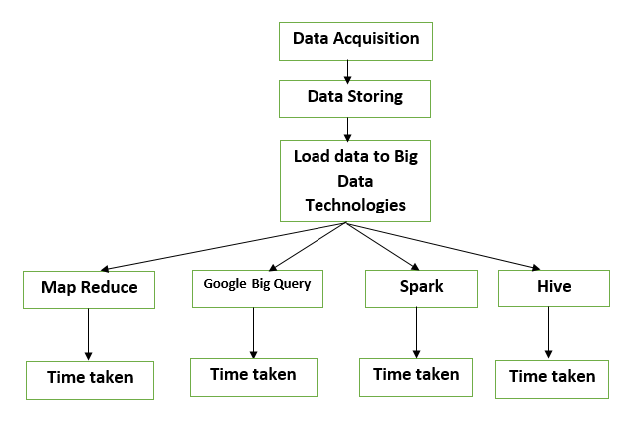

# IMPLEMENTATION:

The main aim is to utilize brainwave signals gathered with neurosky toolkit. We have utilize brain signal capturing tool for collecting eye blink dataset. Eyeblink dataset was approximately of 1 GB in size.

## A) Using Mapreduce

Step1: Create account on Google cloud

Step 2: Open Google Big Query editor

Step 3: Add the eyeblink dataset collected from neurosky toolkit

Step 4: Write the query in Query editor section

Step5. Run the Query and note the time

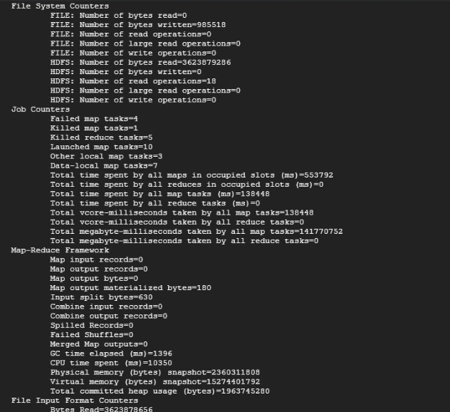

## B) Using Google BigQuery

Step1: Create account on Google cloud

Step 2: Open Google Big Query editor

Step 3: Add the eyeblink dataset collected from neurosky toolkit

Step 4: Write the query in Query editor section

Step5. Run the Query and note the time

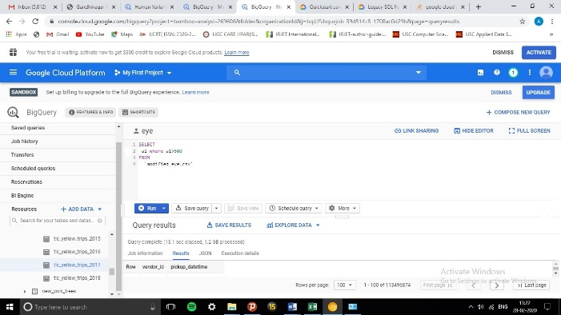

## C) Using Spark

Step 1: Start the Spark shell

Step 2: Use the sql method to pass in the query, storing the result in a variable.

**val** results = spark.sql("SELECT * from eyeblink")

Step 3: Use the returned data.

Step 4: Note the time for execution

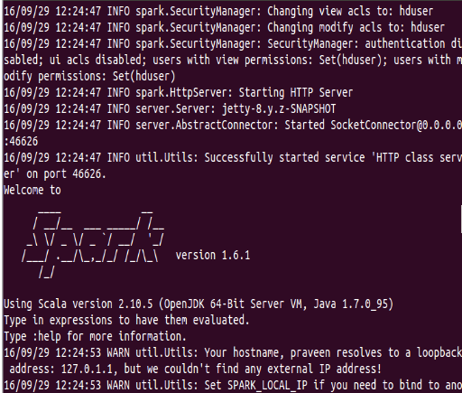

## D) Using Hive

Step1: Write a hive script

Step 2: Create the Table for eyeblink in Hive

Step 3: Describe the Table

Step 4: Retrieve the required data

Step5. Note the retrieval time

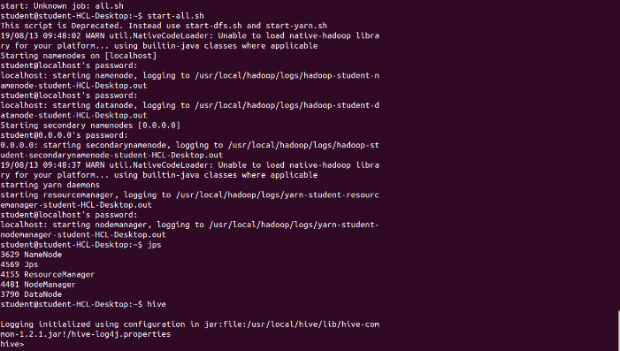

|  |  |  |
| --- | --- | --- |
| Method | Size | Time (ms) |
| Map Reduce | 1 GB | 283541504 |
| Big Query | 1 GB | 18000541 |
| Spark | 1 GB | 28354150 |
| Hive | 1 GB | 21678541 |