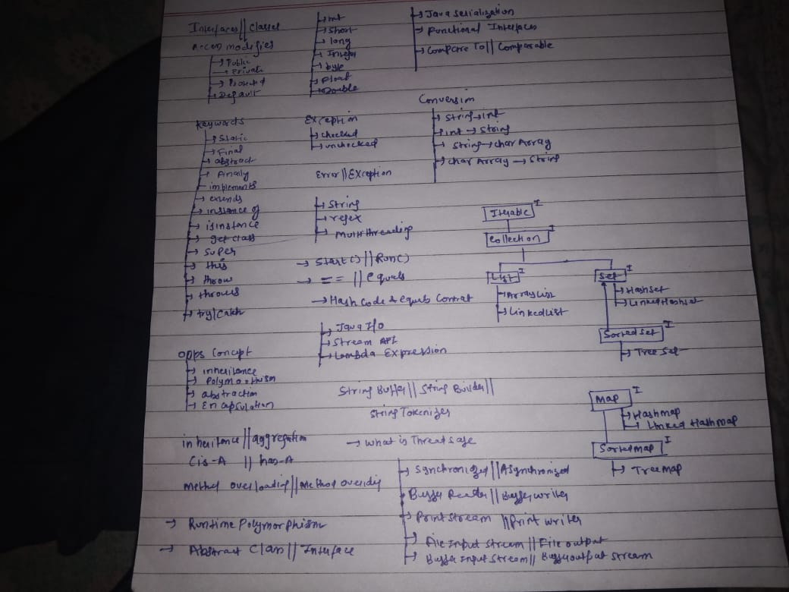

Creating a String
There are two ways to create string in Java:
- String literal
String s = “GeeksforGeeks”;
- Using new keyword
String s = new String (“GeeksforGeeks”);

String Pool in Java

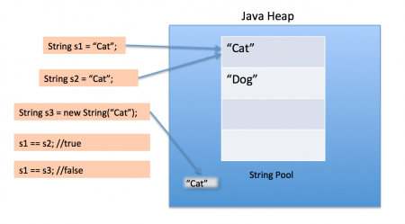

What is Java String Pool?
String Pool in Java corresponds to an allocation of memory in Java heap memory. It consists of a collection of String objects, which are shared and reused among several String object references for same String content.
Note : This capability is gained through the immutability nature of Java String.
Why Java String Pool is useful?
The Java String Pool avoids creating unnecessary String objects as it reuses the existing String objects. Therefore the Java String Pool has a significant impact on improving the memory and the application performance/ utilization of Java String objects.

What is Java String Pool?
String Pool in Java corresponds to an allocation of memory in Java heap memory. It consists of a collection of String objects, which are shared and reused among several String object references for same String content.

Note : This capability is gained through the immutability nature of Java String.

Why Java String Pool is useful?
The Java String Pool avoids creating unnecessary String objects as it reuses the existing String objects. Therefore the Java String Pool has a significant impact on improving the memory and the application performance/ utilization of Java String objects.

Immutability of Strings and Java String Pool
The implementation of the Java String Pool in Java has been possible mainly because of the immutable nature of Java String objects.

Does every Java String object reside in Java String Pool?
However every String object, which is created in Java does not reside in the Java String Pool. For further clarification, it is better to have an idea on different approaches, which can be employed to create a String object in Java.

Immutable String in Java
In java, string objects are immutable. Immutable simply means unmodifiable or unchangeable.
Once string object is created its data or state can't be changed but a new string object is created.
Let's try to understand the immutability concept by the example given below:
- class Testimmutablestring{
- public static void main(String args[]){
- String s="Sachin";
- s.concat(" Tendulkar");//concat() method appends the string at the end
- System.out.println(s);//will print Sachin because strings are immutable objects
- }
- }
Test it Now
Output:Sachin
Now it can be understood by the diagram given below. Here Sachin is not changed but a new object is created with sachintendulkar. That is why string is known as immutable.
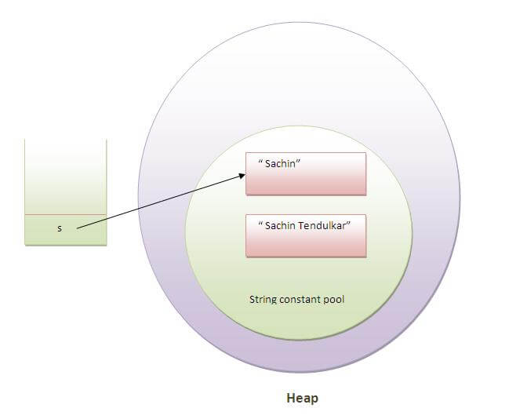
As you can see in the above figure that two objects are created but s reference variable still refers to "Sachin" not to "Sachin Tendulkar".
But if we explicitely assign it to the reference variable, it will refer to "Sachin Tendulkar" object.For example:
- class Testimmutablestring1{
- public static void main(String args[]){
- String s="Sachin";
- s=s.concat(" Tendulkar");
- System.out.println(s);
- }
- }
Test it Now
Output:Sachin Tendulkar
In such case, s points to the "Sachin Tendulkar". Please notice that still sachin object is not modified.

Why string objects are immutable in java?
Because java uses the concept of string literal.Suppose there are 5 reference variables,all referes to one object "sachin".If one reference variable changes the value of the object, it will be affected to all the reference variables. That is why string objects are immutable in java.
The java string charAt() method returns a char value at the given index number.

Replace a character at a specific index in a string?
I'm trying to replace a character at a specific index in a string.
What I'm doing is:
String myName = "domanokz";
myName.charAt(4) = 'x';
This gives an error. Is there any method to do this?

String are immutable in Java. You can't change them.
You need to create a new string with the character replaced.
String myName = "domanokz";
String newName = myName.substring(0,4)+'x'+myName.substring(5);
Or you can use a StringBuilder:
StringBuilder myName = new StringBuilder("domanokz");
myName.setCharAt(4, 'x');

System.out.println(myName);

Mainly there are two different common ways, which can be used to create a new String object.
- Using String literals
- Using new keyword

Using String literals
Here is an example of creating a new String with String literals.

String literalHelloWorld = "Hello World";

Whenever this approach is used to create a new String, following steps will be followed.
First it will look for a String object with similar content in Java String Pool. If there is an already created String object in the Java String Pool equal to the String content of the new String, then the already existing String object in the Java String Pool will be reused.

The reference to the already existing String object in the Java String Pool will be returned as the newly created String object, rather than creating a new String object.

Otherwise a new String object will be created with the required String content and it will be added to the Java String Pool enabling to reuse it in future, if required.

Whenever two String objects created with this approach compared with equal to operator (i.e. ==), it will return true, as both of them are pointing to the same String object in the Java String Pool.

Using new keyword
Here is an example of creating a new String using new keyword.

String newHelloWorld = new String("Hello World");

Every time, when this approach is used to create a String object, a new String object will be created in the Java heap memory, regardless of whether there are already created String objects with same String content in the Java heap memory.
Therefore creating String objects using this approach is not recommended, as this approach is not memory efficient.
On the other hand, whenever two String objects created with this approach compared with equal to operator (i.e. ==), it will return false, as each of them point to two different String objects in Java heap memory.
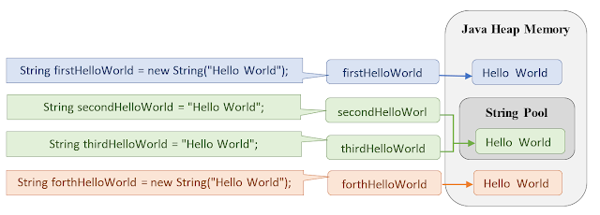

firstHelloWorld == secondHelloWorld => false
firstHelloWorld == thirdHelloWorld => false
firstHelloWorld == forthHelloWorld => false
secondHelloWorld == thirdHelloWorld => true
secondHelloWorld == forthHelloWorld => false

How to Initialize and Compare Strings in Java?
Initializing Strings in Java
1. Direct Initialization(String Constant) : In this method, a String constant object will be created in String pooled area which is inside heap area in memory. As it is a constant, we can’t modify it, i.e. String class is immutable.
Examples:

String str = "GeeksForGeeks";

str = "geeks"; // This statement will make str
// point to new String constant("geeks")
// rather than modifying the previous
// String constant.
String str = “GeeksForGeeks”;
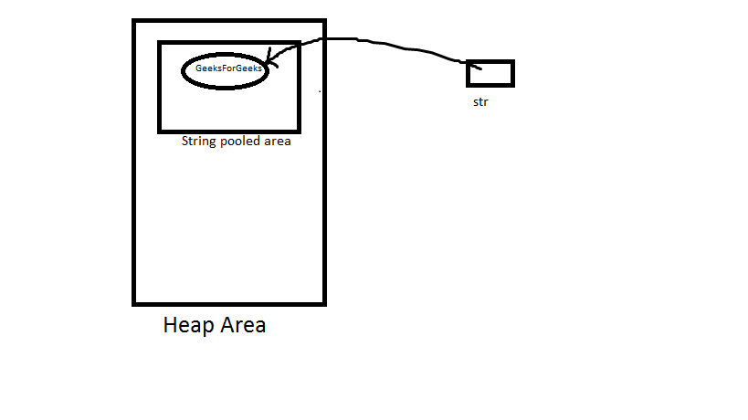
str = “geeks”;
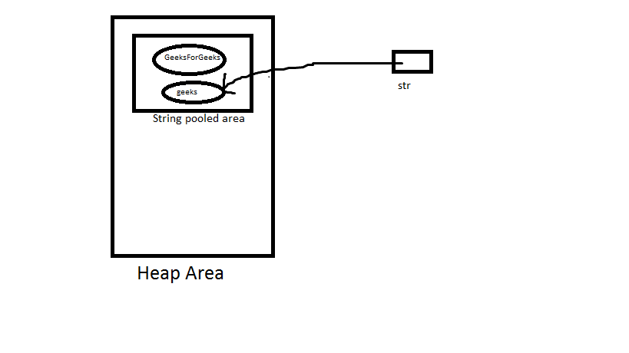
Note: If we again write str = “GeeksForGeeks” as next line, then it first check that if given String constant is present in String pooled area or not. If it present then str will point to it, otherwise creates a new String constant.
2. Object Initialization (Dynamic): In this method, a String object will be created in heap area (not inside String pooled area as in upper case). We can modify it.Also with same value, a String constant is also created in String pooled area, but the variable will point to String object in heap area only.

Examples:
String str = new String("very");
str = "good";
String str = new String(“very”)
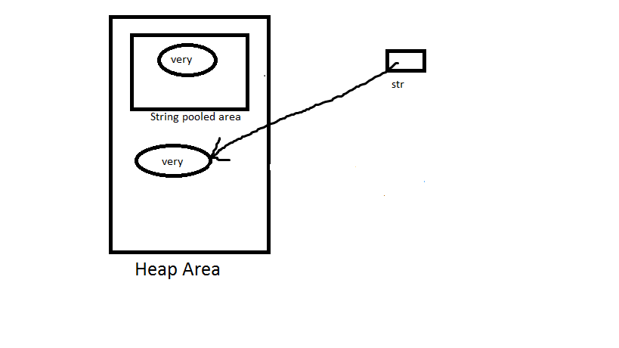
str = “good”
Now this is a direct assignment, so String constant with value “good” is created in String pooled area and str will point to that.
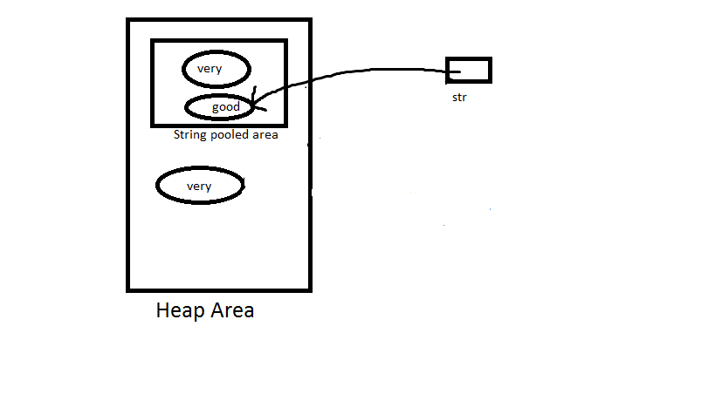
Note: If we again write str = new String(“very”), then it will create a new object with value “very”, rather than pointing to the available objects in heap area with same value.But if we write str = “very”, then it will point to String constant object with value “very”, present in String pooled area.
Comparing Strings and their References
1. equals() method: It compares values of string for equality. Return type is boolean. In almost all the situation you can use useObjects.equals().
2. == operator: It compares references not values. Return type is boolean. == is used in rare situations where you know you’re dealing with interned strings.
3. compareTo() method: It compares values lexicographically and returns an integer value that describes if first string is less than, equal to or greater than second string.For example, if str1 and str2 are two string variables then if
str1 == str2 : return 0
str1 > str2 : return a positive value
str1 < str2 : return a negative value
Note: The positive and negative values returned by compareTo method is the difference of first unmatched character in the two strings.
// Java program to show how to compare Strings

public class Test {
public static void main(String[] args)
{
String s1 = "Ram";
String s2 = "Ram";
String s3 = new String("Ram");
String s4 = new String("Ram");
String s5 = "Shyam";
String nulls1 = null;
String nulls2 = null;

System.out.println(" Comparing strings with equals:");
System.out.println(s1.equals(s2));
System.out.println(s1.equals(s3));
System.out.println(s1.equals(s5));
// System.out.println(nulls1.equals(nulls2)); // NullPointerException

System.out.println(" Comparing strings with ==:");
System.out.println(s1 == s2);
System.out.println(s1 == s3);
System.out.println(s3 == s4);
System.out.println(nulls1 == nulls2);

System.out.println(" Comparing strings with compareto:");
System.out.println(s1.compareTo(s3));
System.out.println(s1.compareTo(s5));
// System.out.println(nulls1.compareTo(nulls2)); // NullPointerException
}
}
Copy CodeRun on IDE
Output:
Comparing strings with equals:
true
true
false
Comparing strings with ==:
true
false
false
true
Comparing strings with compareto:
0
-1

String Literal Vs String Object in Java
Compare string initialization performance for String Literal and String object.
String Literal
String str = “GeeksForGeeks”;
This is string literal. When you declare string like this, you are actually calling intern() method on String. This method references internal pool of string objects. If there already exists a string value “GeeksForGeeks”, then str will reference of that string and no new String object will be created. Please refer Initialize and Compare Strings in Java for details.
String Object
String str = new String(“GeeksForGeeks”);

This is string object. In this method JVM is forced to create a new string reference, even if “GeeksForGeeks” is in the reference pool.
Therefore, if we compare performance of string literal and string object, string object will always take more time to execute than string literal because it will construct a new string every time it is executed.
Note: Execution time is compiler dependent.
Below is the Java program to compare their performances.
// Java program to compare performance
// of string literal and string object

class ComparePerformance {

public static void main(String args[])
{
// Initialization time for String
// Literal
long start1 = System.currentTimeMillis();

for (int i = 0; i < 10000; i++)
{
String s1 = "GeeksForGeeks";
String s2 = "Welcome";
}

long end1 = System.currentTimeMillis();
long total_time = end1 - start1;

System.out.println("Time taken to execute"+
" string literal = " + total_time);

// Initialization time for String
// object
long start2 = System.currentTimeMillis();

for (int i = 0; i < 10000; i++)
{
String s3 = new String("GeeksForGeeks");
String s4 = new String("Welcome");
}

long end2 = System.currentTimeMillis();
long total_time1 = end2 - start2;

System.out.println("Time taken to execute"+
" string object=" + total_time1);
}
}
Copy CodeRun on IDE
Output:
Time taken to execute string literal = 0
Time taken to execute string object = 2

Difference between == and .equals() method in Java
In general both equals() and “==” operator in Java are used to compare objects to check equality but here are some of the differences between the two:
- Main difference between .equals() method and == operator is that one is method and other is operator.
- We can use == operators for reference comparison (address comparison) and .equals() method for content comparison. In simple words, == checks if both objects point to the same memory location whereas .equals() evaluates to the comparison of values in the objects.
- If a class does not override the equals method, then by default it uses equals(Object o) method of the closest parent class that has overridden this method. See this for detail
- Coding Example:
// Java program to understand
// the concept of == operator
public class Test {
public static void main(String[] args)
{
String s1 = new String("HELLO");
String s2 = new String("HELLO");
System.out.println(s1 == s2);
System.out.println(s1.equals(s2));
}
}
- Copy CodeRun on IDE
- Output:
- false
- true
- Explanation: Here we are creating two objects namely s1 and s2.
  - Both s1 and s2 refers to different objects.
  - When we use == operator for s1 and s2 comparison then the result is false as both have different addresses in memory.
  - Using equals, the result is true because its only comparing the values given in s1 and s2.
Let us understand both the operators in detail:
Equality operator(==)

We can apply equality operators for every primitive types including boolean type. we can also apply equality operators for object types.
// Java program to illustrate
// == operator for compatible data
// types
class Test {
public static void main(String[] args)
{
// integer-type
System.out.println(10 == 20);

// char-type
System.out.println('a' == 'b');

// char and double type
System.out.println('a' == 97.0);

// boolean type
System.out.println(true == true);
}
}
Copy CodeRun on IDE
Output:
false
false
true
true
If we apply == for object types then, there should be compatibility between arguments types (either child to parent or parent to child or same type). Otherwise we will get compile time error.
// Java program to illustrate
// == operator for incompatible data types
class Test {
public static void main(String[] args)
{
Thread t = new Thread();
Object o = new Object();
String s = new String("GEEKS");

System.out.println(t == o);
System.out.println(o == s);

// Uncomment to see error
System.out.println(t==s);
}
}
Copy CodeRun on IDE
Output:
false
false
// error: incomparable types: Thread and String
.equals()
In Java, string equals() method compares the two given strings based on the data/content of the string. If all the contents of both the strings are same then it returns true. If all characters are not matched then it returns false.
public class Test {
public static void main(String[] args)
{
Thread t1 = new Thread();
Thread t2 = new Thread();
Thread t3 = t1;

String s1 = new String("GEEKS");
String s2 = new String("GEEKS");

System.out.println(t1 == t3);
System.out.println(t1 == t2);

System.out.println(t1.equals(t2));
System.out.println(s1.equals(s2));
}
}
Copy CodeRun on IDE
Output:
true
false
false
true
Explanation: Here we are using .equals method to check whether two objects contains the same data or not.
- In the above example, we are creating 3 Thread objects and 2 String objects.
- In the first comparison, we are checking that t1 == t3 or not. As we know that both t1 and t3 pointing to same object that’s why it returns true.
- When we are comparing 2 String objects by .equals() operator then we are checking that is both objects contains the same data or not.
- Both the objects contains the same String i.e. GEEKS that’s why it returns true.

This prints true (even though we don't use equals method: correct way to compare strings)
String s = "a" + "bc";
String t = "ab" + "c";
System.out.println(s == t);
When compiler optimizes your string literals, it sees that both s and t have same value and thus you need only one string object. It's safe because String is immutable in Java.
As result, both s and t point to the same object and some little memory saved.
Name 'string pool' comes from the idea that all already defined string are stored in some 'pool' and before creating new String object compiler checks if such string is already defined.

String Pool in Java

Let's start off by asking a simple question. What is a String Literal? A String literal is a sequence of characters between quotation marks, such as "string" or "literal". You've probably used String literals hundreds of times in your own applications. You might not, however, have realized just how special String literals are in Java.

Strings are Immutable
So what makes String literals so special? Well, first of all, it's very important to remember that String objects are immutable. That means that, once created, a String object cannot be changed (short of using something like reflection to get at private data). Immutable, you say? Unchangable? What about this code?
Source Code
public class ImmutableStrings
{
public static void main(String[] args)
{
String start = "Hello";
String end = start.concat(" World!");
System.out.println(end);
}
}

// Output

Hello World!

Well look at that, the String changed...or did it? In that code, no String object was ever changed. We start by assigning "Hello" to our variable, start. That causes a new String object to be created on the heap and a reference to that object is stored in start. Next, we invoke the method concat(String) on that object. Well, here's the trick, if we look at the API Spec for String, you'll see this in the description of the concat(String) method:
Concatenates the specified string to the end of this string.
If the length of the argument string is 0, then this String object is returned. Otherwise, a new String object is created, representing a character sequence that is the concatenation of the character sequence represented by this String object and the character sequence represented by the argument string.
Examples:
"cares".concat("s") returns "caress"
"to".concat("get").concat("her") returns "together"
Parameters:
str - the String that is concatenated to the end of this String.
Returns:
a string that represents the concatenation of this object's characters followed by the string argument's characters.
Notice the part I've highlighted in bold. When you concatenate one String to another, it doesn't actually change the String object, it simply creates a new one that contains the contents of both of the original Strings, one after the other. That's exactly what we did above. The String object referenced by the local variable start never changed. In fact, if you added the statement System.out.println(start); after you invoked the concat method, you would see that start still referenced a String object that contained just "Hello". And just in case you were wondering, the '+' operator does the exact same thing as the concat() method.
Strings really are immutable.

Storage of Strings - The String Literal Pool
If you've done any preparation for the SCJP exam (and quite possibly even if you haven't), you've probably heard of the "String Literal Pool." What is the String Literal Pool? Most often, I hear people say that it is a collection of String objects. Although that's close, it's not exactly correct. Really, it's a collection of references to String objects. Strings, even though they are immutable, are still objects like any other in Java. Objects are created on the heap and Strings are no exception. So, Strings that are part of the "String Literal Pool" still live on the heap, but they have references to them from the String Literal Pool.
Yeah, so that doesn't really explain what the pool is, or what it's for, does it? Well, because String objects are immutable, it's safe for multiple references to "share" the same String object. Take a look at this example:
Source Code
public class ImmutableStrings
{
public static void main(String[] args)
{
String one = "someString";
String two = "someString";

System.out.println(one.equals(two));
System.out.println(one == two);
}
}

// Output

true
true

In such a case, there is really no need to make two instances of an identical String object. If a String object could be changed, as a StringBuffer can be changed, we would be forced to create two separate objects. But, as we know that String objects cannot change, we can safely share a String object among the two String references, one and two. This is done through the String literal pool. Here's how it is accomplished:
When a .java file is compiled into a .class file, any String literals are noted in a special way, just as all constants are. When a class is loaded (note that loading happens prior to initialization), the JVM goes through the code for the class and looks for String literals. When it finds one, it checks to see if an equivalent String is already referenced from the heap. If not, it creates a String instance on the heap and stores a reference to that object in the constant table. Once a reference is made to that String object, any references to that String literal throughout your program are simply replaced with the reference to the object referenced from the String Literal Pool.
So, in the example shown above, there would be only one entry in the String Literal Pool, which would refer to a String object that contained the word "someString". Both of the local variables, oneand two, would be assigned a reference to that single String object. You can see that this is true by looking at the output of the above program. While the equals() method checks to see if the String objects contain the same data ("someString"), the == operator, when used on objects, checks for referential equality - that means that it will return true if and only if the two reference variables refer to the exact same object. In such a case, the references are equal. From the above output, you can see that the local variables, one and two, not only refer to Strings that contain the same data, they refer to the same object.
Graphically, our objects and references would look something like this:
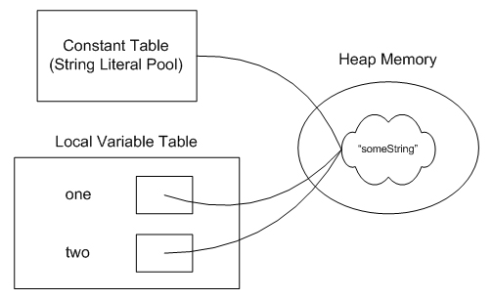
Note, however, that this is a special behavior for String Literals. Constructing Strings using the "new" keyword implies a different sort of behavior. Let's look at an example:
Source Code
public class ImmutableStrings
{
public static void main(String[] args)
{
String one = "someString";
String two = new String("someString");

System.out.println(one.equals(two));
System.out.println(one == two);
}
}

// Output

true
false

In this case, we actually end up with a slightly different behavior because of the keyword "new." In such a case, references to the two String literals are still put into the constant table (the String Literal Pool), but, when you come to the keyword "new," the JVM is obliged to create a new String object at run-time, rather than using the one from the constant table.
In such a case, although the two String references refer to String objects that contain the same data, "someString", they do not refer to the same object. That can be seen from the output of the program. While the equals() method returns true, the == operator, which checks for referential equality, returns false, indicating that the two variables refer to distinct String objects.
Once again, if you'd like to see this graphically, it would look something like this. Note that the String object referenced from the String Literal Pool is created when the class is loaded while the other String object is created at runtime, when the "new String..." line is executed.
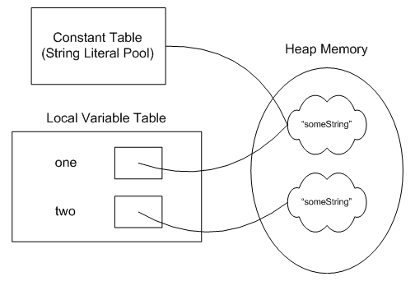
If you'd like to get both of these local variables to refer to the same object, you can use the intern()method defined in String. Invoking two.intern() will look for a String object referenced from the String Literal Pool that has the same value as the one you invoked the intern method upon. If one is found, a reference to that String is returned and can be assigned to your local variable. If you did so, you'd have a picture that looks just like the one above, with both local variables, one and two, referring to the same String object, which is also referenced from the String Literal Pool. At that point, the second String object, which was created at run-time, would be eligible for garbage collection.

Garbage Collection
What makes an object eligible for garbage collection? If you're preparing for the SCJP exam (or even if you're not), the answer to that question should roll right off your tongue. An object is eligible for garbage collection when it is no longer referenced from an active part of the application. Anyone see what is special about garbage collection for String literals? Let's look at an example and see if you can see where this is going.
Source Code
public class ImmutableStrings
{
public static void main(String[] args)
{
String one = "someString";
String two = new String("someString");

one = two = null;
}
}

Just before the main method ends, how many objects are available for garbage collection? 0? 1? 2?
The answer is 1. Unlike most objects, String literals always have a reference to them from the String Literal Pool. That means that they always have a reference to them and are, therefore, not eligible for garbage collection. This is the same example as I used above so you can see what our picture looked liked originally there. Once we assign our variables, one and two, to null, we end up with a picture that looks like this:
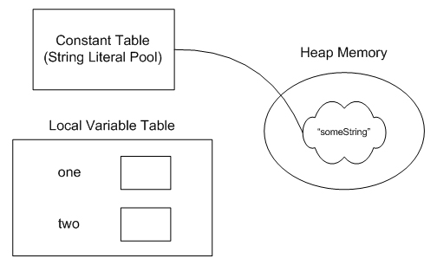
As you can see, even though neither of our local variables, one or two, refer to our String object, there is still a reference to it from the String Literal Pool. Therefore, the object is not elgible for garbage collection. The object is always reachable through use of the intern() method, as referred to earlier.

Conclusion
Like I said at the outset of this article, virtually none of this information is included on the SCJP exam. However, I constantly see this question coming up in the SCJP forum and on various mock exams. These are a few of the highlights you can keep in mind when it comes to String literals:
- Equivalent String Literals (even those stored in separate classes in separate packages) will refer to the same String object.
- In general, String Literals are not eligible for garbage collection. Ever.
- Strings created at run-time will always be distinct from those created from String Literals.
- You can reuse String Literals with run-time Strings by utilizing the intern() method.
- The best way to check for String equality is to use the equals() method.
Difference Between String , StringBuilder And StringBuffer Classes

String
String is immutable ( once created can not be changed )object . The object created as a String is stored in the Constant String Pool. Every immutable object in Java is thread safe ,that implies String is also thread safe . String can not be used by two threads simultaneously. String once assigned can not be changed.
StringBuffer
StringBuffer is mutable means one can change the value of the object . The object created through StringBuffer is stored in the heap. StringBuffer has the same methods as the StringBuilder , but each method in StringBuffer is synchronized that is StringBuffer is thread safe . Due to this it does not allow two threads to simultaneously access the same method . Each method can be accessed by one thread at a time . But being thread safe has disadvantages too as the performance of the StringBuffer hits due to thread safe property . Thus StringBuilder is faster than the StringBuffer when calling the same methods of each class. String Buffer can be converted to the string by using toString() method. StringBuffer demo1 = new StringBuffer("Hello") ; // The above object stored in heap and its value can be changed . demo1=new StringBuffer("Bye"); // Above statement is right as it modifies the value which is allowed in the StringBuffer
StringBuilder
StringBuilder is same as the StringBuffer , that is it stores the object in heap and it can also be modified . The main difference between the StringBuffer and StringBuilder is that StringBuilder is also not thread safe. StringBuilder is fast as it is not thread safe . StringBuilder demo2= new StringBuilder("Hello"); // The above object too is stored in the heap and its value can be modified demo2=new StringBuilder("Bye"); // Above statement is right as it modifies the value which is allowed in the StringBuilder

String vs StringBuilder vs StringBuffer in Java
Prerequisites : String , Initialize a String
Consider below code with three concatenation functions with three different types of parameters, String, StringBuffer and StringBuilder.
// Java program to demonstrate difference between String,
// StringBuilder and StringBuffer
class Geeksforgeeks
{
// Concatenates to String
public static void concat1(String s1)
{
s1 = s1 + "forgeeks";
}

// Concatenates to StringBuilder
public static void concat2(StringBuilder s2)
{
s2.append("forgeeks");
}

// Concatenates to StringBuffer
public static void concat3(StringBuffer s3)
{
s3.append("forgeeks");
}

public static void main(String[] args)
{
String s1 = "Geeks";
concat1(s1); // s1 is not changed
System.out.println("String: " + s1);

StringBuilder s2 = new StringBuilder("Geeks");
concat2(s2); // s2 is changed
System.out.println("StringBuilder: " + s2);

StringBuffer s3 = new StringBuffer("Geeks");
concat3(s3); // s3 is changed
System.out.println("StringBuffer: " + s3);
}
}
Copy CodeRun on IDE
Output:
String: Geeks
StringBuilder: Geeksforgeeks
StringBuffer: Geeksforgeeks

Explanation:
1. Concat1 : In this method, we pass a string “Geeks” and perform “s1 = s1 + ”forgeeks”. The string passed from main() is not changed, this is due to the fact that String is immutable. Altering the value of string creates another object and s1 in concat1() stores reference of new string. References s1 in main() and cocat1() refer to different strings.
2. Concat2 : In this method, we pass a string “Geeks” and perform “s2.append(“forgeeks”)” which changes the actual value of the string (in main) to “Geeksforgeeks”. This is due to the simple fact that StringBuilder is mutable and hence changes its value.
2. Concat3 : StringBuffer is similar to StringBuilder except one difference that StringBuffer is thread safe, i.e., multiple threads can use it without any issue. The thread safety brings a penalty of performance.
When to use which one :
- If a string is going to remain constant throughout the program, then use String class object because a String object is immutable.
- If a string can change (example: lots of logic and operations in the construction of the string) and will only be accessed from a single thread, using a StringBuilder is good enough.
- If a string can change, and will be accessed from multiple threads, use a StringBuffer because StringBuffer is synchronous so you have thread-safety.
Conversion between types of strings in Java
Sometimes there is a need of converting a string object of different classes like String, StringBuffer, StringBuilder to one-another. Below are some techniques to do the same.
- From String to StringBuffer and StringBuilder : This one is easy. We can directly pass String class object to StringBuffer and StringBuilder class constructors. As String class is immutable in java, so for editing a string, we can perform same by converting it to StringBuffer or StringBuilder class objects. Below is the java program to demonstrate the same.
// Java program to demonstrate conversion from
// String to StringBuffer and StringBuilder.
public class Test
{
public static void main(String[] args)
{
String str = "Geeks";

// conversion from String object to StringBuffer
StringBuffer sbr = new StringBuffer(str);
sbr.reverse();
System.out.println(sbr);

// conversion from String object to StringBuilder
StringBuilder sbl = new StringBuilder(str);
sbl.append("ForGeeks");
System.out.println(sbl);
}
}
- Copy CodeRun on IDE
- Output:
- skeeG
- GeeksForGeeks
- From StringBuffer and StringBuilder to String : This conversions can be perform using toString() method which is overridden in both StringBuffer and StringBuilder classes.
Below is the java program to demonstrate the same. Note that while we use toString()method, a new String object(in Heap area) is allocated and initialized to character sequence currently represented by StringBuffer object, that means the subsequent changes to the StringBuffer object do not affect the contents of the String object.
// Java program to demonstrate conversion from
// String to StringBuffer and StringBuilder.
public class Test
{
public static void main(String[] args)
{
StringBuffer sbr = new StringBuffer("Geeks");
StringBuilder sbdr = new StringBuilder("Hello");

// conversion from StringBuffer object to String
String str = sbr.toString();
System.out.println("StringBuffer object to String : ");
System.out.println(str);

// conversion from StringBuilder object to String
String str1 = sbdr.toString();
System.out.println("StringBuilder object to String : ");
System.out.println(str1);

// changing StringBuffer object sbr
// but String object(str) doesn't change
sbr.append("ForGeeks");
System.out.println(sbr);
System.out.println(str);

}
}
- Copy CodeRun on IDE
- Output:
- StringBuffer object to String :
- Geeks
- StringBuilder object to String :
- Hello
- GeeksForGeeks
- Geeks

- From StringBuffer to StringBuilder or vice-versa : This conversion is tricky.There is no direct way to convert the same. In this case, We can use a String class object. We first convert StringBuffer/StringBuilder object to String using toString() method and then from String to StringBuilder/StringBuffer using constructors.Below is the java program to demonstrate the same.
// Java program to demonstrate conversion from
// String to StringBuffer and StringBuilder.
public class Test
{
public static void main(String[] args)
{
StringBuffer sbr = new StringBuffer("Geeks");

// conversion from StringBuffer object to StringBuilder
String str = sbr.toString();
StringBuilder sbl = new StringBuilder(str);

System.out.println(sbl);

}
}
- Copy CodeRun on IDE
- Output:
- Geeks
Conclusion:
- Objects of String are immutable, and objects of StringBuffer and StringBuilder are mutable.
- StringBuffer and StringBuilder are similar, but StringBuilder is faster and preferred over StringBuffer for single threaded program. If thread safety is needed, then StringBuffer is used.

Java – Convert String to int
By mkyong | June 1, 2015 | Updated : July 1, 2015 | Viewed : 1,102,856 | +15,603 pv/w
In Java, you can use Integer.parseInt() to convert a String to int.

1. Integer.parseInt() Examples
Example to convert a String “10” to an primitive int.
String number = "10";
int result = Integer.parseInt(number);
System.out.println(result);
Copy
Output
10
Copy

2. Integer.valueOf() Examples
Alternatively, you can use Integer.valueOf(), it will returns an Integer object.
String number = "10";
Integer result = Integer.valueOf(number);
System.out.println(result);
Copy
Output
10
Copy
Note
In summary, parseInt(String) returns a primitive int, whereas valueOf(String) returns a new Integer() object.

Different ways for Integer to String Conversions In Java
- Convert using Integer.toString(int)
The Integer class has a static method that returns a String object representing the specified int parameter.
Syntax :
- public static String toString(int i)
The argument i is converted and returned as a string instance. If the number is negative, the sign will be preserved.
Example :
class GfG
{
public static void main(String args[])
{
int a = 1234;
int b = -1234;
String str1 = Integer.toString(a);
String str2 = Integer.toString(b);
System.out.println("String str1 = " + str1);
System.out.println("String str2 = " + str2);
}
}
Copy CodeRun on IDE
Output:
String str1 = 1234
String str2 = -1234
- Convert using String.valueOf(int)
Example :
class GfG
{
public static void main(String args[])
{
int c = 1234;
String str3 = String.valueOf(c);
System.out.println("String str3 = " + str3);
}
}
- Copy CodeRun on IDE
- or

class GfG
{
public static void main(String args[])
{
String str3 = String.valueOf(1234);
System.out.println("String str3 = " + str3);
}
}
- Copy CodeRun on IDE
- Output:
- String str3 = 1234

Convert with special radix
All of the examples above use the base (radix) 10. Follwing are convenient methods to convert to binary, octal, and hexadecimal system. Arbitrary custom number system is also supported.
Examples :
Binary
class GfG
{
public static void main(String args[])
{
int h = 255;
String binaryString = Integer.toBinaryString(h);
System.out.println(binaryString);
}
}
Copy CodeRun on IDE
Output:
11111111
11111111 is the binary representation of the number 255.
Ocatal
class GfG
{
public static void main(String args[])
{
int i = 255;
String octalString = Integer.toOctalString(i);
System.out.println(octalString);
}
}
Copy CodeRun on IDE
Output:
377
377 is the octal representation of the number 255.
Hexadecimal
class GfG
{
public static void main(String args[])
{
int j = 255;
String hexString = Integer.toHexString(j);
System.out.println(hexString);
}
}
Copy CodeRun on IDE
Output:
ff
ff is the hexadecimal representation of the number 255.
Custom Base/Radix
you can use any other custom base/radix when converting an int to String.
Following example uses the base 7 number system.
class GfG
{
public static void main(String args[])
{
int k = 255;
String customString = Integer.toString(k, 7);
System.out.println(customString);
}
}
Copy CodeRun on IDE
Output:
513
513 is the representation of the number 255 when written in the base 7 system.

Java String toCharArray() with example
The java string toCharArray() method converts the given string into a sequence of characters. The returned array length is equal to the length of the string.
Syntax :
public char[] toCharArray()
Return : It returns a newly allocated character array.
// Java program to demonstrate
// working of toCharArray() method

class Gfg {
public static void main(String args[])
{
String s = "GeeksforGeeks";
char[] gfg = s.toCharArray();
for (int i = 0; i < gfg.length; i++) {
System.out.println(gfg[i]);
}
}
}
Copy CodeRun on IDE
Output:
G
e
e
k
s
f
o
r
G
e
e
k
s
CharArrayToString.java

CharArrayToString.java
package com.mkyong.utils;

public class CharArrayToString {

public static void main(String[] args) {

char[] charArrays = new char[]{'1', '2', '3', 'A', 'B', 'C'};

String newString1 = new String(charArrays);
System.out.println("newString1 : " + newString1);

String newString2;
newString2 = String.valueOf(charArrays);
System.out.println("newString2 : " + newString2);

}

}
Copy
Output
newString1 : 123ABC
newString2 : 123ABC

Java String Array to String
PANKAJ 3 COMMENTS
Today we will look into how to convert Java String array to String. Sometimes we have to convert String array to String for specific requirements. For example; we want to log the array contents or we need to convert values of String array to String and invoke other methods.

Java String Array to String
Most of the time we invoke toString() method of an Object to get the String representation. Let’s see what happens when we invoke toString() method on String array in java.

package com.journaldev.util;

public class JavaStringArrayToString {

public static void main(String[] args) {
String[] strArr = new String[] {"1","2","3"};

String str = strArr.toString();

System.out.println("Java String array to String = "+str);
}

}
Below image shows the output produced by above program.
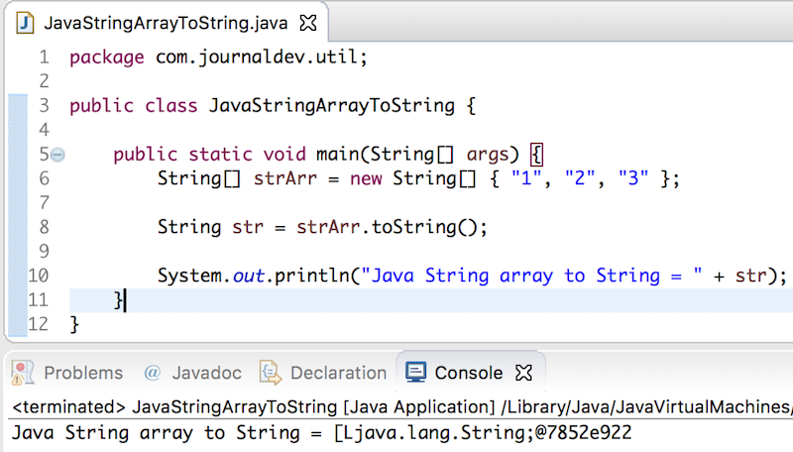
The reason for above output is because toString() call on array is going to Object super class where it’s implemented as below.

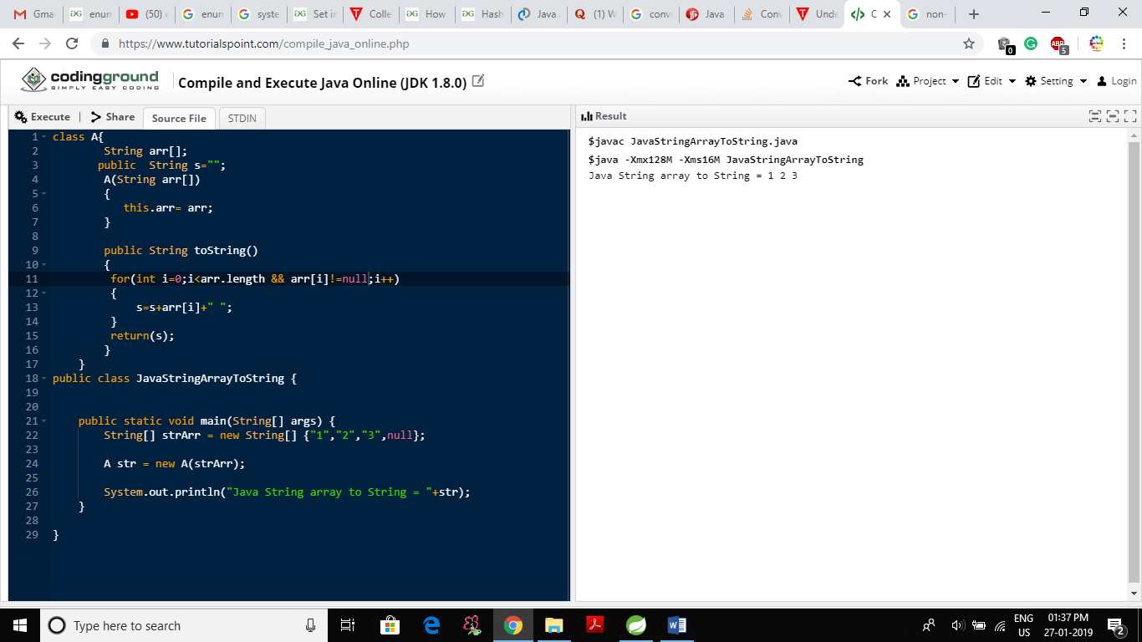

override toString method for print through object .

Java toString() method
If you want to represent any object as a string, toString() method comes into existence.
The toString() method returns the string representation of the object.
If you print any object, java compiler internally invokes the toString() method on the object. So overriding the toString() method, returns the desired output, it can be the state of an object etc. depends on your implementation.

Advantage of Java toString() method
By overriding the toString() method of the Object class, we can return values of the object, so we don't need to write much code.

Understanding problem without toString() method
Let's see the simple code that prints reference.
- class Student{
- int rollno;
- String name;
- String city;

- Student(int rollno, String name, String city){
- this.rollno=rollno;
- this.name=name;
- this.city=city;
- }

- public static void main(String args[]){
- Student s1=new Student(101,"Raj","lucknow");
- Student s2=new Student(102,"Vijay","ghaziabad");

- System.out.println(s1);//compiler writes here s1.toString()
- System.out.println(s2);//compiler writes here s2.toString()
- }
- }
Output:Student@1fee6fc
Student@1eed786
As you can see in the above example, printing s1 and s2 prints the hashcode values of the objects but I want to print the values of these objects. Since java compiler internally calls toString() method, overriding this method will return the specified values. Let's understand it with the example given below:

Convert array of strings into a string in Java

If you just want a "debug-style" dump of an array:
String str = Arrays.toString(arr);
or, for more control (before Java 8):
StringBuilder builder = new StringBuilder();
for(String s : arr) {
builder.append(s);
}
String str = builder.toString();
(Java 8 and above):
String str = String.join(",", arr);

From Java 8, the simplest way I think is:
String[] array = { "cat", "mouse" };
String delimiter = "";
String result = String.join(delimiter, array);

Reverse a string in Java (5 Different Ways)

Reverse a string in Java
This article discusses 5 different ways to reverse a string in Java with examples.
Examples:
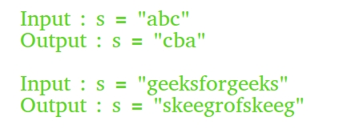

Recommended: Please try your approach on {IDE} first, before moving on to the solution.
Prerequisite : String vs StringBuilder vs StringBuffer in Java
Following are some interesting facts about String and StringBuffer classes :
1. Objects of String are immutable.
2. String class in Java does not have reverse() method, however StringBuilder class has built in reverse() method.
3. StringBuilder class do not have toCharArray() method, while String class does have toCharArray() method.

Recommended: Please try your approach on {IDE} first, before moving on to the solution.
- Converting String into Bytes: getBytes() method is used to convert the input string into bytes[].
Method:
- 1. Create a temporary byte[] of length equal
- to the length of the input string.
- 2. Store the bytes (which we get by using
- getBytes() method) in reverse order into
- the temporary byte[] .
- 3. Create a new String abject using byte[] to
- store result.
// Java program to ReverseString using ByteArray.
import java.lang.*;
import java.io.*;
import java.util.*;

// Class of ReverseString
class ReverseString
{
public static void main(String[] args)
{
String input = "GeeksforGeeks";

// getBytes() method to convert string
// into bytes[].
byte [] strAsByteArray = input.getBytes();

byte [] result =
new byte [strAsByteArray.length];

// Store result in reverse order into the
// result byte[]
for (int i = 0; i<strAsByteArray.length; i++)
result[i] =
strAsByteArray[strAsByteArray.length-i-1];

System.out.println(new String(result));
}
}
- Copy CodeRun on IDE
- Output:
- skeeGrofskeeG
- Using built in reverse() method of the StringBuilder class: String class does not have reverse() method, we need to convert the input string to StringBuilder, which is achieved by using the append method of StringBuilder. After that, print out the characters of the reversed string by scanning from the first till the last index.
// Java program to ReverseString using StringBuilder
import java.lang.*;
import java.io.*;
import java.util.*;

// Class of ReverseString
class ReverseString
{
public static void main(String[] args)
{
String input = "Geeks for Geeks";

StringBuilder input1 = new StringBuilder();

// append a string into StringBuilder input1
input1.append(input);

// reverse StringBuilder input1
input1 = input1.reverse();

// print reversed String
System.out.println(input1);
}
}
- Copy CodeRun on IDE
- Output:

- skeeG rof skeeG
- Converting String to character array: The user input the string to be reversed.
Method:
- 1. First, convert String to character array
- by using the built in Java String class
- method toCharArray().
- 2. Then, scan the string from end to start,
- and print the character one by one.
// Java program to Reverse a String by
// converting string to characters one
// by one
import java.lang.*;
import java.io.*;
import java.util.*;

// Class of ReverseString
class ReverseString
{
public static void main(String[] args)
{
String input = "GeeksForGeeks";

// convert String to character array
// by using toCharArray
char[] try1 = input.toCharArray();

for (int i = try1.length-1; i>=0; i--)
System.out.print(try1[i]);
}
}
- Copy CodeRun on IDE
- Output:
- skeeGrofskeeG
- Convert the input string into character array by using the toCharArray(): Convert the input string into character array by using the toCharArray() – built in method of the String Class. Then, scan the character array from both sides i.e from the start index (left) as well as from last index(right) simultaneously.
- 1. Set the left index equal to 0 and right
- index equal to the length of the string -1.
- 2. Swap the characters of the start index
- scanning with the last index scanning
- one by one. After that, increase the left
- index by 1 (left++) and decrease the right
- by 1 i.e., (right--) to move on to the next
- characters in the character array .
- 3. Continue till left is less than or equal to
- the right.
// Java program to Reverse a String using swapping
// of variables
import java.lang.*;
import java.io.*;
import java.util.*;

// Class of ReverseString
class ReverseString
{
public static void main(String[] args)
{
String input = "Geeks For Geeks";
char[] temparray = input.toCharArray();
int left, right=0;
right = temparray.length-1;

for (left=0; left < right ; left++ ,right--)
{
// Swap values of left and right
char temp = temparray[left];
temparray[left] = temparray[right];
temparray[right]=temp;
}

for (char c : temparray)
System.out.print(c);
System.out.println();
}
}
- Copy CodeRun on IDE
- Output:
- skeeG roF skeeG
- Using ArrayList object: Convert the input string into the character array by using toCharArray() built in method. Then, add the characters of the array into the ArrayList object. Java also has built in reverse() method for the Collections class. Since Collections class reverse() method takes a list object , to reverse the list , we will pass the LinkedList object which is a type of list of characters.
- 1. We copy String contents to an object
- of ArrayList.
- 1. We create a ListIterator object by using
- the listIterator() method on the LinkedList
- object.
- 2. ListIterator object is used to iterate over
- the list.
- 3. ListIterator object helps us to iterate
- over the reversed list and print it one
- by one to the output screen.
// Java program to Reverse a String using ListIterator
import java.lang.*;
import java.io.*;
import java.util.*;

// Class of ReverseString
class ReverseString
{
public static void main(String[] args)
{
String input = "Geeks For Geeks";
char[] hello = input.toCharArray();
List<Character> trial1 = new ArrayList<>();

for (char c: hello)
trial1.add(c);

Collections.reverse(trial1);
ListIterator li = trial1.listIterator();
while (li.hasNext())
System.out.print(li.next());
}
}
- Copy CodeRun on IDE
- Output:
- skeeG roF skeeG

String Methods
- int length(): Returns the number of characters in the String.
"GeeksforGeeks".length(); // returns 13
- Char charAt(int i): Returns the character at i^{th} index.
"GeeksforGeeks".charAt(3); // returns ‘k’
- String substring (int i): Return the substring from the i^{th} index character to end.
"GeeksforGeeks".substring(3); // returns “ksforGeeks”
- String substring (int i, int j): Returns the substring from i to j-1 index.
"GeeksforGeeks".substring(2, 5); // returns “eks”
- String concat( String str): Concatenates specified string to the end of this string.
- String s1 = ”Geeks”;
- String s2 = ”forGeeks”;
- String output = s1.concat(s2); // returns “GeeksforGeeks”
- int indexOf (String s): Returns the index within the string of the first occurrence of the specified string.
- String s = ”Learn Share Learn”;
- int output = s.indexOf(“Share”); // returns 6
- int indexOf (String s, int i): Returns the index within the string of the first occurrence of the specified string, starting at the specified index.
- String s = ”Learn Share Learn”;
- int output = s.indexOf(‘a’,3);// returns 8
- Int lastindexOf( int ch): Returns the index within the string of the last occurrence of the specified string.
- String s = ”Learn Share Learn”;
- int output = s.lastindexOf(‘a’); // returns 14
- boolean equals( Object otherObj): Compares this string to the specified object.
- Boolean out = “Geeks”.equals(“Geeks”); // returns true
- Boolean out = “Geeks”.equals(“geeks”); // returns false
- boolean equalsIgnoreCase (String anotherString): Compares string to another string, ignoring case considerations.
- Boolean out= “Geeks”.equalsIgnoreCase(“Geeks”); // returns true
Boolean out = “Geeks”.equalsIgnoreCase(“geeks”); // returns true
- int compareTo( String anotherString): Compares two string lexicographically.
- int out = s1.compareTo(s2); // where s1 ans s2 are
- // strings to be compared

- This returns difference s1-s2. If :
- out < 0 // s1 comes before s2
- out = 0 // s1 and s2 are equal.
- out >0 // s1 comes after s2.
- int compareToIgnoreCase( String anotherString): Compares two string lexicographically, ignoring case considerations.
- int out = s1.compareToIgnoreCase(s2);
- // where s1 ans s2 are
- // strings to be compared

- This returns difference s1-s2. If :
- out < 0 // s1 comes before s2
- out = 0 // s1 and s2 are equal.
- out >0 // s1 comes after s2.
Note- In this case, it will not consider case of a letter (it will ignore whether it is uppercase or lowercase).
- String toLowerCase(): Converts all the characters in the String to lower case.
- String word1 = “HeLLo”;
- String word3 = word1.toLowerCase(); // returns “hello"
- String toUpperCase(): Converts all the characters in the String to upper case.
- String word1 = “HeLLo”;
- String word2 = word1.toUpperCase(); // returns “HELLO”
- String trim(): Returns the copy of the String, by removing whitespaces at both ends. It does not affect whitespaces in the middle.
- String word1 = “ Learn Share Learn “;
- String word2 = word1.trim(); // returns “Learn Share Learn”
- String replace (char oldChar, char newChar): Returns new string by replacing all occurrences of oldChar with newChar.
- String s1 = “feeksforfeeks“;
- String s2 = “feeksforfeeks”.replace(‘f’ ,’g’); // returns “geeksgorgeeks”
Note:- s1 is still feeksforfeeks and s2 is geeksgorgeeks
Program to illustrate all string methods:
// Java code to illustrate different constructors and methods
// String class.

import java.io.*;
import java.util.*;
class Test
{
public static void main (String[] args)
{
String s= "GeeksforGeeks";
// or String s= new String ("GeeksforGeeks");

// Returns the number of characters in the String.
System.out.println("String length = " + s.length());

// Returns the character at ith index.
System.out.println("Character at 3rd position = "
+ s.charAt(3));

// Return the substring from the ith index character
// to end of string
System.out.println("Substring " + s.substring(3));

// Returns the substring from i to j-1 index.
System.out.println("Substring = " + s.substring(2,5));

// Concatenates string2 to the end of string1.
String s1 = "Geeks";
String s2 = "forGeeks";
System.out.println("Concatenated string = " +
s1.concat(s2));

// Returns the index within the string
// of the first occurrence of the specified string.
String s4 = "Learn Share Learn";
System.out.println("Index of Share " +
s4.indexOf("Share"));

// Returns the index within the string of the
// first occurrence of the specified string,
// starting at the specified index.
System.out.println("Index of a = " +
s4.indexOf('a',3));

// Checking equality of Strings
Boolean out = "Geeks".equals("geeks");
System.out.println("Checking Equality " + out);
out = "Geeks".equals("Geeks");
System.out.println("Checking Equality " + out);

out = "Geeks".equalsIgnoreCase("gEeks ");
System.out.println("Checking Equality" + out);

int out1 = s1.compareTo(s2);
System.out.println("If s1 = s2" + out);

// Converting cases
String word1 = "GeeKyMe";
System.out.println("Changing to lower Case " +
word1.toLowerCase());

// Converting cases
String word2 = "GeekyME";
System.out.println("Changing to UPPER Case " +
word1.toUpperCase());

// Trimming the word
String word4 = " Learn Share Learn ";
System.out.println("Trim the word " + word4.trim());

// Replacing characters
String str1 = "feeksforfeeks";
System.out.println("Original String " + str1);
String str2 = "feeksforfeeks".replace('f' ,'g') ;
System.out.println("Replaced f with g -> " + str2);
}
}
Copy CodeRun on IDE
Output :
String length = 13
Character at 3rd position = k
Substring ksforGeeks
Substring = eks
Concatenated string = GeeksforGeeks
Index of Share 6
Index of a = 8
Checking Equality false
Checking Equality true
Checking Equalityfalse
If s1 = s2false
Changing to lower Case geekyme
Changing to UPPER Case GEEKYME
Trim the word Learn Share Learn
Original String feeksforfeeks
Replaced f with g -> geeksgorgeeks

StringBuffer class in Java
String Class in Java
StringBuffer is a peer class of String that provides much of the functionality of strings. String represents fixed-length, immutable character sequences while StringBuffer represents growable and writable character sequences.
StringBuffer may have characters and substrings inserted in the middle or appended to the end. It will automatically grow to make room for such additions and often has more characters preallocated than are actually needed, to allow room for growth.
StringBuffer Constructors
StringBuffer( ): It reserves room for 16 characters without reallocation.

StringBuffer s=new StringBuffer();
StringBuffer( int size)It accepts an integer argument that explicitly sets the size of the buffer.
StringBuffer s=new StringBuffer(20);
StringBuffer(String str): It accepts a String argument that sets the initial contents of the StringBuffer object and reserves room for 16 more characters without reallocation.
StringBuffer s=new StringBuffer("GeeksforGeeks");
Methods
Some of the most used methods are:
- length( ) and capacity( ): The length of a StringBuffer can be found by the length( ) method, while the total allocated capacity can be found by the capacity( ) method.
Code Example:
import java.io.*;
class GFG
{
public static void main (String[] args)
{
StringBuffer s=new StringBuffer("GeeksforGeeks");
int p=s.length();
int q=s.capacity();
System.out.println("Length of string GeeksforGeeks="+p);
System.out.println("Capacity of string GeeksforGeeks="+q);
}
}
Copy CodeRun on IDE
Output:
Length of string GeeksforGeeks=13
Capacity of string GeeksforGeeks=29
- append( ): It is used to add text at the end of the existence text. Here are a few of its forms:
StringBuffer append(String str)
StringBuffer append(int num)
Code Example:
import java.io.*;
class GFG
{
public static void main (String[] args)
{
StringBuffer s=new StringBuffer("Geeksfor");
s.append("Geeks");
System.out.println(s); //returns GeeksforGeeks
s.append(1);
System.out.println(s); //returns GeeksforGeeks1
}
}
Copy CodeRun on IDE
Output:
GeeksforGeeks
GeeksforGeeks1
- insert( ): It is used to insert text at the specified index position. These are a few of its forms:
StringBuffer insert(int index, String str)
StringBuffer insert(int index, char ch)
Here, index specifies the index at which point the string will be inserted into the invokingStringBuffer object.
Code Example:
import java.io.*;
class GFG
{
public static void main (String[] args)
{
StringBuffer s=new StringBuffer("GeeksGeeks");
s.insert(5, "for");
System.out.println(s); // returns GeeksforGeeks

s.insert(0, 5);
System.out.println(s); // returns 5GeeksforGeeks

s.insert(3, true);
System.out.println(s); // returns 5GetrueeksforGeeks

s.insert(5, 41.35d);
System.out.println(s); // returns 5Getr41.35ueeksforGeeks

s.insert(8, 41.35f);
System.out.println(s); // returns 5Getr41.41.3535ueeksforGeeks

char geeks_arr[] = { 'p', 'a', 'w', 'a', 'n' };

// insert character array at offset 9
s.insert(2, geeks_arr);
System.out.println(s); // returns 5Gpawanetr41.41.3535ueeksforGeeks
}
}
Copy CodeRun on IDE
Output :
GeeksforGeeks
5GeeksforGeeks
5GetrueeksforGeeks
5Getr41.35ueeksforGeeks
5Getr41.41.3535ueeksforGeeks
5Gpawanetr41.41.3535ueeksforGeeks
- reverse( ): It can reverse the characters within a StringBuffer object using reverse( ).This method returns the reversed object on which it was called.
Code Example:
import java.io.*;
class GFG
{
public static void main (String[] args)
{
StringBuffer s=new StringBuffer("GeeksGeeks");
s.reverse();
System.out.println(s); //returns skeeGrofskeeG
}
}
Copy CodeRun on IDE
Output:
skeeGrofskeeG
- delete( ) and deleteCharAt( ): It can delete characters within a StringBuffer by using the methods delete( ) and deleteCharAt( ).The delete( ) method deletes a sequence of characters from the invoking object. Here, start Index specifies the index of the first character to remove, and end Index specifies an index one past the last character to remove. Thus, the substring deleted runs from start Index to endIndex–1. The resulting StringBuffer object is returned. The deleteCharAt( ) method deletes the character at the index specified by loc. It returns the resulting StringBuffer object.These methods are shown here:
StringBuffer delete(int startIndex, int endIndex)
StringBuffer deleteCharAt(int loc)
Code Example:
import java.io.*;
class GFG
{
public static void main (String[] args)
{
StringBuffer s=new StringBuffer("GeeksforGeeks");
s.delete(0,5);
System.out.println(s); //returns forGeeks
s.deleteCharAt(7);
System.out.println(s); //returns forGeek
}
}
Copy CodeRun on IDE
Output:
forGeeks
forGeek
- replace( ): It can replace one set of characters with another set inside a StringBuffer object by calling replace( ). The substring being replaced is specified by the indexes start Index and endIndex. Thus, the substring at start Index through endIndex–1 is replaced. The replacement string is passed in str.The resulting StringBuffer object is returned.Its signature is shown here:
StringBuffer replace(int startIndex, int endIndex, String str)
Code Example:
import java.io.*;
class GFG
{
public static void main (String[] args)
{
StringBuffer s=new StringBuffer("GeeksforGeeks");
s.replace(5,8,"are");
System.out.println(s); //returns GeeksareGeeks
}
}
Copy CodeRun on IDE
Output:
GeeksareGeeks
- ensureCapacity( ): It is used to increase the capacity of a StringBuffer object. The new capacity will be set to either the value we specify or twice the current capacity plus two (i.e. capacity+2), whichever is larger. Here, capacity specifies the size of the buffer.
void ensureCapacity(int capacity)
Besides that all the methods that are used in String class can also be used.
Some Interesting facts:
- java.lang.StringBuffer extends (or inherits from) Object class.
- All Implemented Interfaces of StringBuffer class:Serializable, Appendable, CharSequence.
- public final class StringBuffer extends Object implements Serializable, CharSequence, Appendable
- String buffers are safe for use by multiple threads. The methods can be synchronized wherever necessary so that all the operations on any particular instance behave as if they occur in some serial order.
- Whenever an operation occurs involving a source sequence (such as appending or inserting from a source sequence) this class synchronizes only on the string buffer performing the operation, not on the source.
- It inherits some of the methods from Object class which are clone, equals, finalize, getClass, hashCode, notify, notifyAll.

StringBuffer and StringBuilder
STRINGBUFFER | STRINGBUILDER
Synchronized, hence thread safe. | Not synchronized, not thread safe.
Operates slower due to thread safety feature | Better performance compared to StringBuffer
Has some extra methods – substring, length, capacity etc. | Not needed because these methods are present in String too.
Introduced in Java 1.2 | Introduced in Java 1.5 for better performance.

Java StringBuilder Constructors
CONSTRUCTOR | DESCRIPTION
StringBuilder() | Creates an empty string builder with a default capacity of 16 (16 empty elements).
StringBuilder(CharSequence cs) | Constructs a string builder containing the same characters as the specified CharSequence, plus an extra 16 empty elements trailing the CharSequence.
StringBuilder(int initCapacity) | Creates an empty string builder with the specified initial capacity.
StringBuilder(String s) | Creates a string builder whose value is initialized by the specified string, plus an extra 16 empty elements trailing the string.

This could be the dumbest question ever asked but I think it is a total confusion for a newbie.
- Can somebody clarify what is meant by immutable?
- Why is a String immutable?
- What are the advantages/disadvantages of immutable objects?
- Why should a mutable object such as StringBuilder be preferred over String and vice-verse?
A nice example (in Java) will be really appreciated.

Immutable means that once the constructor for an object has completed execution that instance can't be altered.
This is useful as it means you can pass references to the object around, without worrying that someone else is going to change its contents. Especially when dealing with concurrency, there are no locking issues with objects that never change
e.g.
class Foo
{
private final String myvar;

public Foo(final String initialValue)
{
this.myvar = initialValue;
}

public String getValue()
{
return this.myvar;
}
}
Foo doesn't have to worry that the caller to getValue() might change the text in the string.
If you imagine a similar class to Foo, but with a StringBuilder rather than a String as a member, you can see that a caller to getValue() would be able to alter the StringBuilder attribute of a Foo instance.
Also beware of the different kinds of immutability you might find: Eric Lippert wrote a blog articleabout this. Basically you can have objects whose interface is immutable but behind the scenes actual mutables private state (and therefore can't be shared safely between threads).

Regex tutorial — A quick cheatsheet by examples

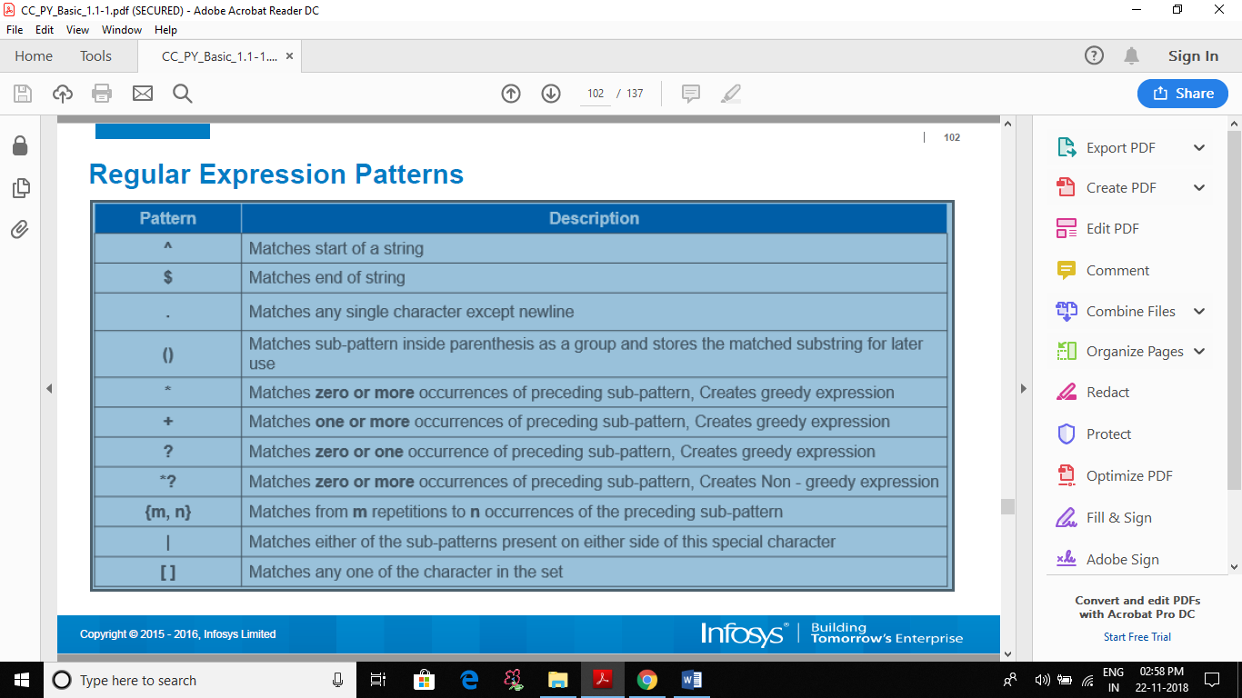

Basic topics

Anchors — ^ and $
^The matches any string that starts with The -> Try it!
end$ matches a string that ends with end
^The end$ exact string match (starts and ends with The end)
roar matches any string that has the text roar in it

Quantifiers — * + ? and {}
abc* matches a string that has ab followed by zero or more c -> Try it!
abc+ matches a string that has ab followed by one or more c
abc? matches a string that has ab followed by zero or one c
abc{2} matches a string that has ab followed by 2 c
abc{2,} matches a string that has ab followed by 2 or more c
abc{2,5} matches a string that has ab followed by 2 up to 5 c
a(bc)* matches a string that has a followed by zero or more copies of the sequence bc
a(bc){2,5} matches a string that has a followed by 2 up to 5 copies of the sequence bc

OR operator — | or []
a(b|c) matches a string that has a followed by b or c -> Try it!
a[bc] same as previous

Character classes — \d \w \s and .
\d matches a single character that is a digit -> Try it!
\w matches a word character (alphanumeric character plus underscore) -> Try it!
\s matches a whitespace character (includes tabs and line breaks)
. matches any character -> Try it!
Use the . operator carefully since often class or negated character class (which we’ll cover next) are faster and more precise.
\d, \w and \s also present their negations with \D, \W and \Srespectively.
For example, \D will perform the inverse match with respect to that obtained with \d.
\D matches a single non-digit character -> Try it!
In order to be taken literally, you must escape the characters ^.[$()|*+?{\with a backslash \ as they have special meaning.
\$\d matches a string that has a $ before one digit -> Try it!
Notice that you can match also non-printable characters like tabs \t, new-lines \n, carriage returns \r.

Flags
We are learning how to construct a regex but forgetting a fundamental concept: flags.
A regex usually comes with in this form /abc/, where the search pattern is delimited by two slash characters /. At the end we can specify a flag with these values (we can also combine them each other):
- g (global) does not return after the first match, restarting the subsequent searches from the end of the previous match
- m (multi line) when enabled ^ and $ will match the start and end of a line, instead of the whole string
- i (insensitive) makes the whole expression case-insensitive (for instance /aBc/i would match AbC)

Intermediate topics

Grouping and capturing — ()
a(bc) parentheses create a capturing group with value bc -> Try it!
a(?:bc)* using ?: we disable the capturing group -> Try it!
a(?<foo>bc) using ?<foo> we put a name to the group -> Try it!
This operator is very useful when we need to extract information from strings or data using your preferred programming language. Any multiple occurrences captured by several groups will be exposed in the form of a classical array: we will access their values specifying using an index on the result of the match.
If we choose to put a name to the groups (using (?<foo>...)) we will be able to retrieve the group values using the match result like a dictionary where the keys will be the name of each group.

Bracket expressions — []
[abc] matches a string that has either an a or a b or a c -> is the same as a|b|c -> Try it!
[a-c] same as previous
[a-fA-F0-9] a string that represents a single hexadecimal digit, case insensitively -> Try it!
[0-9]% a string that has a character from 0 to 9 before a % sign
[^a-zA-Z] a string that has not a letter from a to z or from A to Z. In this case the ^ is used as negation of the expression -> Try it!
Remember that inside bracket expressions all special characters (including the backslash \) lose their special powers: thus we will not apply the “escape rule”.

Greedy and Lazy match
The quantifiers ( * + {}) are greedy operators, so they expand the match as far as they can through the provided text.
For example, <.+> matches <div>simple div</div> in This is a <div> simple div</div> test. In order to catch only the div tag we can use a ? to make it lazy:
<.+?> matches any character one or more times included inside < and >, expanding as needed -> Try it!
Notice that a better solution should avoid the usage of . in favor of a more strict regex:
<[^<>]+> matches any character except < or > one or more times included inside < and > -> Try it!

Advanced topics

Boundaries — \b and \B
\babc\b performs a "whole words only" search -> Try it!
\b represents an anchor like caret (it is similar to $ and ^) matching positions where one side is a word character (like \w) and the other side is not a word character (for instance it may be the beginning of the string or a space character).
It comes with the its negation, \B. This matches all positions where \bdoesn’t match and could be if we want to find a search pattern fully surrounded by word characters.
\Babc\B matches only if the pattern is fully surrounded by word characters -> Try it!

Back-references — \1
([abc])\1 using \1 it matches the same text that was matched by the first capturing group -> Try it!
([abc])([de])\2\1 we can use \2 (\3, \4, etc.) to identify the same text that was matched by the second (third, fourth, etc.) capturing group -> Try it!
(?<foo>[abc])\k<foo> we put the name foo to the group and we reference it later (\k<foo>). The result is the same of the first regex -> Try it!

Look-ahead and Look-behind — (?=) and (?<=)
d(?=r) matches a d only if is followed by r, but r will not be part of the overall regex match -> Try it!
(?<=r)d matches a d only if is preceded by an r, but r will not be part of the overall regex match -> Try it!
You can use also the negation operator !
d(?!r) matches a d only if is not followed by r, but r will not be part of the overall regex match -> Try it!
(?<!r)d matches a d only if is not preceded by an r, but r will not be part of the overall regex match -> Try it!

Summary
As you’ve seen, the application fields of regex can be multiple and I’m sure that you’ve recognized at least one of these tasks among those seen in your developer career, here a quick list:
- data validation (for example check if a time string i well-formed)
- data scraping (expecially web scraping, find all pages that contain a certain set of words eventually in a specific order)
- data wrangling (transform data from “raw” to another format)
- string parsing (for example catch all url’s GET parameters, capture text inside a set of parenthesis)
- string replacement (even during a code session using a common IDE, for example tranform a Java or C# class in the correspective JSON object — replace “;” with “,” make it lowercase, avoid type declaration, etc.)
- syntax highlightning, file renaming, packet sniffing and many other applications involving strings (where data need not be textual)

Regular Expressions in Java
Regular Expressions or Regex (in short) is an API for defining String patterns that can be used for searching, manipulating and editing a text. It is widely used to define constraint on strings such as password. Regular Expressions are provided under java.util.regex package.
The java.util.regex package primarily consists of the following three classes:
- util.regex.Pattern – Used for defining patterns
- util.regex.Matcher – Used for performing match operations on text using patterns
- PatternSyntaxException– Used for indicating syntax error in a regular expression pattern
java.util.regex.Pattern Class
- matches()– It is used to check if the whole text matches a pattern. Its output is boolean.
filter_none
edit
play_arrow
brightness_4
// A Simple Java program to demonstrate working of
// Pattern.matches() in Java
import java.util.regex.Pattern;

class Demo
{
public static void main(String args[])
{
// Following line prints "true" because the whole
// text "geeksforgeeks" matches pattern "geeksforge*ks"
System.out.println (Pattern.matches("geeksforge*ks",
"geeksforgeeks"));

// Following line prints "false" because the whole
// text "geeksfor" doesn't match pattern "g*geeks*"
System.out.println (Pattern.matches("g*geeks*",
"geeksfor"));
}
}
Output:
true
false
- compile()– Used to create a pattern object by compiling a given string that may contain regular expressions. Input may also contains flags like Pattern.CASE_INSENSITIVE, Pattern.COMMENTS, .. etc (See this for details).
- split()– It is used to split a text into multiple strings based on a delimiter pattern.
java.util.regex.Matcher Class
- find() –It is mainly used for searching multiple occurrences of the regular expressions in the text.
- start() – It is used for getting the start index of a match that is being found using find() method.
- end() –It is used for getting the end index of a match that is being found using find() method. It returns index of character next to last matching character
Note that Pattern.matches() checks if whole text matches with a pattern or not. Other methods (demonstrated below) are mainly used to find multiple occurrences of pattern in text.
Java Programs to demonstrate workings of compile(), find(), start(), end() and split() :
- Java Program to demonstrate simple pattern searching
filter_none
edit
play_arrow
brightness_4
// A Simple Java program to demonstrate working of
// String matching in Java
import java.util.regex.Matcher;
import java.util.regex.Pattern;

class Demo
{
public static void main(String args[])
{
// Create a pattern to be searched
Pattern pattern = Pattern.compile("geeks");

// Search above pattern in "geeksforgeeks.org"
Matcher m = pattern.matcher("geeksforgeeks.org");

// Print starting and ending indexes of the pattern
// in text
while (m.find())
System.out.println("Pattern found from " + m.start() +
" to " + (m.end()-1));
}
}
Output:
Pattern found from 0 to 4
Pattern found from 8 to 12
- Java Program to demonstrate simple regular expression searching
filter_none
edit
play_arrow
brightness_4
// A Simple Java program to demonstrate working of
// String matching in Java
import java.util.regex.Matcher;
import java.util.regex.Pattern;

class Demo
{
public static void main(String args[])
{
// Create a pattern to be searched
Pattern pattern = Pattern.compile("ge*");

// Search above pattern in "geeksforgeeks.org"
Matcher m = pattern.matcher("geeksforgeeks.org");

// Print starting and ending indexes of the pattern
// in text
while (m.find())
System.out.println("Pattern found from " + m.start() +
" to " + (m.end()-1));
}
}
Output:
Pattern found from 0 to 2
Pattern found from 8 to 10
Pattern found from 16 to 16
- Java program to demonstrate Case Insensitive Searching
filter_none
edit
play_arrow
brightness_4
// A Simple Java program to demonstrate working of
// String matching in Java
import java.util.regex.Matcher;
import java.util.regex.Pattern;

class Demo
{
public static void main(String args[])
{
// Create a pattern to be searched
Pattern pattern = Pattern.compile("ge*", Pattern.CASE_INSENSITIVE);

// Search above pattern in "geeksforgeeks.org"
Matcher m = pattern.matcher("GeeksforGeeks.org");

// Print starting and ending indexes of the pattern
// in text
while (m.find())
System.out.println("Pattern found from " + m.start() +
" to " + (m.end()-1));
}
}
Output:
Pattern found from 0 to 2
Pattern found from 8 to 10
Pattern found from 16 to 16
- Java program to demonstrate working of split() to split a text based on a delimiter pattern
filter_none
edit
play_arrow
brightness_4
// Java program to demonstrate working of splitting a text by a
// given pattern
import java.util.regex.Matcher;
import java.util.regex.Pattern;

class Demo
{
public static void main(String args[])
{
String text = "geeks1for2geeks3";

// Specifies the string pattern which is to be searched
String delimiter = "\\d";
Pattern pattern = Pattern.compile(delimiter,
Pattern.CASE_INSENSITIVE);

// Used to perform case insensitive search of the string
String[] result = pattern.split(text);

for (String temp: result)
System.out.println(temp);
}
}
Output:
geeks
for
geeks
Important Observations/Facts:
- We create a pattern object by calling Pattern.compile(), there is no constructor. compile() is a static method in Pattern class.
- Like above, we create a Matcher object using matcher() on objects of Pattern class.
- Pattern.matches() is also a static method that is used to check if given text as a whole matches pattern or not.
- find() is used to find multiple occurrences of pattern in text.
- We can split a text based on a delimiter pattern using split()

Java Regex
The Java Regex or Regular Expression is an API to define a pattern for searching or manipulating strings.
It is widely used to define the constraint on strings such as password and email validation. After learning Java regex tutorial, you will be able to test your regular expressions by the Java Regex Tester Tool.
Java Regex API provides 1 interface and 3 classes in java.util.regex package.

java.util.regex package
The Matcher and Pattern classes provide the facility of Java regular expression. The java.util.regex package provides following classes and interfaces for regular expressions.
- MatchResult interface
- Matcher class
- Pattern class
- PatternSyntaxException class
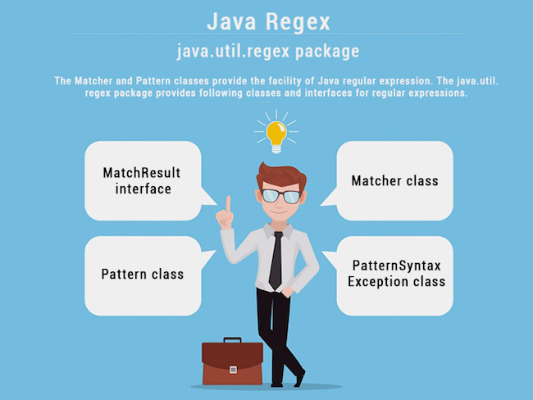

Matcher class
It implements the MatchResult interface. It is a regex engine which is used to perform match operations on a character sequence.
No. | Method | Description
1 | boolean matches() | test whether the regular expression matches the pattern.
2 | boolean find() | finds the next expression that matches the pattern.
3 | boolean find(int start) | finds the next expression that matches the pattern from the given start number.
4 | String group() | returns the matched subsequence.
5 | int start() | returns the starting index of the matched subsequence.
6 | int end() | returns the ending index of the matched subsequence.
7 | int groupCount() | returns the total number of the matched subsequence.

Pattern class
It is the compiled version of a regular expression. It is used to define a pattern for the regex engine.
No. | Method | Description
1 | static Pattern compile(String regex) | compiles the given regex and returns the instance of the Pattern.
2 | Matcher matcher(CharSequence input) | creates a matcher that matches the given input with the pattern.
3 | static boolean matches(String regex, CharSequence input) | It works as the combination of compile and matcher methods. It compiles the regular expression and matches the given input with the pattern.
4 | String[] split(CharSequence input) | splits the given input string around matches of given pattern.
5 | String pattern() | returns the regex pattern.

Example of Java Regular Expressions
There are three ways to write the regex example in Java.
- import java.util.regex.*;
- public class RegexExample1{
- public static void main(String args[]){
- //1st way
- Pattern p = Pattern.compile(".s");//. represents single character
- Matcher m = p.matcher("as");
- boolean b = m.matches();

- //2nd way
- boolean b2=Pattern.compile(".s").matcher("as").matches();

- //3rd way
- boolean b3 = Pattern.matches(".s", "as");

- System.out.println(b+" "+b2+" "+b3);
- }}
Test it Now

Output
true true true

Regular Expression . Example
The . (dot) represents a single character.
- import java.util.regex.*;
- class RegexExample2{
- public static void main(String args[]){
- System.out.println(Pattern.matches(".s", "as"));//true (2nd char is s)
- System.out.println(Pattern.matches(".s", "mk"));//false (2nd char is not s)
- System.out.println(Pattern.matches(".s", "mst"));//false (has more than 2 char)
- System.out.println(Pattern.matches(".s", "amms"));//false (has more than 2 char)
- System.out.println(Pattern.matches("..s", "mas"));//true (3rd char is s)
- }}
Test it Now

Regex Character classes
No. | Character Class | Description
1 | [abc] | a, b, or c (simple class)
2 | [^abc] | Any character except a, b, or c (negation)
3 | [a-zA-Z] | a through z or A through Z, inclusive (range)
4 | [a-d[m-p]] | a through d, or m through p: [a-dm-p] (union)
5 | [a-z&&[def]] | d, e, or f (intersection)
6 | [a-z&&[^bc]] | a through z, except for b and c: [ad-z] (subtraction)
7 | [a-z&&[^m-p]] | a through z, and not m through p: [a-lq-z](subtraction)

Regular Expression Character classes Example
- import java.util.regex.*;
- class RegexExample3{
- public static void main(String args[]){
- System.out.println(Pattern.matches("[amn]", "abcd"));//false (not a or m or n)
- System.out.println(Pattern.matches("[amn]", "a"));//true (among a or m or n)
- System.out.println(Pattern.matches("[amn]", "ammmna"));//false (m and a comes more than once)
- }}
Test it Now

Regex Quantifiers
The quantifiers specify the number of occurrences of a character.
Regex | Description
X? | X occurs once or not at all
X+ | X occurs once or more times
X* | X occurs zero or more times
X{n} | X occurs n times only
X{n,} | X occurs n or more times
X{y,z} | X occurs at least y times but less than z times

Regular Expression Character classes and Quantifiers Example
- import java.util.regex.*;
- class RegexExample4{
- public static void main(String args[]){
- System.out.println("? quantifier ....");
- System.out.println(Pattern.matches("[amn]?", "a"));//true (a or m or n comes one time)
- System.out.println(Pattern.matches("[amn]?", "aaa"));//false (a comes more than one time)
- System.out.println(Pattern.matches("[amn]?", "aammmnn"));//false (a m and n comes more than one time)
- System.out.println(Pattern.matches("[amn]?", "aazzta"));//false (a comes more than one time)
- System.out.println(Pattern.matches("[amn]?", "am"));//false (a or m or n must come one time)

- System.out.println("+ quantifier ....");
- System.out.println(Pattern.matches("[amn]+", "a"));//true (a or m or n once or more times)
- System.out.println(Pattern.matches("[amn]+", "aaa"));//true (a comes more than one time)
- System.out.println(Pattern.matches("[amn]+", "aammmnn"));//true (a or m or n comes more than once)
- System.out.println(Pattern.matches("[amn]+", "aazzta"));//false (z and t are not matching pattern)

- System.out.println("* quantifier ....");
- System.out.println(Pattern.matches("[amn]*", "ammmna"));//true (a or m or n may come zero or more times)

- }}
Test it Now

Regex Metacharacters
The regular expression metacharacters work as shortcodes.
Regex | Description
. | Any character (may or may not match terminator)
\d | Any digits, short of [0-9]
\D | Any non-digit, short for [^0-9]
\s | Any whitespace character, short for [\t\n\x0B\f\r]
\S | Any non-whitespace character, short for [^\s]
\w | Any word character, short for [a-zA-Z_0-9]
\W | Any non-word character, short for [^\w]
\b | A word boundary
\B | A non word boundary

Regular Expression Metacharacters Example
- import java.util.regex.*;
- class RegexExample5{
- public static void main(String args[]){
- System.out.println("metacharacters d....");\\d means digit

- System.out.println(Pattern.matches("\\d", "abc"));//false (non-digit)
- System.out.println(Pattern.matches("\\d", "1"));//true (digit and comes once)
- System.out.println(Pattern.matches("\\d", "4443"));//false (digit but comes more than once)
- System.out.println(Pattern.matches("\\d", "323abc"));//false (digit and char)

- System.out.println("metacharacters D....");\\D means non-digit

- System.out.println(Pattern.matches("\\D", "abc"));//false (non-digit but comes more than once)
- System.out.println(Pattern.matches("\\D", "1"));//false (digit)
- System.out.println(Pattern.matches("\\D", "4443"));//false (digit)
- System.out.println(Pattern.matches("\\D", "323abc"));//false (digit and char)
- System.out.println(Pattern.matches("\\D", "m"));//true (non-digit and comes once)

- System.out.println("metacharacters D with quantifier....");
- System.out.println(Pattern.matches("\\D*", "mak"));//true (non-digit and may come 0 or more times)

- }}
Test it Now

Regular Expression Question 1
- /*Create a regular expression that accepts alphanumeric characters only.
- Its length must be six characters long only.*/

- import java.util.regex.*;
- class RegexExample6{
- public static void main(String args[]){
- System.out.println(Pattern.matches("[a-zA-Z0-9]{6}", "arun32"));//true
- System.out.println(Pattern.matches("[a-zA-Z0-9]{6}", "kkvarun32"));//false (more than 6 char)
- System.out.println(Pattern.matches("[a-zA-Z0-9]{6}", "JA2Uk2"));//true
- System.out.println(Pattern.matches("[a-zA-Z0-9]{6}", "arun$2"));//false ($ is not matched)
- }}

Test it Now

Regular Expression Question 2
- /*Create a regular expression that accepts 10 digit numeric characters
- starting with 7, 8 or 9 only.*/

- import java.util.regex.*;
- class RegexExample7{
- public static void main(String args[]){
- System.out.println("by character classes and quantifiers ...");
- System.out.println(Pattern.matches("[789]{1}[0-9]{9}", "9953038949"));//true
- System.out.println(Pattern.matches("[789][0-9]{9}", "9953038949"));//true

- System.out.println(Pattern.matches("[789][0-9]{9}", "99530389490"));//false (11 characters)
- System.out.println(Pattern.matches("[789][0-9]{9}", "6953038949"));//false (starts from 6)
- System.out.println(Pattern.matches("[789][0-9]{9}", "8853038949"));//true

- System.out.println("by metacharacters ...");
- System.out.println(Pattern.matches("[789]{1}\\d{9}", "8853038949"));//true
- System.out.println(Pattern.matches("[789]{1}\\d{9}", "3853038949"));//false (starts from 3)

- }}
Test it Now

Java Regex Finder Example
- import java.util.regex.Pattern;
- import java.util.Scanner;
- import java.util.regex.Matcher;
- public class RegexExample8{
- public static void main(String[] args){
- Scanner sc=new Scanner(System.in);
- while (true) {
- System.out.println("Enter regex pattern:");
- Pattern pattern = Pattern.compile(sc.nextLine());
- System.out.println("Enter text:");
- Matcher matcher = pattern.matcher(sc.nextLine());
- boolean found = false;
- while (matcher.find()) {
- System.out.println("I found the text "+matcher.group()+" starting at index "+
- matcher.start()+" and ending at index "+matcher.end());
- found = true;
- }
- if(!found){
- System.out.println("No match found.");
- }
- }
- }
- }
Output:
Enter regex pattern: java
Enter text: this is java, do you know java
I found the text java starting at index 8 and ending at index 12
I found the text java starting at index 26 and ending at index 30

Java provides the java.util.regex package for pattern matching with regular expressions. Java regular expressions are very similar to the Perl programming language and very easy to learn.
A regular expression is a special sequence of characters that helps you match or find other strings or sets of strings, using a specialized syntax held in a pattern. They can be used to search, edit, or manipulate text and data.
The java.util.regex package primarily consists of the following three classes −
- Pattern Class − A Pattern object is a compiled representation of a regular expression. The Pattern class provides no public constructors. To create a pattern, you must first invoke one of its public static compile() methods, which will then return a Pattern object. These methods accept a regular expression as the first argument.
- Matcher Class − A Matcher object is the engine that interprets the pattern and performs match operations against an input string. Like the Pattern class, Matcher defines no public constructors. You obtain a Matcher object by invoking the matcher() method on a Pattern object.
- PatternSyntaxException − A PatternSyntaxException object is an unchecked exception that indicates a syntax error in a regular expression pattern.

Java.lang.String.matches() in Java
There are three variants of matches() method. This article depicts about all of them, as follows:
1. String matches() : This method tells whether or not this string matches the given regular expression. An invocation of this method of the form str.matches(regex) yields exactly the same result as the expression Pattern.matches(regex, str).
Syntax:
public boolean matches(String regex)
Parameters
regex : the regular expression to which this string is to be matched.
Return Value
This method returns true if, and only if, this string matches the given regular expression.
filter_none
edit
play_arrow
brightness_4
// Java code to demonstrate the
// working of matches()
public class Match1 {

public static void main(String args[]) {

// Initializing String
String Str = new String("Welcome to geeksforgeeks");

// Testing if regex is present
System.out.print("Does String contains regex (.*)geeks(.*) ? : " );
System.out.println(Str.matches("(.*)geeks(.*)"));

// Testing if regex is present
System.out.print("Does String contains regex geeks ? : " );
System.out.println(Str.matches("geeks"));

}
}
Output:
Does String contains regex (.*)geeks(.*) ? : true
Does String contains regex geeks ? : false
2. String regionMatches() (with ignoreCase) :This method has two variants which can be used to test if two string regions are equal.
Syntax
public boolean regionMatches(boolean ignoreCase,
int str_strt,
String other,
int other_strt,
int len)
Parameters
str_strt : the starting offset of the subregion in this string.
other : the string argument.
other_strt : the starting offset of the subregion in the string argument.
len : the number of characters to compare.
ignoreCase : if true, ignore case when comparing characters.
Return Value
It returns true if the specified subregion of this string
matches the specified subregion of the string argument;
false otherwise.
Whether the matching is exact or case insensitive depends on the ignoreCase argument.
filter_none
edit
play_arrow
brightness_4
// Java code to demonstrate the
// working of regionmatches()
public class Match2 {

public static void main(String args[]) {

// Initializing String
String Str1 = new String("Welcome to geeksforgeeks");

// Initializing test String
String Str2 = new String("GEEKS");

// Tests whether GEEKS starts in geeksforgeeks starting from pos 11
// and from 0 ( i.e starting in GEEKS) and ignores case
// and compares 5 characters of GEEKS
System.out.print("Checking if GEEKS is in geeksforgeeks( case insensitive ) : " );
System.out.println(Str1.regionMatches(true, 11, Str2, 0, 5));

}
}
Output:

Checking if GEEKS is in geeksforgeeks( case insensitive ) : true
3. String regionMatches() :This method has two variants which can be used to test if two string regions are equal.
Syntax
public boolean regionMatches(int str_strt,
String other,
int other_strt,
int len)
Parameters
str_strt : the starting offset of the subregion in this string.
other : the string argument.
other_strt : the starting offset of the subregion in the string argument.
len : the number of characters to compare.
Return Value
It returns true if the specified subregion of this string
matches the specified subregion of the string argument;
false otherwise.
filter_none
edit
play_arrow
brightness_4
// Java code to demonstrate the
// working of regionmatches()
public class Match3 {

public static void main(String args[]) {

// Initializing String
String Str1 = new String("Welcome to geeksforgeeks");

// Initializing test String
String Str2 = new String("GEEKS");

// Tests whether GEEKS starts in geeksforgeeks starting from pos 11
// and compares 5 characters of GEEKS
System.out.print("Checking if GEEKS is in geeksforgeeks( case sensitive ) : " );
System.out.println(Str1.regionMatches(11, Str2, 0, 5));

}
}
Output:
Checking if GEEKS is in geeksforgeeks( case sensitive ) : false

Write a class called MyRegex which will contain a string pattern. You need to write a regular expression and assign it to the pattern such that it can be used to validate an IP address. Use the following definition of an IP address:
IP address is a string in the form "A.B.C.D", where the value of A, B, C, and D may range from 0 to 255. Leading zeros are allowed. The length of A, B, C, or D can't be greater than 3.
Some valid IP address:
000.12.12.034
121.234.12.12
23.45.12.56
Some invalid IP address:
000.12.234.23.23
666.666.23.23
.213.123.23.32
23.45.22.32.
I.Am.not.an.ip
In this problem you will be provided strings containing any combination of ASCII characters. You have to write a regular expression to find the valid IPs.
Just write the MyRegex class which contains a String . The string should contain the correct regular expression.
(MyRegex class MUST NOT be public)
Sample Input
000.12.12.034
121.234.12.12
23.45.12.56
00.12.123.123123.123
122.23
Hello.IP
Sample Output
true
true
true
false
false
false
Java 7

import java.util.regex.Matcher;
import java.util.regex.Pattern;
import java.util.Scanner;

class Solution{

public static void main(String[] args){
Scanner in = new Scanner(System.in);
while(in.hasNext()){
String IP = in.next();
System.out.println(IP.matches(new MyRegex().pattern));
}

}
}

//Write your code here
class MyRegex
{
String pattern =
"^((0{0,2}[0-9])|(0{0,1}[1-9][0-9])|([1-2][0-5][0-5]))\\.((0{0,2}[0-9])|(0{0,1}[1-9][0-9])|([1-2][0-5][0-5]))\\.((0{0,2}[0-9])|(0{0,1}[1-9][0-9])|([1-2][0-5][0-5]))\\.((0{0,2}[0-9])|(0{0,1}[1-9][0-9])|([1-2][0-5][0-5]))$";
/*
String pattern =
"^([01]?\\d\\d?|2[0-4]\\d|25[0-5])\\." +
"([01]?\\d\\d?|2[0-4]\\d|25[0-5])\\." +
"([01]?\\d\\d?|2[0-4]\\d|25[0-5])\\." +
"([01]?\\d\\d?|2[0-4]\\d|25[0-5])$";
*/
}

The steps are:
String regexStr = "......"; // Regex String
String inputStr = "......"; // Input for matching, any CharSequence such as String, StringBuffer, StringBuilder, CharBuffer
// Step 1: Compile a Regex String into a Pattern object
Pattern pattern = Pattern.compile(regexStr);
// Step 2: Allocate a matching engine for the regex pattern bind with the input string
Matcher matcher = pattern.matcher(inputStr);
// Step 3: Perform the matching and process the matching result
// Perform matching operations using:
matcher.find() : scans the input sequence looking for the next subsequence that matches the pattern
matcher.matches() : attempts to match the entire input sequence
matcher.lookingAt() : attempts to match the input sequence, starting at the beginning, against the pattern.
matcher.replaceAll(replacementStr): Find and replace all matches.
matcher.replaceFirst(replacementStr): Find and replace the first match.
// Processing matching result
matcher.group() : returns the input subsequence matched by the previous match.
matcher.start() : returns the start index of the previous match.
matcher.end() : returns the offset after the last character matched.

What is the use of using superclass as reference while creating an object of a subclass, for example superclass obj = new subclass() in Java?

- To avoid the special method defined in sub class.
- To achieve run time polymorphism or late binding
- The methods overridden in subclass will be invoked even when using superclass reference.

- This reference can further hold object of other subclass, and hence rest of the code will need no change

Ask Question

I declared an array as shown below:

Array length in java

int[] arr = new int[10];
Then I assigned following values to the array:
arr[0] = 1;
arr[1] = 2;
arr[2] = 3;
arr[3] = 4;
Then I declared and initialized an integer variable:
int arrayLength = arr.length;
This will be useful to find actual size but is there any method to find logical size of the array?
It contains the allocated size, 10. The unassigned indexes will contain the default value which is 0 for int

instanceof Operator

instance of return true if (childObj instanceof childclass || childobj instanceof parentclass || childobj instanceof interface)? return true : return false

parent

^

|

child

syntax === > {object insanceof class/interface} there must be compulsary relation between object and [class/ interface]

if there is no relation than compile time error is thrown .

instance of operator works for (child -parent relationship )upto any level ie
parent
^
|
Child
^
|
child

parent pobj = new parent();

child cobj = new child();

cobj instanceof parant // true

cobj instanceof child // true

pobj instanceof child // false

null instanceof anyclass // always false // learn it

parent parentReferenceChildObject =new child();

parentReferenceChildObject instanceof child // true

parentReferenceChildObject instanceof parent // true

** parentReferenceChildObject is an object of child class .

Instanceof tells us that there ia relationship between object and class +> relationship i.e of inheritance

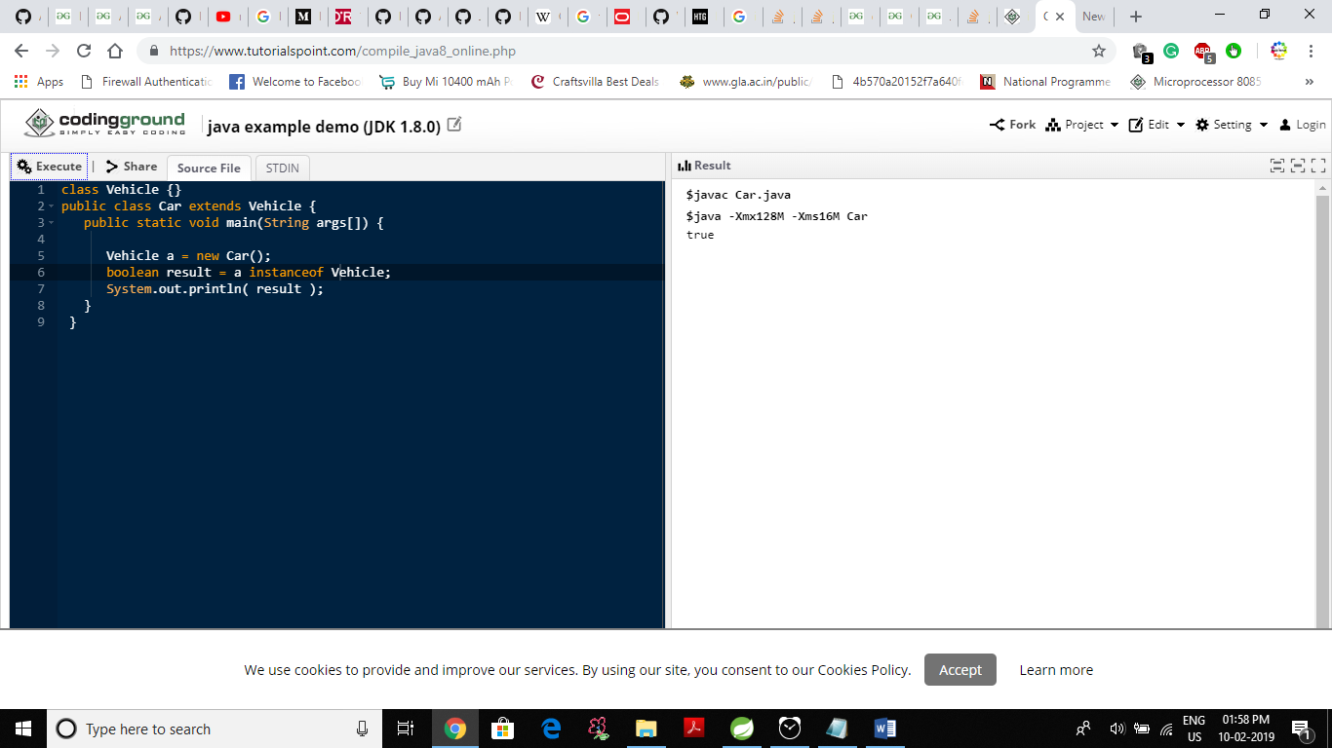

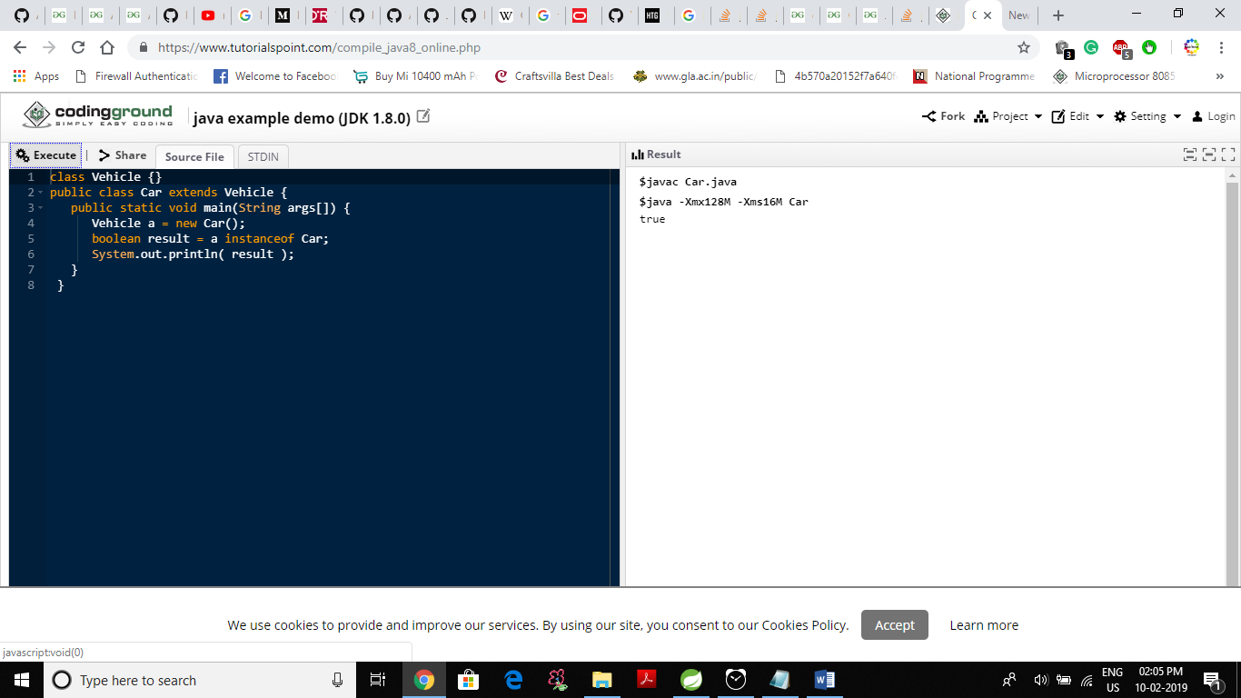

Expore more in the field

parent

^

|

child

parent parentReferenceChildObject =new child();

1.class parent class
{
Int a=10;
Void m1() {sop(“parent method”);}
}
Class childclass extends parent class
{
Int a=20; or float=20.0f; or anydatatype a =20;
Int b=30;
Void m1() { sop(“child method”);}
}
Void m2() { }
Class main
{
Psvm(String args[])
{

parent parentReferenceChildObject =new child();
parentReferenceChildObject.m1() // child method
sop(parentReferenceChildObject.a ) // 10
parentReferenceChildObject.m2 // give compile time error becoze m2 method is not in parent class
parentReferenceChildObject.b );// // give compile time error becoze variable b is not in parent class

}
}
Things you need to remember
1.You can never access variable of subclass with the reference of superclass as by this way abstraction is preserved .
2. you can never access method of superclass if subclass overrides that method with the reference of parent class.

Accessing super class function using (subclass object /superclass reference)

No, it's not possible, and if you think you need it, rethink your design. The whole point of overriding a method is to replace its functionality. If a different class knows that much about that class's internal workings, you're completely killing encapsulation

Overriding member variables in Java
Ask Question
51
27
I am studying overriding member functions in JAVA and thought about experimenting with overriding member variables.
So, I defined classes
public class A{
public int intVal = 1;
public void identifyClass()
{
System.out.println("I am class A");
}
}

public class B extends A
{
public int intVal = 2;
public void identifyClass()
{
System.out.println("I am class B");
}
}

public class mainClass
{
public static void main(String [] args)
{
A a = new A();
B b = new B();
A aRef;
aRef = a;
System.out.println(aRef.intVal);
aRef.identifyClass();
aRef = b;
System.out.println(aRef.intVal);
aRef.identifyClass();
}
}
The output is:
1
I am class A
1
I am class B
I am not able to understand why when aRef is set to b intVal is still of class A?

10 Answers
activeoldestvotes
65
When you make a variable of the same name in a subclass, that's called hiding. The resulting subclass will now actually have both properties. You can access the one from the superclass with super.var or ((SuperClass)this).var. The variables don't even have to be of the same type; they are just two variables sharing a name, much like two overloaded methods.
shareimprove this answer

OverRiding Concept in Java Functions will override depends on object type and variables will accessed on reference type.
- Override Function: In this case suppose a parent and child class both have same name of function with own definition. But which function will execute it depends on object type not on reference type on run time.
For e.g.:
Parent parent=new Child();
parent.behaviour();
Here parent is a reference of Parent class but holds an object of Child Class so that's why Child class function will be called in that case.
Child child=new Child();
child.behaviour();
Here child holds an object of Child Class, so the Child class function will be called.
Parent parent=new Parent();
parent.behaviour();
Here parent holds the object of Parent Class, so the Parent class function will be called.
- Override Variable: Java supports overloaded variables. But actually these are two different variables with same name, one in the parent class and one in the child class. And both variables can be either of the same datatype or different.
When you trying to access the variable, it depends on the reference type object, not the object type.
For e.g.:
Parent parent=new Child();
System.out.println(parent.state);
The reference type is Parent so the Parent class variable is accessed, not the Child class variable.
Child child=new Child();
System.out.println(child.state);
Here the reference type is Child, so the Child class variable is accessed not the Parent class variable.
Parent parent=new Parent();
System.out.println(parent.state);
Here the reference type is Parent, so Parent class variable is accessed.

In Java, if object A contains same the same data of object B, are they equal?

If A and B are:
- objects (instances) of the same class,
- they contain the same data,
- equals is defined for that class, to be done by the fields of the class included inherited ones, or a subset of them, then yes.
If A and B are of different classes, but one is parent of the other, and equals is defined on the parent to allow subclasses, then it is still possible, but less typical and more risky i.e. complex.
When you define equals you should also define hashCode, to be safe when that value object is ever used as key in a HashMap for instance.
An object that contains data, defines hashCode, equals, ideally implements Serializable (potentially defines versionUUID), implements toString, and is ideally immutable, such an object is called a Value Object VO, or a Data Transfer Object DTO.
In rare cases, class loading also comes into play, in case of different classes and even the same class. If class A and class B are loaded by different classloaders, and they are not resolved by a common parent classloader, then, classes A and B will no longer be in the parent-child relationship, but, if A parent of B and A loaded by CL1 and B by CL2, and CL2 does not have CL1 as ancestor, then CL2 will load B and an A’, an entirely different class than A. Even if A and B are the same class, call it A, but that class is dynamically loaded every time (something that happens in deserialization from offheap memory of from responses from remote nodes), and if different classloaders are used (say, each client has its own modules in their distinct classloaders for isolation), and both clients use a library with class A, independently, than there will be 2 different classes A in the 2 classloaders, and 2 instances of them will not be equal because the test of same-class will fail, if there is one, or the one of parent-child relationship. However, if the equals is done without those tests (which is not advisable), hashCode and equals may pass, if the object is directly composed of primitive values, and does not contain other objects which will potentially suffer from a similar issue (classes loaded separately). I partially imagined the scenario of classloading impact, but I hope I shed a light on potential complications. Also thread safety may be an issue when fields are written in one field and read (for equals) in another. Here using final fields (and further more, recursively, i.e. immutable objects) is solving this, or using volatile.

Hash code and Equals method

https://www.youtube.com/watch?v=ghswNpRv2t0

Why do I need to override the equals and hashCode methods in Java?
Ask Question
309
224
Recently I read through this Developer Works Document.
The document is all about defining hashCode() and equals() effectively and correctly, however I am not able to figure out why we need to override these two methods.
How can I take the decision to implement these methods efficiently?
java equals hashcode
shareimprove this question
edited Mar 21 '18 at 3:16



Exploring
1,18532648
asked Feb 15 '10 at 11:17



Shashi
6,3631052103
- 2
There are two great articles at programming.guide explaining exactly this: When should I override equals? and Why you should always override hashCode when overriding equals. (Warning, the accepted answer is actually wrong.) – aioobe Nov 27 '16 at 10:13
- Case Override only equals: two same object will have different hashcode = same objects go in different bucket(duplication). Case Override only hashcode:two same object will have same hashcode = same object go in same bucket(duplication). – VdeX Sep 12 '17 at 9:27
add a comment

28 Answers
activeoldestvotes
456
Joshua Bloch says on Effective Java
You must override hashCode() in every class that overrides equals(). Failure to do so will result in a violation of the general contract for Object.hashCode(), which will prevent your class from functioning properly in conjunction with all hash-based collections, including HashMap, HashSet, and Hashtable.
Let's try to understand it with an example of what would happen if we override equals()without overriding hashCode() and attempt to use a Map.
Say we have a class like this and that two objects of MyClass are equal if their importantField is equal (with hashCode() and equals() generated by eclipse)
public class MyClass {

private final String importantField;
private final String anotherField;

public MyClass(final String equalField, final String anotherField) {
this.importantField = equalField;
this.anotherField = anotherField;
}

public String getEqualField() {
return importantField;
}

public String getAnotherField() {
return anotherField;
}

@Override
public int hashCode() {
final int prime = 31;
int result = 1;
result = prime * result
+ ((importantField == null) ? 0 : importantField.hashCode());
return result;
}

@Override
public boolean equals(final Object obj) {
if (this == obj)
return true;
if (obj == null)
return false;
if (getClass() != obj.getClass())
return false;
final MyClass other = (MyClass) obj;
if (importantField == null) {
if (other.importantField != null)
return false;
} else if (!importantField.equals(other.importantField))
return false;
return true;
}

}

Override only equals
If only equals is overriden, then when you call myMap.put(first,someValue) first will hash to some bucket and when you call myMap.put(second,someOtherValue) it will hash to some other bucket (as they have a different hashCode). So, although they are equal, as they don't hash to the same bucket, the map can't realize it and both of them stay in the map.

Although it is not necessary to override equals() if we override hashCode(), let's see what would happen in this particular case where we know that two objects of MyClass are equal if their importantField is equal but we do not override equals().
Override only hashCode
Imagine you have this
MyClass first = new MyClass("a","first");
MyClass second = new MyClass("a","second");
If you only override hashCode then when you call myMap.put(first,someValue) it takes first, calculates its hashCode and stores it in a given bucket. Then when you call myMap.put(second,someOtherValue) it should replace first with second as per the Map Documentation because they are equal (according to the business requirement).
But the problem is that equals was not redefined, so when the map hashes second and iterates through the bucket looking if there is an object k such that second.equals(k) is true it won't find any as second.equals(first) will be false.
Hope it was clear

One more example
Collections such as HashMap and HashSet use a hashcode value of an object to determine how it should be stored inside a collection, and the hashcode is used again in order to locate the object in its collection.
Hashing retrieval is a two-step process:
- Find the right bucket (using hashCode())
- Search the bucket for the right element (using equals() )
Here is a small example on why we should overrride equals() and hashcode().
Consider an Employee class which has two fields: age and name.
public class Employee {

String name;
int age;

public Employee(String name, int age) {
this.name = name;
this.age = age;
}

public String getName() {
return name;
}

public void setName(String name) {
this.name = name;
}

public int getAge() {
return age;
}

public void setAge(int age) {
this.age = age;
}

@Override
public boolean equals(Object obj) {
if (obj == this)
return true;
if (!(obj instanceof Employee))
return false;
Employee employee = (Employee) obj;
return employee.getAge() == this.getAge()
&& employee.getName() == this.getName();
}

// commented
/* @Override
public int hashCode() {
int result=17;
result=31*result+age;
result=31*result+(name!=null ? name.hashCode():0);
return result;
}
*/
}
Now create a class, insert Employee object into a HashSet and test whether that object is present or not.
public class ClientTest {
public static void main(String[] args) {
Employee employee = new Employee("rajeev", 24);
Employee employee1 = new Employee("rajeev", 25);
Employee employee2 = new Employee("rajeev", 24);

HashSet<Employee> employees = new HashSet<Employee>();
employees.add(employee);
System.out.println(employees.contains(employee2));
System.out.println("employee.hashCode(): " + employee.hashCode()
+ " employee2.hashCode():" + employee2.hashCode());
}
}
It will print the following:
false
employee.hashCode(): 321755204 employee2.hashCode():375890482
Now uncomment hashcode() method , execute the same and the output would be:
true
employee.hashCode(): -938387308 employee2.hashCode():-938387308
Now can you see why if two objects are considered equal, their hashcodes must also be equal? Otherwise, you'd never be able to find the object since the default hashcode method in class Object virtually always comes up with a unique number for each object, even if the equals()method is overridden in such a way that two or more objects are considered equal. It doesn't matter how equal the objects are if their hashcodes don't reflect that. So one more time: If two objects are equal, their hashcodes must be equal as well.

Why to Override equals(Object) and hashCode() method ?
Prerequisite – Equals and Hashcode method
HashMap and HashSet use the hashcode value of an object to find out how the object would be stored in the collection, and subsequently hashcode is used to help locate the object in the collection. Hashing retrieval involves:
- First, find out the right bucket using hashCode().
- Secondly, search the bucket for the right element using equals()
Let us consider all the cases of Overriding in these methods
Case 1: Overriding both equals(Object) and hashCode() method
You must override hashCode() in every class that overrides equals(). Failure to do so will result in a violation of the general contract for Object.hashCode(), which will prevent your class from functioning properly in conjunction with all hash-based collections, including HashMap, HashSet, and Hashtable. (-Joshua Bloch)
Here is the contract, from the java.lang.Object specialization:
- Whenever it(hashcode) is invoked on the same object more than once during an execution of a Java application, the hashCode method must consistently return the same integer, provided no information used in equals comparisons on the object is modified. This integer need not remain consistent from one execution of an application to another execution of the same application.
- If two objects are equal according to the equals(Object) method, then calling the hashCode method on each of the two objects must produce the same integer result.
- It is not required that if two objects are unequal according to the equals(java.lang.Object) method, then calling the hashCode method on each of the two objects must produce distinct integer results. However, the programmer should be aware that producing distinct integer results for unequal objects may improve the performance of hashtables.
filter_none
edit
play_arrow
brightness_4
// Java program to illustrate
// overriding of equals and
// hashcode methods
import java.io.*;
import java.util.*;

class Geek
{

String name;
int id;

Geek(String name, int id)
{

this.name = name;
this.id = id;
}

@Override
public boolean equals(Object obj)
{

// if both the object references are
// referring to the same object.
if(this == obj)
return true;

// it checks if the argument is of the
// type Geek by comparing the classes
// of the passed argument and this object.
// if(!(obj instanceof Geek)) return false; ---> avoid.
if(obj == null || obj.getClass()!= this.getClass())
return false;

// type casting of the argument.
Geek geek = (Geek) obj;

// comparing the state of argument with
// the state of 'this' Object.
return (geek.name.equals(this.name) && geek.id == this.id);
}

@Override
public int hashCode()
{

// We are returning the Geek_id
// as a hashcode value.
// we can also return some
// other calculated value or may
// be memory address of the
// Object on which it is invoked.
// it depends on how you implement
// hashCode() method.
return this.id;
}

}

// Driver code
class GFG
{
public static void main (String[] args)
{

// creating two Objects with
// same state
Geek g1 = new Geek("aditya", 1);
Geek g2 = new Geek("aditya", 1);

Map<Geek, String> map = new HashMap<Geek, String>();
map.put(g1, "CSE");
map.put(g2, "IT");

for(Geek geek : map.keySet())
{
System.out.println(map.get(geek).toString());
}

}
}
output:

IT
In this case we override both methods properly.
When we call map.put(g1, “CSE”); it will hash to some bucket location and when we call map.put(g2, “IT”);, it will generates same hashcode value (same as g1) and replace first value by second value because while iterating over same bucket it found a k such that k.equals(g2) is true, means searching key already exist. So, it replaces old value of that key by new value.
Case 2 : Overriding only the equals(Object) method
If we only override equals(Object) method, when we call map.put(g1, “CSE”); it will hash to some bucket location and when we call map.put(g2, “IT”); it will hash to some other bucket location because of different hashcode value as hashCode() method has not been overridden.
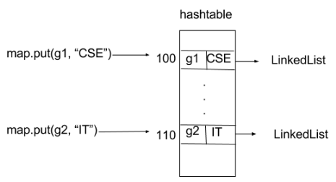
As you can see clearly in image, both values are getting stored into different bucket locations. Like that every insert into map will get different bucket location whether we are using same key objects or different i.e. state of key objects is same or different.
filter_none
edit
play_arrow
brightness_4
// Java program to illustrate
// Overriding only the equals(Object) method
import java.io.*;
import java.util.*;

class Geek
{
String name;
int id;

Geek(String name, int id)
{
this.name = name;
this.id = id;
}

@Override
public boolean equals(Object obj)
{
// if both the object references are
// referring to the same object.
if(this == obj)
return true;

// it checks if the argument is of the
// type Geek by comparing the classes
// of the passed argument and this object.
// if(!(obj instanceof Geek)) return false; ---> avoid.
if(obj == null || obj.getClass()!= this.getClass())
return false;

// type casting of the argument.
Geek geek = (Geek) obj;

// comparing the state of argument with
// the state of 'this' Object.
return (geek.name.equals(this.name) && geek.id == this.id);
}
}

class GFG
{
public static void main (String[] args)
{

// creating two Objects with
// same state
Geek g1 = new Geek("aditya", 1);
Geek g2 = new Geek("aditya", 1);

Map<Geek, String> map = new HashMap<Geek, String>();
map.put(g1, "CSE");
map.put(g2, "IT");

for(Geek geek : map.keySet())
{
System.out.println(map.get(geek).toString());
}

}
}
Output:
CSE
IT
Case 3: Overriding only hashCode() method
Consider another example of map :
Map map = new HashMap();
map.put(“xyz”, “CSE”);
map.put(“xyz”, “IT”);
When we call map.put(“xyz”, “CSE”); it will generate hashcode value and stores it to the bucket location that is specified with this address (hashcode value). And when we call map.put(“xyz”, “IT”); it generates same hashcode value as previous entry since key objects are same and hashCode() method has been overridden. So it should replace first with second as per rule. But it didn’t. Reason is, when it iterate through that bucket and seeks to find k such that k.equals(“xyz”) i.e. if searching key already exist. But it fails to find because equals(Object ) method has not been overridden. It is violation of rule of hashing.
filter_none
edit
play_arrow
brightness_4
// Java program to illustrate
// Overriding only hashCode() method

import java.io.*;
import java.util.*;

class Geek
{
String name;
int id;

Geek(String name, int id)
{
this.name = name;
this.id = id;
}

@Override
public int hashCode()
{

// We are returning the Geek_id
// as a hashcode value.
// we can also return some
// other calculated value or may
// be memory address of the
// Object on which it is invoked.
// it depends on how you implement
// hashCode() method.
return this.id;
}

}

class GFG
{
public static void main (String[] args)
{

// creating two Objects with
// same state
Geek g1 = new Geek("aditya", 1);
Geek g2 = new Geek("aditya", 1);

Map<Geek, String> map = new HashMap<Geek, String>();
map.put(g1, "CSE");
map.put(g2, "IT");

for(Geek geek : map.keySet())
{
System.out.println(map.get(geek).toString());
}

}
}
Output:
CSE
IT
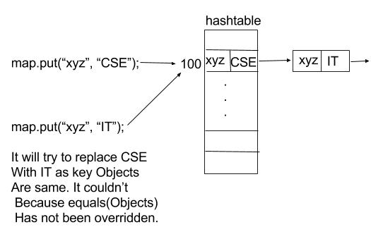
In above diagram when we call map.put(“xyz”, “IT”); then it tried to replace first value (CSE) by second value(IT) but it was not possible so it insert second pair (key, value) into a new LinkedList node that hashmap internally use. It it total violation of rule as key are unique in map.

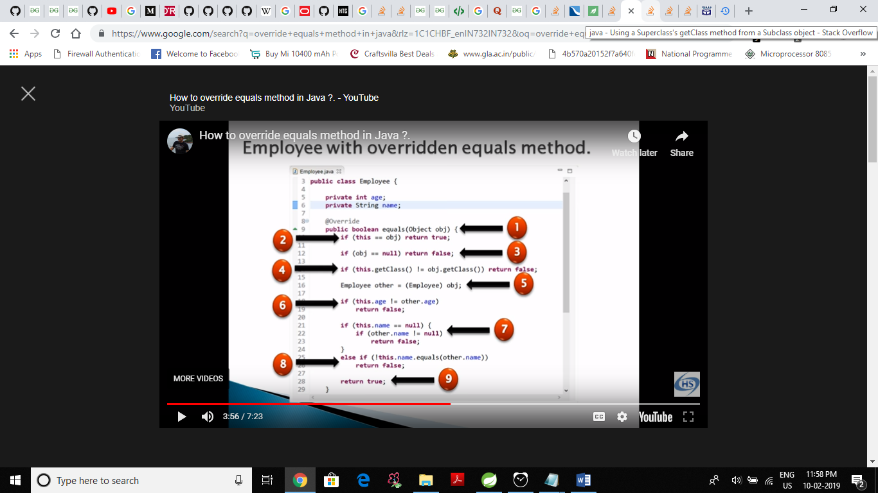

Now used with getClass() method in override equals method in eclipse in line number 4
So now that objects are equal that have same hash code first than have in same class than have same value.
82
A clarification about the obj.getClass() != getClass().
This statement is the result of equals() being inheritance unfriendly.

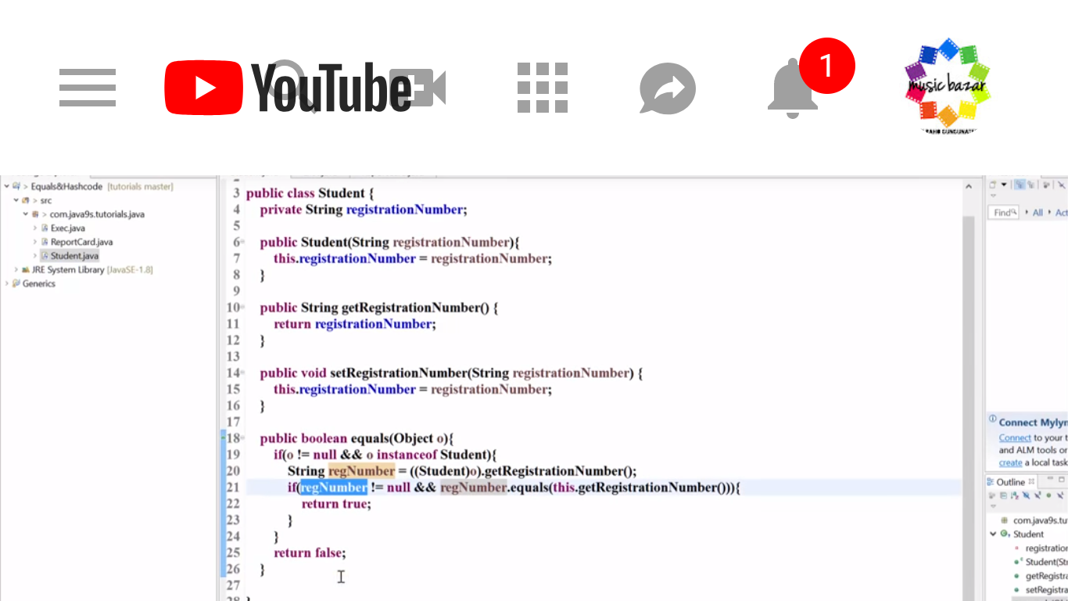

Previously override equals method implements using instance of operator
Ie so previously those objects are equal which have same hash code first then object and class have child – child/parent relationship then values are equal.

Any reason to prefer getClass() over instanceof when generating .equals()?
Ask Question
164
73
I'm using Eclipse to generate .equals() and .hashCode(), and there is an option labeled "Use 'instanceof' to compare types". The default is for this option to be unchecked and use .getClass() to compare types. Is there any reason I should prefer .getClass() over instanceof?
Without using instanceof:
if (obj == null)
return false;
if (getClass() != obj.getClass())
return false;
Using instanceof:
if (obj == null)
return false;
if (!(obj instanceof MyClass))
return false;
I usually check the instanceof option, and then go in and remove the "if (obj == null)" check. (It is redundant since null objects will always fail instanceof.) Is there any reason that's a bad idea?
java eclipse equals instanceof
Josh Bloch favors your approach:
The reason that I favor the instanceof approach is that when you use the getClassapproach, you have the restriction that objects are only equal to other objects of the same class, the same run time type. If you extend a class and add a couple of innocuous methods to it, then check to see whether some object of the subclass is equal to an object of the super class, even if the objects are equal in all important aspects, you will get the surprising answer that they aren't equal. In fact, this violates a strict interpretation of the Liskov substitution principle, and can lead to very surprising behavior. In Java, it's particularly important because most of the collections (HashTable, etc.) are based on the equals method. If you put a member of the super class in a hash table as the key and then look it up using a subclass instance, you won't find it, because they are not equal.

82
A clarification about the obj.getClass() != getClass().
This statement is the result of equals() being inheritance unfriendly.

Why use a prime number in hashCode?
Ask Question
150
60
I was just wondering why is that primes are used in a class's hashCode() method? For example, when using Eclipse to generate my hashCode() method there is always the prime number 31 used:
public int hashCode() {
final int prime = 31;
//...
}
References:

31 is a large enough prime that the number of buckets is unlikely to be divisible by it (and in fact, modern java HashMap implementations keep the number of buckets to a power of 2).

Prime numbers are chosen to best distribute data among hash buckets. If the distribution of inputs is random and evenly spread, then the choice of the hash code/modulus does not matter. It only has an impact when there is a certain pattern to the inputs.
This is often the case when dealing with memory locations. For example, all 32-bit integers are aligned to addresses divisible by 4. Check out the table below to visualize the effects of using a prime vs. non-prime modulus:
Input Modulo 8 Modulo 7
0 0 0
4 4 4
8 0 1
12 4 5
16 0 2
20 4 6
24 0 3
28 4 0
Notice the almost-perfect distribution when using a prime modulus vs. a non-prime modulus.
However, although the above example is largely contrived, the general principle is that when dealing with a pattern of inputs, using a prime number modulus will yield the best distribution.

/*//plays with equals method
hash code
hash map
by just using instance of and getclass
!(obj instanceof A) in class A, instead of ,getClass() != obj.getClass()
in this jus change not equals to to ==
getClass() != obj.getClass() =>getClass() == obj.getClass()
*** see the magic key having same value will be stored in hash map
*** ut conclusion is obj1.equals(obj2)// true
*** obj2.equals(obj1)// false
thats why obj1 and obj2 stored in an hash map after having same key and value
*/

package ashishbhatia;

import java.util.HashMap;
import java.util.Map;

class D
{

int a;
String b;

public D(int a, String b) {
super();
this.a = a;
this.b = b;
}
}
class C
{

int a;
String b;

public C(int a, String b) {
super();
this.a = a;
this.b = b;
}
}

class A
{

int a;
String b;
Map<A,Integer> map = new HashMap<>();
public A(int a, String b) {
super();
this.a = a;
this.b = b;
}

public A() {

}

@Override
public int hashCode() {
System.out.println("A hashode");
final int prime = 31;
int result = 1;
result = prime * result + a;
result = prime * result + ((b == null) ? 0 : b.hashCode());
return result;
}
@Override
public boolean equals(Object obj) {
if (this == obj)
return true;
if (obj == null)
return false;

if (getClass() == obj.getClass())
return false;
B other = (B) obj;
System.out.println(other.c);
if (a != other.c)
return false;
if (b == null) {
if (other.b != null)
return false;
} else if (!b.equals(other.d))
return false;
return true;
}

@Override
public String toString() {
return "A [a=" + a + ", b=" + b + "]";
}

}
class B extends A
{
int c;
String d;

public B(int c, String d) {
super();
this.c = c;
this.d = d;
}
Map<A,Integer> map = new HashMap<>();

@Override
public int hashCode() {
System.out.println("B hashode");
final int prime = 31;
int result = 1;
result = prime * result + c;
result = prime * result + ((d == null) ? 0 : d.hashCode());
return result;
}

@Override
public boolean equals(Object obj) {
if (this == obj)
return true;
if (obj == null)
return false;
if (getClass() != obj.getClass())
return false;
A other = (A) obj;
if (c != other.a)
return false;
if (d == null) {
if (other.b != null)
return false;
} else if (!d.equals(other.b))
return false;
return true;
}

@Override
public String toString() {
return "B [c=" + c + ", d=" + d + "]";
}

}

public class Ques4b {

public static void main(String[] args) {
A obj1 = new A(1,"ashish");
B obj2 = new B(1, "ashish");
C obj3 = new C(1, "ashish");
D obj4 = new D(1, "ashish");
System.out.println(obj1.hashCode());
System.out.println(obj2.hashCode());
System.out.println("bydefault hash code");
System.out.println(obj3.hashCode());
System.out.println(obj4.hashCode());

obj1.map.put(obj1,1);
obj1.map.put( obj2,1);
System.out.println(obj1.equals(obj2));
System.out.println(obj2.equals(obj1));

System.out.println(obj2==(obj1));
System.out.println(obj1.map.keySet());
}
}

output
A hashode
-1408530904
B hashode
-1408530904
bydefault hash code
366712642
1829164700
A hashode
B hashode
1
true
false
false
[A [a=1, b=ashish], B [c=1, d=ashish]]

Question object of same class must posses same hash code ?
Ans is no by default ie without override hashcode function.

