Dependency Injection
http://javainsimpleway.com/constructor-dependency-injection/

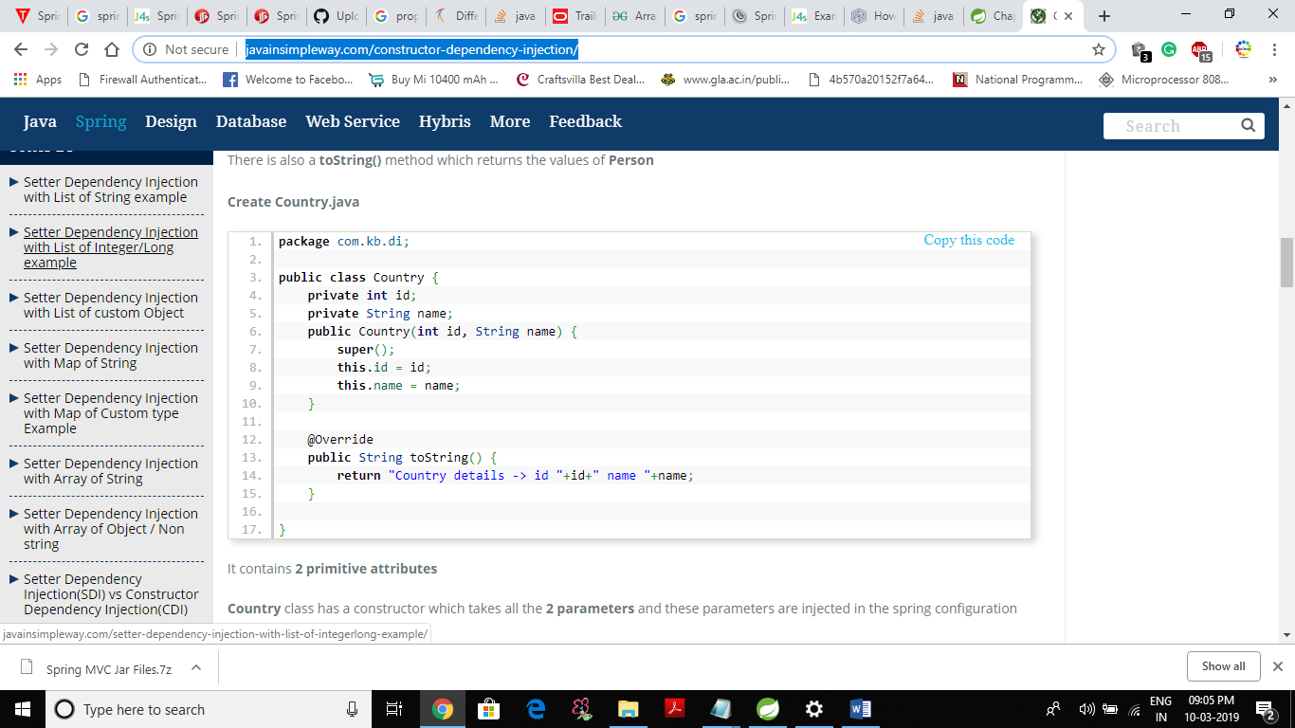

very very good website

Differencing between model.addAttribute(“name”,value) and mv.addObject(“name”,value)?
Ask Question
5
2
What differencing between
model.addAttribute("name",value)
and
mv.addObject("name",value) in spring-mvc?
model is Model
mv is ModelAndView
java spring spring-mvc
shareimprove this question
edited Sep 2 '13 at 15:00



Beryllium
10.8k84173
asked Sep 2 '13 at 14:42
user2740224
- Are these classes found within the standard Java API? If not, perhaps you should specify the classes' origin. – Josh M Sep 2 '13 at 14:46
- @Josh Model is an interface provided by spring-mvc. – Sotirios Delimanolis Sep 2 '13 at 14:47
add a comment

2 Answers
activeoldestvotes
5
Model#addAttribute(String, Object) states
Add the supplied attribute under the supplied name.
while ModelAndView#addObject(String, Object) states
Add an attribute to the model.
If you look at the source code for addObject
public ModelAndView addObject(String attributeName, Object attributeValue) {
getModelMap().addAttribute(attributeName, attributeValue);
return this;
}
it's delegating to the Model reference that a ModelAndView holds and calling addAttribute()on it.
shareimprove this answer

