**Basic Postgres SQL :** is a db we use to store the information and retrieve the information.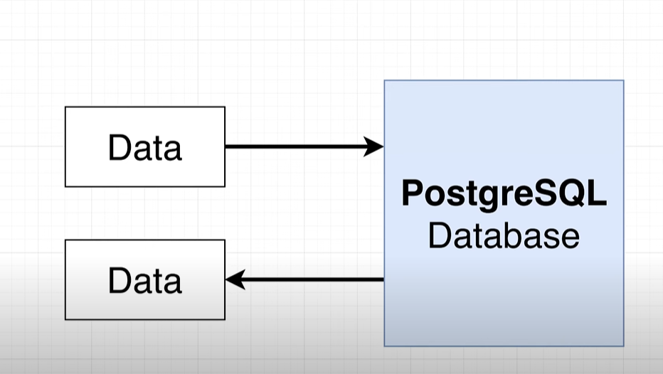

**# To work with postgres we connect to client,** client can we utility server or a program which access and store the data with some purpose.  **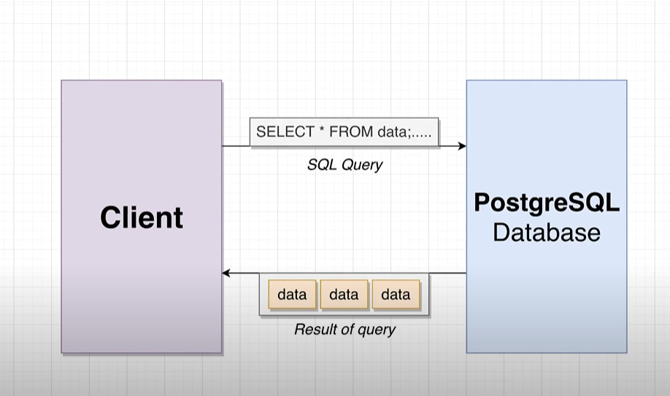  
# we connect client to db using SQL(STRUCTURED QUERY LANG):  
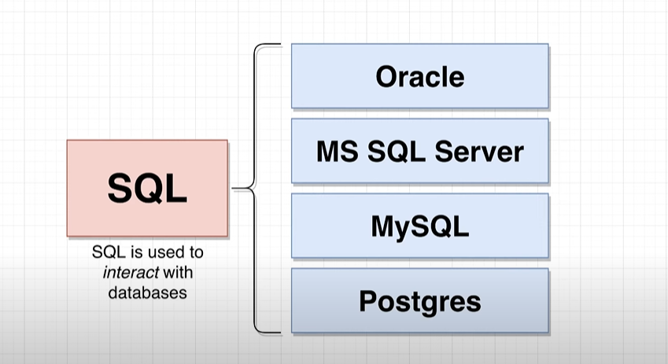  
  
Note :** we use SET in postgres to update the data into db.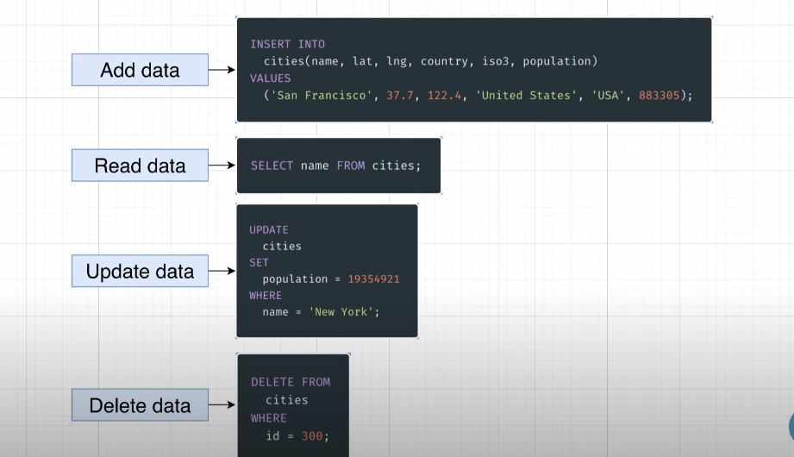  
# when u write the query think following point 1st for facing challenges:  
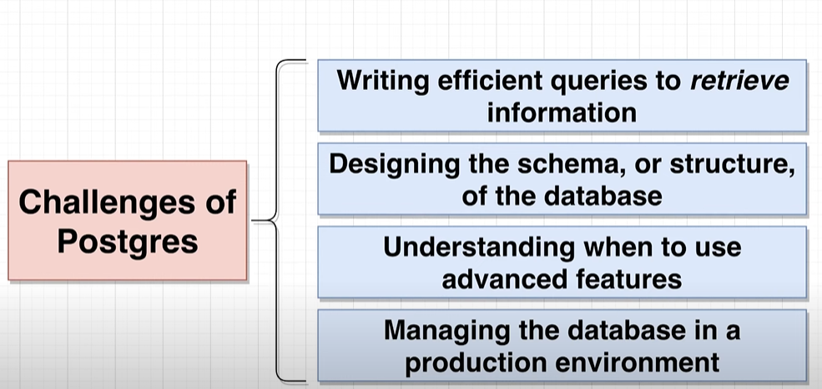  
Here we will focus on 2 challenges :

1. Writing efficient query.
2. Designing the structure of the db.

**# Before designing the db we follow the following process:  
  
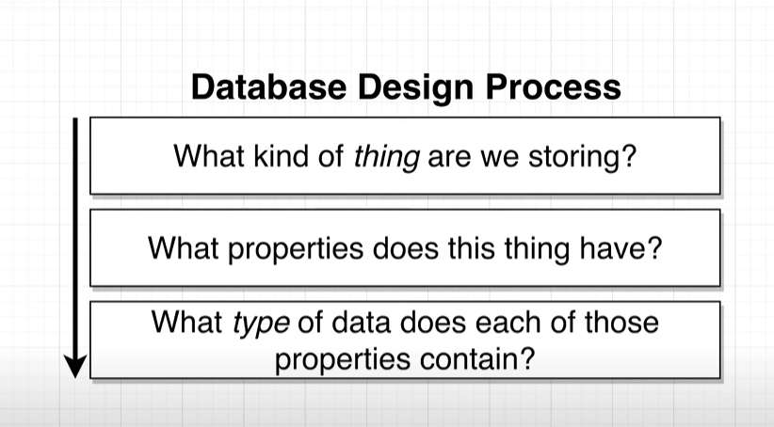  
assume here we are taking example of populated city in the world:  
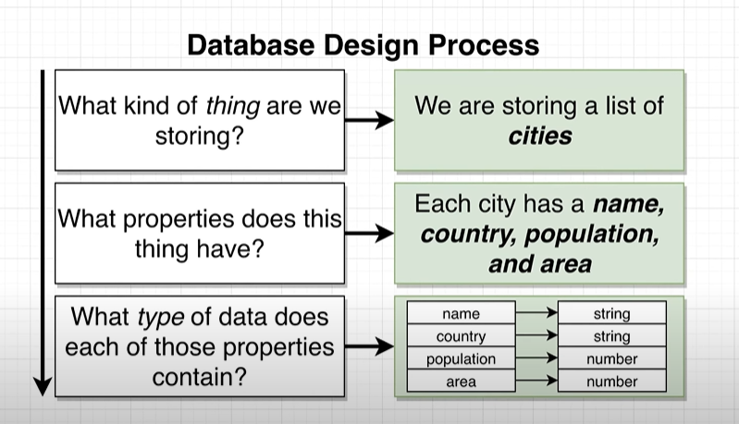  
Than we should think in this way:  
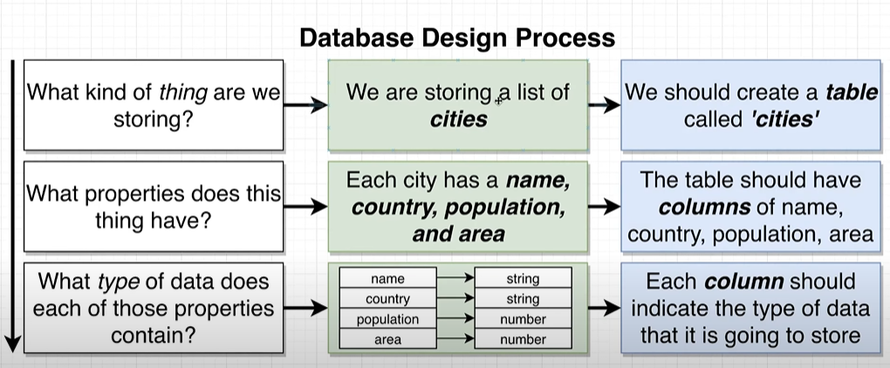  
than we create a table like following:  
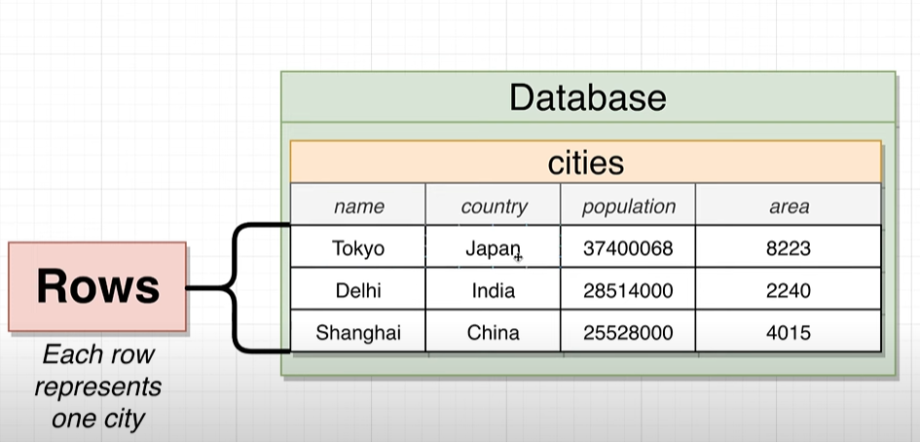  
Now, we will write the query to create a table:**   
CREATE TABLE cities(  
name VARCHAR(50),

Country VARCHAR(50),

Population INTEGER,

Area INTEGER  
); **After running this query following structre will going to create in ur db:  
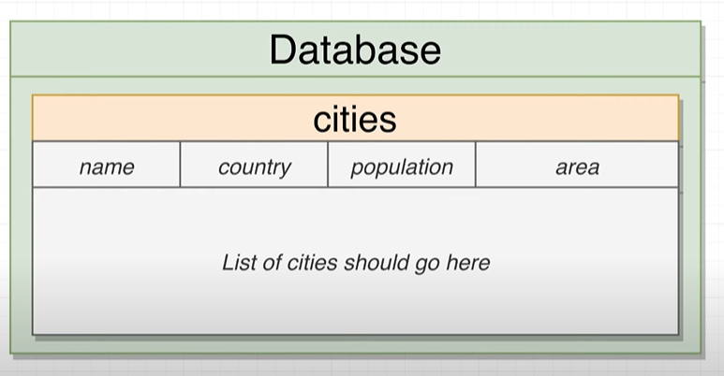**

**Note:  
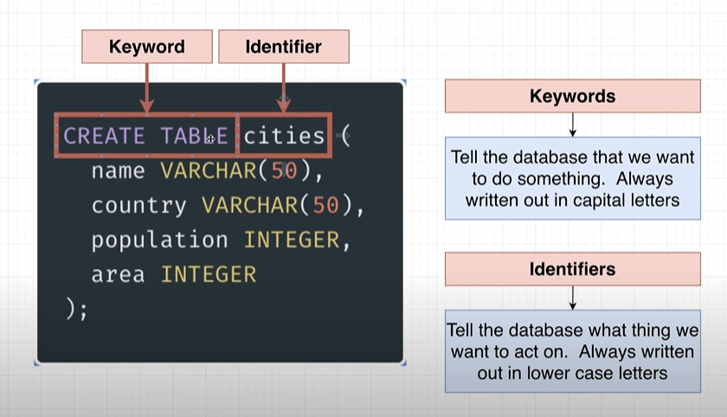  
Now will insert the value into the table:**INSERT INTO cities (name,Country,Population,Area)

VALUES ('begaluru','india',45783783,6876);

Inset multiple rows in single column:

INSERT INTO cities (name,Country,Population,Area)

VALUES ('begaluru','india',45783783,6876),

('tokyo','japan' ,773783,676),

('shanghai','china',6783783,66876),

('Soa_Paul','Brazil',5483783,23876);

To directly fetch the data from the table we can use :  
 SELECT * FROM cities;

If u want specific column than :

SELECT name , Country FROM cities;

# Except pulling data we can perform operation and transform the data before we retrieve, for example I want the density of the city per square km so:

Density= population/area

SELECT name , Population/Area AS Density FROM cities;

# Same like that we can filter the query result :  
 SELECT name , Country FROM cities where area>4000;  
 it execute in following way:  
