**Driver’s Drowsiness Detection**

**Dissertation Submitted in Partial fulfillment of the**

**Requirement for the Award of the Degree of**

*Master of Technology in Information Technology*

*Semester VII*

## *Session July-Dec, 2023*

**Under the guidance of Submitted By**

Mrs.Kirti VijayvargiyaAshish Bhoure IT-2K20-15

Poorv Waghmare IT-2K20-41

### 

**International Institute of Professional Studies**

**Devi Ahilya Vishwavidyalaya, Indore, M.P.**

**2023**

**DECLARATION**

I hereby declare that the project entitled ________________________ which is submitted by me for the partial fulfillment of requirement for the award of **Master of Technology in Information Technology (5 years) Semester VII** to International Institute of Professional Studies, Devi Ahilya Vishwavidyalaya, Indore, is authentic record of my own work carried out under the supervision of **Mrs.Kirti Vijayvargiya**, Batch Mentor, IIPS-DAVV, Indore.

The matter embodied in this dissertation work is authenticated and is genuinely done by me and has not been submitted to this university or any other university or Institute. Thus I solely own the responsibility for the originality of the entire content.

I also declared that the content of project report does not violate the copyright, Trademarks, infringes on the patent, statutory right or propriety right of others.

Signature of Student:

Date:

Place:

.

**CERTIFICATE FROM GUIDE**

It is to certify that dissertation on **“Driver’s Drowsiness Detection”**, submitted by **Mr. Ashish Bhoure and Mr. Poorv Waghmare** to the International Institute of Professional Studies, DAVV, Indore has been completed under my supervision and the work is carried out and presented in a manner required for its acceptance in partial fulfillment for the award of the degree of “**Master of Technology in Information Technology (5 years) Semester VII** ”.

**Project Guide**

Signature:

**Name:**

**Date:**

**CERTIFICATE**

It is to certify that we have examined the dissertation on **“Driver’s Drowsiness Detection”**, submitted by **Mr. Ashish Bhoure and Mr. Poorv Waghmare** to the International Institute of Professional Studies, DAVV, Indore and hereby accord our approval of it as a study carried out and presented in a manner required for its acceptance in partial fulfillment for the award of the degree of **Master of Technology in Information Technology (5 years) Semester VII.**

**Internal Examiner External Examiner**

Signature**:** Signature**:**

Name  **:** Name **:**

Date **:** Date  **:**

Acknowledgements

We, Ashish Bhoure and Poorv Waghmare, extend our sincere gratitude to Mrs. Kirti Vijayvargiya, our project mentor, for her invaluable guidance, support, and expertise throughout the development of the "Driver’s Drowsiness Detection" project. Her insights and encouragement have been instrumental in shaping the project's success.

We would also like to acknowledge International Institute of Professional Studies for providing the necessary resources and a conducive environment for the completion of this project. The support of the college administration has been crucial to our endeavors.

Ashish Bhoure

Poorv Waghmare

International Institute of Professional Studies

### ABSTRACT

The Driver Drowsiness Detection System project addresses the critical issue of drowsy driving, a leading cause of road accidents worldwide. The project aims to develop an intelligent system capable of real-time monitoring of a driver's state to detect signs of drowsiness and mitigate potential hazards. Utilizing advanced technologies such as facial recognition, eye tracking, the system provides a comprehensive solution for identifying fatigue-induced impairment.

The system involves a robust architecture that integrates various hardware and software components. Facial features and eye movements are continuously analyzed to determine the driver's alertness level. Upon detection of drowsiness, the system promptly issues alerts to the driver, facilitating timely intervention and prevention of potential accidents.

The project encompasses a thorough analysis of existing drowsiness detection methods, careful selection of appropriate technologies, and the implementation of an efficient software development methodology. Extensive testing and validation ensure the reliability and effectiveness of the system across diverse driving conditions.

Challenges faced during the implementation phase are addressed, and lessons learned contribute to the system's iterative improvement. The report concludes with recommendations for future enhancements and features. The Driver Drowsiness Detection System project represents a pioneering effort in leveraging technology to address a critical aspect of transportation safety, ultimately contributing to the reduction of accidents associated with drowsy driving.

## **Table of Contents**

|  |  |  |  |
| --- | --- | --- | --- |
| 1 | Introduction | | 8 |
|  | 1.1 | PURPOSE . . . . . . . . . . . . . . . . . . . . . . . . . . . | 8 |
|  |  | 1.1.1 HUMAN PSYCHOLOGY. . . . . . . . . . . . | 8 |
|  | 1.2 | INTENDED AUDIENCE. . . . . . . . . . . . . . . | 9 |
|  | 1.4 | PRODUCT SCOPE. . . . . . . . . . . . . . . | 10 |
|  | 1.5 | PROBLEM DEFINITION. . . . . . . . . . . . . . . | 10 |
| 2 | Literature Survey | | 11 |
|  | 2.1 | SYSTEM REVIEW . . . . . . . . . . . . . . . . . . . . . . . . . . . | 11 |
|  | 2.2 | TECHNOLOGY USED. . . . . . . . . . . . . . . | 11 |
| 3 | Software Requirements Specification | | 12 |
|  | 3.1 | PYTHON . . . . . . . . . . . . . . . . . . . . . . . . . . . | 12 |
|  |  | 3.1.1 LIBRARIES . . . . . . . . . . . . . . . . . . . . | 12 |
|  | 3.2 | OPERATING SYSTEM . . . . . . . . . . . . . . . . . . . . . . . . . . . | 12 |
|  | 3.3 | HARDWARE . . . . . . . . . . . . . . . . . . . . . . . . . . . | 12 |
| 4 | Requirement Analysis | | 13 |
|  | 4.1 | PYTHON . . . . . . . . . . . . . . . . . . . . . . . . . . . | 13 |
|  |  | 4.1.1 LIBRARIES . . . . . . . . . . . . . . . . . . . . | 13 |
|  | 4.2 | OPERATING SYSTEM . . . . . . . . . . . . . . . . . . . . . . . . . . . | 13 |
|  | 4.3 | HARDWARE . . . . . . . . . . . . . . . . . . . . . . . . . . . | 13 |
|  |  | 4.3.1 LAPTOP . . . . . . . . . . . . . . . . . . . . | 13 |
|  |  | 4.3.2 WEBCAM . . . . . . . . . . . . . . . . . . . . | 13 |
| 5 | System Design | | 14 |
|  | 5.1 | USE CASE MODEL . . . . . . . . . . . . . . . . . . . . . . . . . . . | 14 |
|  | 5.2 | ACTIVITY DIAGRAM . . . . . . . . . . . . . . . . . . . . . . . . . | 15 |
|  | 5.3 | CLASS DIAGRAM . . . . . . . . . . . . . . . . . . . . . . . . . | 16 |
| 6 | System Testing | | 17 |
|  | 6.1 | TEST CASES & TEST RESULTS . . . . . . . . . . . . . . . . . . . . . . | 17 |

|  |  |  |  |
| --- | --- | --- | --- |
| 7 | Project Planning | | 18 |
|  | 7.1 | SYSTEM MODEL . . . . . . . . . . . . . . . . . . . . . . . . . . . . . . | 18 |
| 8 | Implementation | | 19 |
| 9 | Screenshots of Project | | 21 |
|  | 9.1 | NON-DROWSY STATE . . . . . . . . . . . . . . . . . . . . . . . . . . . | 21 |
|  | 9.2 | DROWSY STATE . . . . . . . . . . . . . . . . . . . . . . . . . . . | 21 |
| 10 | Conclusion and Future Scope | | 22 |
|  | 10.1 | CONCLUSION . . . . . . . . . . . . . . . . . . . . . . . . . . . . . . | 22 |
|  | 10.2 | FUTURE SCOPE . . . . . . . . . . . . . . . . . . . . . . . . . . . . . . | 22 |

|  |  |
| --- | --- |
| 11 References | 23 |

**List of Figures**

|  |  |  |
| --- | --- | --- |
| 5.1 | USE CASE MODEL . . . . . . . . . . . . . . . . . . . . . . . . . . . | 14 |
| 5.2 | ACTIVITY DIAGRAM . . . . . . . . . . . . . . . . . . . . . . . . . | 15 |
| 5.3 | CLASS DIAGRAM . . . . . . . . . . . . . . . . . . . . . . . . . | 16 |
| 5.3 | BLOCK DIAGRAM . . . . . . . . . . . . . . . . . . . . . . . . . | 18 |

# Chapter 1

# Introduction

#### 

#### **1.1 PURPOSE**

**1.1.1 HUMAN PSYCHOLOGY WITH CURRENT TECHNOLOGY**

Humans have always invented machines and devised techniques to ease and protect their lives, for mundane activities like traveling to work, or for more interesting purposes like aircraft travel. With the advancement in technology, modes of transportation kept on advancing and our dependency on it started increasing exponentially. It has greatly affected our lives as we know it. Now, we can travel to places at a pace that even our grandparents wouldn’t have thought possible. In modern times, almost everyone in this world uses some sort of transportation every day. Some people are rich enough to have their own vehicles while others use public transportation. However, there are some rules and codes of conduct for those who drive irrespective of their social status. One of them is staying alert and active while driving.

Neglecting our duties towards safer travel has enabled hundreds of thousands of tragedies to get associated with this wonderful invention every year. It may seem like a trivial thing to most folks but following rules and regulations on the road is of utmost importance. While on road, an automobile wields the most power and in irresponsible hands, it can be destructive and sometimes, that carelessness can harm lives even of the people on the road. One kind of carelessness is not admitting when we are too tired to drive. In order to monitor and prevent a destructive outcome from such negligence, many researchers have written research papers on driver drowsiness detection systems. But at times, some of the points and observations made by the system are not accurate enough. Hence, to provide data and another perspective on the problem at hand, in order to improve their implementations and to further optimize the solution, this project has been done.

**1. 2 INTENDED AUDIENCE**

The intended audience for this document are the development team, the project evaluation jury, and other tech-savvy enthusiasts who wish to further work on the project

#### **1.3 PRODUCT SCOPE**

There are many products out there that provide the measure of fatigue level in the drivers which are implemented in many vehicles. The driver drowsiness detection system provides the similar functionality but with better results and additional benefits. Also, it alerts the user on reaching a certain saturation point of the drowsiness measure.

#### **1.4 PROBLEM DEFINITION**

Fatigue is a safety problem that has not yet been deeply tackled by any country in the world mainly because of its nature. Fatigue, in general, is very difficult to measure or observe unlike alcohol and drugs, which have clear key indicators and tests that are available easily. Probably, the best solution to this problem are awareness about fatigue-related accidents and promoting drivers to admit fatigue when needed. The former is hard and much more expensive to achieve, and the latter is not possible without the former as driving for long hours is lucrative

# Chapter 2

# Literature Survey

#### **2.1 SYSTEM REVIEW**

This survey is done to comprehend the need and prerequisite of the general population, and to do as such, we went through different sites and applications and looked for the fundamental data. Based on these data, we made an audit that helped us get new thoughts and make different arrangements for our task. We reached the decision that there is a need of such application and felt that there is a decent extent of progress in this field too.

#### **TECHNOLOGY USED**

1. PYTHON - Python is an interpreted, high-level, general-purpose programming language. Python's design philosophy emphasizes code readability with its notable use of significant whitespace. Its language constructs and object-oriented approach aim to help programmers write clear, logical code for small and large-scale projects. Python is dynamically typed AND supports multiple programming paradigms, including procedural, object-oriented, and functional programming.
2. JUPYTER Lab - Project Jupyter is a [nonprofit organization](https://en.wikipedia.org/wiki/Nonprofit_organization) created to develop [open-source software](https://en.wikipedia.org/wiki/Open-source_software), open-standards, and services for [interactive computing](https://en.wikipedia.org/wiki/Interactive_computing) across dozens of programming languages.
3. IMAGE PROCESSING - In [computer science](https://en.wikipedia.org/wiki/Computer_science), digital image processing is the use of computer [algorithms](https://en.wikipedia.org/wiki/Algorithm) to perform image processing on [digital](https://en.wikipedia.org/wiki/Digital_image) [images](https://en.wikipedia.org/wiki/Digital_image).
4. MACHINE LEARNING - Machine learning is the [scientific](https://en.wikipedia.org/wiki/Branches_of_science) [study](https://en.wikipedia.org/wiki/Branches_of_science) of [algorithms](https://en.wikipedia.org/wiki/Algorithm) and [statistical models](https://en.wikipedia.org/wiki/Statistical_model) that [computer systems](https://en.wikipedia.org/wiki/Computer_systems) use in order to

# Chapter 3

## **Software Requirements Specification**

## **Python:**

## Python

## **Libraries**

* Numpy
* Scipy
* Playsound
* Dlib
* Imutils
* opencv, etc.

#### 3.3**Operating System**

* Windows or Ubuntu

## **Hardware Requirements Specification**

I. Laptop with basic hardware.

II. Webcam

**Chapter 4**

**Requirement Analysis**

**4.1 Python:** Python is the basis of the program that we wrote. It utilizes many of the python libraries.

* 1. **Libraries:**
* Numpy: Pre-requisite for Dlib
* Scipy: Used for calculating Euclidean distance between the eyelids.
* Playsound: Used for sounding the alarm
* Dlib: This program is used to find the frontal human face and estimate its pose using 68 face landmarks.
* Imutils: Convenient functions written for Opencv.
* Opencv: Used to get the video stream from the webcam, etc.
  1. **OS:** Program is tested on Windows 10
  2. **Laptop:** Used to run our code.

**4.5 Webcam:** Used to get the video feed.

# Chapter 5

## **System Design**

#### **USE CASE DIAGRAM**

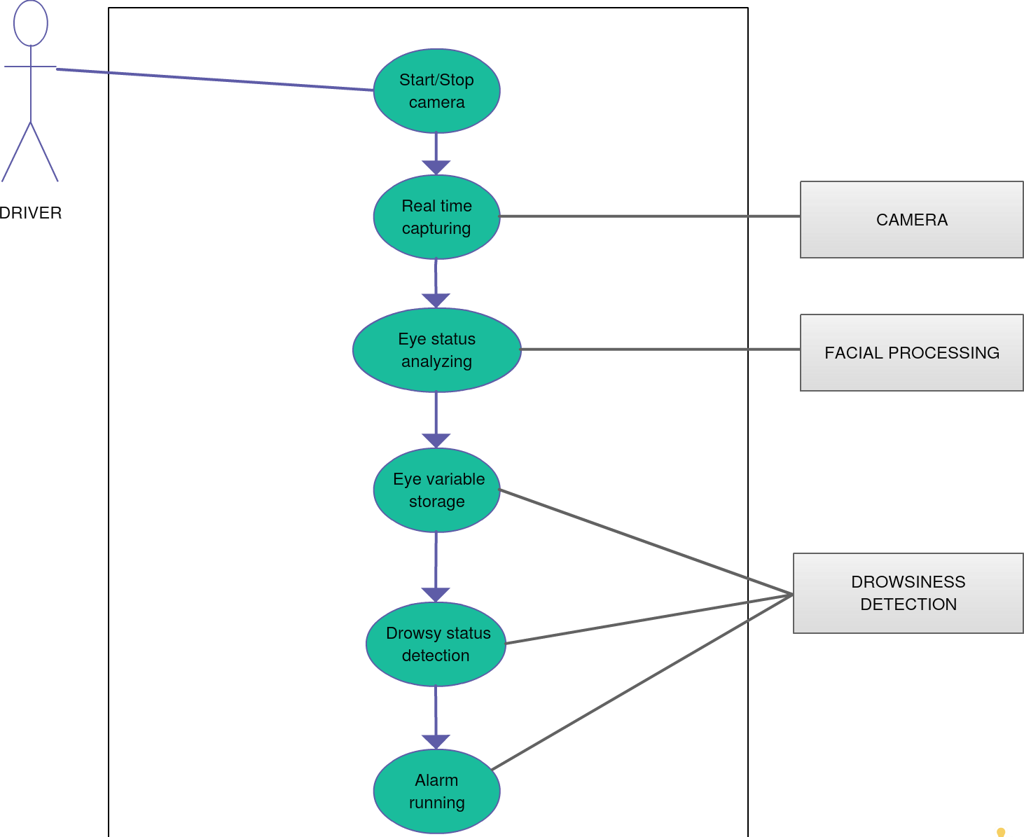

Figure 1

#### **5.2 ACTIVITY DIAGRAM**

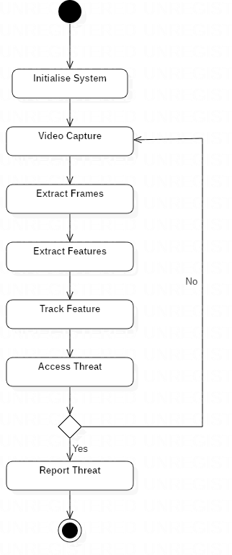

Figure 2

#### 5.3 **CLASS DIAGRAM**

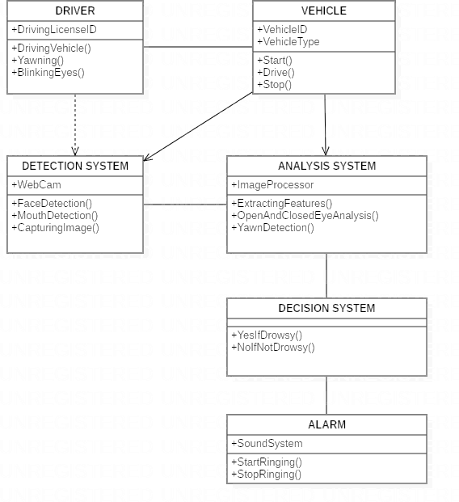

Figure 3

# Chapter 6

## **System Testing**

**6.1 Test Cases and Test Results**

|  |  |  |  |  |
| --- | --- | --- | --- | --- |
| Test | Test Case Title | Test Condition | System Behavior | Expected Result |
| ID |
| T01 | NSGY | Straight Face, Good Light, With Glasses | Non Drowsy | Non Drowsy |
| T02 | YTGN | Tilted Face, Good Light, No Glasses | Drowsy | Drowsy |
| T03 | YTGY | Tilted Face, Good Light, With Glasses | Drowsy | Drowsy |

**Note: Testing is performed manually**

# Chapter 7

## **Project Planning**

**7.1** **SYSTEM MODEL**

The framework is created utilizing the incremental model. The center model of the framework is first created and afterwards augmented in this way in the wake of testing at each turn. The underlying undertaking skeleton was refined into expanding levels of ability.

At the following incremental level, it might incorporate new execution backing and improvement.

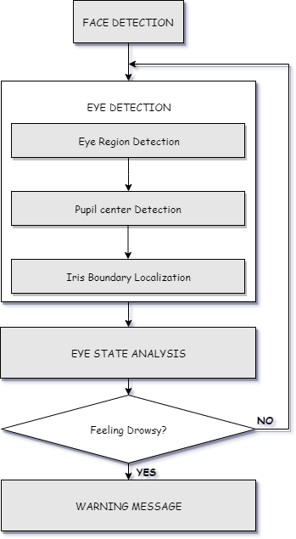

Figure 4: Block Diagram

# Chapter 8

## **Implementation**

* + - 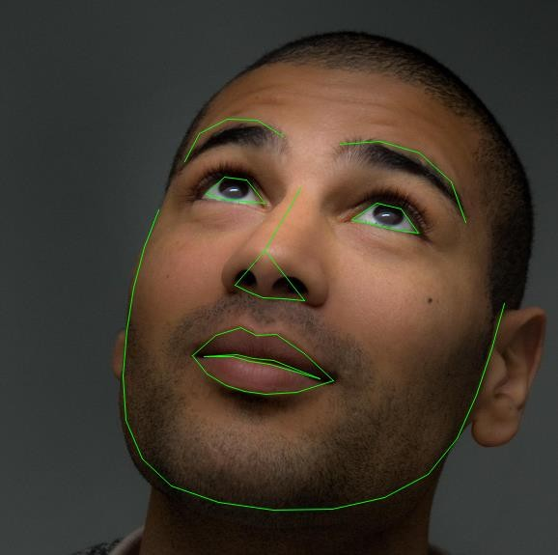In our program we used Dlib, a pre-trained program trained on the to detect human faces using the pre-defined 68 landmarks.

Landmarked Image of a person by Dlib

* + - After passing our video feed to the dlib frame by frame, we are able to detect left eye and right eye features of the face.

Now, we drew contours around it using OpenCV.

* + - Using Scipy’s Euclidean function, we calculated sum of both eyes’ aspect ratio which is the sum of 2 distinct vertical distances between the eyelids divided by its horizontal distance.
    - Now we check if the aspect ratio value is less than 0.25 (0.25 was chosen as a base case after some tests). If it is less an alarm is sounded and user is warned.

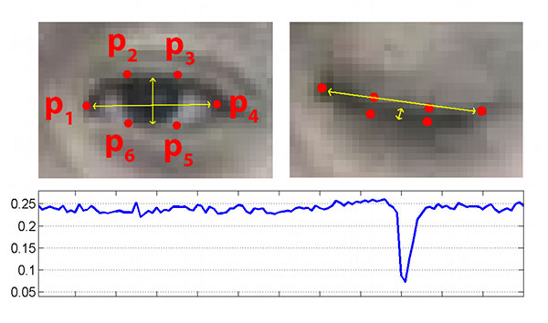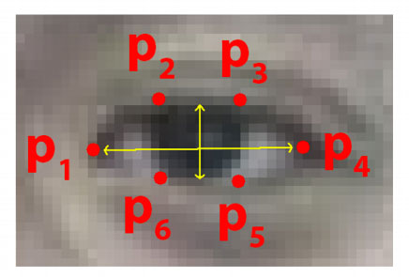Landmarks on eye

# Chapter 9

## **Screenshots of Project**

#### 

#### **9.1 Face landmarks 9.2 Non-drowsy Person**

#### 

#### **9.3 Drowsy Person: 9.4 Sleeping Person:**

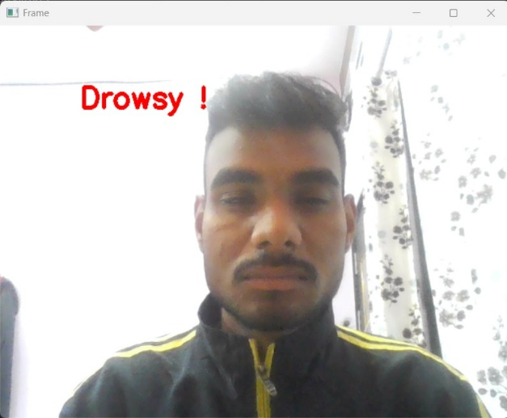 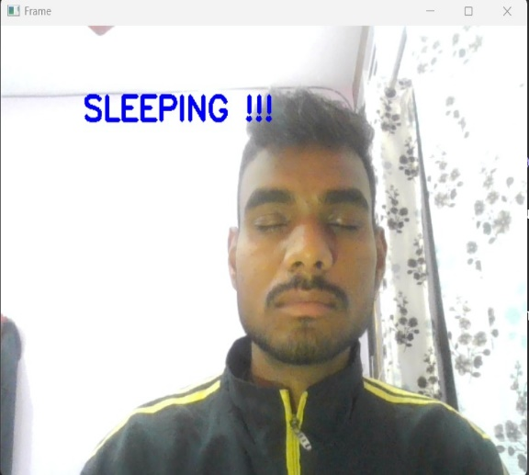

Drowsy state Sleeping state

# Chapter 10

## **Conclusion and Future Scope**

* 1. **Conclusion**

It completely meets the objectives and requirements of the system. The framework has achieved an unfaltering state where all the bugs have been disposed of. The framework cognizant clients who are familiar with the framework and comprehend it's focal points and the fact that it takes care of the issue of stressing out for individuals having fatigue-related issues to inform them about the drowsiness level while driving.

**10.2** **Future Scope**

The model can be improved incrementally by using other parameters like blink rate, yawning, state of the car, etc. If all these parameters are used it can improve the accuracy by a lot.

We plan to further work on the project by adding an alarm to warn the driver that he is sleeping in order to prevent accidents caused due to sudden heart attacks to drivers.

Same model and techniques can be used for various other uses like Netflix and other streaming services can detect when the user is asleep and stop the video accordingly. It can also be used in application that prevents user from sleeping