**Program No:24**

Aim: Given below is the list of marks obtained by a class of 50 students in

annual examination.

43,65,51,27,82,67,49,08,17,15,77,44,22,77,11,34,43,28,64,93,29,83,65,25,18,

09,02,01,64,73,47,82,82,81,64,64,23,43,31,45,36,56,37,81,93,76,57,38,82,03.

Write a program to count the no. of students belonging to each of the

following group of the marks: 0-9,10-19,20-29,30-39,40-49,------,100.*/

#include<stdio.h>

#include<conio.h>

void main()

{

int i,count1=0,count2=0,count3=0,count4=0,count5=0,count6=0,count7=0,count8=0,count9=0,count10=0,mark[55]={43,65,51,27,82,67,49,8,17,15,77,44,22,77,11,34,43,28,64,93,29,83,65,25,18,9,2,1,64,73,47,82,82,81,64,64,23,43,31,45,36,56,37,81,93,76,57,38,82,3};

clrscr();

printf("Marks obtained by 50 students in an Annual Examination is:\n");

for(i=0;i<50;i++)

{

printf("%d\t",mark[i]);

}

for(i=0;i<50;i++)

{

if(mark[i]<=9)

{

count1++;

}

}

printf("No. of students belong to 0-9 group are:%d\n",count1);

for(i=0;i<50;i++)

{

if((mark[i]>=10)&&(mark[i]<=19))

{

count2++;

}

}

printf("No. of students belong to 10-19 group are:%d\n",count2);

for(i=0;i<50;i++)

{

if((mark[i]>=20)&&(mark[i]<=29))

{

count3++;

}

}

printf("No. of students belong to 20-29 group are:%d\n",count3);

for(i=0;i<50;i++)

{

if((mark[i]>=30)&&(mark[i]<=39))

{

count4++;

}

}

printf("No. of students belong to 30-39 group are:%d\n",count4);

for(i=0;i<50;i++)

{

if((mark[i]>=40)&&(mark[i]<=49))

{

count5++;

}

}

printf("No. of students belong to 40-49 group are:%d\n",count5);

for(i=0;i<50;i++)

{

if((mark[i]>=50)&&(mark[i]<=59))

{

count6++;

}

}

printf("No. of students belong to 50-59 group are:%d\n",count6);

for(i=0;i<50;i++)

{

if((mark[i]>=60)&&(mark[i]<=69))

{

count7++;

}

}

printf("No. of students belong to 60-69 group are:%d\n",count7);

for(i=0;i<50;i++)

{

if((mark[i]>=70)&&(mark[i]<=79))

{

count8++;

}

}

printf("No. of students belong to 70-79 group are:%d\n",count8);

for(i=0;i<50;i++)

{

if((mark[i]>=80)&&(mark[i]<=89))

{

count9++;

}

}

printf("No. of students belong to 80-89 group are:%d\n",count9);

for(i=0;i<50;i++)

{

if((mark[i]>=90)&&(mark[i]<=100))

{

count10++;

}

}

printf("No. of students belong to 89-100 group are:%d\n",count10);

getch();

}

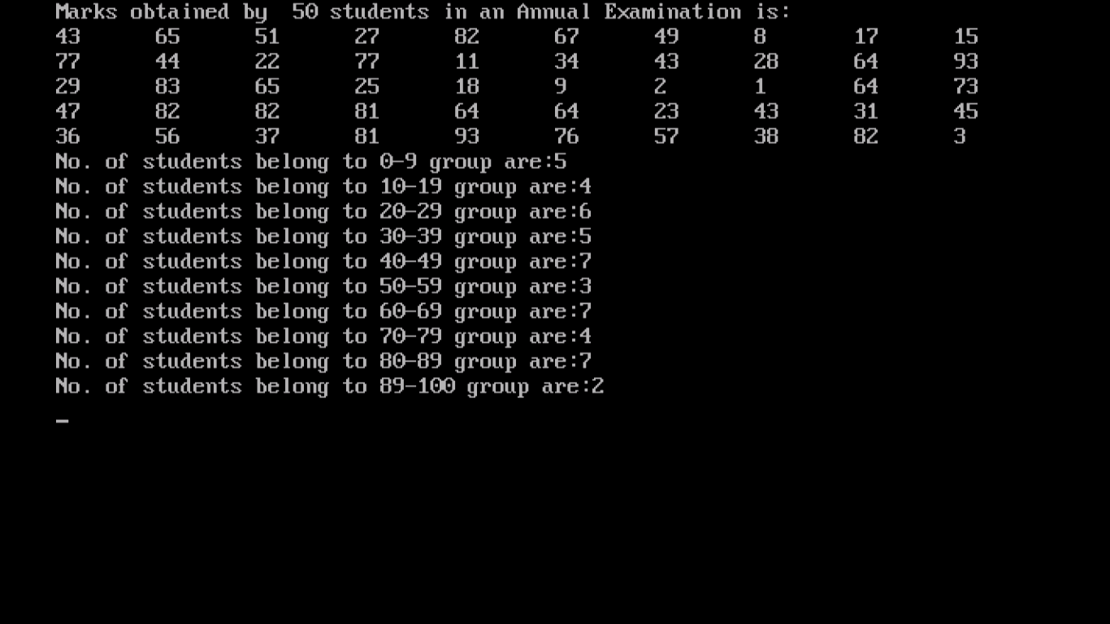

**Program No.25**

**Aim:WAP that contains the recursive function void listNumbers(int start, int end) that outputs the numbers from start to end to console. Write one version that outputs the numbers in ascending order, and another that outputs them in “HelloHelloHello”. If n equals zero, the method should return the empty string.**

#include<stdio.h>

#include<conio.h>

void listNumbers(int start, int end);

void main()

{

int a,z;

clrscr();

printf("Enter the starting list number \t");

scanf("%d",&a);

printf("Enter the number where the list ends \t");

scanf("%d",&z);

listNumbers(a,z);

printf("\n\nRecursion terminated");

getch();

}

void listNumbers(int start, int end)

{

printf("%d\n",start);

start++;

if(start<=end)

{

listNumbers(start,end);

}

printf("Hello");

}

