Cloud Data Security Techniques

Syed Timazer Ajaz [B.Tech 8th Sem]
SSM College of Engg. & Tech CSE dept.
timazermasoodi@gmail.com
Syed Irfan Yaqoob [A.P]
SSM College of Engg. & Tech CSE dept.
Syedirfan.ssm@gmail.com

Abstract— Cloud computing is the internet based computing, and has been emerged as the fast growing technology. Cloud computing provides us with simple way to access servers, storage, databases and a broad set of application services over the Internet. However, this technology of cloud computing introduces many challenges for the cloud service providers to the users, one of the major concern is the data security provided to the users. Data security arises because data is stored at all the places around the globe. Thus, raising the issue of security of the data and privacy of user data that is being stored in the cloud. This paper discusses the techniques and methods to secure the data in the cloud.

Keywords—Cloud Computing; Security; services;

Introduction
Cloud computing is seeing significant growth around the world. By deploying cloud technology most organizations have deployed to reduce the cost reduction, increase the flexibility in IT, and become more competitive and meet time to market objectives.
Over the recent survey it has been found that: Almost 70% of organizations feel more good putting away information in the cloud than on a heritage framework. Over half (56%) of organizations spend more than $100,000 on extra safety efforts for their cloud.
Almost 1 out of 4 organizations on the cloud use IoT highlights, regardless of potential security concerns. Very nearly 66% of organizations (65%) take after administrative principles from the Cloud Security Alliance.
Extra encryption is the most utilized extra security highlight. It has been found in regards to the security, many were asked where they feel more comfortable storing data. And the analysis were as follows:
In the cloud- 69% On a legacy system-25% No opinion- 5% Thus, as we see the majority of the people believe storing data on cloud is more comfortable but data security is the major concern and many business are investing a lot of money in additional security features.
There are three elements of cloud security: 1. Physical security 2. Infrastructure security 3. Application level security: Application-level security includes which clients can get to information, how they get to it, and other individual collaborations. While physical and framework security are mostly the obligation of the supplier, application-level security falls more inside the duty of the organization and its clients.
A cloud provider can't completely ensure a client's information if the client is sharing their secret key uninhibitedly, in the event that they aren't controlling which clients can and can't get to the information, or if the client falls prey to a lance phishing endeavor.
Methods and techniques to secure the data: Cloud computing is widely adopted in various industries, with the adoption comes security concerns. But there are ways to prevent the data loss and ensure the privacy. Securing stored information includes keeping unapproved individuals from getting to it and in addition forestalling incidental or purposeful decimation, contamination or debasement of data. While information encryption is a prevalent theme, it is only one of numerous systems and innovations that can be utilized to execute a layered information security methodology. Ventures to secure information include understanding pertinent dangers, adjusting fitting layers of protection and persistent checking of action logs making a move as required. Data movement is required for approved general access, business duration (BC) and calamity recuperation (DR), general information security and also documenting for information conservation and consistence. Data residency and data security are key concerns when moving to the cloud. Data residency refers to the physical or geographic area of an association's information or data. Like information power, data residency likewise refers to the legitimate or administrative necessities forced on information in view of the nation or locale in which it dwells.
The main concerns of data residency are:
Who manages and have access to the data?
Where is the data stored and what laws apply?
Will you know when data is breached?
Will data remain in cloud even after the termination of service?
Data encryption and tokenization are key solutions to overcome the data residency concerns.
Data encryption is the mathematical process of converting clear text data into secured text, which can’t be read by anyone, but only the person who retains the encryption key.
In tokenization, the actual data resides locally in a token database. Randomly generated tokens are associated with the data intercepted to the cloud. The data can only be read by the custodian of the token database.
The significant difference between tokenization and encryption is that tokenization saves from only external threats, since anyone can access token database could access clear data, whereas encryption saves internal and external threat.
Since there are segregation of duties between where the keys are managed and where the encrypted data is stored.
Tokenization requires higher capacity servers and databases and more operational oversite to manage the critical token database that grows with increasing data volumes.
Data encryption in the cloud is the way toward changing or encoding information before it's moved to distributed storage. Ordinarily cloud specialist co-ops offer encryption administrations — going from an encoded association with constrained encryption of delicate information — and give encryption keys to decode the information as required.
Keeping data secure in the cloud ought to be most important. Simply taking a couple of deterrent measures around information encryption can fix security for our most sensitive data.
The most important data security principles are:
- Confidentiality: by confidentiality we mean to prevent unauthorized access to the data.
- Integrity: means preserving information integrity.
- Availability: by availability it means to ensure the information is available when needed.
Techniques used to secure data in cloud computing:
- Multi tenancy access control.
- Intrusion detection system.
- Secure socket layer.

Multi tenancy access control:
Multi tenancy access control is one of the features of the cloud computing. By tenant we mean the customer. For the purpose of securing data and privacy of each customer, cloud service providers apply multi-tenant schemes to their shared services.
In multi-tenant design, multiple customers (tenant) of the cloud services are able to access the same instance of resources simultaneously. Multi tenancy spans the layers at which services are provided.
Multi tenancy protection is offered by cloud service providers for all the layers.
The advantages of multi tenancy access control are:
It offers more flexibility.
It is easily assign to the resources.

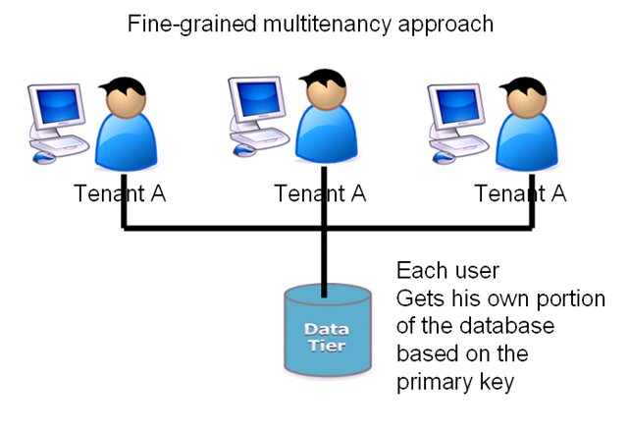
Fig 1: Fine grained multitenancy approach

Intrusion detection system:
It works by detecting the malicious activities that happened in the system and produces its report.
There are two methods in intrusion detection system (IDS):
- Behavior based method or also known as anomaly detection method.
- Knowledge based method.
In behavior based method, the recent action of user is compared with its usual behavior.
The knowledge based method, detects the trail left by the attackers. The patterns are being used artificial Intelligence system.
The main advantage of the intrusion detection system is that it is able to detect pervious unknown attacks launched by attackers.

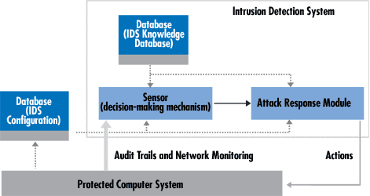

Fig 2: Intrusion Detection System (IDS)

Secure socket layer:
It is a protocol which is used to secure and protect transactions between destinations in a network. It is also known as transport layer security.
Secure socket layer depends upon the encryption to make these transactions private.
It is designed to allow:
To secure online transaction.
To secure system log ins and any sensitive information exchanged online.

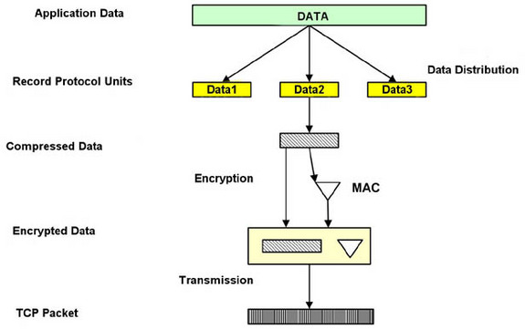

Fig 3: Secure Socket Layer

CONCLUSSION
Security issues in the field of distributed computing are dynamic zone of research and experimentation.
The recognizable proof of security difficulties and alleviation methods in Cloud Processing is tested by considering the large number of services. Cloud administrations are accessible to accomplish security with the changing strategies and techniques.

Acknowledgment
I express my sincere thanks to my parents for supporting and believing in me. It gives me immense pleasure to express my heartfelt gratitude to my professor Mr. Syed Irfan, for his guidance and encouragement without which this would have not been possible. Finally I would like to thank my HOD and college.

References

- https://www.agileit.com/news/data-encryption-methods-secure-cloud
- Armbrust M, Fox A, Griffith R, Joseph A D, Katz R, Konwinski A, Lee G, Patterson D, Rabkin A, Stoica I and Zaharia M 2010 A view of cloud computing, Communications of the ACM Magazine 53 50-58
- https://azure.microsoft.com/en-in/overview/what-is-cloud-computing
- https://aws.amazon.com/what-is-cloud-computing
- https://en.wikipedia.org/wiki/Cloud_computing

