Program-1
package truthta;
/**
*
* @author ASHISH
*/
public class Truthta {

public static void main(String[] args) {
// TODO code application logic here
boolean x = false;
boolean y = false;
int j;
System.out.println("x\t y\t x&&y \t x||y \t !x \t !y");
for(int i = 1 ;i<=4;i++ ){
for (j = 1 ;j<2;j++ ){
System.out.print(x+"\t");
System.out.print(y+"\t");
}
if (j == 2)
System.out.println((x&&y)+"\t"+(x||y)+"\t"+(!x)+"\t"+(!y));
y = !y;
if ( i==2){
x=!x;
}
}
}
}
Output

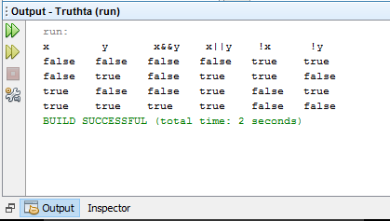

Program-1(b)
import java.util.Scanner;
/**
*
* @author ASHISH
*/
public class Switch {
public static void main(String[] args){
boolean x = false;
boolean y = false;
int j;
System.out.println("Enter the oprator to perform operation:--");
Scanner sc = new Scanner(System.in);
String s = sc.nextLine();
switch(s)
{
case "&" :
{
System.out.println("x\t y\t x&&y");
for(int i = 1 ;i<=4;i++ )
{
for (j = 1 ;j<2;j++ )
{
System.out.print(x+"\t");
System.out.print(y+"\t");
}
if (j == 2)
System.out.println(x&&y);
y = !y;
if ( i == 2)
x=!x;
}
}
break;
case "|" :
{
System.out.println( "x\t y\t x||y" );
for(int i = 1 ;i<=4;i++ )
{
for (j = 1 ;j<2;j++ )
{
System.out.print(x+"\t");
System.out.print(y+"\t");
}
if (j == 2)
System.out.println(x||y);
y = !y;
if ( i==2)
x=!x;
}
} break;
case "!" :
{
System.out.println("x\t y\t !x \t !y");
for(int i = 1 ;i<=4; i++ )
{
for (j = 1 ;j<2; j++ )
{
System.out.print(x+"\t");
System.out.print(y+"\t");
}
if (j == 2)
System.out.print(!x+"\t"+!y);
System.out.println(" ");
y = !y;
if ( i==2)
x=!x;
}
} break;
case "^" :
{
for(int i = 1 ;i<=4; i++ )
{
for (j = 1 ;j<2;j++ )
{
System.out.print(x+"\t");
System.out.print(y+"\t");
}
if (j == 2)
System.out.println(x^y);
y = !y;
if ( i==2 )
x=!x;
}
} break;
default:
System.out.println("Please Enter valid operator:--");
}
}
}

Output

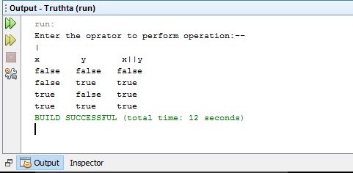

Program-2(a)

package pro2;
/**
*
* @author ASHISH
*/
public class Pro2 {
public static void main(String[] args) {
// TODO code application logic here
for(int i=0;i<=20;i++)
{
if (i % 2 != 0) {
System.out.println(i +" is a number odd " + " and square is = " + i * i);
}
}
}
}
Output
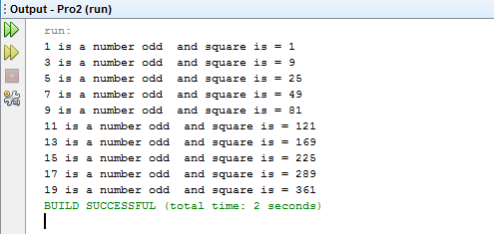

Program-2(b)
package pro2;
import java.util.Scanner;
public class Fibonacci {
public static void main(String[] args)
{
int i=1,n,t1=0,t2=1;
Scanner sc = new Scanner(System.in);
System.out.println("Enter the value of n");
n = sc.nextInt();
System.out.println("first "+n+" term");
while(i<=n)
{
System.out.print(t1 +" \t");
int sum=t1+t2;
t1=t2;
t2=sum;
i++;
}
}
}
Output
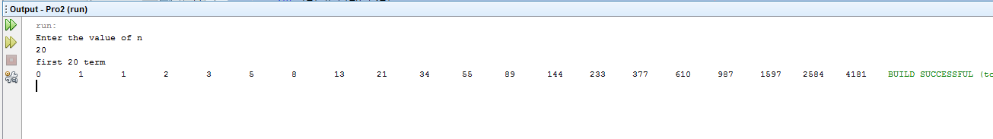
Program-3
Testcalculator.class
package calculator;\
import java.util.Scanner;
/**
* @author ASHISH
*/
public class Testcalculator {
public static void main(String[] args){
Scanner sc = new Scanner(System.in);
int n ;
float a,b,c;
do {
System.out.println("1: for Airthmatic Opration ");
System.out.println("2: for Logical Opration ");
System.out.println("3: for Relation Opration ");
System.out.println("4: for bitwise Opration ");
System.out.println("5: for exit ");
System.out.println("Enter your choice :--");
n = sc.nextInt();
Calculator cc = new Calculator();
//tc.cal(n);
switch(n)
{
case 1 : cc.Airthmatic();
break;
case 2 : cc.Logical();
break;
case 3 : cc.Relation();
break;
case 4 : cc.bitwise();
break;
case 5 : System.exit(0);
break;
default : System.out.print("Wrong Choice!!!");
break;
}
System.out.print("\n---------------------------------------\n");
}while (n!=5);
}
}

Class calculator
package calculator;
/**
*
* @author ASHISH
*/
import java.util.Scanner;
public class Calculator {

Scanner sc1 = new Scanner(System.in);

double a,b,c;
public void Airthmatic(){
System.out.println("Please Select Operation to Perform:");
System.out.println("1-Addition");
System.out.println("2-Subtraction");
System.out.println("3-Division");
System.out.println("4-Multiplication");
int n = sc1.nextInt();
switch(n)
{
case 1 : System.out.print("Enter Two Number : ");
a = sc1.nextFloat();
b = sc1.nextFloat();
c = a + b;
System.out.print("Result = " + c);
break;
case 2 : System.out.print("Enter Two Number : ");
a = sc1.nextFloat();
b = sc1.nextFloat();
c = a - b;
System.out.print("Result = " + c);
break;
case 3 : System.out.print("Enter Two Number : ");
a = sc1.nextFloat();
b = sc1.nextFloat();
c = a * b;
System.out.print("Result = " + c);
break;
case 4 : System.out.print("Enter Two Number : ");
a = sc1.nextFloat();
b = sc1.nextFloat();
c = a / b;
System.out.print("Result = " + c);
break;
case 5 : System.exit(0);
break;
default : System.out.print("Wrong Choice!!!");
break;
}

}public void Logical(){
boolean x = false;
boolean y = false;
int j;
System.out.println("x\t y\t x&&y \t x||y \t !x \t !y");
for(int i = 1 ;i<=4;i++ ){
for (j = 1 ;j<2;j++ ){
System.out.print(x+"\t");
System.out.print(y+"\t");
}
if (j == 2){
System.out.print((x&&y)+"\t"+(x||y)+"\t"+(!x)+"\t"+(!y));
}
System.out.print("\n");
y = !y;
if ( i==2){
x=!x;
}
}
}public void Relation(){
System.out.print("Enter Two Number : ");
a = sc1.nextFloat();
b = sc1.nextFloat();
System.out.print("Enter a operator : ");
String c= sc1.next();
switch(c){
case ">":
if (a > b)
System.out.println("a is greater than b");
else
System.out.println("a is less than or equal to b");
break;
case ">=":
if (a >= b)
System.out.println("a is greater than or equal to b");
else
System.out.println("a is lesser than b");
break;
case "<" :
if (a < b)
System.out.println("a is less than b");
else
System.out.println("a is greater than or equal to b");
break;
case "<=" :
if (a <= b)
System.out.println("a is lesser than or equal to b");
else
System.out.println("a is greater than b");
break;
case "==" :
if (a == b)
System.out.println("a is equal to b");
else
System.out.println("a and b are not equal");
break;
case "!=" :
if (a != b)
System.out.println("a is not equal to b");
else
System.out.println("a is equal b");
break;
default:
System.out.println("Please enter valid oprator ");
}
}public void bitwise()
{
System.out.print("Enter Two Number : ");
int x = sc1.nextInt();
int y = sc1.nextInt();
System.out.println("Please Select Operation to Perform:");
System.out.println("&");
System.out.println("!");
System.out.println(">>");
String n = sc1.next();
switch(n)
{
case "&" :
System.out.print("Result = " + (x&y));
break;
case "!" :
System.out.print("Result = " + ((x)|(y)));
break;
case ">>" :
System.out.print("Result = " + (x>>1));
break;
case " " : System.exit(0);
break;
default : System.out.print("Wrong Choice!!!");
break;
}
}
}
Output
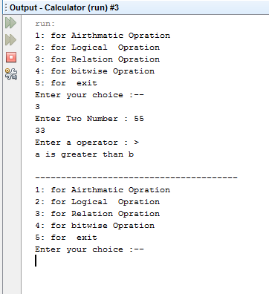

Program-4
package fruit;
/**
*
* @author ASHISH
*/
class Fruit {
private String seeds,category;
private int price;
Fruit(){
seeds = null;
category = null ;
price = 0;
}
Fruit(String x,String y, int z){
seeds = x;
category = y;
price = z;
}

void showOutput(){
System.out.println("Seeds = "+seeds);
System.out.println("category = "+category);
System.out.println("price = "+price);
}
public String getSeeds(){ return seeds; }
public String getCategory(){ return category; }
public int getPrice(){ return price; }

public String setSeeds(String x){
seeds = x;
return seeds;
}
public String setCategory(String x){
category = x;
return category; }
public int setPrice(int z){
price =z;
return price; }
}

public class Fruitt{
public static void main(String[] args) {

Fruit f = new Fruit();
System.out.println("Seed "+f.getSeeds());
System.out.println("category"+f.getCategory());
System.out.println("price "+f.getPrice());
System.out.println("----------------------------------");
Fruit f1 = new Fruit("a","z",1);
f1.setSeeds("ccc");
f1.showOutput();

}

}
Output
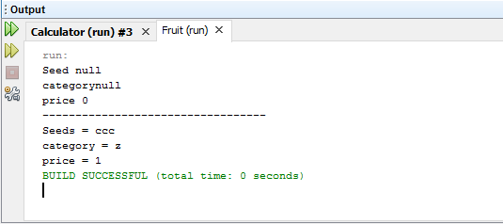

Program-5
Employee.class
public class Employee {
private String name;
private String gender;
private String officeName;
Employee(){ super();name= "ashish"; gender = ""; }
Employee(String officeName){ this.officeName = officeName ;}
public String getName() {
return name;
}
public String getGender() {
return gender;
}
public String getOfficeName() {
return officeName;
}
public void setName(String nam) {
this.name = nam;
}
public void setGender(String gender) {
this.gender = gender;
}
void showOutput(){
System.out.println("GeNder of employee "+gender);
System.out.println("Name of employee "+name);
System.out.println("**************************************");
}
}

Worker. class
public class Worker extends Employee
{
private char category;
private boolean dressallowence;
Worker(){
category ='c';
dressallowence = true;
}
public char getCategory() {
return category;
}
public void setDressallowence(boolean dressallowence) {
this.dressallowence = dressallowence;
}
public void setCategory(char category) {
this.category = category;
}
public boolean getDressallowence(){
return dressallowence;
}
void showOutput(){
System.out.println("Category of Worker "+category);
System.out.println("Name of emp :-"+getName());
setGender("mail");
System.out.println("Gender of employee :-"+getGender());
System.out.println("dreassAllowece of Worker"+dressallowence);
System.out.println("**************************************");
}
}

Office.class
public class Officer extends Employee
{
private char category;
private int experience;
private boolean vehicle;
Officer(){
category = 'a';
experience = 0;
vehicle = false;
}
Officer(String officeName){
super(officeName);
}
public char getCategory() {
return category;
}
public int getExperience() {
return experience;
}
public boolean getVehicle() {
return vehicle;
}
public void setCategory(char category) {
this.category = category;
}
public void setExperience(int experience) {
this.experience = experience;
}
public void setVehicle(boolean vehicle) {
this.vehicle = vehicle;
}
void showOutput(){
System.out.println("Category of Officer:-"+category);
System.out.println("Experiece of Officer:-"+experience);
System.out.println("Vehical of Officer:-"+vehicle);
System.out.println("Name of office :-"+getOfficeName());
System.out.println("**************************************");
}
}

Super.class
public class Super {
public static void main(String[] args) {
Worker w = new Worker();
Officer o = new Officer();
Officer o1 = new Officer("Super office ");
System.out.println("**************************************");
o.setCategory('g');
o.setExperience(3);
o.setVehicle(true);
o.showOutput();
System.out.println("Worker catrgory "+w.getCategory());
System.out.println("Worker Dress "+w.getDressallowence());
System.out.println("**************************************");
w.showOutput();
}
}

Output
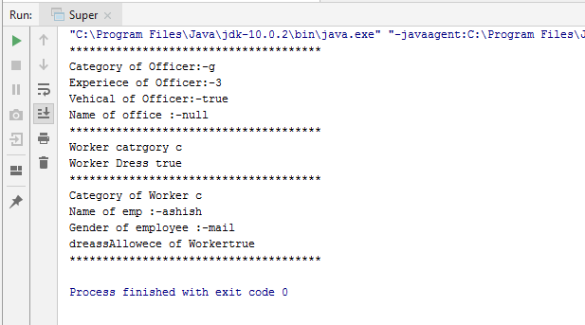

Program-5
Card.class
public class Card
{
//public static int king;
private final int rank; // Shapes of cards
private final int suit; // Values of cards
//-------------Define suit value---------------------------------------//
private static int Spade = 1;
private static int Heart = 2;
private static int Diamond = 3;
private static int Club = 4;
//-------------Define rank---------------------------------------//
private static int Ace = 1 ;
private static int Two = 2 ;
private static int Three = 3 ;
private static int Four = 4 ;
private static int Five = 5 ;
private static int Six = 6 ;
private static int Seven = 7 ;
private static int Eight = 8 ;
private static int Nine = 9 ;
private static int Ten = 10 ;
private static int Jack = 11 ;
private static int Queen = 12 ;
private static int King = 13 ;
//------------------Constructor----------------------------------//
// Card(){ suit = 0; rank = 0; } //Default
public Card(int suit,int rank)
{
// = (int)(Math.random()*(suit));
// = (int)(Math.random()*(rank));
this.rank = rank;
this.suit = suit;
}
//----------------------------------------------------//
public int getSuit() { return suit; }
public int getRank() { return rank; }
public static int getAce() {
return Ace;
}
public static int getHeart() {
return Heart;
}
public static int getSpade() {
return Spade;
}
public static int getClub() {
return Club;
}
public static int getDiamond() {
return Diamond;
}
public static int getEight() {
return Eight;
}
public static int getFive() {
return Five;
}
public static int getFour() {
return Four;
}
public static int getJack() {
return Jack;
}
public static int getKing() {
return King;
}
public static int getNine() {
return Nine;
}
public static int getQueen() {
return Queen;
}
public static int getSeven() {
return Seven;
}
public static int getSix() {
return Six;
}
public static int getTen() {
return Ten;
}
public static int getThree() {
return Three;
}
public static int getTwo() {
return Two;
}
//-------------------int-To-String---------------------------------//
String suit_toString(int s)
{
switch (s)
{
case 1: return "Spade";
case 2: return "Heart";
case 3: return "Diamond";
case 4: return "Club";
}
return null;
}
String rank_toString(int r)
{
switch (r)
{
case 1: return "Ace";
case 2: return "Two";
case 3: return "Three";
case 4: return "Four";
case 5: return "Five";
case 6: return "Six";
case 7: return "Seven";
case 8: return "Eight";
case 9: return "Nine";
case 10: return "Ten";
case 11: return "Jack";
case 12: return "Queen";
case 13: return "King";
}
return null;
}
}

Deck.class

} public class Deck
{
private static int numSuit = 4;
private static int numRank = 13;
public static int numCards = numRank * numSuit;
Card [][] Cards ;
Deck()
{
Cards = new Card[numSuit][numRank];
for (int suit = Card.getSpade(); suit <= Card.getClub(); suit++)
for (int rank = Card.getAce(); rank <= Card.getKing(); rank++)
Cards[suit-1][rank-1] = new Card(suit, rank);
}
public Card[][] getCards() {
return Cards;
}
public Card get_Card(int suit, int rank)
{
return (Cards[suit][rank]);
}
void shuffle(int repeat)
{
int suit , rank ;
Card c ;
while (repeat >0)
{
for (int i = numSuit - 1;i>0;i--)
{
for (int j = numRank - 1; j > 0; j--)
{
suit = (int)(Math.random()*(i+1));
rank = (int)(Math.random()*(j+1));
c = Cards[i][j];
Cards[i][j] = Cards[suit][rank];
Cards[suit][rank] = c;
}
}
repeat--;
}
}
boolean compare(char a,Card c1,Card c2)
{
int suit1 = c1.getSuit();
int suit2 = c2.getSuit();
int rank1 = c1.getRank();
int rank2 = c2.getRank();
if(a=='l')
{
if (suit1 > suit2)
return true;
else if (suit2 == suit1)
{
if (rank1>rank2)
return true;
return false;
}
}
else if (a=='h') {
if (suit1 < suit2)
return true;
else if (suit1 == suit2) {
if (rank1 < rank2)
return true;
return false;
}
}
return false;
}
}

play.class
import java.util.Scanner;
public class play {
public static void main(String[] args)
{
Deck d = new Deck();
// Card c = new Card(4,10);
char a = 'y';
Scanner sc = new Scanner(System.in);
Card c1 = d.get_Card(1,1);
while (a == 'y') {
d.shuffle(3);
Card c2 = d.get_Card(1, 1);
System.out.println("Comparing Card is: "+c1.suit_toString(c1.getSuit()) + " of " + c1.rank_toString(c1.getRank()));
System.out.println("Enter h for next card to b higher and l for next card to be lower the value of above shown card: ");
char n = sc.next().charAt(0);
boolean b = d.compare(n, c1, c2);
if (b)
System.out.println("You Win");
else
System.out.println("You loose");
System.out.println("Next Card is: "+c1.suit_toString(c2.getSuit()) + " of " + c1.rank_toString(c2.getRank()));
System.out.println("If you wanna continue press y else press n: ");
a = sc.next().charAt(0);
if (a == 'y')
c1 = c2;
}
}
}

Output
