**Various Daylighting Systems for Energy Conservation: A Review**

**1Dharmbir Singh, 2Harry Garg,3Harvinder Singh Dhaliwal, 4Vinod Karar**

1M.Tech, Department of Mechanical Engineering, Punjabi University,Patiala.

2Sr. Scientist,CSIO, Chandigarh.

3Assistant Professor,Department of Mechanical Engineering, Punjabi University, Patiala.

4Chief Scientist, CSIO, Chandigarh.

randhawadharmbir@gmail.com

**Abstract**

In the highly populated urban areas, there is the obstruction to the daylight by high rise buildings which minimize the light level in the deeper and inside the lower floors. The usage of natural energy in commercial and non-commercial building leads in minimizes lighting, heating and the cooling loads. A novel approach is to introduce the advanced daylighting systems and strategies. It effectively reduces building’s electricity consumption and improves the quality of light indoors. Multiple functions served by daylighting systems using various strategies, e.g. redirecting/deflecting the direct sunlight which helps in illuminating deep dark spaces and the usage of controlled shading devices results in heat control. The objective of the innovative daylighting systems (IDS) is to deliver the desired levels of illuminance in deep-plan and high rise buildings where conventional fenestration fails to illuminates the target areas. This study reviews the various existing systems and analytical approach used to design IDS. An overview on the various daylighting systems with division into the main principle, sketches and brief descriptions of elements helps up to an extent to choose the appropriate daylighting system for the specific weather conditions and Location.

**Keywords:**Innovative daylighting systems (IDS), Total Internal Reflection (TIR), Laser Cut Panel (LCP), Mirror Light Pipe (MLP).

1. **Introduction**

In a world becoming increasingly concerned with global warming has led the usage of the renewable energy systems. Daylight is a renewable resource of the energy that has a gigantic potential. On a bright sunny day, immense amount of the natural light keeps on bumping into the walls of buildings being unutilized: 100,000 - 140,000 lumen on 1m2 area. Efforts should be made to bring it to internal of our buildings to illuminates dark spaces. To illuminate the deep dark spaces in the building where the reach of the sunlight is almost impossible, daylighting systems play an important role. Electric lighting is the major region of the expenditure of electrical energy in the commercial buildings in deep interior spaces. Due to poor penetration, the non-uniform distributions, directional nature of light and glare, fenestrations alone can’t provide the sufficient daylighting of the deeper spaces. IDS are appropriate devices to deliver the daylight from external environment to the internal deep plan rooms. Daylight improving systems can use various approaches which are based on the phenomena of light propagation i.e. specular reflection, the TIR (Total internal reflection)[[1](#_ENREF_1), [2](#_ENREF_2)],the prismatic light guide [[3](#_ENREF_3)]and the holographic panels (optical diffraction)[[4](#_ENREF_4)]. In 2001 Kischkoweit-Lopin[[5](#_ENREF_5)]represents an overview of the daylighting technologies in which various categories which are based on the basic operating principle sand type of light (i.e. direct or diffuse) were design for utilization. Although the author tries to classify the different types of daylighting systems but the analysis on the compatibility with the climate was not done. This paper presents a detailed review on the daylighting devices which are based on various classification, viz: The light guiding system, Light shading devices and light transport system and Tubular daylighting systems as well as integrated and hybrid systems where major emphasis is given to the characteristics such as the range of applicability, the nature of the light output, the climate suitability, the efficiency, and their relatives pros and cons.

1. **Shading system:**

Shading systems are primarily used to block the direct sun and admit diffuse light. The utility of conventional shading devices to prevent superheat or shine effects also diminish the utility of sunlight for optical work indoors. To enhance the use of sunlight in these circumstances, shading systems are improved which are able of reorient the diffuse skylight into inner by diffusing or redirecting sunlight. Shading system are used along with diffuse and the direct sunlight system.

**2.1.Shading system using diffuse skylight:**These are the panels which restricts the direct sunlight but allow diffuse skylight (Figure1)

**2.1.1. Prismatic panels:**It comprises of two simultaneous prismatic panels with series of the plastic prisms. The exterior flat facade of each panel has metal specular surface and the other movable part with a non-specular surface (Figure2).

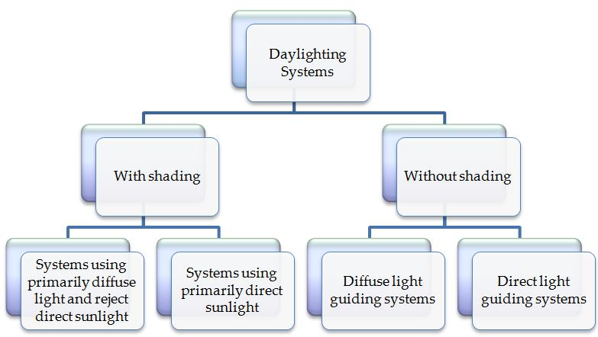

Figure1:Classification of Daylighting System

The Opposite face of the panels is strictly design to provide the desired daylight cut-off[[6](#_ENREF_6)].

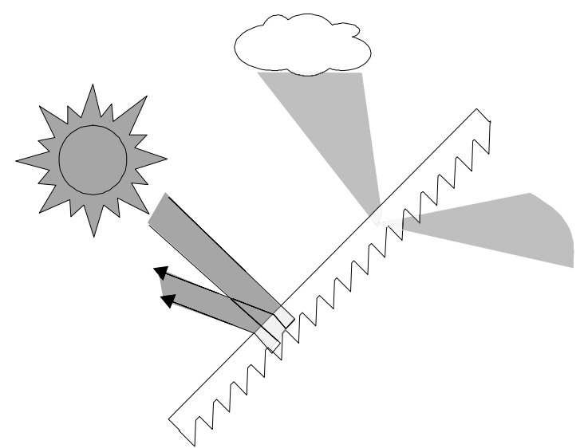

Figure2: A prismaticpanel[6]

**2.1.2.Opening with AnidolicZenithal:**This is used in temperature climates attached in skylight. It prevents glare and decrease the use of the artificial light during sun hours [[7](#_ENREF_7)].

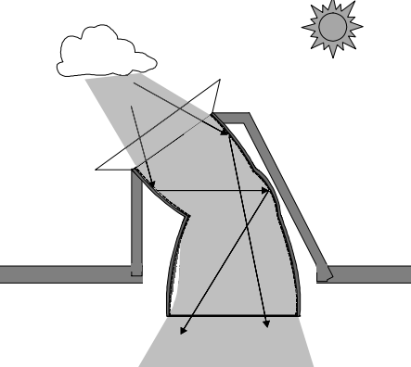

Figure 3: AnidolicZenithalOpening [7]

* + 1. **Sun protecting mirror elements:**This is used in temperature climates attached in skylight and glazed roofs [5].

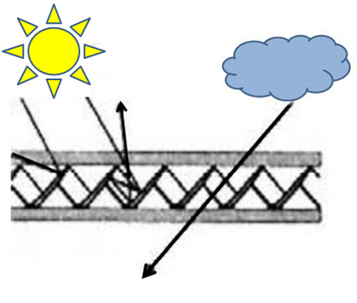

Figure 4: Sun protecting mirrors [5]

* 1. **Shading system using Direct Skylight:**These are the shading systems that redirect the light on ceiling and above eye height level.

**2.2.1. Louvers:**This is a typical daylighting system which prevent shining, shadowing and daylighting. These comprises of various multiple vertical and horizontal slats (Figure 5). The exterior blinds are mainly made of stainless steel, painted aluminium or PVC, anodize, which is highly resistant and low costing. The slats can be curved or smooth. According to size of the blind, size of sla­­­ts can differ [[8](#_ENREF_8), [9](#_ENREF_9)].

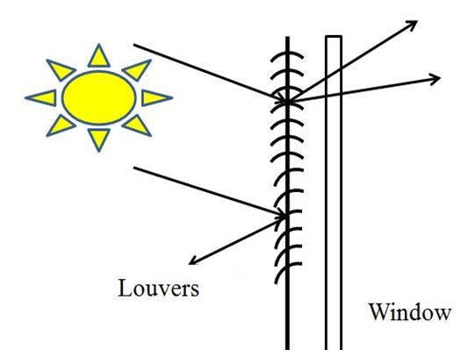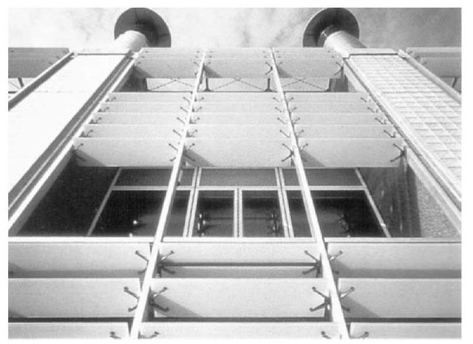

Figure 5: a)Shading systems that use direct sunlight: Window shade with Louvers [8,9],

b) Louvers: Automatically controlled exterior shading device made of glass[[10](#_ENREF_10)].

**2.2.2. Skylight with Laser Cut Panels (LCP):**The LCP is the thin acrylic panel which is transparent, on which the parallel cuts are drawn by the use of laser cutting machine (Figure 6). In LCP, at an angle an array of cuts which is perpendicular to its surface are made. There is periphery around the array of cut. The cuts are done by melting and ablation. The phenomenon of TIR (total internal reflection) is used in this system[[11](#_ENREF_11)].

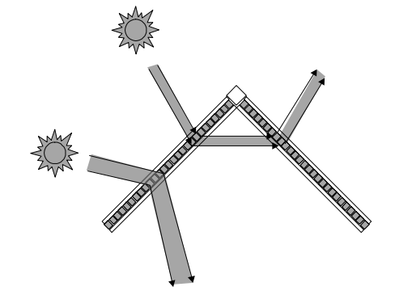

Figure6: Ray pattern of Skylight with laser cut panels[[5](#_ENREF_5)].

### **2.2.3. Glazing with reflecting Profile (Okasolar):** The Okasolar unit is a good example of fixed, between the glass shading devices, made with very high level reflective of steel light gauge. A between the glass shading device may be installed in air cavity from the one among the two ways: Now in the first of the case between the two planes of glass in the double insulating glass unit (DGU) (Figure 7) and Between the two facade of the layers in the double-skin facade [[12](#_ENREF_12)].

### C:\Users\Harry\Desktop\tmp23E3_thumb_thumb.jpg

Figure 7:Okasolarsystem [12]

**2.2.4.Venetian Blinding:**This is the Interior shading devices which are installed in building interior (Figure 8). The Interior shading which can capture the sun energy which is used in winter for the space heating. The maintenance of interior devices is less expensive and easier than for the exterior devices. The efficient solar protection in the summer is very hard to attain with interior device, since the sunlight entering in the internal space and that overheat space between the blinds and internal of glass layer. The slats are made by the perforated aluminium [[13](#_ENREF_13)].

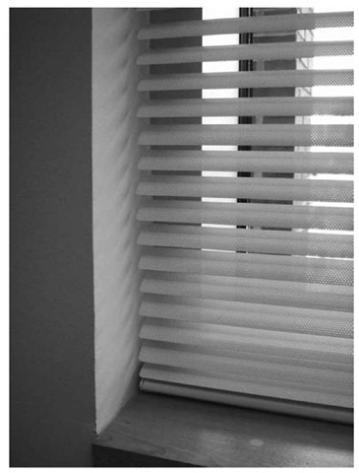

Figure 8: Venetian Blinds: Interior shading devices manually controlled[[13](#_ENREF_13)].

**3.Light Guiding System:** It redirects both form of light i.e. diffuse and direct toward the interior of the deeper spaces by the phenomenon of the reflection, refraction up to the distance of 9 to 10 meters.Light guiding system are categorized into two categories i.e. Direct and the diffuse light system[[14](#_ENREF_14)].

**3.1. Diffuse light guiding system:** The overcast sky having high intensity of brightness in zenithal area. The light guiding elements which redirect light from these areas into the interior area of space which allows better utilization of the daylight[[15](#_ENREF_15)]. The other reason for using these elements are the high external obstructions. These obstructions don’t allow direct light in the deeper floors. So diffuse lighting guide is the alternative which solve this problem.Scartezzini and Courret[[16](#_ENREF_16)]has discussed in his paper the three anidolic systems: an anidolic ceiling, an integrated anidolic ceiling and the anidolic solar blinds (Figure 9). Based on the non-imaging optics which has been more widely adopted for solar thermal concentration.Wittkopf[[17](#_ENREF_17)] and Wittkopf et al.[[18](#_ENREF_18)]  have recommended that this framework is preferable where the high concentration is more important than the clear images.

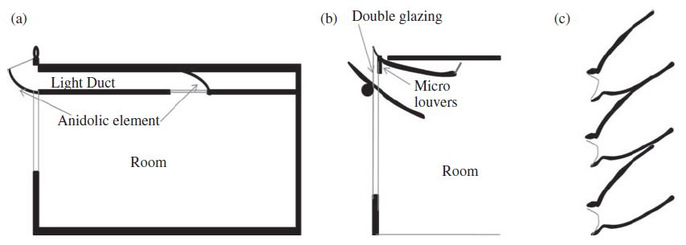

Figure 9:a)AnAnidolic ceilingb)The integrated anidolic system

c)Theanidolic solar blinds[[18](#_ENREF_18)]

**3.1.1. Anidolic Ceiling:**This comprises a collector on the exterior side of facade, there is a rectangular mirror light duct and at ends of the duct there is a distributer in Figure 9(a). High reflective aluminium used for the making of ceiling panel which act as parabolic reflectors. Scartezzini and Courret[[16](#_ENREF_16)] assembled this system into a particular facade and the ceiling which having an Inner surface reflectance 90% to minimize the absorption losses. Courret et al. [[19](#_ENREF_19)]tested anidolic ceiling that utilise a large duct 500mm of height and using reflector with aluminium foil. So it is concluding that (i) without solar precautions at the collector, the light patches projected on to alongside walls and (ii) from zenithal sky it is possible to collect much light with the system tilted towards the sky.

**3.1.2. Integrated anidolic system**It has some similar characteristics to the anidolic ceiling but includes micro-louvres for the shading as shown in Figure 9(b). The Angular spread of light beam is in the range of - 37˚and +10˚. Hence glare problems can easily reduce. The smaller size of the external collector (<300 mm) and the absence of light duct make the construction processing of the room with less headroom[[18](#_ENREF_18)].

**3.1.3. Anidolic solar blinds:**This system, which proposed by Scartezzini and Courret[[16](#_ENREF_16)] uses a 3D non- imaging technique for asymmetrical CPC to achieve greater angular and directional control of sunlight. A combination of two 3D CPC is included in each hollow elements, viz, For the entry of sunlight for different seasonal selection of the sunrays one is directed outward and for redirecting the sunlight in the room’s rear, second is placed in opposite direction Figure 9(c). Various Salient features are (i) cost effective (ii) The low altitude evening sun’s rays are excluded, (iii) under diffuse light low efficiency, (iv) heat transfer and (v) For the outside view it causes obstruction.

**3.1.4. Anidoliczenithal light guide:**The collector contains three plane mirror surfaces. The tilt angles of these surfaces redirects the solar rays at an acceptance angle of 80˚, into funnel and it is parallel to axis of it so as to reduce the numbers of reflection. It has feature of collection of the diffuse light from the wide range area of the sky without allowing the direct light. Molteni et al [[20](#_ENREF_20)] also proposed this system that provides the daylighting in carparks, subway and the basements.

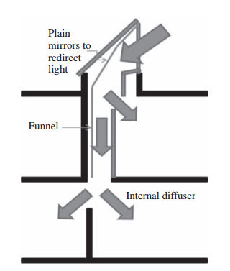

Figure 10:Plain mirrors redirect light in the anidoliczenithal light guide[[20](#_ENREF_20)]

**3.1.5. Anidolic daylighting system:**This has anidoliczenithal collectors which are integrated into the facade. Both the form of light i.e. Direct and diffuse from the sun and the sky reaches the anidolic element via zenithal collector and then is reflected on the ceiling. Linhart and Scartezzini[[21](#_ENREF_21)] studied the anidolic daylighting systems on some rooms which are south facing and concluded that this system uses a power density of below than 5 W/m2.

**3.2 Direct light guiding systems:**Through reflection of the sunlight is redirected into the deeper interior with these systems. Overheating and glare is minimized by the selective transmittance and by the redirection of light onto ceiling. So with this cooling load getting decreased and these systems make the building energy efficient. In various tropical and the subtropical region where mainly clear sky is predominant along with lighting so in those areas shading is required to restrict excess heat and sunlight. The direct sunlight consists large luminous energy than the diffuse light, so small aperture is required to obtain the same illumination level in these areas[[22](#_ENREF_22)]. Direct light also produces some discomfort to the users but with some of modern daylighting system these types of issues can easily be resolved.

**3.2.1. Light shelf:**This is passive daylighting system which is least complex and most financially, the light shelve are inclined or plane horizontal elements that are placed above a window, either inside or by remotely, to control and redistribute approaching light through reflection[[11](#_ENREF_11)]. The high angle of the solar radiation is prevented by external overhang thus also act as a shading device. It is investigating that towards rear of the rooms these systems increase the daylight levels, enhance daylight consistency and diminish glare and uneasiness for occupants[[23](#_ENREF_23)]. Claros and Soler[[24](#_ENREF_24), [25](#_ENREF_25)] looked at white, matte, methacrylate, mirror and aluminium for light shelves as reflective materials and revealed that the light shelf of methacrylate (as it has little reflectance for specular segment and huge diffuse reflectance) is much efficient daylight device at the time of higher solar elevation in comparison to the mirror light shelf. Steemers[[26](#_ENREF_26)] concluded that the inward light shelves enhance the light distribution while the illuminances close the window is reducing. Aghemoet al. [[27](#_ENREF_27)]determine that under clear cloud conditions, interior light shelves purvey the maximum Norma illuminance as compare with to exterior light shelves, while the consistency of skylight distribution as well as skylight sharpness to the rear part of space was higher for exterior light shelves. Soler and Oteiza[[28](#_ENREF_28), [29](#_ENREF_29)] from scale model contemplation of light retire with reflectance of around 91% and an upright shade angle 50 degree, observed that light shelves can be custom as both a shading design and the daylighting device.Though passive and simple, the geometry of the light shelf is not desire to deviate sky conditions. Moreover, the light input relies on window breadth which places the constraint on design. In compare with passive or static light shelve, Raphael[[30](#_ENREF_30)]propose a pliable light shelfs with active control where the exterior part could be rotate and the internal part changed in breadth, and describe that it furnish 12% savings. Ochoa and Capeluto[[31](#_ENREF_31)]describe that the causativeness of the systems reduced after 6 to 7 m from window, careless of orientation. Edmonds and Greenup [[14](#_ENREF_14)]have terse out that the work over period is diminish due to its scope to aggregate dirt.

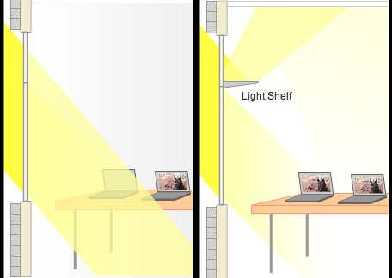

Figure 11: Light Self[59]

**3.2.2. Light guiding shade (LGS):** In this type of framework there are two form of reflectors, in the top part comprises of an external shade that is with the diffusing glass interstice at outer edge of it[[32](#_ENREF_32)].

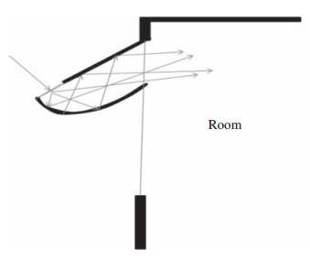

Figure 12:Light guiding shade[[32](#_ENREF_32)]

**3.2.3. Microlight guiding shade:** This is a fixed type of shade panels which comprising of various micro-reflecting elements that act as 2D light collimators. Edmonds and Greenup[[14](#_ENREF_14)] have designed a unique system in which every component has a disseminative input interstice and two specially shaped reflectors (based on the edge principle of non-imaging optical theory) so as to deviate light into inner parts within a certain angular range. A little Portion of the episode daylight is entered by the diffusing info interstice (involved translucent glass or plastic) having a high transmittance (in the vicinity of half and 80%). It was accounted for that the glare could be kept away from because of the heading of light and by its diffused nature. Despite the fact that there is simplicity of establishment, the reliance on rakish range licenses it to perform well just finished a specific timeframe[[32](#_ENREF_32)].

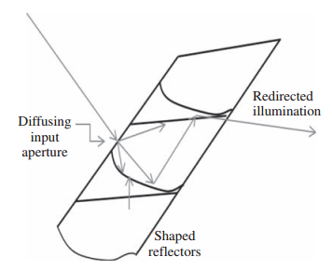

Figure 13: Element of Microlight guiding shade[[32](#_ENREF_32)]

**3.2.4. Beam daylighting system**: This framework is designed with two kinds of Venetian blinds viz, a silvered shaft dazzle mounted behind the upper window and an incompletely intelligent sun based control daze situated behind the lower window which gives diffuse daylighting when there was no immediate sun on a specific building height[[33](#_ENREF_33)]. Also, the support edge can be acclimated to change sun based edges to give ideal brightening at a steady profundity in the room. At a brilliant adequacy of 100 lm/W, this framework is accounted for to be more effective than fluorescent lighting and furthermore fit of directing illuminate to 10 m internal from the outside façade[[11](#_ENREF_11)]

**3.2.5. Prismatic panel system:** This comprises of two kaleidoscopic boards each with a progression of glass or plastic prisms. The level outside face of each settled board has a metalized specular surface while the versatile part has a non-specular surface[[6](#_ENREF_6)].

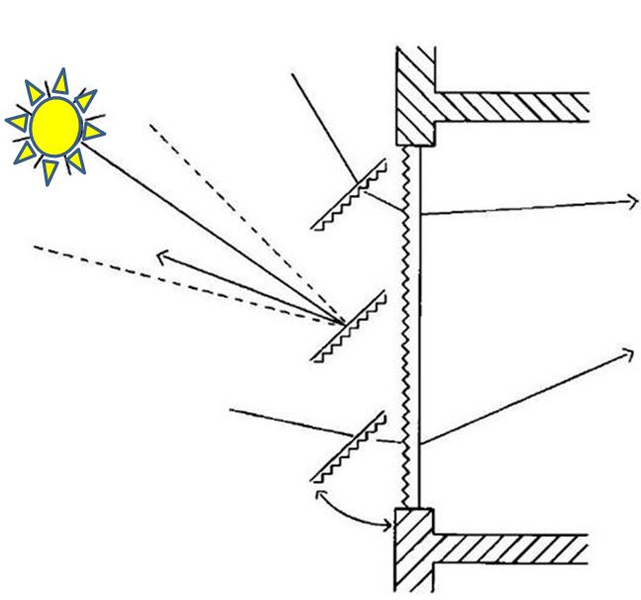

Figure 14: A prismatic panel system [[6](#_ENREF_6)]

**3.2.6. Prismatic glazing and film system:**Prismatic coating can control coordinate daylight and warmth pick up while decreasing glare. Likewise, these frameworks can expand illuminances at the backside of the rooms at specific times of the year, while causing a decrease under shady conditions[[34](#_ENREF_34)]. In the kaleidoscopic film the crystals are scratched onto a thin film and covered to glass. Analysts have presumed that:(i) particular transmittance has the advantage of diverting undesirable direct sun powered radiation, while permitting diffuse sunlight[[25](#_ENREF_25)] and (ii) consistency in lighting condition was accomplished and it performed well under cloudy conditions[[35](#_ENREF_35)].

**3.2.7. Light channelling panel:**These are formed by two layers of acrylic plastic sheet in which arrays of angled cuts by the means of laser which act as reflecting surfaces. These sheets are covered into a solitary board containing channels and joined with the blinds to divert light. This encourages high height daylight occurrence on the info face to reflect through the channels to the yield confront and thus on to the roof at the back of a room [[36](#_ENREF_36)].

**4. Light transport systems:** The Light guiding systems are not able to brighten the deeper spaces of the buildings. So to overcome the issue the light transport systems is very effective. Light transport systems mainly have three components, i.e. collection, transportation and distribution [[37](#_ENREF_37)]. The light transport systems are mainly depending upon the direct light[[38](#_ENREF_38)]. So the research has done on (i) under the high turbidity sky conditions [[39](#_ENREF_39), [40](#_ENREF_40)] and (ii) on those devices that collect and transport the light either director diffuses[[41](#_ENREF_41)]. Some commonly used routing devices are lens systems, fibre optics and prismatic or mirrored light pipes (MLPs).

**4.1. Collector:** The Light collector are the devices which collects the sunlight from the atmosphere and illuminates or brighten the space very effectively. The collector is generally made of polymethylmethacrylate (PMMA).

**4.1.1. Passive collection systems:**These systems are static in a certain orientation during the installation to increase the light collection. They can be group into those that light redirect (LCP) and concentrate (Anidolic concentrators and FFSC).

**4.1.1.1.Laser cut panel:** LCP works on the principle of TIR (total internal reflection). The following figure shows the parallel laser cuts in clear acrylic panel, in which deflection of light in each element by refraction and reflection. It functions well both in clear and high turbidity sky conditions at the input interstice to direct daylight into a collimated beam. When external surfaces are vertical the panel does not acquire dust. It was observed that laser cut panel deflectors incorporated into a collector dome enhances performance of the system during early morning and late evening. It has been found that due to the absence of rounded surfaces scattering of light is low and the panel has to be oriented towards East or West to maximize light collection. Further, it provides an outside view through the window[[42](#_ENREF_42)].

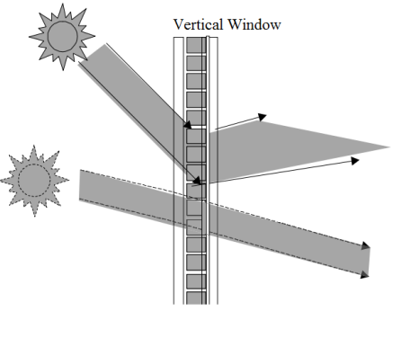

Figure 15: Ray pattern in laser cut panels[[43](#_ENREF_43)]

**4.1.1.2. Anidolic concentrators:** An anidolic concentrator or compound parabolic concentrator (CPC) is designed with high reflective material and the concentration is attained by its parabolic geometry through the principle of the non-imaging optics. When the diffuse light falling on the entry of device is then collected and concentrated on an exit aperture which is in smaller interstice where the receiver is placed[[21](#_ENREF_21), [44](#_ENREF_44)].

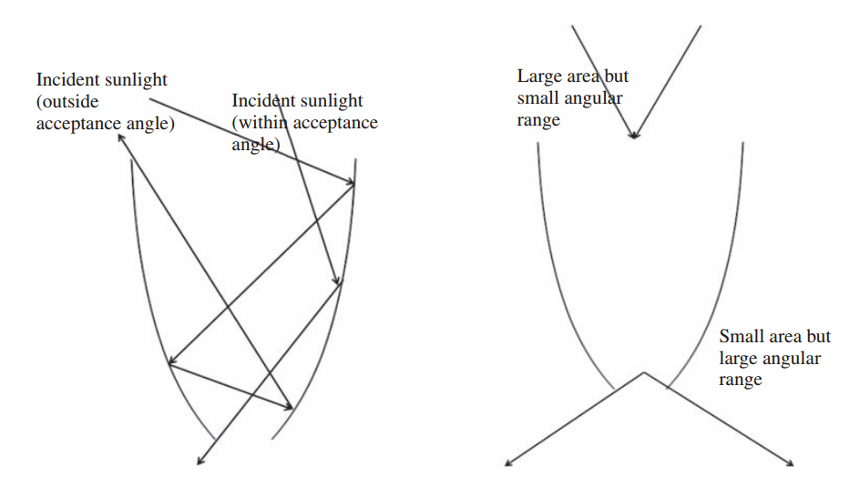

Figure 16: A parabolic concentrator system[[21](#_ENREF_21)]

**4.1.1.3. Fluorescent fibre solar concentrator (FFSC):**This contains the solar concentrator optical fibre with a PMMA plate and three-colour fluorescent fibres pieces [[45](#_ENREF_45)].The solar radiation which is being incident on plate is absorbed by the dye molecules and again emit the fluorescent radiation that in turn is then transferred to the edges of the plate by TIR. Design and implemented by Wang et.al.[[46](#_ENREF_46)], this device can be placed on the roof and through clear fibre the concentrated light is transported inside the room. Its luminous efficacy and efficiency are reported to be less [[41](#_ENREF_41)].

**4.1.2. Active collection systems:**The passive system can capture only a certain angle of sunlight hence it requires a large area of collector and transport component should also be huge. The active collection systems comprise of a tracking framework which orient the collector continuously towards the sun[[47](#_ENREF_47)]. Similarly, to the active systems these can be categorized into as following.

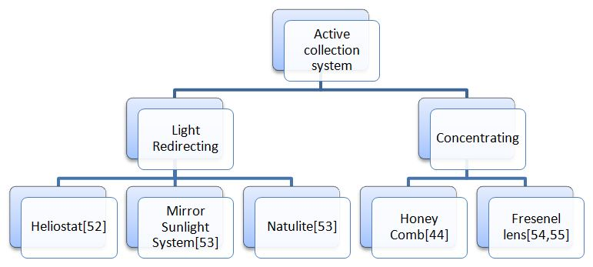

Figure17:Classification of Active Collection System[[30](#_ENREF_30)]

**4.1.2.1. Heliostat:** It is a mechanical system which is controlled by the computer and allows the mirror to track the sun’s motion. Rosemann and Kaase[[48](#_ENREF_48)] investigates that heliostats mainly comprising of Fresnel lens or the plane mirror which can redirect/reflect the sunlight into light transport devices which further illuminating the deep places with help of clear optical fiber.

**4.1.2.2. Mirror sun lighting systems:** This system for the most part utilizes two to three reflective mirrors relying upon its scale. The principal intelligent, roundabout mirror tracks the sun and reflects to a moment reflect planned as a flat or concave surface that can turn every direction. Sun movement, climate turbidity, reflects surface reflectance and light misfortune because of dirt are factors known to impact the system performance. Kim and Kim [[48](#_ENREF_48)] tried this kind of framework comprising of a dynamic sun following sensor, glass substrate and a mirror to focus reflected light and revealed that it has lower efficiency.

**4.1.2.3. Natulite system:** Kim and Kim [[38](#_ENREF_38),[48](#_ENREF_48)] studied the Natulite framework which performs with the assistance of a photometric detecting controller for sun following /tracking and a reflector and detailed that this framework or system had the quality of wiping out UV beams and giving obvious and infrared beams.

**4.1.2.4.Honeycomb system:** The tracking framework comprises of an image shaping parabolic mirror that gathers light into a little aperture of light transport guide. Axis of optical is intended for height or azimuth tracking, combined elevation/azimuth tracking or polar axis/azimuth tracking [[48](#_ENREF_48)].

**4.1.2.5. Fresnel lens:** This thin transparent material having concentric prismatic round grooves is essentially a chain of prisms. Customarily consumed as a part of the sun powered concentration and accumulation of heat energy, this focal point is used for daylighting[[49](#_ENREF_49)].

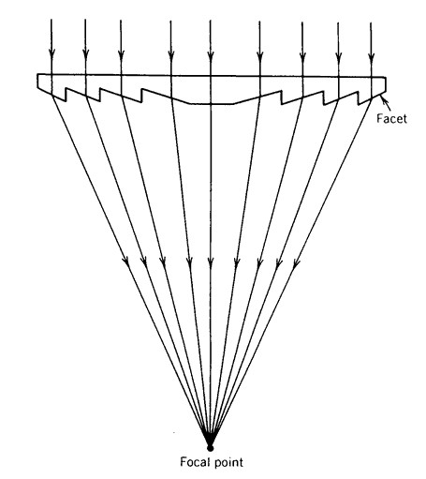

Figure18: Light concentration achieved with a Fresnel lens[[50](#_ENREF_50)]

Tsangrassoulis et.al.[[51](#_ENREF_51)] built up and design a model cross breed lighting framework/ hybrid system where sunlight is transported from the heliostat with the assistance of concentrating Fresnel focal point to a luminaire in a room through fluid optical fiber. It has observed [[49](#_ENREF_49)]that (i) The Fresnel focal point with its low volume and weight, littler focal length and minimal effort is appropriate for optical purposes contrasted with conventional convex or concave, (ii) light concentration gets warm focus too which has to possibly be dealt with, (iii) because of its limited acceptance angle the focal points require a tracking system to arranged with the sun[[52](#_ENREF_52)].

## 5. TUBULAR DAYLIGHT DEVICE: The Tubular daylight devices are the affordable, high-performance lighting devices that convey the daylight into internal spaces of the where the conventional or traditional windows simply can’t reach as shown in Figure 20, this is one of daylighting devices[[53](#_ENREF_53)]. Tubular light pipes have three components:

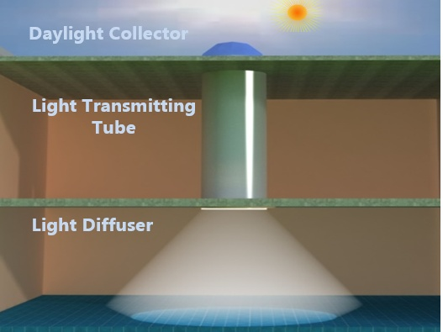

Figure19: Tubular daylight device[[53](#_ENREF_53), [54](#_ENREF_54)]

**5.1. Collector:** Light collector mainly collects the daylight from all the directions and then delivers the light effectively throughout the daytime even at less sun angle. The collector is generally made of polymethylmethacrylate (PMMA).

**5.2. Transmitting tube (Mirrored light pipes)**: Transmitting tubes are hollow structures having reflective lining on internal surface. For the deeper plan building with greater depths, illumination can only have achieved by light transport system [[55](#_ENREF_55)].

**5.3.Diffusor**:The daylight in lightpipes is properly controlled and then distributed into the indoor spaces by the light diffusor. P.D.Swift et al.[[50](#_ENREF_50)]shows the effective use of the diffuser at the inlet aperture of the mirror light pipe overcomes the problem of glare without a substantial reduction in the transmission efficiency.

**6. Hybrid and integrated systems:**

**6.1. Hybrid solar system developed by Oak Ridge National Laboratory:** The previously mentioned the daylighting systems that can be joined with electric sources to give continuous lighting whenever there is low accessibility of daylight either amid high cloudy conditions or in early mornings and late nights. A hybrid system makes utilization of optical fibre as a transport medium, however adds high-proficiency electric light to keeps up light levels. It conveys the daylight and the electric light all the while into the centre of a building where they are joined and appropriated through luminaires[[56](#_ENREF_56)]. Compared with light pipes hybrid system can light further inside a room. An investigation done on hybrid frameworks announced that the couplers requiring both the lights to converge into one optic link brought about lost general framework effectiveness of around 40% for each coupling. Besides, the extra electric light makes a sentiment electric lighting instead of daylighting. Thus, the diurnal and occasional variety felt in daylighting is absent in this framework which is required in a decent daylighting framework[[57](#_ENREF_57)].

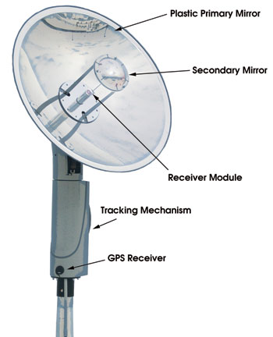

Figure20: The daylight is collected when the tracking mechanism move towards the sun, and a series of the mirrors focus on the beam onto the receiver [[56](#_ENREF_56), [58](#_ENREF_58)].

Conversely with the hybrid system, the integrated system utilizes isolate sunlight (both skylight and daylight) and electric lighting framework with adjoining output devices and a connected keen electric lighting control system. The two light sources lessen the general electric light output. The intelligent lighting framework consolidates a control framework which looks for most extreme advantage from any source of the light and a building administration framework. The luminaires are introduced with coordinated system controls, inhabitancy sensors and sunlight dimming. Variety in source and output light shading/colour is the constraint of the integrated system [[59](#_ENREF_59)].

**6.2. Universal fiber optics:** Universal fiber optics was a scheme think by European Commission Energy Program [[60](#_ENREF_60)]. It comprises of heliostat which gather the daylight and 1 m width of the Fresnel lens that consolidate the collected towards the 10 m extended and 20 mm diameter fluid-core optical fibers. These set of optical fibers delivers skylight to the indoor room in the construction via luminaires. Two metal halide lamps (150 W each) are mounted near to the heliostat and skylight from them is give forth to the luminaries by foldable optical fibers. An exemplar of this system was in state in Athens which had a production of 3060 lumens. The system had an overall effectiveness of around 3.4% as the huge number of optical staging[[61](#_ENREF_61)].

**6.3. Solar canopy illumination system (SCIS):** This hybrid system is improved by University of British Columbia, Canada [[62](#_ENREF_62)]. It comprises of 70 plane 16 cm broad squares mirrors which are surrounded interior a tempest proof clear enclosure understood as Adaptive Butterfly Array (ABA). ABA is restraint by a microprocessor which actuate all the mirrors with solarize motion throughout the Time. Sunlight from the plane mirrors is addressed towards two parabolic mirror at unchanging angle. These mirror combine the light and again reorient it to another parabolic mirror which redirect the re- collimated skylight into the skylight regulator. The light guide gives forth the daylight light into internal room. Electric lights are placed side the skylight guide to split the sunlight as demand. Two exemplar of this system were in stateat institute of University of British Columbia[[63](#_ENREF_63)]. It was narrating that the instate system were fitted to give forth a usual illuminance of 500 lux for floor region 15m2.

**6.4. Optical fiber based solar lighting system (Parans System):** The SP3 lighting system is third production solar lighting system improved by Swedish society Parans. The first system was SP1 evident in 2004 succeed by SP2. SP3 has the skill to trace sunshine every conjuncture of the Time. This system can be mounted on roof or facades of the construction. It comprises of recipient and the optical fiber cabling. The recipient comprises of a matrix of the Fresnel lenses trace the sunshine over the whole Time to collects its skylight. This solar skylight is centered by lenses into the optical fiber through a strainer which removal the ultraviolet and infrared ability of the solar skylight. The skylight is then direct through these set of optical fibers by different practice designed luminaries to the interiors of the construction[[64](#_ENREF_64)]. Hybrid luminaires bind daylight with LED so as to supply a consistent clearness during wavering in intenseness of the daylight. Further, these LEDs also supply lighting during night.

**6.5. Sunportal system:** Sunportalsystem [[65](#_ENREF_65)] has design and developed by a lighting system which can provide more than 60000 lumens of daylight. For the distance up to 200 m it provides light with the help of series of lenses. For cloudy weather conditions it has the provision of LED lighting.

**7. System’s commercially available in the Market:**A number of the innovative solar lighting system which are available in the market. Most of the important one has been discussed as below.

**7.1. Himawari solar lighting system**:This system was improved by Japanese association and it [[63](#_ENREF_63), [66](#_ENREF_66)] comprise of three principal components - a collector (for trace sun and gather daylight), cable of optical fiber (for transmitting daylight to the inward of construction) and skylight fit at the end. The Himawaricollector is of two versions, one possession 12 lenses and the other possession 36 lenses. Light after departing from optical fibers insert into the inward of room using different custom made skylight fittings[[67](#_ENREF_67)].

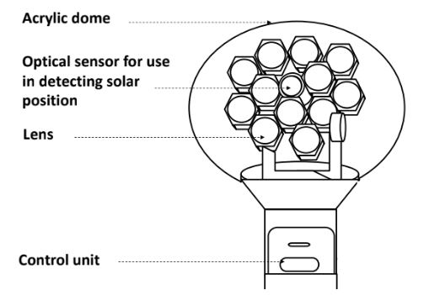

Figure21: Shows the collector of Himawari solar lighting system [[67](#_ENREF_67)].

**7.2. American Sundoiler daylight harvester:** It has skylight of 0.6 m roof penetration. It develops a concentrated parallel beam of daylight with up to 100000 lumens of the sunlight which further can used for the deep core, large open space for the daylighting applications[[68](#_ENREF_68)].

**7.3. Suncentral system:** It is lighting system improved by a Canadian association which can trace daylight at the roof of the construction and transmitting it down to every floor in the building. It comprises of sun beamer which trace the sunshine and transmits a collimated ray of skylight along any side of the construction. This daylight ray is blockade by sunshade (instate on every floor of the construction) and addressed towards a sun spandrel which passage the sunshine skylight into sun luminaire and entranced to the internal room of the commercial building. This system can shorten electricity waste by 75% of day hours. Although these systems have noble price and their pay-back duration is extended but they can reduce/less the energy waste greatly[[69](#_ENREF_69), [70](#_ENREF_70)].

**7.4. Solar tube day lighting system**: It seizure daylight on the top of floor and transmit it through the highly reflective pipe into inward space of the room [[71](#_ENREF_71)]. Fig. 4 shows the diagram sight of the solartube lighting system. It is presently available as 160 DS which has 6 m extent, 250 mm pipe diameter, and 6 m of pipe length. 290 DS has a dimension of 350 mm, and extent of 9 m.

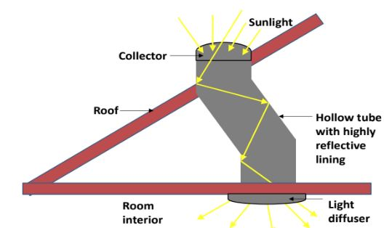

Fig. 22: The Solar tube lighting system [[71](#_ENREF_71)].

**7.5. Ciralight Sun Tracker:**It comprises of three plates of aluminium which are highly reflective and their movement and motion is controlled by solar power GPS motor. This motor keeps the mirror in proper alignment along the sun as source throughout the day[[72](#_ENREF_72)].

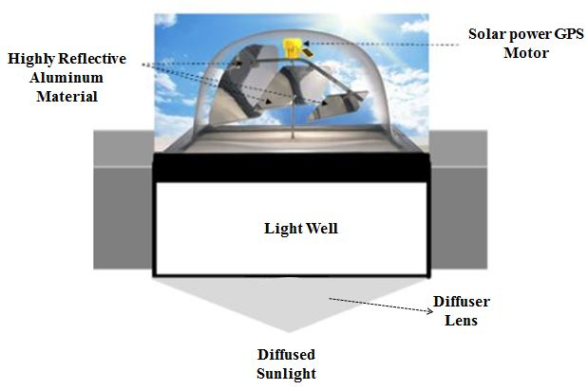

Figure 23: Ciralight sun tracker [[72](#_ENREF_72)].

**8. LATEST TECHNOLOGICAL ADVANCEMENTS:** M. Ulla [[73](#_ENREF_73)] design the notion of solar tower for daylighting in several business constructions. Since formal Time lighting system have obstruction in brightness of domestic space of huge building.Their design shape comprises of huge count of heliostat ordered in round curve around mirror light pipe (MLP). A focus mirror is assembled on the MLP and daylight form the heliostats are addressed to the focusing mirror which re- directs into the MLP.

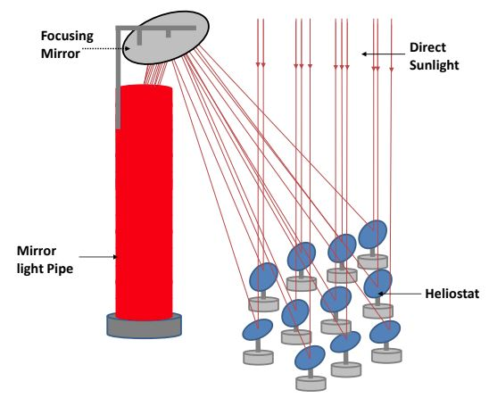

Figure 24: Proposed model day lighting system [[73](#_ENREF_73)].

Daylight guiding system has optimal illumination performance when sunlight drop perpendicularly on the daylight collector but it has moderate production when the sunlight drops indirectly on the collector.

Chang et al. [[74](#_ENREF_74)] propose heliostats which can straight daylight perpendicularly on the Time lighting system. They intend a 3 x 3 mirror heliostat in compare to an individual mirror in conventional heliostat. They reported a 3.32 times increase in system effectiveness. Figure 26 tells the matrix heliostat.

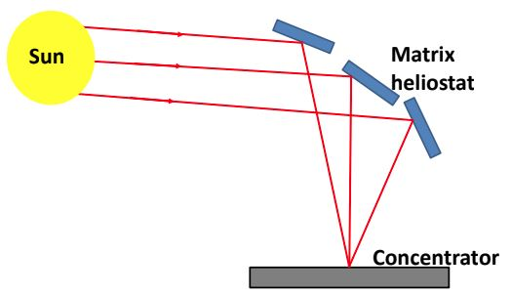

Figure 25: Matrix heliostat [[74](#_ENREF_74)].

Leutz et al. [[75](#_ENREF_75)] synthesised on improving efficiency and less cost of the daylighting system by designing developing parabolic trough sun lighting with the thermal system. In their design they involved the splitting up of the sunlight spectrum into the visible and infrared region by using a cold mirror. The visible light is then passed through the second stage of the Fresnel lens that concentrates it again and through the optical fibres it finally reaches the internal space of the portion and building to be illuminated. The infrared region of light is used for heat generation. For optimal illumination of around 500 m2 space of office space, 8 m2 of the PTC is required.

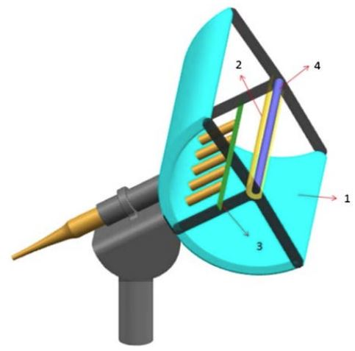

Figure26: Lighting system comprises of (1) Parabolic trough solar collector, (2) Cold mirror,(3) Fresnel lens and (4) thermal system [[75](#_ENREF_75)].

**9. CONCLUSION**

From the broad classifications of the daylighting systems made based on the physical phenomena of light propagation, it is observed that each system has its own advantages and disadvantages regarding aspects of cost, durability, aesthetics, efficiency, light output, transportation, effective throw and complexity. The positive attributes of a good daylighting enhancement system are passiveness, ease of installation, visual acceptance, solar shading against direct radiation and well controlled output distribution. Daylighting enhancement systems need to be designed considering factors like need, type of building and most importantly the climatic conditions (latitude). All light guiding/transmission systems require constant care through periodic maintenance for sustain the design efficiency. Typically, 20% to 30% of illuminance is diffuse even under relatively clear weather conditions[[50](#_ENREF_50)]. Daylighting systems with limited acceptance angle will collect little of this component of radiation. The solar lighting systems analysis in this review paper can effectively assist in reduction of the overall consumption of energy of building. For example, the annual energy conservation for lighting using the Parans, Sun central lighting system and sunportal system is estimated around 55%, 60% and 75% respectively [[63-65](#_ENREF_63), [69](#_ENREF_69)]. The Cost and expenditure of all these daylighting system is major concern for their universal acceptability and therefore, with creative approaches for the development cost can be reduced. Architectural modification is required for the implementation of these daylighting devices which is very inconvenient for the users. Maintenance like cleaning of lenses of this lighting system at regular duration for attains satisfactory system efficiency.

**10**. **REFRENCES:**

[1] J. J. Dengler and V. Wittwer, "Glazings with granular aerogel," in *Optical Materials Technology for Energy Efficiency and Solar Energy Conversion XIII*, 1994, pp. 718-728.

[2] J.-H. Liu, H.-T. Liu, and Y.-B. Cheng, "Preparation and characterization of gradient refractive index polymer optical rods," *Polymer,* vol. 39, pp. 5549-5552, 1998.

[3] L. Whitehead, R. Nodwell, and F. Curzon, "New efficient light guide for interior illumination," *Applied Optics,* vol. 21, pp. 2755-2757, 1982.

[4] H. Müller, "Application of holographic optical elements in buildings for various purposes like daylighting, solar shading and photovoltaic power generation," *Renewable Energy,* vol. 5, pp. 935-941, 1994.

[5] M. Kischkoweit-Lopin, "An overview of daylighting systems," *Solar Energy,* vol. 73, pp. 77-82, 2002.

[6] G. Sweitzer, "Three advanced daylighting technologies for offices," *Energy,* vol. 18, pp. 107-114, 1993.

[7] F. Linhart, S. K. Wittkopf, and J.-L. Scartezzini, "Performance of Anidolic Daylighting Systems in tropical climates–Parametric studies for identification of main influencing factors," *Solar Energy,* vol. 84, pp. 1085-1094, 2010.

[8] N. Ekren and S. Gorgulu, "An investigation into the usability of straight light-pipes in Istanbul," *ENERGY EDUCATION SCIENCE AND TECHNOLOGY PART A-ENERGY SCIENCE AND RESEARCH,* vol. 30, pp. 637-644, 2012.

[9] I. Task, "21, Daylight in Buildings–A source book on daylighting systems and components," ed: LBNL, 2000.

[10] P. Viera-González, G. E. Sánchez-Guerrero, G. Cárdenas-Ortíz, V. Guzmán-Ramos, A. Castillo-Guzmán, D. Peñalver-Vidal*, et al.*, "Design and optimization of fiber lenses in plastic optical fibers for indoor illumination," in *Nonimaging Optics: Efficient Design for Illumination and Solar Concentration X*, 2013, p. 88340P.

[11] L. Beltran, E. Lee, and S. Selkowitz, "Advanced optical daylighting systems: light shelves and light pipes," *Journal of the illuminating engineering society,* vol. 26, pp. 91-106, 1997.

[12] D. Heim and K. Kieszkowski, "Shading devices designed to achieve the desired quality of internal daylight environment," in *PLEA2006-The 23rd Conference on Passive and Low Energy Architecture, Geneva, Switzerland*, 2006, pp. 6-8.

[13] E. Lee, D. DiBartolomeo, and S. Selkowitz, "Thermal and daylighting performance of an automated venetian blind and lighting system in a full-scale private office," *Energy and buildings,* vol. 29, pp. 47-63, 1998.

[14] P. Greenup and I. Edmonds, "Test room measurements and computer simulations of the micro-light guiding shade daylight redirecting device," *Solar Energy,* vol. 76, pp. 99-109, 2004.

[15] K. Johnsen and R. Watkins, "Daylight in Buildings–A Source Book on Daylighting Systems and Components," *ECBCS Annex,* vol. 29, 2000.

[16] J.-L. Scartezzini and G. Courret, "Anidolic daylighting systems," *Solar Energy,* vol. 73, pp. 123-135, 2002.

[17] S. Wittkopf, "Daylight performance of anidolic ceiling under different sky conditions," *Solar Energy,* vol. 81, pp. 151-161, 2007.

[18] S. K. Wittkopf, E. Yuniarti, and L. K. Soon, "Prediction of energy savings with anidolic integrated ceiling across different daylight climates," *Energy and buildings,* vol. 38, pp. 1120-1129, 2006.

[19] G. Courret, J.-L. Scartezzini, D. Francioli, and J.-J. Meyer, "Design and assessment of an anidolic light-duct," *Energy and Buildings,* vol. 28, pp. 79-99, 1998.

[20] S. C. Molteni, G. Courret, B. Paule, L. Michel, and J. Scartezzini, "Design of anidolic zenithal lightguides for daylighting of underground spaces," *Solar Energy,* vol. 69, pp. 117-129, 2001.

[21] F. Linhart and J.-L. Scartezzini, "Minimizing lighting power density in office rooms equipped with anidolic daylighting systems," *Solar Energy,* vol. 84, pp. 587-595, 2010.

[22] R. W. Gruhike, M. Mienko, G. Xu, and I. Bita, "Systems and methods of providing a light guiding layer," ed: Google Patents, 2010.

[23] P. J. Littlefair, "Light shelves: computer assessment of daylighting performance," *International Journal of Lighting Research and Technology,* vol. 27, pp. 79-91, 1995.

[24] S.-T. Claros and A. Soler, "Indoor daylight climate-comparison between light shelves and overhang performances in Madrid for hours with unit sunshine fraction and realistic values of model reflectance," *Solar energy,* vol. 71, pp. 233-239, 2001.

[25] S.-T. Claros and A. Soler, "Indoor daylight climate–influence of light shelf and model reflectance on light shelf performance in Madrid for hours with unit sunshine fraction," *Building and Environment,* vol. 37, pp. 587-598, 2002.

[26] K. Steemers, "Daylighting design: Enhancing energy efficiency and visual quality," *Renewable Energy,* vol. 5, pp. 950-958, 1994.

[27] C. Aghemo, A. Pellegrino, and V. LoVerso, "The approach to daylighting by scale models and sun and sky simulators: A case study for different shading systems," *Building and Environment,* vol. 43, pp. 917-927, 2008.

[28] A. Soler and P. Oteiza, "Dependence on solar elevation of the performance of a light shelf as a potential daylighting device," *Renewable energy,* vol. 8, pp. 198-201, 1996.

[29] B. Raphael, "Active control of daylighting features in buildings," *Computer‐Aided Civil and Infrastructure Engineering,* vol. 26, pp. 393-405, 2011.

[30] M. G. Nair, K. Ramamurthy, and A. Ganesan, "Classification of indoor daylight enhancement systems," *Lighting Research & Technology,* vol. 46, pp. 245-267, 2014.

[31] D. Mirkovich, "Assessment of beam lighting systems for interior core illumination in multi-story commercial buildings," *TRANSACTIONS-AMERICAN SOCIETY OF HEATING REFRIGERATING AND AIR CONDITIONING ENGINEERS,* vol. 99, pp. 1106-1106, 1993.

[32] I. Edmonds and P. Greenup, "Daylighting in the tropics," *Solar Energy,* vol. 73, pp. 111-121, 2002.

[33] A. Tsangrassoulis, L. Doulos, M. Santamouris, M. Fontoynont, F. Maamari, M. Wilson*, et al.*, "On the energy efficiency of a prototype hybrid daylighting system," *Solar Energy,* vol. 79, pp. 56-64, 2005.

[34] G. Oakley, S. Riffat, and L. Shao, "Daylight performance of lightpipes," *Solar energy,* vol. 69, pp. 89-98, 2000.

[35] E. Mills and M. A. Piette, "Advanced energy-efficient lighting systems: progress and potential," *Energy,* vol. 18, pp. 75-97, 1993.

[36] I. R. Edmonds, "Performance of laser cut light deflecting panels in daylighting applications," *Solar Energy Materials and Solar Cells,* vol. 29, pp. 1-26, 1993.

[37] R. Compagnon, B. Paule, and J.-L. Scartezzini, *Application of nonimaging optics to the development of new daylighting systems*, 1993.

[38] M. AyersBEng and D. Carter, "Remote source electric lighting systems: A review," *International Journal of Lighting Research and Technology,* vol. 27, pp. 1-15, 1995.

[39] W. Welford and R. Winston, "High Collection Nonimaging Optics (New York: Academic)," 1989.

[40] A. Earp, G. Smith, P. Swift, and J. Franklin, "Maximising the light output of a luminescent solar concentrator," *Solar Energy,* vol. 76, pp. 655-667, 2004.

[41] A. Zastrow and V. Wittwer, "Daylighting with Mirror Light Pipes and with Fluorescent Planar Concentrators. First Results from the Demonstration Project Stuttgart-Hohenheim," in *Materials and Optics for Solar Energy Conversion and Advanced Lightning Technology*, 1987, pp. 227-235.

[42] V. Garcia Hansen and I. Edmonds, "Natural illumination of deep-plan office buildings: light pipe strategies," 2003.

[43] M. Nair, A. Ganesan, and K. Ramamurthy, "Daylight enhancement using laser cut panels integrated with a profiled Fresnel collector," *Lighting Research & Technology,* vol. 47, pp. 1017-1028, 2015.

[44] C. E. Ochoa and I. G. Capeluto, "Evaluating visual comfort and performance of three natural lighting systems for deep office buildings in highly luminous climates," *Building and Environment,* vol. 41, pp. 1128-1135, 2006.

[45] C. Wang, H. Abdul-Rahman, and S. Rao, "Daylighting can be fluorescent: Development of a fiber solar concentrator and test for its indoor illumination," *Energy and Buildings,* vol. 42, pp. 717-727, 2010.

[46] A. Rosemann and H. Kaase, "Lightpipe applications for daylighting systems," *Solar energy,* vol. 78, pp. 772-780, 2005.

[47] J. G. Bornstein and P. S. Friedman, "Lighting system combining daylight concentrators and an artificial source," ed: Google Patents, 1985.

[48] J. T. Kim and G. Kim, "Overview and new developments in optical daylighting systems for building a healthy indoor environment," *Building and Environment,* vol. 45, pp. 256-269, 2010.

[49] W. Xie, Y. Dai, R. Wang, and K. Sumathy, "Concentrated solar energy applications using Fresnel lenses: A review," *Renewable and Sustainable Energy Reviews,* vol. 15, pp. 2588-2606, 2011.

[50] P. Swift and G. Smith, "Cylindrical mirror light pipes," *Solar Energy Materials and Solar Cells,* vol. 36, pp. 159-168, 1995.

[51] Y. Tripanagnostopoulos, C. Siabekou, and J. Tonui, "The Fresnel lens concept for solar control of buildings," *Solar Energy,* vol. 81, pp. 661-675, 2007.

[52] K. Ryu, J.-G. Rhee, K.-M. Park, and J. Kim, "Concept and design of modular Fresnel lenses for concentration solar PV system," *Solar energy,* vol. 80, pp. 1580-1587, 2006.

[53] M. Al-Marwaee and D. Carter, "Tubular guidance systems for daylight: Achieved and predicted installation performances," *Applied energy,* vol. 83, pp. 774-788, 2006.

[54] B. Eschke, S. Vogt, and H. Flohr, "Lighting fitting with a diffusser," ed: Google Patents, 2002.

[55] D. Carter, "The measured and predicted performance of passive solar light pipe systems," *Lighting Research & Technology,* vol. 34, pp. 39-51, 2002.

[56] C.-K. Johnson and I. Ortep, "Oak Ridge National Laboratory," *Oak Ridge, TN,* 1976.

[57] S. Dai, M. C. Burleigh, Y. Shin, C. C. Morrow, C. E. Barnes, and Z. Xue, "Imprint coating: a novel synthesis of selective functionalized ordered mesoporous sorbents," *Angewandte Chemie International Edition,* vol. 38, pp. 1235-1239, 1999.

[58] S. C. Davis and O. R. N. Laboratory, *Transportation energy data book*: National Technical Information Service, 1995.

[59] A. V. Melechko, V. I. Merkulov, T. E. McKnight, M. Guillorn, K. L. Klein, D. H. Lowndes*, et al.*, "Vertically aligned carbon nanofibers and related structures: controlled synthesis and directed assembly," *Journal of applied physics,* vol. 97, p. 3, 2005.

[60] G. M. Larson and T. R. Mayberry, "Universal fiber optic module system," ed: Google Patents, 1999.

[61] J. Hecht, *City of light: the story of fiber optics*: Oxford University Press on Demand, 2004.

[62] A. Rosemann, M. Mossman, and L. Whitehead, "Development of a cost-effective solar illumination system to bring natural light into the building core," *Solar Energy,* vol. 82, pp. 302-310, 2008.

[63] M. Mayhoub and D. Carter, "Towards hybrid lighting systems: A review," *Lighting Research & Technology,* vol. 42, pp. 51-71, 2010.

[64] M. Mayhoub and D. Carter, "A feasibility study for hybrid lighting systems," *Building and Environment,* vol. 53, pp. 83-94, 2012.

[65] M. Mayhoub, "WHAT IS PREVENTING INNOVATIVE DAYLIGHTING SYSTEMS FROM WIDESPREAD USE?," *Proceedings of the 12th LuxEuropa, Krakow, Poland,* pp. 17-19, 2013.

[66] J. L. Cuello, D. Jack, P. Sadler, and T. Nakamura, "Hybrid solar and artificial lighting (HYSAL): next-generation lighting strategy for bioregenerative advanced life support," SAE Technical Paper 0148-7191, 1999.

[67] D. Lingfors and T. Volotinen, "Illumination performance and energy saving of a solar fiber optic lighting system," *Optics express,* vol. 21, pp. A642-A655, 2013.

[68] R. Singh, G. Baradia, and A. Gupta, "Hybrid Solar Lighting System for Energy Conservation: A Review."

[69] M. Alata, M. Al-Nimr, and Y. Qaroush, "Developing a multipurpose sun tracking system using fuzzy control," *Energy Conversion and Management,* vol. 46, pp. 1229-1245, 2005.

[70] M. Mayhoub, "Innovative daylighting systems’ challenges: A critical study," *Energy and Buildings,* vol. 80, pp. 394-405, 2014.

[71] J. E. Fries, "Solar lighting system," ed: Google Patents, 1981.

[72] R. L. Dominguez, "Solar lighting reflector apparatus having slatted mirrors and improved tracker," ed: Google Patents, 1989.

[73] M. Ullah, "International daylight measurement programme—Singapore data III: Building energy savings through daylighting," *International Journal of Lighting Research and Technology,* vol. 28, pp. 83-87, 1996.

[74] C.-H. Chang, H.-C. Hsiso, C.-M. Chang, C.-Y. Wang, T.-H. Lin, Y.-Y. Chen*, et al.*, "Heliostat design for the daylighting system," *Applied optics,* vol. 53, pp. H165-H169, 2014.

[75] R. Leutz, A. Suzuki, A. Akisawa, T. Kashiwagi, and J. Toksoy, "Developments and designs of solar engineering Fresnel lenses," in *Proceedings Symposium on Energy Engineering*, 2000, pp. 759-765.