**Table of Contents**

1.Introduction……………………………………...................................6

1.2Objective……………………………………………………............6-7

` 1.3Project Category…................................................................................7

1.4Technology Used……………………………………………...............7

2.Requirement……………………………………………...............…....7

3. Feasibility Study …………..………………….................................7-8

4.Design………………………........................................................….8-11

5.Future scope and enhancement..............................................................12

6.Bibliography.......................................................................................... 13

**List of Tables**

**Table 1. 1. Journal .................................................................................................................8**

**Table 1. 2. Author.....................................................................................................................9**

**Table 1. 3. Paper submission...................................................................................................9**

**Table 1.4. Paper pdf.................................................................................................................9**

**Table 1.5. Stream.....................................................................................................................10**

**Table 1.6 Auther detail............................................................................................................10**

**Table 1.7 All table.....................................................................................................................10**

**Lists of figures**

* 1. **Home.........................................................................................**
  2. **Login.........................................................................................**
  3. **Paper submission.....................................................................**

**1.1 Use-Case diagram……………………………………………10**

**1.2 Class diagram………………………………………………...11**

**ABSTRACT**

## “Online Journal Research” is a web-based project which is made an independent publisher specializing in the publication of high-impact journals, proceedings and books, in both printed and online versions, across all areas of engineering, science, humanities, arts etc. We are aiming to the leading scientific publisher and publish an expanding academic research content programme. As the technology is being advanced the way of life is changing accordance. The main aim of the journal is to provide a platform to researchers from Engineering Streams (Computer / I.T., Mechanical and Electronics) to present their high quality research work and innovation in the form original, unpublished research paper.

**ACKNOWLEDGEMENT**

Foremost, we would like to express our sincere gratitude to almighty for givig us courage to rig up this project successfully. Our sincere thanks goes to Dr.Gagan deep kaur and Dr. Rajneesh Randhawa. They has been of great help in carrying out the project work and is accredited with courteous thanks.

We express gratitude to other faculty members of DCS of Punjabi University Patiala for their Intellectual support throughout the project. Last but not least we would like to thanks our family and friends for the sleepless nights we were working together before deadlines.

**Ashish Bindra**

**1.INTRODUCTION**

## “Online Journal Research” is a web-based project which is made an independent publisher specializing in the publication of high-impact journals, proceedings and books, in both printed and online versions, across all areas of engineering, science, humanities, arts etc. We are aiming to the leading scientific publisher and publish an expanding academic research content programme. As the technology is being advanced the way of life is changing accordance. The main aim of the journal is to provide a platform to researchers from Engineering Streams (Computer / I.T., Mechanical and Electronics) to present their high quality research work and innovation in the form original, unpublished research paper.

## There is a admin which has over all control of all website he/she can add/remove events, reviewer, editors etc. There is over all three panels which are followings:-

1. Admin panel
2. Editor panel
3. Reviewer panel
4. Admin panel (in front end)

## This project entitled “Online Journal Research” is an implementation of the above description. In this website users can submit their papers after that editor can assign the paper to assistant and assistant assign to different different revivers by this is process of paper accept or reject process author can only submit or see their paper status by sign up.

**1.2 OBJECTIVE**

There are several objective of this websites are following given bellows.

2.1 Understand **the state of the art**

1. What is current substantive knowledge?
2. What are the most important questions?
3. What research has been done most recently?
4. Who is doing the research?
5. What are they investigating?

* 1. What is current methodological knowledge?

1. What research methods are being used?
2. What tools and techniques are being used?
3. How are results being analysed?

**1.3 PROJECT CATEGORY**

Web based PHP application, asp.net, c#, xml, js, Ajax with MySQL as back end.

**1.4 TECHNOLOGY USED**

It is a web based environment with PHP 7 as the server side scripting language and MySQL 5.6.25 as the relational DBMS and JavaScript is used for client side scripting xml is used for data transfer Ajax is used for real time change in front end. Clients will be Google Chrome based. Mozilla Firefox etc can also be used. All front-end design is done using PHP with JavaScript, jquery, HTML5, Cascading Style Sheets (CSS) and Bootstrap.

[Internet Technologies: JavaScript, HTML5, jquery, Java Scr

PHP 5.6.25 and Apache Server (WAMP) or xampp

RDBMS/Back End: MySQL DB]

**2. REQUIREMENTS**

Software requirements

• WAMP Server

• Notepad ++

• Browsers (Google Chrome/ Mozilla Firefox)

Hardware requirements

• Intel Duel Core 2.0GHz or higher processor

• 2 GB RAM

• 10 GB HDD Space

3. **FEASIBILITY STUDY**

The main aim of the feasibility study activity is to determine whether it would be financially and technically feasible to develop the project. It involves analysis of the problem and collection of all relevant information.

After collecting all the relevant information (like who are the users, how they interact with the system etc) and details about our project “**Online Journal Research**” we reach at the conclusion that the system is financially feasible and can be developed using the technology that we presently have. It helps to get lot of author from the university.

**4. DESIGN**

System Design is a detailed study of various operations performed by a system and its relationships within and outside the system. The commonly used tools for analysis are Use-case diagram,Class diagam etc.

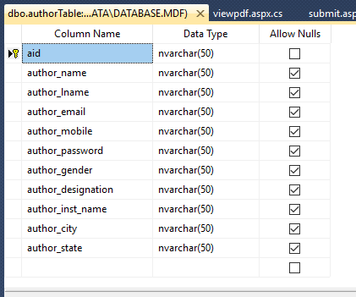

Table 1.1

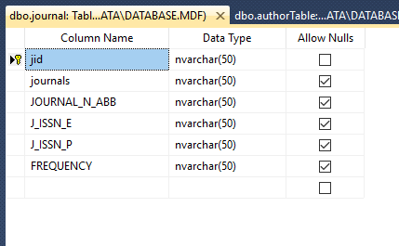

Table 1.2

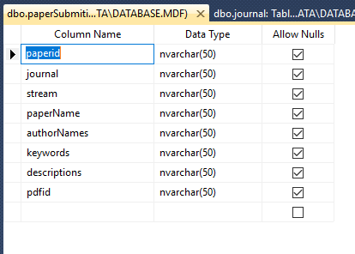

Table 1.3

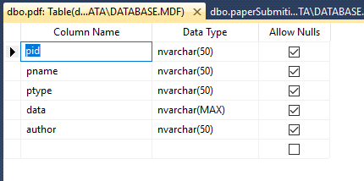

Table 1.4

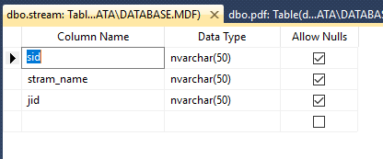

Table 1.5

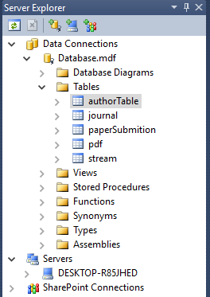

Table 1.6

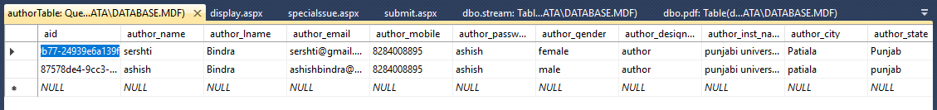

Table 1.7

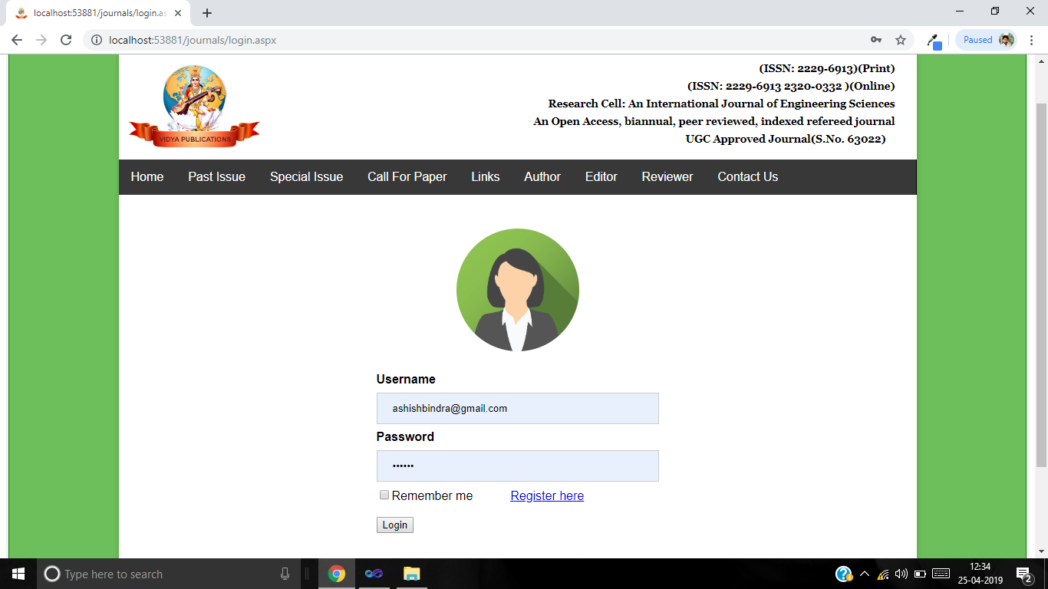

Figure 1.1



Figure 1.2

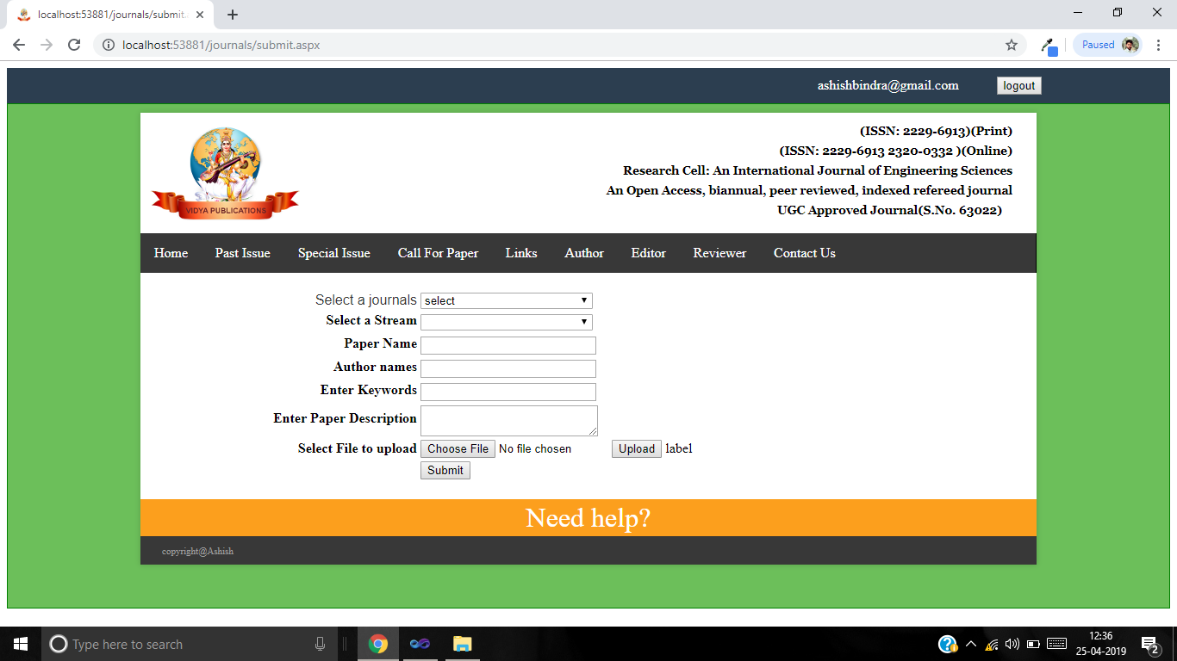

Figure 1.4

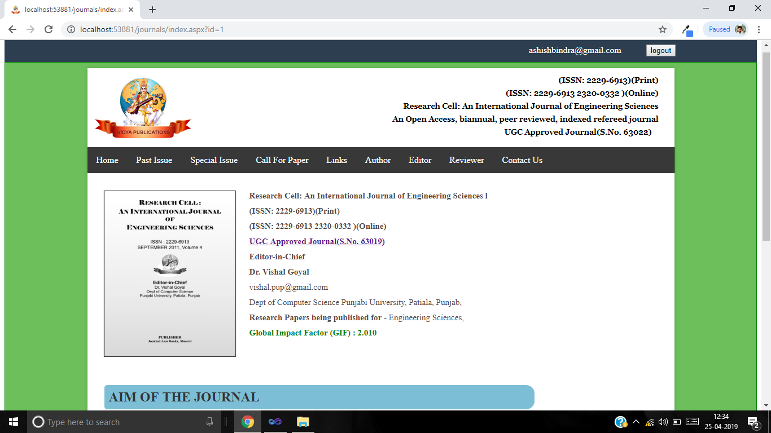

Figure 1.5

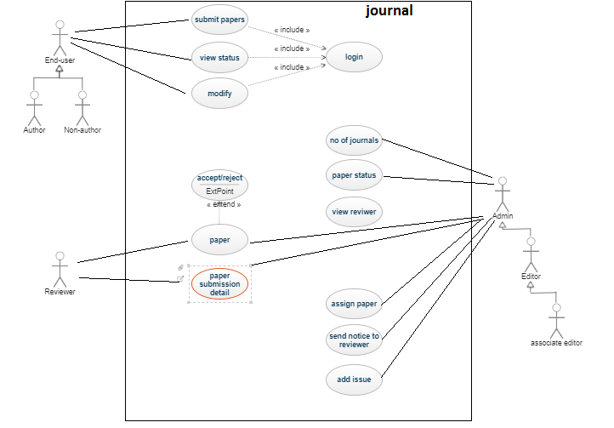

Figure-1.1 Use-Case diagram for journals

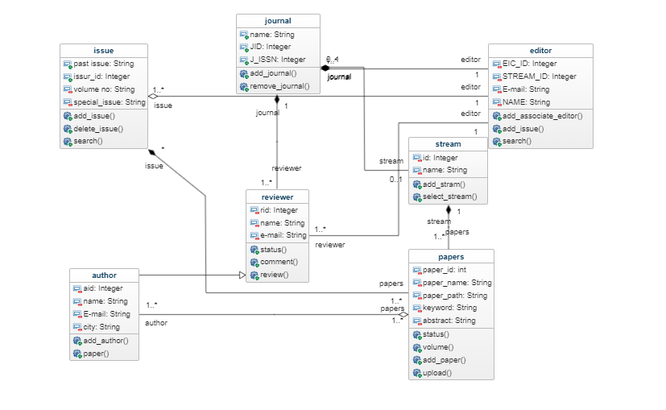

Figure-1.2 Class diagram for journals

**FUTURE SCOPE AND ENHANCEMENT**

This software will help to reduce manual effort and time. It also provides security. The proposed system is user-friendly and every aspects of this system can be easily understood and the user can operate the system easily. We have planned to develop this software as independent in nature and cost effective. As the saying goes “There is always scope for the improvement in every system”, even this system could be improved at various stages.

The enhancements are

Payment through Net banking and Debit/Credit card facility.

Payment through paytm and PayPal.

We can use AI and machine learning in this project

**Bibliography**

1. Head First PHP & MySQL: A Brain-Friendly Guide by Lynn Beighley and Michael Morrison.

2. Database Management System by L. Mathu Krithiga Venkatesh.

3. Database Analysis and Design by Igor Hawryszkiewycz .