POPULATION VS TOTAL REVENUE:

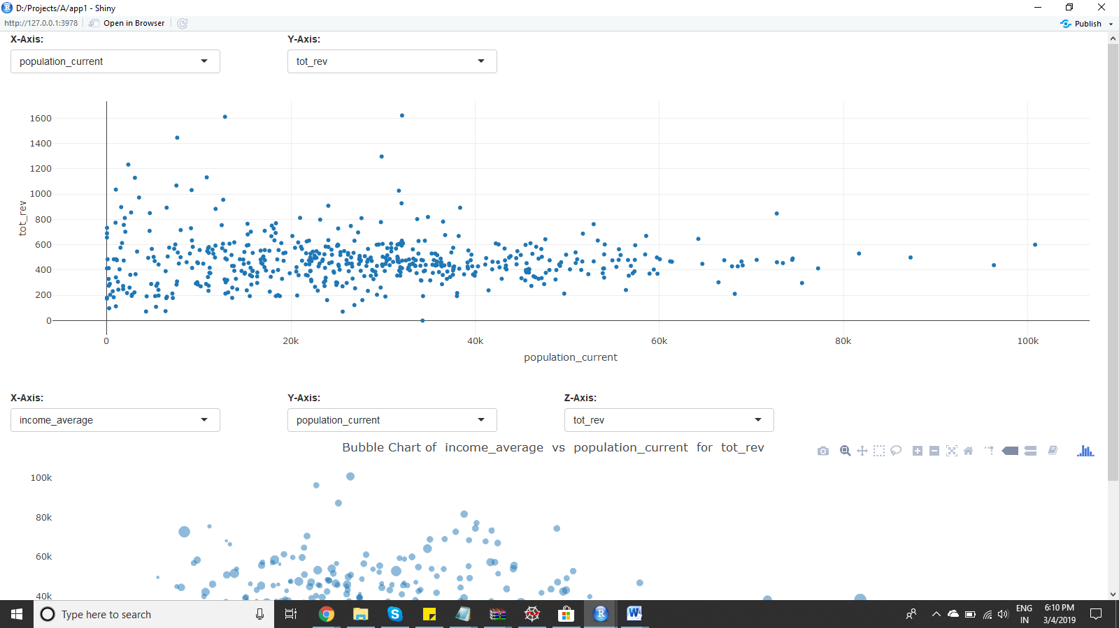

Irrespective of population, we can expect average revenue of $500. Population doesn’t have an effect on the revenue

AGE MEDIAN VS TOTAL REVENUE

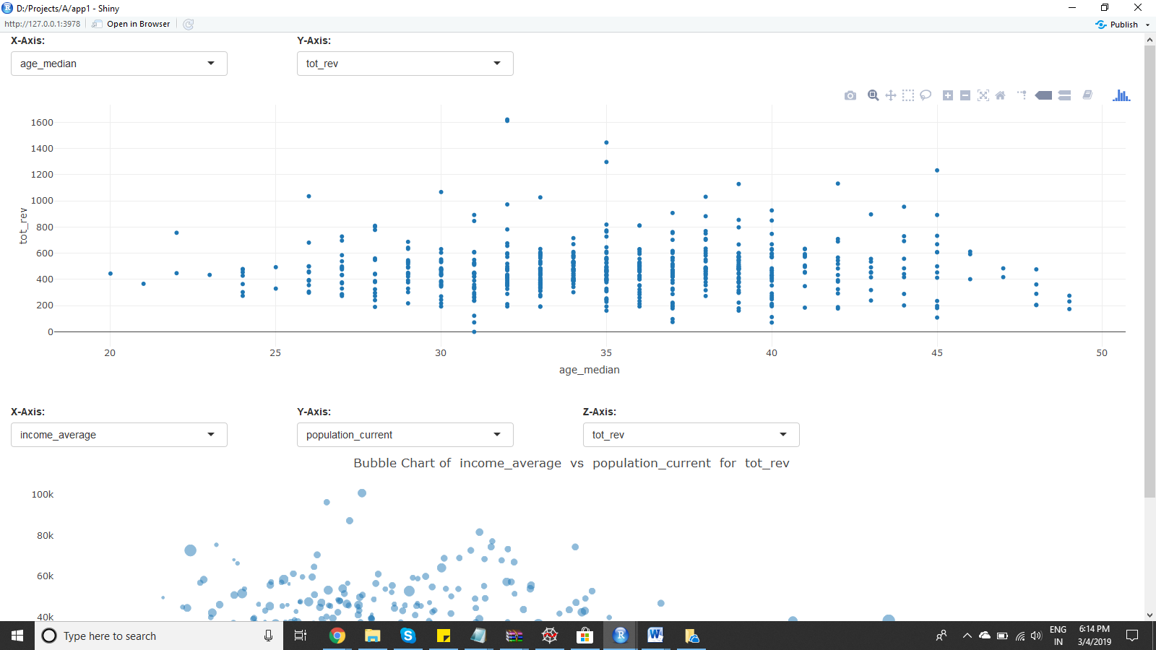

Maximum revenue is got from customers between ages 30-40

HOUSEHOLDS TOTAL VS TOTAL REVENUE

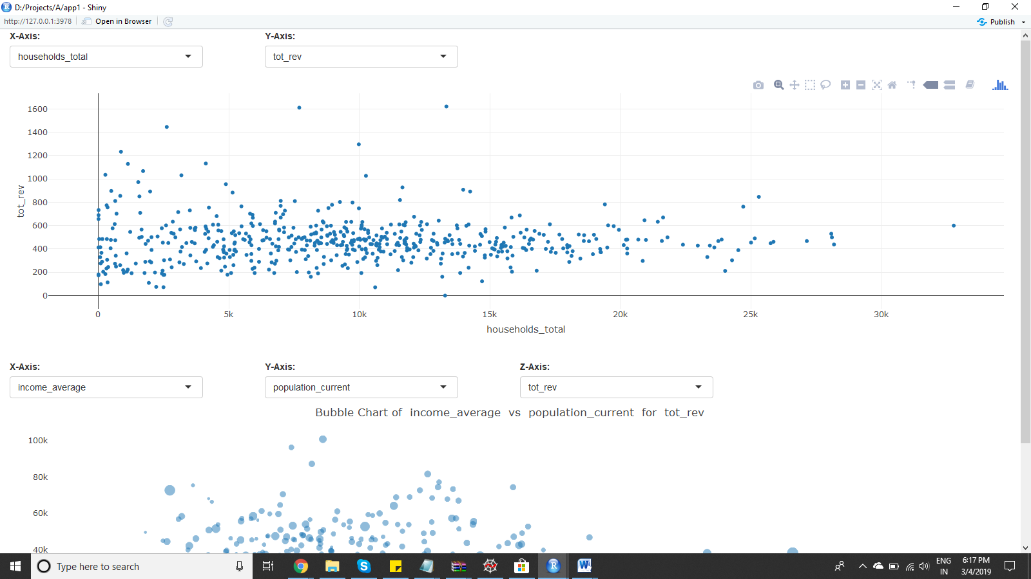

When the number of households is high, revenue is lesser

HOUSEHOLD YEAR BUILT VS TOTAL REVENUE

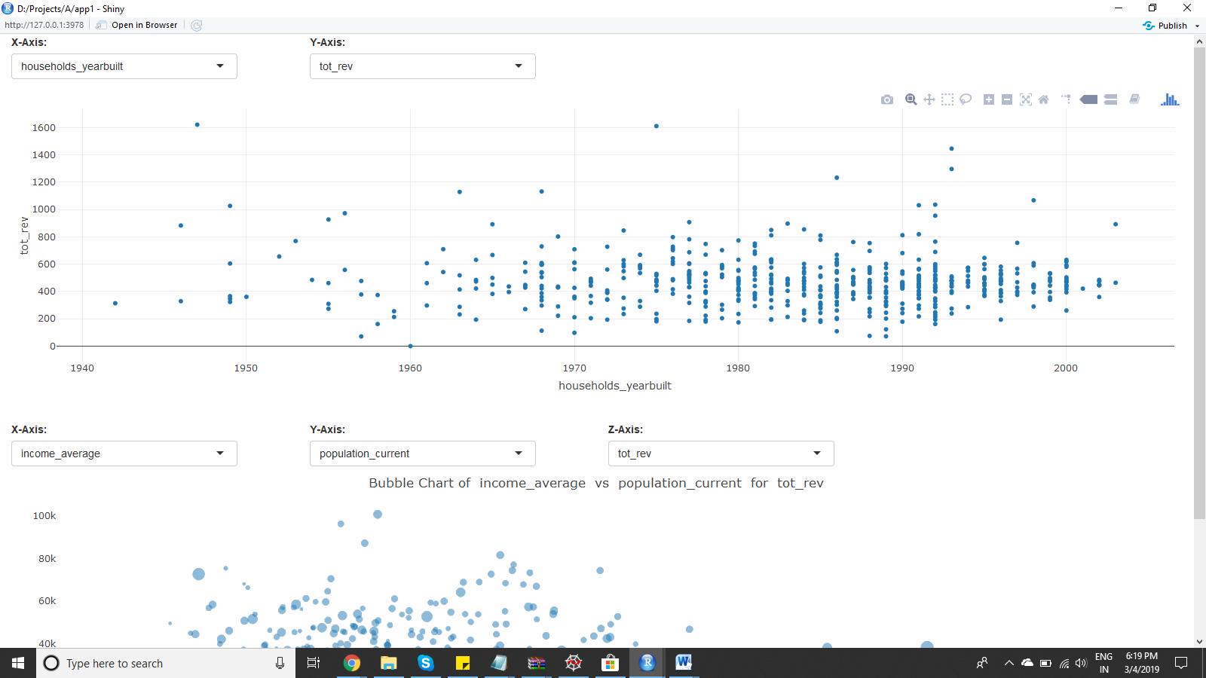

Newer the houses (more recent the year built), more the total revenue.

HOUSEHOLDS OCCUPANCY OWNED VS TOTAL REVENUE

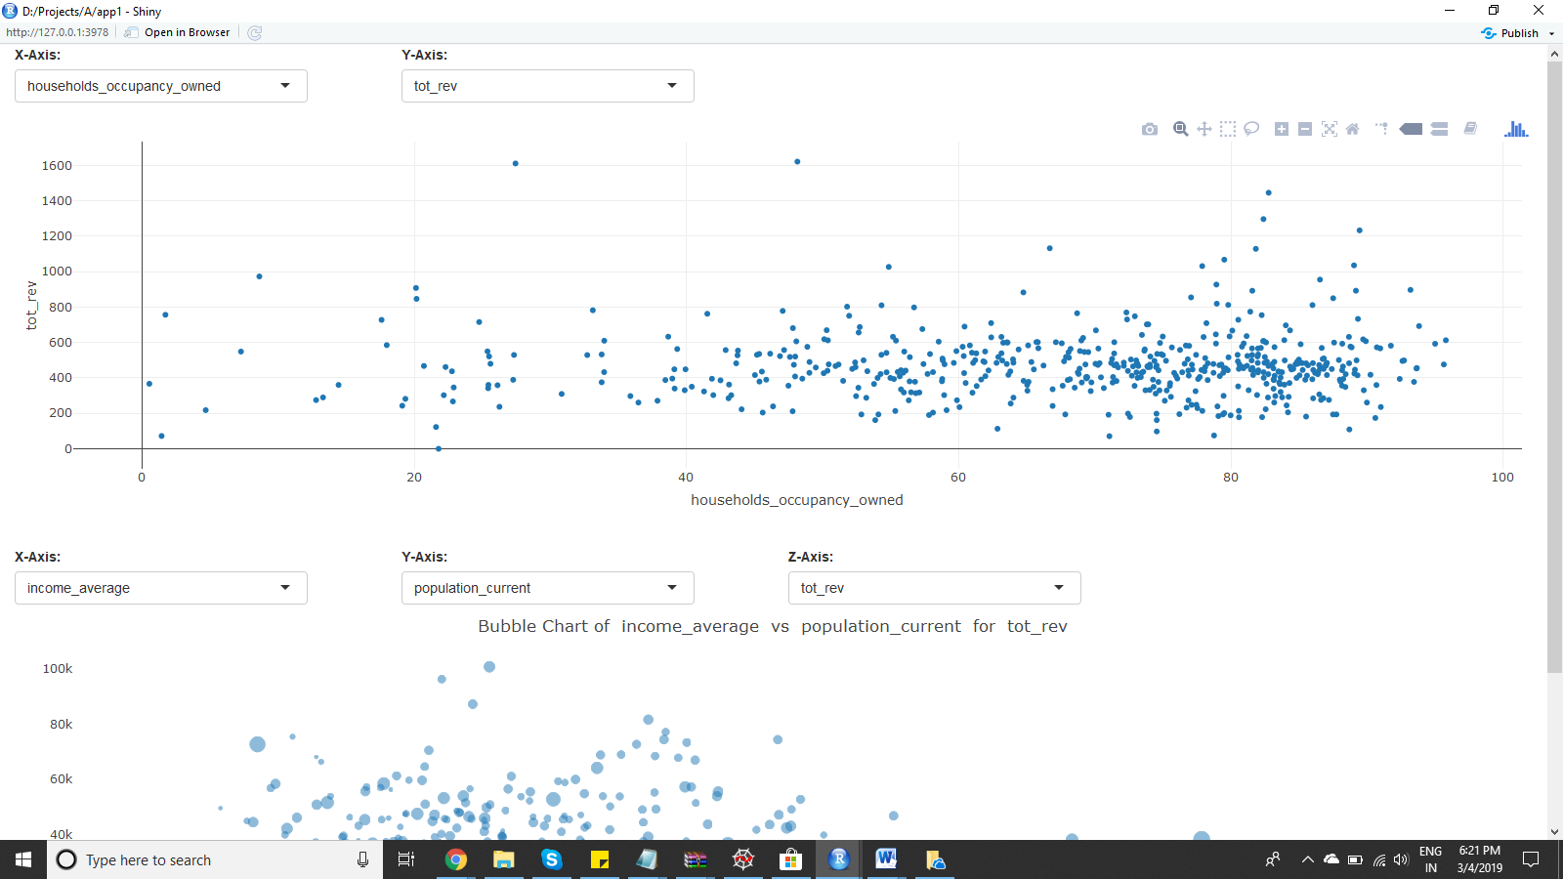

Customers with own houses tend to care for them more, thus increasing total revenue.

HOUSEHOLD VALUE VS INCOME AVERAGE

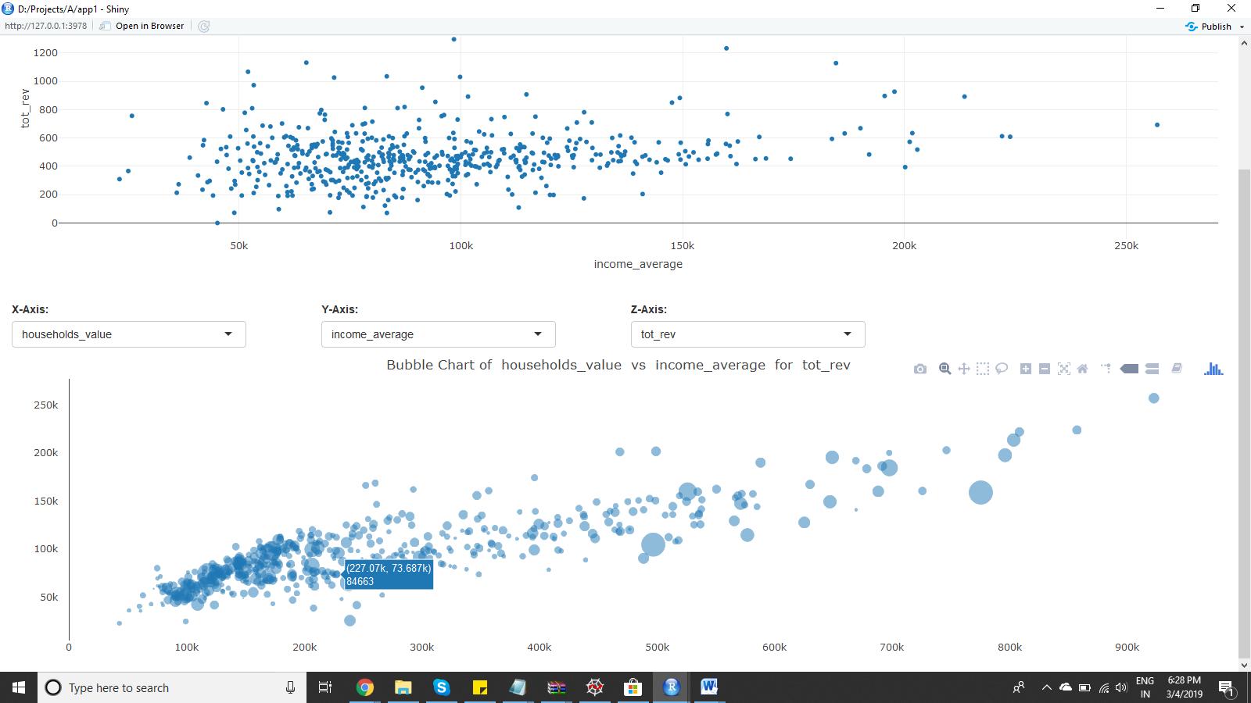

Most zips have income average less than 150K and household value less than 250K. Most customers are from the lower income range.

CORRELATION PLOT



INSIGHTS:

1. When the income is higher, the customer spending is more.
2. When the age median is high, the Cost incurred by the company is high.