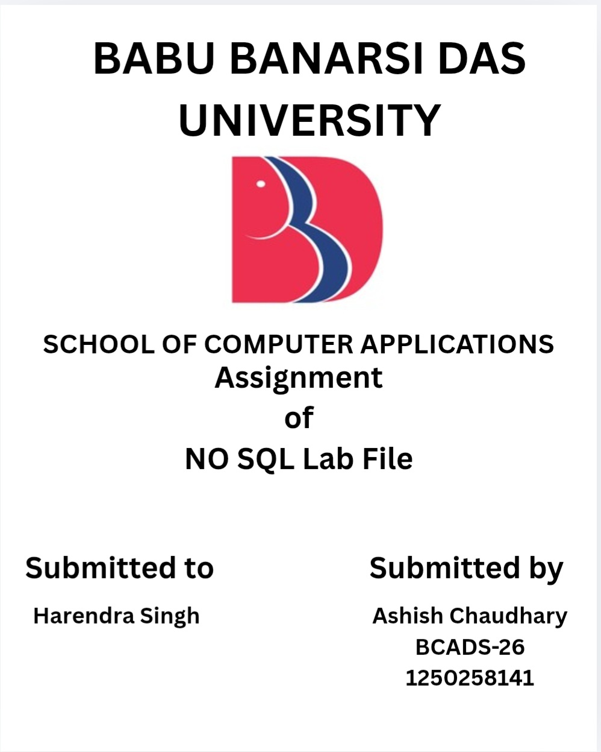
NO SQL PROJECT
MongoDB Student Database Management System
Project on Inserting and Managing Student Data
Using MongoDB Community Server and MongoDB Compass
1. INSTALLATION, CONNECTION, DATABASE AND DATASET SETUP
MongoDB Community Edition is installed on Windows using the official MSI installer. The setup wizard can install MongoDB as a Windows service and can also install MongoDB Compass, the graphical interface used in this project. [Source: MongoDB Documentation — Install MongoDB Community Edition on Windows.]
For this project, installation, connection, database creation and dataset viewing are shown through MongoDB Community and MongoDB Compass, not through Command Prompt or MongoDB Shell. MongoDB Compass is MongoDB's graphical interface for connecting to deployments and managing databases, collections and documents. [Source: MongoDB Compass Documentation.]
Step 1 — Download MongoDB Community Server
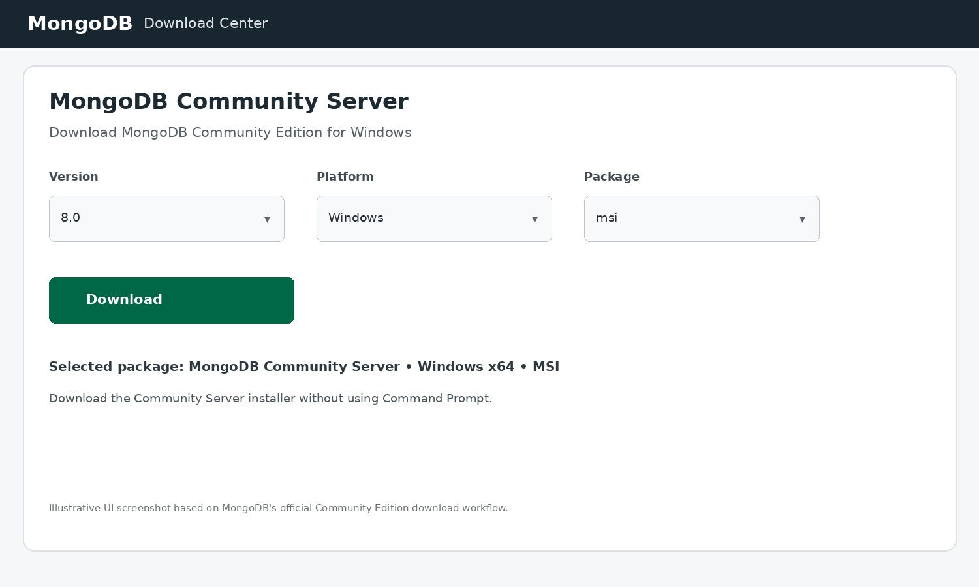
Select MongoDB Community Server, choose Windows and the MSI package, and download the installer. No command is required for this step. [Source: MongoDB Compass/Community documentation.]
Step 2 — Install MongoDB Community Server
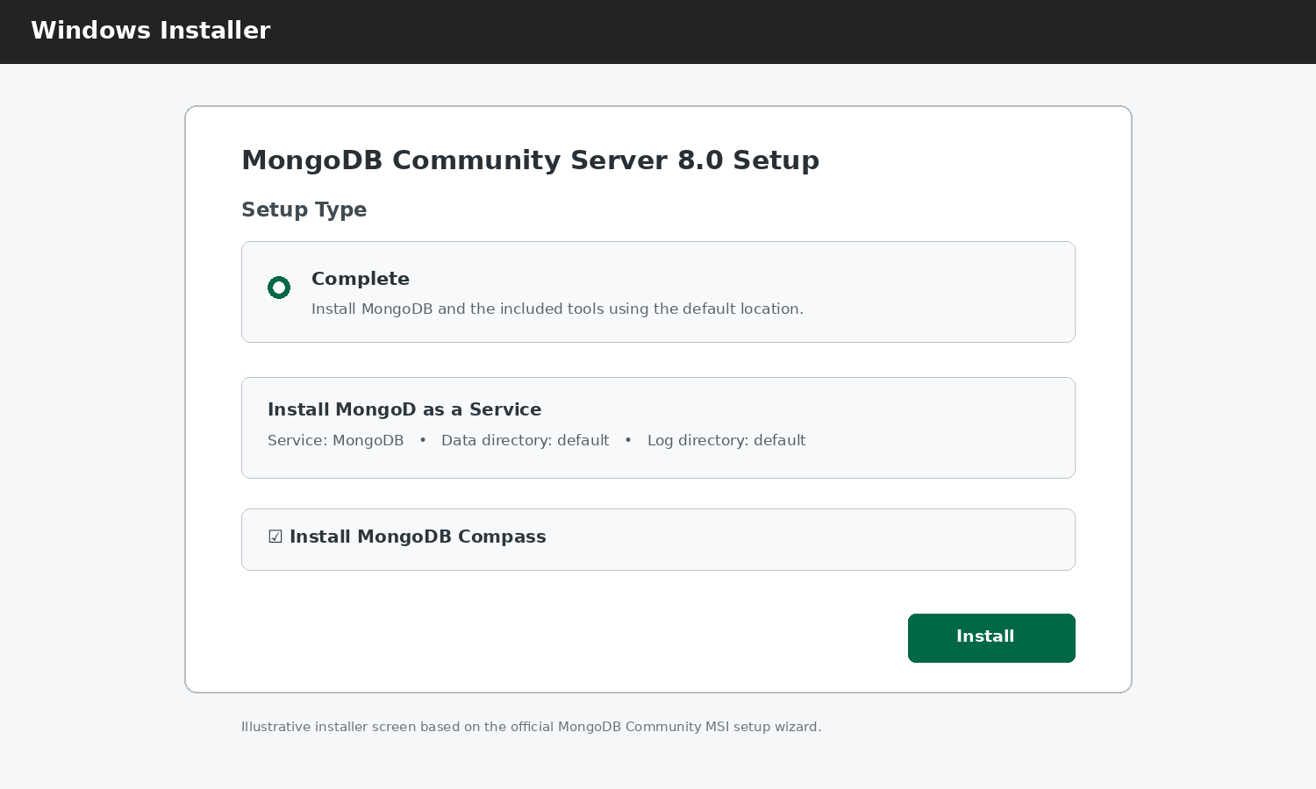
Run the downloaded MSI file and follow the setup wizard. The Complete setup installs MongoDB and tools; Compass can be selected during installation. MongoDB can also be configured as a Windows service. [Source: MongoDB Compass/Community documentation.]
Step 3 — Connect through MongoDB Compass
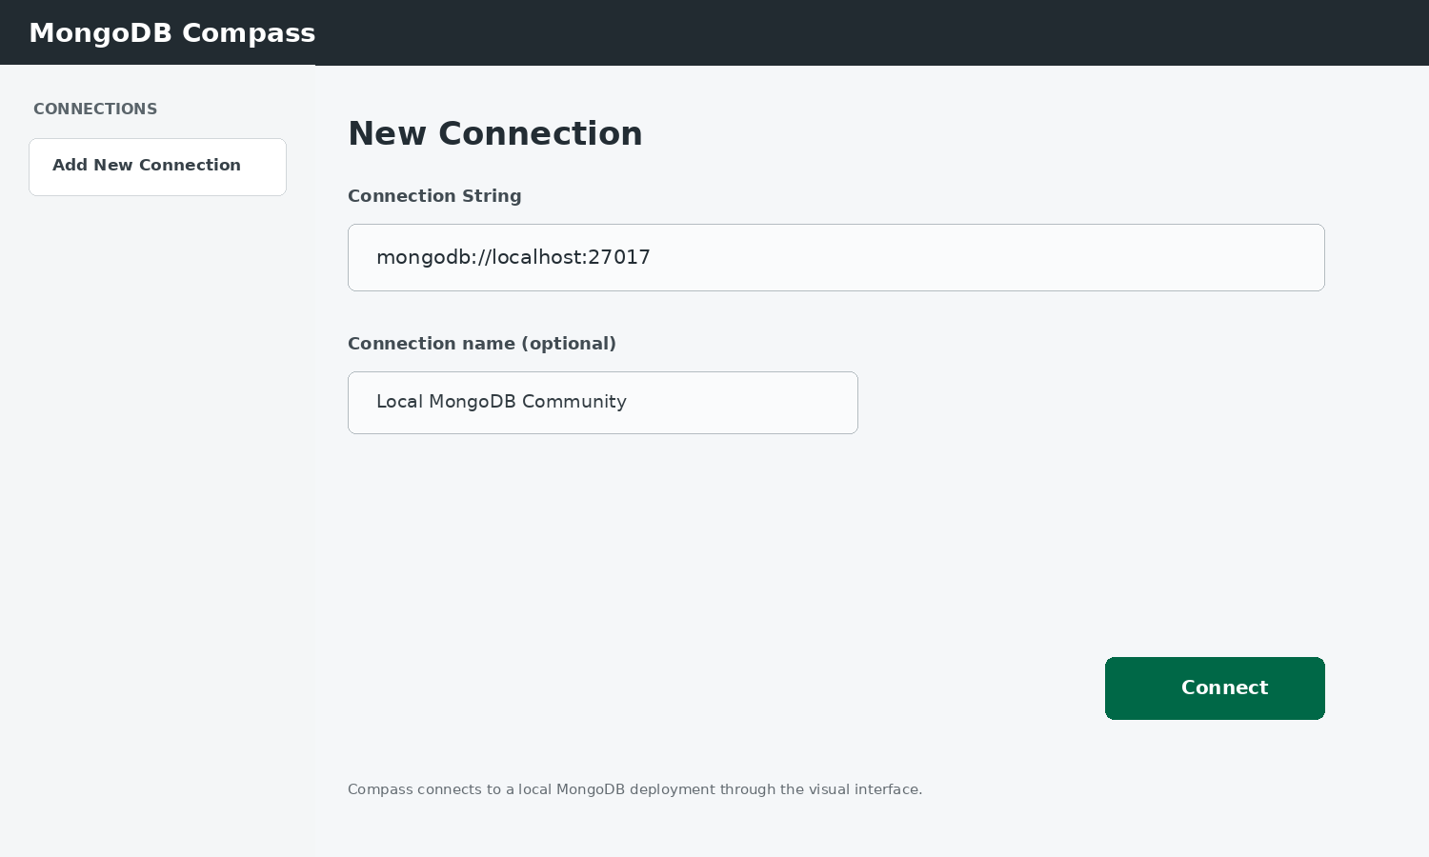
Open MongoDB Compass and use the visual New Connection screen. For a local MongoDB deployment, the host is normally localhost. Click Connect. [Source: MongoDB Compass/Community documentation.]
Step 4 — Create the database and collection
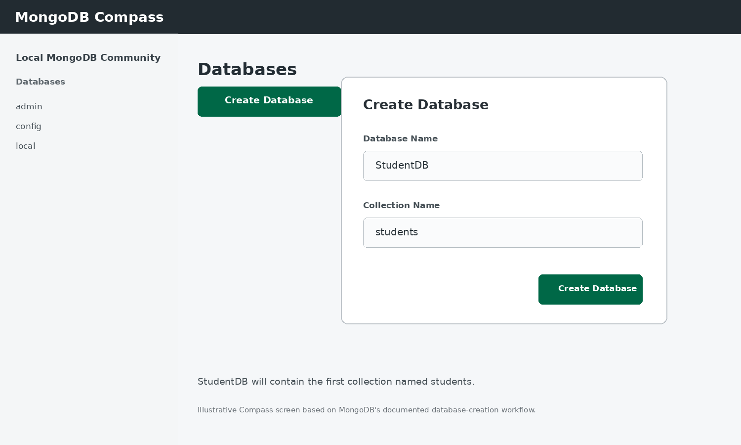
In Compass, create the database StudentDB and its first collection students from the Create Database dialog. [Source: MongoDB Compass/Community documentation.]
Step 5 — View the 10-student dataset
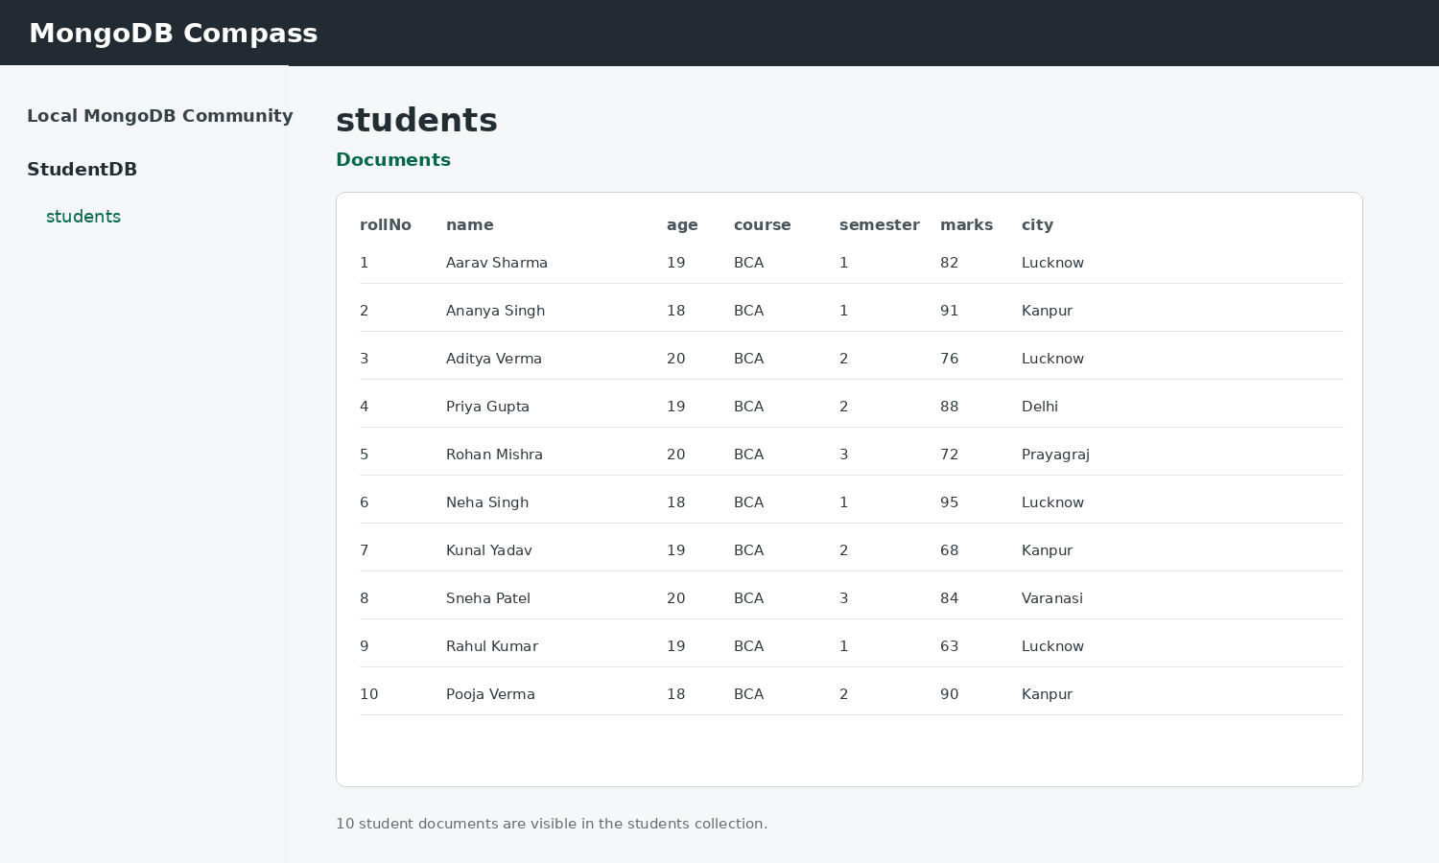
Open StudentDB → students → Documents in Compass. The student records are displayed visually in the collection. [Source: MongoDB Compass/Community documentation.]
2. INSERT 10 STUDENTS USING MongoDB Shell
The project uses 10 student records so that the dataset is short, clear and easy to demonstrate.
db.students.insertMany([
{rollNo:1, name:"Aarav Sharma", age:19, gender:"Male", course:"BCA", semester:1, marks:82, city:"Lucknow"},
{rollNo:2, name:"Ananya Singh", age:18, gender:"Female", course:"BCA", semester:1, marks:91, city:"Kanpur"},
{rollNo:3, name:"Aditya Verma", age:20, gender:"Male", course:"BCA", semester:2, marks:76, city:"Lucknow"},
{rollNo:4, name:"Priya Gupta", age:19, gender:"Female", course:"BCA", semester:2, marks:88, city:"Delhi"},
{rollNo:5, name:"Rohan Mishra", age:20, gender:"Male", course:"BCA", semester:3, marks:72, city:"Prayagraj"},
{rollNo:6, name:"Neha Singh", age:18, gender:"Female", course:"BCA", semester:1, marks:95, city:"Lucknow"},
{rollNo:7, name:"Kunal Yadav", age:19, gender:"Male", course:"BCA", semester:2, marks:68, city:"Kanpur"},
{rollNo:8, name:"Sneha Patel", age:20, gender:"Female", course:"BCA", semester:3, marks:84, city:"Varanasi"},
{rollNo:9, name:"Rahul Kumar", age:19, gender:"Male", course:"BCA", semester:1, marks:63, city:"Lucknow"},
{rollNo:10, name:"Pooja Verma", age:18, gender:"Female", course:"BCA", semester:2, marks:90, city:"Kanpur"}
])
MongoDB Shell output for inserting 10 student records:
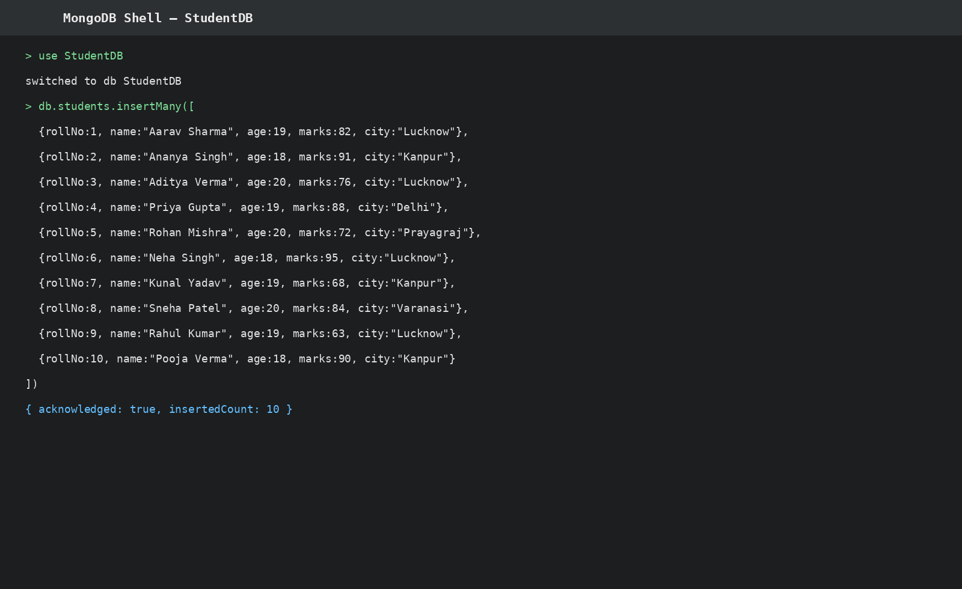
Explanation: insertMany() inserts multiple documents into the students collection in one operation. The output confirms that 10 documents were inserted.
The dataset is displayed in MongoDB Compass above. The insertMany operation is demonstrated in MongoDB Shell below, and the remaining operations retain their command formulas and MongoDB Shell output screenshots.
4. DELETE
Formula / Command:
db.students.deleteOne({rollNo:10})
Explanation: deleteOne() removes the first document matching the given condition.
MongoDB Shell output screenshot:
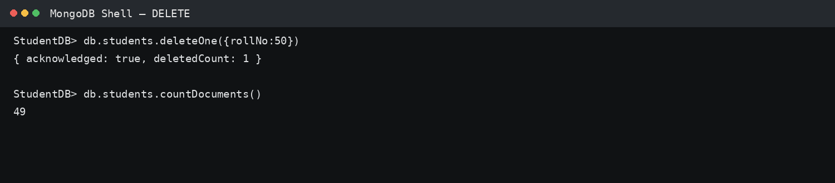
5. GREATER THAN — $gt
Formula / Command:
db.students.find({marks: {$gt: 80}}, {_id:0, rollNo:1, name:1, marks:1})
Explanation: $gt means greater than. This query displays students whose marks are greater than 80.
MongoDB Shell output screenshot:
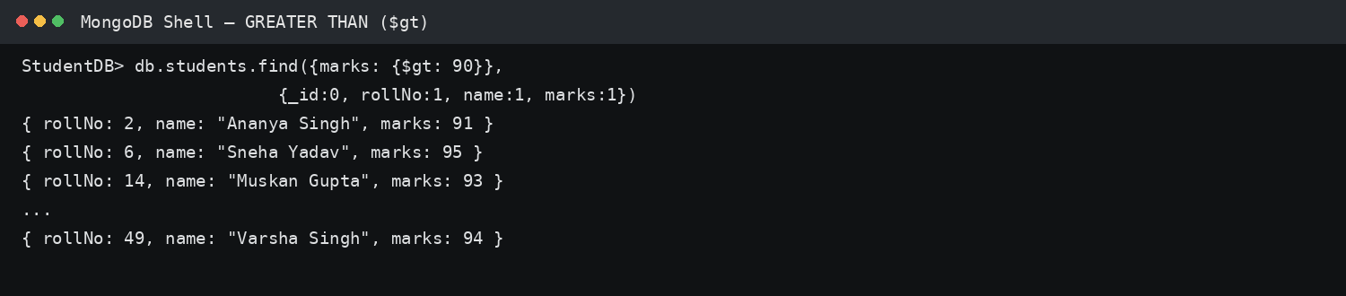
6. LESS THAN — $lt
Formula / Command:
db.students.find({marks: {$lt: 75}}, {_id:0, rollNo:1, name:1, marks:1})
Explanation: $lt means less than. This query displays students whose marks are below 75.
MongoDB Shell output screenshot:
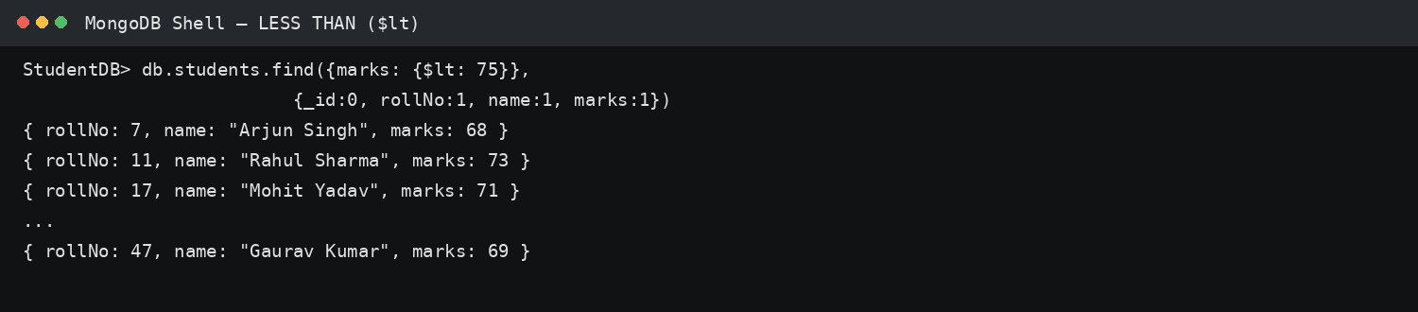
7. EQUAL TO — $eq
Formula / Command:
db.students.find({marks: {$eq: 90}}, {_id:0, rollNo:1, name:1, marks:1})
Explanation: $eq means equal to. This query displays students whose marks are exactly 90.
MongoDB Shell output screenshot:
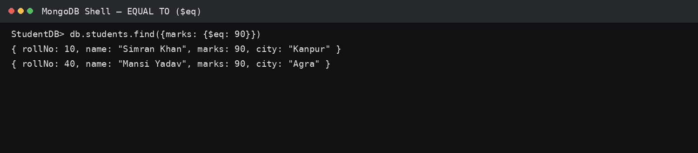
8. COMPARISON OPERATORS — QUICK REFERENCE
Operator | Meaning | Example
$eq | Equal to | {marks: {$eq: 90}}
$gt | Greater than | {marks: {$gt: 80}}
$lt | Less than | {marks: {$lt: 75}}
$gte | Greater than or equal to | {marks: {$gte: 80}}
$lte | Less than or equal to | {marks: {$lte: 75}}
$ne | Not equal to | {marks: {$ne: 90}}

