Preliminary Sizing using approximations:

MTOW: 10 kg

Payload weight: 10 kg

Structures: 4.98 kg (49% MTOW)

Motor/Prop + electronics: 0.739 kg

Vmax: 50kts = 25.72 m/s

Thrust expected at Cruise: 5.5 kg (55% MTOW)  
  
Motor: Tmotor-AT7215 (<https://store.tmotor.com/product/at7215-fixed-wing-motor.html>)

Battery: 10000 mAh (12S LiPo) (<https://genstattu.com/ta-30c-10000-12s1p-as150u.html>)

ESC: 180A HV (<https://www.premium-modellbau.de/t-motor-flame-180a-hv-v2.0-brushless-regler-6s-12s-multicopter-esc>)

Current at ~70% Throttle: 30 A

Flight Time: 20 minutes

Flight time with 20% buffer: ~ 16 mins

Assumption of Mission Profile Parameters

Cruise speed: 14.64 m/s

L/D during cruise = 17.94

Aircraft Constraint Analysis and Sizing Parameters



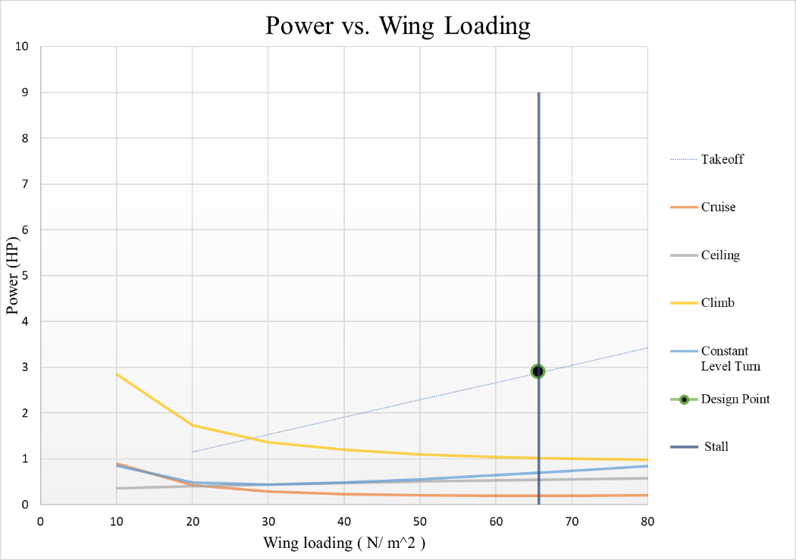

(W/S) @ chosen design point = 65.6 N / m^2

Wing Surface Area (S) = MTOW / (W/S) @ design point and is given by:



Drone Inertia Tensor:

$\left[\begin{matrix}Ixx & Ixy & Ixz \\ Iyx & Iyy & Iyz \\ Izx & Izy & Izz\end{matrix}\right]=\left[\begin{matrix}0.047 & 0 & 0.002 \\ 0.0 & 0.029 & 0 \\ 0.002 & 0 & 0.073\end{matrix}\right]$ kg m^2



Aircraft CoG in principal axis: 0.63 m

A static margin of 12% was chosen as a base assumption and the Neutral point (Xnp) and the CG (XCG) were calculated and matched with the previous section’s calculation of Aircraft CG.



Flap Design

We design flaps in such a way that the aircraft can takeoff successfully in the given conditions and avoid stall during taking or landing due to flow separation at high angles of attack.

**1. Establish Takeoff Performance Requirements**

* L $V_{LOF}=1.2 ∙ V_{STALL}$
* Assuming takeoff occurs at 50m.

$$Takeoff Lift coefficient, C_{L}=\frac{W}{\frac{1}{2}ρ_{50m}V_{LOF}^{2}S}$$

From this equation, we calculate the required $C_{L}$ ​ for takeoff.

This value is then compared with the $C_{L}$ of a wing in a clean configuration.

The flaps should increase the lift coefficient to meet this requirement.

The deflection angle is chosen based on the amount of lift increment needed.

Open source VLM softwares can be used to size the flap and measure its performance.

Increasing lift with flaps deployed also increases the total drag, which causes a penalty during takeoff We use the drag polar to detect Drag due to flaps during takeoff.

$$C_{D}=C_{D_{0}}+k{C_{L}}^{2}$$

Where $C_{D_{0}}$ is the parasitic drag, k is the induced drag factor and $C_{L}$ is the total lift during takeoff.

Evaluate the drag at takeoff conditions to ensure the aircraft can still accelerate within the 10-meter takeoff distance.

We equate this to the takeoff distance of 10m and thereby size the flap.

$$Takeoff Distance S_{TO}=\frac{W^{2}}{gρSC_{L} (T-D)}$$

Airfoil Selection

After choosing the respective design point, $\frac{W}{S}$ and $P_{req}$

The Required Aircraft Lift Coefficient can be calculated by

$$C_{L}=\frac{W}{\frac{1}{2}ρ_{50m}V^{2}S}$$

The airfoil lift coefficient can be calculated by $$C_{l}=\frac{C_{L}}{0.9∙\cos{Λ}}$$



Calculating the Reynolds number using $Re=\frac{ρϑl}{μ}$, we can find the required airfoil from airfoiltools.com

I have hence chosen GOE 502. (<http://airfoiltools.com/airfoil/details?airfoil=goe502-il>) which has the required Lift characteristics that choosen my design point.

References:

Reference / Hand Books

[1] Daniel P. Raymer, “Aircraft Design: A Conceptual Approach”, AIAA, 6th edition, ISBN

[2] Brandt S. et al, “Introduction to Aeronautics: A Design Perspective”, AIAA, 3rd edition,

ISBN (print): 978-1-62410-327-8

[3] Snorri Gudmundsson, “General Aviation Aircraft Design: Applied Methods and

Procedures”, Elsevier, 1st edition, ISBN: 97801239730385

[4] Mohammed H. Sadraey, “Aircraft Design: A Systems Engineering Approach”, A John

Wiley & Sons, Ltd., Publication, 1st edition, ISBN: 978-1-119-95340-1