ASHISH KUMAR DUBEY

17BIT0033

SLOT – TE2

LEAN STARTUP MANAGEMENT

ASSESSMENT - 01

1.

Innovation is basically defined as “novelty in idea, device or a method”. It can also be defined as the implementation of better ideas that meet the never-ending requirements or the existing market needs. This kind of innovation taken place by devising more-effective product, better processes, end to end services, advancement in technologies or effective business models that are easily accessible to the target audience.

Innovation is nothing but the practical implementation of invention.

UAV’s or drones are hunger demand products ever since its invention. It is because of the utilities that are contained in these flying copters which attract each and every age group and all cadre of the audience.

Utilisation of the UAV’s for strengthening the defence mechanism of our country is what makes the term innovation understood broadly by the start-up idea forge technology Pvt limited.

Developed by Ankit Mehra and team in 2008, this drone is capable of performing many high end battle field tasks to rescue operation loaded with surveillance camera undetectable body, object tracking system and in built antenna ,this product has become the most trusted unmanned surveillance system for the Indian defence system.

Existence of similar product in the market and the influence of international goods in the local market was the great challenge for the start-up. Here is where the role of innovation came into the play. The idea forge technology designed the world’s lightest UAV, weighing around 10gm in 2009.this made the start-up stand fall at the international platform and made itself the best choice for DRDO who was in search of such ignited minds, after analysing the defence mechanism of US army.

The device is equipped with high resolution camera for tracking, search and surveillance operation, inbuilt GPS to retrace its path to its source, low propeller sound frosting operation, silicon body which makes it invisible on radar, trans receiver system for sound capturing,16 hours of in air time and kilometres of r.c range, makes it different from its competitors.

Innovation is the sole factor which has lead to such distinct features in the product which has helped the start-up to create a firm hold over the market and has created its monopoly over the market.

The company launch the two different models of its product with varying features which helps the end user choose the product as per its requirement .the two models “netra” and “skybox” (fixed wing) are fully loaded UAV’s ,all set to serve the army. The companies tagline “create an inspire” is being fully justified by the efforts made to device new and better products.

The start-up instead of diluting its market by involving private buyers, kept focusing of the needs of the Indian defence system, and hence was able to uproot the Israel drone company, which was leading the market in 2013.

Innovation is a productive field adds value to the society and its people. Advancement done in technology for betterment of the society is always appreciated and gains market value very easily. The context in which the innovation happens is also equally happened. Innovations in the field of nature, security, defence , accessibility of services is believed to have an utter importance.

Defence system of any nation is also an important sector of innovation .This enables a country to safeguard its borders and also serve its people with ease.

Idea forge made its contribution in the field of Indian Defence System. The drone made by this startup is being utilized by the indian army since 2008. May it be rescue operation of Uttarakhand in 2013 or positioning of militants in 2016 surgical strike or even the surveillance of border region at all altitudes, these drones have proved themselves to be of high importance.

In order to keep up with the latest technology in the field of defence, startups like ideaforge should be encouraged and should be given platform to show their innovation for the betterment of human civilisation.

(544 words)

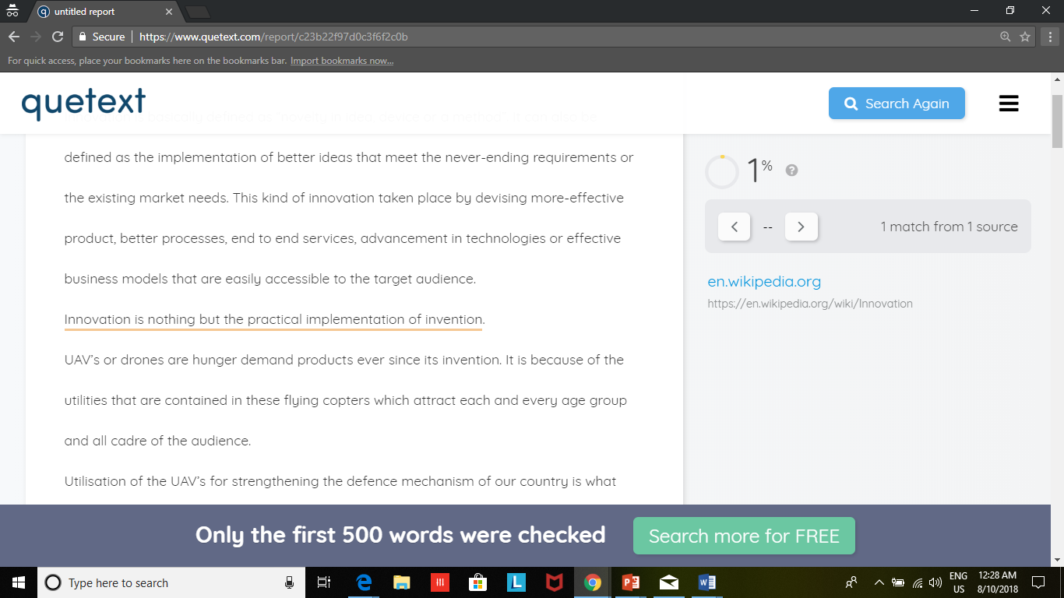

2.

Startups are human institution designed to create a new product or service under condition of extreme uncertainty. Any startup begins with a simple idea and if the factors are favourable, it flourishes to form a successful company. It is just like a seed which is sown but is uncertain about its growth and is dependent upon the availability of resources such as sunlight, water, nutrients and most importantly space . In the same manner, startups struggle for resources like sponsorship, manpower and most importantly market space.

The existing market monopoly has to be overcome by proposing new ideas, business models, better process, end to end services and proper marketing strategies . Anybody deciding to have its startup is bereft of the thoughts about the future of the startup, the investment required, the manpower needed, the marketing strategy.

The only thing that he is aware is the idea over which he is determined to start a new business. The term startup in itself says the initiation or the beginning. Once someone is upto making a beginning with novelty and idea is said to have a startup.

When the process of creating a product starts , then only one has the first interface with the market. Here is when the real definition of a startup begins.

A startup must perfectly define its size , sector of the economy , target audience ,manpower required, funds etc . so that establishment of the startup becomes easier.

The field of work for startups segregated into various sectors depending on the target and the market environment. These sectors, as defined by certain economists are, primary sectors which include agriculture, mining and other natural resources, industries. This sector is dependent more in nature for its resources hence are highly unpredictable. Once these startups take place, they become highly profitable for the entrepreneurs.

Other sector is secondary sector covering manufacturing, engineering and construction. This sector has the work of establishment of the primary sector; it contributes to the betterment of the living standards of the common people.

Tertiary sector focuses on the processing of the goods produced in the primary sectors, hence it is related to factories and industries. It has a direct connection with the primary sector. Therefore if the market turns around for the primary sector, it has an adverse effect on the tertiary sector too.

Quaternary sector involves development of intellectual stalls involving education and research. This sector helps in making new resource called the human resource. Training and education leads to creation of efficient manpower, which further contribute to the betterment of the society. It is one of the most valuable and profit earning startups now a days. This is because, it requires very less investment and high turnover.

The ultimate sector is reserved for high level decision maker in government and industries. This sector also involves the development and defence wing of the country. This sector has the people who decide the fate of the other sector and is really important sector. Ideaforge technology pvt. Ltd. Is a startup ventured by Ankit Mehta and his group in 2008. This company manufactures unmanned Arial vehicles or drones , which are now being used by the indian army for all sort of surveillance and rescue operations . This startup belongs to the quinnary sector as it contributes to the defence of the country and is backed by the government. Until 2007 the company was surrounded by uncertainties and was overcoming from many field venture to establish its control over the market . Ankit never believed himself to be an entrepreneur but the ups and downs of the market made him believe this fact. DRDO seen the progress of other nations in defence mechanism , brought the startup to the main stream and now it has the sole monopoly over the market.

According to me startup is defined as the initiative to convert an idea into a product by analysing the market need, economy sector , target audience and the competitors .

Once individual completes this analyses, he is all set to launch a startup which has the potential to witstand the market and provide the flawless service to the society. (560 words).

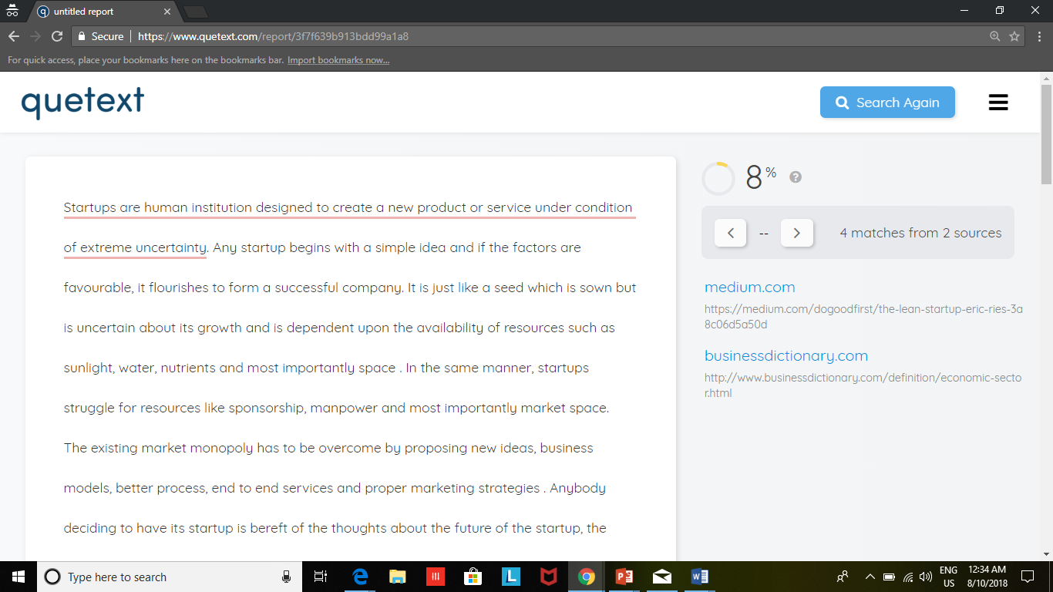

3.

A Startup is a human institution designed to create a new product or service under conditions of extreme uncertainty. Innovation is basically defined as novelty in idea, device or method. It can also be defined as the implementation of better ideas that meet the never-ending requirements or the existing market needs. These kind of innovation takes place by devising more effective product, better end-to-end services advancement in technologies for effective business models that are easily accessible to the target audience.

Any idea should be revised and then the implemented in order to establish a perfect company which earns profit for the entrepreneur. Beating about the bush never gives any desired output for the startup, rather the main concept should be focused.

Build-Measure-Learn loop acts as a life-saving handle for the startups. This enables the startup to turn the wheel at the right time in order to increase the profit percent at the correct time.

Build-Measure-Learn may sound simplistic, but it's been a game-changing technique for businesses that previously developed products without getting potential customers' input. Sometimes, companies would get lucky, but many wound up making sophisticated products that no one wanted. Build-Measure-Learn improves on the "just do it" approach with an incremental, iterative methodology that replaces assumption with knowledge and certainty.

The Build-Measure-Learn feedback loop consists of several steps namely plan, build, product, measure, data, learn. Each and every step of this cycle has it’s own role to play and skipping any of the step may lead to blunders in the further processing of the product.

Planning is the most important step in establishing a startup. The market analysis, need of the target audience, innovation in technology, funding and future scope should all be kept in mind before establishing any startup.

Next comes the build stage where the real product is designed and manufactured. The result of this stage is the finished product. The testing and debugging is also done in this step. This is when the product comes into play and implementation is completed.

Now comes the measurement stage. In this stage, the finished product is measured over several parameters and is judged over the current marketing environment. Here is when the product is almost ready to be launched to the market with basic modifications. It is the step which is followed every-time any product is launched into the market.

In the learn stage, the product is already in the market and the entrepreneurs and waiting for the public feedback which is awaited to make the ultimate modifications governing the needs of the society. By the time you reach this stage, you'll be equipped to make sound, evidence-based business decisions about what to do next.

There are then two ways forward:

* **Persevere:** Your hypothesis was correct, so you decide to press on with the same goals. You repeat the feedback loop to continuously improve and refine your idea.
* **Pivot:** The experiment has refuted your hypothesis, but you've still gained valuable knowledge about what doesn't work. You can reset, or correct your course and repeat the loop, using what you've learned to test new hypotheses and carry out different experiments.

Finally comes the prepare stage when the startup is old to the market and in this stage the startup is preparing for the changes or the modifications made to survive the requirements of the market.

If all these steps are followed efficiently then the startup is sure sort to emerge a success and is expected to lead the market in the coming days.

Hence, the product is not the sole concern of any startup but all the Build-Learn-Measure Feedback loop is important to follow. (550 words).