PROJECT ON VOCATIONAL TRAININING
AT
BSNL, JAMSHEDPUR

21/05/2018 to 15/06/2018



ASHISH KUMAR DUBEY
INFORMATION TECHNOLOGY
VIT VELLORE

BONAFIDE

This is to certify that Ashish Kumar Dubey of 2th Semester B.E (INFORMATION TECHNOLOGY) VIT VELLORE, TAMIL NADU has successfully undergone practical training from 21/05/2018 to 15/06/2018 in BSNL Jamshedpur. His conduct throughout the period was satisfactory and he was a good asset to our institution. We highly appreciate the effort and the initiatives taken by him during the training, in the process he has gained handy knowledge about the internal and external systems and working of this institution.

Date:-
NODAL OFICER
&
JTO (I/C), IT Cell
Main Telephone Exchange
Jamshedpur

ACKNOWLEDGEMENT

I thank the GMTD Jamshedpur, Mr. Sanjeev Verma for allowing us to undergo Vocational Training in BSNL Jamshedpur . Moreover, I wish to extend our gratitude to Mr. V. M. Kanth, DE (Internal), Nodal Officer for Vocational Training Mr. V. K. Kauntia JTO (IT), Ms. Swati Toppo JE and Mr. B. K. Ram PS to GMTD who were a constant source of information and help. I would also wish to thank Mr. Umashankar Sharma JTO (NIB/BB), Mr. Mannan Ali SDE (LL), Mr. P. Ramu SDE (OCB), Mrs. Priyanka Verma JTO(OCB), Mr. Anand (JTO) who all delivered very good lectures and guided us every moment throughout our training period. Last but not the least we would like to thank all the staff members of BSNL (Garamnala, Jamshedpur) without their co-operation this training would not have been possible.

Signature of Trainee-

Name Of Institution :- VIT VELLORE, TAMIL NADU

CONTENTS

1. INTRODUCTION
2. TELECOMMUNICATION NETWORK
3. TELEPHONE EXCHANGE
4. MDF
5. POWER PLANT
6. IP ADDRESS
7. BROADBAND
8. GLOBAL SYSTEM FOR MOBILE COMMUNICATION
9. 3G NETWORK
10. WIMAX
11. FIBER OPTICS
12. LEASED LINE
13. CONCLUSION
14. BIBLIOGRAPHY

INTRODUCTION

Bharat Sanchar Nigam Limited (abbreviated BSNL) is an Indian state-owned telecommunications company headquartered in New Delhi. It was incorporated on 15 September 2000 and assumed the business of providing telecom services and network management from the erstwhile Central Government Departments of Telecom Services (DTS) and Telecom Operations (DTO) as of 1 October 2000 on a going-concern basis. It is the largest provider of fixed telephony and broadband services with more than 60% market share, and is the fifth largest mobile telephony provider in India.

It has the share of mani-ratna, a status to reputed public sector companies in India. BSNL is India's oldest communication service provider and had a customer base of 93.29 million as of June 2015.

BSNL Mobile is a major provider of GSM cellular mobile services under the brand name Cellone. BSNL provides a complete telecom services solution to enterprise customers including MPLS, P2P and Internet leased lines. It provides fixedline services and landline using CDMA technology and its own extensive optical fiber network. BSNL provides Internet access services through dial-up connections as prepaid, NetOne as Postpaid and DataOne as BSNL Broadband.

BSNL offers value-added services such as Free Phone Service (FPH), India Telephone Card (Prepaid card), Account Card Calling (ACC), Virtual Private Network (VPN), Tele-voting, Premium Rate Service (PRM) and Universal Access Number (UAN). BSNL also offers the IPTV which enables customers to watch television through the Internet and Voice and Video Over Internet Protocol (VVoIP). In 2007, BSNL announced plans to provide 5 million broadband connections and secured 80% of the INR 25 billion rural telephony project of the Government of India. On 20 March 2009, BSNL launched blackberry services across India. BSNL paid Rs. 101.87 billion for 3G spectrum in 2010. As of 2011, BSNL offered coverage in over 800 cities across India. BSNL launched in 2012 a 3G wireless pocket-sized router called Winknet Mf50. BSNL 3G provides HSPA+ service with a top speed of 21.1 Mbit/s downlink and 5.76 Mbit/s uplink.

Telecommunication Network

A telecommunications network is a collection of terminal nodes; links are connected so as to enable telecommunication between the terminals. The transmission links connect the nodes together. The nodes use circuit switching, message switching or packet switching to pass the signal through the correct links and nodes to reach the correct destination terminal.
Each terminal in the network usually has a unique address so messages or connections can be routed to the correct recipients. The collection of addresses in the network is called the address space.
Examples of telecommunications networks are:
- computer networks
- the internet
- the telephone network
- the global Telex network
- the aeronautical ACARS network

BENEFITS OF TELECOMMUNICATION NETWORK

Telecommunications facilitates interaction and information transfer over large distances. Businesses use telecommunications to expand and grow their networks. With Internet, computer, and telephone networks, businesses can allocate their resources efficiently. These core types of networks will be discussed below:
- Computer network: a computer network consists of computers and devices connected to one another. Information can be transferred from one device to the next. For example, an office filled with computers can share files together on each separate device. Computer networks can range from a local area network (LAN) to a wide area network (WAN). The difference between the types of networks is the size. These types of computer networks work at certain speeds, also known as broadband. The Internet network connects computers worldwide.
- Internet network: access to the network allows users to use many resources. Over time the Internet network will replace books. This will enable users to discover information almost instantly and apply concepts to different situations. The Internet can be used for recreational, governmental, educational, and other purposes. Businesses in particular use the Internet network for research or to service customers and clients.
- Telephone network: the telephone network connects people to one another. This network can be used in a variety of ways. Many businesses use the telephone network to route calls and/or service their customers. Some businesses use a telephone network on a greater scale through a private branch exchange. It is a system where a specific business focuses on routing and servicing calls for another business. Majority of the time, the telephone network is used around the world for recreational purposes.

TELEPHONE EXCHANGE

A telephone exchange is a telecommunications system used in the public switched telephone network or in large enterprises. An exchange consists of electronic components and in older systems also human operators that interconnect (switch) telephone subscriber lines or virtual circuits of digital systems to establish telephone calls between subscribers.
In historical perspective, telecommunication terms have been used with different semantics over time. The term telephone exchange is often used synonymously with central office (CO), a Bell System term. Often, a central office is defined as a building used to house the inside plant equipment of potentially several telephone exchanges, each serving a certain geographical area. Such an area has also been referred to as the exchange. Central office locations may also be identified in North America as wire centers, designating a facility from which a telephone obtains dial tone. For business and billing purposes, telephony carriers also define rate centers, which in larger cities may be clusters of central offices, to define specified geographical locations for determining distance measurements.
In the United States and Canada, the Bell System established in the 1940s a uniform system of identifying central offices with a three-digit central office code, that was used as a prefix to subscriber telephone numbers. All central offices within a larger region, typically aggregated by state, were assigned a common numbering plan area code. With the development of international and transoceanic telephone trunks, especially driven by direct customer dialing, similar efforts of systematic organization of the telephone networks occurred in many countries in the mid-20th century.
For corporate or enterprise use, a private telephone exchange is often referred to as a private branch exchange (PBX), when it has connections to the public switched telephone network. A PBX is installed in enterprise facilities, typically collocated with large office spaces or within an organizational campus to serve the local private telephone system and any private leased line circuits. Smaller installations might deploy a PBX or key telephone system in the office of a receptionist.
Many terms used in telecommunication technology differ in meaning and usage among the various English speaking regions. For the purpose of this article the following definitions are made:
- Manual service is a condition in which a human telephone operator routes calls inside an exchange without the use of a dial.
- Dial service is when an exchange routes calls by a switch interpreting dialed digits.
- A telephone switch is the switching equipment of an exchange.
- A concentrator is a device that concentrates traffic, be it remote or co-located with the switch.
- An off-hook condition represents a circuit that is in use, e.g., when a phone call is in progress.
- An on-hook condition represents an idle circuit, i.e. no phone call is in progress.
- A wire center is the area served by a particular switch or central office.
Central office originally referred to switching equipment and its operators, it is also used generally for the building that houses switching and related inside plant equipment. In United States telecommunication jargon, a central office (C.O.) is a common carrier switching center Class 5 telephone switch in which trunks and local loops are terminated and switch. In the UK, a telephone exchange means an exchange building, and is also the name for a telephone switch.
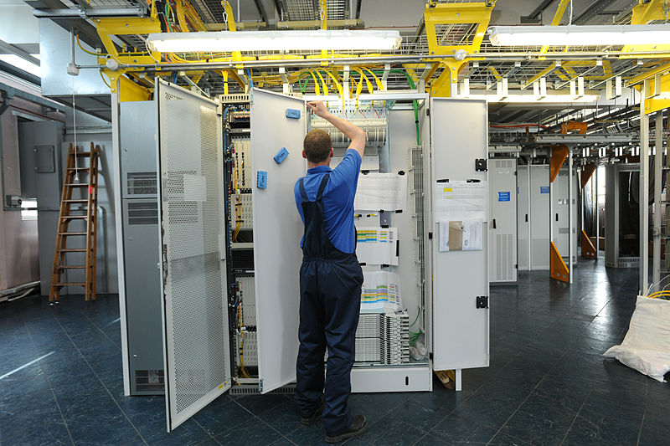

MAIN DISTRIBUTION FRAME
In telephony, a main distribution frame (MDF or main frame) is a signal distribution frame for connecting equipment to cables and subscriber carrier equipment .The MDF is a termination point within the local telephone exchange where exchange equipment and terminations of local loops are connected by jumper wires at the MDF. All cable copper pairs supplying services through user telephone lines are terminated at the MDF and distributed through the MDF to equipment within the local exchange e.g. repeaters and DSLAM. Cables to intermediate distribution frames (IDF) terminate at the MDF. Trunk cables may terminate on the same MDF or on a separate trunk main distribution frame (TMDF).
Like other distribution frames the MDF provides flexibility in assigning facilities, at lower cost and higher capacity than a patch panel.
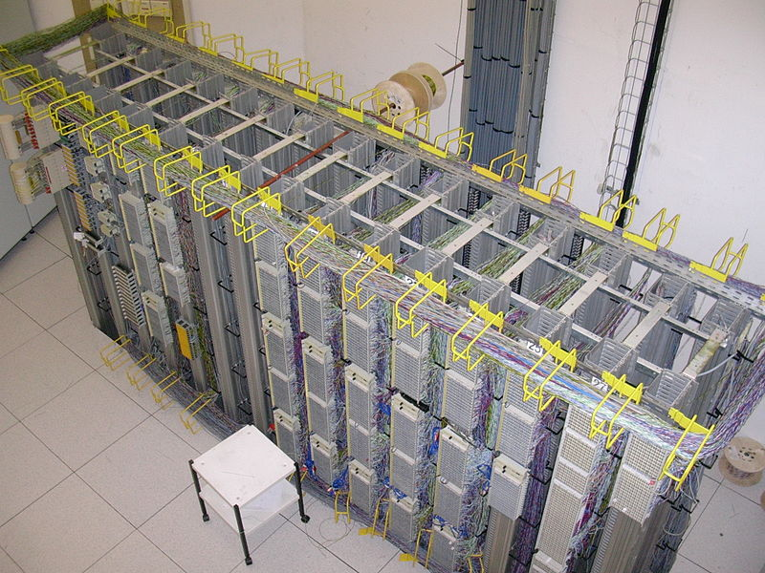
The most common kind of large MDF is a long steel rack accessible from both sides. On one side, termination blocks are arranged horizontally at the front of rack shelves. Jumpers lie on the shelves and go through an insulated steel hoop to run vertically to other termination blocks that are arranged vertically. There is a hoop or ring at the intersection of each level and each vertical. Installing a jumper historically required two workers, one on either side of the MDF. The shelves are shallow enough to allow the rings to be within arm's reach, but the workers prefer to hang the jumper on a hook on a pole so their partner can pull it through the ring. A fanning strip at the back of each termination block prevents the wires from covering each other's terminals. With disciplined administration the MDF can hold over a hundred thousand jumpers, with dozens changed every day, for decades without tangling.
The MDF usually holds telephone exchange protective devices including heat coils, and functions as a test point between a line and the exchange equipment.

POWER PLANT

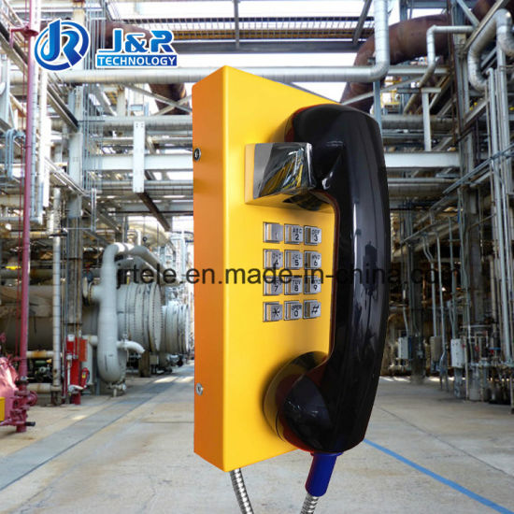
As we know that, the power of any organization. The first requirement of any organization is the input, the main source of this exchange is AC supply. Here AC input is converted into desired DC voltage (-48V DC).
The power plant of any telecommunication system is usually referred as the heart of the installation since the communication system can function only as long as power supply is available. Failure of power supply system in any installation renders the communication facilities offered by it to be instantly paralyzed.
The Support power system in BSNL
- Power plant: To convert ac input into desired dc output (-48 V dc)
- Battery system: To give a backup supply load in case commercial supply is not available.
- DG Set: Alternative supply to battery backup. The power plant has the capability to recharge the battery once as discharged.

Requirement of power supply:

- Reliability of the components of the power plant and continuity of the power supply.
- The power fed to the exchange equipment should be free from noise or hum and to telegraph equipment from large ripple harmonics.

An Internet Protocol address (IP address) is a numerical label assigned to each device connected to a computer network that uses the Internet Protocol for communication. An IP address serves two principal functions: host or network interface identification and location addressing.
Internet Protocol version 4 (IPv4) defines an IP address as a 32-bit number. However, because of the growth of the Internet and the depletion of available IPv4 addresses, a new version of IP (IPv6), using 128 bits for the IP address, was developed in 1995, and standardized in December 1998. In July 2017, a final definition of the protocol was published. IPv6 deployment has been ongoing since the mid-2000s.
IP addresses are usually written and displayed in human-readable notations, such as 172.16.254.1 in IPv4, and 2001:db8:0:1234:0:567:8:1 in IPv6. The size of the routing prefix of the address is designated in CIDR notation by suffixing the address with the number of significant bits, e.g., 192.168.1.15/24, which is equivalent to the historically used subnet mask 255.255.255.0.
The IP address space is managed globally by the Internet Assigned Numbers Authority (IANA), and by five regional Internet registries (RIRs) responsible in their designated territories for assignment to end users and local Internet registries, such as Internet service providers. IPv4 addresses have been distributed by IANA to the RIRs in blocks of approximately 16.8 million addresses each. Each ISP or private network administrator assigns an IP address to each device connected to its network. Such assignments may be on a static (fixed or permanent) or dynamic basis, depending on its software and practices.

IP VERSIONS
Two versions of the Internet Protocol are in common use in the Internet today. The original version of the Internet Protocol that was first deployed in 1983 in the ARPANET, the predecessor of the Internet, is Internet Protocol version 4 (IPv4).
The rapid exhaustion of IPv4 address space available for assignment to Internet service providers and end user organizations by the early 1990s, prompted the Internet Engineering Task Force (IETF) to explore new technologies to expand the addressing capability in the Internet. The result was a redesign of the Internet Protocol which became eventually known as Internet Protocol Version 6 (IPv6) in 1995. IPv6 technology was in various testing stages until the mid-2000s, when commercial production deployment commenced.
Today, these two versions of the Internet Protocol are in simultaneous use. Among other technical changes, each version defines the format of addresses differently. Because of the historical prevalence of IPv4, the generic term IP address typically still refers to the addresses defined by IPv4. The gap in version sequence between IPv4 and IPv6 resulted from the assignment of version 5 to the experimental Internet Stream Protocol in 1979, which however was never referred to as IPv5.

IP V4 ADDRESS

An IPv4 address has a size of 32 bits, which limits the address space to 4294967296 (2³²) addresses. Of this number, some addresses are reserved for special purposes such as private networks (~18 million addresses) and multicast addressing (~270 million addresses).
IPv4 addresses are usually represented in dot-decimal notation, consisting of four decimal numbers, each ranging from 0 to 255, separated by dots, e.g., 172.16.254.1. Each part represents a group of 8 bits (an octet) of the address. In some cases of technical writing, IPv4 addresses may be presented in various hexadecimal, octal, or binary representations.

IP V6 ADDRESS

In IPv6, the address size was increased from 32 bits in IPv4 to 128 bits or 16 octets, thus providing up to 2¹²⁸ (approximately 3.403×10³⁸) addresses. This is deemed sufficient for the foreseeable future.
The intent of the new design was not to provide just a sufficient quantity of addresses, but also redesign routing in the Internet by more efficient aggregation of subnetwork routing prefixes. This resulted in slower growth of routing tables in routers. The smallest possible individual allocation is a subnet for 2⁶⁴ hosts, which is the square of the size of the entire IPv4 Internet. At these levels, actual address utilization ratios will be small on any IPv6 network segment. The new design also provides the opportunity to separate the addressing infrastructure of a network segment, i.e. the local administration of the segment's available space, from the addressing prefix used to route traffic to and from external networks. IPv6 has facilities that automatically change the routing prefix of entire networks, should the global connectivity or the routing policy change, without requiring internal redesign or manual renumbering.
The large number of IPv6 addresses allows large blocks to be assigned for specific purposes and, where appropriate, to be aggregated for efficient routing. With a large address space, there is no need to have complex address conservation methods as used in CIDR.
All modern desktop and enterprise server operating systems include native support for the IPv6 protocol, but it is not yet widely deployed in other devices, such as residential networking routers, voice over IP (VoIP) and multimedia equipment, and network peripherals.

BROADBAND
In general, broadband refers to telecommunication in which a wide band of frequencies is available to transmit information. Because a wide band of frequencies is available, information can be multiplexed and sent on many different frequencies or channels within the band concurrently, allowing more information to be transmitted in a given amount of time (much as more lanes on a highway allow more cars to travel on it at the same time).
It is generally agreed that Digital Subscriber Line (DSL) and cable TV are broadband services in the downstream direction. As of February, 2015, the United States Federal Communications Commission's (FCC’s) benchmark for broadband data transfer rates is 25 megabits-per-second for downloads and 3 Mbps for uploads.
In telecommunications, broadband is wide bandwidth data transmission which transports multiple signals and traffic types. The medium can be coaxial cable, optical fiber, radio or twisted pair.
In the context of Internet access, broadband is used to mean any high-speed Internet access that is always on and faster than dial-up access over traditional analog or ISDN PSTN services.

FEATURES:

- Large Bandwidth
- High speed internet access
- More uptime
- Highly acceptable for business purpose
- Low overall cost

GSM

GSM (Global System for Mobile communications) is a standard developed by the European Telecommunications Standards Institute (ETSI) to describe the protocols for second-generation digital cellular networks used by mobile devices such as tablets, first deployed in Finland in December 1991. As of 2014, it has become the global standard for mobile communications – with over 90% market share, operating in over 193 countries and territories.
In wireless communication every region is divided into cells. Cell size is a constant for whole system. GSM is a form of multiplexing, which divides the available bandwidth among the different channels. GSM differs from its predecessor technologies in that both signaling and speech channels are digital and thus GSM is considered a second generation (2G) mobile phone system.
2G networks developed as a replacement for first generation (1G) analog cellular networks, and the GSM standard originally described as a digital, circuit-switched network optimized for full duplex voice telephony. This expanded over time to include data communications, first by circuit-switched transport, then by packet data transport via GPRS (General Packet Radio Services) and EDGE (Enhanced Data rates for GSM Evolution, or EGPRS).
Mobile services based on GSM technology were first launched in Finland in 1991. Today, more than 690 mobile networks provide GSM services across 213 countries and GSM represents 82.4% of all global mobile connections. According to GSM World, there are now more than 2 billion GSM mobile phone users worldwide. GSM World
references China as "the largest single GSM market, with more than 370 million users, followed by Russia with 145 million, India with 83 million and the USA with 78 million users." Since many GSM network operators have roaming agreements with foreign operators, users can often continue to use their mobile phones when they travel to other countries. SIM card (Subscriber Identity Module) holding home network access configurations may be switched to those will metered local access, significantly reducing roaming costs while experiencing no reductions in service.
Subsequently, the 3GPP developed third-generation (3G) UMTS standards, followed by fourth-generation (4G) LTE Advanced standards, which do not form part of the ETSI GSM standard.
"GSM" is a trademark owned by the GSM Association. It may also refer to the (initially) most common voice codec used, Full Rate.

3G NETWORKS

3G, short for third generation, is the third generation of wireless mobile telecommunications technology. It is the upgrade for 2G and 2.5G GPRS networks, for faster internet speed. This is based on a set of standards used for mobile devices and mobile telecommunications use services and networks that comply with the International Mobile Telecommunications-2000 (IMT-2000) specifications by the International Telecommunication Union. 3G finds application in wireless voice telephony, mobile Internet access, fixed wireless Internet access, video calls and mobile TV.
3G telecommunication networks support services that provide an information transfer rate of at least 0.2 Mbit/s. Later 3G releases, often denoted 3.5G and 3.75G, also provide mobile broadband access of several Mbit/s to smartphones and mobile modems in laptop computers. This ensures it can be applied to wireless voice telephony, mobile Internet access, fixed wireless Internet access, video calls and mobile TV technologies.
A new generation of cellular standards has appeared approximately every tenth year since 1G systems were introduced in 1979 and the early to mid-1980s. Each generation is characterized by new frequency bands, higher data rates and non–backward-compatible transmission technology. The first 3G networks were introduced in 1998 and fourth generation 4G networks in 2008.
Some of the applications are:
- Global Positioning System (GPS)
- Location-based services
- Mobile TV
- Telemedicine
- Video Conferencing
- Video on demand.
Its features:
- More bandwidth
- Security
- Reliability
- Instant Messaging
- Always online device
- Rich multimedia

WIMAX

WiMAX (Worldwide Interoperability for Microwave Access) is a family of wireless communication standards based on the IEEE 802.16 set of standards, which provide multiple physical layer (PHY) and Media Access Control (MAC) options. The name "WiMAX" was created by the WiMAX Forum, which was formed in June 2001 to promote conformity and interoperability of the standard, including the definition of predefined system profiles for commercial vendors. The forum describes WiMAX as "a standards based technology enabling the delivery of last mile wireless broadband access as an alternative to cable and DSL". IEEE 802.16m or Wireless MAN Advanced was a candidate for the 4G, in competition with the LTE Advanced standard. WiMAX was initially designed to provide 30 to 40 mbps data rates, with the 2011 update providing up to 1 Gbit/s for fixed stations.
Uses of WiMAX The bandwidth and range of WiMAX make it suitable for the following potential applications:
- Providing portable mobile broadband connectivity across cities and countries through various devices
- Providing a wireless alternative to cable and digital subscriber line (DSL) for "last mile" broadband access
- Providing data, telecommunications (VoIP) and IPTV services (triple play)
- Providing Internet connectivity as part of a business continuity plan
- Smart grids and metering
Internet access: - WiMAX can provide at-home or mobile Internet access across whole cities or countries. In many cases this has resulted in competition in markets which typically only had access through an existing incumbent DSL (or similar) operator. Additionally, given the relatively low costs associated with the deployment of a WiMAX network (in comparison with 3G, HSDPA, xDSL, HFC or FTTx), it is now economically viable to provide last-mile broadband Internet access in remote locations.
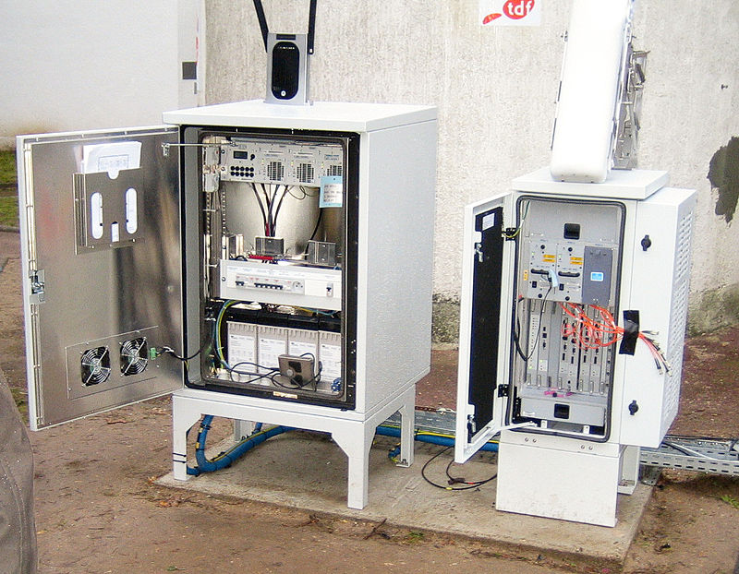

LEASED LINE

A leased line is a private bidirectional or symmetric telecommunications circuit between two or more locations provided in exchange for a monthly rent. Sometimes known as a private circuit or data line in the UK. Unlike traditional PSTN lines they do not have telephone numbers, each side of the line being permanently connected and dedicated to the other. Leased lines can be used for telephone, Internet, or other data services. Some are ring down services, and some connect to a private branch exchange or router. Typically, leased lines are used by businesses to connect geographically distant offices. Unlike dial-up connections, a leased line is always active. The fee for the connection is a fixed monthly rate. The primary factors affecting the monthly fee are distance between end points and the speed of the circuit. Because the connection does not carry anybody else's communications, the carrier can assure a given level of quality. An Internet leased line is a premium Internet connectivity product, normally delivered over fiber, which provides uncontended, symmetrical speeds with full duplex. It is also known as an ethernet leased line, dedicated line, data circuit or private line.
For example, a T1 can be leased and provides a maximum transmission speed of 1.544 Mbit/s. The user can channelize the T1 to separate the 24 DS0 circuits for voice communication, partial the T1 for data and voice communications, or multiplex the channels into a single data circuit. Leased lines, as opposed to DSL, are being used by companies and individuals for Internet access because they afford faster data transfer rates and are cost-effective for heavy users of the Internet.

APPLICATIONS:

Leased lines are used to build up private networks, private telephone networks (by interconnecting PBXs) or access the internet or a partner network (extranet).
Here is a review of the leased-line applications in network designs over time:

Site to site data connectivity
Terminating a leased line with two routers can extend network capabilities across sites. Leased lines were first used in the 1970s by businesses with proprietary protocols such as IBM System Network Architecture and Digital Equipment DECnet, and with TCP/IP in University and Research networks before the Internet became widely available (note; other Layer 3 protocols were used such as Novell IPX on enterprise networks until TCP/IP became ubiquitous in the 2000s. Today, point to point data circuits are typically provisioned as either TDM, Ethernet, or Layer 3 MPLS).

Site to site PBX connectivity
Terminating a leased line with two PBX allowed customers to by-pass PSTN for inter-site telephony. This allowed customers to manage their own dial plan (and to use short extensions for internal telephone number) as well as to make significant savings if enough voice traffic was carried across the line (especially when the savings on the telephone bill exceeded the fixed cost of the leased line).

Site to network connectivity
As demand grew on data network telcos started to build more advanced networks using packet switching on top of their infrastructure. A number of telecommunication companies added ATM, Frame-relay or ISDN offerings to their services portfolio. Leased lines were used to connect the customer site to the telco network access point.

International private leased circuit
An international private leased circuit (IPLC) functions as a point-to-point private line. IPLCs are usually time-division multiplexing (TDM) circuits which utilize the same circuit amongst many customers. The nature of TDM requires the use of a CSU/DSU and a router. Usually the router will include the CSU/DSU.
Beginning with the rise Internet (in the mid-1990s) and since , the most common application for leased line is to connect a customer to its ISP point of presence. With the changes the Internet brought in the networking world, other technologies were developed to propose alternatives to frame-relay or ATM networks such as VPNs (hardware and software) and MPLS networks (that are in effect an upgrade to TCP/IP of existing ATM/frame-relay infrastructures).

Types of leased line

1. Traditional leased line
2. Managed leased line

Managed leased line-
The MLLN is a Managed Leased Line Network system which provides a variable bandwidth leased line connectivity. The state of the art technology equipment MLLN is designed mainly for having effective control on the leased line so that the down time is very much minimized. This mainly supports with the data circuits ranging from 64 KBPs to 2048KBPs. These leased lines can carry voice, data and video and can be used for connecting telephone sets, computers, electronic private automatic branch exchange (EPABX) and for establishing a virtual private network (VPN). These lines are exclusive for the designated user and are particularly not shared in common amongst multiple users as dial-up lines.
Such ordinary leased lines are not very efficient and have lots of disadvantages such as limited range of services, bandwidth support only up to 64kbps (2.4kbps, 4.8kbps, 9.6kbps and 64kbps), no support for n×64kbps bandwidth provisioning, cumbersome operation and vendor-specific equipment.

Applications of MLLN
Managed leased line network (MLLN) is a system that can provide leased line connectivity, that is, a dedicated telecommunication path between two fixed points. It is an integrated, fully managed, multi-service digital network platform through which a service provider can offer a wide range of services at an optimal cost to business subscribers. MLLN allows the service provider to keep an end-to-end control and monitor over the leased line and hence provide guarantees of uptime of the circuit.
With the use of managed leased line circuits by various sectors such as banking and financial institutions, stock markets, news and print media industry, broadcasting houses and Internet service providers (ISPs), people of all the sections are benefitted by way of accessibility of bank accounts from anywhere, instant news coverage, faster Internet access, etc.
The applications/services offered by MLLN are
1. Speech circuits (hot line or P-wire). Dedicated telecom links for speech, say, hot line for voices between two different locations is established by local or long distance circuits within a city or between two different cities. The terminating equipment at both ends is telephone set without dialing facility. In such a connection, both-way signaling and speech is possible.
2. Data circuits. Dedicated local or long-distance point-to-point or point-to-multipoint data circuits at different speeds, namely, n×64kbps and up to 2Mbps can be offered for different bandwidth needs of the customer. MLLN offers flexibility of providing leased circuits with speeds of n×64kbps and up to 2Mbps with differential time-dependent bandwidth provisioning.
3. Private data network. More than one local or long distance leased circuit can be provided such that data from one leased circuit can be transferred automatically to another leased circuit for the same subscriber.
4. International leased circuits. International long distance leased circuits can be offered for business across the globe, which are useful for Internet leased lines and international private leased circuits (IPLCs).

The MLLN also supports enhanced features such as corporate hi-speed Internet access, EPABX interconnection, EPABX remote extension (EPABX of one city can be connected to EPABX of another city), ISDN (integrated services digital network) line extension, virtual private network (VPN), local area network (LAN) interconnection (LAN of one city can be connected to LAN of another city) and extension of VPN to customer through MLLN. A typical MLLN system connecting various facilities of a customer.

optical fiber

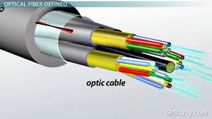
An optical fiber is a flexible, transparent fiber made by drawing glass (silica) or plastic to a diameter slightly thicker than that of a human hair. Optical fibers are used most often as a means to transmit light between the two ends of the fiber and find wide usage in fiber-optic communications, where they permit transmission over longer distances and at higher bandwidths (data rates) than electrical cables. Fibers are used instead of metal wires because signals travel along them with less loss; in addition, fibers are immune to electromagnetic interference, a problem from which metal wires suffer excessively. Fibers are also used for illumination and imaging, and are often wrapped in bundles so they may be used to carry light into, or images out of confined spaces, as in the case of a fiberscope. Specially designed fibers are also used for a variety of other applications, some of them being fiber optic sensors and fiber lasers.
Optical fibers typically include a core surrounded by a transparent cladding material with a lower index of refraction. Light is kept in the core by the phenomenon of total internal reflection which causes the fiber to act as a waveguide. Fibers that support many propagation paths or transverse modes are called multi-mode fibers, while those that support a single mode are called single-mode fibers (SMF). Multi-mode fibers generally have a wider core diameter and are used for short-distance communication links and for applications where high power must be transmitted. Single-mode fibers are used for most communication links longer than 1,000 meters (3,300 ft).
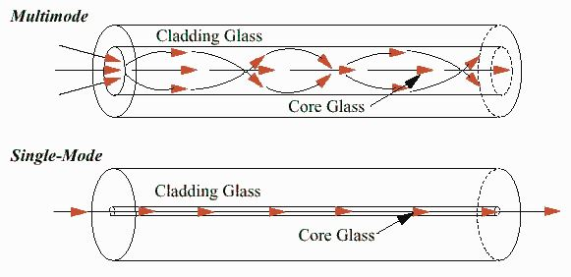
Being able to join optical fibers with low loss is important in fiber optic communication. This is more complex than joining electrical wire or cable and involves careful cleaving of the fibers, precise alignment of the fiber cores, and the coupling of these aligned cores. For applications that demand a permanent connection a fusion splice is common. In this technique, an electric arc is used to melt the ends of the fibers together. Another common technique is a mechanical splice, where the ends of the fibers are held in contact by mechanical force. Temporary or semi-permanent connections are made by means of specialized optical fiber connectors.

Modes Of Propagation: -
- Single mode optical fibres
- Multi-mode optical fibres

SINGLE MODE OPTICAL FIBRE

In fiber-optic communication, a single-mode optical fiber (SMF) is an optical fiber designed to carry light only directly down the fiber - the transverse mode. Modes are the possible solutions of the Helmholtz equation for waves, which is obtained by combining Maxwell's equations and the boundary conditions. These modes define the way the wave travels through space, i.e. how the wave is distributed in space. Waves can have the same mode but have different frequencies. This is the case in single-mode fibers, where we can have waves with different frequencies, but of the same mode, which means that they are distributed in space in the same way, and that gives us a single ray of light. Although the ray travels parallel to the length of the fiber, it is often called transverse mode since its electromagnetic oscillations occur perpendicular (transverse) to the length of the fiber.

MULTIMODE OPTICAL FIBER
Multi-mode optical fiber is a type of optical fiber mostly used for communication over short distances, such as within a building or on a campus. Typical multi-mode links have data rates of 10 Mbit/s to 10 Gbit/s over link lengths of up to 600 meters (2000 feet). Multi-mode fiber has a fairly large core diameter that enables multiple light modes to be propagated and limits the maximum length of a transmission link because of modal dispersion.

Applications

The equipment used for communications over multi-mode optical fiber is less expensive than that for single-mode optical fiber. Typical transmission speed and distance limits are 100 Mbit/s for distances up to 2 km (100BASE-FX), 1 Gbit/s up to 1000 m, and 10 Gbit/s up to 550 m.
Because of its high capacity and reliability, multi-mode optical fiber generally is used for backbone applications in buildings. An increasing number of users are taking the benefits of fiber closer to the user by running fiber to the desktop or to the zone. Standards-compliant architectures such as Centralized Cabling and fiber to the telecom enclosure offer users the ability to leverage the distance capabilities of fiber by centralizing electronics in telecommunications rooms, rather than having active electronics on each floor.\

Advantages
- Thinner than other tubes
- Less expensive
- High carrying capacity
- Provides a very large Bandwidth
- Less signal distortion
- Light weight

Disadvantages

- Expensive over short distances
- Very high installation charges
- Adding additional nodes is difficult
- Demands high skills

CONCLUSION

Engineering student will have to serve in public and private sector and workshop based training has its own limitations. The lack of expo sure to real life and functioning of industrial organization is the measure hindrance in student employment. Practical training is one of the major steps in this direction. I did my training from BSNL, Jamshedpur which is one of the best known communication service provider companies of India. The training helps me in gaining the deep knowledge of working of telephone exchange, various technologies of BSNL-GSM, GPRS, SIM, WIFI and optical fibre transmission. In the end I hereby conclude that I have successfully completed my industrial training on above topics.

BIBLIOGRAPHY

- Google.com
- Wikipedia
- Study material

