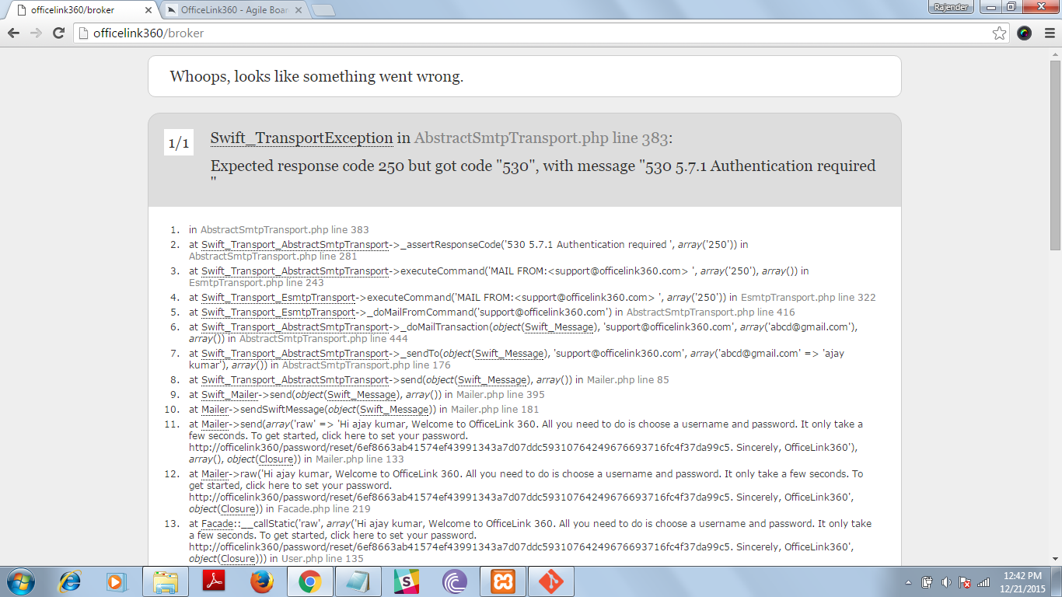

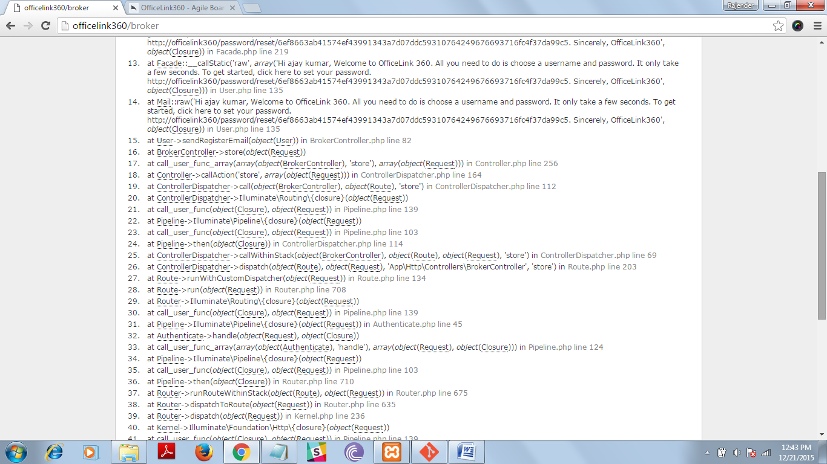

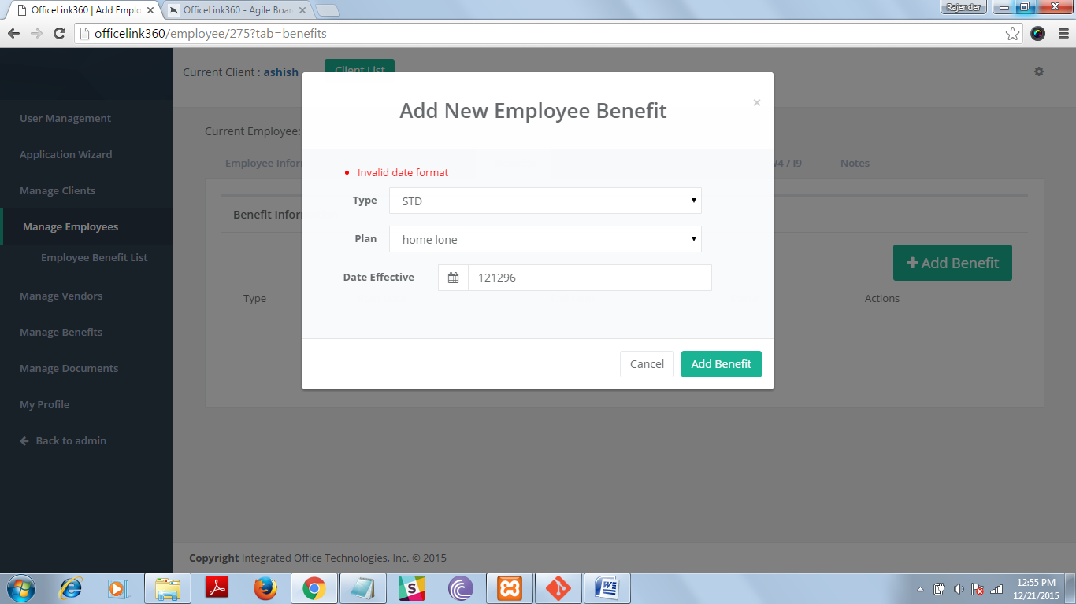

our vision

Our vision is to establish a state of the art design, manufacturing and services capability delivering unconditional quality and value to customers through:

* An ethical work environment with integrity at the core
* Culture of creativity and collaboration
* Leveraging technology and tightly integrating it with talent
* Respectful and harmonious relationship with nature
* Attaining, retaining and refining operational excellence using the culture and infrastructure created

### careers at DigitalFox

DigitalFox provides a stimulating and dynamic work environment that encourages initative and promotes creativity and professional growth.

For employment oppurtunities, please send your resume to [hello@digitalfox.co](mailto:hello@digitalfox.co)

**PHP Developer**   
DigitalFox - Mohali, Punjab

|  |
| --- |
| **Hiring for PHP Developer: -**  Job Description We are seeking PHP Developers from mid to senior levels with a passion for engineering and bringing concepts to life.  **Designation: - PHP Developer** **Level: - Mid-Level, Senior-Level** **Location: - Mohali,Punjab,India** **Salary: - 25k-35k**  **Skills & Qualification Note** : - Candidate Must have Wordpress,CMS Knowledge.   * Min. 2+ years experience coding web based applications in PHP 5 * Strong concepts working with Object Oriented Programming * Experience working with latest social networking technologies * Can work with a number of MVC frameworks and write strong, scalable code * Ability to write and performance optimize SQL queries for MySQL (PostgreSQL a plus) * Experience programming APIs. * Strong work ethic and ability to construct complex projects quickly * An ardent problem-solver.   **Contact No.**  **Email id:**  **Website:**  **Regards** **HR Team** |