Ecosystem Diagnostic Study (EDS) — Executive Summary Report
State Teacher Professional Development (TPD) Program | Madhya Pradesh CM RISE

Synthesised Monograph for Senior Leadership & Policymakers
―――――――――――――――――――――――――――――――――――――――――――――――――――――――
[IMPORTANT] Executive Reader Guide (10–15 Minute Digest) This summary report synthesises the findings, empirical evidence, ecosystem dynamics, and strategic recommendations of the Ecosystem Diagnostic Study (EDS) Full Report v7. It is structured to provide senior decision-makers with rapid, actionable clarity on where the MP TPD ecosystem excels, where systemic friction occurs, and how to optimize the next planning cycle.
―――――――――――――――――――――――――――――――――――――――――――――――――――――――

1. Quick-Reference Executive Mapping
Core Leadership Question | Diagnostic Findings Summary | Key Empirical Evidence
1. Why was the diagnostic conducted? | To evaluate how the cascaded MP CM RISE TPD model is experienced by teachers in the field, moving beyond administrative completion metrics to assess classroom transfer. | Shift from purely digital (COVID-19) to blended model (IPT, Digital, CLSS, CRO) serving ~28k primary target teachers.
2. What aspects were examined? | Four core TPD delivery channels: In-Person Training (IPT), Digital Courses (DIKSHA/iGOT), Cluster Shaikshik Samvaad (CLSS), and Classroom Observation & Mentoring (CRO). | 60 in-depth qualitative teacher interviews cross-analysed across 7 analytical themes.
3. How was the study conducted? | Stratified random sample of 60 teachers grounded in Guest et al.'s Law of Data Saturation; 3-tiered classroom transfer coding framework; 3-way data triangulation. | Triangulated with 50,899 post-training feedback forms and 411 independent classroom observations.
4. What are the 4–6 key findings? | 1. Participation-Reality Gap (completion $\neq$ practice)<br>2. Post-Delivery Gap (isolated follow-up)<br>3. Peer Learning Dominance (CLSS highest transfer)<br>4. Inspection vs. Mentoring Tension in CRO<br>5. Gendered Time Constraints in digital study<br>6. Cascade & Materials Friction. | IPT: 93% attendance vs 43% transfer.<br>Digital: 67% participation vs 38% recall.<br>CLSS: 88% attendance vs 64% transfer.<br>32% never received IPT materials.
5. What do findings reveal about TPD? | TPD performance bottlenecks stem from delivery chain mechanics and instrument design, not teacher motivation or disengagement. | Teachers demonstrate high intent but encounter structural barriers (competing admin load, timing clashes, lack of classroom practice time).
6. Where is the current model working? | High overall program perception; CLSS peer-learning dynamics; strong appreciation for interactive digital assets (quizzes/animations); high attendance in IPT. | 70% overall satisfaction in IPT feedback; 34/53 CLSS attendees achieved confirmed classroom transfer.
7. Where does the model experience friction? | Theory-heavy IPT without classroom practice; passive YTL/SKY follow-up; absence of formal school-level cascade; association of observation with compliance inspection. | Only 5% of observed classrooms had written lesson plans; only 2 teachers reported formal CLSS cascade to non-attendees.
8. What should be strengthened/changed? | 1. Embed practice time & context in IPT<br>2. Anchor Digital Courses into monthly CLSS (Blended Samvaad)<br>3. Reschedule YTL to Saturday Baal Sabha slot<br>4. Formalize school cascade & 1-page summary sheets<br>5. Encode dignity & co-teaching into CRO protocols. | Priority Action Roadmap detailed in Section 6.

―――――――――――――――――――――――――――――――――――――――――――――――――――――――

2. Essential Methodology & Triangulation Architecture

2.1 Realized Sample & Scientific Saturation Logic
The study employed a stratified random sampling design derived from the official population of 28,193 teachers who participated in all three primary TPD interventions during 2025–26. A sample of 60 teachers was drawn across three distinct engagement categories (High, Moderate, Low).

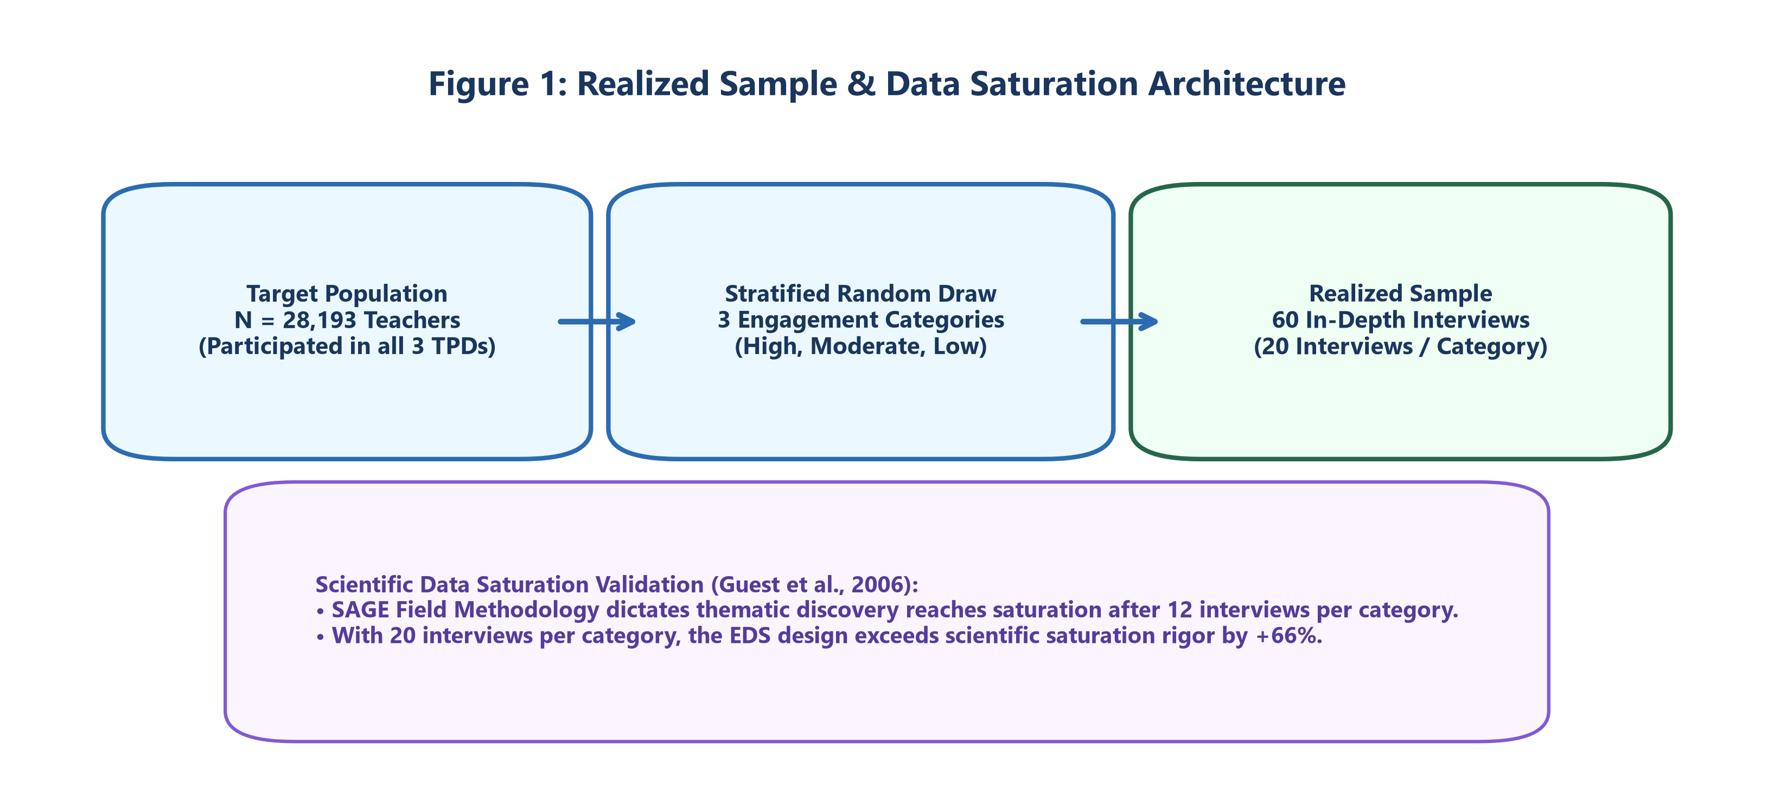
Figure: Realized Sample & Scientific Saturation Design
[NOTE] Data Saturation Validation: According to established research in field methods (Guest, Bunce, & Johnson, 2006), thematic discovery reaches full saturation after 12 interviews within a targeted sub-group. By conducting 20 interviews per engagement category, the EDS design exceeded scientific saturation requirements by 66%.

2.2 Learning Transfer Coding Framework
To measure actual classroom impact objectively, teacher accounts were evaluated using a rigorous 3-Tiered Learning Transfer Coding Framework:
[ TIER 1: SUBSTANTIAL TRANSFER ]
Named Technique + Specific Context + Outcome / Confirmation
(n = 11 CLSS)
│
[ TIER 2: MODERATE TRANSFER ]
Named Technique + Application Context
(n = 16 CLSS)
│
[ TIER 3: MINIMAL TRANSFER ]
Technique Named without Context / Outcome
(n = 7 CLSS)

2.3 Three-Way Triangulation Engine
To eliminate self-report bias, the EDS cross-referenced data across three independent evidence streams:
- Qualitative Study: 60 in-depth teacher interviews with parallel note-taker observational validation.
- Statewide Administrative Feedback: 50,899 post-training feedback responses collected at the block-level cascade.
- Independent Classroom Observation: 411 independent single-day classroom observation snapshots (CRO dataset).
―――――――――――――――――――――――――――――――――――――――――――――――――――――――

3. Top 6 Synthesised Findings & Ecosystem Interpretation

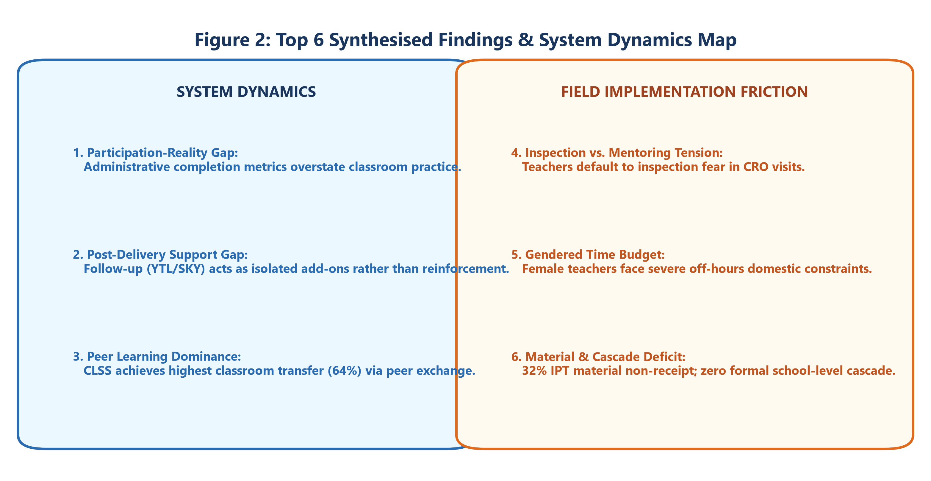
Figure: Synthesised Findings & System Dynamics Map

Finding 1: The Participation-Reality Gap as a System Property
Across all interventions, administrative participation tracking significantly overstates classroom adoption. This is not driven by teacher dishonesty, but because system metrics track delivery compliance rather than classroom practice.
- In-Person Training: 93% attendance $\rightarrow$ 43% confirmed classroom transfer (50 pt gap).
- Digital Courses: 67% completion $\rightarrow$ 38% specific topic recall (29 pt gap).
- CLSS: 88% attendance $\rightarrow$ 64% confirmed transfer (24 pt gap).

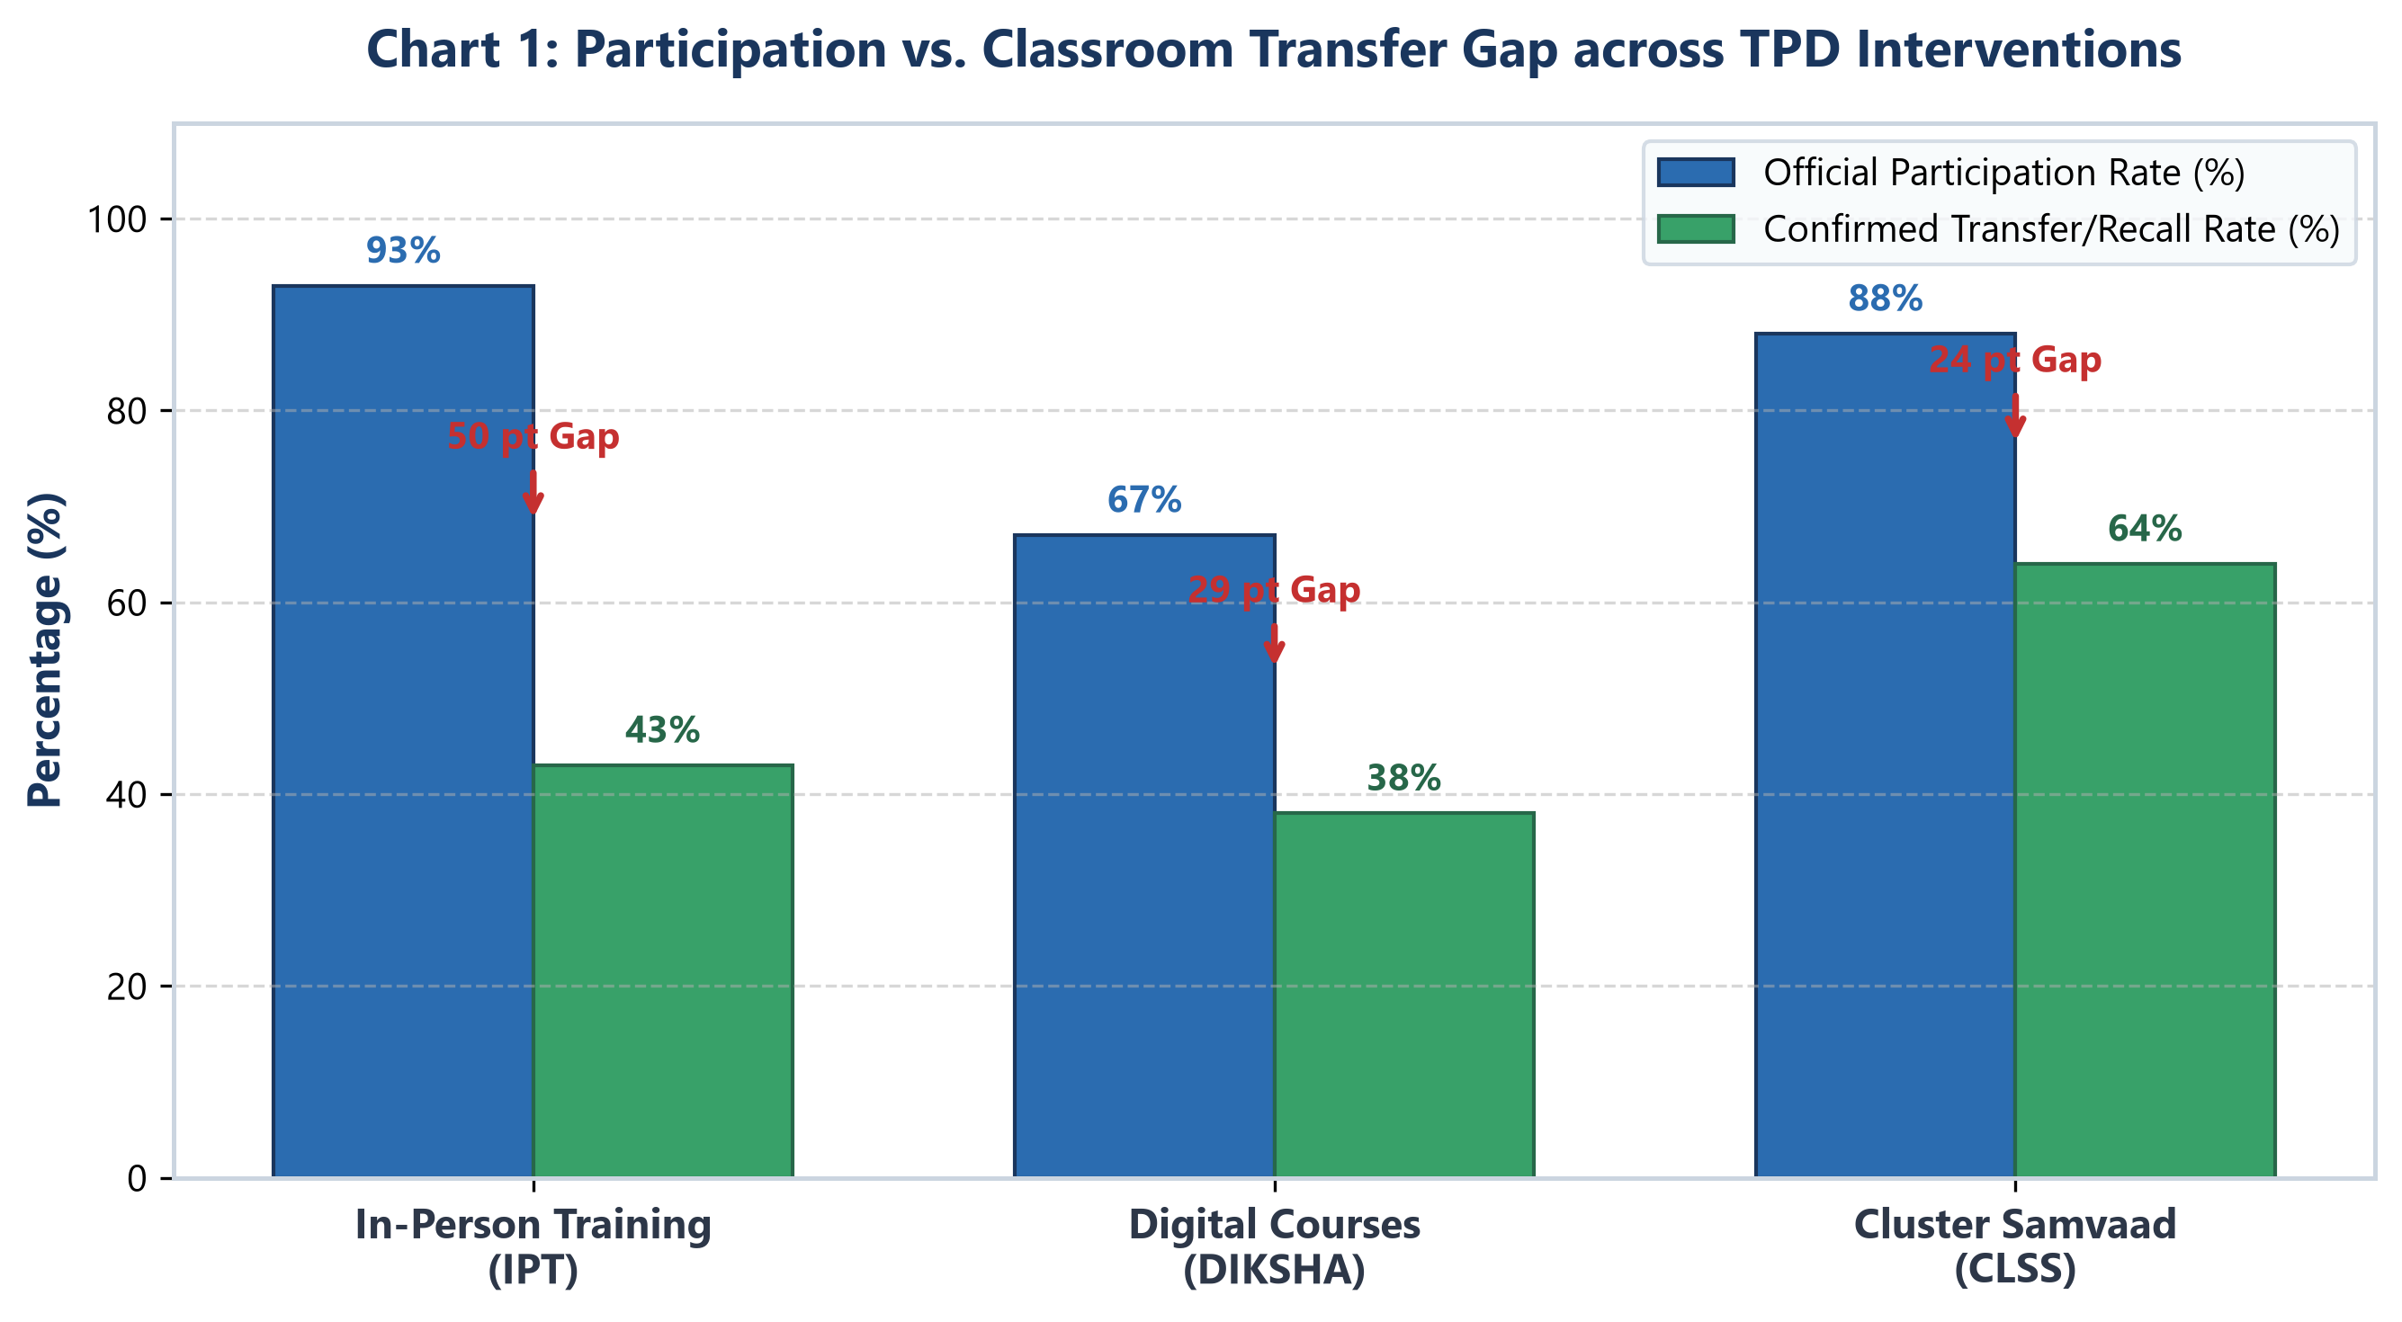
Figure: Participation vs Classroom Transfer Gap Across TPD Interventions

Finding 2: The Post-Delivery Support Gap
Follow-up activities (Youva Tarang Live - YTL and Sheekh ki Yatra - SKY) currently function as isolated, optional add-ons rather than an integrated reinforcement loop. YTL reaches only 21 of 60 teachers (with 22 of 60 reporting passive/zero recall), while SKY reaches only 9 of 60 due to administrative communication overload.

Finding 3: Peer Learning Drives Highest Classroom Transfer
CLSS emerged as the single most effective intervention in the ecosystem, generating confirmed classroom transfer in 64% of attendees (34 of 53). Teacher evidence proves that peer-to-peer exchange is the primary mechanism driving adoption, far outperforming passive lectures or video modules.

Finding 4: The Inspection vs. Mentoring Tension in CRO
Because CRO has not been formally launched, classroom observation is historically associated with administrative compliance inspection. 12 of 60 teachers explicitly state that observation is currently not a form of professional development. Teachers overwhelmingly demand dignity (private feedback), solution-focused guidance, and subject-credible observers.

Finding 5: Gendered Time Constraints & Digital Friction
Digital learning operates within a narrow weekly time budget (65% of teachers spend $\le 2$ hours per week). Female teachers report severe domestic time constraints during evening hours, creating an equity barrier for mandatory evening webinars or off-hours digital coursework.

Finding 6: Materials & Cascade Delivery Breakdowns
- Material Deficit: 32% of teachers (19 of 60) did not receive physical IPT training modules (Margdarshika) or PPTs at the training venue.
- School Cascade Failure: Formal cascade of CLSS learning to non-attending school colleagues is almost completely non-existent (only 2 of 53 teachers conducted formal sharing).
―――――――――――――――――――――――――――――――――――――――――――――――――――――――

4. Intervention-by-Intervention Diagnostic

4.1 In-Person Subject Training (IPT)
[ IPT PERFORMANCE SNAPSHOT ]
■ Attendance: 56 / 60 (93%)
■ Perceived Usefulness: 52 / 56 (93%)
■ Confirmed Classroom Transfer: 24 / 56 (43%)
■ Materials Received (Margdarshika): 41 / 60 (68%)

What is Working
- Ceiling Attendance & Perceived Value: 93% of teachers attend and value the opportunity to gather for subject-focused learning.
- Statewide Satisfaction: Large-scale data (50,899 teachers) shows 70% rate overall training as highly satisfactory.

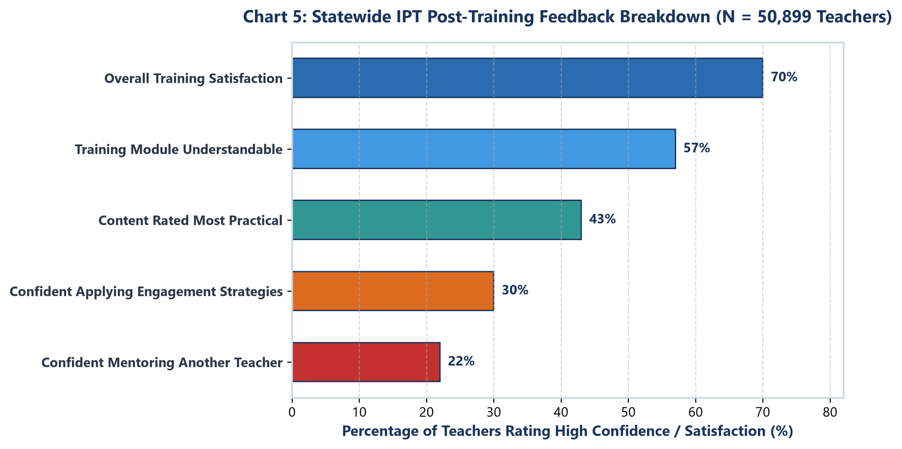
Figure: Statewide In-Person Training Feedback Breakdown (N=50,899)

Friction Points & Evidence
- Theory-Heavy Delivery vs. Practical Application: Of 50,899 teachers, 65% feel confident creating lesson plans, but only 30% feel confident applying student engagement strategies in real classrooms.
- Differentiation Difficulty: 56% of teachers name managing multi-level/differentiated classrooms as their single hardest challenge—4x higher than any other issue.
- Observed Lesson Plan Deficit: In the independent CRO dataset (411 classrooms), only 5% of observed classrooms had a written lesson plan on the day of observation, revealing a dramatic gap between self-reported confidence (65%) and daily practice (5%).

Teacher Voices
"The content should focus more on the application of topics from the subject and less on theory. There should be more time allotted for practice."
— IPT Feedback Respondent
"Doing activities in the classroom isn't always easy... You all who teach us these activities should first go do them in the classroom yourselves and see how many difficulties there are."
— T60, Primary School Teacher
"I received Science-labelled training content despite teaching Hindi and English."
— T41, Sidhi District
―――――――――――――――――――――――――――――――――――――――――――――――――――――――

4.2 Digital Courses (DIKSHA / iGOT Karmayogi)
[ DIGITAL COURSES SNAPSHOT ]
■ Recorded Participation: 40 / 60 (67%)
■ Perceived Effectiveness of Online Format: 38 / 60 (63%)
■ Specific Content Recall: 23 / 50 (46%)
■ Weekly Study Time Budget: <= 2 Hours/Week for 65% of Teachers

What is Working
- High Platform Reach: 50 of 60 teachers have engaged with digital modules across DIKSHA (40) and iGOT (30).
- Engaging Features: Teachers highlight interactive mid-course quizzes (20), animated videos (17), and end-of-course assessments (14) as highly engaging.

Friction Points & Evidence
- Low Deep Recall: 23 of 50 teachers recalled a course name/topic, but virtually no teacher could recall specific pedagogical content or techniques.
- Lack of Two-Way Interaction: Digital learning is experienced as a one-way broadcast. Teachers cite the inability to ask questions or clear doubts as its primary limitation.
- Technical & Connectivity Friction: Server buffering, login errors, and lack of offline downloadable access deter sustained engagement.

Teacher Voices
"I completed the courses on my phone at night after finishing housework. But without anyone to discuss it with, it's easy to complete the quiz and forget the content."
— T22, Digital Course Participant
―――――――――――――――――――――――――――――――――――――――――――――――――――――――

4.3 Cluster Shaikshik Samvaad (CLSS)
[ CLSS PERFORMANCE SNAPSHOT ]
■ Attendance (>=1 Session): 53 / 60 (88%)
■ Full Annual Cycle Attendance (5/5 Sessions): 20 / 53 (38%)
■ Confirmed Classroom Transfer: 34 / 53 (64%) <-- HIGHEST IN TPD ECOSYSTEM
■ Formal School Cascade Rate: 2 / 53 (3.8%)

What is Working
- Ecosystem-Leading Transfer Rate: 64% of attending teachers successfully implemented a specific technique learned in CLSS.
- Peer Learning Engine: Peer exchange is explicitly identified as the primary catalyst for 5 of the top 9 transfer cases.

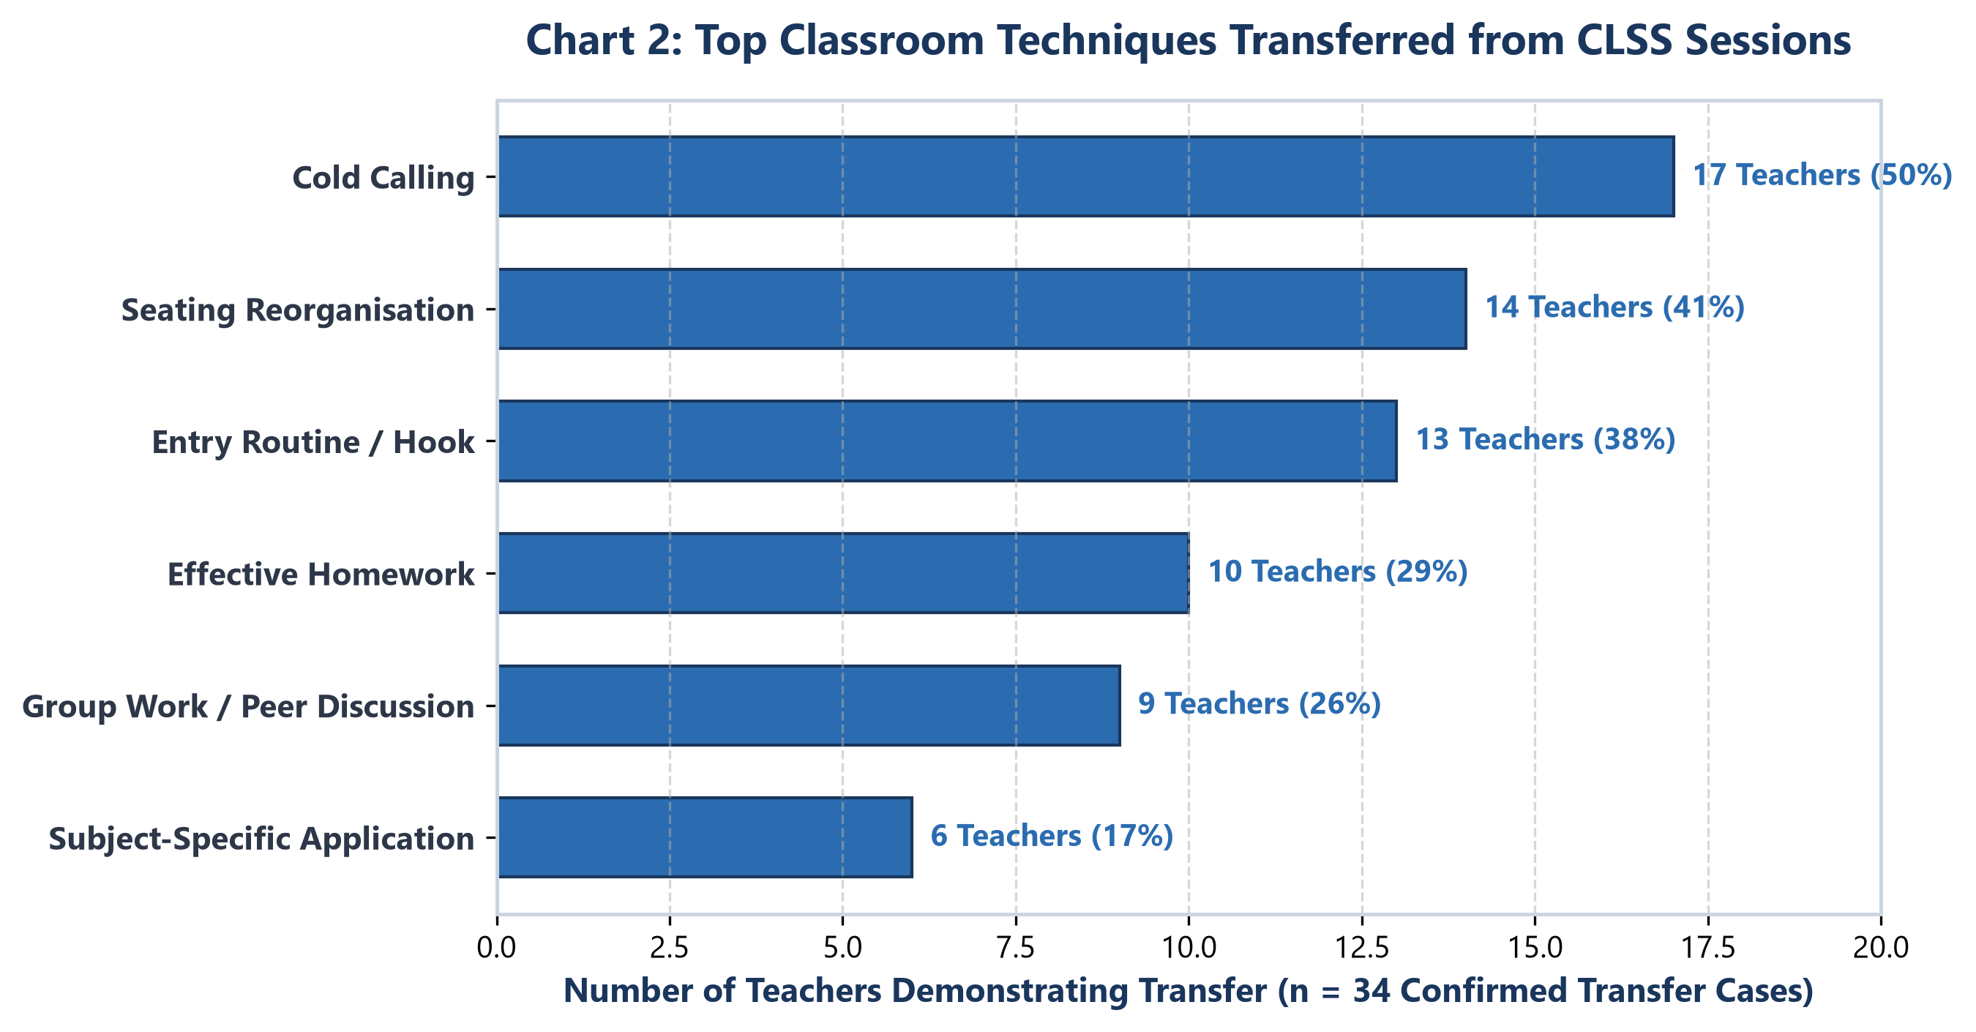
Figure: Top Classroom Techniques Transferred from CLSS Sessions

Friction Points & Evidence
- Fragmented Program Perception: 11 of 53 attendees view CLSS as isolated monthly meetings rather than a structured, annual developmental program.
- Cascade Breakdown: 15 teachers perform zero cascade, while 20 rely on informal verbal chat. Only 2 teachers conduct formal staff meeting sharing.
- Post-Session Feedback Friction: 12 of 60 teachers cite post-session online attendance forms as confusing, time-consuming, or buggy.

Teacher Voices
"In Shaikshik Samvaad, when another teacher shares how they solved a math problem in their class, it feels practical. We can try it the very next day."
— T56, Sehore District
"I go to CLSS, but when I return to school, there is no system or time set aside to explain what I learned to the other teachers."
— T28, Primary Teacher
―――――――――――――――――――――――――――――――――――――――――――――――――――――――

4.4 Classroom Observation and Mentoring (CRO)
[ CRO BASELINE SNAPSHOT ]
■ Status: Pre-Rollout Baseline Exploration
■ Observation Associated with Inspection: 12 / 60 (20%)
■ Middle-Grade Mentoring Coverage: Almost 0%
■ Core Demand: Dignity, Solution-Focus, Subject Credibility

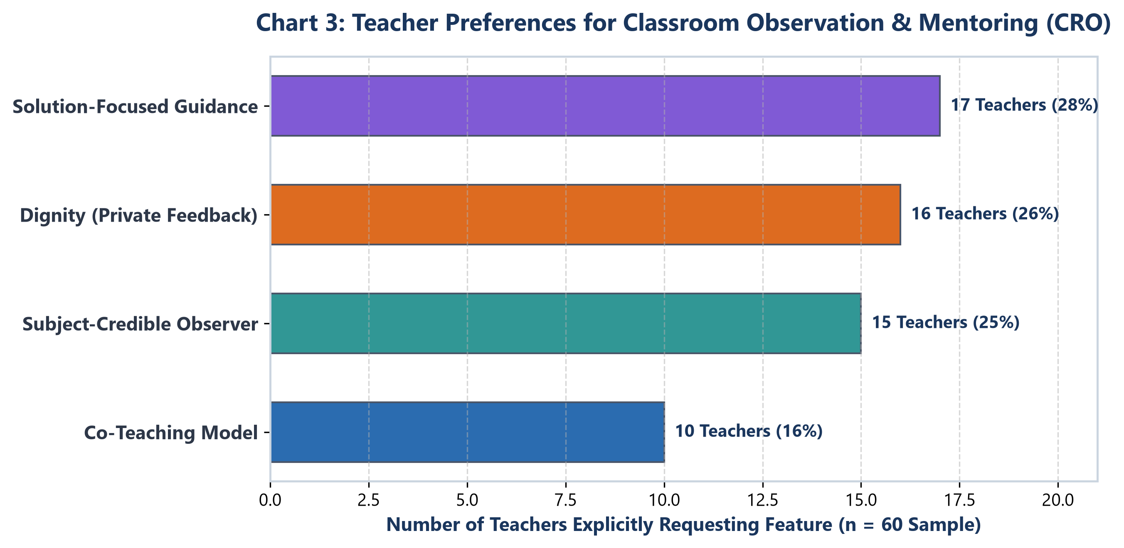
Figure: Teacher Preferences for Classroom Observation and Mentoring

Crucial Pre-Rollout Risk
Mid-level academic officials (Jan Shikshaks, BACs, CACs) who are being trained for CRO are the exact same personnel who currently conduct administrative compliance inspections. Without clear structural separation, teachers will default to viewing CRO visits as punitive inspections.

Teacher Voices
"They should come, sit at the back quietly, and help us... Not inspect and write reports in front of the students."
— T56, Sehore District
"If the observer doesn't know how to teach Science, how can they give me feedback on my Science lesson?"
— T19, Science Teacher
―――――――――――――――――――――――――――――――――――――――――――――――――――――――

5. Ecosystem Synthesis & Visual Communication

5.1 System Delivery Architecture & Friction Map

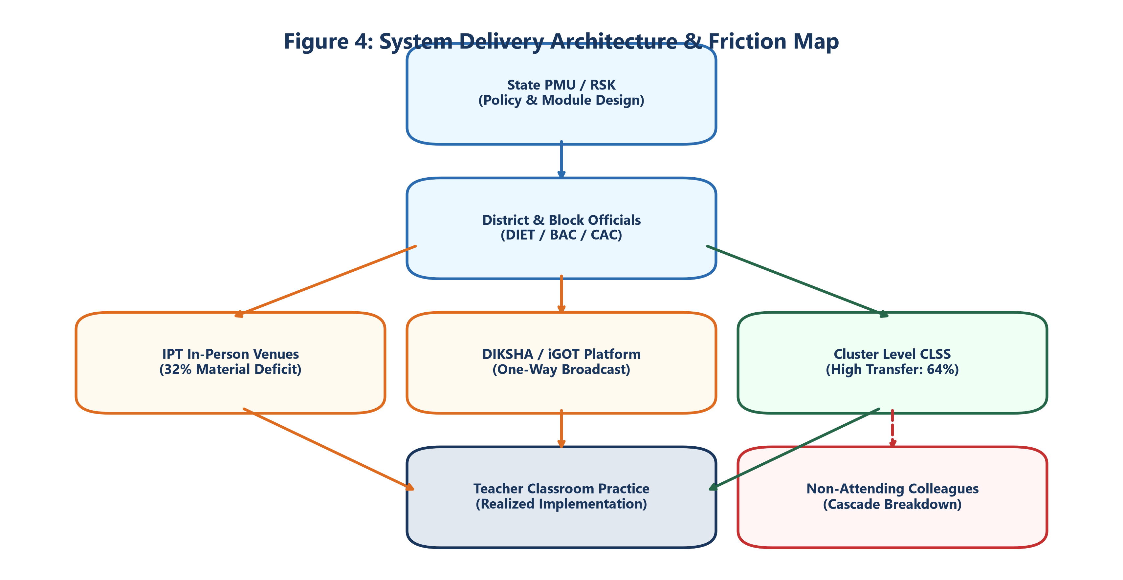
Figure: System Delivery Architecture & Friction Map

5.2 Comparative Intervention Matrix
Metric / Dimension | In-Person Training (IPT) | Digital Courses (DIKSHA) | Cluster Samvaad (CLSS) | Observation (CRO)
Official Participation Rate | 93% (56/60) | 67% (40/60) | 88% (53/60) | Pre-rollout
Confirmed Transfer / Recall | 43% (24/56) | 38% (23/60) | 64% (34/53) | N/A
Participation-Reality Gap | 50 percentage pts | 29 percentage pts | 24 percentage pts | N/A
Primary Driver of Success | Peer interaction & gathering | Interactive quizzes/videos | Peer-to-peer exchange | Solution focus (desired)
Primary Friction Point | Theory heavy, low practice | No 2-way doubt clearing | Zero formal school cascade | Inspection fear

5.3 Triangulation Matrix: Self-Reported vs. Independently Observed Practices

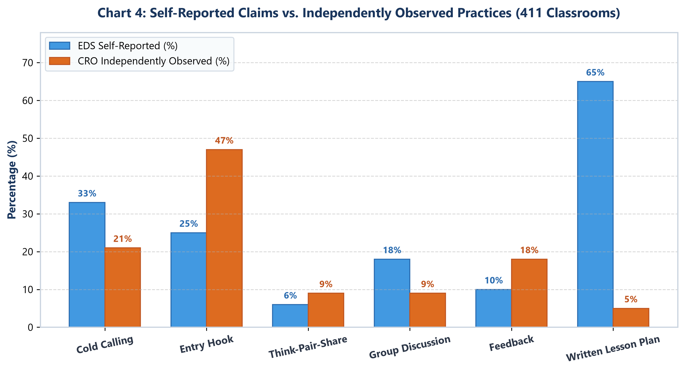
Figure: Self-Reported Claims vs. Independently Observed Classroom Practices (411 Classrooms)
[WARNING] Measurement Discrepancy Alert: Comparing teacher self-reports (EDS) against independent classroom observations (411 CRO snapshots) reveals significant variation depending on the nature of the technique:
Technique EDS Self-Reported CRO Observed Analysis / Interpretation
─────────────────────────────────────────────────────────────────────────────────────────────────────────────
Cold Calling 33% 21% Over-reported in self-report
Entry Routine / Hook 25% 47% Under-reported (practiced unconsciously)
Think-Pair-Share 6% 9% Consistently low adoption
Group Discussion 18% 9% Over-reported in self-report
Constructive Feedback 10% 18% Under-reported in self-report
Written Lesson Plan 65% (Confidence) 5% (Observed) CRITICAL PRACTICE GAP
―――――――――――――――――――――――――――――――――――――――――――――――――――――――

6. Actionable Strategic Recommendations & Priority Roadmap
To transition the MP TPD ecosystem from delivery compliance to embedded classroom transformation, recommendations are organized across short-term operational fixes, structural policy changes, and next-phase diagnostics.

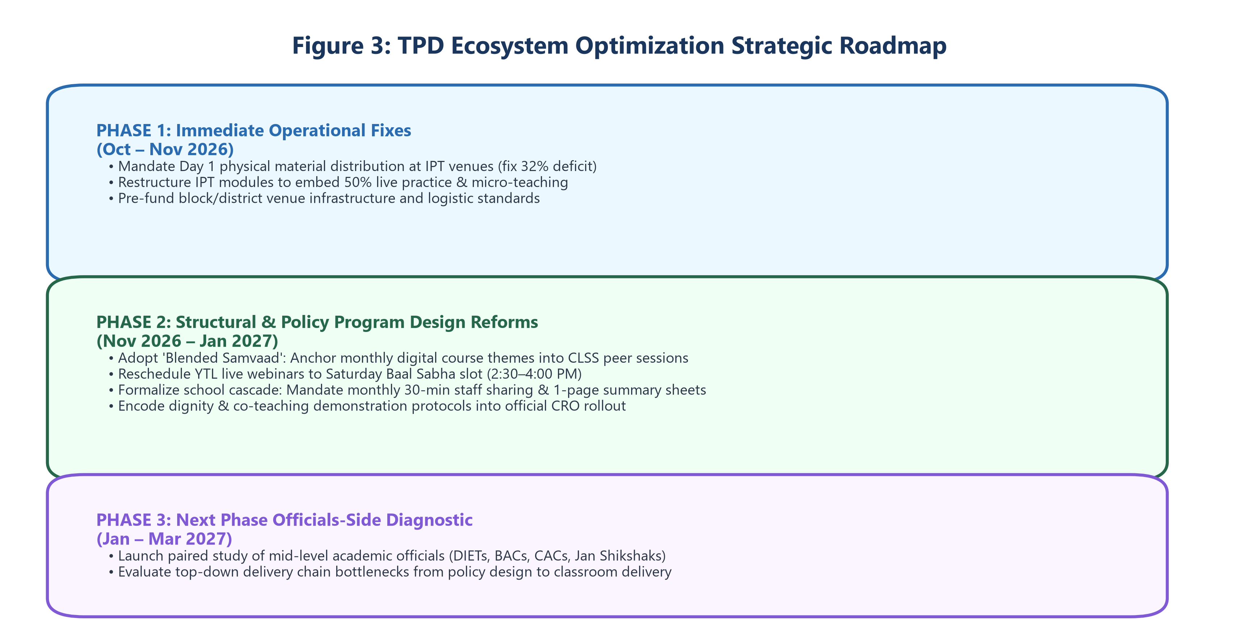
Figure: TPD Ecosystem Optimization Strategic Roadmap

6.1 Immediate Operational Fixes (Next IPT Cycle)
- Rebalance IPT Modules (50% Practice Rule): Restructure IPT sessions to dedicate at least 50% of time to live lesson planning, micro-teaching, and differentiated instruction practice.
- Day 1 Material Delivery Guarantee: Mandate physical distribution of Margdarshika modules and hand-outs at the training venue on Day 1 to eliminate the 32% non-receipt rate.
- Venue Infrastructure Standards: Establish clear block/district accountability for training logistics (seating, audio-visuals, meals) backed by pre-funded budgets.

6.2 Structural Policy & Program Design Reforms
- Adopt the "Blended Samvaad" Model: Formally link monthly Digital Courses directly to that month's CLSS session topic. Use digital modules for pre-reading and CLSS for two-way peer discussion, solving the digital isolation bottleneck without building new platform features.
- Reschedule YTL to Saturday Baal Sabha Window: Move YTL live sessions from class-clashing hours to the existing Saturday afternoon Baal Sabha window (2:30–4:00 PM), eliminating scheduling conflicts while respecting female teachers' evening domestic constraints.
- Formalize School-Level CLSS Cascade:
* Mandate a 30-minute monthly staff meeting slot for attending teachers to share key techniques with colleagues.
Provide a concise 1-page teacher-facing summary sheet* per CLSS session.
- Encode Dignity & Co-Teaching into CRO Protocol:
* Explicitly train officials to separate compliance inspections from developmental mentoring.
* Mandate private, solution-focused feedback protocols.
Pilot a co-teaching demonstration model* where mentors teach alongside classroom teachers.

6.3 Proposal for Phase 2: Officials-Side Delivery Chain Study
Because this diagnostic evaluated the ecosystem exclusively from the teacher's perspective, several delivery bottlenecks (undelivered materials, uncommunicated follow-up sessions, inspection behavior) remain unexamined at the administrative source.
[IMPORTANT] Phase 2 Scope Proposal: Conduct a paired diagnostic studying mid-level academic officials (DIET faculties, BACs, CACs, Jan Shikshaks, Master Trainers) to evaluate how directives, materials, and support flow down the administrative chain, enabling comprehensive end-to-end TPD system optimization.
―――――――――――――――――――――――――――――――――――――――――――――――――――――――
Report compiled from EDS Full Report v7 empirical dataset (N=60 qualitative interviews, N=50,899 feedback forms, N=411 CRO observations).

