

Unique Identification Authority of India

Government of India

Ministry of Communication & IT

Ministry of Electronics and Information Technology (Meity)

Installation Procedure

On

Child Enrolment Lite Client (CELC)





Introduction

The current document is the Steps for Install and Uninstall the Child Enrolment Lite Client.

APK Uninstallation and Installation Steps:

## If you have already use the existing Child Enrolment Client application then follow the step 1 and Then Step 2.

## If you are going to use the Child Enrolment Client application for First time then follow Step 2.

1. **APK Uninstallation Steps**

1. If **Child Enrolment Client** application already installed in the device, go to the Settings and Click Applications Manager.

2. Search **Child Enrolment Client** Application and Click over the Application.

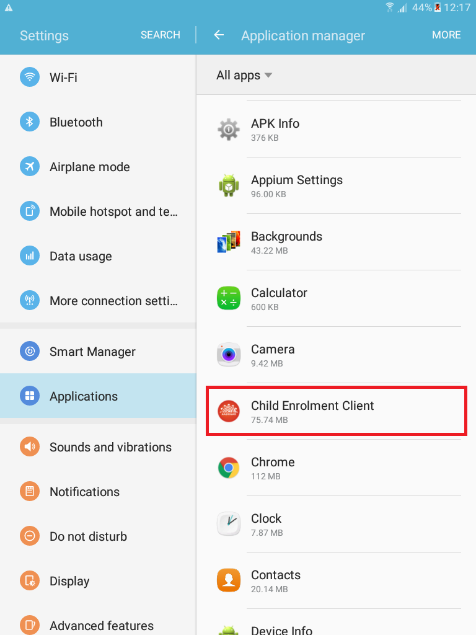

3.Then lick Uninstall.

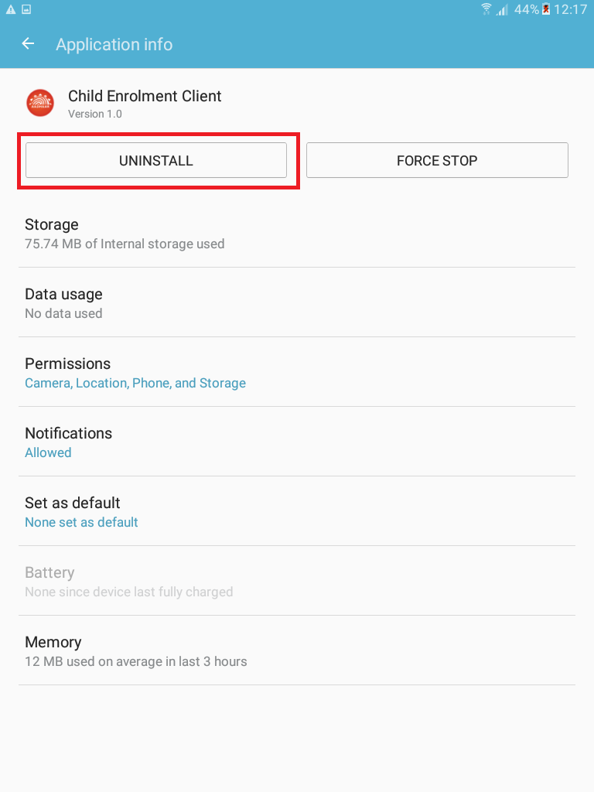

## APK Installation Steps

1. Copy ECL_3.3.5.2.apk file to either SD card or internal Tab memory.

2. Go to APK pasted location, tap over on ECL_3.3.5.2.apk file. Follow the instructions click next.

3. Open the application on successful installation.

4. Application can be found from phone menu buttons application list.

5. After installation done please launch application from your device.

Application Launching Procedure:

## If your device is android v6.0, then follow below step.

1. When you launch the Application, it will ask the runtime permission as “ALLOW” or “DENY”

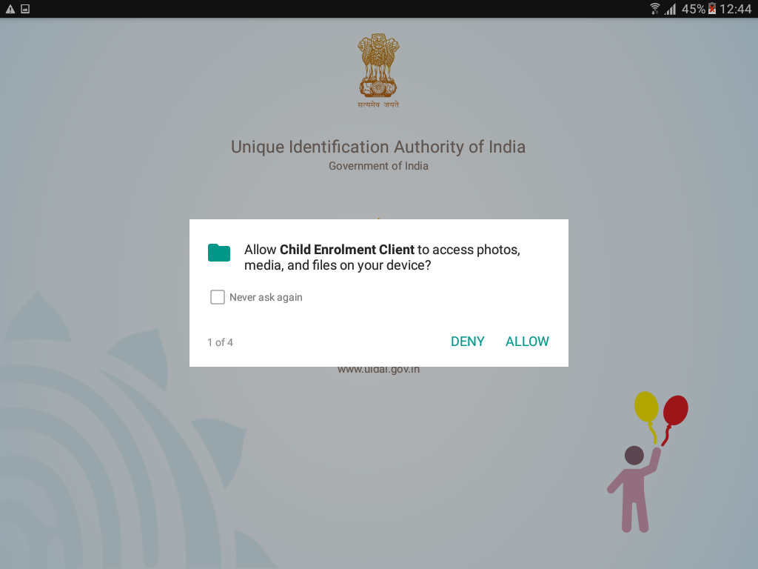

2. If you click “ALLOW” for all the permissions, then **Child Enrolment Client** application will start normally (recommended).

1. If you “DENY” for any permission for the first time, then **Child Enrolment Client** application will ask togive the permissions.

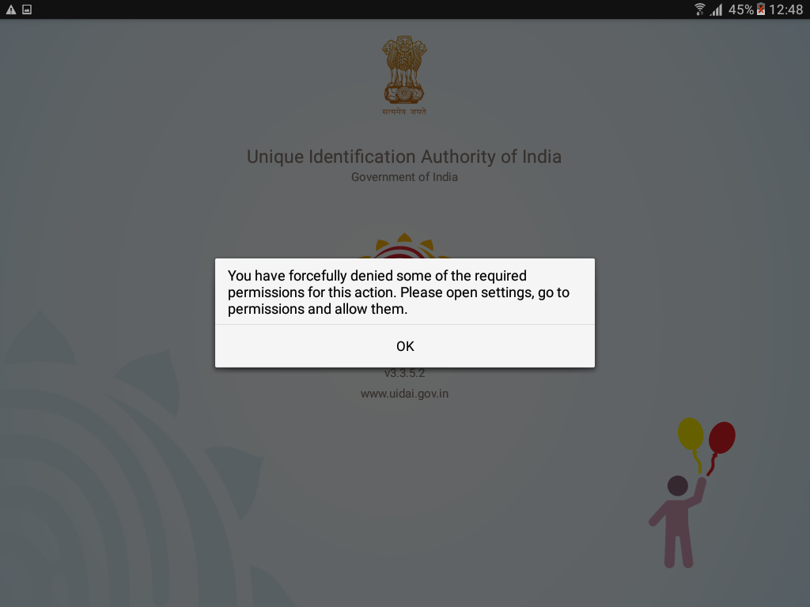

1. If you “DENY” and “never ask again” for any permission then **Child Enrolment Client** application will ask togive the permissions forcefully in Settings.

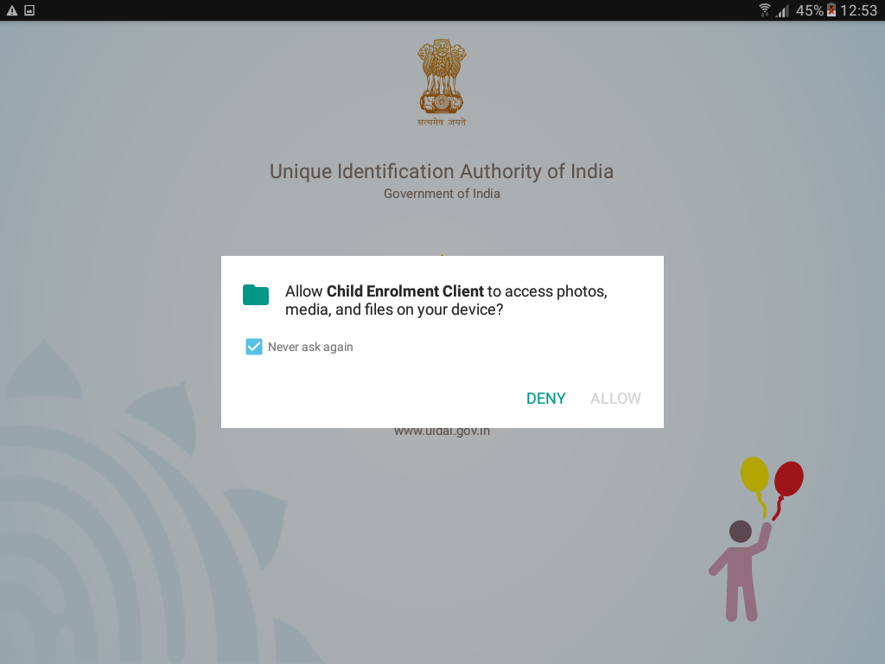

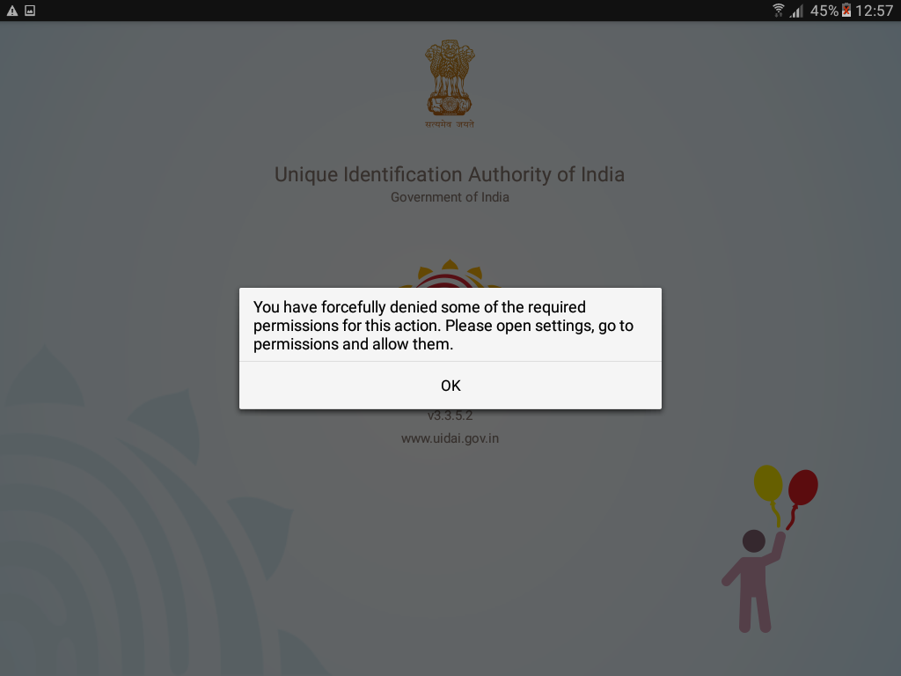

5.Click “ok” Application Will go to **Application Info and** Tab over **“Permissions”**.

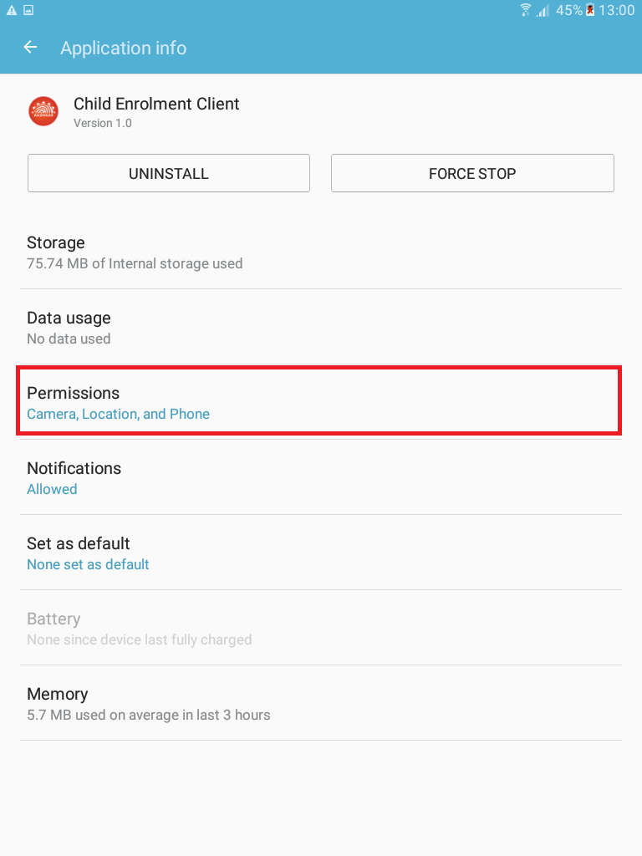

1. You have to give all permission over here .Then launch application from your device.

