IIRS Daily Space Digest Thursday, 07/05/2026

1. Blue Origin's cargo Moon lander moves closer to launch after Nasa testing
Science | The Indian Express
Read more
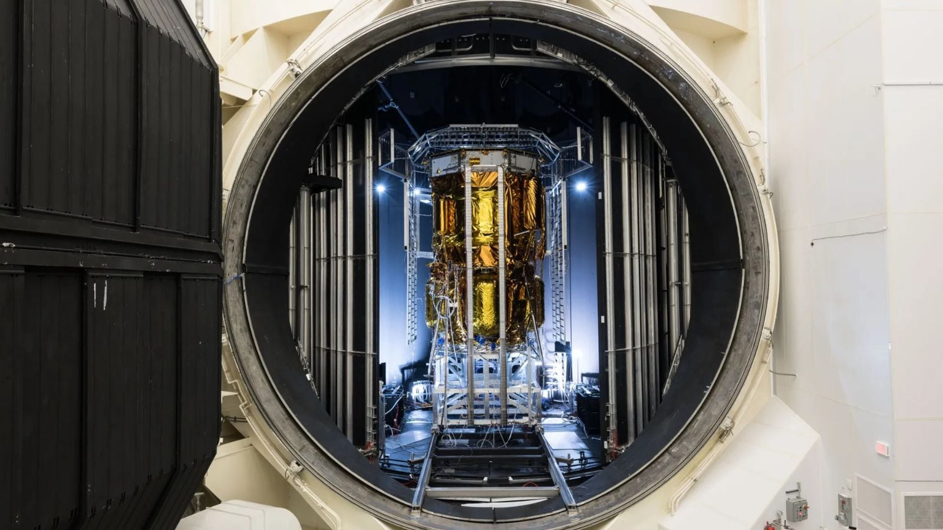

This lander does not carry any crew but can deliver necessary cargo and other items to the Moon's surface. This unmanned craft is part of the effort aimed at achieving the goals set out by the Artemis program. (Image: Nasa)a Blue Origin has successfully completed a major round of testing for its lunar lander inside a specialised vacuum chamber at Nasa's Johnson Space Center, marking an important step towards future Moon missions. The spacecraft, known as Blue Moon Mark 1 (MK1) or "Endurance", underwent environmental testing inside Thermal Vacuum Chamber A, one of the largest facilities of its kind in the world. MK1 is subjected to the same conditions experienced in space, such as freezing cold temperatures and almost no air. What the test means The purpose of this test was simply to confirm that the lander could withstand the conditions in space and work effectively. Therefore, engineers managed to recreate the environmental conditions the lander would face on its way to the Moon.

2. ISRO expanding student participation in space missions, 11 student satellites already launched: Jitendra Singh - DD News
"ISRO OR NRSC OR IIRS after:2026-05-06" - Google News
Read more

Union Minister of State for Science and Technology Dr. Jitendra Singh on Thursday said the Indian Space Research Organisation (ISRO) is expanding student participation in space missions through structured programmes that allow young researchers to design satellites, develop payloads and participate in real mission experiments. Replying to an unstarred question by Sumitra Balmik in the Rajya Sabha, Singh said the government is committed to widening access to space technology so that students from institutions across the country, including those in tier-2 and tier-3 cities, can contribute to India's growing space ecosystem. The minister said ISRO has launched several initiatives aimed at providing hands-on exposure to space technology for students and researchers. Student satellite programme gaining momentum Singh said that ISRO's Student Satellite Programme, led by the U R Rao Satellite Centre, encourages academic institutions to design and develop satellites with technical mentorship from ISRO scientists. The organisation also supports integration and launch opportunities for these satellites through its missions. So far, the Indian National Space Promotion and Authorisation Centre (IN-SPACe) has authorised 17 student satellites and payloads, of which 11 have already been successfully launched, the minister informed. These projects have involved several academic institutions including the Indian Institute of Astrophysics, Indian Institute of Space Science and Technology, RV College of Engineering, Amity University Maharashtra, MIT World Peace University, Assam Don Bosco University and CV Raman Global University, reflecting growing national participation in student-led space missions. Competitions and innovation initiatives Singh said student engagement is also being promoted through national competitions organised by IN-SPACe. These include satellite and model rocketry competitions in which 97 student teams comprising nearly 850 students have participated. One such event - the Model Rocketry and CanSat India Student Competition - was organised jointly by IN-SPACe, ISRO and the Astronautical Society of India in October 2025 at Kushinagar in Uttar Pradesh. The event saw 67 teams with nearly 500 students design, fabricate and launch model rockets carrying CanSat payloads to an altitude of about one kilometre. Internship and research support The minister said students are also benefiting from internship and project trainee programmes that provide research exposure at ISRO centres for undergraduate, postgraduate and doctoral students. To strengthen collaboration between universities and ISRO scientists, the government has established Space Technology Incubation Centres (STICs) across various regions. These centres support students in developing indigenous space technologies under expert mentorship. In addition, Regional Academic Centres for Space (RAC-S) have been created to help students from smaller towns and institutions access ISRO programmes and research opportunities. Strengthening space education ecosystem Singh also highlighted the role of ISRO's RESPOND Programme, which provides financial and technical support to universities undertaking research in space science, technology and applications. He said the All India Council for Technical Education has approved a Space Technology Minor Course, while a national committee has been formed to promote adoption of space technology education in line with the Indian Space Policy 2023. The government has also earmarked around ₹10 crore annually for educational outreach activities in space science and technology. Singh said IN-SPACe is further supporting the next generation of space entrepreneurs through mentorship from domain experts, pre-incubation programmes and co-working facilities at its technical centres. "These initiatives are part of the government's broader vision to build a vibrant and inclusive space ecosystem in India, where students, startups, academic institutions and industry all contribute to the country's expanding role in the global space sector," the minister said.

3. India aims to land astronauts on the Moon by 2040: Former ISRO chief - MSN
"ISRO OR NRSC OR IIRS after:2026-05-06" - Google News
Read more

India aims to land astronauts on the Moon by 2040: Former ISRO chief MSN

4. NASA-ISRO satellite maps Mexico City's rapid sinking as water crisis deepens - Smart Water Magazine
"ISRO OR NRSC OR IIRS after:2026-05-06" - Google News
Read more

NASA-ISRO satellite maps Mexico City's rapid sinking as water crisis deepens Smart Water Magazine

5. Vidyarthi Vigyan Vari scheme: Maharashtra launches new programme for schools; top students to visit NASA and ISRO - Mid-day
"ISRO OR NRSC OR IIRS after:2026-05-06" - Google News
Read more

The state government has approved an expenditure of Rs 3.30 crore for the initiative. Separate committees will be set up at the taluka, district and state levels to ensure effective planning and execution The Maharashtra government on Wednesday approved the 'Vidyarthi Vigyan Vari scheme' initiative, under which meritorious students will get an opportunity to visit leading space and research centres such as Indian Space Research Organisation (ISRO) and National Aeronautics and Space Administration (NASA) in the United States, officials said.

6. ISRO provides updates on planned planetary exploration missions - MSN
"ISRO OR NRSC OR IIRS after:2026-05-06" - Google News
Read more

ISRO provides updates on planned planetary exploration missions MSN

7. Webb & Hubble find massive star clusters emerge faster
ESA Space Science
Read more
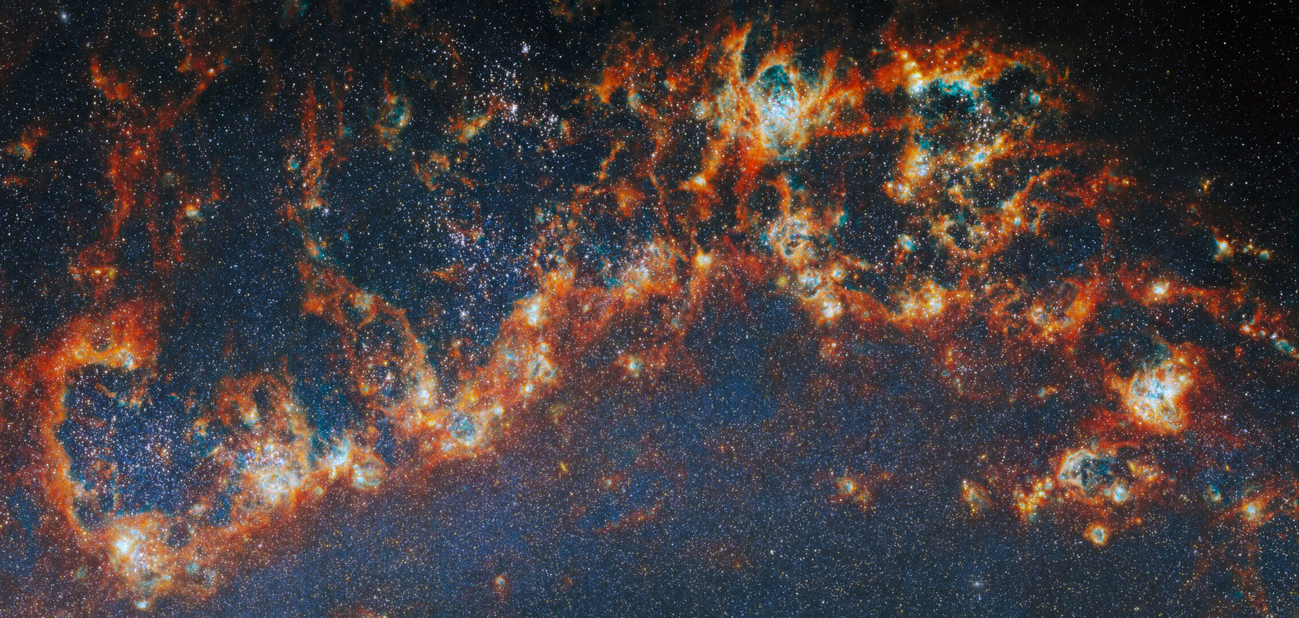

Science & Exploration Webb & Hubble find massive star clusters emerge faster 06/05/2026 1510 views 33 likes Astronomers using the NASA/ESA/CSA James Webb Space Telescope together with the NASA/ESA Hubble Space Telescope have looked deeply at thousands of young star clusters in four nearby galaxies, studying clusters at different stages of evolution. Their findings show that more massive star clusters emerge more quickly from the clouds they are born in, clearing away gas and filling the galaxy with ultraviolet light. The result gives us a better understanding of star formation in galaxies, as well as how and where planets can form. Star-forming regions in M51 Astronomers have long known that understanding how star clusters come to be is key to unlocking other secrets of galactic evolution. Stars form in clusters, created when clouds of gas collapse under gravity. As more and more stars are born in a collapsing cloud, strong stellar winds, harsh ultraviolet radiation and the supernova explosions of massive stars eventually disperse the cloud, ending star formation before all the gas is used up. Once the cloud of gas a star cluster was born in is gone, its light can bear down on other star-forming regions in the galaxy, too. This process is called stellar feedback, and it means that most of the gas in a galaxy never gets used for star formation. Researching how star clusters develop, then, can answer questions about star formation at a galactic scale. Studies of the closest star-forming regions, in the Milky Way galaxy and the dwarf galaxies that orbit it, allow us to dissect star clusters in the smallest details, but our position in the disc of our galaxy means only a few such regions are visible to us. By observing nearby galaxies, astronomers can survey thousands of star-forming regions and characterise entire populations of star clusters at many stages of evolution - a feat made possible with the launch of space telescopes, most prominently the NASA/ESA Hubble Space Telescope. Both kinds of investigation are necessary to truly understand how star formation takes place in galaxies. Star-forming region in M51 (close-up) The continuous development of infrared astronomy has allowed us to pull back the gaseous curtains that still hide the youngest star clusters and learn about the earliest stages of their development, but some subjects still puzzle researchers. For instance: when a star cluster forms, what determines how long it takes to disperse its natal cloud and begin radiating ultraviolet light out into the galaxy? Now, the state of the art has been further developed with both Hubble and Webb working together to provide a broad-spectrum view of thousands of young star clusters. An international team of astronomers has pored over images of four nearby galaxies - Messier 51, Messier 83, NGC 4449, and NGC 628 - from the FEAST observing programme (#1783), trying to solve this mystery. Their results, published today in Nature Astronomy, show that it is the most massive star clusters that clear away their gaseous shroud the fastest, and begin lighting their galaxy the earliest. The team identified nearly 9000 star clusters in the four galaxies in different evolutionary stages: young clusters just starting to emerge from their natal clouds of gas, clusters that had partially dispersed the gas (both from Webb images), and fully unobstructed clusters visible in optical light (found in Hubble images). With Webb's ability to peer inside the gas clouds, they were able to then estimate the mass and age of each cluster from its light spectrum. The most massive clusters had fully emerged and dispersed the clouds of gas after around five million years, while less massive clusters were between seven and eight million years old when they emerged from their nurseries. Answering this open question of which star clusters clear away their birth clouds the fastest advances our understanding of galaxy formation. "Simulations of star formation and stellar feedback have struggled to reproduce how star clusters form and emerge from their natal clouds. These results give us important new constraints on that process," explained Angela Adamo of Stockholm University and the Oskar Klein Centre in Sweden, a lead author on the study and PI of the FEAST programme. Nearby star-forming FEAST galaxies Massive star clusters with their abundances of hot stars naturally emit most of the ultraviolet light in galaxies, but this work confirms that they also get a head start on producing stellar feedback over lighter clusters. Knowing where and when this stellar feedback is strongest throughout the lifetime of a galaxy allows astronomers to better predict how star-forming fuel is pushed around the galaxy and therefore how stars, and star clusters, are likely to form. Our theories of how planets form are also impacted by this research. The faster gas is cleared away within a star cluster, the earlier protoplanetary discs around stars are exposed to harsh ultraviolet radiation from other stars, and the less opportunity they have to attract further gas from the nebula. This reduces the opportunities they have to grow dust and create planets. "This work brings together researchers simulating star formation and those working with observations, as well as groups researching planet formation," said Alex Pedrini, lead author, also of Stockholm University and the Oskar Klein Centre in Sweden. "Using Webb, we can look into the cradles of star clusters and connect planet formation to the cycle of star formation and stellar feedback." Location of star-forming region in M51 More information Webb is the largest, most powerful telescope ever launched into space. Under an international collaboration agreement, ESA provided the telescope's launch service, using the Ariane 5 launch vehicle. Working with partners, ESA was responsible for the development and qualification of Ariane 5 adaptations for the Webb mission and for the procurement of the launch service by Arianespace. ESA also provided the workhorse spectrograph NIRSpec and 50% of the mid-infrared instrument MIRI, which was designed and built by a consortium of nationally funded European Institutes (The MIRI European Consortium) in partnership with JPL and the University of Arizona. Webb is an international partnership between NASA, ESA and the Canadian Space Agency (CSA). Science paper Release on esawebb.org Contact: ESA Media relations media@esa.int

8. NASA's Dryden Aeronautical Test Range Supports Flight, Space Missions
NASA
Read more
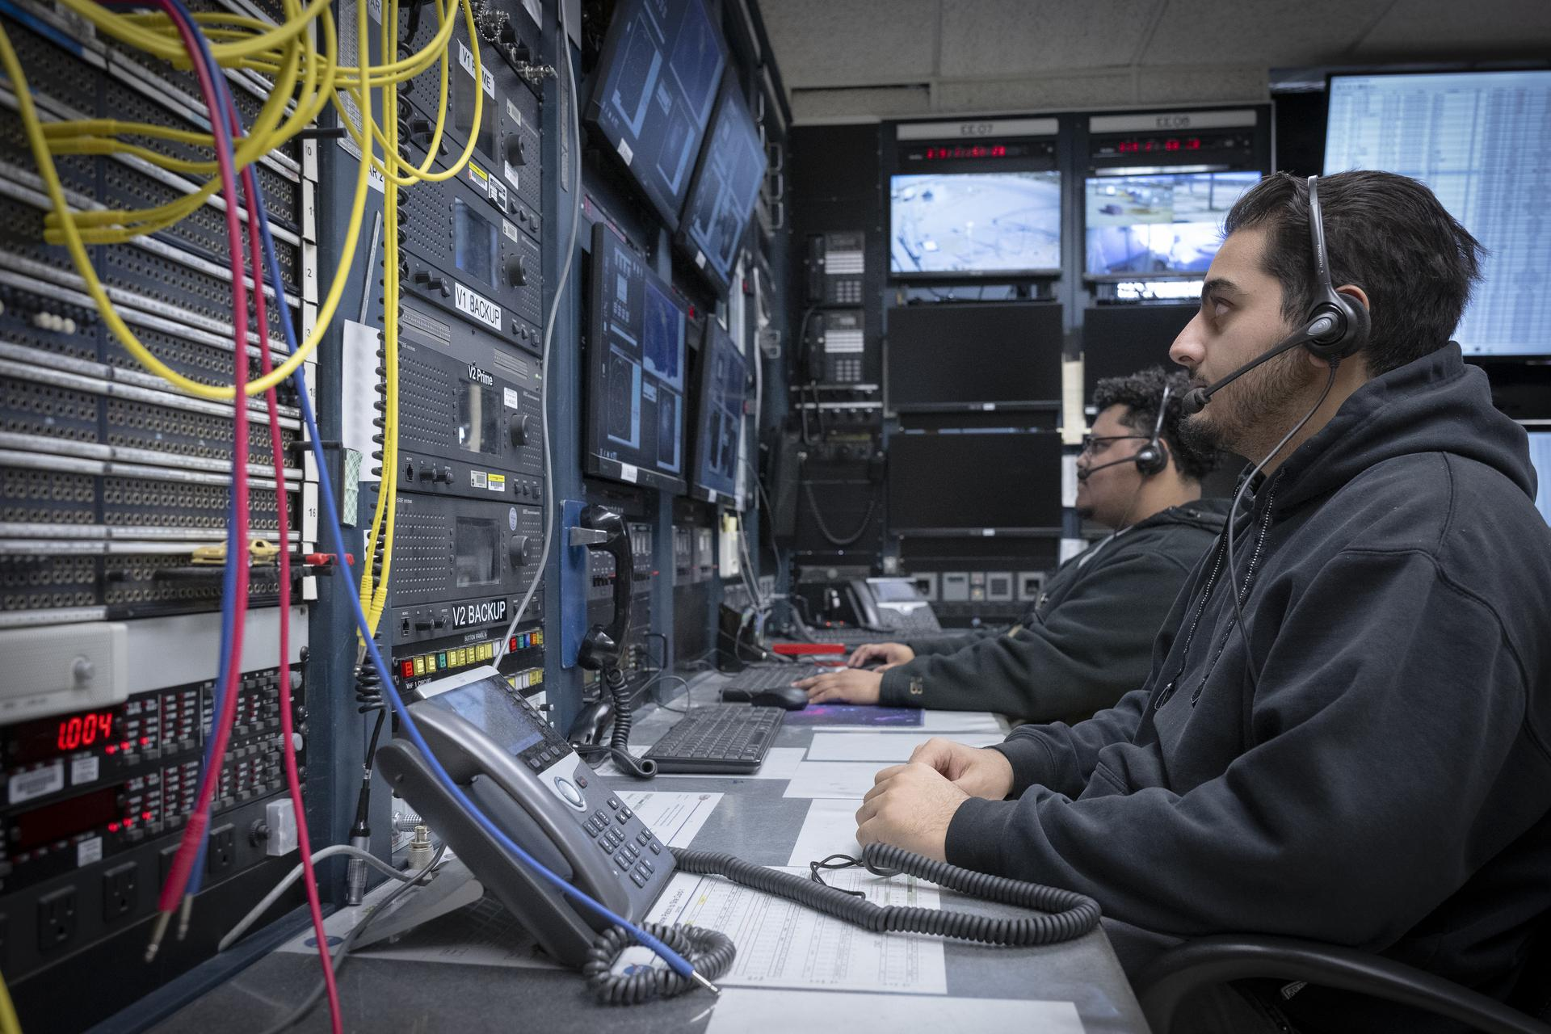

Range operators at the Dryden Aeronautical Test Range at NASA's Armstong Flight Research Center in Edwards, California, provide voice and tracking support to the International Space Station. In this Friday, Dec. 6, 2025, photo, Alex Oganesyan, left, and Deming Ingles are at their workstations, where they support communications backup for space station missions. NASA/Christopher LC Clark NASA advances aeronautics and space technologies through experimental aircraft and flight research at the agency's Armstrong Flight Research Center in Edwards, California. Behind those efforts is the Dryden Aeronautical Test Range (DATR), which provides the communications, tracking, and data services that enable safe and effective missions. For most NASA Armstrong research flights, the DATR supplies communications, radar, and telemetry. The range's video capabilities can also capture ground footage as well as long-range coverage for flights. Modernization efforts started in the early 2020s expanded those capabilities and prepared the range to support efforts such as test flights of NASA's X‑59 quiet supersonic research aircraft, as well as spaceflight communications. "The DATR provides real‑time data, tracking, and situational awareness that help keep flight research safe and efficient," said Tara McCoy, acting deputy director for DATR Mission Operations at NASA Armstrong. "The range also supports science missions, works with industry partners, and provides capabilities used for International Space Station operations." Ongoing upgrades include new very high frequency (VHF) ground antennas, updated electronic components, and software improvements for tracking the International Space Station and visiting spacecraft. NASA installed additional antennas to ensure backup coverage. The range's ability to processes and display real‑time radar, telemetry, and video data is critical for monitoring research flights, such as NASA's Crossflow Attenuated Natural Laminar Flow (CATNLF) wing model. CATNLF, a scale-model wing attached under a NASA F-15B research jet, is designed to improve the smooth flow of air known as laminar flow, reducing drag and lowering fuel costs for future commercial aircraft. The DATR also supports aircraft platforms that enable science missions, such as the ER-2 high-altitude aircraft and the C-20A aircraft. NASA's X-59 quiet supersonic research aircraft first flight travels from Lockheed Martin's Skunk Works facility in Palmdale, California, to NASA's Armstrong Flight Research Center in Edwards, California, on Tuesday, Oct. 28, 2025. The control room at NASA Armstrong enabled engineers to monitor real-time flight data, maintain communication, and view video throughout the mission, demonstrating the capabilities of the center's Dryden Aeronautical Test Range. NASA Television Preparing for future flights The range is developing multiple approaches to streamline and shorten the time it takes to process and validate raw flight data for researchers, saving time and resources. "The faster we can get data to the project engineers to review, the faster they can determine whether certain test points need to be repeated, or future test points can be skipped," said David Tow, DATR chief engineer. "We are working these efforts simultaneously because each one has the potential to drastically improve how long it takes to deliver post-processing data." One NASA approach is to automate and consolidate the data processing steps from five down to one. Another approach leverages an existing partnership with the U.S. Air Force to enable multiple computers to post-process data from separate missions simultaneously. The collaboration between the Air Force and DATR aims to reduce processing time for post-flight data from two hours to less than 30 minutes. Mission operator Mike Webb sits at one of the radar stations used to track the International Space Station as it passes high above NASA's Armstrong Flight Research Center in Edwards, California, on Sept. 30, 2025. Webb is part of the center's Dryden Aeronautical Test Range, which provides voice and tracking support to the space station. NASA/Christopher LC Clark Supporting space station operations The DATR is part of NASA's safety and communications infrastructure that supports International Space Station missions. Its capabilities are used for backup communications and telemetry during launches, dockings, and reentries. NASA Armstrong is one of only two ground stations in the United States capable of sending and receiving messages on all space station frequencies. The other is NASA's Wallops Flight Facility in Virginia. Armstrong has provided communications and radar tracking for the station since its first component launched in 1998 and continues to support commercial cargo and crew missions. A telemetry antenna, right, and two radars are part of the Dryden Aeronautical Test Range at NASA's Armstrong Flight Research Center in Edwards, California. NASA/Lauren Hughes Sonja Belcher and Zack Springer support research flights at the telemetry and radar acquisition processing system at NASA's Armstrong Flight Research Center at Edwards, California. NASA Advancing NASA's mission The range operates within NASA's Flight Demonstrations and Capabilities project in its Aeronautics Research Mission Directorate and remains positioned to support aeronautics, science, and International Space Station missions with communications, tracking, and data services.

9. NASA Wallops to Host Public Information Session May 13
NASA
Read more
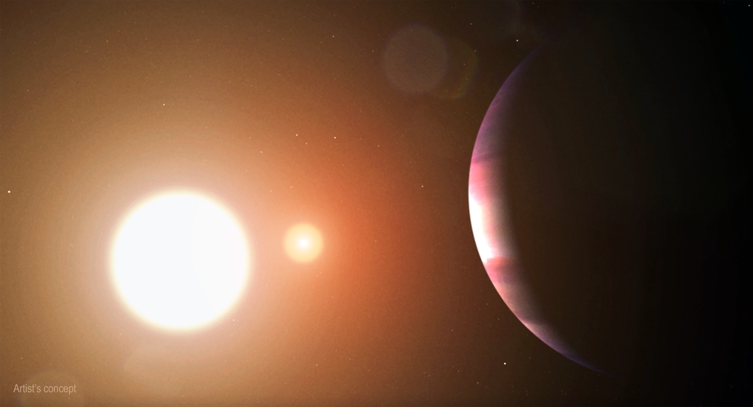

Aerial view of NASA's Wallops Flight Facility main base in Wallops Island, Virginia. Courtesy of Patrick Hendrickson To facilitate discussion and information sharing on activities at NASA's Wallops Flight Facility in Virginia, a public information session is being held 4-6 p.m., Wednesday, May 13, at the NASA Wallops Visitor Center. During the event, NASA will have information booths on the status on the causeway bridge construction, updates on beach replenishment, and a representative from the GLOBE program. Federal and state health experts will be on hand to speak with the public on the PFAS health consultation report released by the Agency for Toxic Substances and Disease Registry. The NASA Wallops Visitor Center is located on Virginia Route 175 about five miles from U.S. Route 13 and five miles from Chincoteague.

10. NASA Sets Coverage for SpaceX 34th Station Resupply Launch, Arrival
NASA
Read more


A SpaceX Dragon cargo spacecraft supporting NASA's SpaceX CRS-33 mission approaches the International Space Station on Aug. 25, 2025, for an automated docking to the Harmony module's forward port. Credit: NASA NASA and SpaceX are targeting 7:16 p.m. EDT Tuesday, May 12, for the next launch to deliver science, supplies, and equipment to the International Space Station. This will be the 34th SpaceX commercial resupply services mission to the orbital outpost for NASA. Carrying about 6,500 pounds of cargo, a SpaceX Dragon spacecraft will lift off aboard a Falcon 9 rocket from Space Launch Complex 40 at Cape Canaveral Space Force Station in Florida. Dragon is scheduled to dock autonomously at about 9:50 a.m. Thursday, May 14, to the forward port of the station's Harmony module. Watch NASA's launch and arrival coverage on NASA+, Amazon Prime, and the agency's YouTube channel. Learn how to watch NASA content through a variety of online platforms, including social media. In addition to cargo for the crew aboard the space station, Dragon will deliver several new experiments, including a project to determine how well Earth-based simulators mimic microgravity conditions, a bone scaffold made from wood that could produce new treatments for fragile bone conditions like osteoporosis, and equipment to evaluate how red blood cells and the spleen change in space to protect future astronauts. The Dragon spacecraft also will carry a new instrument to study charged particles around the Earth that can impact power grids and satellites, an investigation that could provide a fundamental understanding of how planets form, and an instrument designed to take highly accurate measurements of sunlight reflected by Earth and the Moon. The Dragon spacecraft is scheduled to remain at the space station until mid-June when it will depart the orbiting laboratory and return to Earth with time-sensitive research and cargo, ahead of splashing down off the coast of California. NASA's mission coverage is as follows (all times Eastern and subject to change based on real-time operations): Monday, May 11 11 a.m.: Prelaunch media teleconference with the following participants: Bill Spetch, operations and integration manager, NASA's International Space Station Program Dr. Liz Warren, deputy chief scientist, NASA's International Space Station Program Lee Echerd, senior mission manger, Government and Commercial Mission Management, SpaceX Brian Cizek, launch weather officer, Cape Canaveral Space Force Station's 45th Weather Squadron Media who wish to participate by phone must request dial-in information by 10 a.m. on May 11, by emailing the NASA Kennedy newsroom at: ksc-newsroom@mail.nasa.gov. Audio of the media teleconference will stream live on the agency's YouTube channel. Tuesday, May 12 7 p.m.: Launch coverage begins on NASA+, Amazon Prime, and YouTube. Launch coverage also will be available on the NASA website, and will include live streaming and blog updates beginning no earlier than 7 p.m., and proceed as countdown milestones occur. On-demand streaming video on NASA+ and photos of the launch will be available shortly after liftoff. For questions about countdown coverage, contact the NASA Kennedy newsroom at 321-867-2468. Follow countdown coverage on NASA's International Space Station blog for updates. 7:16 p.m.: Launch Thursday, May 14 8:20 a.m.: Arrival coverage begins on NASA+, Amazon Prime, and YouTube. 9:50 a.m.: Docking Attend launch virtually Members of the public can register to attend this launch virtually. NASA's virtual guest program for this mission also includes curated launch resources, notifications about related opportunities or changes, and a stamp for the NASA virtual guest passport following launch. Watch, Engage on social media Let people know you're watching the mission on X, Facebook, and Instagram by following and tagging these accounts: X: @NASA, @NASASpaceOps, @NASAKennedy, @Space_Station, @ISS_CASIS Facebook: NASA, NASAKennedy, ISS, ISS National Lab Instagram: @NASA, @NASAKennedy, @ISS, @ISSNationalLab Learn more about International Space Station operations and research at: https://www.nasa.gov/station -end- Jimi Russell Headquarters, Washington 202-358-1100 james.j.russell@nasa.gov Danielle Sempsrott / Leejay Lockhart Kennedy Space Center, Fla. 321-867-2468 danielle.c.sempsrott@nasa.gov / leejay.lockhart@nasa.gov Sandra Jones / Joseph Zakrzewski Johnson Space Center, Houston 281-483-5111 sandra.p.jones@nasa.gov / joseph.a.zakrzewskI@nasa.gov

11. NASA's Roman Poised to Transform Hunt for Elusive Neutron Stars
NASA
Read more


This artist's concept shows an isolated neutron star as an ultra-dense stellar remnant, packing more mass than the Sun into a city-sized sphere and radiating energy as it slowly cools in the depths of space. NASA's upcoming Nancy Grace Roman Space Telescope will search for, and could measure the mass of, isolated neutron stars using astrometric microlensing. NASA, STScI, Ralf Crawford (STScI) Astronomers have long known that neutron stars, the crushed cores left behind after massive stars explode, should be scattered throughout the Milky Way galaxy. However, most of them are effectively invisible. A new study published in Astronomy and Astrophysics suggests NASA's upcoming Nancy Grace Roman Space Telescope could spot them anyway. Using detailed simulations of the Milky Way and Roman's future observations, researchers showed the flagship observatory may be able to identify and characterize dozens of isolated neutron stars through a subtle effect called gravitational microlensing. "Most neutron stars are relatively dim and on their own," said Zofia Kaczmarek of Heidelberg University in Germany, who led the study. "They are incredibly hard to spot without some sort of help." Finding what's invisible Neutron stars pack more mass than the Sun into a sphere about the size of a city. Studying them helps us understand how stars live, die, and spread heavy elements throughout the universe. They also provide a chance to study what happens under the most extreme conditions (pressures and densities) imaginable. Yet, unless they are pulsars that beam in radio wavelengths or glow in X-rays, they can remain hidden from even the most powerful telescopes. Roman can search for them in a different way. When a massive object like a neutron star moves in front of a distant background star, its intense gravity warps spacetime and deflects the background star's light. This microlensing effect briefly makes the background star brighter and appear offset from its true position in the sky. While many telescopes can detect the temporary brightening, Roman can measure both the brightening (photometry) and the tiny positional shift (astrometry) of the lensed star with exceptional precision. Astrometric microlensing occurs when a foreground object, like a neutron star, passes in front of a more distant background star. The neutron star's gravity bends the distant star's light, splitting it into multiple paths that reach the telescope. Although these distorted images can't be resolved, their combined light appears brighter and slightly shifted from the distant star's true position. As the alignment between the two objects changes over time, this apparent shift traces a small elliptical pattern on the sky. The size of that ellipse depends on how strongly the light is bent, meaning more massive objects produce larger shifts, allowing astronomers to directly measure the mass of the otherwise invisible neutron star. NASA, STScI, Joyce Kang (STScI) Because neutron stars are relatively massive, they produce a larger astrometric signal than lighter objects, allowing missions like Roman to not only detect them, but also weigh them in some cases, something that is nearly impossible with photometry alone. "What's really cool about using microlensing is that you can get direct mass measurements," said paper co-author Peter McGill of Lawrence Livermore National Laboratory. "Photometry tells us that something passed in front of the star, but it's the amount the star's position shifts that tells us how massive that object is. By measuring that tiny deflection on the sky, we can directly weigh something that is otherwise unseen." Roman's measurements could help astronomers determine whether there is a true gap between the masses of neutron stars and black holes and how fast neutron stars are moving. Scientists are particularly interested in understanding the powerful "kicks" neutron stars receive when they are born in supernova explosions. These kicks can send them racing through the galaxy at hundreds of miles per second. Huge surveys, high chance of payoff The research team will utilize Roman's future Galactic Bulge Time Domain Survey, which will monitor millions of stars at a time in vast images of the sky, taken at a high frequency. "We're going to get to work as soon as the data start coming in," said McGill. "Even in the first months after commissioning, we expect to start identifying promising events." Even a relatively small number of confirmed detections could significantly improve models of stellar explosions and extreme matter. "We don't know the mass distribution of neutron stars, black holes, or where one ends and the other begins with any certainty," McGill said. "Roman will really be a breakthrough in that." Although only a few thousand neutron stars have been detected so far, mostly as pulsars, scientists estimate there could be tens of millions to hundreds of millions in the Milky Way. Additionally, to date, researchers have only been able to measure the masses of neutron stars in binary pairings. "We're seeing a small sample that's not representative of the big picture," Kaczmarek said. "Even a single mass measurement would be very powerful. If we found just one isolated neutron star, it would already be incredibly stimulating to our research." Looking ahead The study also highlights a creative use of the mission's capabilities. While Roman's survey is designed primarily to find exoplanets using photometric microlensing, its powerful astrometric capabilities open the door to entirely new discoveries with astrometric microlensing. "This wasn't part of the original plan," said McGill. "But it turns out Roman's astrometric capability is really good at detecting neutron stars and black holes, so we can add a whole new kind of science to Roman's surveys." If the predictions hold true, the mission could provide the first large sample of isolated neutron stars discovered through their gravity alone, revealing a hidden population that has remained out of reach until now. Roman is expected to transform the study of microlensing and the hidden populations of objects in our galaxy, from rogue exoplanets to stellar remnants like neutron stars. The Nancy Grace Roman Space Telescope is managed at NASA's Goddard Space Flight Center in Greenbelt, Maryland, with participation by NASA's Jet Propulsion Laboratory in Southern California; Caltech/IPAC in Pasadena, California; the Space Telescope Science Institute in Baltimore; and a science team comprising scientists from various research institutions. The primary industrial partners are BAE Systems Inc. in Boulder, Colorado; L3Harris Technologies in Rochester, New York; and Teledyne Scientific & Imaging in Thousand Oaks, California. To learn more about Roman visit: https://nasa.gov/roman By Hannah Braun Space Telescope Science Institute, Baltimore, Md. hbraun@stsci.edu Media contacts: Claire Andreoli NASA's Goddard Space Flight Center, Greenbelt, Md. 301-286-1940 Christine Pulliam cpulliam@stsci.edu

12. New NASA Technology Mimics Extreme Cold of the Lunar Night
NASA
Read more


Cryogenic engineer Adam Rice tests the Lunar Environment Structural Test Rig at NASA's Glenn Research Center in Cleveland to simulate the thermal-vacuum conditions of the lunar night on Thursday, May 22, 2025. NASA/Jef Janis As NASA looks to explore the Moon, Mars, and beyond, researchers must develop materials capable of withstanding the extreme temperatures found in space and on other planets and their moons. In frigid conditions, rubber can shatter like glass, circuit boards may fail, and electrical connections can freeze and fracture. Gaining a deeper understanding of how materials respond to these temperature extremes is critical - especially as NASA looks to build its Moon Base at the lunar South Pole, where surface temperatures swing dramatically from blistering heat during the day to bitter cold at night. Researchers developed a ground-breaking method for testing how materials hold up in the extreme cold of space. Engineers at NASA's Glenn Research Center in Cleveland invented the Lunar Environment Structural Test Rig (LESTR), a machine that can test materials, electronics, and other flight hardware at temperatures as low as 40 Kelvin, or about -388 degrees Fahrenheit. "Just as no building ever gets built without knowing exactly how the construction materials behave, no space mission is complete without a robust structural design that hinges on knowing how the materials used within it behave," said Ariel Dimston, technical lead for LESTR at NASA Glenn. Traditionally, NASA has used a process that involves super-cold liquids - called liquid cryogens - to test how materials respond to extreme cold. These liquids, like nitrogen, hydrogen, and helium, are some of the coldest materials on Earth and are stored in specialized tanks. Engineers use them to chill materials during testing and collect data to see how they perform. "What makes LESTR special is that the entire rig operates in a completely dry vacuum: no liquid nitrogen, no liquid helium, no liquid anything," Dimston said. "This is the first mechanical test rig that escapes from all of the challenges involved with cryogenic fluids." LESTR takes a new approach by using a high-powered refrigerator, called a cryocooler, to remove heat without using any liquid at all. This creates the first "dry" cryogenic test environment within the mechanical testing industry. This new test rig is safer and more affordable than traditional methods and allows scientists to test materials at a much wider range of temperatures, Dimston said. "By leaving behind the liquid cryogen, you no longer need specialized handling equipment such as dewers, wet heaters, nor valves," Dimston said. "You no longer require oxygen displacement sensors and other safety systems that add time, complexity, and cost to the process since without these cryogens they are no longer needed." Dimston and his team are working with NASA programs and projects to put materials through their paces using the new apparatus. The team has been testing yarns that may someday be woven into fabrics used for next-generation spacesuits and is looking to develop advanced materials for rover tires, including a new metal that can return to its original shape after being bent, stretched, heated, and cooled. This shape memory alloy technology could help future rovers travel across the uneven, rocky surfaces of the Moon and Mars without the risk of flat tires. The Lunar Environment Structural Test Rig at NASA's Glenn Research Center in Cleveland simulates the intense cold of the lunar night on Friday, June 6, 2025. NASA/Steven Logan NASA researchers spent more than two years designing and building the first version of the technology - LESTR 1 - and are currently building its twin, LESTR 2. In a partnership with Fort Wayne Metals, NASA delivered LESTR 1 to the company's facility in Fort Wayne, Indiana, where experts there will use it to test shape memory alloy material for the extreme temperatures present on the Moon. "We are working to develop a next-generation shape memory alloy that is capable of functioning at temperatures down to 40 Kelvin, one of the coldest regions we could go to with rover capability," said Dr. Santo Padula II, principal investigator for LESTR at NASA Glenn. "With this rig, we can test how shape memory alloys will behave in the coldest areas of the Moon and Mars. That will be a very big day for us: to be able to see what its properties look like at such low temperatures - something we've never seen before." Beyond LESTR, NASA Glenn has other world-class ground test facilities that mimic environments like the vacuum of space, the microgravity aboard the International Space Station, the sulfuric pressure cooker that is Venus, or the terrain of the Moon and Mars. Glenn leads the agency in both advanced materials testing and in-space cryogenic fluid management, playing a vital role in developing technologies for future space exploration. For more information on Glenn's new test rig, visit LESTR's web page.

13. Europe's 1st reusable spacecraft 'Space Rider' clears key hurdles on the road to launch
Latest from Space.com
Read more

Click for next article Before Europe's new spacecraft design can lift off on its first mission, the European Space Agency must first test the hardest parts of bringing it home. Space Rider, a novel spacecraft concept from the European Space Agency (ESA), is advancing toward its first flight, with new milestones tackling two of the vehicle's biggest challenges: surviving the heat of reentry and executing a precise landing back on Earth. Engineers recently pushed the spacecraft's thermal protection system to extreme conditions while also completing assembly of a full-size drop-test model that will soon undergo a guided landing attempt. Together, the progress marks a shift from component-level validation toward mission simulation, as Europe moves closer to flying its first reusable orbital vehicle later this decade. Render of ESA's Space Rider orbiter. (Image credit: European Space Agency) Space Rider is designed as an uncrewed laboratory that can stay in low Earth orbit for about two months before returning experiments and cargo to Earth . It can support microgravity research, technology demonstrations and on-orbit validation work, with the ability to return its contents for analysis back on the ground. Instead of splashing down or drifting under parachutes, the vehicle uses a lifting-body design (without wings) and will land under a steerable parafoil for a runway-style touchdown - a flight system unlike any that has matured to operability on a spacecraft to date. It's a design meant to allow for more precise landing predictions and faster recovery. The minivan-sized drop model includes the spacecraft's avionics system, which can autonomously control the parafoil once deployed. It carries onboard guidance, navigation and control software that will actively steer the descent during each drop, reacting to wind and changing conditions in real time. ESA plans to conduct multiple helicopter drop tests over theSalto di Quirra range, on the Italian island of Sardinia, later this year, releasing the model from altitude and tracking its full descent profile. The campaign will not replicate orbital reentry, but it will target the final phase of flight - the portion most directly tied to recovery and reuse. To reach that point on an actual mission, though, Space Rider must also survive atmospheric reentry, which is why ESA also recently completed plasma wind tunnel testing of the vehicle's thermal protection system, exposing materials to temperatures around 2,900 degrees Fahrenheit (1,600 degrees Celsius). The spacecraft's unique lifting-body shape features 21 tiles on its underside and control flaps that are made of "ISiComp," a ceramic material developed by the Italian Aerospace Research Centre (CIRA) and Petroceramics. To test the thermal system under flight conditions, CIRA used its own in-house plasma wind tunnel - the largest in the world - to bombard the components with a jet of gas blasted at 10 times the speed of sound. Separate tests examined how the thermal protection system performs when its surface is damaged, simulating impacts from debris or micrometeoroids. To do this, engineers introduced defects into the material and then exposed it to reentry-like conditions inside the plasma tunnel to better understand how the system functions under off-nominal conditions. The prototype "has been acing its tests so far," according to an ESA statement on April 29. "It is wonderful to see Space Rider reentry module taking shape like this; the teams have been working years on this project," said Aldo Scaccia, ESA's Space Rider Space Segment manager, in the statement.

14. 'Whatever Russia is testing, it's sophisticated': 2 Russian satellites get within 10 feet of each other in orbit
Latest from Space.com
Read more
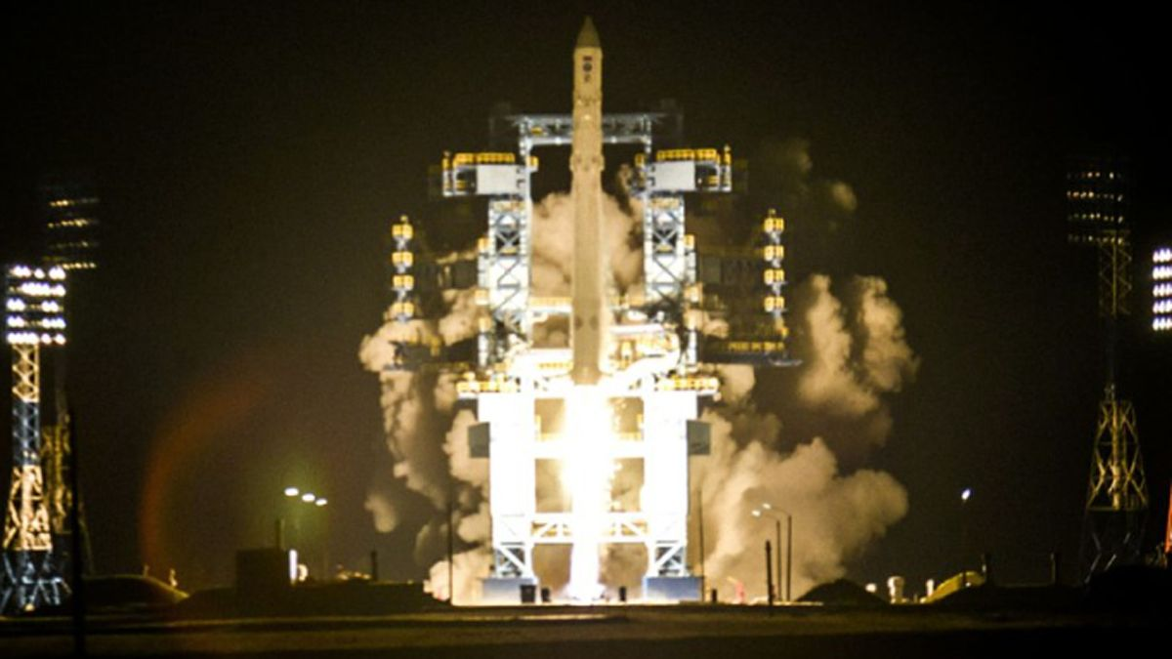

Click for next article An Angara rocket launches the COSMOS 2560 satellite from Plesetsk Cosmodrome on Oct. 15, 2022. Another trio in the COSMOS series - COSMOS 2581, 2582 and 2583 - launched in February 2025 and has performed sophisticated rendevzous operations in orbit. Two Russian spacecraft just demonstrated a very particular set of orbital skills. The satellites , known as COSMOS 2581 and COSMOS 2583, got within just 10 feet (3 meters) or so of each other on April 28, according to COMSPOC, a Pennsylvania-based space situational awareness company. "This wasn't a coincidental pass - COSMOS 2583 performed several fine maneuvers to maintain this tight configuration," COMSPOC wrote in a May 1 post on X , which featured an animation of the rendezvous. 🛰️Russian satellites multi-object proximity event in LEORadar tracking data via @LeoLabs_Space, processed through COMSPOC SSA Suite.This week we observed a complex proximity event involving Russian satellites: COSMOS 2581, 2582, 2583, and Object F (a subsatellite released by… pic.twitter.com/3nDkcOmTuDMay 1, 2026 The two satellites and a third one, COSMOS 2582, launched to low Earth orbit in February 2025 atop a Soyuz rocket. According to COMSPOC, all three of them were involved in the recent rendezvous and proximity operations (RPO), as was "Object F," a subsatellite previously deployed by COSMOS 2583 . During the 10-foot close approach, "COSMOS 2582 trailed the formation at sub-100 km range, while Object F passed within 15 km of 2582 and within 10 km of 2581 - neither maneuvered," wrote COMPSOC, which analyzed radar tracking data gathered by the California company LeoLabs . "For context: in late 2025 to now, we tracked these same COSMOS satellites performing 3-object RPO," COMSPOC added in the May 1 post. "Whatever Russia is testing, it's sophisticated." Such sophisticated orbital maneuvering is not exactly surprising; we've seen similar things from Russia before. For example, according to outside observers, the nation has operated multiple " inspector satellites ," including COSMOS 2542, which made a close approach to a U.S. spy satellite in 2020 .

