**Assignment – Dialogs Basic**

1. **What is dialog?**

* A dialog is a small window that prompts the user to make a decision or enter additional information.
* A dialog does not fill the screen and is normally used for modal events that require users to take an action before they can proceed.
* 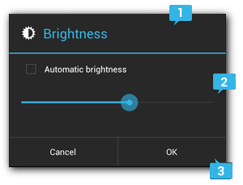 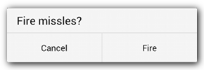
* The [Dialog](https://developer.android.com/reference/android/app/Dialog.html) class is the base class for dialogs, but you should avoid instantiating [Dialog](https://developer.android.com/reference/android/app/Dialog.html) directly. Instead, use one of the following subclasses:
  + [AlertDialog](https://developer.android.com/reference/android/app/AlertDialog.html)
  + [DatePickerDialog](https://developer.android.com/reference/android/app/DatePickerDialog.html) or [TimePickerDialog](https://developer.android.com/reference/android/app/TimePickerDialog.html)

1. **How to create custom dialog?**

To create a dialog create a class that inherits from the DialogFragment class and create an AlertDialog object in the onCreateDialog() method import

android.support.v4.app.DialogFragment;

public class LinkDialogFragment extends DialogFragment { @Override public Dialog onCreateDialog(Bundle savedInstanceState) { AlertDialog.Builder builder = new AlertDialog.Builder(getActivity()); builder.setTitle(getText(R.string.title).toString()); .setNegativeButton(R.string.cancel, new DialogInterface.OnClickListener() {

public void onClick(DialogInterface dialog, int id) { listener.onDialogNegativeClick(LinkDialogFragment.this);

}

}); return builder.create();

}

}

1. **How to use existing dialogs?**

* Your DialogFragment can implement the onCreateDialog method and return an existing dialog.
* The Dialog class is the base class for implementing a dialog. Typically, you use one of its subclasses, e.g., AlertDialog, ProgressDialog, DatePickerDialog or TimePickerDialog.
* Android also provides a ProgressDialog, which can be opened via a ProgressDialog.open()method call.
* To display the dialog we just created we have to create an instance of the class in our business and invoke the show() method so that the dialog appears. With getSupportFragmentManager() call method get access to FragmentManager that is responsible for managing the fragments of the application.

//LinkDialogFragment object

LinkDialogFragment t linkDialogFragment=new LinkDialogFragment();

//fragment parameters

Bundle args = new Bundle();

args.putString(“CLOSE", close);

linkDialogFragment.setArguments(args); linkDialogFragment.show(getSupportFragmentManager(), "");